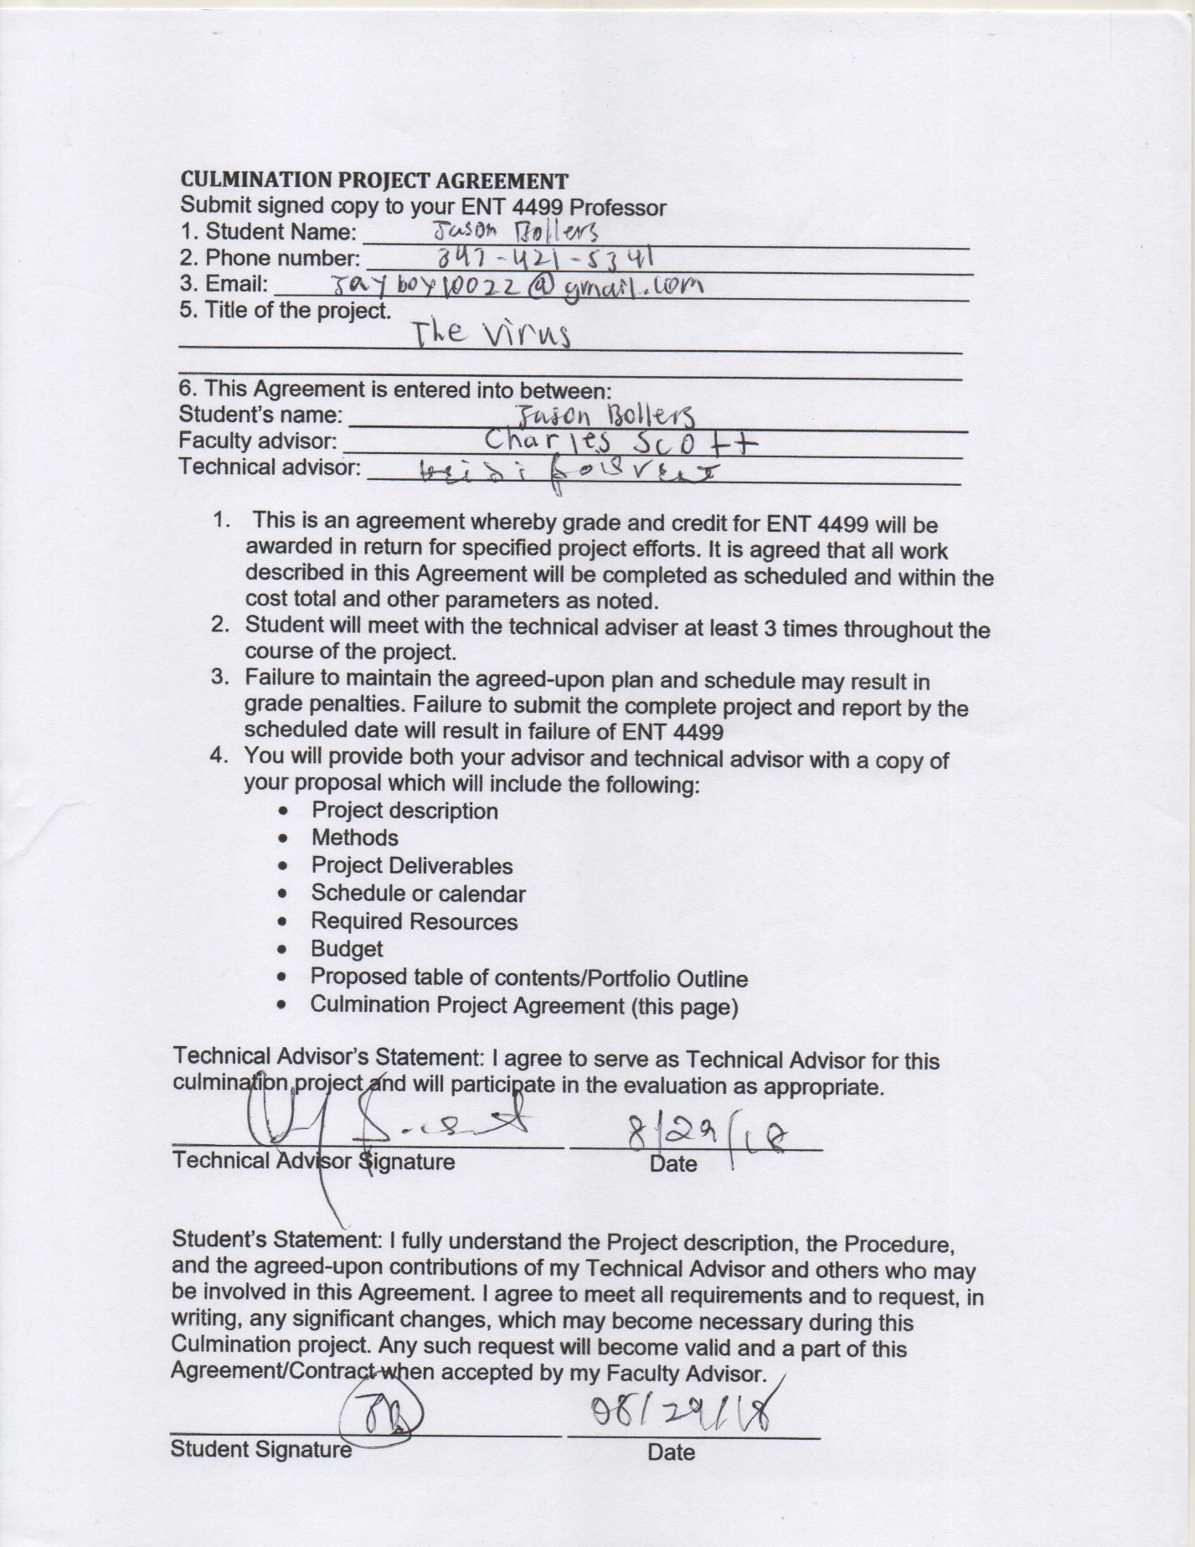The Virus
Jason Bollers
Game Designer

Project Description:
In my time at City Tech I have learned many things about game design and development. My goal is to be a game designer and create high end games, but I don’t have much to show on game development. Doing this culmination project is a test to show that I can do this and to show my skills that I developed over time, To show that one day my games can help people connect and have fun. The Virus will be a game of puzzles and hacking (not literal). The player will be given powers to hack into cameras and bots that roam each testing room and use them to advance through the levels of this maze. They will also have to solve puzzle that can lead to a game over if not done properly or a way to advance, if successful. Using my modeling and scripting skills in Unreal Engine and Maya I will be able to create dynamic yet simple mechanics to challenge the players brain. This idea was inspired by a game called Watch Dogs where you’re able to hack anything in the world and I thought what if someone had these skills to escape a place they don’t remember being in. What happens when a person’s brain is transferred into a computer?

Methodology:
Though my skills in modeling and scripting is intermediate I still will need to do some research on certain scripts. I would mainly be using YouTube as a reference to create these scripts and to understand how/if the scripts will work in my game. I plan to start off with creating minor assets like the security camera inside of Maya. Then moving on to creating the computer interior and trap rooms, since the environment will be simple shapes like cubes I can easily build them with in Unreal Engine. After the environment is set up and the objects are in place, then I will start to work on game mechanics and scripting within Unreal Engine. The last thing is just testing and making sure everything runs well with in Unreal Engine and that the mechanics work properly.

Models Needed:
- Robots
- Virus (a worm looking creature)
- Cameras
- Humanoid hands
- Doors
- Keypad
- Connect the circuits puzzle
- Destroy the virus puzzle
- Power sorting puzzle
- Music
- Menu Graphics

Programs:
- Unreal Engine
- Maya
- Photoshop
- Audacity

Timeline: 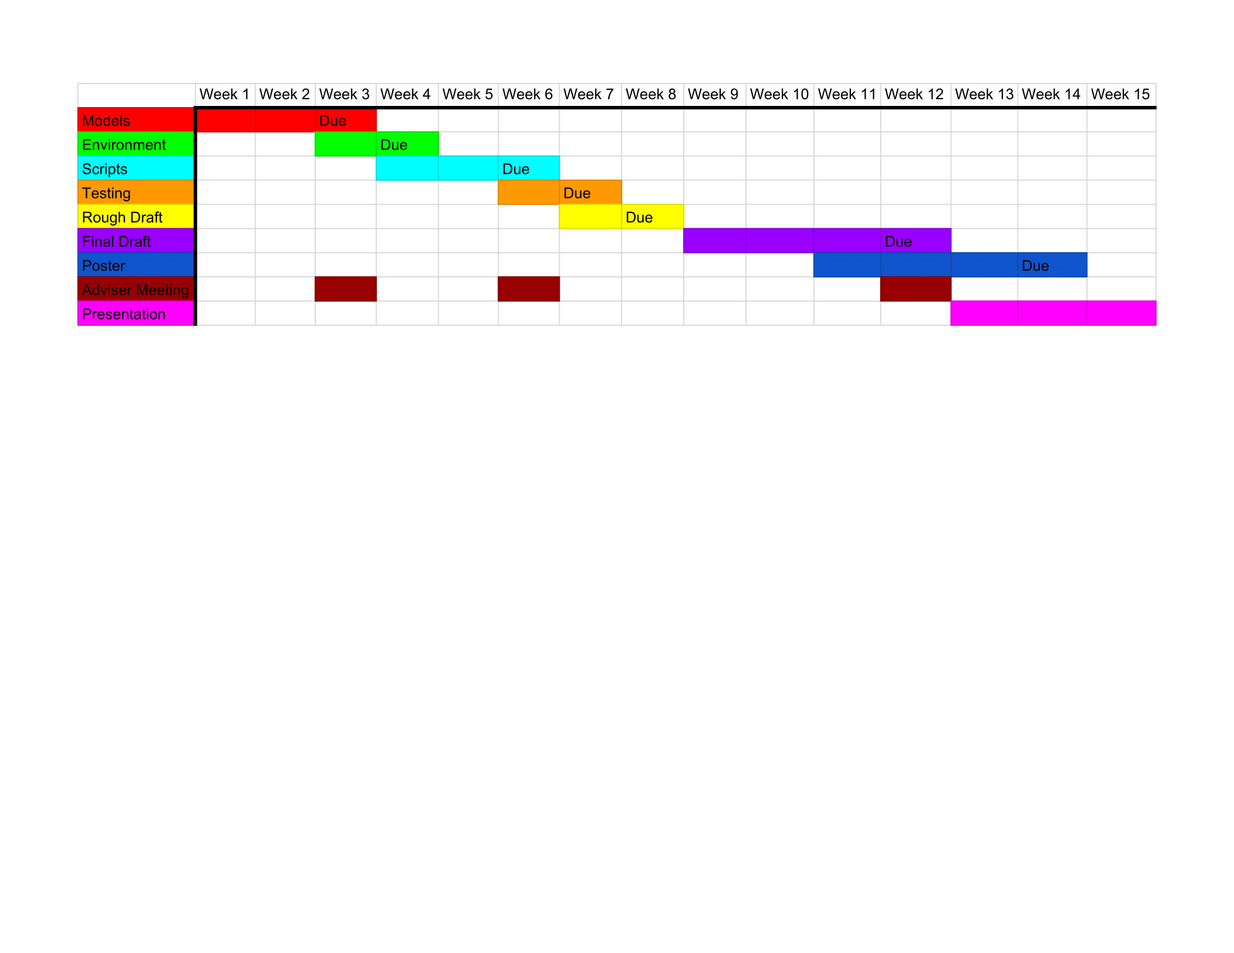
Budget:
The budget will be zero because all resources will come from me.

The Virus
Jason Bollers

Game Identity / Mantra:
Strategic puzzle platformer about being trapped in a computer by a virus.

Design Pillars:
Challenging
Action-packed
Revolutionary

Genre/Story/Mechanics Summary:
- This game uses a unique hacking mechanic to take control of the environment and npcs inside the computer to solve puzzles and to get to unreachable places.
- Using your newly found powers you’ll be able to hack certain systems to disable or destroy them.

Features:
List the cool features or unique elements that you want to include in your game.
- Npc control
- Hacking Puzzles
- Stealthy Interactions

Interface:
List the player input method, the controls, and how the player interacts with your game.
- The player will use the wasd or arrow keys to move
- The mouse will control head movement/body rotation
- Left click is to control hackable objects and npcs
- Right click is to interact with doors, keypad, etc
- Space is to jump
- Shift is to run

Art Style:
Hacking Puzzle
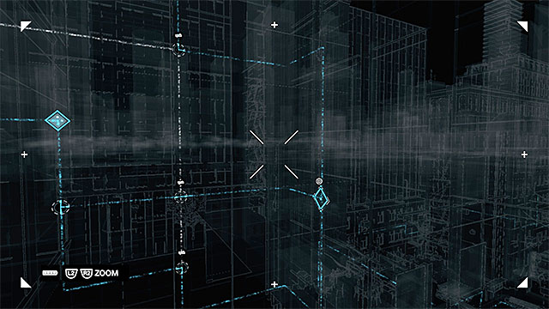
Hacking Cameras and Hacking Through Cameras
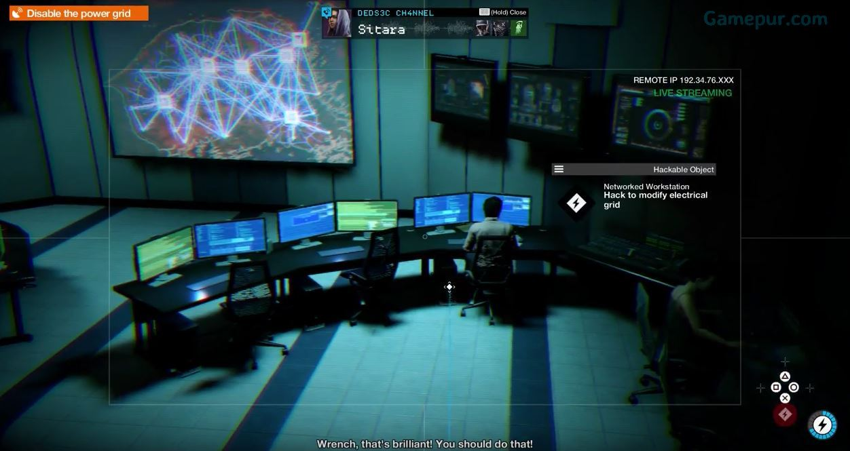
Hacking From a Distance
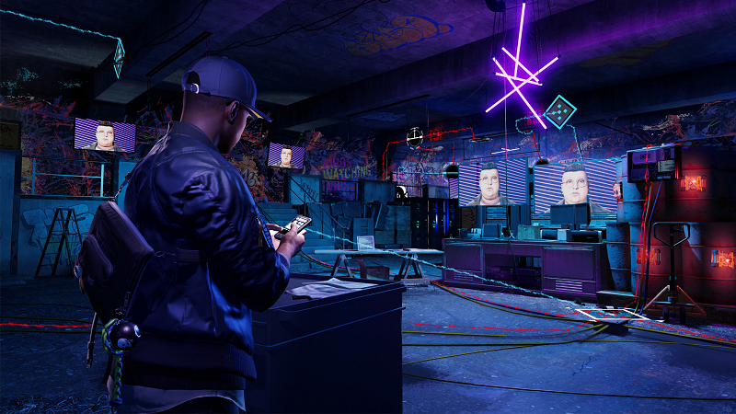

Music/Sound:
- Action https://www.youtube.com/watch?v=UBVoONryE3s
- Fight https://www.youtube.com/watch?v=NP3_aITHC8U

Development Roadmap / Launch Criteria:
Platform: PC Audience: Any age/Puzzle Lovers

