The Virus

*Jason Bollers*

## Game Identity / Mantra:

Strategic puzzle platformer about being trapped in a computer by a virus.

## Design Pillars:

Challenging

Action-packed

Revolutionary

## Genre/Story/Mechanics Summary:

* This game uses a unique hacking power to take control of the environment inside the computer to solve puzzles and to get to unreachable places.
* The player will be able to physically control objects and npcs in the environment with a POV perspective.
* Using your newly found powers you’ll be able to hack certain systems to disable or destroy them.

## Features:

List the cool features or unique elements that you want to include in your game.

* Npc control
* Hacking Puzzles
* Stealthy Interactions

## Interface:

List the player input method, the controls, and how the player interacts with your game.

* The player will use the wasd or arrow keys to move
* The mouse will control head movement/body rotation
* Left click is to control hackable objects and npcs
* Right click is to interact with doors, keypad, etc
* Space is to jump
* Shift is to run

## 

## Art Style:

Hacking Puzzle

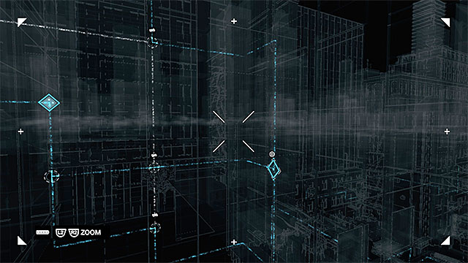

Hacking Cameras and Hacking Through Cameras

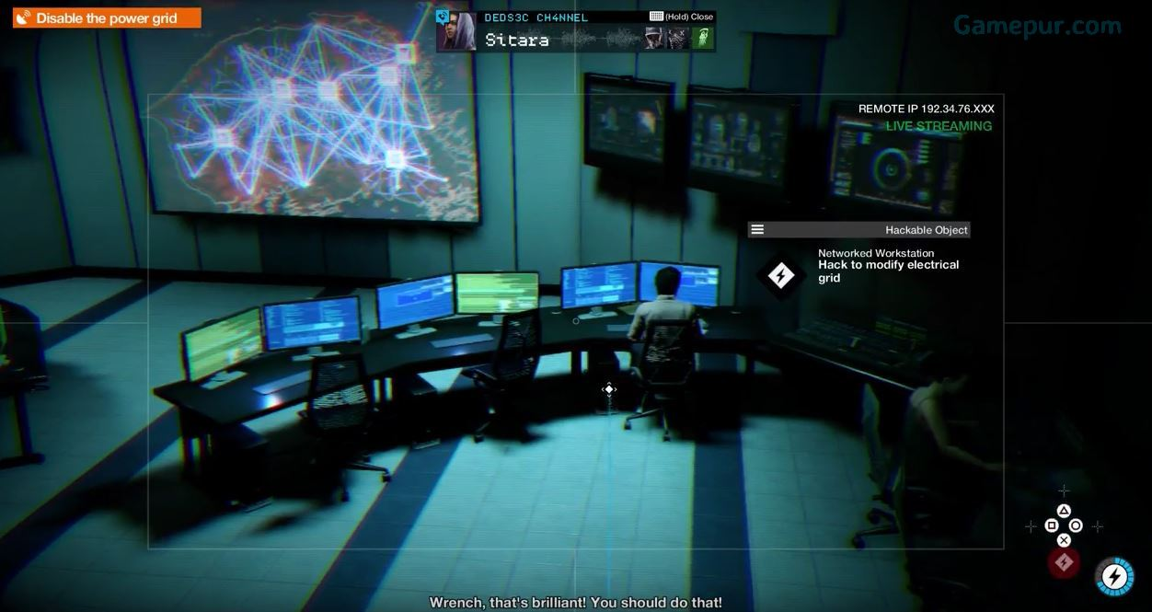

Hacking From a Distance

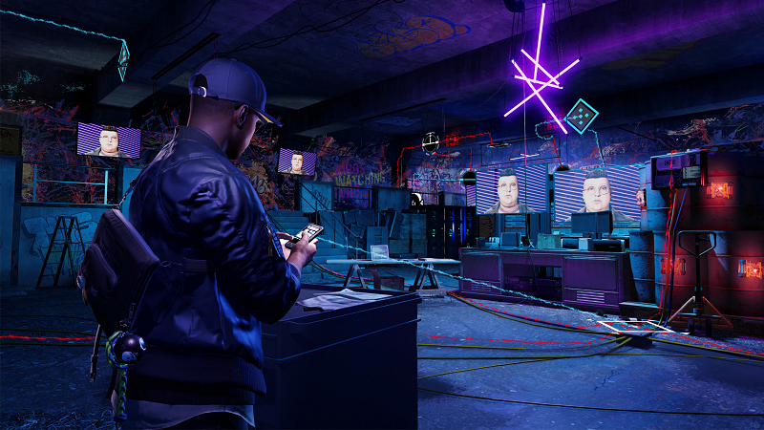

## Music/Sound:

* Action <https://www.youtube.com/watch?v=UBVoONryE3s>
* Fight https://www.youtube.com/watch?v=NP3_aITHC8U

## Development Roadmap / Launch Criteria:

**Platform:** PC **Audience:** Any age/Puzzle Lovers