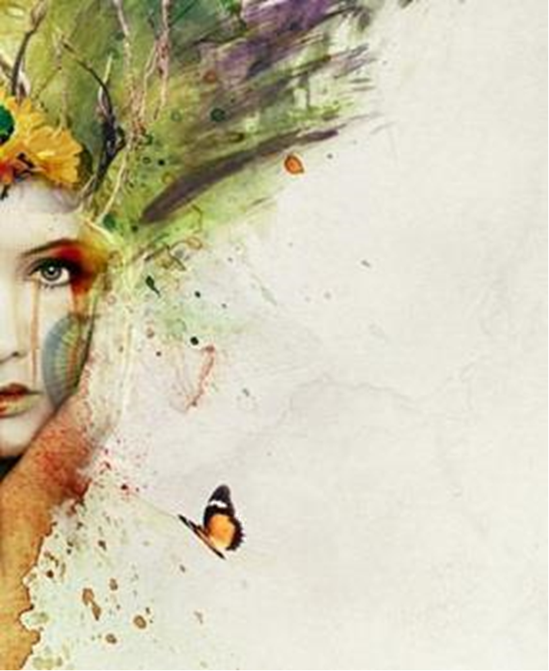
INSTRUCTION MANUAL ON HOW TO USE ADOBE PHOTOSHOP

Contents

• Getting Started with Adobe Photoshop |  | 3
• Starting and Closing Photoshop |  | 6
• | Layers and Filters | 7
• | Retouching | 9
• How to Use the Free Transform Tool |  | 10
• | Selection Tools | 11
• | Brushes | 12
• | Actions | 13
• | References | 14

2 | P a g e

How to Use Adobe Photoshop

Adobe Photoshop, the universal and productive standard graphics software for photographers, designers and digital artists, as well as casual fans. This application can be a bit tricky to understand at first but once you get to know it, you're a professional. This instruction guide will get you ready to know the ins and outs about all key aspects of using the application. There are many techniques to understand and learn in this application which we will explore step-by-step.

• Getting Started with Adobe Photoshop

The first thing to do is identify and understand the structure of Adobe Photoshop. Let us take a look at the first image. (Image_1) shows an outlined structure of how the Adobe Photoshop interface looks. To start using these menus and toolbars we have to know what they are used for.
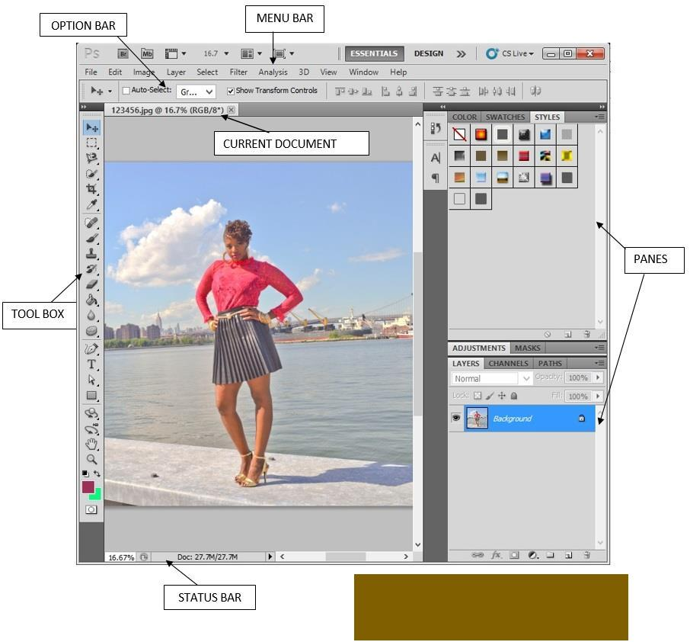

 | Image_1
Menu Bar | A view of Adobe Photoshop interface.
3 | P a g e

The menu bar is a logically constructed and identified section to provide commands for working with your documents and consists of nine menus: File, Edit, Image, Layer, Select, Filter,

View, Window, and Help. In each of these menus you’ll find a sign like ‘ (...) ’which means you can make additional alterations to you document. You will also see a sign ‘ ’ like which means there is more options to be selected if needed.

Option Bar

The options bar is movable and it changes as different tools are selected. By using the options bar you can toggle the opacity, fade distance, blending mode and so on.

Status bar

The status bar can be found at the bottom edge of the application’s workspace. The status bar is a valuable tool that appears when you open a document. It shows you information such as the size of the document as well as the magnification of your document.

Tool Box

The toolbox is one of the main essential elements used in Photoshop. It is basically used to do anything you want to the picture. On the toolbox, you will find some buttons have a small arrow in the lower right corner which means that there are more unseen tools under it.
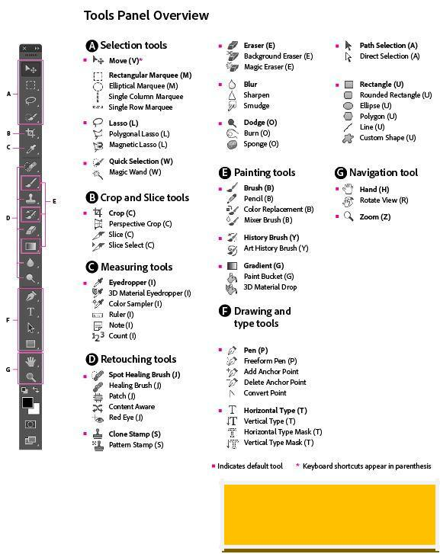

Image_2

An overview of the tools in the toolbox.

Panes

4 | P a g e

The panes found on the right side of the application is used to keep control of the layers, masks and color styles used as well as other different aspects such as coordination of paths and channels to you document.

Now that we have understood the structure of the interface, let’s take a step further and learn how to use some of the elements used in the menus. The image below (Image_3) shows you what the elements in each toolbar is used for.
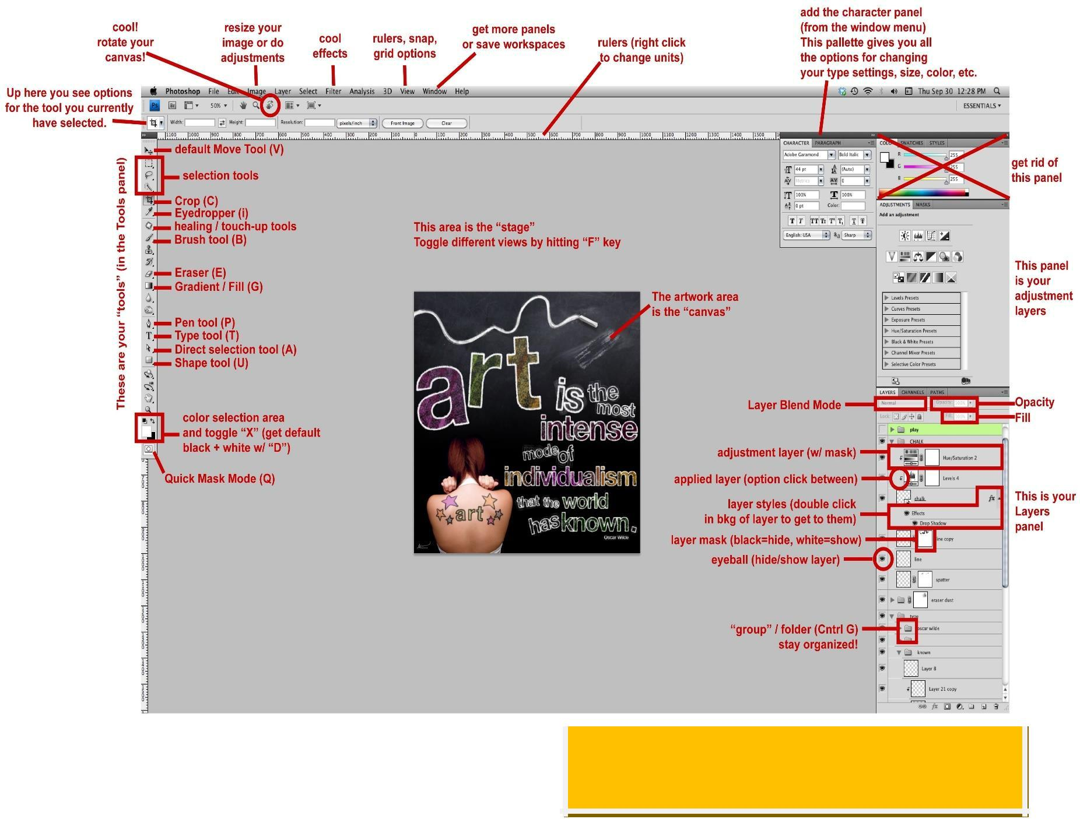

Image_3

Elements in Adobe Photoshop taken from

http://tfa.stanford.edu/sp2011/

• Starting and Closing Photoshop

5 | P a g e

One important aspect about starting and closing down your Photoshop application is to always remember to save your work every step of the way like every other application in your system. However, in Photoshop, you are going to save it in two different ways: one way is by saving it as a picture and the other way is saving it in a Photoshop application format.

To Start a New Page:

- Click on File

- Click on New (to open a new page))

- Select on the Select text box and type in your desired name.

- Select on the Present selection box and select you desired type of document you are creating.

- Select the Size and Width, Resolution and Color Mode in accordance format as you wish.

- Select Background Color to set the appropriate color you wish to set as you open a new page.

- Press OK.

To start with a current document:

- Click on File

- Click on Open and select your desired document to start.

To save the document:

- Click File

- Click Save As

- Select the desired Name and the Format you wish to save it as.

To remove the document you have created or opened:

- Right Click on the tab located with the name of the picture

- Select Close.

To shutdown Adobe Photoshop by closing the whole document:

  - Press Close on the top right hand corner of the application.

- Layers and Filters

6 | P a g e

By: Jovaria Asif

