**Finding My Way Back Home**

**Written and Illustrated by: Jailine Collado**

Finding My Way Back Home

By Jailine Collado

**Prologue**

As you read this book, you will connect with me on how fashion changed my life. A story of self-discovery where the path I was meant to be on was apparent, but I took detours to adjust my course according to what I presumed the ideal might be. Follow me on my journey as a daughter of Dominican immigrants growing up in the Bronx; I was able to not only find my style but reconnect with passions that kept me motivated in my life and reinvent myself every day. This journey resulted in finding my way back home, where I was meant to be.

**Foreword**

There hasn't ever been a time when Jailine did not care about fashion or her appearance. Since she could form her own opinions, Jailine tried to choose her outfits and hairstyles. Usually, though, our mother would refuse her because they were “impractical” (in her opinion) for school or the playground. Jailine was always very headstrong, however, and seeing as though she was her last child, Jailine did get away with wearing small-heeled shoes, knee-high socks, plaid shorts, and a Dora the Explorer T-shirt to Daycare. To pinpoint an exact time when she was interested in fashion is impossible, but discerning when she wanted to study fashion is more attainable.

When Jailine went off to college upstate at Buffalo State, She went off to study education since it’s more practical than fashion; but as she lost interest in that field, the Covid-19 pandemic struck- and she had more time to find herself and what she wanted for her future. The y2k fashion scene spoke to her; the bright colors, ironic graphics, and leather caught her attention. Being born after this era, she couldn’t explore this scene at the time, but being stuck at home for so long gave her time to explore textures, fabrics, and colors at home. The thought that this fashion gained so much popularity decades after it was more prevalent interested her. Finding patterns in fashion trends interested her more than lesson planning ever could, and so she decided to transfer schools and return to her home in the Bronx, where access to fashion trends is more accessible on a daily basis. Since returning home, Jailine went thrifting for clothes, looked through influencers’ pages, and dressed in outfits an average person would not be able to pull off. With her confidence, Jailine is able to pull off any look. We all have faith that she’ll find her way in fashion and continue to do what she loves. In any case, she enjoys remaking herself daily, ensuring that she looks her best everywhere she goes.

**Table of Contents**

Chapter 1: Facing my Fears…………………………………………………………………....p.6

Chapter 2: My Super Sweet 16...………………………………………………………………p.8

Chapter 3: Sisterhood of The Green Plaid Pants………………………………………………p.10

Chapter 4: Number 7…………………………………………………………………………..p.12

Chapter 5: Prom…………………………………………………………………………….....p.15

Chapter 6: 22………………………………………………………………..………………....p.18

Chapter 7: Canadian Tuxedo…………………………………………………………..……....p.21

Chapter 8: Jade…………………………………………………………………..…………….p.23

Chapter 9: Daphne……………………………………………………………………………..p.25

Chapter 10: The Christmas Show……………………………………………………………...p.27

About the Author………………………………………………………………………………p.29

**Chapter 1: Facing My Fears**

It was lunchtime in the school cafeteria at PS.79. We had pizza boats and chocolate milk on the menu, and I was too nervous to think about eating. My heart was racing, and my palms were sweaty. The end of the day was approaching quickly, so it was almost time for StepTeam auditions. The nerves were rushing through my body. I contemplated with myself if I should even do this. If I was this nervous, I simply was not ready. Finally, I put my nerves aside and told myself I needed to be brave; if I did not, I would be scared to do things for the rest of my life. The end of the day was here, I made my way downstairs to the gym from the 3rd floor, and there was Ms. Hernadez and at least 40 other girls. I took a deep breath and found a place in line at the back. We began the tryouts. Girls were getting pulled from the line left and right. Before I knew it, I had already reached the front line with 15 other girls.

The uniform was mandatory in PS. 79. I usually wear a navy blue pleated dress with thick sleeveless straps, my short sleeve pale yellow-colored shirt underneath the dress, and white stockings with my black shoes. However, it would be more fitting to wear something I can move around better while still wearing the school uniform. But I could not find my navy blue slim straight pants. So, unfortunately, my only option was not my favorite pleated dress, but my pleated skirt blue pants, which did not have much *stretch and recovery,* but I was limited in options.

I woke up early to *straighten* my bangs and the ends of my *waist-length* *hair*; I applied *heat protectant* to not damage my curls. My mom never knew how to manage my curly hair; it was much easier for me to get my hair *straightened* at the salon every month. Next, I splashed water on my face and brushed my teeth so hard that my gums bled a little. My little *hoop* *earrings suspended* down my ear. Then, I got into my uniform and walked to school alone, across the street from my apartment building. I could not help but *bite* my nails on the walk to PS.79, I was doing something I did not think I dared to do, but by the end of the day, I made myself proud by facing my fears. I left the gym with *bruises* along my thigh and my hands as red as ever, but I went home with my head held high.

Walking into the gym for step tryouts, I wiped my sweaty hands on my navy blue uniform skirt. When I made my way to the back of the line, I immediately felt a rush of emotions that I could not process all at once. It felt foreign to me that I could be good in anything, let alone step. I have never been one to run to the spotlight, but at that moment, the spotlight found me as I inched my way closer and closer to the form of the line. The memory of the yellow and blue uniform will live on within me forever.

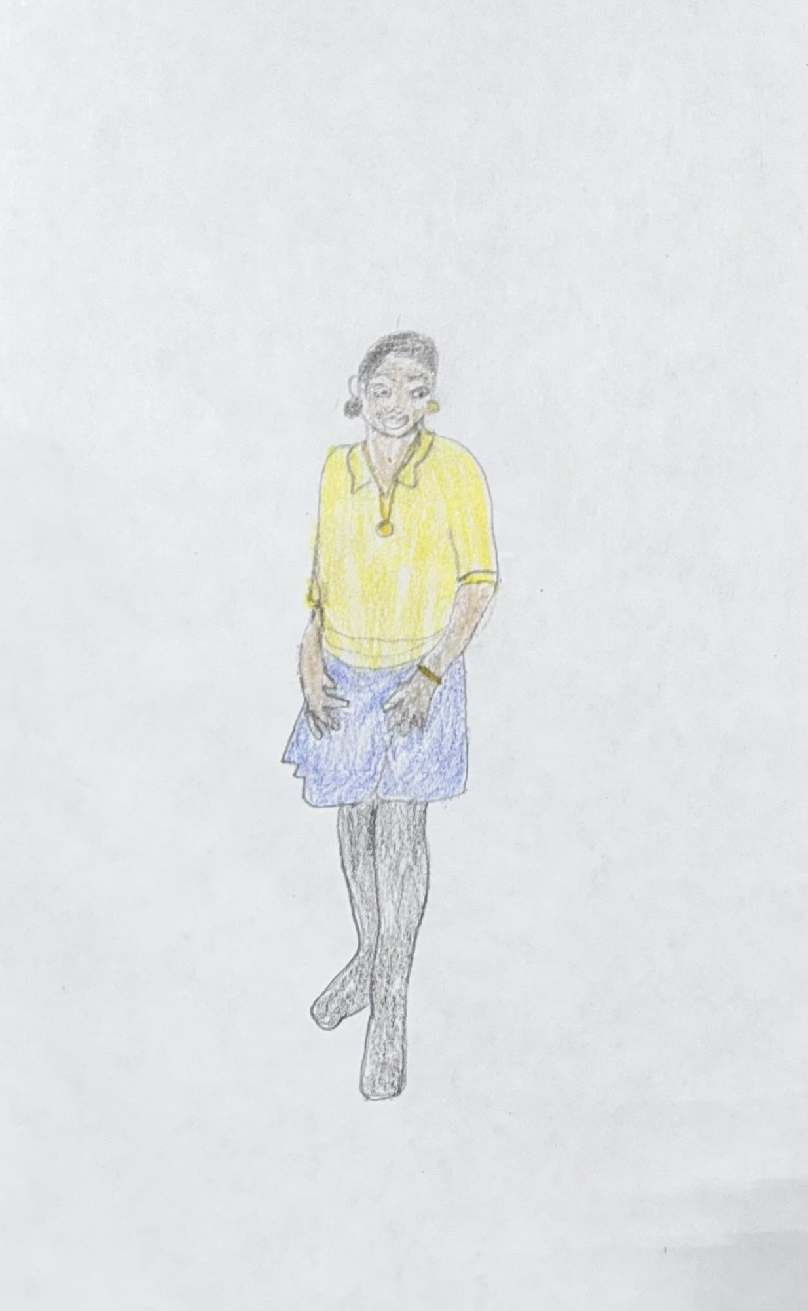

**Chapter 2: My Super Sweet 16**

My Sweet 16 was the event of the year to look forward to. The year was 2016, my Junior Year of High School at Hostos Lincoln Academy. My mom is an enthusiastic party planner; whenever there is an event, she likes to take control of the event. My sweet 16 was just another excuse to keep my mom busy planning a party. We settled on the party being a masquerade theme. Hence the face mask is mandatory. The color scheme was white, black, and gold, fitting the masquerade theme. As July 1st was approaching, I struggled with the anxiety of being in the spotlight, a concept I usually run far away from. Ordering my dress online took a lot of work. I was hesitant about my sizes being done incorrectly or the timing of when it may come in. Although the dress was not exactly what I had imagined, it was perfect because I felt like a princess, which I’ve always fantasized about growing up. Finally, I walked down the runway and made my entrance with my gown, everyone’s camera was facing me, and I saw grinning smiles behind those cameras. I felt nothing but beauty as I walked through and made my way to my gold throne.

Few 15-year-old girls would be willing to buy their sweet 16 dress online blindly,y but I took the risk. I knew exactly what I wanted; a *champagne-colored* dress with *gold* *embroidered* and *stones*. A *strapless* *sweetheart* *neckline*. *Long ball gown*. When the dress arrived, it was not identical to the image I found online; there were several layers of different fabrics, the very one on top being a *mesh* material. I had to purchase a *petticoat* underneath the dress to give it more of a fuller look than I intended, which *suspended* down my legs.

I went to Bonnie’s salon early in the morning to give myself enough time to go to the beauty supply store and pick up the extensions I needed to add to my hair in order to *enhance* and *texturize* it. I showed Bonnie some inspirational pictures of how I wanted my updo to look after 2 hours of *snagging*, pulling, and a few burn marks from the flat iron; I showed Bonnie some inspirational pictures of how I wanted my updo to look. I was not excited about it, but unfortunately, there was not enough time to *tweak* it. Bonnie provided me with a free service as a birthday present. As the time to leave quickly approached, I was dredging every moment. It was a year into my *braces*, and the idea of smiling with my teethmortified me. Not only was I incredibly insecure about my *braces*, but I was also struggling with my weight*.* I knew, especially with the style of dress I chose, I was opening the door for a conversation about how slim I looked.

I was not eager to have a sweet 16; the party was not necessarily for me. I went through with having it because of my sister and my mom. My older sister never had one, and she wanted her little sister to experience having a grand party. My mom enjoys party planning as escapism; once I saw how excited they were, I could not tell them I did not want the party. It would have disappointed them. The only opinion I cared about having was the dress. I knew exactly how I wanted the dress to look, but growing up financially insecure, I did not want my mom to pay $500+ for a beautiful dress. We searched and searched, and although we found so many pretty dresses, I gasped every time I looked at the price tag. When I saw the dress I desired, I knew it did not matter how chaotic the party was; I genuinely felt beautiful in my champagne dress.

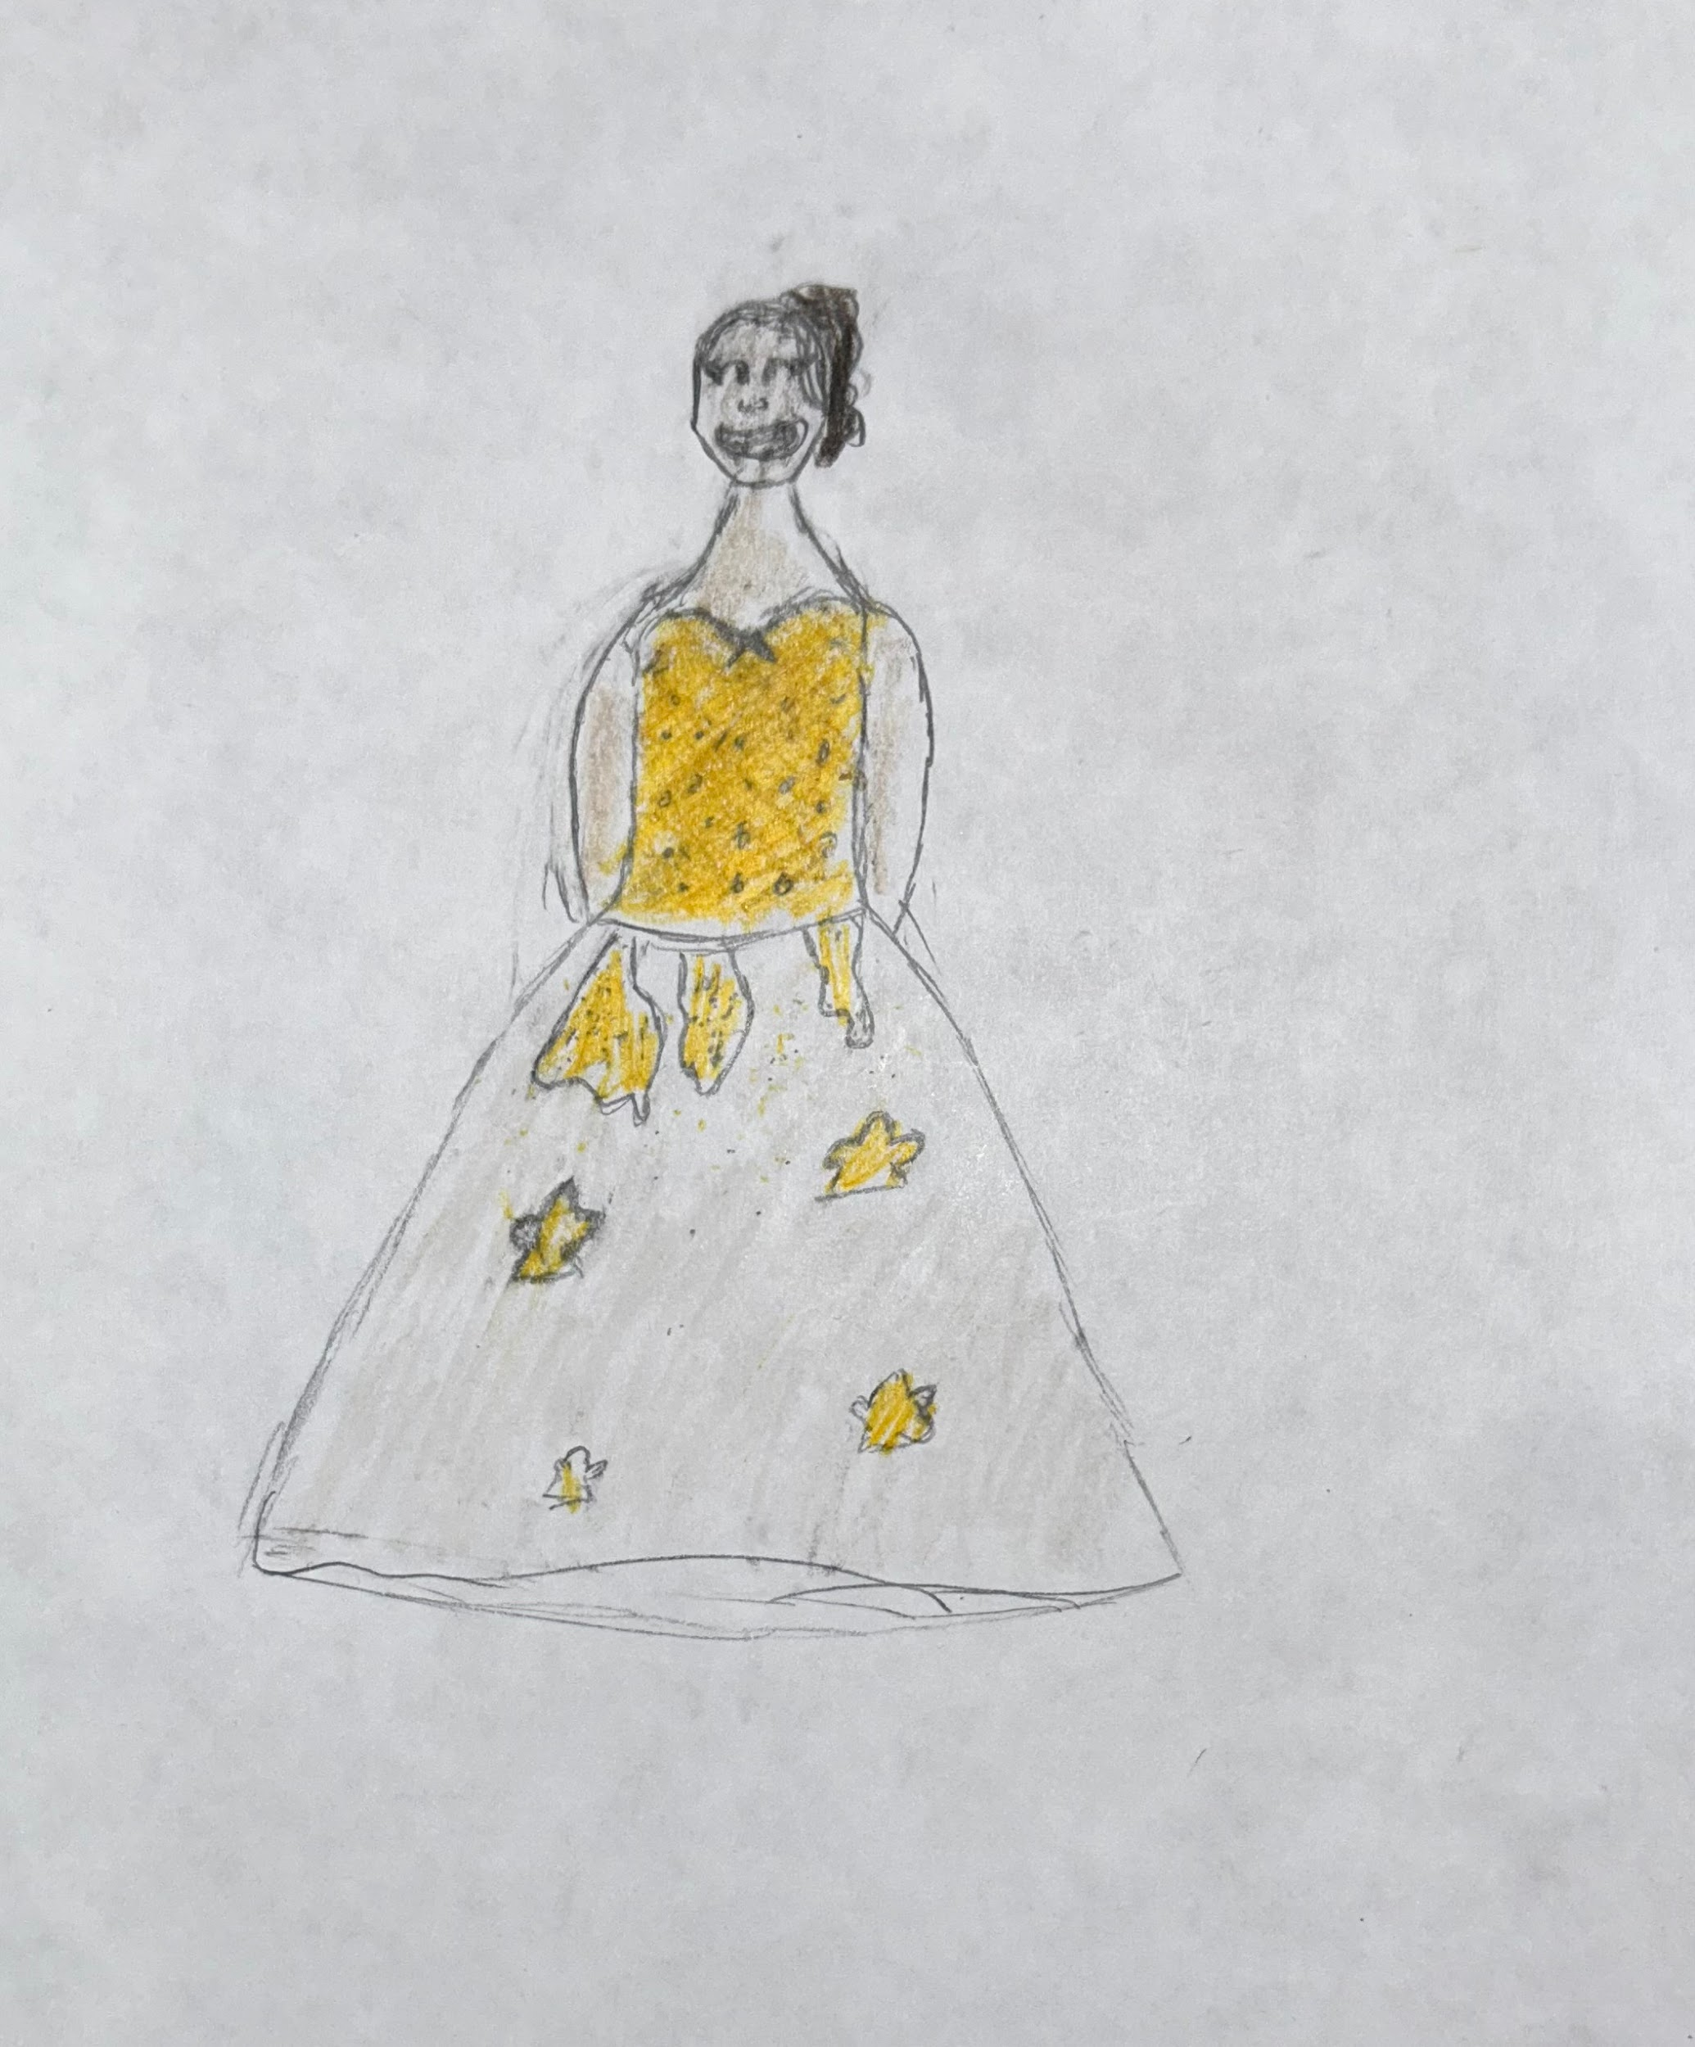

**Chapter 3: Sisterhood of The Green Plaid Pants**

Growing up with my sister in our one-bedroom apartment in the Bronx, Yanelza has always been my greatest inspiration. Since my adolescence, not only did I admire her beauty and the person she helped shaped me to be, but she was also part of the reason why I could analyze clothes differently. I saw firsthand the clothes she would constantly wear and those she held on to but tossed to the side. She would get home late most days because she was always with school, after-school programs, and work. I enjoyed sneaking into her closet in the hallways, playing dress up with her clothes, and layering dresses over jeans. I would rummage through her little wardrobe. As I looked up, I would see a mountain of clothing,s and my eyes would immediately light up. I was finding anything that looked fun or cool. I would walk up and down our little apartment modeling and dancing, feeling free and like myself as I looked through her closet one last time before putting all her clothes away. I see a green plaid pattern peaking under a purple sweater. As I pulled on what I presumed was a jacket, I discovered the ultimate pants.

These green plaid pants were not ordinary yet extraordinary. The pants were incredibly *skinny,* yet they *stretched,* almost like *a jegging*. The pants were *high-rise*. They sat right above my belly button. There were no buttons on the pants. Instead, there was only a *side zipper,* but the clasp that used to sit right about the zipper to keep the pants together fell off.

It was simply to dress these pants up or down. At the time, plaid was associated with either flannel shirts or punk rock styles. As I finally got my hands on the iconic pants, I realized how much these pants *enhanced* my most significant insecurity; mylegs. I have always been skinny growing up. Although I hated how tightly the pants *snugged* onto my body, I could not help but channel my inner Hayley Willaims. Then suddenly, I was confident to go out and show off these statement pants. I paired the pants with a burnt orange band t-shirt that I had cropped and added some *distressing*. With my green Adidas stan smith, which I bought solely to match my new green pants. And, of course, every outfit would be the same with my staple beauty supply of silver hoops which I *inserted* into my earlobe and *applying* lip gloss.

My sister and I enjoyed listening to Paramore, hence my slight obsession with Hayley Williams. I have always used a lot of inspiration from my fashion and found it in artists I enjoy listening to. As we sit on the couch in our living room watching Paramore videos, I see Hayley has these super skinny yellow plaid pants. I eagerly yell to my sister that she has pants like that but in her favorite color, green. Years later, I was never allowed to wear those pants because they were Hayley Williams pants. Then the years passed before I left for college in Buffalo, New York. The last thing my sister gave me was those green plaid pants. I could not believe she was letting them go. Unfortunately, as she was letting me go, she also let go of those pants.

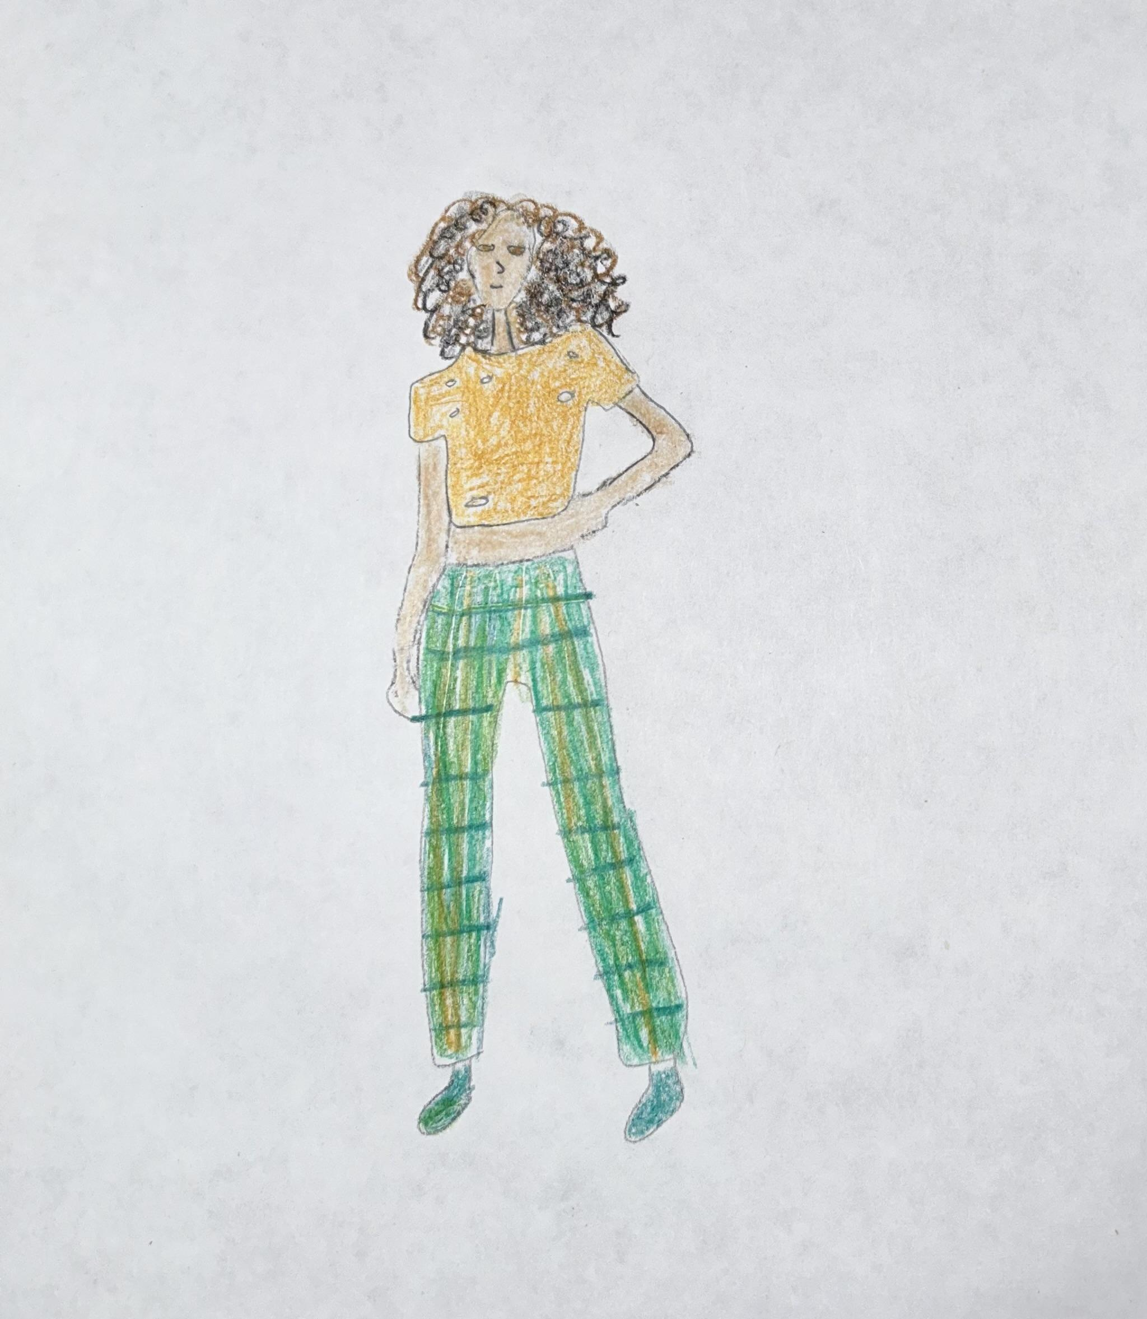

**Chapter 4: Number 7**

It is 2015, my sophomore year of high school at Hostos Lincoln Academy. My best friend Nicole and I are sitting on a bench at St. Mary’s Park across the street from the school. We discussed that we need a hobby and an activity after school. We often stayed together after school at our local pizza spot, Frescos or St. Marys, avoiding the fate of going home. We had limited options as we attended a small school with only volleyball and basketball teams. We both enjoyed baseball and how difficult it could be to start a group if we could find the required amount of girls, a minimum of 8, and a coach to stay with us after school. The next day we got to work; we started talking to girls in our inner circle, then girls from our grade, and branched out to the other grades. After a week of scouting, we put up a list of girls who would like to try out for the team, and there were 23 sign-ups. I could not believe it, and after another week of hunting for a coach, I met Mr. Lopez, a baseball enthusiast. After a year of building up the softball team, Mr. Lopez recognized my hard work and how softball saved me, giving me the drive and discipline I needed to excel. Mr. Lopez made me captain of the team.

When starting the softball team, I knew it would be an investment of sorts, Hostos Lincoln Academy did not have much funding, so I knew this would be a self-funded sport. Shopping for cleats, baseball pants, gloves, bats, and balls was fun. I was the most excited to create a one-of-a-kind jersey for the team. Collectively we agreed to spend at most $75 on the Jerseys, keeping the budget we were limited in options. We had expectations for the jersey to be suitable for warm and cold weather. After three weeks, the jerseys were finally ready. Mr. Lopez opens the box, and we’re all quickly shuffling to find our number. As I pull out the number 7 jersey, I see that everyone’s faces are in awe of this jersey. Our school’s colors are Royal blue and orange. We choose to keep royal blue as our primary color and orange as our accent color. The back had our last name and number stitched on in white with orange piping along our letters and numbers. The jersey is a Royal blue color, *v-neck* style with Hostos *stitched* across the chest. These jerseys made us feel good about ourselves.

I woke up at 6:30 to prepare for school the morning of our last game. Typically during the game day, the girls and I will wear our uniform with Nike slides to be comfortable and ready for the game and have a little extra time to practice. That morning I brushed my teeth and *inserted* my rubber bands onto my braces, my teeth were *shifting*, and I was in incredible pain. So first, I put on my black and white Nike sports bra, with a white tee shirt, royal blue under-armor hoodie, black softball pants that went down to my mid-calf, and royal blue knee-high socks with my black and white Nike slides. I did not have my jersey because Mr. Lopez said he wanted to show some of his baseball friends the quality of our jersey; of course, I said no problem as long as he had it with him for game day. At this point, I had 10 minutes before I needed to run a catch the four train from Burnside to 149th Street. My hair was already parted in the middle; I had shoulder-length hair almost always *straightened* during this time. A benefit from overally *processing* my hair is that I have mastered two Dutch braids in under 5 minutes. Making me the certified braider of the group. I *adapted* quickly and learned I needed to work fast if we wanted to look good and get some practice in before the game. So I packed my bag and was eager for the day to end; I could not wait to play. When the last period ended, we gathered in front of the auditorium. I see Mr. Lopez and ask for my jersey. He gave it to me, and I noticed a poached letter C on the left-hand corner of my jersey. When I see it, I look up and ask why? And he told me because I deserved it. And at that moment, I realized I was worthy of a title.

As we go through different phases in our life, the people we cross paths with during each stage is for a reason. Softball gave me the drive I never knew I had. The practice began at 6 am every other day. I would leave my apartment at 5:25 am smiling because I was a part of something I was profoundly proud of. Initially, I could have been better, but I preserved and continued to show up for my team and myself, holding myself accountable for a team that still exists today. When I see my Jersey hanging in my closet, it is not a jersey. It gives me pride; it reminds me of sisterhood and everything I was able to conquer in my life.

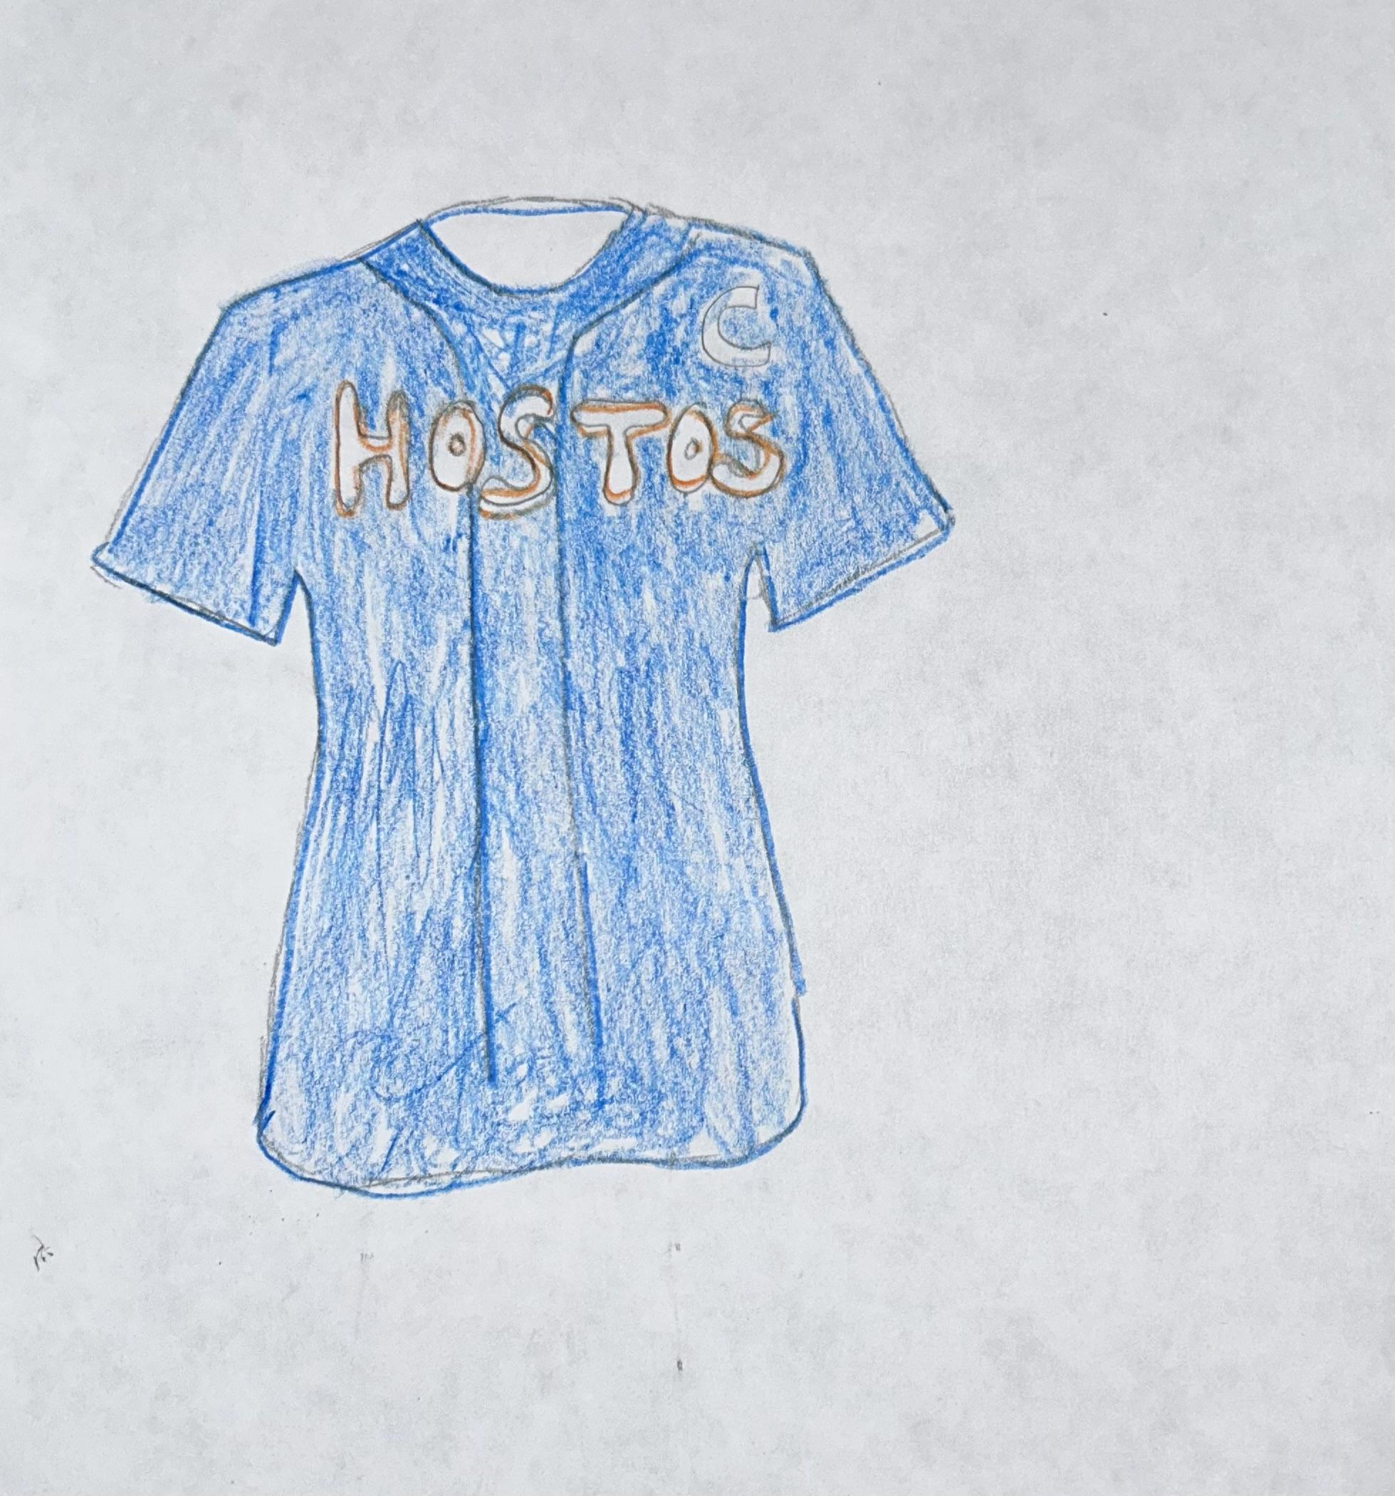

**Chapter 5: Prom**

It was the morning of prom, and the chaos began. I have been anticipating this day since September 8th, the start of my senior year at Hostos Lincoln Academy. Prom was on a Friday; I did not attend school that day. It seemed like a waste of a day. I was nervous because I was doing my hair and makeup. I woke up and immediately took a shower and brushed my teeth. I needed to ensure I had enough time to get my hair situated, considering it would be my first time installing a drawstring ponytail. I’m getting ready in the little bedroom my siblings and I shared. It took 30 minutes, but after a pound of gel on my hair, I was able to slick it back just well enough so it looked decent; I made a small tight bun with the remaining hair from my ponytail and then clicked the ponytail to the base of the bun and then tightened the drawstring. I went on to do my brown smokey eye and then applying on my foundation, concealer, blush, and highlight. Finally, I got into my black dress and silver heels. My friends Latoya and Marvin were meeting at my building to take prom pictures along with my prom date Kevin. We ordered our Uber and entered Maestros, where the timeless prom was. Growing up, I was never allowed to go to any parties; technically, prom would be my very first party, so I needed everything to be perfect; I needed to look perfect.

I knew the reality was with prom being three away; I needed to find a short dress. I quickly went to Google and searched for “cheap prom dress” The 2nd link I clicked was PrettyLittleThing, clothing made for petite women. At the time, I struggled with my weight and was a very slim 17-year-old girl. When looking for the dress, I was focused on two things a black and a cheap dress. Like my sweet 16 ball gown, my prom dress had a strapless sweetheart neckline. It was a long *form-fitting* black dress with a slit down the left leg. I knew I had to order the smallest size so that when I danced or moved my arms, round my dress would be tight enough around my chest area to hold itself up. I ordered the dress in an xss for $27 with free shipping. I paired the dress with $15 silver strappy heels from easy pickins that *wrapped* around the ankle., a silver embroidered clutch from Forever21, and silver chandelier earrings from Forever21. This little black dress made me realize that my collar bones are beautiful, having a small chest does not make me any less of a woman, and that my legs were strong and lean.

In the days leading up to my prom, I knew I needed to be well-prepared. My previously yellow-toned blonde hair was freshly *dyed* jet black using hair dye from the beauty supply. While buying the black hair *dye*, I envisioned doing a high ponytail to *enhance* the length of my hair. At the time, I was obsessed with Ariana Grande, who exclusively wore her hair in a ponytail, and I adored that look. So I picked out a 1b color drawstring ponytail that was 32in long. I also ensured to get my eyebrows *waxed* the day before so they could have time to settle down, considering my eyebrows get very red and irritated after the wax. And I got my manicure and pedicure done all white polish with a coffin-shaped style which *enhanced* the length of my nails*.* The day of, I made sure to *shave* my legs and my armpits. Unfortunately, after slipping on my dress, putting on my heels, and packing my purse, I was missing my signature red lip.

After my sweet 16, I truly realized how much I enjoyed dressing up for an ocasión and feeling beautiful. It was radiating. I could not wait for my senior year at Hostos Lincoln Academy to attend my prom. During this time, I knew I was attending Buffalo State College; any money I earned was saved for college, which was very costly. However, I wanted to splurge on my ideal prom dress. Unfortunately, everything about the dress I picked out accentuated the parts of my body I hated the most. And that is when I started to love the things I hate.

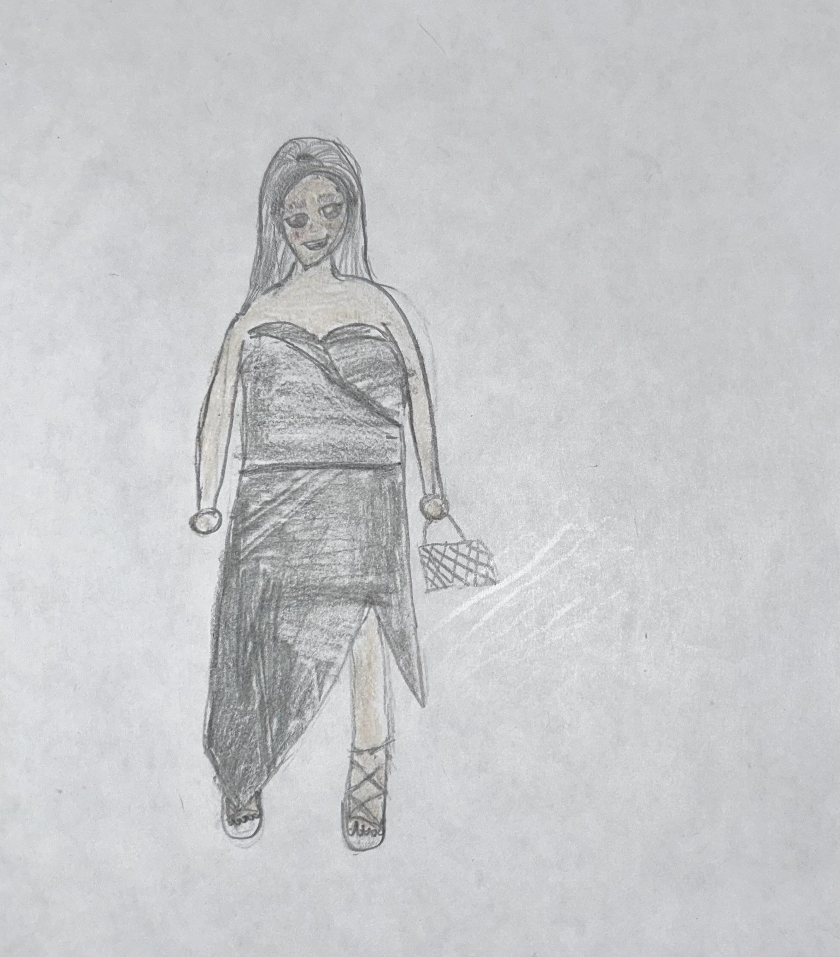

**Chapter 6: 22**

This is the first birthday I am spending in the Bronx in 3 years. Since leaving for college in 2018, I made it a point to move all my belongings because there was no reason to return to that apartment when I started a new chapter in my different home. My sister Yanelza and mom were preparing to begin my 22nd birthday festivities in our apartment. Twenty-two felt like a prominent age, and I needed it to be memorable. So I made reservations at a restaurant/lounge in Washington Heights called Republic. The location was recommended to me by my cousin Sacrly. She said that Republica was known for their drinks which is ideally what I wanted to do. So we got to the restaurant and walked several flights of stairs. But the walkup was genuinely worth it when we got to the rooftop location Republica; it felt like an enchanted garden. There were so many gorgeous flowers everywhere. It truly felt like a dream location. My mom, sister, and I sat before this beautiful cherry blossom tree. We drank the night away and ate fantastic food. At that moment, I remembered how precious having family around is and could not imagine celebrating another year without the two.

In the weeks leading up to my birthday, I wanted my dress to be pink with chunky green heels. I had many options but settled on my Pink *sweetheart neckline* dress that *adhered* to my body, With light *tulle* fabric and *preshaped* sheer pink long-sleeve gloves. And chunky green heels in which the strap *wrapped* around my ankle. But the main attraction was this beautifully boxed purse with a silver chain that I *knotted* up to be shorter with *beaded* and *embroidered* yellow, green, and pink flowers. It was the perfect accessory to complete my look.

I’m the type of person that wants to save money in any way I can and do things myself if I’m capable. The morning of, I took a shower and put on a shower cap to protect my hair. After getting out, I showered, brushed my teeth, and applied body oil. I *enhanced* my natural nails with an almond shape double French tip with a light pink coat and white French. I had already gone to the beauty supply store down the block to pick up the ginger-colored extension for my newly *dyed* ginger hair. Along with hair-bonding glue and gems to *adhere* to my hair. I quickly went home to get ready; I needed to rush home to give myself enough time to prepare, considering I was doing a hairstyle I had never attempted before. My hair was already *pre-stretched* for styling to be much easier. I used my eco styler gel to first mold my side part ponytail. I then *slicked* my hair down with got2b glue I, *wrapped* the extensions around the band of my ponytail to *enhance* to achieve a more extended look, then completed my hair by adhering the gems to my side part. I *altered* by applying a face of makeup; I used brown shadows on my eyes to keep my face simple. I began putting my outfit together by slipping into the opening of my dress, putting on my chunky green heels, and finishing the look by *spraying* on Gucci flora. I put on the purse to complete my look and was ready. I looked in the mirror and realized I was missing the most important part: my *sheer* pink long-sleeve glove that exposed my candle tattoo. I felt like princess aurora, and I could not be happier.

Music has a lot of influence on what I wear and how I choose to wear certain pieces. I knew that for my 22nd birthday, I wanted to feel magical. I have always been a Taylor Swift fan; I was

13 when I first heard her song 22. And that song made me feel like that age would be magical. And for that moment on July 1st, I felt enchanted. To me, feeling enchanted entails feeling like a princess but with a twist. My style has evolved, and my confidence in my Dress has grown. Wearing a sweetheart neckline and a mini skirt was not something I have been a fan of, let alone the combination of the two, but I never felt more comfortable in my skin until that day. I had embodied my idealized version of what a princess means; those sheer pink gloves are a staple in my closet until now.

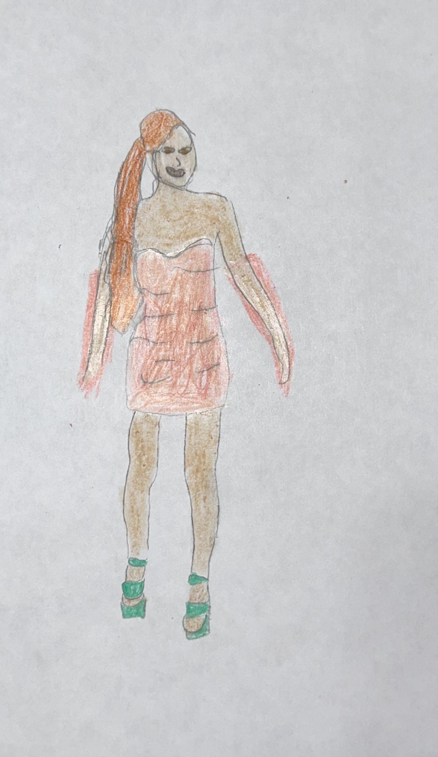

**Chapter 7: Canadian Tux**

In 2021 during the pandemic, in the most straightforward way, I felt stuck. As many of us did, I did not have any passions. I was questioning pursuing education and was unsure of a positive future. I knew I needed to initiate a change, especially with being isolated from my family 8 hours away in Buffalo. It was up to me to change my attitude toward life. Growing up, I always enjoyed what I called re-inventing my clothes; a memory of minor me distressing my jeans came to mind, and I thought, While I’m trapped in my room with clothes that I’m not necessarily keen to wearing immediately, I rummaged through my drawers for jeans that I’ve been hoarding around and not loving and this moment truly altered my life.

I have been holding on to these waist size 25 light wash *flare* denim jeans. I picked these out because I figured I would not fit into them anytime soon, and these were the jeans that I least cared about. I laid the jeans flat on the floor to see if a vision had come to me. Creatively I was stuck, which was disappointing after feeling such a spark. After hours of scrolling through my phone, I encountered Britney Spears and Justin Timberlake’s *denim-on-denim* moment; And I knew these pants would have to be a Candian Tux. I *altered* my flare jean by grabbing the front layer of the jean and cutting 4cm strips to the top of the flare, then used tweezers to pull the thread from the edges of each strip and used a nail filer to give some contrast of colors. I was so proud of the final look but could not sport them outside because there was nowhere to go and I was two sizes too small for them, and I could not get away with it. 2 years later, I now had a reason to wear these, and I was able to fit into it. When I could finally wear these Jeans, I knew they had to be a spinoff of Britney Spear’s outfit. It had to be a Candian Tux. A *sweetheart neckline* top is a style of dress that I needed to learn to love and embrace, and it *enhances* my neck and gives the illusion of having a taller height. I paired my revamped *distressed flare* jeans with cropped denim corset that *zipped up* from the back and *adhered* to my body.

I woke up that morning to prepare for my first day of class in City Tech. I *wrapped* my freshly *straightened colored* hair so I could shower, and I bruised my teeth. I applied my moisturizer and body oil. My first day needed to reflect on who I am creatively, but I wanted to feel like my most authentic self, considering I could not hide behind my big curly hair. I slipped on my jeans through their *preshaped* holes. I put on a denim corset and paired it with my frayed jean jacket, navy air max, and Navy Kanken backpack. I felt ready to take on the world with my outfit, but one class at a time.

I take on several of my styling inspiration from celebrities and influencers. A lot of my inspiration comes from early 2000s celebrity looks. Whenever I wear those jeans, it reminds me of the hope I felt for myself when I created them. The potential to unlock fully and I knew that there was so much more for me to learn. Those jeans remind me of how iconic Britney Spears was for wearing that very bold outfit, and it correlated with how bold I felt considering that my finding my fashion niche came later in my life.

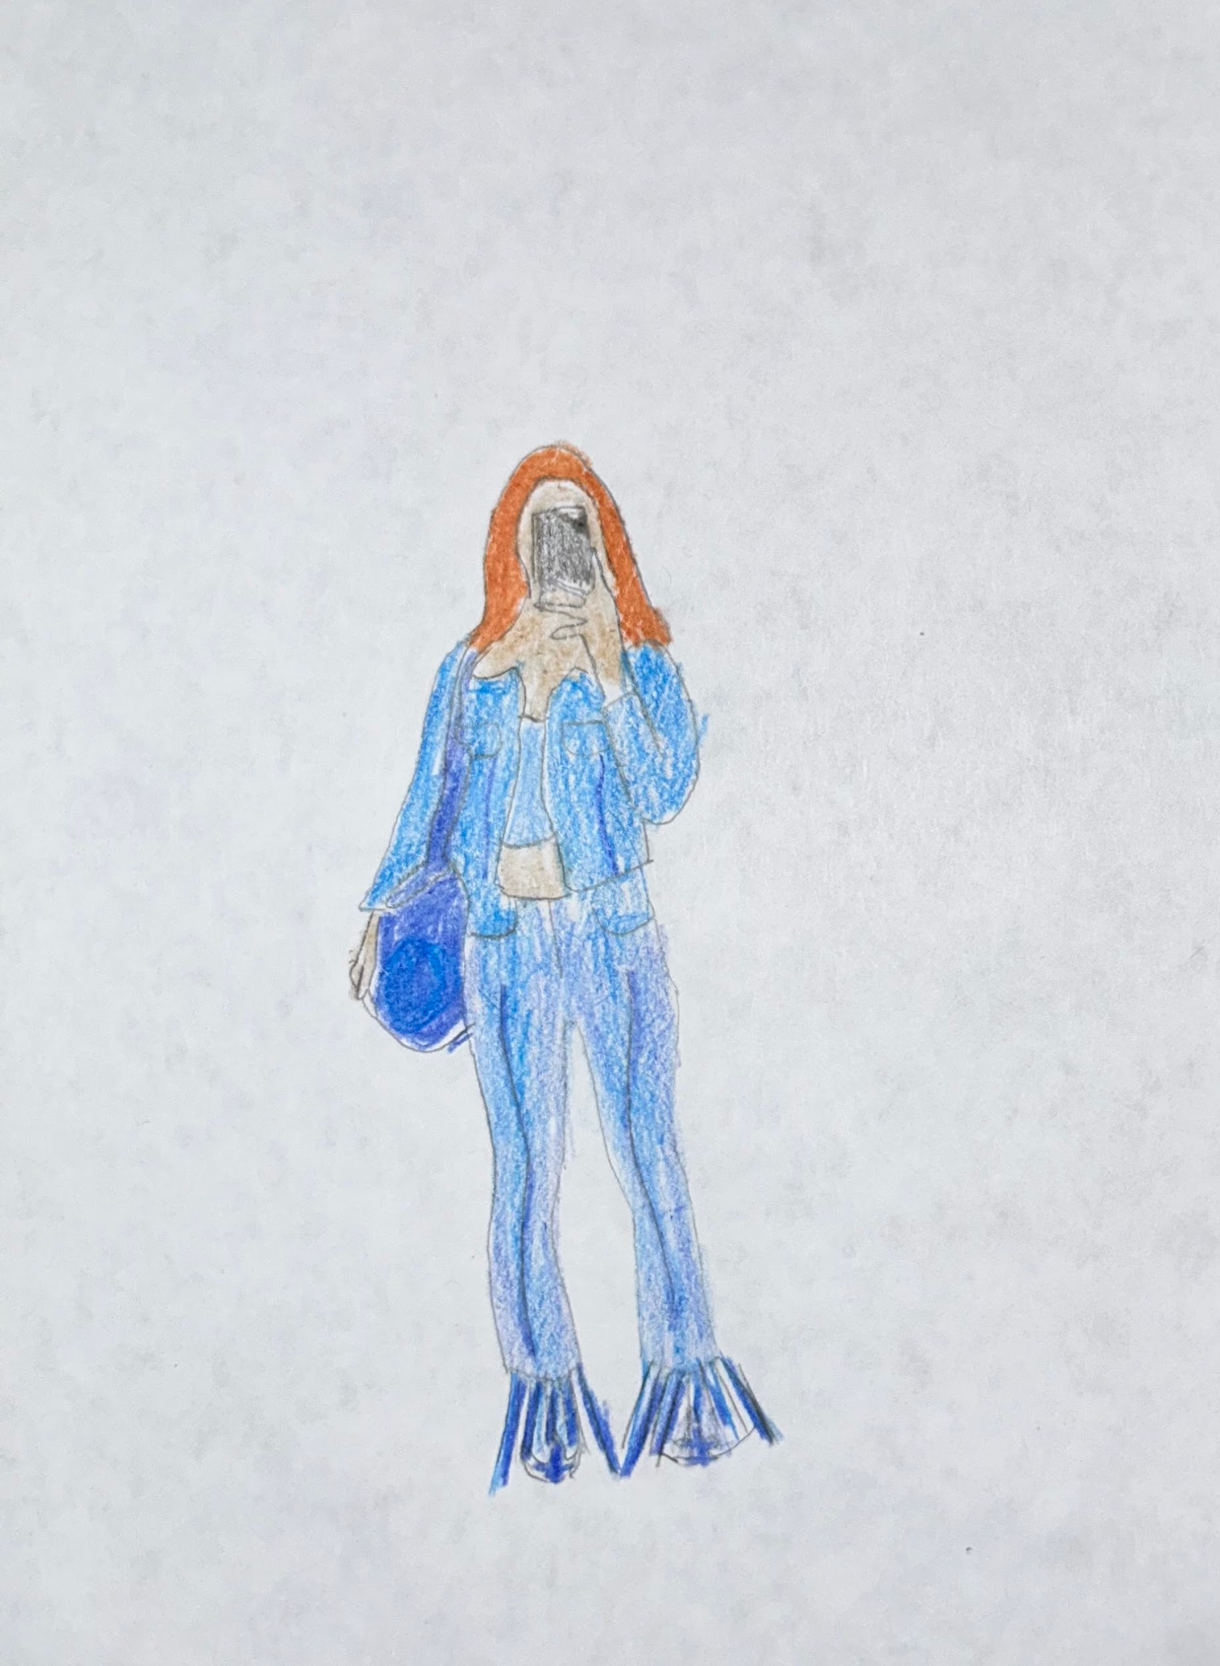

**Chapter 8: Jade**

In most colleges, Halloween is the event of the year; in Buffalo State College, it was the event of the year, and I could not wait. Halloween was on a Saturday, but my friends and I were going to a party for Halloween weekend. So Friday was the first night of festivity.

Planning my Jade costume went smoother than I thought it would. I found all the pieces I needed and could wear these items individually other than as a costume. Initially, I wanted to be Yasmin was portrayed as the Hispanic girl Iwhom who I identify with. However, Denise called dibs on Yamin before I could, resulting in me choosing the Jade Bratz doll because the inspirational picture I found of her was stunning. I knew it would be creatively challenging, which is something I craved. The accessory I used around my neck was a dog collar purchased online, which was an XL. The white under t-shirt was cropped and *ribbed* with a slight mock neck. The red top was a patent leather top with a zipped front that I altered using safety pins to prevent the top from suspending further down my midriff. I enhance my nail by gluing on fire flame press nails and also *altering* My pointed stiletto heels by painting them with the original fire flame design that Jade originally had. Jade wore a fur jacket, considering my hesitation about carrying around a fur or faux fur jacket. Instead, I purchased a black and white boa and wrapped each end around it to create this illusion of a jacket.

It was 9 pm, and my roommates and I were rallying to prepare. I knew I needed to do some last-minute thing, so I hurried and started getting ready. First, I *altered* the look of my skin and shaved my legs, considering I would be wearing a very mini skirt. I put on my outfit first when, the *embroidered* dress, then the white tee, red patent leather top, and fishnet thigh-high stockings with ruffles on top. I had a few final things to do before installing the wig. I did minimal makeup but needed the brown liner with a clear gloss over my lips. I then braided my hair and put a wig cap underneath to protect my hair from any damage considering ill be got2b hair spray to keep the wig intact and adhered to the front of my hair. Next, I brushed my hair to ensure it was flat and not moving. Finally, I put on the silver chunky erring putt on my fire flame pointed heels and adjusted my boa. Denise and I took several pictures together and were ready to enjoy the night.

Denise, my roommate, and I wanted to coordinate matching themed outfits. Denise and I are women of color, and embodying these Bratz dolls who looked like us growing up felt fitting. Although Halloween is all about dressing up and being who you want to be, it is imperative to be intentional with what you decide to wear because, as humans, we manifest things in our lives. Dressing up as a Bratz, I genuinely embodied a doll just to conclude that I felt like me. I was dressing up as me because that’s precisely how Bratz dolls cater to young girls from different ethnicities. Although I love Barbies, they distort this idealized version of who and what young girls want to be. It is hard finding influence in someone or something that does not look the way you do.

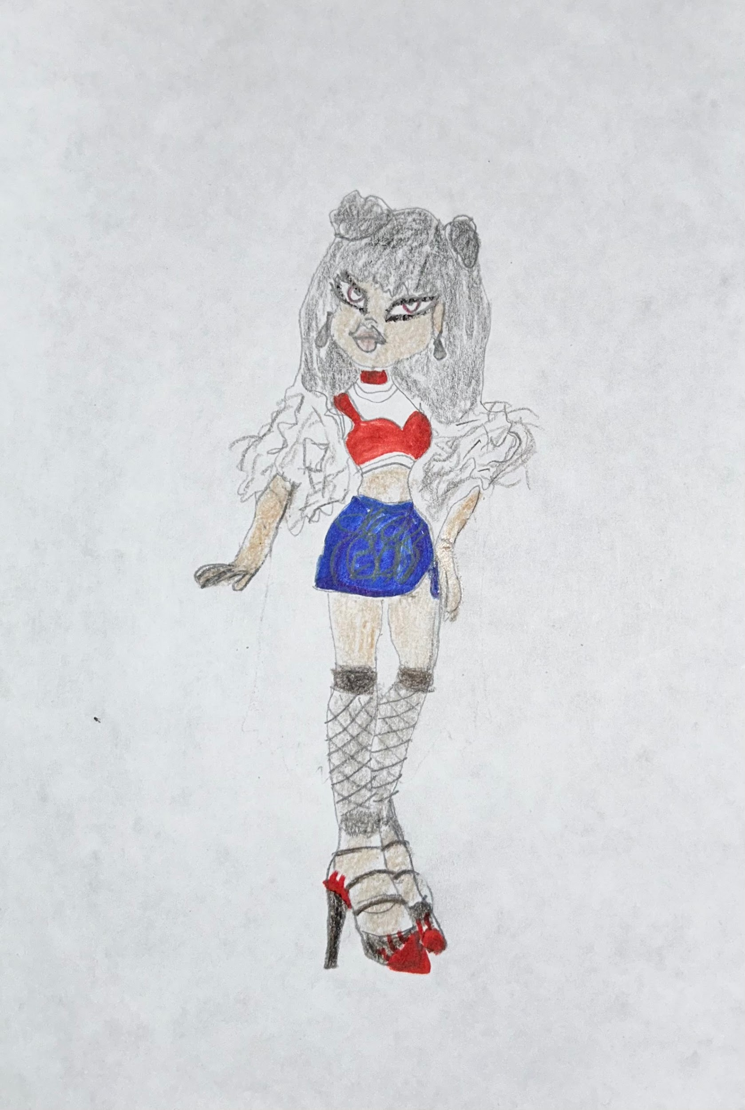

**Chapter 9: Daphne**

It was my first college Halloween party at Buffalo State. I’m living in my off-campus housing with my three roommates, and we’re getting ready for one of the craziest Halloween parties of the year. Not only is Halloween, but it is Halloween weekend. My roommate and I, Denise, love Halloween, so we knew we would celebrate Friday and Saturday. In the weeks leading up to the Halloween event, I wanted to base one of the outfits on a character with ginger hair. So I went to Google and immediately took inspiration from Daphne from Scooby doo.

I knew I did not want to buy a Daphne costume for many reasons. First, I was a college student working $12 an hour at a retail store three days a week. I did not have the budget to buy a $60 costume, especially if I would only be wearing it once. And I knew it was very likely that if I did decide to purchase a costume, it would not *adhere* to my body, considering how slim I was. So my most practical and cost-efficient resolution was to create my Daphne costume. I took inspiration from the live-action film Scooby doo, where Sarah Michelle Gellar plays Daphne along with the original animated version of her as well. I needed to embody that look to the fullest. I went to the nail salon, *enhanced* my natural nails*,* and got almond-style *acrylic* nails with a purple swirl design. Considering at the time, I was in search of outfits that were not only cheap but that I could wear outside of Halloween, and I found just that. I quickly went to Amazon to find a ginger-colored wig and a chunky dark purple headband.

Dressing up is one of my favorite things to do, so Halloween is one of my favorite holidays to celebrate. Growing up, I was always either a witch or a princess until I went away to Buffalo State College and realized that I could be more than that. That ginger hair resonates with me today because I’ve dyed it that ginger color, which is a look I like. This moment was about re-discovery and dressing up to figure out what I wanted and how much I could elevate my look with a different dress. It took many years for me to realize that I am not obliged to look like everyone else, and it is perfect for wanting to be like me.

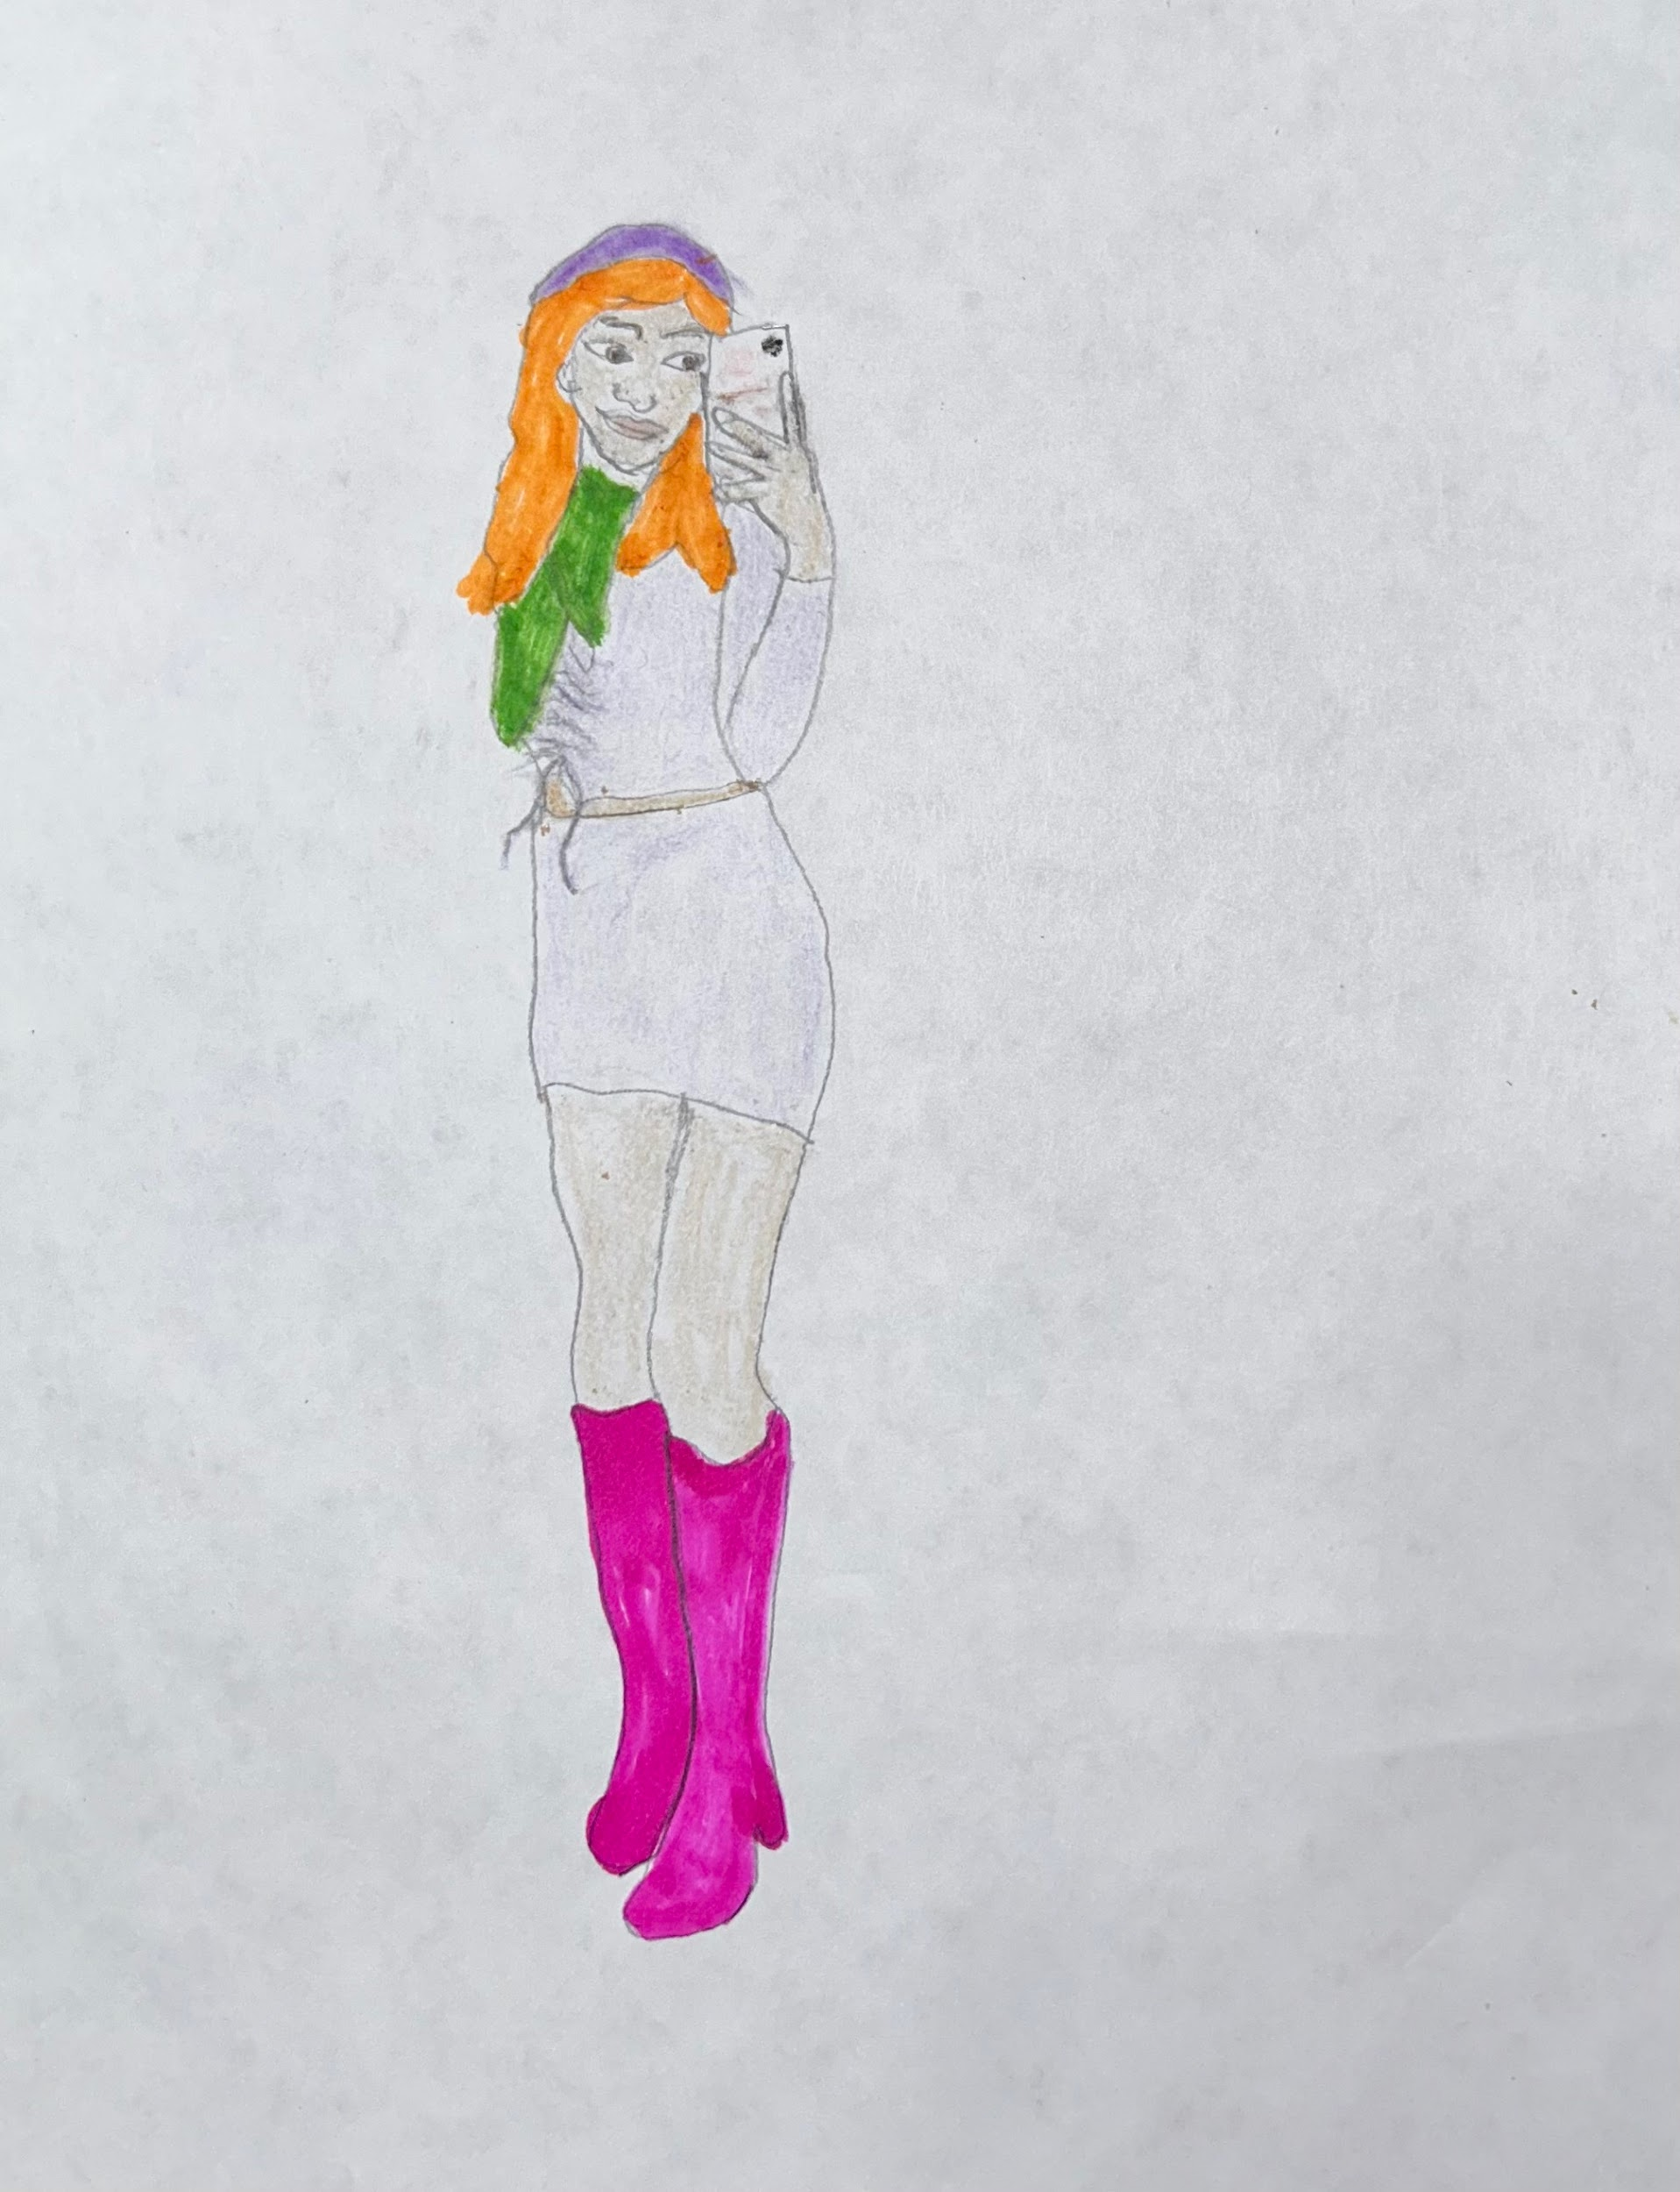

**Chapter 10: The Christmas Show**

It was the day of our most anticipated event for Ms. Hernandez’s Step Team. The Christmas Show occurred in my elementary school, Ps.79, at 3 pm. I went to the auditorium and met with the rest of the girls for a quick practice. It was imperative to the routine and Ms. Hernandez that we were in unison as we flowed through each step. I looked up and saw the seats in the auditorium filling quickly. Ms. Hernadez lined us up for the final time. I was the 3rd girl in line; she carefully looked at us individually to ensure we looked perfect. A few moments later, the seats in the auditorium were filled, and just like that, the show began. We walked up the stairs onto the big stage. The team and I knew we needed to be at arm’s length apart. I looked over at my friend Teresa to the left of me, and she was just as nervous as me, which eased me a little. Teresa and I were the only 3rd graders on our step team; it was a big deal. I looked up, and the spotlight was hitting my face, but all I could look forward to was seeing my mom for comfort. As Ms. Hernadez is introducing us, I gleefully see my mom on the right side of the auditorium a few rows back. At that moment, I felt the courage the perform, and we bang.

Ms. Hernadez made it clear that we need to look all look alike per her request of her wanting our team to be in unison. We needed to achieve that in the most cost-effective way considering many of the students my family included were low-income. I confidently raised my hand while we practiced discussing our outfits; I suggested black jeans because black jeans are a staple in anyone’s closet instead of blue jeans, which could be several shades. We concluded that we would be wearing skinny black jeans that *adhered* to our legs with a black shirt thatwas *loose* and *long* enough that we would be able to tuck into our skinny jeans with a black belt along with black *lace-up* combat boots. Before the Christmas Show, Ms. Hernadez had asked us our favorite colors, and we were curious why. The day of our show, she gave us these sequin elastic bowties as the final touch for our outfit, and I thought it was perfect. I was so nervous about performing, but I sure felt cool.

I woke up at 6:30 in the morning and was so worried that I felt butterflies in my stomach the minute I opened my eyes. I went to the bathroom, washed my face, and brushed my teeth. I went on to do my hair; I grabbed a handful of gel and spread it through my hair. I brushed my hair back into a slick ponytail and *wrapped* my hair with a large *elastic* band, and put the remainder hair in a bun. I put on my outfit for the day; I put each leg through its *preshaped* hole. Put on my long black songs that adhered to my calves—then put on a white undershirt with my black button-up on top, and completed the outfit by s*uspending* my belt through the belt loops.

The Step team was the first time I felt that I was good at something and could excel in an environment where I was in the spotlight, a concept I needed to be used to. When Ms. Hernadez handed us our bow ties, I thought it was the most spectacular thing. Growing up, During that time in 2009, I never thought it was possible or acceptable for girls to wear men’s clothing, but Ms. Hernadez made me feel that was possible. Not only did I feel fashionable, but I felt powerful.

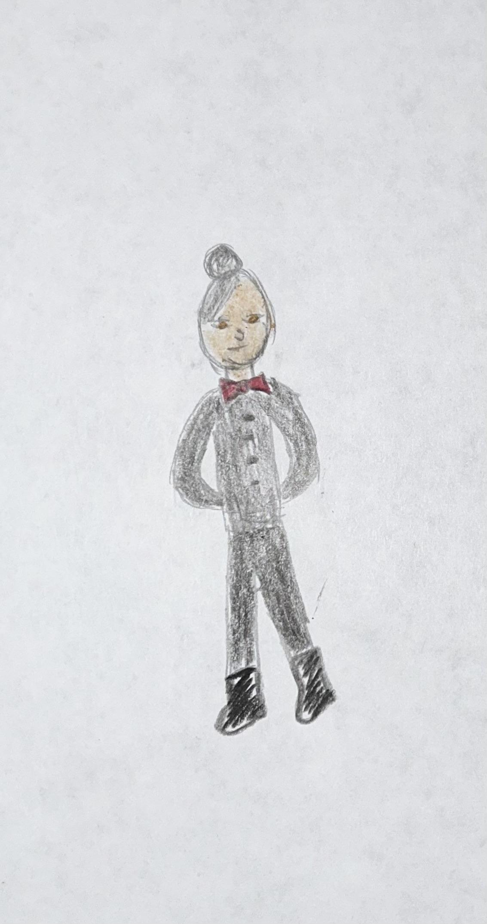

**About the Author**

Jailine Collado is a Dominican-American woman; Born and raised in The Bronx. She is the Youngest of 4 siblings. Jailine attended Hostos Lincoln Academy, where she received her High School diploma alongside an associate’s Degree in Liberal arts. Later, she attended Buffalo State College, pursuing a bachelor’s degree in Early Childhood Education. After three years, Jailine transferred to New York City College of Technology, where she is now pursuing a bachelor’s degree in Business and Fashion of Technology. Jailines’ first job was at 14, where she tutored students, resulting in her pursuit of a higher education in Early Childhood; She then worked her first Retail Job and realized how well she could excel in fashion with the right knowledge leading to her Change of heart.

Jailine has several hobbies, which include crocheting, painting, photography, and scrolling through fashion blogs for daily inspiration and updates. Growing up in a low-income family, Jailine struggled with the idea of the potential to have more. Jailine worked her first New York Fashion Week event with Cutler x Priscavera and instantly knew she could amount to so much more.

