# **The AD Agency**

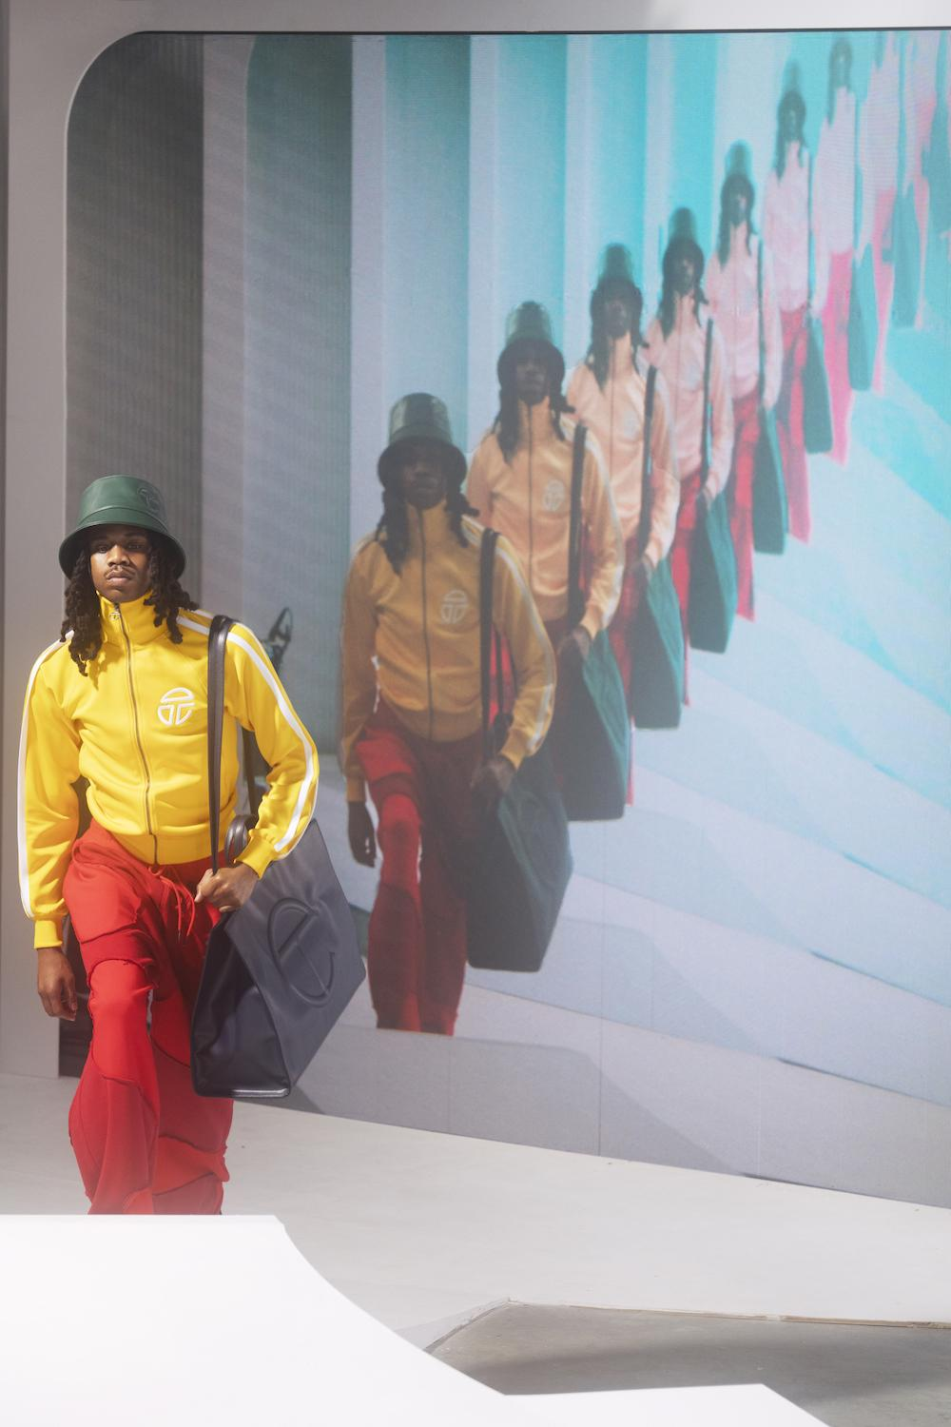

**Team Profile & Responsibility**

**Jailine Collado: Account Executive & Copywriter/Production**

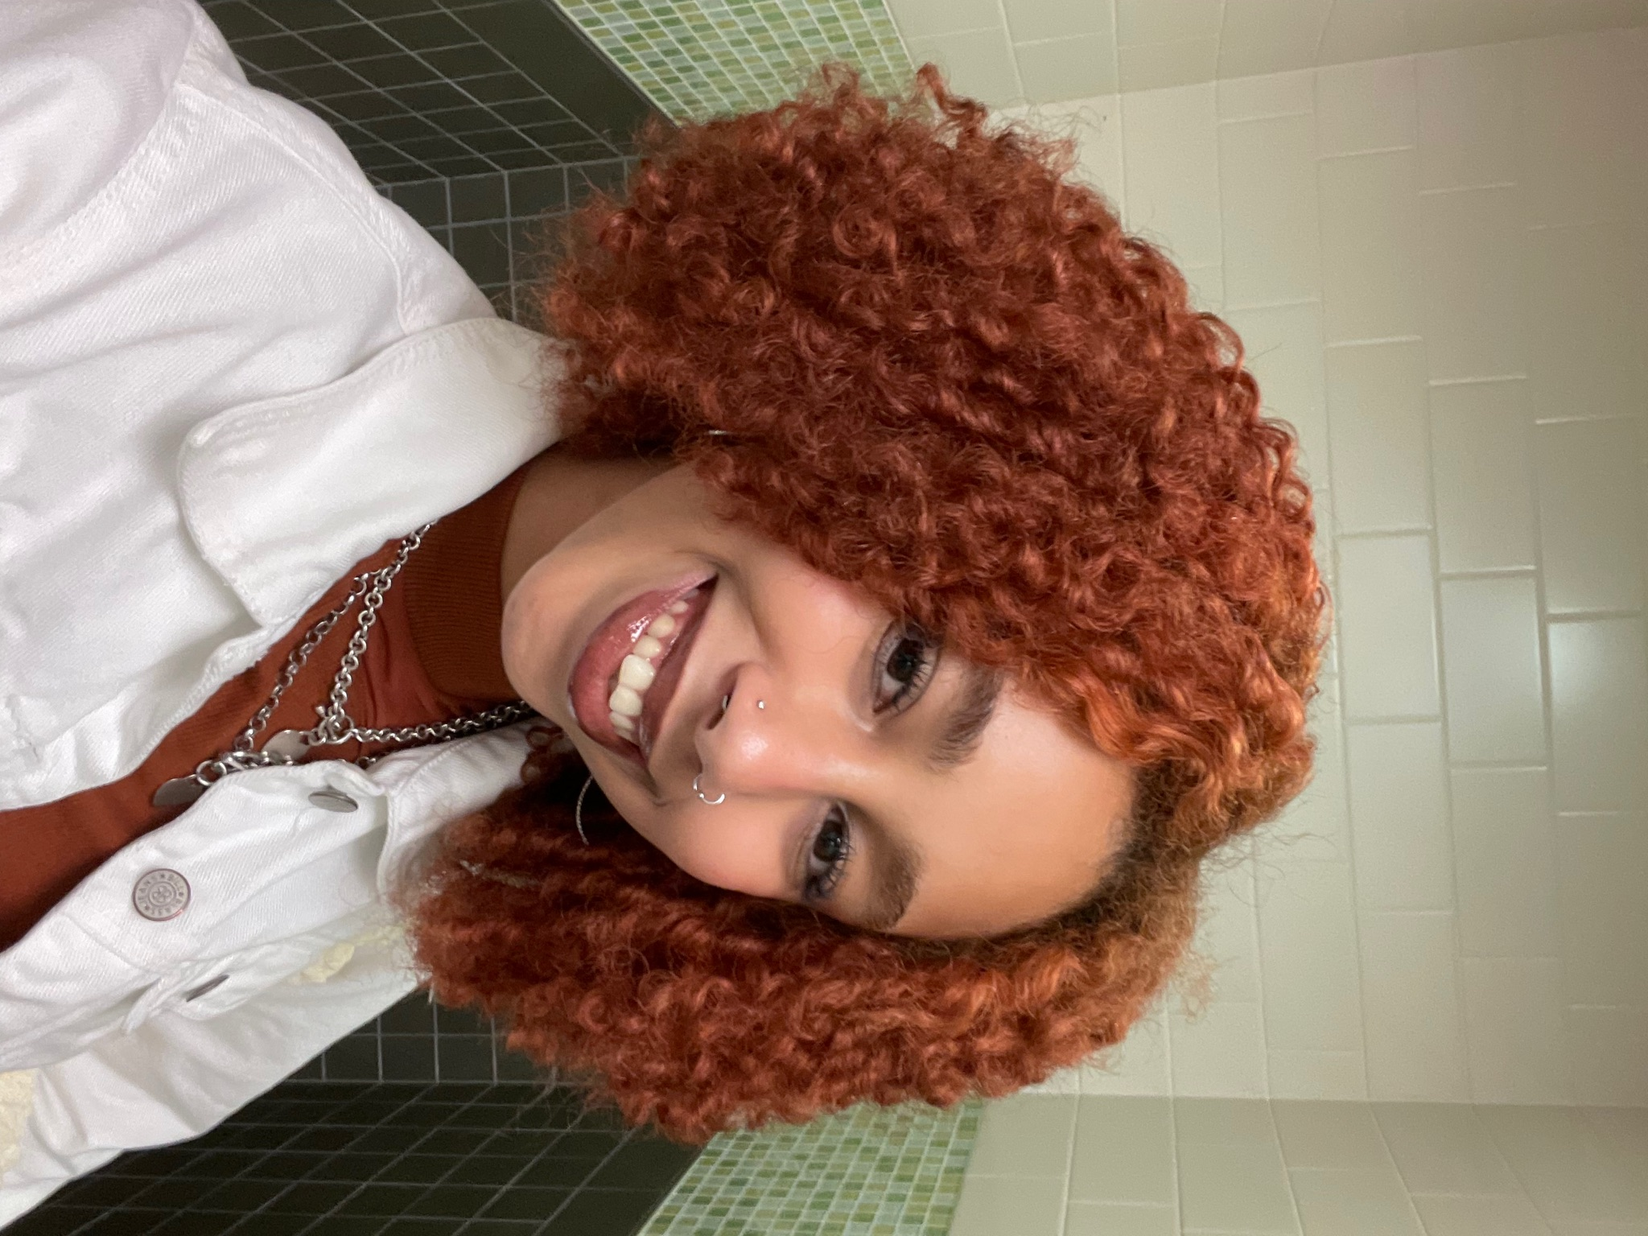

Jailine Collado is a Senior at New York City College of Technology majoring in Business and Technology of Fashion. Jailine hopes to further her career in the Fashion Industry as a creative director in editorial fashion magazines. Until then, Jailine continues mastering skills like sewing, crocheting, and networking with different individuals and companies in the industry. As the Account Executive, she manages the overall team and individual roles by supporting the group to meet deadlines and overseeing budgetary responsibility. As the Copywriter/Production, her commitment includes writing and editing all the copy text for the campaign.

**Gabriela Pimentel: Media Planner/Media Buyer**

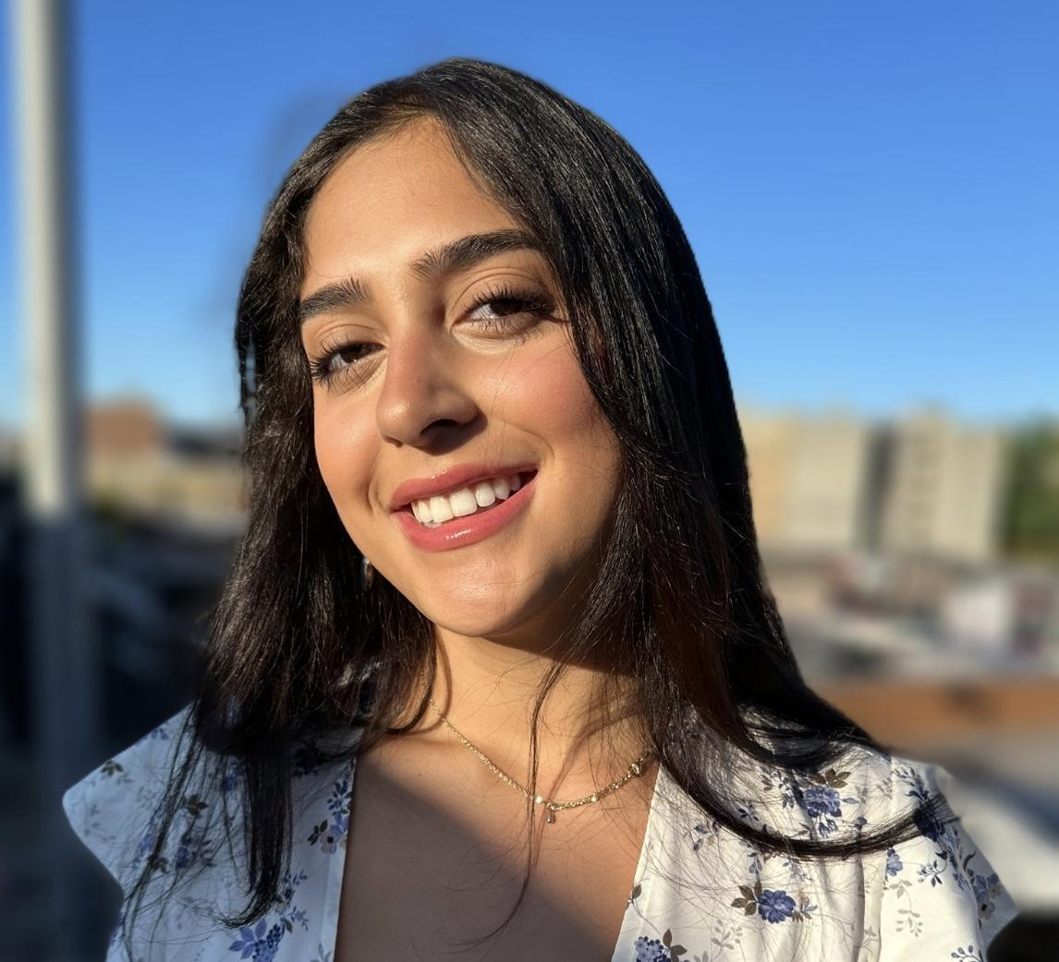

Gabriela is a second-year New York City College of Technology student majoring in marketing management and sales. She would like to further her career in the marketing industry and work as a social media marketer or media analyst. As the media planner/media buyer, she is responsible for choosing the appropriate advertising media to promote the product, in this case, Telfar, and promote this product to the target market.

**Rania Musleh: Media/Market Researcher**



Rania Musleh, a second-year student at New York City College of Technology, is pursuing a Marketing Management and Sales degree. Despite initially planning to major in Business Administration, Rania has decided to transfer to another college next semester to ensure she can fully embrace her desired major. Throughout her academic journey, Rania remains committed to her goals and unwaveringly pursues her dreams. As a media/market researcher, Rania will gather and analyze all the necessary product, competitive, and market research data to complete the Advertising Campaign.

**Axel Cordova: Graphic Artist**



Axel Cordova is a student at New York City College of Technology majoring in Marketing and management sales; his dream is to finish college and become a real estate agent in New York City. By majoring in marketing, Axel will gain experience in the marketing industry, making it easier to become a successful real estate agent. As a graphic artist, Axel will be responsible for creating all graphic materials such as Storyboards, Layouts, Sales Promotional Pieces, etc.

**Imani Jean-Charles: Copywriter/Production**



Imani Jean-Charles is a senior at New York City College of Technology, majoring in Business Technology in Fashion. From switching majors multiple times, Imani has landed on this one, so she can then go and pursue her dreams of being a stylist of many forms and be able to brand herself and many talents through a strong business. Studying Business Tech in Fashion would allow her to know the tools to not only be able to advertise herself and her skills but also keep her soon-to-business running with an understanding of customer connection and product flow. Imani is responsible for writing all the copy (words or text) for the campaign, including the words for all Internet, Magazine, Outdoor, Newspaper, Television, and Radio

**Marketing Review**

Telfar Clemens is a queer, self-taught Black designer and founder of Telfar. He was born to Liberian parents in Queens, New York. Clemens started his label with three-figure checks every week, and an aunt who worked for a sleepwear company supplied him with Jersey-knit remnants. In 2003, he began to create his collection of deconstructed and reconstructed vintage clothes, which he sold in boutiques in SOHO and the LES. In 2004, Telfar launched his eponymous fashion house with comfortable sportswear and simplexity principles as an undergraduate at Pace University, where he studied Accounting. Clemens launched his unisex label before androgynous clothing was the norm in the fashion market. Telfar was marketed as unisex a decade before Gucci, Balenciaga, and Tom Ford had coed runway shows. Clemens does not want to elevate things in fashion; he wants to make fashion more horizontal. Telfar designs clothing and accessories with accessibility in mind while creating an aura of exclusivity. At the Autumn/ Winter 2014 runway show, Telfar introduced the bag. In 2017, Clemens was the recipient of the C.F.D.A/Vogue Fashion Fund Award because of his innovative designs, investing much of the prize money of $400,000 to focus on the production of the shopping bag. He improved it and re-released the bag in 2018 with a broader range of colors, and it now comes in three sizes ranging between $150-$257.The shopping bag was measured based on a Bloomingdale bag to make the first sample, and when it came to the price, Clemens based it on what a DJ might make in a night. The idea for the bag came during Christmas years ago. Looking at everyone with their paper shopping bags, Clemens realized that this is an entirely unisex silhouette, which is the core of his brand. In 2017, Telfar collaborated with fast food chain White Castle to redesign employee uniforms and donated all proceeds of his capsule collection to a bail fund for incarcerated teens. Since then, Telfar has collaborated with UGG, Converse, Moose Knuckles, Eastpak, and most recently Melissa. Telfar became famous for his self-name unisex vegan faux leather shopping bag, and 2020 was the year of Telfar thanks to a rise of activism and social awareness due to the protests around the country. Apart from its signature bags, Telfar also sells monogrammed CT hats, belts, jewelry, a line of durags, shoes, and, most recently, his line of Unisex apparel. For years creatives and queer black people in NYC have been omnipresent supporters of Telfar. Compared to other designers’ luxury brands, the Telfar is affordable and is the label’s best-selling item, jokingly coined the nickname the “Bushwick Birken.” The Telfar is a perfect marriage of functionality, fashion, and price. Sustainability, inclusivity, and accessibility are pillars that drive the brand’s management. Clemens’s teacher drew little monograms on the chalkboard using each student’s initials, which inspired Clemens to monogram a “T” and a “C,” becoming Telfars’ logo. With the rise of fashion labels, Telfar created Telfar TV, a streaming shopping channel. instead of hosting a traditional fashion show, Telfar established the bag security program, which lets customers preorder bags online, ensuring they never sell out. In 2019, Telfar reportedly took in $1.9 million in revenue. Today, the company can make upwards of $7 million in a single product drop. Telfar is a bag of status but has nothing to do with how much money you have; the whole point of fashion is to have things but not to sacrifice yourself. In the past, high fashion was only attainable to those of a particular class, but as the designer world evolves, so do its consumers. Telfar’s motto is Not for you, for everyone. With the help of Babak Radboy, who is known as an artist disguised as a Creative Director, he partnered up with Telfar to be a business partner and Artistic Director of the brand in 2014. Radboy chose to work exclusively with the mature but still uncompromising Telfar Clemens, whose career as a fashion designer he had been following closely since 2004. Comparing Telfar to any other brand is impossible. Since 2006, Telfar’s collections, campaigns, and presentations have broken each mold consistently, and Telfar continues expanding its brand., Telfar has grown from a niche brand to one fully embraced by the culture and one that collaborates with others. It has been mentioned that a Telfar flagship store is coming to New York City, making the brand’s first foray into brick-and-mortar retail.

**Situation Analysis**

Telfar Clemens founded this namesake brand in 2005. Our motto, “It’s not for you - It’s for everyone,” promotes the idea of inclusivity and accessibility to luxury for all. The brand prides itself on offering unisex luxury designs at a lower price point so that everyone can experience a lavish lifestyle. Telfar improved and developed in 2014 when the infamous mononymous vegan leather shopping bag was first showcased. This year was a big hit for Telfar. The brand became increasingly popular in 2020 when the iconic shopping bag trended worldwide, and the Black community vowed to support their businesses. The fan-proclaimed “Brooklyn Birkin” can be spotted in many celebrities, from Beyonce to the Obamas. Everyone loves the Telfar shopping bag with its minimalistic embossed logo, street-style aesthetic, and vegan leather exterior. Now offered in a plethora of colors, the bag often sells out in a matter of minutes, making this a highly coveted fashion staple. Our dedication to keeping the brand for the people led to the creation of the bag security program in 2020. This allows consumers to pick all the bags and colors they need without worrying about bots and resellers making our brand inaccessible. In addition, many people believe that Telfar transformed the meaning of luxury and exclusivity; one is Kathryn Lewis, a fashion enthusiast. “I mean, we’ve seen everyone from Beyonce, Normani, and many more black elite rocking a Telfar bag. So I believe Telfar changed the game by showing that Black is luxury”. Telfar has collaborated with many familiar brands, like Ugg, Converse, and, more recently, Melissa, to offer fun new looks to our familiar design. 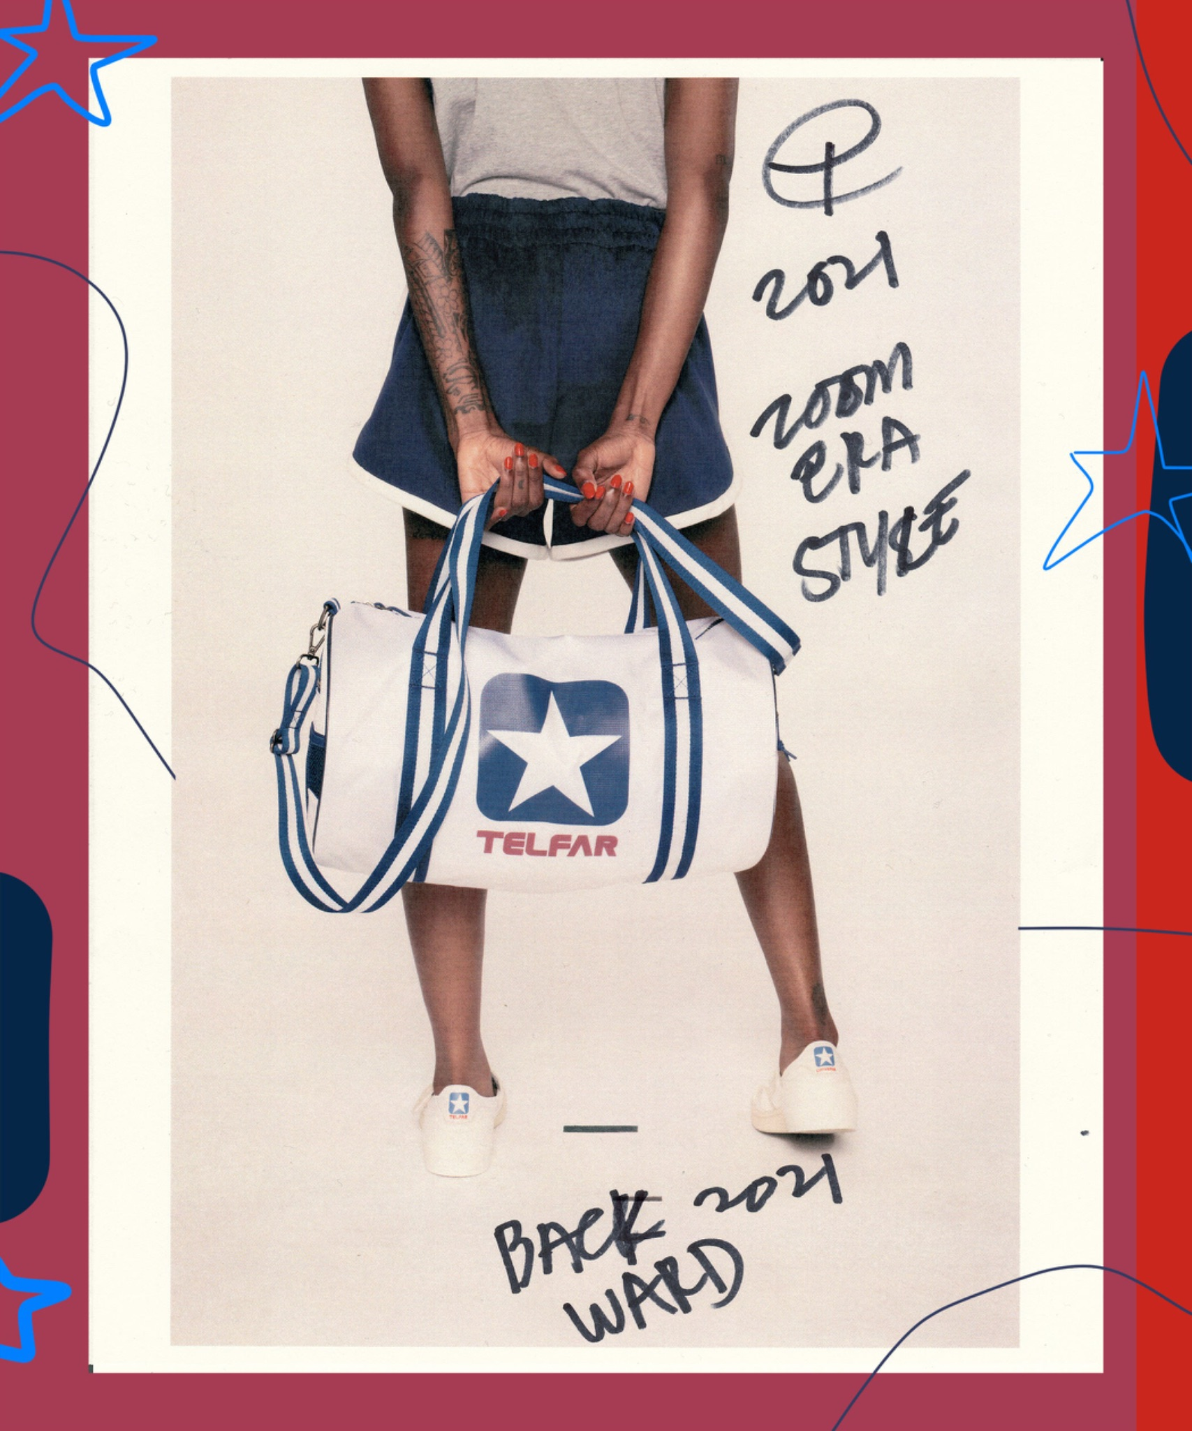

Telfar, a unique and innovative fashion brand, has employed several key marketing strategies that have contributed to its success. One of the standout strategies is its focus on inclusivity and accessibility. Telfar has positioned itself as a brand for "everyone" by offering gender-neutral and size-inclusive designs. This inclusive approach has resonated with a diverse customer base, breaking away from traditional fashion industry norms. Telfar has also leveraged the power of collaborations to boost its brand awareness and appeal. Notably, the Telfar "Shopping Bag" became a cult favorite and a symbol of status. Limited edition drops and partnerships with brands like White Castle and Converse generated substantial buzz and demand among fashion enthusiasts. Social media and digital marketing have been crucial in Telfar's strategy. The brand has effectively utilized platforms like Instagram to engage with its audience and create community. User-generated content and influencer partnerships have expanded its reach and contributed to its unique brand identity. The brand's commitment to using eco-friendly materials and minimizing waste aligns with the values of environmentally-conscious consumers.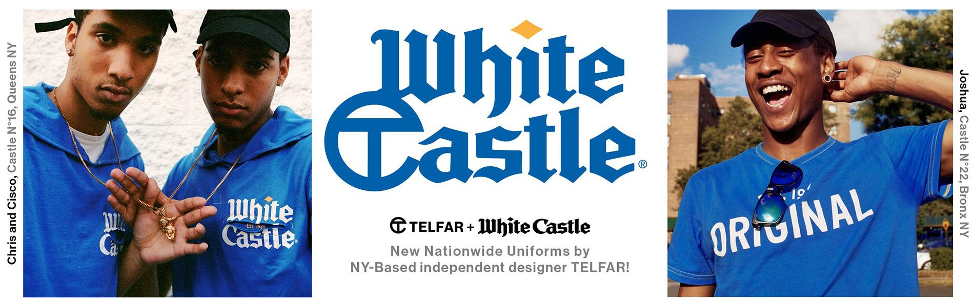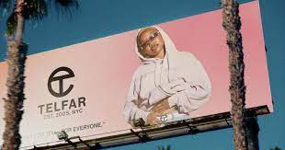

***SWOT* Analysis Brand: Telfar**

| Strengths   * Brand image * eCommerce sales model * Affordable luxury line * Direct to consumer * Social media popularity | Weaknesses   * Inventory mismanagement * Popular now, possibility of that dwindling * Online bots/ Resellers * Lacking resources, Self-funded |
| --- | --- |

| Opportunities   * Social media international attention * Influencer creators * Other distribution channels | Threats   * Replicas/Knockoffs * Self-funded * Competition on saturated market * Global pandemic threatening marketing * Tariffs on imported goods |
| --- | --- |

**Research Foundation**

The agency is currently conducting a survey among individuals who live in New York City who love fashion and want to know what they like about Telfar. Your responses are significant to our research and will be kept strictly confidential. We would appreciate it if you answered all the questions honestly and to the best of your ability. Thank you!

1. What is your Gender?

* Male
* Female
* Nonbinary
* Prefer not to say

1. What is your age?

* 18-24
* 25-35
* 36-45
* 46 and older

1. What is your occupation?

* Employed Part-time
* Employed Full-time
* Part-time Student
* Full-time Student
* Self-employed
* Unemployed
* Retired

1. What is your ethnic background?

* American Indian or Alaska Native
* Asian
* Black/African American
* Hispanic/Latino
* Native Hawaiian or Pacific Islander
* Caucasian
* Other

1. Where do you currently reside

* The Bronx
* Brooklyn
* Manhattan
* Staten Island
* Queens

1. What is your preferred method of payment?

* Cash
* Debit
* Credit
* Other (Please Specify) _________________________________

1. Have you ever made a purchase from Telfar?

* Yes
* No

1. What is your perspective about the prices?

* Fair
* Satisfied
* Unsatisfied

1. Did this product meet your expectations?

* Yes
* No

1. What are the factors that influenced you in buying Telfar?

* Advertising
* Brand Image
* Family and friends
* Other (please specify) __________________________________

1. How long have you known about Telfar?

* 1 month - 6 months
* 6 months- 1 year
* 1 year- 3 years
* Over 3 years
* Never

1. What size bag do you prefer?

* Small
* Medium
* Large

1. How do you receive advertisements from Telfar?

* Social Media
* Email marketing
* Consumer-generated marketing

1. How many Telfar Shopping bags do you own

* One
* Two
* Three or more
* None

1. What do you most like about Telfar?

* Quality
* Price
* Variety of Color
* Accessibility
* Style
* Size
* Packaging
* Other (Please Specifiy)___________________________________________________

1. How would you rate from 1-5 your experience with the Telfar customer support team?

* 1
* 2
* 3
* 4
* 5

1. How would you rate your most recent delivery experience with Telfar?

* Unsatisfied
* Fair
* Satisfied
* Very satisfied

Thank you for your participation in our questionnaire! If you have any comments or concerns about this topic, please use the space below.

______________________________________________________________________________

______________________________________________________________________________

______________________________________________________________________________

______________________________________________________________________________

______________________________________________________________________________

Forms response chart. Question title: What is your Gender?
. Number of responses: 20 responses.

Forms response chart. Question title: 
What is your age?

. Number of responses: 20 responses.

Forms response chart. Question title: What is your occupation?
. Number of responses: 20 responses.

Forms response chart. Question title: What is your ethnic background?
. Number of responses: 20 responses.

Forms response chart. Question title: Where do you currently reside 
. Number of responses: 20 responses.

Forms response chart. Question title: What is your preferred method of payment?
. Number of responses: 20 responses.

Forms response chart. Question title: Have you ever purchased Telfar?
. Number of responses: 20 responses.

Forms response chart. Question title: What is your perspective about the prices?
. Number of responses: 19 responses.

Forms response chart. Question title: Did this product meet your expectations?
. Number of responses: 17 responses.

Forms response chart. Question title: What are the factors that influenced you in buying Telfar?
. Number of responses: 15 responses.

Forms response chart. Question title: How long have you known about Telfar?
. Number of responses: 20 responses.

Forms response chart. Question title: What size bag do you prefer? 
. Number of responses: 19 responses.

Forms response chart. Question title: How do you receive advertisements from Telfar?
. Number of responses: 18 responses.

Forms response chart. Question title: How many Telfar Shopping bags do you own?
. Number of responses: 20 responses.

Forms response chart. Question title: What do you most like about Telfar?
. Number of responses: 18 responses.

Forms response chart. Question title: How would you rate your experience with the Telfar customer support team?
. Number of responses: 15 responses.

Forms response chart. Question title: How would you rate your most recent delivery experience with Telfar?

. Number of responses: 14 responses.

**Proposed Target Market**

Telfar, in its brand philosophy, doesn't confine itself to a specific geographical audience but instead embraces a global approach. While rooted in the spirit of New York and its cultural diversity, Telfar's appeal extends far beyond regional boundaries. The brand's message of inclusivity, accessibility, and gender neutrality resonates with individuals worldwide seeking fashion transcending geographic constraints. Through a combination of online presence, collaborations, and a commitment to universal themes, Telfar has managed to attract a diverse and international audience. Whether you're in the heart of New York City or on a different continent, Telfar's fashion narrative is crafted to be relatable and accessible, emphasizing a global community united by a shared appreciation for progressive and inclusive style**.**

**Demographics**

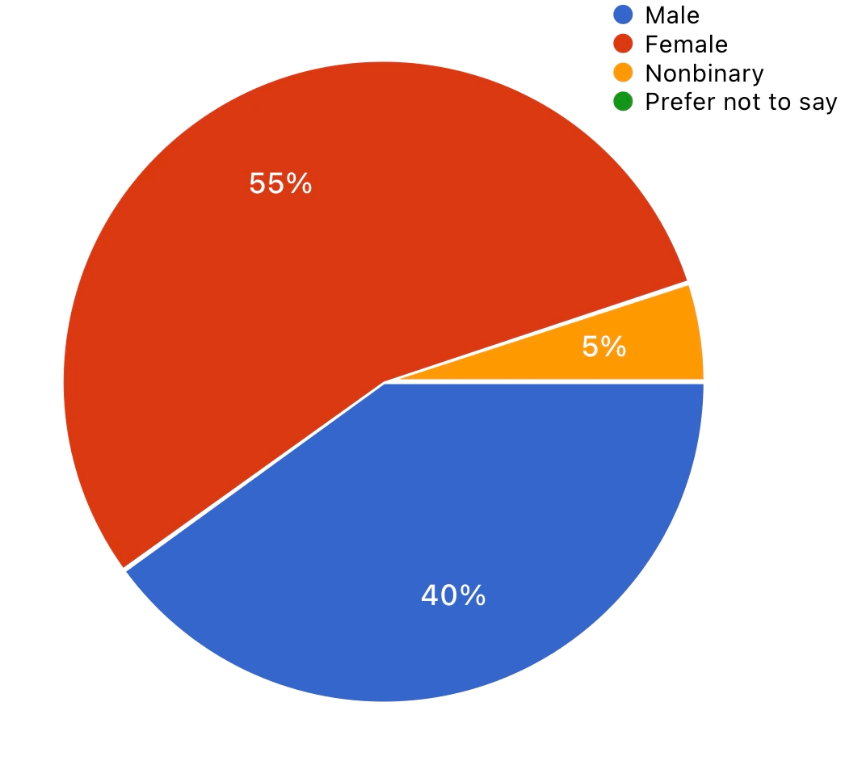

Gender

Our findings reveal a clear trend, with over 50% of Telfar product purchases made by women, while 40% are attributed to men. More men have gradually been shouldering bags with smaller, sturdier, more traditional feminine silhouettes; it is a rise in gender fluidity.

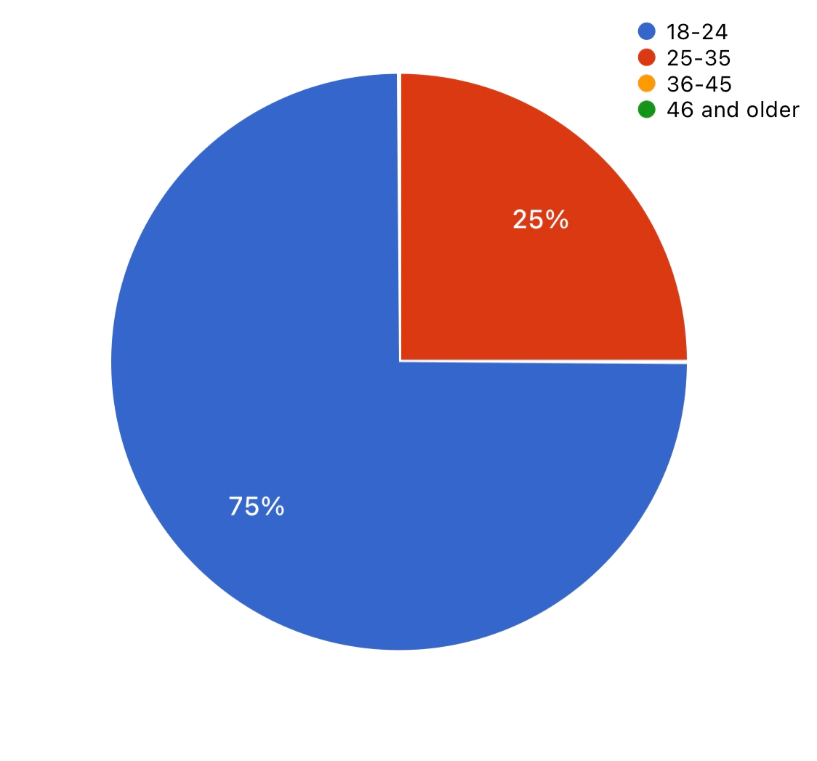

Age

According to our findings, the age group between 18 and 24 is the top choice for purchasing Telfar products. This suggests a significant preference among young adults, with almost 75% of Telfar’s consumer base within this age range. Telfar has successfully captured the attention and preference of a youthful demographic.

Occupation & Location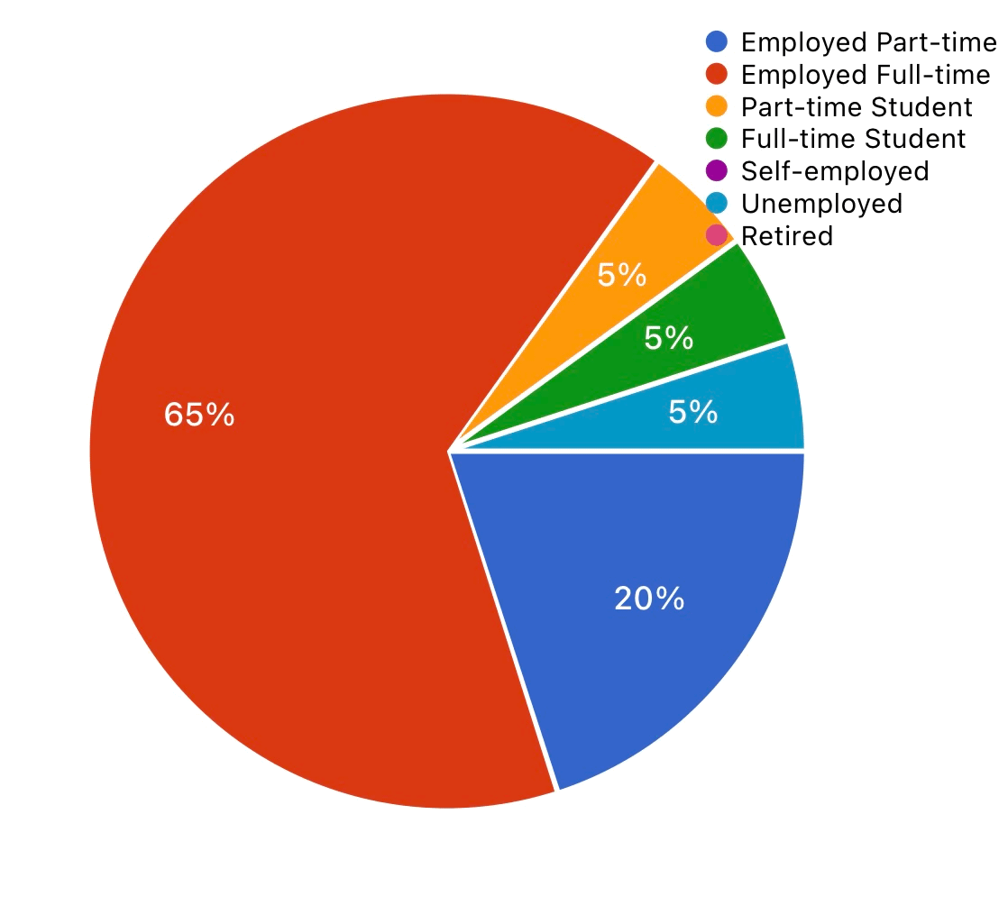

Analyzing our results, a substantial 65% of consumers are full-time employed. Part-time employees follow closely, suggesting that a considerable portion of Telfar’s audience is engaged in some form of work. This data implies that Telfar products resonate well with a primarily employed demographic, whether full-time or part-time. Although coined the “Bushwick Birkin,” many of Telfar’s consumers are from The Bronx; to be exact, 70% of the second largest in Brooklyn with 20% of our Target Consumers.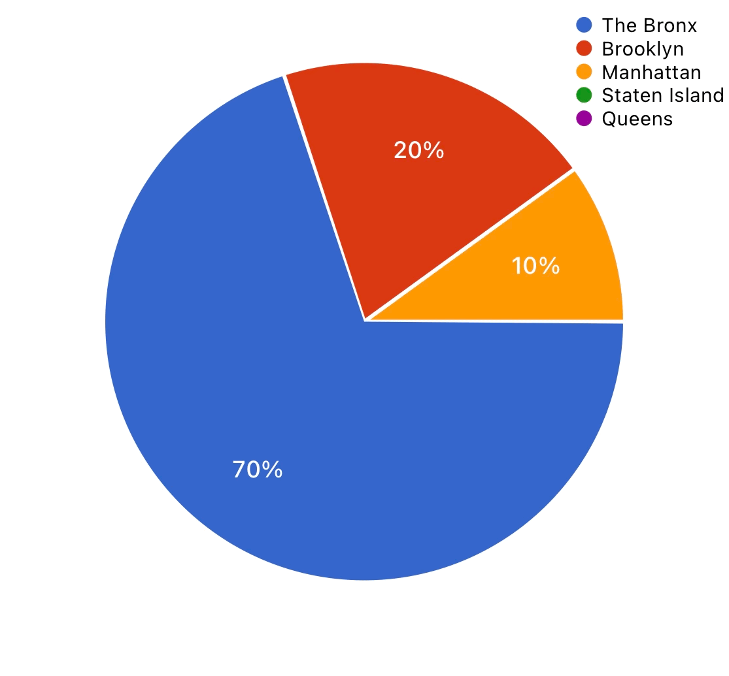

Psychographic

According to our findings, 33.3% most like the style of Telfar shopping bags, a simple, boxy carryall with double shoulder straps and top handles, and 33.3% most like the variety of colors the line of shopping bags provides. 11.1% are appealed to the price of a Telfar Shopping Bag. Our Target Consumer is an individual who needs an everyday bag for everyday lifestyle, whether that entails the working man or woman, the college student, a DJ, or a model. 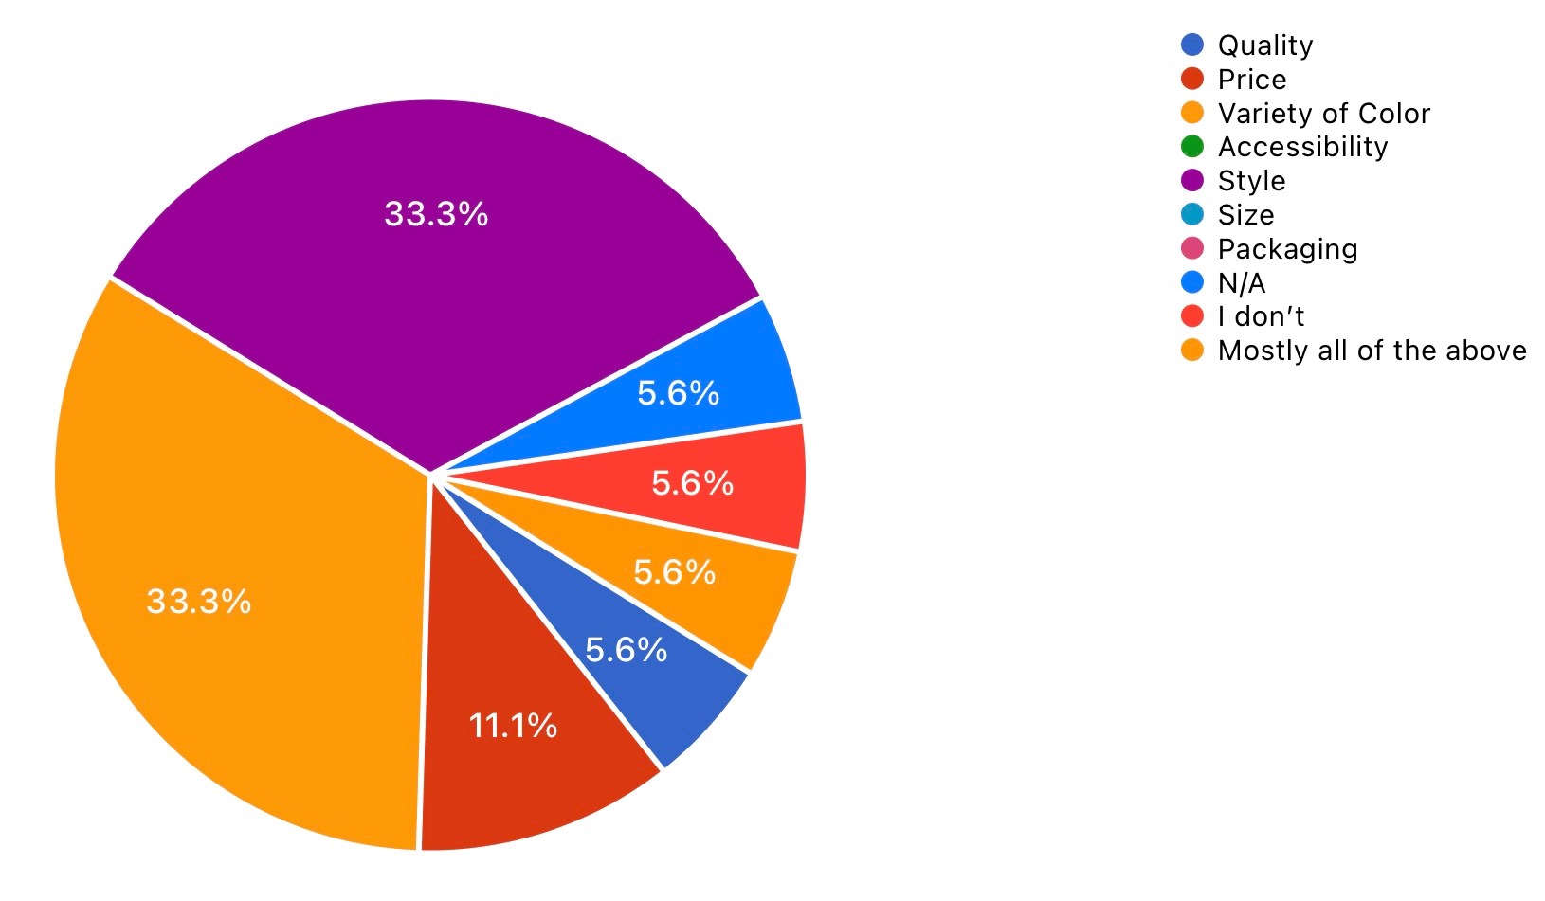

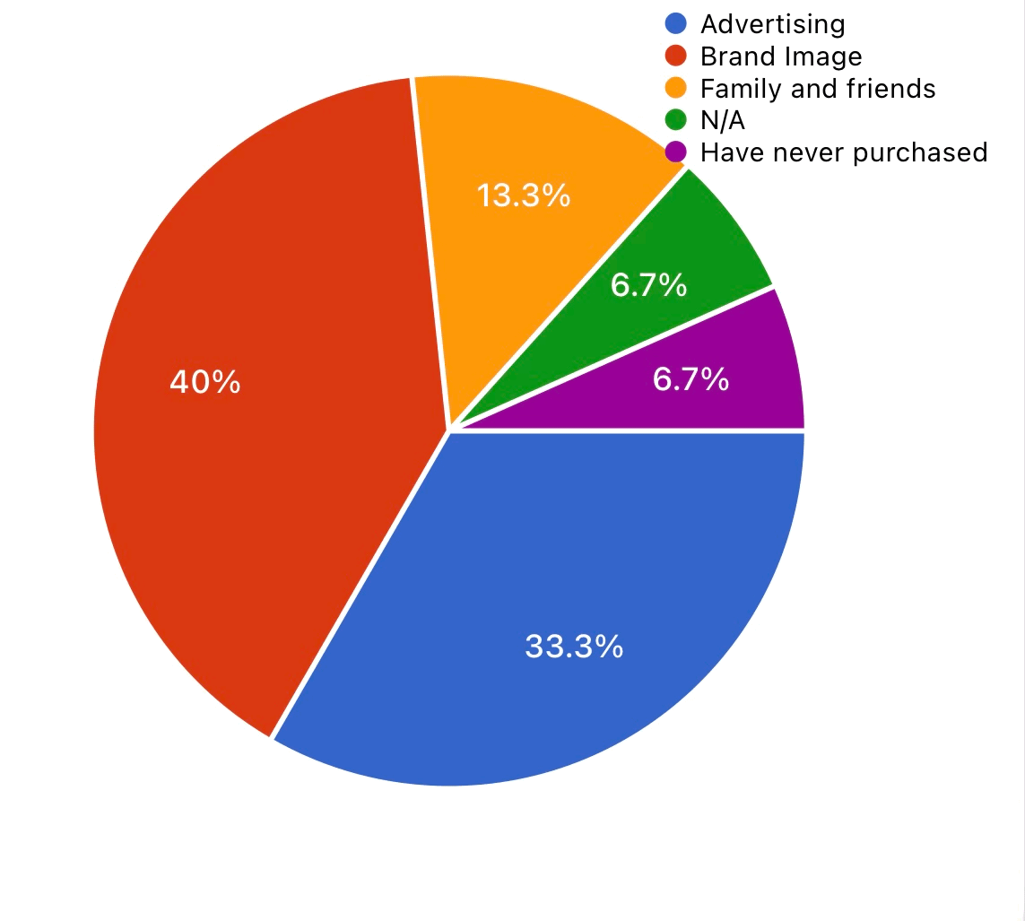

According to our findings, the factor influencing target consumers the most, with 40%, is Brand Image. The Telfar shopping bag truly caters to everyone, for everyone. The audience can relate to Telfar’s product when they see people who look just like them using or wearing it, encouraging them to buy it themselves. Many influencers of celebrities who wear and purchase Telfar are POC based on the brand image. 33.3% state that advertising contributes to the influence of purchasing Telfar, these advertisements are based on social media.

Behavioral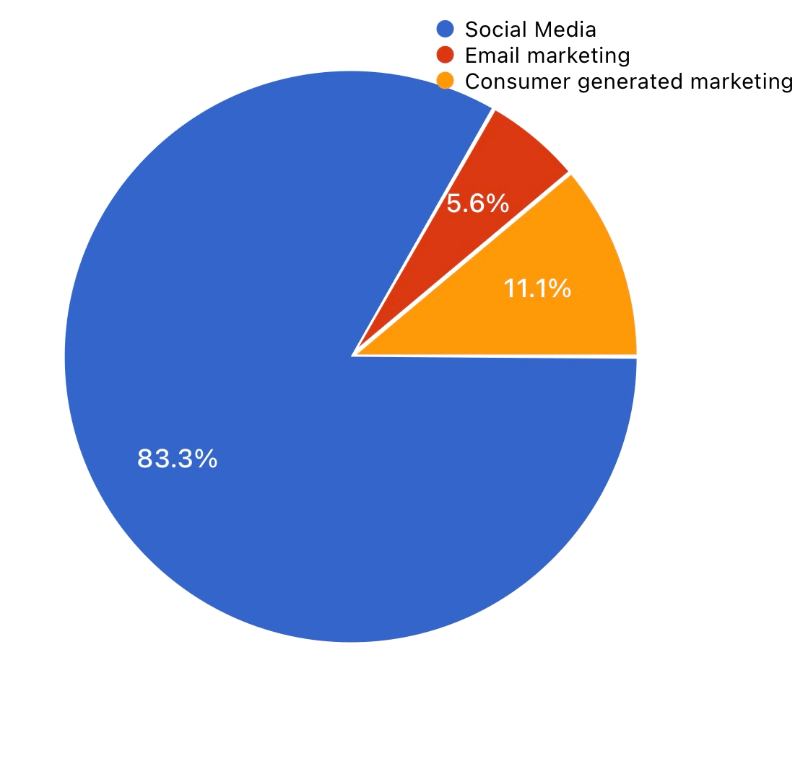

According to our findings, 83.3% of our target consumers receive their Telfar advertisements from Social Media. People have a lot of connections on social media. The information becomes a source of influence on consumers and their buying behavior. Telfar platforms include YouTube, Instagram, Facebook, and TikTok as well as their Telfar.TV, their most popular medium, is Instagram, with a total following of 1.5 million.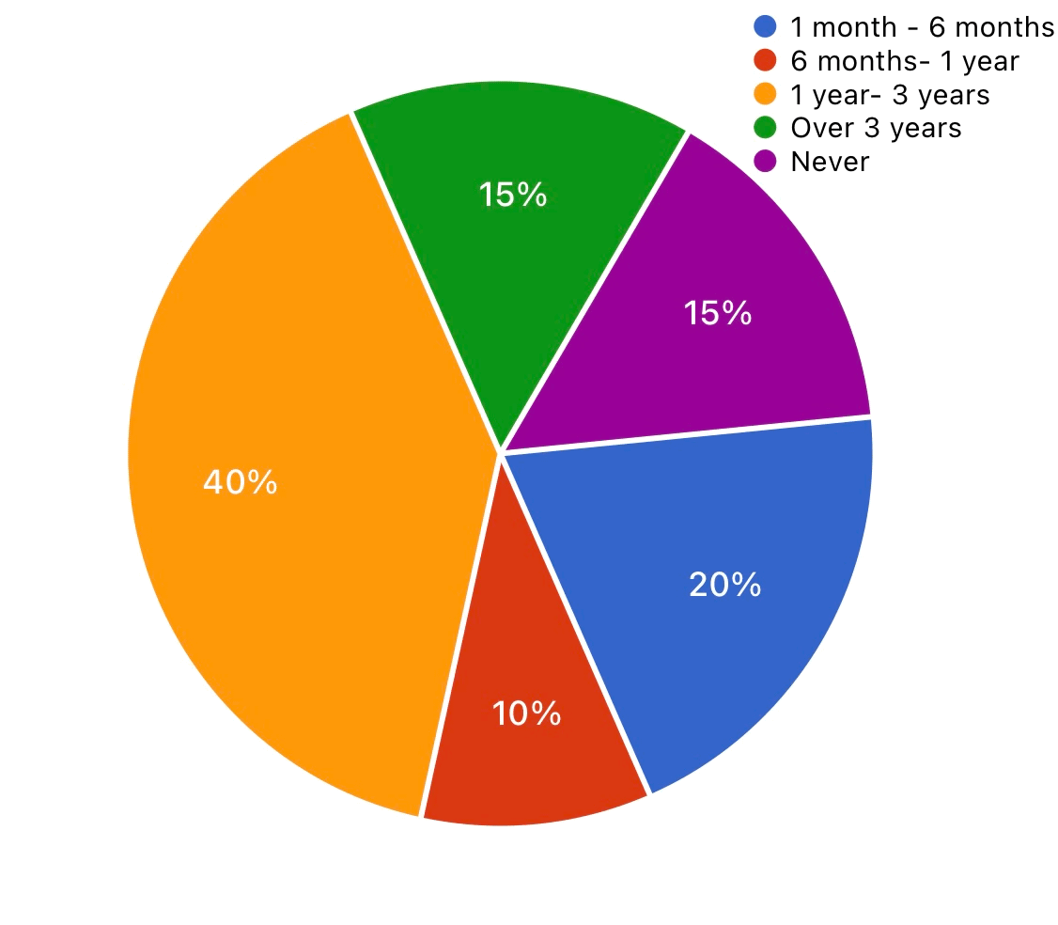

According to our findings, 40% of Telfars Target consumers have known about the brand for a minimum of 1 year to 3 years, and a concerning 15% have never heard of Telfar.

**Advertising Objective**

Our research aims to identify how to increase sales or improve promotional tactics, what benefits consumers get, and what motivates them to shop from Telfar. To discover that, we will focus on getting an overview from our esteemed customers while attracting new loyalties from all over New York City. Therefore, we focus on quality advertising, asking questions, and providing accurate information about our products to enhance credibility and trust. While social media is the best way to advertise our brand, we agreed that social media is our most effective source to gather new consumers because our target audience is primarily individuals who enjoy using media and are engaged with Telfar in an online community, with advertisements primarily featuring Black models and influencers and everyday people. Telfar Clemens has said they don't want to be featured in the glossy pages of fashion magazines, considering that Telfar’s marketing is based on social media. It is time for The brand to open its doors to being featured in a fashion magazine. The next step for Telfar will be to be featured in a prominent fashion magazine like Vogue or Elle because it will help increase sales and improve brand image. Furthermore, an internet connection will give Telfar a new vision of accessibility to new consumers. Telfar has announced a new UGG Krinkle-patent collaboration featuring shopping bags and matching boots in a new color, spicy pumpkin. This is the second time Telfar has collaborated with a global lifestyle brand, and it was successful. Additionally, collaborating with a brand will target a larger audience/consumers. A celebrity like Drake, a Canadian rapper and singer with a significantly large platform and fanbase, endorses Telfar as a game changer for more men sporting shopping bags. Drake will be going on his 2024 Its All A Blur Tour; Drake can provide Telfar bags to gift to audience members; there should be more product placements besides a bag and advertising on TV shows with celebrities, etc., to help the brand get recognized by a new audience. Therefore, we will use social media, magazines, and surveys to help motivate more people to buy from Telfar. Through this advertising campaign, our primary goal is to attract more consumers, increase sales, and retain existing customers.

**Media Plan & Schedule**

Media planning and scheduling are about managing adverts to reach as many people as possible. Executing the plan also involves being on top of what is most current in today’s marketplace. We must learn and study our consumers to understand how to attract our target audience. Multiple vehicles will be used to advertise your adverts to the public. Social Media, Celebrity Endorsements, Magazines, Billboards, Television, and transportation are specific categories to discuss. We will break down each category and explain precisely why each vehicle was chosen to help maximize our advertising potential and why it is necessary to go this route for our particular client’s branding.

**Social Media**

Social Media is one of the best media vehicles for our target consumers. We use popular apps like Instagram, TikTok, YouTube, and Snapchat, where many individuals use the platform for content creation, such as Get Ready With Me, Outfit Of the Days, and Hauls showcasing newly purchased products. These platforms are where many people find their fashion influence.

**Celebrity Endorsements**

These endorsements are a large factor in why individuals are influenced to purchase Telfars Shopping bags. Seeing your favorite celebrity or influencer sport an item that you desire entices these consumers to not only shop Telfar but to be repeat customers as well; not only are we trying to gain popularity, but we also want to retain these consumers.

**Magazines**

It is prevalent not only for the agency but also for Telfar’s brand image to highlight

urban magazines that cater to people of color who want to keep the integrity of Telfar’s brand while also helping to broaden their target audience. While we live in a digital world, we also must print our ads and post them in busy locations while reaping the benefits of Telfar being listed in Fashion Magazines such as Vogue, Cosmopolitan, Vanity Fair, Harpers Bazaar, and more. These advertisements will run in printed and digital versions of the magazines to reach a wide age range of consumers.

**Billboards**

The Agency has selected Digital Billboards nationwide where all individuals can imagine themselves wearing the shopping bag as they walk or drive by the advertisement. Advertisements will appear in industrialized cities like Union Square, Soho, Times Square, Los Angeles, Chicago, Washington D.C., Houston, and Seattle. All these cities are metropolises and well known for their fashion diversity.

**Television**

The Agency had to think strategically about how to spend wisely yet reach as many target audience individuals as possible. Although Telfar.TV exists; using different channels to reach different audiences on other platforms is prevalent. We strategically place television commercials during shows and networks that our target demographic watches or where their family or friends might engage. It will be commonplace for these advertisements to be placed during award shows such as the Grammys and Oscars. Using product placement on television would increase interest in the Telfar shopping bag.

**Transportation**

The transportation vehicles used to aid in exposing our adverts to a broader audience nationwide are NYC MTA, Los Angeles Metro Rail, Washington Metro, The Las Vegas ARIA Express Tram and Downtown Loop, The Washington Metropolitan Area Transit Authority, Atlanta MARTA Public Transit, and Houston's METRO System. These locations were chosen to attract a majority in major cities locally and nationwide. These transportation systems and locations have consistent and constant foot traction daily, with the NYC MTA transportation system guiding over 4 million New Yorkers in just one morning a day. Nearly 8 million people commute through the NYC MTA transportation service daily. In the chart below showing the advertising budget per city transportation system, you will notice that the chosen cities are budgeted at an equal value because it is prevalent to catch the attention of all audiences as best as possible.

**Social Media**

| **Social media** | **Type of ad** | **Time and Monthly Budget** | **Yearly Cost** | **Goal- Monthly Engagement** |
| --- | --- | --- | --- | --- |
| **Snapchat** | -ads in between stories | **1 year ~ $15,270** | **~$183,240** | **10 Million monthly active story views** |
| **YouTube** | -paid YouTube ads before and after videos and in between  - surveys before and after videos | **1 year ~$ 15,463.50** | **~$185,562** | **500,000 page and ad views.** |
| **Instagram** | -picture and video posts  -ads in between stories  -Sponsored posts  -campaign posts | **1 year ~ $20,000** | **~$240,000** | **1 Million page views and active movement in posts(likes/comments/reposts)** |
| **Twitter** | -sponsored posts  -ads about campaigns | **1 year ~$12,000** | **~$144,000** | **50,000 views on page/ posts** |
| **Tik Tok** | -ads in between videos/feeds  -paid influencer sponsorship ads  -create trending video/photo posts  -campaign video posts. | **1 year ~$25,100** | **~$301,200** | **2 Million views on the page and videos and active movement on posts (likes/comments)** |
| **Facebook** | -ads in timeline/feeds  - campaign ads/posts | **1 year ~ $15,500** | **~$186,000** | **10,000 views on page/posts** |
| **Total** |  |  | **$1,240,000** |  |

**Celebrity Endorsements**

| **Name** | **Platform** | **Followers** | **Post** | **Cost Per Post** |
| --- | --- | --- | --- | --- |
| **Jackie Aina** | Youtube | 3.5m+ | Six posts per month for one year | $10,000  $60,000 |
| **Aaliyah Jay** | Instagram | 2.1m+ | Six posts per month for one year | $10,000  $60,000 |
| **Ice spice** | Spotify | 27.4m+ | Six posts per month for one year | $60,000  $360,000 |
| **Monet McMichael** | Youtube | 386k+ | Six posts per month for one year | $10,000  $60,000 |
| **Megan Thee Stallion** | Apple Music | 23m+ | Six posts per month for one year | $200,000  $1,200,000 |

| **Larri Merrit** | Tik Tok | 29m+ | Six posts per month for one year | $10,000  $60,000 |
| --- | --- | --- | --- | --- |
| **Lil Nas X** | Youtube | 19m+ | Six posts per month for one year | $140,000  $840,000 |
| **Total** |  |  |  | $2,640,000 |

**Magazines**

| **Edition** | **Frequency** | **Format** | **Cost per Issue** | **Total** |
| --- | --- | --- | --- | --- |
| **Vogue** | 12 issues- 12 times per year | 1 Full-page color Ad | $195,000 | $2,340,000 |
| **Cosmopolitan** | 12 issues- 12 times per year | 1 Full-page color Ad | $195,000 | $2,340,000 |
| **Vanity Fair** | 12 issues- 12 times per year | 1 Full-page color Ad | $215,000 | $2,580,000 |
| **Harper's Bazaar** | 12 issues- 12 times per year | 1 Full-page color Ad | $195,000 | $2,340,000 |
| **Latina** | 12 issues- 12 times per year | 1 Full-page color Ad | $55,000 | $660,000 |
| **The Cut** | 12 issues- 12 times per year | 1 Full-page color Ad | $95,000 | $1,140,000 |
| **Ebony** | 12 issues- 12 times per year | 1 Full-page color Ad | $85,000 | $1,020,000 |
| **Allure** | 12 issues- 12 times per year | 1 Full-page color Ad | $185,000 | $2,220,000 |
| **Total** |  |  |  | **$14,640,000** |

**Billboards**

| **Cities/States** | **Type of Advertising** | **Frequency** | **Time Period** | **Cost** | **Total** |
| --- | --- | --- | --- | --- | --- |
| New York | Large Digital Billboards | One Month | One Year | $65,000 | $780,000 |
| Denver | Large Digital Billboards | One Month | One Year | $40,000 | $480,000 |
| Washington D.C | Large Digital Billboards | One Month | One Year | $65,000 | $780,000 |
| Chicago | Large Digital Billboards | One Month | One Year | $70,000 | $840,000 |
| Los Angeles | Large Digital Billboards | One Month | One Year | $80,000 | $960,000 |
| Dallas | Large Digital Billboards | One Month | One Year | $65,000 | $780,000 |
| Miami | Large Digital Billboards | One Month | One Year | $85,000 | $1,020,000 |
| Chicago | Large Digital Billboards | One Month | One Year | $85,000 | $1,020,000 |
| Houston | Large Digital Billboards | One Month | One Year | $65,000 | $780,000 |
| Seattle | Large Digital Billboards | One Month | One Year | $70,000 | $840,000 |
| Phoenix | Large Digital Billboards | One Month | One Year | $65,000 | $780,000 |
| Philadelphia | Large Digital Billboards | One Month | One Year | $95,000 | $1,140,000 |
| San Francisco | Large Digital Billboards | One Month | One Year | $90,000 | $1,080,000 |
| Nashville | Large Digital Billboards | One Month | One Year | $80,000 | $960,000 |
| Atlanta | Large Digital  Billboards | One Month | One Year | $75,000 | $900,000 |
| **Total** |  |  |  |  | **$13,140,000** |



**A visual representation of one of the Billboards**

**Television**

| **Network** | **Type of Ad** | **Time** | **Cost** | **Frequency** | **Total** |
| --- | --- | --- | --- | --- | --- |
|  | Commercial | Mondays 10 pm | $350,000 | 12 months | $4,200,000 |
|  | Commercial | Thursdays 8 pm | $350,000 | 12 months | $4,200,000 |
|  | Commercial | Wednesday 8 pm | $300,000 | 12 months | $3,600,000 |
|  | Commercial | Tuesdays 9 pm | $600,000 | 12 months | $7,200,000 |
|  | Commercial | Tuesdays 9 pm | $325,000 | 12 months | $3,900,00 |
|  | Commercial | Fridays 7 pm | $250,000 | 12 months | $3,000,000 |
| **Total** |  |  |  |  | **$26,100,000** |

**Transportation**

| **Cities/States** | **Type of Advertising** | **Type of Advertising** | **Time Period** | **Cost** | **Total Cost** |
| --- | --- | --- | --- | --- | --- |
| New York City | Digital Bus Stop/Ads | Digital Train/Ads | 12 months | $85,000/12  $80,000/12 | $1,020,000  $1,020,000 |
| Los Angeles | Digital Bus Stop/Ads | Digital Train/Ads | 12 months | $85,000/12  $80,000/12 | $1,020,000  $1,020,000 |
| Las Vegas | Digital Bus Stop/Ads | Digital Train/Ads | 12 months | $85,000/12  $85,000/12 | $1,020,000  $1,020,000 |
| Washington D.C | Digital Bus Stop/Ads | Digital Train/Ads | 12 months | $85,000/12  $85,000/12 | $1,020,000  $1,020,000 |
| Atlanta | Digital Bus Stop/Ads | Digital Train/Ads | 12 months | $85,000/12  $85,000/12 | $1,020,000  $1,020,000 |
| Houston | Digital Bus Stop/Ads | Digital Train/Ads | 12 months | $85,000/12  $85,000/12 | $1,020,000  $1,020,000 |
| Total |  |  |  |  | **$12,240,000** |

**Advertising Budget**

| **Item** | **Expenditures** |
| --- | --- |
| **Social Media** | $1,240,000 |
| **Celebrity Endorsements** | $2,640,000 |
| **Magazines** | $14,640,000 |
| **Billboards** | $13,140,000 |
| **Television** | $26,100,000 |
| **Transportation** | $12,240,000 |
| **Production Cost (15%)** | $15,000,000 |
| **Contingency Fund (15%)** | $15,000,000 |
| **Total** | **$100,000,000** |

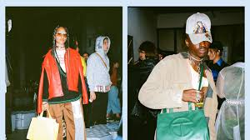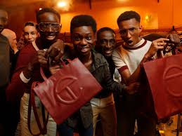

**Creative Rationale**

**Purpose**: The primary objective of our advertising campaign is to convey the message that our product is designed for everyone. We want to emphasize that it's not just for a select few but for people from all walks of life. Through our campaign, we aim to showcase the diverse range of individuals who can benefit from and enjoy our product

**Slogan:** Fashion for all, Always

**Target Audience:** Especially as a Black designer, Clemens worked carefully to create a brand that speaks specifically to Black Americans. Telfar marketing is based on social media rather than the glossy pages of fashion magazines, and its advertisements primarily feature Black models and influencers. It's for those who enjoy luxury without exclusivity and appreciate fashion that's for any age or gender.

**Reason:** Our slogan "Fashion for All, Always" means our clothes are for everyone, all the time. It doesn't matter who you are, where you come from, or how old you are – our fashion is open to everyone. This slogan shows that we want everyone to feel like they belong and can buy our clothes without any restrictions. We are here to serve a wide and diverse group of people.

**Storyboards**

