Jailine Collado, Ritchy Isaac, Valerie Waldron

BUF 3300

7/26/23

**Apparel and Textiles Complex in Kenya**

**Geography - Physical, Economic, and Cultural**

Kenya is among the nineteen countries located in East Africa and it is made up of forty-seven counties. Its longitude and latitude measurements are 0.0236° S, 37.9062° E and its neighboring countries are Somalia, Uganda, and Ethiopia (Wandibba, 2005). The Indian Ocean is east of the Kenya coastline and Lake Victoria is southwest. Kenya’s major rivers include the Nile, a river that runs through eleven countries, the Tana, the largest and longest river in Kenya, the Ewaso Ng’iro, and the Dawa Mara (Sobania, 2003). Amongst Kenya’s vast plains and towering mountains is the world’s largest alkaline desert lake, lake Turkana, and the second highest mountain in Africa, Mount Kenya (Yu, 2019). Mount Kenya is an extinct volcano that last erupted 2.6 million years ago. Kenya’s low plains consist of central highlands that are bisected by the Great Rift Valley. The Great Rift Valley is geologically active with hot springs, geysers, and frequent earthquakes (National Geographic Society, 2023). With Lake Victoria being the most productive surface water resource in Kenya, other than the precipitation runoff from the five water towers, most of Kenya’s fertile plateau is in the west part of the country (Wandibba, 2005).

Due to its geographical position, climate conditions, and natural resources, Kenya’s culture consists of a blend of traditional practices that serve communal purposes and crucial steps towards a modernized society (Sobania, 2003). Significant industries in Kenya include agriculture, forestry, mining, manufacturing, tourism, and financial services, with agriculture as the leading industry. Fresh flowers, fruits, vegetables, tea, and coffee represent the most significant portions of Kenya’s exports, and machinery, transportation equipment, and petroleum represent Kenya’s imports (OEC, 2023). Although agriculture makes up about 33% of Kenya’s Gross Domestic Product (GDP) and employs 40% of the total population and 70% of the suburban population, Kenya’s population still suffers from poverty, inequality, youth unemployment, and weak private sector investments (USAID, 2023). During periods of drought or excessive rain, Kenyan people experience an increase in food prices, leading to an increase in the inflation rate, and increases in oil trading prices alter the price of energy and transportation leading to higher inflation (Central Bank of Kenya, 2023). Local and international factors influence inflation and deflation in the Kenya economy (Bodo, 2023). In Kenya, the currency is known as shilling (KES) and it is divided into 100 cents similar to the United States. One US dollar is equivalent to about 141 KES (The Royal Mint Museum, 2023). Kenya’s monetary policy is regulated by The Central Bank of Kenya to maintain cost stability in the economy. The Central Bank of Kenya is responsible for stabilizing the cost of goods and services to further encourage the purchase of Kenyan supplies. There are three branches of The Central Bank of Kenya located in Kenya; two location’s in the country’s capital Nairobi, and one location in Kapseret, a constituency in Kenya (Central Bank of Kenya, 2023).

The preexistence and growth of private equity firms in Kenya characterizes Kenyans current conquense and expansion with their geography. Kenya has a growing franchising market that can increase the disposable income, however, the country has experienced a decline of major U.S international brands, such as Shoprite, a grocery/pharmacy store. There has been a change in profile demographics of the African shop proprietors, who are commonly more tech-savvy and educated than general consumers (Ivers et al., 2022). The decline of international powerhouses that are locally established specifically in the supermarket industry, due to ineffective corporate governance and teaming up with private firms are the next steps for a company to stay afloat (Anyanzwa, 2022). In Kenya, there is a demand for more goods and services such as food, beverages, clothing, recreational and leisure activities. Some popular United States Franchises that successfully operate in Kenya include Burger King, Domino’s Pizza, KFC, Subway, and Ashley Furniture (Kenya, 2022). It has been cost-efficient for the local operators to build malls, shopping centers, and recreational centers in the area to contribute to the persistent demand and to scope in on managerial elements of retail. The decline of international powerhouse are examples of ineffective corporate governance forfeiting Kenya resources for Kenya investors to invest in their own trades such as retail (Kenya, 2022).This would also allow better market share for international companies, contributing to the overall consumer experience in Kenya (Anyanzwa, 2022). On May 28th, 2021, the Retail Trade Code of Practice was adopted by the Competition Authority of Kenya. This regulates buying power that retailers and traders have to make investments, whether it be indirectly or directly with clothing, factor greater success for the country (Kigwiro, 2022).

The prominence of the music, media, theater, and television scene contributes to Kenya's growing economy. Live entertainment and performing arts are heavily enjoyed amongst crowds but can also symbolize the overcoming of a dark past (Porter, 2022). Existing in not only Kenya’s culture but also African culture is the urge to oppose the infiltration of European legal procedures, medicines, political processes, and religion that do not coincide with traditional values possessed by Africans that their ancestors passed down. Common trades in Kenyan societies include pottery, beadwork, and wood carving (Murage, 2023). As a result of Great Britain’s colonization and control of Kenya until 1963, the two share similar sporting interests. Soccer, cricket, rugby, golf, bowling, squash, and polo are popular in Kenya (World Trade Press, 2010). In rural areas in Kenya, fewer resources are available to locals. Experiencing a higher poverty rate, many residents of rural Kenya live agriculturally. Aside from farming, irrigation access and livestock are other ways these families maintain feasible incomes (World Agroforestry, 2010). Christianity is the most commonly practiced religion among Kenya’s population, making up 85% of the population. This includes Protestants, Catholics, and Evangelicals. 10% are Muslim or followers of Islam, while 5% follow other religions (Kamer, 2022). Sometimes, religious practices derived from indigenous beliefs can cause tension between Kenyan and Christian churches. Religious groups are typically treated equally in the country. The Registrar of Societies allows newly registered religious organizations to apply for tax-exempt status, including exemption from the duty of imported goods (World Trade Press, 2010). Although there is currently no religious conflict in Kenya as of today, one factor that is relative to the issue contributing to a geographical decline is terrorism. Corruption and disagreements among allied powers have been the leading causes of past terrorist attacks in the area. Detrimental to the country’s politics, economy, and social life, the increase in security and decrease in tourism and visitors is typically what follows. For example, The East African Embassy Bombings in 1998 killed two hundred twenty-four people and wounded around 4,500. The attacks were later confirmed to be connected with Al Qaeda, an Islamist militant organization. This, of course, prompted fear worldwide as travel bans for flights going to and coming from Kenya were placed by many nations (Oino & Sorre, 2022). The bombings and previous terrorist attacks negatively impacted politics as AMISOMU, a military institution, took control of political affairs (ACLED, 2023).

**Climate**

Kenya’s agricultural methods have played a major role in how the country was able to gain sustenance on its own rurally. One may say that Kenya had found ways to be able to stay afloat even when some crops were no longer exported; they were innovative enough to find other products that could still actively maintain their agriculture intact. According to the author, they stated “the crops that could be grown are corn and wheat. Also, cattle and goats are raised, and their dairy products are made for domestic purposes. Kenya’s reason to regulate a supply for such in case of emergencies like cheese and butter; if there’s a surplus Kenya’s government exports the product” (Britannica, n.d). Kenya was able to sustain itself agriculturally by adopting methods to keep the progress moving up steadily. According to the article, Kenya maintains the running rank for best farming output like producing wheat, rice, milk, beef, and seafood products adopting this strategy ensures the longevity of farmers available to continue farming in Kenya (Global Monitor, n.d). Agriculture continues to be Kenya’s strong suit by continuing its security for its agriculture practices for the future and how the weather patterns dictate what sort of crop would be ideal to plant during that season.

Kenya’s diverse weather patterns all year depend on its equatorial location on the Earth and what month its climate resides in. The climate in Kenya depends on the geography and how warm/ humid the Indian Ocean is since at times the Indian Ocean may be cooler which means that Kenya Is cooler or Warmer during that season. According to the article, it states “Even though Kenya has good all-year-round sunshine with summer attire being worn, usually evenings and early mornings are cool. In Nairobi, Kenya July is predicted to be the chilliest month with its average temperatures scaling between 48- and 71 degrees Fahrenheit, while March and February are when Kenya reaches its warmest averaging between 52- and 80 degrees Fahrenheit” (IExplore, n.d). Since Kenya has a lot of land and different regions within Kenya; each region has its own climate which makes it difficult to generalize the Kenyan weather. Even though generally you can’t generalize the weather you could still apply some tips universally to its climate. The weather is dictated by monsoon winds, which help bring its high temperatures down to a more cooling effect whilst the winds encourage the country's rainy season, which is their longest because it lasts from April to June (Zijlma, 2020). These climate patterns in Kenya are crucial to its development because Its climate dictates on how the Kenyan people need to adapt to their environment.

**Natural Resources**

Kenya is a coastal zone, and their livelihood depends on the country’s natural resources to support life and meet the needs of its people. The Kenya Lake System presents an exceptional range of geological and biological natural properties of outstanding beauty (Centre, 2023). According to an article titled *A Drowning World: Kenyas Quiet Slide Underwater* (2022), The Indian Ocean surrounds the region of Eastern Africa, but Kenya’s lakes are essential to the country’s people, economy, and wildlife wrestling in About 1 million people living near Kenya’s freshwater lakes. Kenya’s *land* comprises water, Lake Baringo and Lake Naivasha, and salt lakes, including Lake Baringo, Lake Borgio, Lake Nakuru, and Lake Magadi, which are essential to help sustain marine and bird life. Kenya’s lakes and rivers are home to several fish species, which include Large-Toothed Lake Turkana Robber, The Ewaso Nyiro Barb, The Boji Plains Nothobrach, Elongate Nothobranch, and the Dwarf Lake Turkana Robber (Sawe, 2017). However, According to an article titled *The Status of Kenya Fisheries* (2021*),* one will say that Lake Victoria contributes to about 80% of the fish production in Kenya, and only 6% of the lake is in Kenya. For their *labor*, Fisheries production earns between Ksh35,162 and Ksh110,560 monthly (Mywage, 2023). Kenya’s *land* includes rainforests, Savanna, and semi-arid and arid ecosystems, and their terrain is mainly made up of low plains that rise into central highlands by the Great Rift Valley; most Kenyans live in the highlands (Britannica, 2023).

Among its land, Kenya is rich in mineral resources, including gold, iron ore, talc, soda ash, and gems, including Amethyst, Aquamarine, lolite, ruby, and sapphire. Kenya’s most valuable resource is soda ash, Kenya’s leading mineral export (AZoMining, 2019). Along with Kenya being known for the outstanding beauty of their landscapes, the country in East Africa is also known for its delectable cuisines. Kenya's staples consist of corn, sorghum, millet, and various meats and vegetables. Ugali is Kenya’s most famous dish, made from maize flour that becomes a dough-like consistency. Nyama Choma, which translates to Roasted meat, goat, and beef, are specialty meats of Kenya; Kuku choman (chicken) and samaki choma (fish) are also appetizing choices, as well as the most popular deep-fried snack Bhajias which are thinly sliced potatoes coated in flour seasoned with cumin, coriander, parsley, chili powder, and ginger (Simborio, 2023). According to Horticulture Kenya (2022), Kenyan Cuisine must include spices and herbs such as Pepper, Parsley, Paprika, Marjoram, Capsicum (chilies and cayenne pepper), Oregano, Pimento, Thyme, Coriander, Bay leaves, Cinnamon, Rosemary, Ginger, Basil, Nutmeg, Mint, Caraway, Savoury, Turmeric, Dill, Cumin, Tarragon, Cloves, Sage, Mace, Cardamom, Anise, Fenugreek, Saffron, Vanilla, Fennel seeds, and Juniper berries. The soils used in agriculture are ferralsols, vertisols, acrisols, lixiosols, luvisols, and nitisols (Infonet-biovision, 2023).

Considering *labor,* many profitable crops can be grown in Kenya, varying on factors such as local climate, soil conditions, and market demand; typically, a Farmer working in Kenya can range from the lowest average salary of 277,400 KES to the highest average salary of 885,000 KES and *labor* is typically dived among the people in the family of all different ages (Worldsalaries, 2023). One may say that one of Kenya’s greatest struggles is poverty, the wealthiest people are Kikuyu, the best-represented ethnic group with the highest status. Their job reflects that status with government, business, and education positions—followed by the Luo, who find jobs such as fishermen and boat loaders (Everyculture, 2023). Typically minimum wage varies by job; since 2015, there has been a 12% wage increase. Skilled workers get paid around USD 170/month, while others may receive USD 107/month (Lloydsbanktrade, 2023). Kenya’s *capital* is based on its monetary unit, Shilling. Kenya has a lower middle-income status, yet it is the most powerful economy in Africa, with many commercial, merchants, and foreign banks (Britannica, 2023). One may say that Kenya is the leader in digital technology in Africa, witnessing significant growth in *Entrepreneurship* due to new technology. Kenyans have depended on agriculture for economic growth; however, increased literacy and human labor created more opportunities, resulting in early entrepreneurs working in roles such as pottery, carpentry, and wool making (Mutuku, 2022). These natural resources are essential for the economic life of the people in Kenya.

**Population and Demographic**

**Figure 1**

**The population of Kenya as of 2019 by ethnic group**

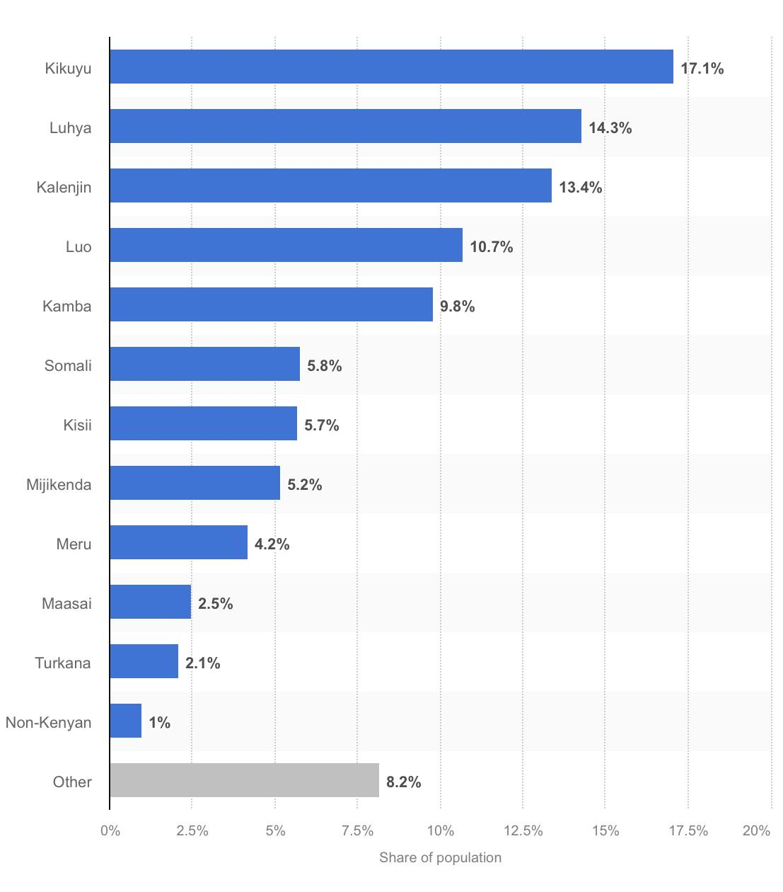

Kamer (2022) provides commentary that Kenya has more than 40 ethnic groups, but the Kikuyu, the largest ethnic group in Kenya, constitutes a Bantu group with more than eight million people. The population is divided into three language groups: Bantu, Nilo-Saharan, and Afro-Asiatic; Bantu is the largest (Britannica, 2023).

**Figure 2**

**Kenya: Age structure from 2011 to 2021**

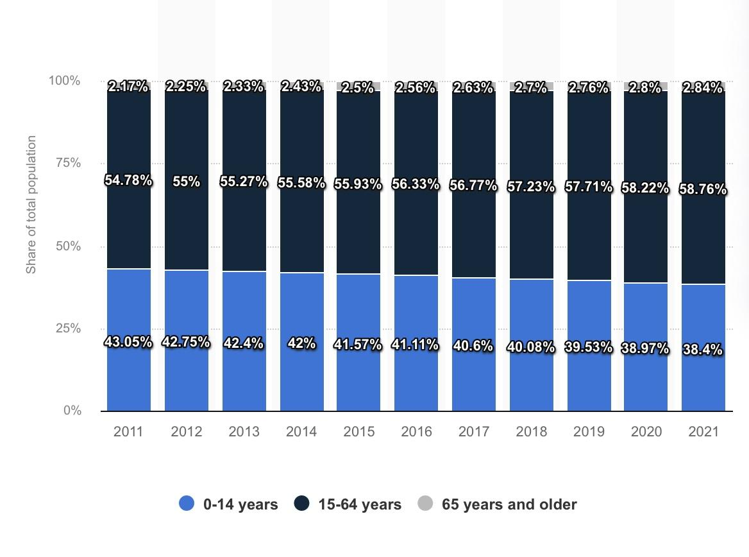

O’Neill (2023) provides commentary on the age structure of the people in Kenya; as of 2021, 58.76% of the population ranges from 15-64 years old.

**Figure 3**

**Kenya Religious Affiliation, 2019**

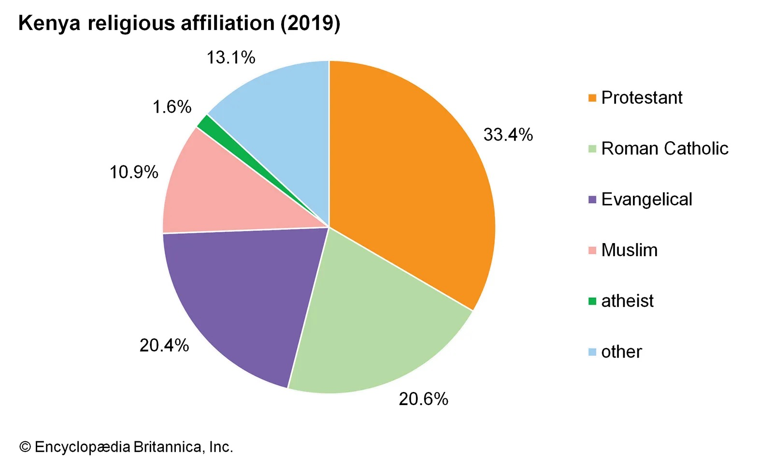

Religion plays a significant role in the life of most Kenyans, and Kenya’s religion in Kenya is not mutually exclusive. However, Christianity is the country’s most influential and dominant religion. Protestantism is a branch of Christianity; more than four-fifths of the people in Kenya follow Christian values (Scroope, 2018).

**Figure 4**

**Kenya Completion Rate of Education, 2019**

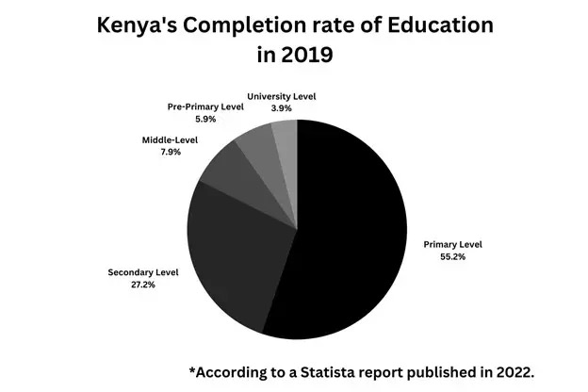

Education in Kenya consists of a three-level educational system. Beginning at six years old, students will obtain a primary education, four years at the secondary level, and four years of higher education (ZoeTalentSolutions, 2023).

**References**

A ‘private-sector success story’? uncovering the role of politics and ... (n.d.). <https://www.tandfonline.com/doi/pdf/10.1080/00220388.2020.1715944>

ACLED, C. (2023, July 17). *Kenya situation update: July 2023: Al-Shabaab attacks surge ahead of Somalia-kenya border reopening*. ACLED. https://acleddata.com/2023/07/07/kenya-situation-update-july-2023-al-shabaab-attacks-surge-ahead-of-somalia-kenya-border-reopening/ Anyanzwa, J. (2022, December 28). *Kenya: Private equity firms develop appetite for retailers as global brands Exit Markets*. ZAWYA. <https://www.zawya.com/en/economy/africa/kenya-private-equity-firms-develop-appetite-for-retailers-as-global-brands-exit-markets-gyej6otz>

*Average farmer salary in Kenya for 2023*. World Salaries. <https://worldsalaries.com/average-farmer-salary-in-kenya/>

Bein, R . Retrieved from <https://iu.pressbooks.pub/travelingfarmer/chapter/1404/#:~:text=Agricultural%20production%20involves%20mainly%20mixed,beans%20the%20most%20important%20legume>

*Centre, U. W. H. (n.d.). Kenya Lake System in the Great Rift Valley. UNESCO World Heritage Centre.* [*https://whc.unesco.org/en/list/1060/*](https://whc.unesco.org/en/list/1060/)

*Climate & Clothing*. Africa Expert. (2021, March 8). <https://www.africa-expert.com/about-kenya/climate-and-clothing/>

*Educational Statistics for Kenya*. Zoe Talent Solutions. (2023, April 19). <https://zoetalentsolutions.com/educational-statistics-for-kenya/#:~:text=The%20completion%20rate%20for%20primary,a%20completion%20rate%20of%2024.5%25>.

Encyclopædia Britannica, inc . *Agriculture, forestry, and fishing*. Encyclopædia Britannica. <https://www.britannica.com/place/Kenya/Agriculture-forestry-and-fishing>

Encyclopædia Britannica, inc. (n.d.-b). *People of kenya*. Encyclopædia Britannica. <https://www.britannica.com/place/Kenya/People>

Guardian News and Media. (2022, March 17). *A drowning world: Kenya’s Quiet Slide Underwater*.The Guardian. <https://www.theguardian.com/world/2022/mar/17/kenya-quiet-slide-underwater-great-rift-valley-lakes-east-africa-flooding>

*Home*. Horticulture Kenya LTD. (n.d.-a). https://horticulturekenya.com/kenyas-vegetables-herbs-spices

Ivers, L., Niavas, S., Mitchell, C., Sqalli, Z., & Frikha, O. (2023, May 8). *The future of traditional retail in Africa*. BCG Global. <https://www.bcg.com/publications/2022/the-future-of-traditional-retail-in-africa>

*Jobs & Salaries*. WageIndicator Foundation. (. <https://mywage.org/kenya/career/kenya-jobs-salaries/kenya-aquaculture-and-fisheries-production-managers>

Kamer, L. (2022, August 1). *Kenya: Population by religious groups*. Statista. <https://www.statista.com/statistics/1199572/share-of-religious-groups-in-kenya/>

*Kenya - Agribusiness*. International Trade Administration | Trade.gov. <https://www.trade.gov/country-commercial-guides/kenya-agribusiness>.

*Kenya Agriculture Market Trends, statistics, growth, and forecasts*. GlobalMonitor. (n.d.). <https://www.globalmonitor.us/product/kenya-agriculture-market#table-of-contents>

*Kenya*. Countries and Their Cultures. (n.d.). <https://www.everyculture.com/Ja-Ma/Kenya.html#:~:text=Many%20Luo%20are%20fishermen%20and,of%20Indian%20or%20Arab%20descent>.

*Kenya - market overview*. International Trade Administration | Trade.gov. (2022, August). <https://www.trade.gov/knowledge-product/kenya-market-overview>

*Kenyan soils*. Return to site content. (G. Kimaru). <https://infonet-biovision.org/EnvironmentalHealth/kenyan-soils#:~:text=Soil%20resources%20vary%20from%20sandy,%2C%20lixisols%2C%20luvisols%20and%20nitisols>.

*Kenya - Weather*. Adventure Tourism - Experiential Travel Guides. (n.d.). <https://www.iexplore.com/articles/travel-guides/africa/kenya/weather>

Mahendira.K. (2020). Global Textiles: Kenya <https://textilevaluechain.in/in-depth-analysis/articles/textile-articles/global-textiles-kenya/#:~:text=Kitenges%20are%20colourful%20pieces%20of,on%20only%20a%20long%20side>

Messenger, D. (2023, May 27). *Kenya ranked sixth most beautiful country in the world*. DIASPORA MESSENGER NEWS MEDIA. <https://diasporamessenger.com/2022/02/kenya-ranked-sixth-most-beautiful-country-in-the-world/>

Mutuku, R. (2022, November 28). *The history of entrepreneurship in Kenya and its evolution*. Tuko.co.ke - Kenya news. <https://www.tuko.co.ke/263846-history-of-entrepreneurship-kenya.html>

Murage, M. (2023, February 17). *6 indigenous crafts to immerse you in Kenyan culture*. The Expat Mummy. <https://theexpatmummy.com/6-strong-indigenous-crafts-to-immerse-you-in-kenyan-culturenbsp-strong/>

National Geographic Society. (2023, July). *Rift Valley*. National Geographic Society: Education. <https://education.nationalgeographic.org/resource/rift-valley/>

Oino, P. (2014, January 1). *Impact of terrorism on the society: The Kenyan experience*. Academia.edu. <https://www.academia.edu/64889329/Impact_of_terrorism_on_the_society_The_Kenyan_experience>

O’Neill, A. (2023). Retrieved from <https://www.statista.com/statistics/451141/age-structure-in-kenya/>

Porter, J. (2000). *The Sound of Music in Kenya*. Docslib. (n.d.). <https://docslib.org/doc/8763599/the-sound-of-music-in-kenya>

Sawe, B. E. (2017). Retrieved from <https://www.worldatlas.com/articles/native-fish-species-of-kenya.html>

Scroope, C. (2018). Retrieved from <https://culturalatlas.sbs.com.au/kenyan-culture/kenyan-culture-religion>

Simborio, T. S. (2023). Retrieved from <https://www.willflyforfood.net/food-in-kenya/>

Sobania, N. (2003, June 30). Culture and customs of kenya - south african history online. <https://www.sahistory.org.za/sites/default/files/archive-files/neal_sobania_culture_and_customs_of_kenya_cultubook4you.pdf>

Tech, F. T., Corporation, F. R., GmbH, F. C. Z. M., From Carl Zeiss - Raw Materials, & Ltd, F. K. I. (2019, August 15). *Kenya: Mining, minerals and fuel resources*. AZoMining.com. <https://www.azomining.com/Article.aspx?ArticleID=143#:~:text=The%20natural%20resources%20of%20Kenya,zinc%2C%20wildlife%2C%20and%20hydropower>.

*The Competition Authority of Kenya Retail Trade Code of Practice*. Afronomicslaw.org. <https://www.afronomicslaw.org/category/analysis/competition-authority-kenya-retail-trade-code-practice#:~:text=The%20RTCP%20seeks%20to%20regulate,not%20abuse%20their%20buyer%20power>.

*The status of Kenya Fisheries*. MAHB. (2021, December 10). <https://mahb.stanford.edu/library-item/the-status-of-kenya-fisheries/>

Wandibba, S. (2005, December). *Kenyan cultures and our values*. Wajibu. <https://africa.peacelink.org/wajibu/articles/art_4484.html>

*Work conditions in Kenya*. Work conditions in Kenya - International Trade Portal. (n.d.). <https://www.lloydsbanktrade.com/en/market-potential/kenya/work-conditions#:~:text=Working%20Conditions&text=52%20hours%20per%20week%20>(60,to%20do%20non%2Dpaid%20overtime.

World, T. P. (2010). *Kenya society & culture complete report: An all-inclusive profile combining all of our society and culture reports*. World Trade Press.

Why Kenya’s seasonal rains keep failing and what needs to be done - kenya. (2019). Retrieved from <https://reliefweb.int/report/kenya/why-kenya-s-seasonal-rains-keep-failing-and-what-needs-be-done>

Yu, W., Wardrop, N. A., Bain, R. E. S., Alegana, V., Graham, L. J., & Wright, J. A. (2019, May). *Mapping access to domestic water supplies from incomplete data in developing countries: An Illustrative Assessment for Kenya*. PLOS ONE. <https://journals.plos.org/plosone/article?id=10.1371%2Fjournal.pone.0216923>

Zijlma, A. (2020, November 26). *The weather and climate in Kenya*. TripSavvy. <https://www.tripsavvy.com/kenya-weather-and-average-temperatures-4071455>