**Financial Management Project: Walt Disney**

Jailine Collado

New York City College of Technology

BUF 2339

Prof. Akazi

December 4, 2023

The Walt Disney Company’s mission statement is to entertain, inform, and inspire people around the globe through the power of unparalleled storytelling, reflecting the iconic brands, creative minds, and innovative technologies that make them the world’s premier entertainment company (The Walt Disney Company, 2023). Disney aims for high performance and leadership in its industries in direct-to-consumer media streaming. As Walt Disney develops new products, its competitive landscape becomes increasingly complex, creating new challenges to fulfilling the corporate mission and vision statements. Disney’s Mission statement describes the main aspects of Disney’s business (Williams, 2023).

1. Entertainment, information, inspiration
2. Global market reach
3. Unparalleled and premier status
4. Storytelling, branding, creativity, and innovative technologies

The Walt Disney Company’s vision statement complements the mission statement. The corporate vision is future-oriented and transparent regarding the media company’s strategic aspirations—Disney is for leadership in the global market for entertainment products (Williams, 2023). Walt Disney provides several products and services; the media networks Disney owns are ABC Television Network, ABC Owned Television Stations Group, ABC Entertainment Group, Disney Channels Worldwide, ABC Family, and Disney Media Distribution. The Parks and Resorts are 11 Theme Parks (including Walt Disney World and Walt Disney Land), 43 Resorts, Disney Cruise Line (4 ships: The Disney Magic, Disney Wonder, Disney Dream and Disney Fantasy), Disney Vacation Club (11 properties and over 500,000 members), and Adventures by Disney (guided vacations around the world). Walt Disney Studios includes Walt Disney Animation Studios, Pixar Animation Studios, Disneynature, Marvel Studios, Touchstone Pictures, DreamWorks Studios, Disney Music Publishing, Disney on Broadway, Disney on Ice, and Disney Live. Consumer products include apparel, toys, home decor, books, magazines, food, beverages, stationery, electronics, fine art, and the Disney Store retail chain. The Walt Disney Company has a wide range of products to choose from when purchasing them and numerous entertainment opportunities through all of its parks worldwide (The Walt Disney Company Stock Project, 2023).

Walt Disney World was born in Chicago, Illinois, on December 5, 1901. Walt was one of five children, four brothers, and a sister. He was raised on a farm near Marceline, Missouri. Walt became interested in drawing early on in life; when he was seven years old, he sold his first sketches to neighbors. After the war, Walt returned to Kansa City, where he began his career as an advertising cartoonist. Walt later created and marketed his first original animated cartoons and perfected a new method for combining live-action and animation in 1920. In August of 1923, Walt Disney left Kansa City for Hollywood with only a few drawing materials, $40 in his pocket, and a finalized animated and live-action film. Walts’s brother Roy O. Disney was already in California with a dream and $250. With minimal resources, Walt and Roy borrowed an additional $500 and constructed a camera stand in their uncle’s garage to get to where the company is today (D23, 2018).

Disney started as a small animation studio on October 16, 1923, founded by brothers Walt and Roy Disney; the brothers created the Disney Brothers Cartoon Studio in Hollywood, California. The studio, now famously known as the Walt Disney Company, has had an enormous impact on the entertainment industry and is now known as one of the largest companies in the world. Walt Disney was a talented artist from a young age and drew cartoons for various publications. Furthermore, Walt quickly became interested in cel animation while working for the Kansa City Film Ad Company. The company’s first successes were creating short animated films like the Alice Comedies and Oswald the Lucky Rabbit During the release of Steamboat Willie, in 1928 the world was introduced to Mickey Mouse. The character would become one of the most recognizable cartoons in history. The popularity of the Mickey Mouse shorts convinced Disney that his studio could produce a feature film. These early successes allowed Disney to expand its studio and create feature-length animated films in the 1930s. The studio’s first feature film was Snow White and the Seven Dwarfs, released just before Christmas in 1937 and was a hit. The film was a massive success and is credited with being the first full-length animated feature film. The Success of Snow White led to the release of several other Disney classics such as Pinocchio, Fantasia, and Dumbo. These real successes, combined with the creation of the first Disney theme park, Disneyland, in 1955, solidified Disney as a leading entertainment company. In the 1960s, Disney began diversifying, creating live-action films, television programs, and Other media. Disney has also established its distribution arm and made deals to release its films in foreign markets. This opportunity has allowed the company to expand its reach and become more profitable. In the 1980s, Disney made several acquisitions, including the acquisition of the Muppets and the rights to the Star Wars franchise. These acquisitions further increased Disney’s reach and helped to make it the massive multimedia conglomerate it is today. The company has since expanded its business to include theme parks, cruise lines, consumer products, and more (History, 2023).

Robert A. Iger is the chief Executive officer of The Walt Disney Company; Robert served as the CEO and Chairman from 2005 to 2020 and then as Executive Chairman and Chairman of the Board through 202. Since returning as CEO, Mr.Iger has led a significant enterprise-wide transformation to restore creativity to the center of the company and position Disney’s streaming business for sustained growth and profitability. His strategic vision focuses on generating the best creative content possible, fostering innovation, utilizing the latest technology, and expanding into new global markets (The Walt Disney Company, 2020). The Walt Disney Company is headquartered at the Walt Disney Studios complex in Burbank, California, and has 18 office and retail locations located throughout the US (Zippia, 2023). According to Zippia The Walt Disney Company has 223,000 employees. Of 223,000 employees, 55% are women, and 45% are men. The most common ethnicity at The Walt Disney Company is white, at 57%. The Hispanic or Latino employees make up 20%. Furthermore, 12% of The Walt Disney Company employees are black or African American.

|  |  |  |  |  |
| --- | --- | --- | --- | --- |
|  |  |  |  |  |

|  |  | **Figure 1** |  |  |
| --- | --- | --- | --- | --- |



**Figure 2**

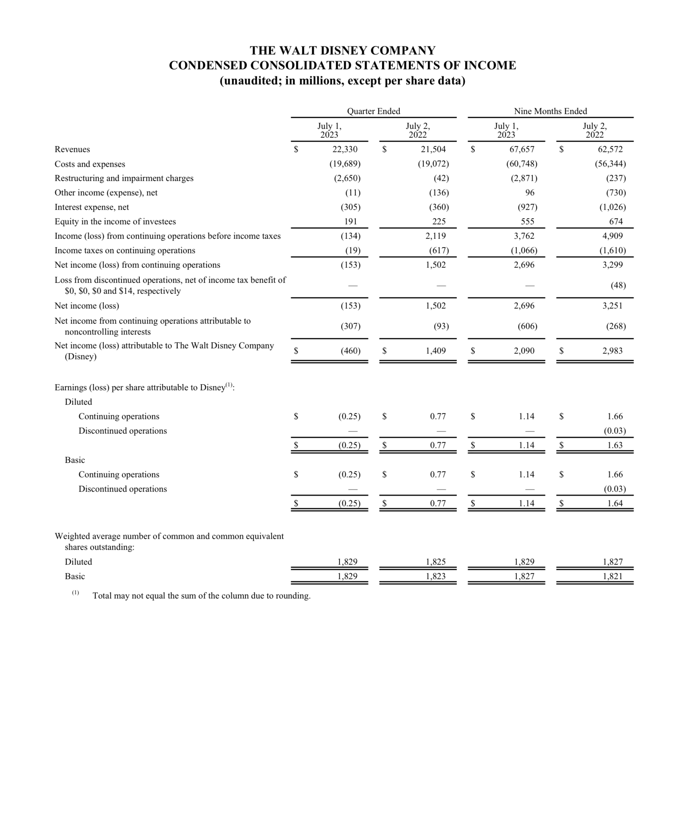

In conclusion, Disney is a solid and resilient company that has successfully adapted to changing market conditions. Their diversified portfolio of businesses, substantial brand recognition content library, and strategic investments in technology and new ventures make them well-positioned for continued growth and success. As the world continues to evolve, Disney will remain a significant force in the entertainment industry for years. They have the resources and capabilities to remain competitive and continue to provide quality, family-friendly entertainment for audiences Worldwide. The company’s ability to remain innovative and embrace new technologies while staying true to its core values will ensure it remains a leader in the industry. Disney’s commitment to quality and customer satisfaction while maintaining a solid financial position makes it a great long-term investment option for investors. Walt Disney Company continues to be helpful and is one of the most influential media conglomerates in the world.

**References**

A&E Television Networks. (n.d.). *Walt Disney Company is founded | October 16, 1923*. History.com. https://www.history.com/this-day-in-history/walt-disney-company-founded

*About Walt Disney*. D23. (2018, April 10). https://d23.com/about-walt-disney/#:~:text=The%20creator%20of%20Mickey%20Mouse,four%20boys%20and%20a%20girl.

*Disney - leadership, history, Corporate Social Responsibility*. The Walt Disney Company. (2020, March 2). https://thewaltdisneycompany.com/about/

For immediate release August 9, 2023 The Walt Disney Company reports ... (n.d.). https://thewaltdisneycompany.com/app/uploads/2023/08/q3-fy23-earnings.pdf

*Get the job you really want*. Zippia. (n.d.-a). https://www.zippia.com/the-walt-disney-company-careers-11541/demographics/

*Get the job you really want*. Zippia. (n.d.-b). https://www.zippia.com/the-walt-disney-company-careers-11541/locations/

*Products and services*. The Walt Disney Company Stock Project. (n.d.). https://thewaltdisneycompanystockproject.weebly.com/products-and-services.html

The Walt Disney Company. (2023, October 26). https://thewaltdisneycompany.com/#:~:text=The%20mission%20of%20The%20Walt,the%20world’s%20premier%20entertainment%20company.

Williams, A. (2023, September 20). *Walt Disney’s Mission Statement & Vision statement (an analysis)*. Panmore Institute. https://panmore.com/walt-disney-company-mission-statement-vision-statement-analysis