Africa’s Fashion Diaspora: An Exploration of Cultural Influence Through Fashion

Jailine Collado

BUF 4900

New York City College Of Technology

The groundbreaking Africa's Fashion Diaspora exhibition, presented by the Fashion Institute of Technology (FIT) Museum, examines how fashion has influenced Black diasporic cultures around the world. Supported by a number of institutional and private sources, this exhibition emphasizes fashion as a creative force and a link between social groups. Sponsors of these exhibitions make a substantial contribution to the development of a more comprehensive, diverse, and equitable history of fashion by ensuring that the achievements and influence of Black designers like Arthur McGee are acknowledged and honored in the broader context of fashion and by establishing venues that value cultural diversity in fashion, transcending gender, geography, sexual orientation, and religion. By means of its artwork, the show explores the intricate relationships of gender, location, and identity in African influence. One standout piece in the exhibition is Arthur McGee’s *Wool blanket coat with leather trim*. This garment manifests these themes of cross-cultural influence and innovation (The Museum at FIT, 2024). The exhibition highlights the groundbreaking work of Arthur McGee, a visionary Black designer who created a shift in the American fashion industry at a time when racial representation was limited.

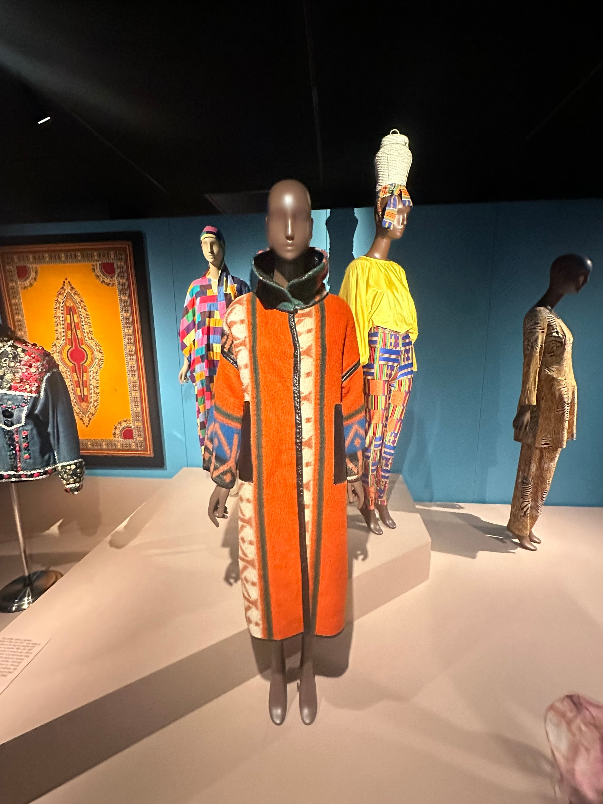

Arthur McGee, Wool blanket coat with leather trim, 1980s United States *The Museum at FIT*

Starting his career in the 1950s, McGee became one of the few Black design leaders employed by Seventh Avenue manufacturers, an area historically dominated by white designers and often closed off to people of color. McGee’s approach to fashion is characterized by what he described as “simple, unadorned ‘clean’ dresses in good fabrics made in ways that mass production would prohibit,” which reflects a dedication to craftsmanship, quality, and individuality over the standardization that often comes with mainstream fashion. His 1980s-era wool blanket coat with a leather accent is one of the exhibition's main attractions. This item exemplifies McGee's creative approach to fusing African-inspired textiles and cultural patterns into upscale American design. A Basotho blanket inspired it he saw while traveling to South Africa. Although McGee initially referred to the garment as a “Zulu” blanket, this coat reflects his deep appreciation for African materials and his ability to blend global cultural influences into designs that appeal to an American audience (The Museum at FIT, 2024).

The contributions of Black designers must now be acknowledged to comprehend the intricate narratives that shape fashion. These kinds of exhibitions challenge long-standing prejudices and traditional notions of who has power, thereby broadening the historical and cultural scope of the fashion industry. In doing so, they raise awareness of and appreciation for the unique perspectives that Black designers offer to the fashion industry while also celebrating diversity as a foundation of creativity and innovation. The exhibition reinforces that fashion is not merely about aesthetics but also serves as a cultural dialogue that reflects respect and amplifies the voices of all communities (The Museum at FIT, 2024).

In Arthur McGee’s wool blanket coat, the use of *tones, shading*, and *value* brings out the garment’s depth and richness. The vibrant orange wool radiates warmth and energy, while the navy blue adds a cooler, more subtle contrast. In addition to enhancing the coat's visual appeal, these contrasting values give the composition more depth. These contrasting colors work together to give the coat a dynamic visual appeal while adding layers and dimension to its design. The *shade* produced by the light's interaction with the wool fabric highlights areas where the garment naturally drapes and curves. The dramatic yet elegant look of the garment is enhanced by the precise manipulation of *value*, which also aids in defining the silhouette (Bell & Ternus, 2017).

McGee's coat features vertical linework, with the zipper running directly down the middle. Because of the elongation created by this *line*, the garment appears sleek and structured and the viewer's eye is drawn upward. McGee's design perfectly reflects the qualities of height, dignity, and formality that Silent Selling claims vertical lines convey (Bell & Ternus, 2017). The vertical seams on either side of the coat also accentuate the central line, strengthening the garment's overall shape and adding to its silhouette.

This garment's repetition of geometric forms and patterns around the sleeves creates *rhythm.* Visual movement is produced throughout the coat by the alternating shapes, which are organized in a regular, rhythmic succession. According to Bell and Ternus (2017), *rhythm* in design guides the eye of the observer through the garment in a methodical and regulated manner. Because of the fluid, harmonic flow of this repetition, the eye is naturally attracted down the garment as it follows the shape sequence. The pattern is evocative of traditional African textiles, where recurrent themes are often significant or tell a story.

*Form* describes the coat's general three-dimensional shape. A comfortable and sophisticated silhouette is produced by the garment's natural drape over the body thanks to McGee's design's flowing, loose shape. According to Bell and Ternus (2017), Silent Selling talks about form as the way a garment adds volume and presence. Fitted sleeves balance the coat's large appearance while adding volume without overpowering the user. This style is both practical and fashionable, providing mobility while maintaining a strong and unique silhouette.

Because of the thoughtful blending of colors, textures, and patterns, this garment has *balance*. In order to create harmony, McGee combines the vivid orange wool with a subdued navy blue. Both symmetrical and asymmetrical balance are possible, as mentioned in Silent Selling, and McGee's design is primarily symmetrical, offering stability and harmony (Bell & Ternus, 2017). Despite the coat's striking use of color, it feels balanced because to the symmetry of the design, which includes a central zipper and geometric designs on each sleeve. Because of the design's symmetry, the coat looks lively without being disorganized.

The coat's combination of vivid colors and various textures makes the idea of *contrast* clear. The *contrast* between the clean, sleek leather trim and the rough, textured wool is both physical and visual. McGee's use of *contrast* is an excellent illustration of the concept of silent selling, which highlights the significance of *contrast* in highlighting important aspects of a garment (Bell & Ternus, 2017). The garment is highlighted by the details. The coat's aggressiveness is accentuated and grounded in refinement by the striking contrast between the brilliant orange and navy blue. These particulars contribute to the garment's distinctiveness, making it striking and well-balanced.

McGee's coat's striking orange hue is its most *dominant* trait. This striking color makes the coat the main attraction right away (Bell & Tetanus, 2017). The orange's supremacy in McGee's design is further accentuated by the remainder of the garment's design being simple; the color isn't overly embellished, so it can command attention. The viewer's eye is also directed by the sleeves' *dominant* geometric patterns, although the eye is still drawn to the bright orange.

For the design to seem cohesive, *repetition* is essential. The garment gains rhythm and flow from the constant appearance of the geometric shapes on the sleeves. The coat feels unified because of the *repetition*, which also keeps the design visually appealing and ties the pieces together (Bell & Tetanus, 2017). This sense of harmony is reinforced by the coat's repeated usage of orange and blue in different areas, which resurface in a balanced manner. McGee gives the design a deliberate, well-made feel by using *repetition*.

The *texture* of McGee’s coat, particularly the interplay between wool and leather, reflects his work’s fusion of African and American influences. While the smooth leather accent lends a hint of contemporary luxury, the roughness of the wool testifies to the usefulness of traditional African textiles. The greater cultural conversation in African diasporic fashion, where traditional craftsmanship meets modern design, is reflected in this blend of textures. Much like African music or art, the garment’s​​ texture reflects a merging of past and present, tradition and innovation. In a broader cultural context, this garment symbolizes how Black fashion, like music or art, is a powerful means of expression and influence in today’s society (Smith, 2020; Wilson, 2016).

A masterwork that perfectly captures the fusion of contemporary fashion with African and diasporic cultures is Arthur McGee's wool blanket coat. The coat becomes more than just a piece of clothing because to its careful application of design elements like line, rhythm, and texture. It is a visually arresting and important piece because of its vibrant colors, dynamic pattern, and inventive structure. McGee's capacity to innovate in the fashion industry is shown in the coat. When Black designers started to make their presence known in largely white fashion circles in the 1980s and beyond, it reflected broader cultural changes.

Like many other pieces in the exhibition Africa’s Fashion Diaspora, this garment reflects how Black and African dress influences and mirrors life. In today’s culture, African-inspired fashion continues to shape various aspects of society, from music to politics. Artists like Beyonce include African designers in her performance elements and themes. Fashion is a potent medium for cultural reclamation and self-expression. Black cultural pride has also experienced a resurgence as a result of movements like #BlackLivesMatter, with fashion acting as a vehicle for heritage celebration and resistance. McGee’s designs, which incorporate traditional African elements such as the Basotho blanket, are part of this larger conversation about identity and belonging (Smith, 2020; Wilson, 2016)—McGee’s coat blends African traditions with a modern twist.

**References**

Bell, J. A., & Ternus, K. (2017). Silent Selling: Best practices and effective strategies in visual merchandising (5th ed.). Bloomsbury Academic.

Smith, J. (2020). African fashion and diaspora: The global influence of African style. The New York Times. <https://www.nytimes.com/article/african-fashion-diaspora.html>

The Museum at FIT. (2024.). Africa’s fashion diaspora. Arthur McGee: *Wool blanket coat with leather trim*. The Museum at FIT. <https://www.fitnyc.edu/museum/exhibitions/africas-fashion-diaspora.php>

Wilson, E. (2016). Adorned in Dreams: Fashion and modernity (2nd ed.). I.B. Tauris.