Jailine Collado

**Developing My Brand: Welcome Page**



The color choice of this logo, especially the shades of blue, is inspired by the Cancer horoscope’s connection to water and its symbolic depth of emotion, intuition, and strength. Soft blues and silvery grays evoke a sense of calm, serenity, and emotional sensitivity, traits often associated with the Cancer sign (Color Psychology, 2024). These cool, muted tones are also symbolic of quiet power—reflecting a personality that is gentle on the surface but harbors deep resilience and strength underneath. Deep indigo accents represent emotional depth and subtle intensity, complementing the overall vibe of a calm yet powerful presence (Elliott & Maier, 2014).

Including a mountain in the logo carries personal significance tied to my last name, Collado, which means “dweller by the mountain pass” in Spanish. This imagery reflects my roots and connection to nature, symbolizing strength, stability, and the pursuit of higher goals. The mountain is also a universal symbol of overcoming challenges and rising above obstacles, aligning with my aspirations in fashion and marketing. It embodies both physical and metaphorical growth, serving as a reminder of the resilience required to navigate the career landscape.

The flowing lines of the mountain are designed to blend seamlessly with the initials “JC,” representing harmony between my personal and professional journey. The clean, modern font used for the initials reflects professionalism, elegance, and simplicity. Its boldness reinforces the strength and ambition embodied by the mountain, while its minimalistic design speaks to my aesthetic sensibilities in fashion (Choi & Taylor, 2014). The smooth lines of the font echo the fluidity of the mountain, creating a cohesive balance between nature and ambition (Bell & Ternus, 2011). This combination of colors, shapes, and typography creates a personal, professional, and timeless logo, representing who I am and the brand I am building in the world of fashion and marketing.

**Mission Statement:**

As a passionate professional in fashion and marketing, my mission is to catalyze positive change within the industry by championing sustainable fashion practices that honor creativity and responsibility. My direction is rooted in a commitment to personal growth and using my platform to give back to my community in the Bronx, creating opportunities and resources for aspiring creatives. By merging my dedication to sustainable fashion with my drive to uplift my community, I seek to foster a future where fashion has a lasting impact on the marketplace and people’s lives. Through collaboration and creativity, I aspire to elevate brands while nurturing social and environmental responsibility, leaving a legacy that reflects my values.

**Professional Long-Term Goals:**

**Objective 1: Launch my own fashion-related business**

* Step 1: Conduct market research to identify gaps in the fashion market.
* Step 2: Develop a business plan, including finances, target audience, and branding.
* Step 3: Start small by offering a limited product line or service to test the market.
* Step 4: Build a robust online presence through a website and social media platforms.
* Step 5: Network with fashion industry professionals and seek mentorship from successful entrepreneurs.

**Objective 2: Become a Leader in Fashion Marketing**

* Step 1: Stay updated with the latest trends and technologies in fashion marketing.
* Step 2: Attend workshops, webinars, or digital marketing and branding courses.
* Step 3: Seek leadership roles in current work or internships that allow me to lead projects.
* Step 4: Build a portfolio showcasing successful marketing campaigns I have led.
* Step 5: Connect with thought leaders in fashion marketing through network events.

**Objective 3: Build a solid personal brand and online presence**

* Step 1: Define my brand’s mission, values, and target audience.
* Step 2: Create consistent content across my social media platforms.
* Step 3: Collaborate with other creators or influencers in the fashion industry.
* Step 4: Engage with my audience by responding to comments and participating in relevant discussions.
* Step 5: Regularly update my portfolio to reflect my latest work

**Objective 4: Expand my network in the fashion and Business world:**

* Step 1: Attend industry events, seminars, and fashion shows.
* Step 2: Join professional associations like the American Marketing Association (AMA) or Fashion related groups
* Step 3: Schedule informational interviews with professionals in the industry.
* Step 4: Connect with my internship mentors and colleagues on platforms like LinkedIn.
* Step 5: Actively participate in online fashion marketing communities.

**Objective 5: Contribute to community-based fashion initiatives:**

* Step 1: Research local or national organizations that focus on fashion sustainability or social causes
* Step 2: Volunteer my time and skills for a community fashion event or sustainability program.
* Step 3: Pitch ideas to collaborate with community organizations in fashion-related projects.
* Step 4: Use social media to promote and support community-based initiatives.
* Step 5: Host workshops or awareness campaigns on sustainable fashion in the Bronx.

**Personal Long-Term Goals**

**Objective 1: Achieve financial independence:**

* Step 1: Create a detailed budget to track your expenses and identify areas where you can save more.
* Step 2: Establish an emergency fund to cover 3-6 months of living expenses.
* Step 3: Explore additional income streams, such as freelance work or side projects in your field of expertise.
* Step 4: Invest in personal finance education to better understand savings, investments, and retirement planning.
* Step 5: Set monthly savings goals and automate transfers into a savings or investment account.

**Objective 2: Travel to explore international fashion trends:**

* Step 1: Research and create a list of fashion capitals or regions you want to explore (e.g., Paris, Milan, Tokyo).
* Step 2: Set a specific savings goal for travel expenses, including flights, accommodation, and fashion-related activities.
* Step 3: Plan your travel itinerary around primary fashion weeks or industry events to maximize trend exposure.
* Step 4: Network with international fashion professionals through online communities or LinkedIn to get insights and recommendations.
* Step 5: Before you travel, learn about different cultures and fashion trends through online resources, books, and documentaries.

**Objective 3: Purchase a home:**

* Step 1: Research the housing market in your desired area to understand pricing and market trends.
* Step 2: Meet with a financial advisor or mortgage lender to assess your home-buying budget and financing options.
* Step 3: Set up a savings plan for a down payment and closing costs.
* Step 4: Improve your credit score by paying off debts and making timely payments on loans or credit cards.
* Step 5: Start visiting open houses or virtual tours to familiarize yourself with the types of homes within your budget.

**Objective 4: Establish a balanced work-life routine:**

* Step 1: Set clear boundaries for work and personal life, including designated times for both.
* Step 2: Create a daily or weekly schedule that allocates time for work, rest, exercise, and social activities.
* Step 3: Practice time management techniques, such as the Pomodoro method, to stay focused during work hours and maximize productivity.
* Step 4: Prioritize self-care routines like meditation, hobbies, or physical activities to prevent burnout.
* Step 5: Regularly evaluate your routine and adjust to ensure a healthy balance between work and personal life.

**Objective 5: Continue learning and developing in my career:**

* Step 1: Identify areas for growth in your current role and pursue professional development opportunities (e.g., online courses and workshops).
* Step 2: Stay updated on industry trends by following relevant blog news or attending conferences.
* Step 3: Seek mentorship or coaching from professionals who provide career guidance and advice.
* Step 4: Set annual career goals that challenge you to acquire new skills or certifications.
* Step 5: Engage in reflective practice by regularly evaluating your achievements and setting new learning objectives.

**SWOT Analysis:**

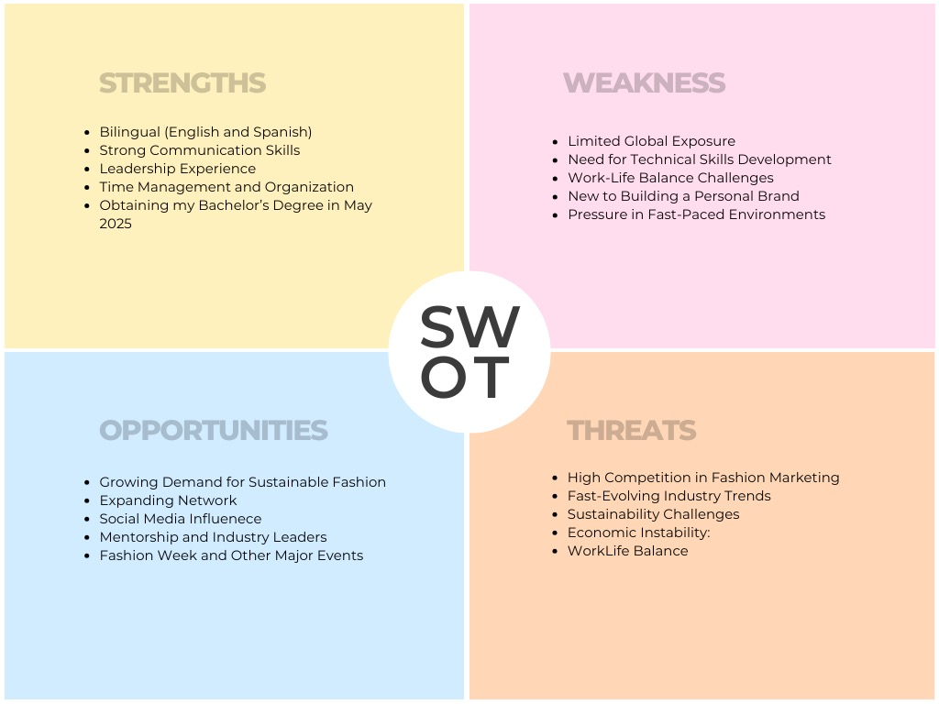

**References:**

Bell, J., & Ternus, K. (2017). Design Elements-The Tools. In Silent selling: Best practices and effective strategies in visual merchandising (5th ed., p. 47). Bloomsbury Academic & Professional.

Choi, S., & Taylor, C. (2014). The Role of Fonts in Brand Perception. Journal of Brand Management, 21(3), 169-183. doi:10.1057/bm.2014.23

Color Psychology. (2024). The Psychology of Color in Branding and Marketing. Retrieved from ColorPsychology.org

Elliott, A. J., & Maier, M. A. (2014). Color Psychology: Effects of Perceiving Color on Psychological Functioning in Humans. Annual Review of Psychology, 65(1), 95-120. doi:10.1146/annurev-psych-010213-115035