**EcoFabri**

Jailine Collado and Leah Newell

New York City College of Technology

| **Table of Contents**  **Meet the Team**3  1.1 Leah Newell: Co-CEO & Co-Founder…………………………………………...3  1.2 Jailine Collado: Co-CEO & Co-Founder………………………………………...5  **About EcoFabri**……………………………………………………………….7  2.1 Get to Know EcoFabri………………………………………………………...7  2.2 EcoFabri: The App…………………………………………………………..…..8  **Problems in the Fashion Industry**…………………………………………………12  3.4 Target Market Analysis…………………………………………………………..16  3.5 Global Market…………………………………………………………………....18  **Competitor Analysis**………………………………………………………………..20  4.1 Quality Assurance……………………………………………………………….21  **Cost Sheet Production**……………………………………………………………...22  **References**……………………………………………………………………..25 |
| --- |

**Meet the Team**

**CO-CEO & CO-Founder**

Leah Newell is a native of Queens, New York, who grew up amidst the city’s vibrant energy. She is one of two children born to her parents. Her educational journey has taken her to New York City College of Technology, where she diligently works to earn her bachelor's degree in Business and Technology of Fashion. Before this, Leah spent her initial two years at SUNY Delhi, where she successfully obtained her associate degree in liberal arts, laying the foundation for her future endeavors. The fashion world has always captivated Leah’s heart; her dream of becoming a model has driven her life. From a young age, she exhibited a strong affinity for fashion, and a pivotal moment occurred when she received a fashion kit set that allowed her to design exquisite outfits. This early exposure ignited her deep passion for the fashion industry. Additionally, Leah inherited a love for art from her mother, which has allowed her to explore her artistic talents in numerous ways. At 15, she had the chance to participate in a summer youth job program called Groundswell, where she collaborated with others to create a stunning mural behind an elementary school.

EcoFabri holds a special place in my heart, not just as an eco-friendly brand but as a beacon of hope for sustainable living and environmental consciousness. The inspiration to start this company stemmed from witnessing the alarming levels of waste generated by the fashion and textile industries, coupled with the pressing need for innovative solutions to address the housing crisis and promote sustainability. EcoFabri's mission is deeply rooted in promoting sustainability and reducing waste. We aim to revolutionize. Utilizing discarded fabric to build homes addresses the environmental concerns associated with fast fashion waste and provides a tangible solution to housing shortages.

**CO-CEO & CO-Founder** 

In the vibrant streets of the Bronx, a resilient girl named Jailine Collado navigated the challenge of being the youngest in a family of four children raised by parents who immigrated from the Dominican Republic. Amidst adversities, she discovered her passion for fashion, a journey that unfolded against the colorful backdrop of the Bronx. Inspired by her mother and grandmother, she learned the art of sewing, observing their nimble fingers weave magic through the fabric. Her mother, a trailblazer who had paved the way for the families’ creative endeavors, became her guiding light. Determined to transcend limitations, the girl honed her craft in the rhythmic heartbeat of the Bronx, transforming adversity into a tapestry of creativity and self-discovery. Jailine Collado is a New York City College of Technology senior majoring in business and fashion technology. Jailine hopes to further her career in the fashion industry as a creative director for editorial fashion magazines. Until then, Jailine continues mastering skills like sewing, crocheting, and networking with different individuals and companies in the industry.

EcoFabri is not just a company to me but a beacon of hope and sustainability. In a community grappling with challenges, EcoFabri transforms discarded water bottles into homes, addressing the homelessness crisis in America with ingenuity. Witnessing my surroundings, where every resource matters, the idea of repurposing donated garments and fabric into beautiful tiles resonates deeply. This addresses landfill waste and underscores the importance of reducing our carbon footprint. The prolonged decomposition time of clothes is a stark reality. EcoFabri’s commitment to repurposing contributes significantly to environmental well-being while simultaneously providing a glimmer of optimism for those seeking shelter.

**EcoFabri: Get to Know Us**

A green company uses old fabrics to make houses, reducing waste in the fabric industry and creating eco-friendly homes. The brand will reduce environmental harm and make housing more sustainable by reducing waste in the fabric industry and making eco-friendly homes. The fashion industry has big problems like too much waste and clothes that do not break down quickly. To fix these issues, we can promote eco-friendly fashion by using recycled fabrics, reducing waste, and encouraging people to buy fewer but better clothes. Renting clothes and buying secondhand can also help people make more eco-friendly choices. We support projects that use old materials to build new homes and solve the housing problem. By using fashion waste to build houses, we are helping the environment and finding a sustainable solution to the housing shortage.

The EcoFabri donation box will be created from different green materials to last long and care for the earth. Plastics like high-density polyethylene from customer trash will be used to shape the central part. Old wood from thrown-away pallets will build a solid foundation. Bamboo, a quickly renewable stuff, will fill in other parts. Reusing metals for key bits such as hinges and supports will make the whole thing rot away instead of standard paint. These substances are set to keep these boxes strong, which matches its Earth-loving aim.

**EcoFabri: The App**

Welcome to EcoFabri. We make Earth-friendly homes using recycled fabrics and encourage environmental care. EcoFabri changes living spaces and helps the Earth. We make sustainable homes from old fabrics and change living spaces with clever designs and reused materials. Our EcoFabri app works on all mobile devices.

EcoFabri cares about working with communities and teaming up. We made a website where people can join by giving us their old plastic bottles. We turn these into bricks for houses that are good for the earth. Buyers get points for each bottle they give, which they can use to get rewards like discounts, cool things, or donations to charity. Doing this will make people keep helping us and build good relationships with them. Our group is dedicated to taking old clothes from the trash or getting clothes people give us and turning them into tiles for houses. This cuts down on trash and makes the homes of people in need look better.

We will change things and build a better future together. Our site helps you know our mission, see the creative designers, and join community projects. With EcoFabri, we can make a greener world together.

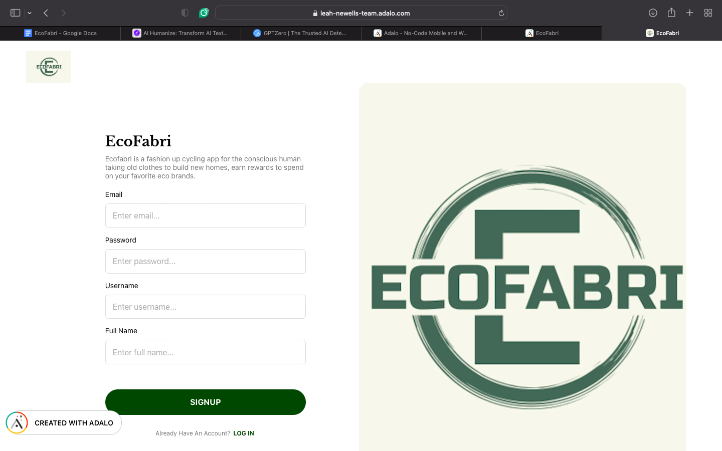

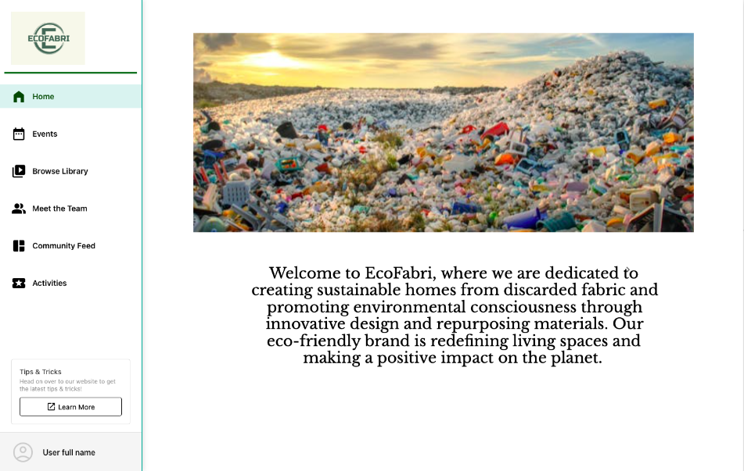

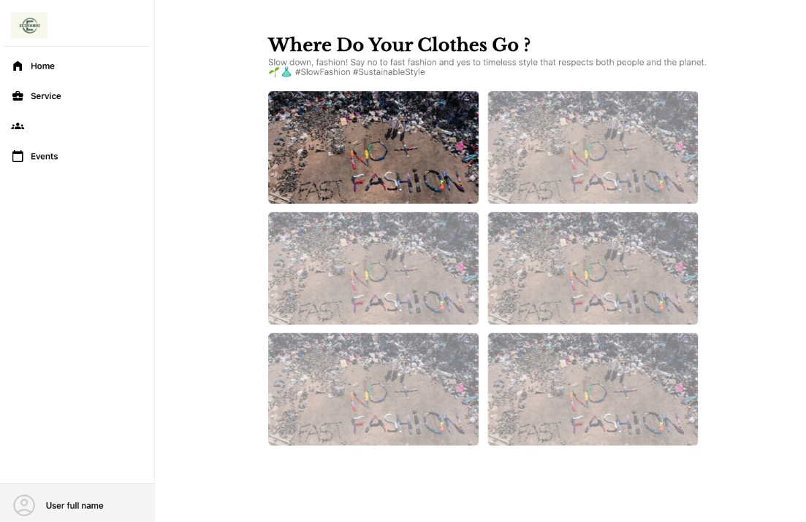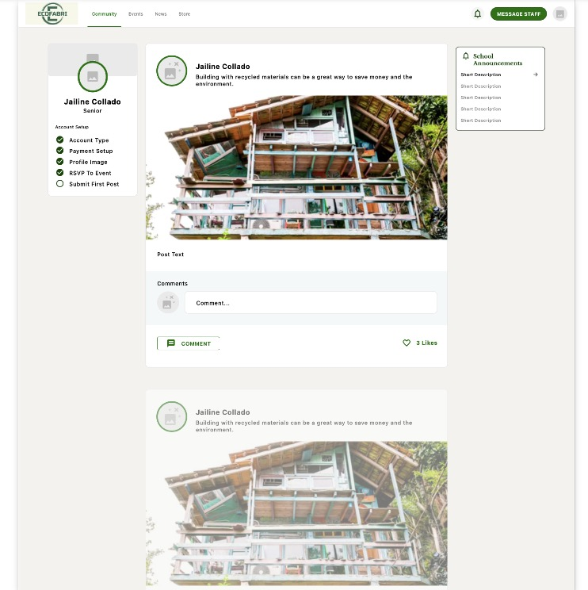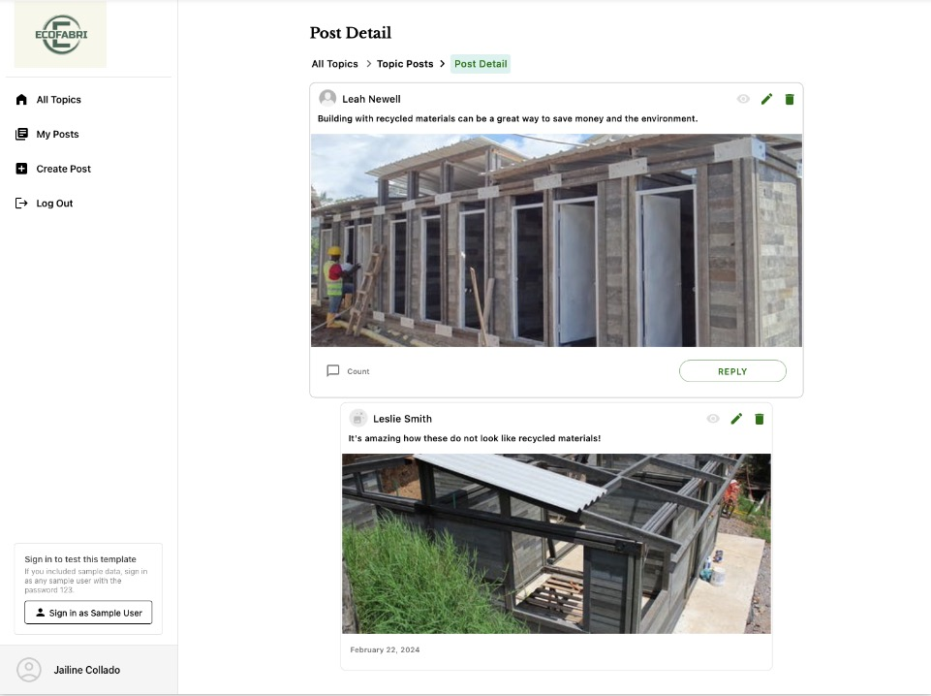

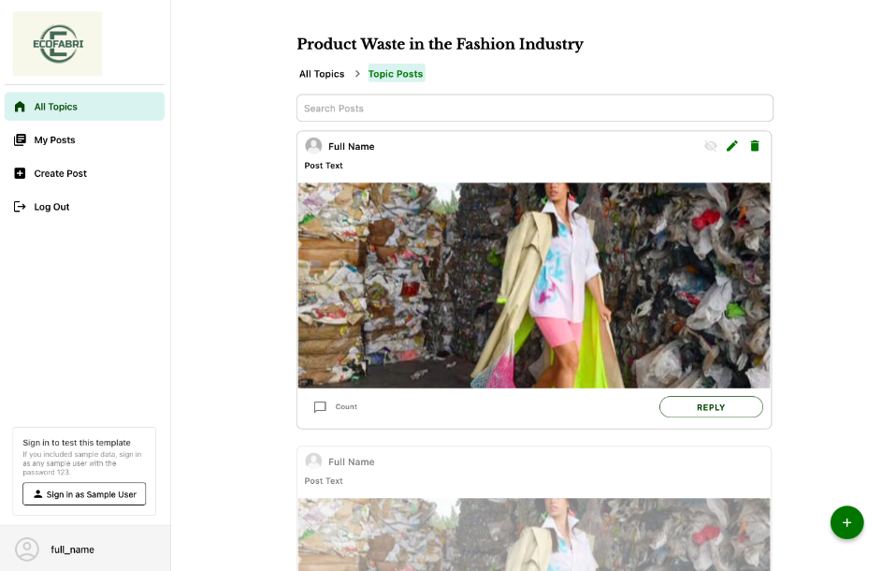

**Problems in the Fashion Industry**

Much trash, like plastic bottles and clothes from fast fashion, is a big issue for landfills. Plastic bottles, mainly made of non-biodegradable materials like PET (polyethylene terephthalate), take many years to break down and cause much pollution. Fast fashion worsens this with fast clothes production, which leads to a lot of textile waste and uses up many resources. These industries harm the environment and encourage a cycle of using and throwing away that is not good for the balance.

Quick fashion is a big problem in fashion. It affects the environment, how workers are treated, and how people buy clothes. Quick fashion works by making many clothes quickly, cheaply, and always having new ones. This causes big problems for the environment. Clothes last only a short time and are made from materials that do not go away quickly, so they cause a lot of waste and pollution. One study shows that this 'throwaway' fashion makes much trash and uses many resources (Kaikobad et al., 2015). Fast fashion affects how people work. In struggling countries, workers face bad conditions and low pay. The need to make things quickly and cheaply leads to worse treatment of workers. A study shows that fast and cheap clothes demand keeps workers poor and mistreated (Linden, 2016). Fast fashion also changes how people buy. Cheap clothes make people buy more without valuing what they have. This behavior adds to the issue of too much waste from clothes (Garcia-Torres, 2017).

An approach is needed to address the issues arising from fast fashion, which includes industry-wide changes in terms of sustainability. Studies suggest that stricter environmental regulations and new business models focusing on sustainability should be introduced to motivate customers to embrace more environmentally friendly consumption (Centobelli et al., 2022.) Environmental risks, exploitation of workers, and promotion of unsustainable consumer behavior are challenges faced by the fashion industry. However, actions can be taken to lessen these problems and move towards a more sustainable fashion industry; EcoFabri will combat this issue by repurposing and reusing discarded or donated garments.

The decomposition of clothing in landfills differs from material to material. Still, the process takes place slowly due to anaerobic oxygen conditions usually found in landfills—clothing from natural fibers such as cotton, linen, and wool breaks down more quickly than synthetic materials. Nevertheless, even organic materials are slowly broken down by landfill anaerobic conditions. Based on environmental factors such as moisture and landfill management practices, millions of clothing waste are dumped in landfills yearly; natural fibers can decompose under these conditions for up to five years (Gupta & Saini, 2020). Synthetic fibers, such as polyester and nylon, are made from petroleum, which can take decades or hundreds of years to degrade and go to landfills. The anaerobic conditions are exacerbating the slow decomposition of organic matter, which is slowed considerably by bacterial processes that generally break it up (Aishwariya & Jaisri, 2020). Due to its thick, rigid fabric structure, which prevents breakdown, denim is usually manufactured from cotton and decomposes significantly more slowly. If the denim is dyed or finished with chemical substances, its decomposition period will be further prolonged. Denim can take a few decades in the landfill to decay completely. The slow rate is mainly due to the lack of oxygen and the low microbial activity in most landfill sites (Juanga-Labayen, 2022).

Clothes take a long time to break down and can cause space and environmental worries in landfills. When clothes break down, they release methane, a potent greenhouse gas, and leak chemicals into local soil and water. Also, the process can release dyes and chemicals, putting local plants and animals in danger (Moazzem, 2021). To lessen the impact of the fashion world on the environment and back sustainability, an active approach is making tiles from old jeans or thrown-away clothes. This new way of recycling changes trash clothes into valuable tiles, stopping lots of fabric from going into landfills where they would add to methane and other pollutants because they break down so slowly. Transforming clothes into tiles helps by reusing stuff. This cuts the need for new resources and eases pressure on the environment. Using old fabrics to create tiles also cuts pollution from raw materials. The fashion industry could use this to cut waste and promote new sustainable ideas. This would lead to more sustainable methods and materials being used. Tiles made from old fabrics hold heat and cut noise, adding worth to sustainable building materials and creating new opportunities.

Plastic bottles can take a very long time to break apart in landfills with little light, air, and other things needed for breaking down. Studies show plastic bottles need over 500 years to break down in dumps. This long life is because of the robust nature of the plastics used, like PET, made to last and resist breaking down in the environment (Babaremu et al., 2022). Using plastic bottles again to make building stuff is a good choice. This is because of the significant environmental impact and the long time plastic waste takes to break down. Making eco-friendly building stuff like house bricks from recycled plastic bottles is a smart way to use them. These reused materials help decrease dump waste and provide a cheap, energy-saving option for building, which is also good for the environment.

​​ Studies have been carried out to demonstrate that it is possible to reduce the total environmental impact, decreasing the consumption of virgin raw materials and reducing the carbon footprint of construction projects by integrating crushable polyethylene terephthalate bottles and plastic waste in building material (Silva et al., 2021). To ensure safety, the effectiveness of using recycled plastic bottles in construction depends on several factors, including the treatment of plastic waste, the mixing ratio of composite materials, and adherence to building standards.

In conclusion, Reusing plastic bottles for bricks is suitable for many reasons: - Helps nature: Stops plastic in landfills and less need for new stuff - Keeps heat in: Plastic is suitable for holding warmth, helps save energy - Saves money: Using old stuff cuts building costs. Making bricks from plastic helps stop waste and backs eco-friendly buildings. These moves aim to use things wisely and cut waste, fitting with circular economy ideas.

**Target Market Analysis**

The new EcoFabri app helps with sustainable problems, fast clothing, and too much trash by rewarding people for recycling plastic bottles. They can then use the points they earn to get discounts at eco-friendly stores. This plan does not just say we should care for the earth; it also gets folks to participate. EcoFabri aims at folks who care about the earth. They know about the earth's problems and want to help. EcoFabri might make this group want to do more to help the earth by making recycling simple.

Demographic:

EcoFabri focuses on young adults or middle-aged individuals, ranging from late teens to mid-40s. This group is good with technology and cares about social and environmental issues. Millennials like eco-friendly brands that can help promote EcoFabri’s app online. People who care about the environment and social problems will be interested in this company. We include all genders potentially leaning towards females as they often engage more sustainably and ethically choices. They are likely middle to upper middle class as they have more disposable income to spend on sustainable products and brands and individuals with higher education levels. They care about society and like sustainable products. They want to make society better and are active on social media. They join community events and support projects that help with social and environmental problems. Overflowing landfills and environmental damage keep affecting city dwellers. They want to keep their cities clean and healthy. The EcoFabris app could help. It offers simple solutions for handling trash in towns. People who like being part of their community can get involved. EcoFabri lets them join others and work for a better environment. The app's community-based style can attract those who want to work with neighbors and local businesses to achieve shared environmental goals.

Psychographic:

These individuals emphasize environmental sustainability, social responsibility, and reducing waste. They are also likely to lead a conscious and mindful lifestyle, making choices that align with their values, including purchasing eco-friendly products and supporting ethical brands with a positive attitude towards recycling and reducing consumption. They are interested in environmental activism, sustainable fashion, and ethical consumerism.

Geographic:

Urban and suburban areas are often home to a higher concentration of environmentally conscious individuals who are more willing to engage in recycling and sustainable practices.

Behavioral:

EcoFabri's prizes may attract shoppers who like eco-shops or care about green items. Offers of coupons and deals at green stores for recycling could match their habits and beliefs, making them good app users. Schools with green programs could be good places to discuss EcoFabri’s app. Students and educators keen on green ideas could promote the app, using it in school projects and campus plans to stay green. EcoFabri uses tech to recycle and build community. It can attract tech-savvy people who can test, improve, and spread the app through tech networks. Green volunteers and activists may also use the app for their environmental work, expanding their impact. We will likely attract individuals who participate in recycling programs and initiatives and individuals willing to donate plastic bottles and clothing to combat landfill waste.

The EcoFabri app is where tech, people, and eco meet. EcoFabri can promote its app well by aiming at green-minded buyers, young adults, city people, community-focused folks, eco shoppers, schools, tech fans, and helpers. Each group has its strengths and can help spread the app. This can make a green, active group that wants less waste and better nature.

**Global Market:**

EcoFabri is a business focused on helping the planet and people. It is a shining light of hope. To deal with environmental and social problems at the same time, EcoFabri has started a new plan. They are using hi-tech bins for donations. These bins are a prominent spot in the city. They lead to a better future. Each bin has a keypad. People can put their phone numbers on it. This sets up a system to count points for each water bottle given. These points help to make eco-friendly homes.

Furthermore, the EcoFabri plan goes beyond just giving. To address the impact of fabric waste on nature, the company has made a space in the donation bins for clothes and fabrics. It takes up to 200 years for fabrics to break down in landfills. As of 2018, around 14.7% of fabric waste in the U.S. was reused, which is about 2.5 million tons. Also, more than 11 million tons of fabric waste ended up in landfills, almost 8% of all trash buried that year (RoadRunner, 2024). These materials are often disregarded, so they are used to make tiles for eco-friendly buildings. This fresh approach reduces landfill waste and encourages community participation by including people in the building process. The value of EcoFabri's donation bin goes beyond just giving; it shows a complete approach to tackling society's issues. By rewarding donations with points and recycling fabric waste, EcoFabri supports environmental conservation. Working with green organizations, recycling programs, and Environmentally Friendly Construction Companies could be necessary to create a project that uses technology and community participation to make meaningful solutions. Using technology and community involvement, EcoFabri has set out to make a more equal and greener future for New York City.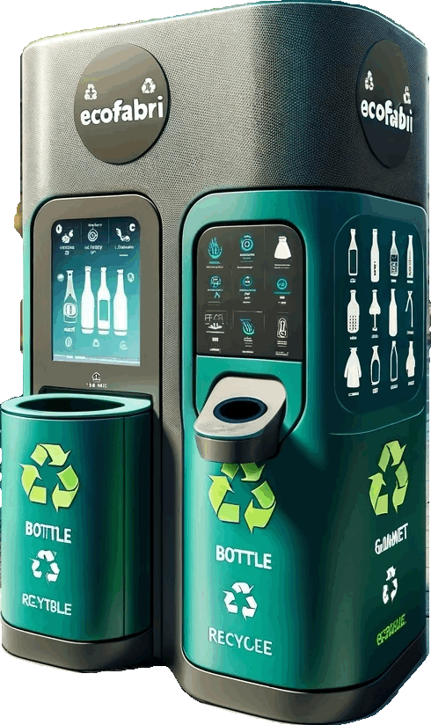

***Prototype of EcoFabri donation bin***

**Competitor Analysis**

| **Competitors** | **Product** | **Price** | **Quality** | **Service** |
| --- | --- | --- | --- | --- |
|  | **Strength:**   * Combating two issues in 1: Homeless and Garment waste   **Weakness:**   * How durable the tiles are and their longevity * Keeping the customers motivated by the loyalty points system | * Donation-based | How do they ensure that standards are met?   * Customer feedback and engagement metric to ensure its effectiveness | Using discarded fabric to recreate and build homes promotes sustainability by repurposing materials, reducing waste in the textile industry, and contributing to constructing environmentally conscious living spaces. |
|  | **Strength:**   * leader in material science innovation- recyclable and bio-based plastics * Strong global presence allowing efficient distribution and diverse market penetration   **Weakness:**   * Production processes that are energy-intensive and contribute to pollution. | * vary based on product type, market demand, and the cost of raw materials, such as crude oil, which is a primary input for many of their products | * Stringent quality control measures across all stages of production. | * Provides extensive support services to clients, helping them to select the suitable materials for specific applications |
|  | **Strengths:**   * Strong focus on sustainable sourcing * Aiming for 100% of materials and ingredients to be bio-based or recycled   **Weakness:**   * Complexity and cost of achieving zero waste | * Recycled and post-consumer materials | * Rigorous standards * Transparent reporting * Advocacy for ingredient disclosure * Leverage certifications | Has a goal to use 100% biobased or post-consumer recycled material for their products and packaging, striving to become a zero waste company. |

**Quality Assurance**

Quality assurance testing ensures that products meet specified standards and requirements. We can verify quality, safety, and compliance with regulations, helping to maintain customer satisfaction. Some quality assurance tests for the EcoFabris donation bin with the knowledge of include evaluating the durability of the materials used in the donation bin. A weather resistance test is performed by exposing the donation bin materials to simulated sunlight using ASTM D4329-21 to evaluate their resistance to light, heat, and moisture. Conduct ASTM D695-23 to test methods for the compressive properties of rigid plastics and evaluate their compressive strength and resistance (ASTM, 2024).

**Cost Sheet Production**

|  | | |  | | | DESCRIPTION: Technologically advanced donation bin | | | | **Style#:**  Delivery**:** | | |
| --- | --- | --- | --- | --- | --- | --- | --- | --- | --- | --- | --- | --- |
| TEXTILE: n/a | | | |  | | |
| COST SHEET-PRODUCTION | | | | | | | | | | | | |
|  |  | | | |  | | | |  | | | |
| COO | United States of America | | | |  | | | |  | | | |
| min |  | | | |  | | | |  | | | |
| textile |  | | | |  | | | |  | | | |
| HTS |  | | | |  | | | |  | | | |
| TD target | 40% / 60% | | | |  | | | |  | | | |
|  | q'nty | per unit | unit | prelim | q'nty | per unit | unit | alter-native | q'nty | per unit | unit | FINAL |
| **materials** |  |  |  | $0.00 |  |  |  | $0.00 |  |  |  | $0.00 |
| Aluminum |  |  |  | $0.00 |  |  |  | $0.00 | 1,0000 | 150 | 150 | $150,00000 |
| Steel |  |  |  | $0.00 |  |  |  | $0.00 | 1,0000 | 270 | 270 | $270,0000 |
| Silver |  |  |  | $0.00 |  |  |  | $0.00 | 1,0000 | 200 | 200 | $2000000.00 |
| Magnets |  |  |  | $0.00 |  |  |  | $0.00 | 10,0000 | 1 | 1 | $10000.00 |
| Epoxy |  |  |  | $0.00 |  |  |  | $0.00 | 1000 | 2 | 2 | $2000.00 |
|  |  |  |  | $0.00 |  |  |  | $0.00 |  |  |  | $0.00 |
|  |  |  |  | $0.00 |  |  |  | $0.00 |  |  |  | $0.00 |
| **packaging** |  |  |  | $0.00 |  |  |  | $0.00 |  |  |  | $0.00 |
|  |  |  |  | $0.00 |  |  |  | $0.00 |  |  |  | $0.00 |
|  |  |  |  | $0.00 |  |  |  | $0.00 |  |  |  | $0.00 |
|  |  |  |  | $0.00 |  |  |  | $0.00 |  |  |  | $0.00 |
|  |  |  |  | $0.00 |  |  |  | $0.00 |  |  |  | $0.00 |
|  |  |  |  | $0.00 |  |  |  | $0.00 |  |  |  | $0.00 |
| **labor** |  |  | SAM | $0.00 |  |  | SAM | $0.00 |  |  | SAM | $0.00 |
| **total** |  |  |  | **$0.00** |  |  |  | **$0.00** |  |  |  | **$0.00** |
| com-mission % |  |  |  | $0.00 |  |  |  | $0.00 |  |  |  | $0.00 |
| duty % |  |  |  | $0.00 |  |  |  | $0.00 |  |  |  | $0.00 |
| shipping |  |  | pc | $0.00 |  |  | pc | $0.00 |  |  | pc | $0.00 |
| **total CoG** |  |  |  | **$0.00** |  |  |  | **$0.00** |  |  |  | **$0.00** |
| wholesale mark up |  | 50.00% |  | $0.00 |  | 50.00% |  | $0.00 |  | 50.00% |  | $0.00 |
| wholesale price |  |  |  | $0.00 |  |  |  | $0.00 |  |  |  | $0.00 |
| trade discount % |  |  |  |  |  |  |  |  |  |  |  |  |
| **list price** |  |  |  |  |  |  |  |  |  |  |  |  |
|  | | | | | | | | | | | | |

| **Description** | **Style/Delivery** | **Final** |
| --- | --- | --- |
| Per bin based on recycled materials | Bin Manufacturing | $500- $1000 |
| Transportation and labor for setup per bin | Bin Installation | $200 |
| Monthly per bin | Bin Maintenance | $100 |
| Transportation cost per bin per month | Logistics | $75 |
| Hourly wage, 10 hours weekly per bin | Sorting and Processing Labor | $800 |
| Cost for 10 cubic yards per home | Cement for Building Homes | $1500 |
| Hourly wage, total 400 hours per home | Construction Labor | $8000-$12000 |
| Processing and modification per home | Integration of Recycled Materials | $3000 |
| Cost per pound of clothing, 2000 pounds | Material Processing for Tiles | $1000 |
| Labor and machinery per bin of tiles | Manufacturing Tiles | $5000 |
| The monthly cost for staffing | Project Management and Administration | $10,000 |
| Month cost for activities | Marketing and Community Engagement | $2000 |

**References**

Aishwariya, S., & Jaisri, M.J. (2020). "Harmful Effects of Textile Wastes." *ResearchGate*.(<https://www.researchgate.net/profile/Dr-Aishwariya/publication/342625358_Harmful_effects_of_textile_waste/links/5f093c43299bf18816128492/Harmful-effects-of-textile-waste.pdf>).

ASTM International - Standards Worldwide. (2024, May 5). <https://www.astm.org/>

Babaremu, K.O., Okoya, S.A., Hughes, E., Tijani, B., Teidi, D., et al. (2022). "Sustainable plastic waste management in a circular economy." *Heliyon*. (<https://www.cell.com/heliyon/pdf/S2405-8440(22)01272-5.pdf>).

*Build an eco-friendly house from plastic bottles*. DIY projects for everyone! (2023, October 5). https://diyprojects.ideas2live4.com/2015/10/02/how-to-build-a-house-using-plastic-bottles/

Centobelli, P., Abbate, S., Nadeem, S.P., et al. "Slowing the fast fashion industry: An all-round perspective." Current Opinion in Green and Sustainable Chemistry. 2022. (<https://www.sciencedirect.com/science/article/pii/S2452223622000967>).

Garcia-Torres, S., Rey-Garcia, M., Albareda-Vivo, L. "Effective disclosure in the fast-fashion industry: From sustainability reporting to action." Sustainability. 2017. (<https://www.mdpi.com/2071-1050/9/12/2256>).

Gupta, L., & Saini, H.K. (2020). "Achieving sustainability through zero waste fashion-A review." *Current World Environment*.(<https://www.a-i-l-s-a.com/pdf/vol15no2/CWE_Vol15_No2_p_154-162.pdf>).

*HUD releases 2023 Annual Homeless Assessment Report*. National Low Income Housing Coalition. (2023, December 18). https://nlihc.org/resource/hud-releases-2023-annual-homeless-assessment-report#:~:text=HUD%20released%20on%20December%2015,70%2C650%20more%20people)%20from%202022.

Kaikobad, N.K., Bhuiyan, M.Z.A., Sultana, F., et al. "Fast fashion: Marketing, recycling, and environmental issues." International Journal of Environmental Research and Public Health. 2015. (<https://www.academia.edu/download/54982045/E0472028033.pdf>).

*The environmental crisis caused by textile waste*. RoadRunner Modern Waste + Recycling. (2024, March 9). https://www.roadrunnerwm.com/blog/textile-waste-environmental-crisis#:~:text=Textiles%20can%20take%20up%20to%20200%2B%20years%20to%20decompose%20in%20landfills

*Journey to a more sustainable, Equitable Planet: Seventh Generation’s 2025 goals*. Seventh Generation. (2018, November 7). https://www.seventhgeneration.com/blog/journey-more-sustainable-equitable-planet-seventh-generations-2025-goals

Juanga-Labayen, J.P., Labayen, I.V., & Yuan, Q. (2022). "A review on textile recycling practices and challenges." *Textiles*. (<https://www.mdpi.com/2673-7248/2/1/10>).

Linden, A.R. "An analysis of the fast fashion industry." 2016. Bard College. (<https://digitalcommons.bard.edu/cgi/viewcontent.cgi?article=1033&context=senproj_f2016>).

Moazzem, S., Wang, L., Daver, F., & Crossin, E. (2021). "Environmental impact of discarded apparel landfilling and recycling." *Resources, Conservation and Recycling*.(<https://www.sciencedirect.com/science/article/pii/S0921344920306534>).

Olukoya, S. (2011, November 9). *Nigeria’s plastic bottle house*. BBC News. https://www.bbc.com/news/world-africa-14722179

*Our impact*. Seventh Generation. (2024, March 10). https://www.seventhgeneration.com/company/goals-impact

Silva, T.R. da, Azevedo, A.R.G. de, Cecchin, D., Marvila, M.T., et al. (2021). "Application of plastic wastes in construction materials: A review using the concept of life-cycle assessment." *Materials*. (<https://www.mdpi.com/1996-1944/14/13/3549>).

*Sustainability*. H&M Group. (2023, December 14). https://hmgroup.com/sustainability/

*Sustainability*. H&M. (2024, March 10). https://www2.hm.com/en_us/sustainability-at-hm.html

Thornton, C. (2023, December 15). *The number of homeless people in America grew in 2023 as high cost of living took a toll*. USA Today. https://www.usatoday.com/story/news/nation/2023/12/15/homelessness-in-america-grew-2023/71926354007/

Your old clothes could become construction materials for your house ... (2018, December 4). https://www.technology.org/2018/12/04/your-old-clothes-could-become-construction-materials-for-your-house/