Motion Gear
Group 5
Jailine Collado, Ritchy Isaac, Lisette Mercedes
Table of Contents
Abstract…………………………………...………………………………………3

Meet The Team
1.1 Jailine Collado-Co-Founder & COO ………………………………….……………4
1.2 Ritchy Isaac Co-Founder & CEO………………………………………………...…6
1.3 Lisette Mercedes Co-Founder & CFO ………………………………………….….7

VALS & Target Customer
2.1 Demographic…………………………………………………………………….. 9
2.2 Geographic……………………………………………………………………..…11
2.3 Psychographic………………………………………………………………….…13
2.4 Behavioral………………………………………………………………………..15

Motion Gear: Store Information
3.1 Seasonal Colors ………………………………………………………………….18
3.2 Fabric Swatches………………………………………………………………24
3.3 Manufacturing Process……………………………………………………….27
3.4 Inventory/ SKU Illustration…………………………………………………..31
3.5 Drawings/Designs…………………………………………………………..…37
3.6 Store Front & Store layout……………………………...……………...…….49

Part B:
4.1 B1-B4……………………………………………………………………..50-53

References……………………………………………………….………………54
Abstract
Embark on a journey through Utah’s breathtaking landscapes with our premier hiking store. As avid outdoor enthusiasts, we understand the thrill of traversing rugged terrains and the importance of reliable gear. Our store offers a comprehensive selection of top-quality equipment, from durable hiking boots to lightweight backpacks, ensuring you’re fully equipped for any adventure. Discover the beauty of Utah's diverse terrain, from the iconic red rock formations of Arches National Park to the towering peaks of the Wasatch range. Whether you’re a seasoned hiker or a novice explorer, our knowledgeable staff is here to provide expert advice and recommendations tailored to your experience level and preferences.At our store, we prioritize sustainability and environmental stewardship. We offer eco-friendly gear options and promote leave-no-trace principles to preserve Utah’s wilderness for future generations. Additionally, we support local artisans and brands, showcasing Utah’s rich outdoor culture and craftsmanship.

Motion Gear is a premier destination for outdoor enthusiasts seeking top-quality hiking apparel and gear. Nestled in the heart of a vibrant outdoor community, our store caters to adventures of all skill levels, providing a carefully curated selection of performance-driven clothing and equipment. From moisture-wicking base layers to durable outerwear, our collection is designed to withstand the rigors of the trail while keeping our customers comfortable and protected in any environment. With a commitment to sustainability and environmental stewardship, Motion Gear offers eco-friendly options that minimize our impact on the planet without compromising performance. Whether embarking on a day hike or a multi-day expedition, our knowledgeable staff is dedicated to helping customers find the perfect gear to enhance their outdoor experience. Join us at Motion Gear and let your next adventure begin.
Meet The Team
Co-Founder and COO

Jailine Collado
In the vibrant streets of the Bronx, a resilient girl by the name of Jailine Collado navigated the challenge of being the youngest in a family of four children, raised by parents who immigrated from the Dominican Republic. Amidst adversities, she discovered her passion for fashion, a journey that unfolded against the colorful backdrop of the Bronx. Inspired by her mother and grandmother, she learned the art of sewing, observing their nimble fingers weave magic through the fabric. Her mother, a trailblazer who had paved the way for the families’ creative endeavors, became her guiding light. Determined to transcend limitations, the girl honed her craft in the rhythmic heartbeat of the Bronx, transforming adversity into a tapestry of creativity and self-discovery. Jailine Collado is a Senior at New York City College of Technology majoring in Business and Technology of Fashion. Jailine hopes to further her career in the Fashion Industry as a creative director in editorial fashion magazines. Until then, Jailine continues mastering skills like sewing, crocheting, and networking with different individuals and companies in the industry.
Jailine serves as the Chief Operating Officer (COO) of Motion Gear, where she is instrumental in overseeing the day-to-day administrative and operational functions of the company. In her role, she ensures that operations such as production, procurement, and logistics run smoothly and efficiently, embodying the strategic plans developed alongside the CEO and other top executives. Jailine manages a team of department heads, including those in human resources, finance, and operations, fostering effective collaboration to meet Motion Gear's business objectives. She diligently monitors key performance indicators, guiding the organization toward achieving its financial and operational goals through meticulous performance management. Committed to continual improvement, Jailine is always on the lookout for ways to enhance processes and incorporate new technologies that increase organizational effectiveness. Additionally, she plays a vital role in external communications, skillfully representing Motion Gear in major negotiations and acting as a liaison with investors, suppliers, and customers. Jailine also takes on the responsibility of managing risks and overseeing resource allocation, which includes budgeting and capital investments. Beyond her operational duties, she acts as a mentor within Motion Gear, helping to cultivate a positive corporate culture and nurturing the development of its future leaders.

Ritchy Isaac
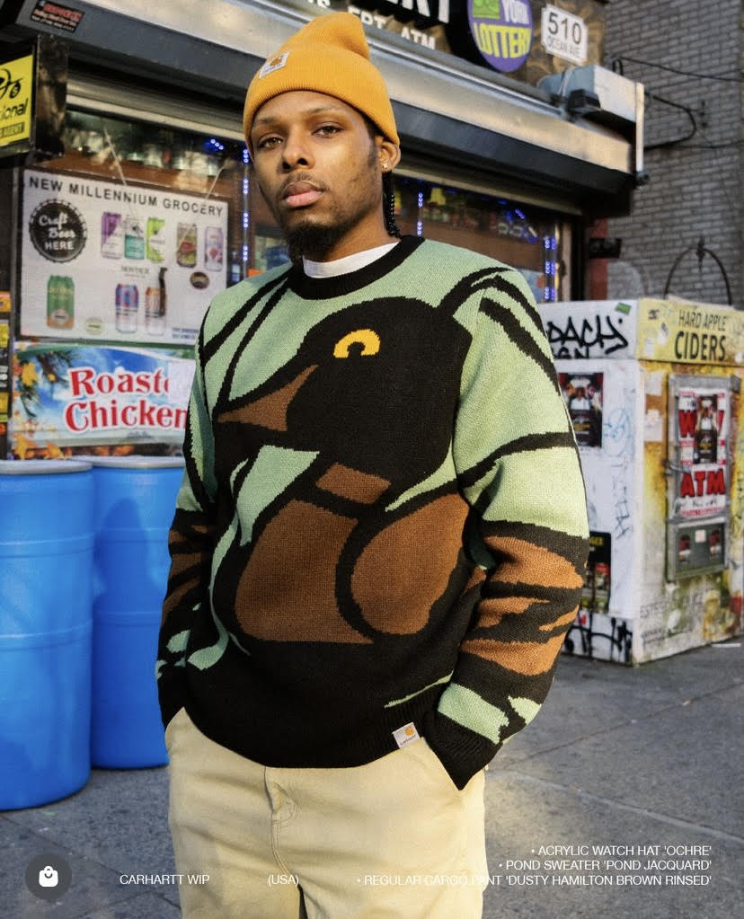
Co-Founder and CEO
I’m Ritchy Isaac, a current student at New York City College of Technology studying Business and Technology of Fashion, and the Co-Founder and CEO of Motion Gear. Growing up in Flatbush, Brooklyn, I dreamed of becoming an architect or an apparel designer while drawing inspiration from maps, floor planning, interior design, history, music, and fashion in pop culture. Learning how to sew as a teen was his introduction to handmade design. I currently specialize in denim garment reconstruction, patchwork, and embroidery. These dreams connect me with my current education path because they help fuel different ways for him to engage with new people, find more purpose in endeavors through entrepreneurship, and help him see endless opportunities for himself in the design world.
As the CEO of Motion Gear, I am responsible for establishing company brand representation, professional appearance, and strong cultural presence. As the person in charge of relations, I must coordinate meetings with managers, potential stakeholders, and investors to ensure a smooth flow of company operations. The organization must first seek our (the co-founders) approval before beginning the production of new company merchandise. I will provide strategic directions for marketing and advertising, and motivate employee performance/output.

LISETTE MERCEDES

CO-FOUNDER AND CFO
My name is Lisette Mercedes. I was born and raised in the Dominican Republic. A tropical country with beautiful beaches and sunsets. We have landscapes and nature that inspire me to represent my country in the fashion industry. From a very young age fashion caught my heart. I like to watch movies and shows where women and men are well-dressed and styled. Also, I have a passion for art. When I was very young, I drew landscapes in school and at my house in the Dominican Republic. I always liked fashion and coming to New York awakened my passion for fashion more and more. Additionally, I like to paint too. Also, I like vintage style and the history of arts and architecture. I developed my obsession with arts and architecture from my mom's family side. My grandfather was a carpenter in the Dominican Republic and my uncle also likes art and architecture too. On the other hand, I want to become a visual merchandise director. The reasons why I want to become a visual merchandise director are the cities, nature, and art; they have inspired me to create a better world through fashion and try to make a more just world for humans. In the fashion industry, I love to recreate art pieces using garment materials. Art has become a great inspiration for designers because they get ideas for the patterns and colors from the artworks. from artworks and nature, people get the idea to create colors and silhouettes on the runway. Fashion makes me happy and I believe that fashion makes people creative and express the best of themselves. Also, fashion unites people from different backgrounds and cultures.

Moreover, as a CFO I will be responsible for managing the financial actions of a company, including financial planning, budgeting, and overseeing financial reporting. In my position, I will be developing strategies for managing the company’s finances, including long-term financial planning, budgeting, and forecasting. Ensuring accurate and timely financial reporting to stakeholders, including shareholders, board members, and regulatory authorities. This includes preparing financial statements like balance sheets, income statements, and cash flow statements. Also, identifying and assessing financial risks that could impact the company’s performance or financial health, and implementing strategies to mitigate these risks. Moreover, managing the company’s capital structure, including decisions related to debt and equity financing, dividend policies, and capital expenditure. Overseeing cash flow, liquidity, and investments to ensure the company has adequate funds to meet its obligations and pursue its strategic objectives. Ensuring compliance with financial regulations, accounting standards, and corporate governance requirements and providing financial analysis and insights to support strategic decision-making by the executive team.

VALS & Target Customer

Demographic
In the bustling urban environment of Salt Lake City, a unique demographic emerges as the prime market for an innovative hiking company specializing in high-tech jackets designed to monitor vital health metrics such as water intake, blood pressure, and heart rate. This demographic comprises diverse groups of individuals united by their shared interests in health, technology, and outdoor activities. This delves into the specifics of these target customers, examining their demographic characteristics, lifestyle preferences, and consumption habits. The target demographic spans various age groups, with significant concentrations in the young adult (25-35 years), middle-aged (36-55 years), and active older adult (56-70 years) categories. These individuals typically reside in urban and suburban settings where access to outdoor activities is readily available, and they often have higher education levels, which correlate with heightened health awareness and a propensity to engage with advanced technology. These consumers generally fall within the middle to high-income bracket, enabling them to invest in premium outdoor gear that incorporates the latest technological innovations. A defining feature of the target market is a strong inclination towards maintaining health and wellness. These individuals are not only interested in regular physical activities but are also keen on monitoring their physiological metrics to ensure optimal performance and safety during their outings. This health-conscious approach is complemented by a robust enthusiasm for technology. The demographic includes tech-savvy consumers who are early adopters of new gadgets that can enhance their outdoor experience, offering functional and safety benefits. Eco-consciousness is another critical attribute of this demographic. Consumers within this group are drawn to brands that emphasize sustainability, both in product design and corporate practices. This reflects a broader trend of environmental responsibility, where customers prefer products that are eco-friendly and contribute to sustainable living. This preference influences their purchasing decisions, aligning with a lifestyle that respects and preserves the natural surroundings they frequently enjoy. The social characteristics of these consumers reveal a dynamic and interconnected community. Younger demographics, especially, are active on social media platforms, sharing their outdoor experiences and seeking products that marry functionality with environmental stewardship. Middle-aged and older adults, possessing more disposable income and a mature perspective on health, look for products that offer longevity and reliability. Furthermore, family dynamics also play a role, with many consumers being part of families that value outdoor activities, influencing the next generation of hikers and outdoor enthusiasts. Occupationally, the demographic spans professionals, tech industry workers, healthcare providers, educators, and others whose careers underscore the importance of health, technology, and environmental stewardship. Their educational and professional backgrounds enable a deeper understanding and appreciation for the advanced features of the hiking gear, reinforcing the product's value proposition. The demographic profile of potential customers for innovative hiking gear in Salt Lake City is multifaceted, reflecting a blend of age, professional background, and lifestyle preferences. These consumers are unified by their passion for the outdoors, a commitment to health and wellness, and a keen interest in technological innovations that enhance their outdoor experiences. As awareness of personal health metrics and environmental sustainability continues to grow, so too does the potential market for products that effectively integrate these elements into the hiking and outdoor adventure experience. This demographic's robust engagement with both technology and nature underscores a significant opportunity for hiking companies aiming to introduce innovative, health-monitoring gear into the market.
Geographic

The geographic characteristics of a consumer base can profoundly influence the demand for specific products, especially in industries where the activity is tied to the environment, such as hiking. In Salt Lake City, the local geography uniquely positions it as an ideal market for innovative hiking gear that incorporates health monitoring technologies. This explores the geographic analysis of potential customers for such hiking gear, examining how the local environment and urban characteristics foster a strong market for these high-tech products. Salt Lake City, nestled in the valley with the Wasatch Range to the east and the Oquirrh Mountains to the west, offers an abundance of natural landscapes that are ideal for outdoor activities, particularly hiking (VisitSaltLake, 2024). The proximity of these mountain ranges provides residents with unique access to a variety of hiking trails that can range from easy to highly challenging, accommodating a broad spectrum of hiking enthusiasts. The region’s diverse topography and variable climate conditions demand versatile and durable outdoor gear, making it a fertile market for advanced hiking jackets that monitor health metrics (Paulsen, 2021). The urban layout of Salt Lake City, combined with its proximity to national forests, parks, and wilderness areas, uniquely positions it as a hub for outdoor enthusiasts. (ForestService, 2024). This geographic advantage allows for quick transitions from urban to natural settings, making it convenient for residents to engage in spontaneous or planned hiking activities. The ease of access encourages regular participation in hiking, which increases the demand for specialized gear that can enhance the outdoor experience and provide safety through health monitoring. The population distribution and demographics in Salt Lake City are also influenced by its geography. The city attracts a diverse mix of young professionals, families, and active older adults, many of whom are drawn by the outdoor lifestyle that the city's geography supports (Bartlett, 2022). This demographic diversity contributes to a broad customer base for hiking gear, as different age groups and lifestyle groups seek products that can support their health and enhance their outdoor experiences. Salt Lake City experiences a range of climatic conditions throughout the year, from cold, snowy winters to hot, dry summers (VisitSaltLake, 2024). This variability necessitates outdoor gear that is adaptable to changing conditions. Innovative hiking jackets that can monitor hydration levels, heart rate, and blood pressure become particularly appealing as they provide functional benefits that help hikers manage their health in response to environmental stresses. The climate thus directly influences the demand for multi-functional and durable outdoor gear. The geography of Salt Lake City not only promotes outdoor activities but also fosters an eco-conscious community. Residents who enjoy natural landscapes tend to be more aware of environmental issues and sustainability, which influences their purchasing decisions. Products that are sustainably produced and offer long-term utility without harming the environment align well with the values of this community, enhancing the market potential for innovative hiking gear (White et al, 2024). Lastly, the geographic centrality of Salt Lake City within the mountainous regions of the western United States makes it an accessible market for distributing outdoor gear (Colliers, 2023). Companies can leverage the city as a distribution hub to reach broader markets in the western states, where similar geographic and climatic conditions prevail, expanding the potential customer base beyond the local population. The geographic analysis of Salt Lake City reveals a significant alignment between the city’s environmental features, its urban-to-nature dynamics, and the lifestyles of its residents, all of which contribute to a strong market for innovative hiking gear. Understanding these geographic factors is crucial for outdoor gear companies looking to introduce products that not only meet the functional needs of hikers but also align with the health-conscious and environmentally aware values that are prominent among the residents of this region. By tailoring products to these geographic and consumer specifics, companies can effectively tap into the robust market potential offered by Salt Lake City.
Psychographic
In the evolving landscape of outdoor recreational activities, the introduction of high-tech hiking gear that tracks health metrics represents a confluence of technological innovation and consumer lifestyle trends. We’ll provide a detailed psychographic analysis of the target market for such products, focusing on the motivations, values, and lifestyles that drive their purchasing behaviors. These insights are pivotal for a hiking company based in Salt Lake City, which offers jackets designed to monitor water intake, blood pressure, and heart rate. At the core of the psychographic profile for this target market is a profound commitment to health and wellness. Consumers interested in innovative hiking gear tend to prioritize their physical health and are proactive about managing their well-being. This orientation goes beyond mere participation in outdoor activities to include a keen interest in real-time health monitoring. These consumers use technology as a tool to enhance their understanding of their body’s responses to different environments and stressors, thus integrating health maintenance into their lifestyle choices. Technology enthusiasm significantly shapes the psychographics of these consumers. They are not just passive users of technology but are actively engaged in seeking out and utilizing the latest innovations that can enhance their outdoor experiences. This group is typically early adopters, inclined to explore and embrace new gadgets that promise to improve both the safety and enjoyment of their hiking ventures. Their enthusiasm for technology is tied closely to its functional benefits, particularly those that offer health monitoring and environmental sustainability. Environmental consciousness is another key component of the psychographic profile. This demographic is highly aware of the environmental impact of their activities and the products they consume. They are drawn to companies and products that demonstrate a commitment to sustainability, preferring items that are durable, eco-friendly, and sustainably produced. Their purchasing decisions are influenced by a product’s ability to align with their values of minimizing environmental footprints and promoting a sustainable lifestyle. Adventure-seeking mixed with a focus on safety characterizes this consumer group. They are individuals who enjoy challenging themselves through various outdoor activities and value the role of reliable gear in enhancing their safety and performance. This psychographic trait supports a preference for products that not only withstand the rigors of the outdoors but also provide added safety features through health monitoring, thus allowing them to push their limits with confidence. The target market is also characterized by a strong sense of community and social engagement. These consumers are active participants in both local and online communities related to outdoor activities. They often share their experiences and knowledge, and look for products that can be a topic of discussion within these groups. Social media plays a crucial role in their engagement, providing a platform for them to connect with like-minded individuals, share their adventures, and discuss the latest in hiking gear and technology. Finally, these consumers are value-driven shoppers. They are willing to invest in high-quality, high-priced items that align with their lifestyle and values. Their purchases are considered investments in their health, safety, and environmental beliefs. They seek out products that promise durability and functionality, reflecting a long-term approach to consumerism where quality and alignment with personal values dictate buying decisions. The psychographic profile of potential customers for innovative hiking gear in Salt Lake City illustrates a sophisticated consumer base that integrates technology, health, and environmental consciousness into their outdoor lifestyles. Understanding these psychographic elements helps tailor marketing strategies and product development to meet the nuanced needs of this dynamic group. As the demand for products that encapsulate health monitoring and sustainability continues to grow, tapping into the psychographic traits of this market segment will be crucial for companies aiming to lead in the outdoor recreation industry.
Behavioral
The introduction of innovative hiking gear equipped with health monitoring technology represents a significant evolution in outdoor equipment. Understanding the behavioral patterns of potential customers is essential for successfully marketing these products. We’ll provide a behavioral analysis of the target market for such gear in Salt Lake City, highlighting the key activities, purchasing behaviors, and engagement strategies that define this consumer group. The target customers for innovative hiking gear in Salt Lake City are highly active and regularly engage in outdoor activities, particularly hiking. Their behavioral patterns show a strong preference for integrating technology with physical activity, which aids in health monitoring and enhances outdoor experiences. These consumers value both the adventure and the health benefits of hiking, and they seek products that can support and extend these benefits. Frequent engagement in outdoor activities necessitates gear that is not only functional but also equipped with advanced technology to monitor physiological responses to various environmental challenges. Behaviorally, these consumers are early adopters of technology, particularly when it enhances safety and improves the user experience. They show a keen interest in gadgets and apparel that incorporate the latest advancements in technology, such as GPS, hydration tracking, and vital signs monitoring. This tech-savvy nature drives them to be among the first to try new products, share their experiences with peers, and influence trends within their social and professional circles. Health and wellness are deeply ingrained in the behavioral traits of this consumer segment. They actively seek products that offer health-related functionalities, demonstrating a preference for brands that align with their personal health goals. This includes gear that can monitor heart rate, blood pressure, and water intake—features that enable them to manage and improve their physical well-being actively. Their purchasing decisions are often influenced by the potential of a product to provide health insights that could prevent injuries and improve their overall fitness levels. The behavioral patterns of this demographic also reveal a strong sense of environmental and social responsibility. They prefer to purchase from brands that are committed to sustainability and ethical practices. This behavior is reflective of a broader lifestyle choice that emphasizes eco-friendliness and responsible consumerism. Products that are durable, made from recycled materials, or produced in an environmentally friendly manner are particularly attractive to this group. This target market exhibits high levels of community involvement and social interaction. They are active in local and online hiking communities, participate in group hikes, and often share their experiences on social media platforms. This behavior not only strengthens communal ties but also plays a crucial role in their decision-making processes, as they value recommendations from within their community networks. The social aspect of their behavior extends to participation in events and activities that promote outdoor lifestyles, where they can connect with like-minded individuals. Lastly, the behavioral analysis shows that these consumers have an affinity for premium products and tend to display strong brand loyalty once they identify brands that meet their expectations in terms of quality, functionality, and ethical standards. They are willing to invest in higher-priced items that offer enhanced features, particularly those that combine technology with practical utility. Once satisfied, they become loyal customers who not only repeat purchases but also advocate for the brand within their circles. The behavioral traits of potential customers for innovative hiking gear in Salt Lake City reflect a sophisticated blend of activity-focused, health-conscious, and technology-driven preferences. These behaviors underscore the importance of aligning product offerings with the lifestyle and values of this target market. Understanding these behavioral patterns is crucial for companies aiming to engage effectively with this demographic and succeed in a competitive market. By catering to the specific behaviors and preferences of these consumers, brands can build lasting relationships and drive both market penetration and customer loyalty.

Season Colors
Color plays a crucial role in branding because it can stimulate emotions, convey messages, and create strong associations with a brand. Keeping up with color trends is essential for clothing businesses to remain relevant, attract customers, and stay competitive in the ever-evolving fashion industry. For several reasons, color trends are crucial in the clothing business: colors greatly influence consumer purchasing decisions. Following color trends ensures that clothing businesses offer products that align with current consumer preferences, increasing the likelihood of sales. Staying updated with color trends helps clothing businesses maintain a modern and relevant brand image. It shows that the brand is aware of current fashion trends and is adaptable to changing consumer tastes.

Moreover, the peach fuzz color is the official color of the year. According to Pantone, it is defined as a light pastel color that represents peace and serenity. The color is described as a pale pastel that symbolizes tranquility and peace. The peach fruit inspired the color Peach Fuzz. In addition, in the past, we saw designers inspired by peach colors. This is a color that will be available for a long time. Also, Peach tones represent women's characteristics like nostalgia, endurance, optimism, courage, and strength. Following that peach fuzz color, more colors are taken from nature. The 2024 color palette includes Peach fuzz, Marlin, Orangeade, Lemon Drop, Chambray Blue, Mint, Desert flower, Watercress, Capri, Pastel Lilac, and Rooibos Tea. As we mentioned, those colors are created by the beauty of nature.



For Motion Gear, we choose different colors that capture people's attention and preferences. Most customers wear colors that inspire them, mean something to them, or enhance their skin tone.
Marlin “is inspired by an aquatic blue tone and comes from the tropical and temperate waters which bring calmness and responsibility.” Moreover, blue represents confidence, stability, and seriousness. It’s a deep, dark shade of blue often associated with authority and professionalism. Also, it can provoke a sense of calmness and tranquility. It is a versatile color used in various contexts, from fashion and design to corporate branding and home décor.

Capri is a “bright blue hue reminiscent of the azure-colored waters of the blue grotto.” This color represents qualities such as clarity, freshness, and vibrancy. It often brings feelings of optimism, positivity, and expansiveness. Bright blue can also represent creativity, innovation, and a sense of adventure. It’s a lively and energetic color that can attract attention and convey a sense of dynamism and enthusiasm.

“Dessert flower is a “warm and engaging pink whose blooms thrive under the sun.” The color Dessert Flower represents warmth, compassion, and a nurturing spirit. It’s a soft, muted shade of pink-orange that often recalls feelings of comfort and tenderness. This color relates to femininity, grace, and sensitivity, and it can convey a sense of affection and empathy. In branding and design, desert flower color is often used to create a welcoming and soothing atmosphere.

Orangeade “is a sweet and mildly tangy red-orange hue; Orangeade has a fruity citrus touch.” Orange-red combinations represent energy, warmth, and passion. It’s a bold and vibrant color that combines the enthusiasm of red with the friendliness of orange. Oranges red often provoke feelings of excitement, vitality, and determination. It’s related to courage, creativity, and a zest for life. In design and branding, orange-red can be used to create a sense of urgency, grab attention, and convey a bold and dynamic personality.
.
Rooibos Tea “is a full-bodied red imbued with rich, woody notes.” Red with woody notes represents warmth, earthiness, and depth. It combines the passionate energy of red with the grounding and natural essence of woody tones. This color evokes feelings of coziness, stability, and connection to nature. It is associated with strength, resilience, and a sense of rootedness. In design and aesthetics, red with woody notes creates a comforting and inviting atmosphere, perfect for spaces where people gather to relax and unwind.

Watercress is “a refreshing peppery green with a sprightly presence.” It is a shade that combines the freshness of green with the spicy warmth of pepper. It’s vibrant and lively color with a hint of intensity. Peppery green evokes a sense of excitement, energy, and zest for life, reminiscent of the refreshing aroma of fresh peppercorns. It has the potential to represent creativity, boldness, and openness to new experiences. In design and aesthetics, Watercress is an excellent choice for spaces or products that seek to inspire and stimulate the senses, thanks to its dynamic and adventurous touch.

Lemon Drop “a sugar-coated lemon drop filled with zest.” It is a vibrant and energetic shade of yellow that exudes positivity, vitality, and enthusiasm. It's reminiscent of the zest of lemon or the brighteners of sunlight. Zest yellow evokes feelings of optimism, cheerfulness, and warmth. It’s associated with creativity, innovation, and a zest for life, inspiring a sense of joy and excitement. In design and branding, zest yellow is often used to create a lively and uplifting atmosphere, making it perfect for products or spaces that aim to energize and uplift people’s spirits.

Chambray Blue is “a brightened denim blue infused with an easy vitality.” Chambray blue is a soft, muted shade of blue inspired by traditional chambray fabric. It’s a versatile color that combines the calming qualities of blue with a touch of casual elegance. Chambray blue evokes feelings of serenity, simplicity, and sophistication. It's associated with tranquility, authenticity, and timeless style, reminiscent of denim or relaxed coastal vibes. In design and aesthetics, chambray blue is often used to create a sense of comfort and familiarity, making it a popular choice for both modern and interiors, fashion, and branding.




Fabric Swatches
Fabric selection plays an important role in determining the quality, functionality, aesthetics, and sustainability of a product, thereby impacting customer satisfaction, brand image, and ultimately, the company’s success in the market. The fabric directly affects the quality of the product. High-quality fabric guarantees durability, comfort, and general satisfaction for customers. It affects how the product feels, looks, and performs. The fabric is chosen to demonstrate the brand’s identity and values. Whether it’s luxury, sustainability, or performance-oriented, the fabric communicates a message to consumers about the brand’s standards and essence. Different fabrics have different properties suited for various purposes. For example, activewear requires moisture-wicking and stretchy fabrics, while formal attire demands fabrics with smooth drapes and a luxurious feel.
Choosing the right fabric certifies that the product serves its intended function effectively. Fabrics that offer comfort are the key to customer satisfaction. Fabrics that are soft, breathable, and hypoallergenic enhance the wearer’s comfort and overall experience, leading to positive reviews and repeat purchases. Fabric greatly influences the aesthetics of a product. The texture, color, pattern, and sheen of the fabric contribute to the overall visual appeal. The right fabric can elevate the design and make the product stand out in the market. While quality is essential, the cost of the fabric also impacts the pricing and profitability of the product. Balancing quality with cost is crucial to ensure competitiveness in the market without compromising on the product’s integrity. Moreover, with increasing consumer awareness about environmental issues, sustainable fabric choices are becoming more important for companies. Options for eco-friendly materials, such as organic cotton, bamboo, or recycled polyester, demonstrate a commitment to environmental responsibility and can attract environmentally conscious consumers. Fabrics may be subject to regulations regarding safety, chemical content, and production processes. Ensuring compliance with these regulations is essential to avoid legal issues and maintain the company’s reputation. For our store, we choose fabrics with great quality and comfort for our customer satisfaction. Polyester, nylon, and merino wool are the best fabrics for hiking clothes.
For example, rPET polyester is excellent at removing moisture from the skin and keeping you dry. Also, polyester is the most lightweight material, yet it is also durable and dries faster than anything else. rPET Polyester is a popular choice for hiking clothes because it’s lightweight, breathable, and quick drying, making it great for moisture management during physical activity. Additionally, it’s durable and resistant to wrinkles and shrinking, making it suitable for outdoor adventures where ruggedness is important.

Mesh Polyester

Recycled rPET Polyester

Manufacturing Process

Motion Gear is a store that is focused on attracting customers who are passionate about hiking, enjoy nature and love to wear quality clothes that are made of sustainable materials and fabrics. Also, they are customers who want to wear lightweight and comfortable fabrics making them feel good and comfortable when they wear our jackets. When it comes to the fabric we choose rPET Polyester is an eco-conscious material builder from recycled plastics, especially used plastic bottles, garments, and industrial plastic waste. This inventive textile is crafted by changing this plastic into exceptional fibers through a process that starts with a group of plastic items (Qima,2024). Besides, Motion Gear is focused on sustainability, health, and quality and we are looking for a fabric that is manufactured thinking about our plan, rPET polyester is the best choice for our store and for our customers who are interested in taking care of the planet. Thinking about being greenery helps us reduce production costs for suppliers, helps us with regulatory limits, helps us improve our brand’s sustainability image and gives us an aggressive advantage in the marketplace.

Additionally, rPET Polyester is the best fabric for hiking clothes because polyester fabric is often used for jackets due to several advantages. But we select the recycled Polyester that is best known for rPET and is known for its strength and resilience, making it ideal for outerwear that needs to withstand daily wear and tear. Also tends to rebut water rather than absorb it, making it a good choice for coats worn in rainy or snowy conditions. Unlike natural fibers like cotton, rPET polyester dries relatively quickly, which is favorable for outerwear that may get wet. rPET Polyester is less prone to wrinkling compared to some other fabrics, helping the coat maintain its appearance over time. Also, rPET can be expensive depending on factors such as the quality of the recycled material, the manufacturing process, and the brand. rPET is a great option because it can be blended with other fibers to enhance specific properties, such as adding stretch or warmth to the fabric (authors,2017).

On the other hand, the country that makes the best quality polyester is China, becoming one of the largest producers of polyester fabric in the world, offering a wide range of options in terms of quality and price. China is one of the largest producers of polyester in the world, with a significant portion of the global polyester manufacturing capacity located within the country. Chinese manufacturers have extensive experience and expertise in producing polyester fibers, yarns, and fabrics. China's manufacturing sector benefits from economies of scale, efficient production processes, and relatively low labor costs compared to many other countries (Linkedin,2024). This cost competitiveness makes Chinese polyester products attractive to buyers worldwide. Also, Chinese textile manufacturers have made significant interest in technology and innovation, majoring in advancements in polyester manufacturing processes, machinery, and product quality. This has given China’s competitiveness in the global market. China has a skilled supply chain infrastructure that supports the entire manufacturing process, from raw material sourcing to finished product delivery. This integrated supply chain helps streamline production and reduce times for polyester products. While China offers cost-effective manufacturing solutions, it is critical to implement robust quality control measures to ensure that polyester products meet desired quality standards and specifications. This may involve working closely with manufacturers, conducting inspections, and executing quality assurance protocols. Keeping abreast of market trends, consumer preferences, and emerging opportunities in the polyester industry can help inform sourcing strategies and business decisions related to manufacturing in China (JYPF, 2024).

The process of manufacturing rPET involves several steps: used PET bottles are collected from recycling bins, waste management centers, and other sources. These bottles are sorted based on color and rPET type. The collective bottles undergo cleaning to remove labels, caps, and any remaining liquid or contaminants. This is essential to ensure the quality of the recycled material. The cleaned PET bottles are shredded into small flakes using industrial machinery. This increases the surface area and prepares the material for further processing. Also, the PET flakes are washed again to remove the remaining impurities. They also undergo a separation process to remove non-PET materials such as PVC or other plastic. On the other hand, the PET flakes are then heated in a reactor to break down the polymer chains into monomers, typically ethylene glycol and terephthalic acid. This process is known as depolymerization and can be achieved through various methods, including chemical or enzymatic processes and the purified monomers are then polymerized to form long chains of polyester, which can be extruded into fibers or other forms suitable for manufacturing various products. Then, the polyester fabrics fibers are spun into yarns and then woven or knitted into fabric. The fabric can be used to make an extensive range of products. Moreover, throughout the manufacturing process, efforts are made to optimize energy efficiency, reduce water usage, and minimize environmental impact. The resulting rPET producer offers a sustainable alternative to traditional polyester, helping to reduce plastic waste and conserve resources (Naomi, 2023).

The post-production process of rPET involves several additional steps to transform the recycled polyester material into finished products. After the polyester fabric is woven or knitted; it may undergo different finishing processes to enhance its properties. This can include treatments such as dyeing, printing, or applying coatings for water repellency, flame resistance, or antimicrobial properties. Once the fabric has been finished, it is cut into pattern pieces according to the design of the final product. Throughout the post-production process, rigorous quality control measures are implemented to ensure that the finished products meet the required standards for durability, appearance, and performance. Then after making the quality control inspections, the finished products are packaged and prepared for shipping to retailers or directly to customers. During the post-production process, efforts are made to minimize waste and energy consumption while maximizing the use of sustainable materials and practices. This helps to ensure that rPET products not only offer environmental benefits but also meet high standards of quality and performance (Qima, 2024).

Inventory / SKU Illustration
STORE ITEMS:
- Water-Repellent Down Puffer Vest
- Fleece Quarter Zip Sweater
- Compression Pants
- Waterproof Leg Gaiters
- Lightweight Trekking Anorak
- Sweatpants
- Moisture Wicking Poncho
- Quick Dry Convertible Cargo Pants
- Utility Shorts
- Soft Shell Sun Cap
- Temperature Regulating Windbreaker
- Lightweight Down Jacket

TOTAL RETAIL: $1,236,000
TOTAL COST: $618,000
MONTHLY BUDGET: $206,000
TOTAL SPENT: 535,000

EXTRA SMALL SKU’s – XS
SMALL SKU’s – SS
MEDIUM SKU’s – MM
LARGE SKU’s - LL
XLARGE SKU’s – XL
SMALL/MEDIUM– SM
MEDIUM/LARGE – ML
LARGE/EXTRA LARGE - LXL

INVENTORY NUMBER - AT THE END

FEBRUARY
NAME | MATERIAL | COLOR | SIZE | COST (thousands) | RETAIL  (thousands) | SKU
WATER-REPELLENT DOWN PUFFER VEST | RECYCLED POLYESTER | ROOIBOS | XS, S, M, L, XL | 50 | 100 | WATR-ROO-XS-011  WATR-ROO-SS-011  WATR-ROO-MM-011  WATR-ROO-LL-011  WATR-ROO-XL-011
FLEECE QUARTER ZIP SWEATER | T-RECYCLED COTTON | CAPRI | XS, S, M, L, XL | 20 | 40 | FLEQ-CAP-XS-021  FLEQ-CAP-SS-021  FLEQ-CAP-MM-021  FLEQ-CAP-LL-021  FLEQ-CAP-XL-021
COMPRESSION PANTS | NYLON BLEND | QUIET SHADE | XS, S, M, L, XL | 30 | 60 | COMP-QUIS-XS-031  COMP-QUIS-SS-031  COMP-QUIS-MM-031  COMP-QUIS-LL-031  COMP-QUIS-XL-031
WATERPROOF LEG GAITERS | GORE-  TEX | QUIET SHADE | S/M,L/XL | 20 | 40 | WATL-QUIS-SM-041  WATL-QUIS-ML-041  WATL-QUIS-LXL-041
LIGHTWEIGHT DOWN JACKET | RECYCLED POLYESTER | DESERT FLOWER | S/M/L/XL | 20 | 40 | LTWT-DWN-SM-56  LTWT-DWN-MM-56  LTWT-DWN-LL-056  LTWT-DWN-XL-056
Cost: $160,000

MARCH
NAME | MATERIAL | COLOR | SIZE | COST (thousands) | RETAIL (thousands) | SKU
WATER-REPELLENT DOWN PUFFER VEST | RECYCLED POLYESTER | MARLIN | XS, S, M, L, XL | 25 | 50 | WATR-MAR-XS-011  WATR-MAR-SS-011  WATR-MAR-MM-011  WATR-MAR-LL-011  WATR-MAR-XL-011
FLEECE QUARTER ZIP SWEATER | T-RECYCLED COTTON | MINT | XS, S, M, L, XL | 10 | 20 | FLEQ-MIN-XS-021  FLEQ-MIN-SS-021  FLEQ-MIN-MM-021  FLEQ-MIN-LL-021  FLEQ-MIN-XL-021
COMPRESSION PANTS | NYLON BLEND | NORTHERN DROPLET | XS, S, M, L, XL | 15 | 30 | COMP-NORD-XS-031  COMP-NORD-SS-031  COMP-NORD-MM-031  COMP-NORD-LL-031  COMP-NORD-XL-031
WATERPROOF LEG GAITERS | GORE-  TEX | NORTHERN DROPLET | S/M, M/L, L/XL | 20 | 40 | WATL-NORD-SM-041  WATL-NORD-ML-041WATL-NORD-LXL-041
TEMPERATURE REGULATING WINDBREAKER | RECYCLED NYLON | GRADIENT LILAC | S/M/L/XL | 20 | 40 | TMP-WNDBR-SM-055  TMP-WNDBR-MM-055  TMP-WNDBR-LL-055  TMP-WNDBR-XL-055
Cost: $110,000

APRIL
NAME | MATERIAL | COLOR | SIZE | COST (thousands) | RETAIL  (thousands) | SKU
LIGHTWEIGHT TREKKING ANORAK | DRY-TEX | CHAMBRAY BLUE | XS, S, M, L, XL | 15 | 30 | LIGT-CHAB-XS-051  LIGT-CHAB-SS-051  LIGT-CHAB-MM-051  LIGT-CHAB-LL-051  LIGT-CHAB-XL-051
SWEATPANTS | RECYCLED HEMP | QUIET SHADE | XS, S, M, L, XL | 30 | 60 | SWEP-QUIS-XS-061  SWEP-QUIS-SS-061  SWEP-QUIS-MM-061  SWEP-QUIS-LL-061  SWEP-QUIS-XL-061
MOISTURE WICKING PONCHO | RECYCLED NYLON | DESERT  FLOWER | XS, S, M, L, XL | 15 | 30 | MOIW-DESF-XS-071  MOIW-DESF-SS-071  MOIW-DESF-MM-071  MOIW-DESF-LL-071  MOIW-DESF-XL-071
WATERPROOF LEG GAITERS | GORE-  TEX | WATER  CRESS | S/M, M/L, L/XL | 10 | 20 | WATL-WATC-SM-041  WATL-WATC-ML-041  WATL-WATC-LXL-041
Cost: $70,000

MAY
NAME | MATERIAL | COLOR | SIZE | COST (thousands) | RETAIL  (thousands) | SKU
LIGHTWEIGHT TREKKING ANORAK | DRY-TEX | PASTEL LILAC | XS, S, M, L, XL | 20 | 40 | LIGT-PASL-XS-051  LIGT-PASL-SS-051  LIGT-PASL-MM-051  LIGT-PASL-LL-051  LIGT-PASL-XL-051
SWEATPANTS | RECYCLED HEMP | MUSHROOM | XS, S, M, L, XL | 60 | 120 | SWEP-MUS-XS-061  SWEP-MUS-SS-061  SWEP-MUS-MM-061  SWEP-MUS-LL-061  SWEP-MUS-XL-061
MOISTURE WICKING PONCHO | RECYCLED NYLON | ORANGEADE | XS, S, M, L, XL | 20 | 40 | MOIW-ORA-XS-071  MOIW-ORA-SS-071  MOIW-ORA-MM-071  MOIW-ORA-LL-071  MOIW-ORA-XL-071
WATERPROOF LEG GAITERS | GORE-  TEX | MUSHROOM | S/M, M/L, L/XL | 5 | 15 | WATL-MUS-SM-041  WATL-MUS-ML-041WATL-MUS-XLX-041
Cost: $105,000

JUNE
NAME | MATERIAL | COLOR | SIZE | COST (thousands) | RETAIL  (thousands) | SKU
QUICK DRY CONVERTIBLE CARGO PANTS | RECYCLED COTTON | WATER  CRESS | 23 - 40 | 60 | 120 | QUID-WATC-23-081  QUID-WATC-24-081  QUID-WATC-25-081  QUID-WATC-26-081  QUID-WATC-27-081  QUID-WATC-28-081  QUID-WATC-29-081  QUID-WATC-30-081  QUID-WATC-31-081  QUID-WATC-31-081  QUID-WATC-33-081  QUID-WATC-34-081  QUID-WATC-35-081  QUID-WATC-36-081  QUID-WATC-37-081  QUID-WATC-38-081  QUID-WATC-39-081  QUID-WATC-40-081
UTILITY SHORTS | RIPSTOP, RECYCLED POLYESTER | WATER  CRESS | XS, S, M, L, XL | 60 | 120 | UTIS-WATC-XS-091  UTIS-WATC-SS-091  UTIS-WATC-MM-091  UTIS-WATC-LL-091  UTIS-WATC-XL-091
MOISTURE WICKING PONCHO | RECYCLED NYLON | NORTHERN DROPLET | XS, S, M, L, XL | 5 | 5 | MOIW-NORD-XS-101  MOIW-NORD-SS-101  MOIW-NORD-MM-101  MOIW-NORD-LL-101  MOIW-NORD-XL-101
SOFT-SHELL SUN CAP | RECYCLED NYLON | WATER  CRESS | S/M, M/L, L/XL | 30 | 60 | SOFS-WATC-SM-111  SOFS-WATC-ML-111  SOFS-WATC-XLX-111
Cost: $155,000

JULY
NAME | MATERIAL | COLOR | SIZE | COST (thousands) | RETAIL  (thousands) | SKU
QUICK DRY CONVERTIBLE CARGO PANTS | RECYCLED COTTON | MUSHROOM | 23 - 40 | 20 | 40 | QUID-MUS-23-081  QUID-MUS-24-081  QUID-MUS-25-081  QUID-MUS-26-081  QUID-MUS-27-081  QUID-MUS-28-081  QUID-MUS-29-081  QUID-MUS-30-081  QUID-MUS-31-081  QUID-MUS-32-081  QUID-MUS-33-081  QUID-MUS-34-081  QUID-MUS-35-081  QUID-MUS-36-081  QUID-MUS-37-081  QUID-MUS-38-081  QUID-MUS-39-081  QUID-MUS-40-081
UTILITY SHORTS | RIPSTOP, RECYCLED POLYESTER | BRUSH | XS, S, M, L, XL | 40 | 80 | UTIS-BRU-XS-091  UTIS-BRU-SS-091  UTIS-BRU-MM-091  UTIS-BRU-LL-091  UTIS-BRU-XL-091
MOISTURE WICKING PONCHO | MOISTURE WICKING POLYESTER KNIT | BRILLIANT WHITE | XS, S, M, L, XL | 5 | 5 | MOIW-BRIW-XS-101  MOIW-BRIW-SS-101  MOIW-BRIW-MM-101  MOIW-BRIW-LL-101  MOIW-BRIW-XS-101
SOFT-SHELL SUN CAP | RECYCLED NYLON | LEMON DROP | S/M, M/L, L/XL | 20 | 40 | SOFS-LEMD-SM-111  SOFS-LEMD-ML-111  SOFS-LEMD-XLX-111

Cost: $85,000
Total Cost for 6 months period: $615,000
618,000 - 615,000 = 3,000 dollars remaining

Drawings/Designs
Soft Shell Cap
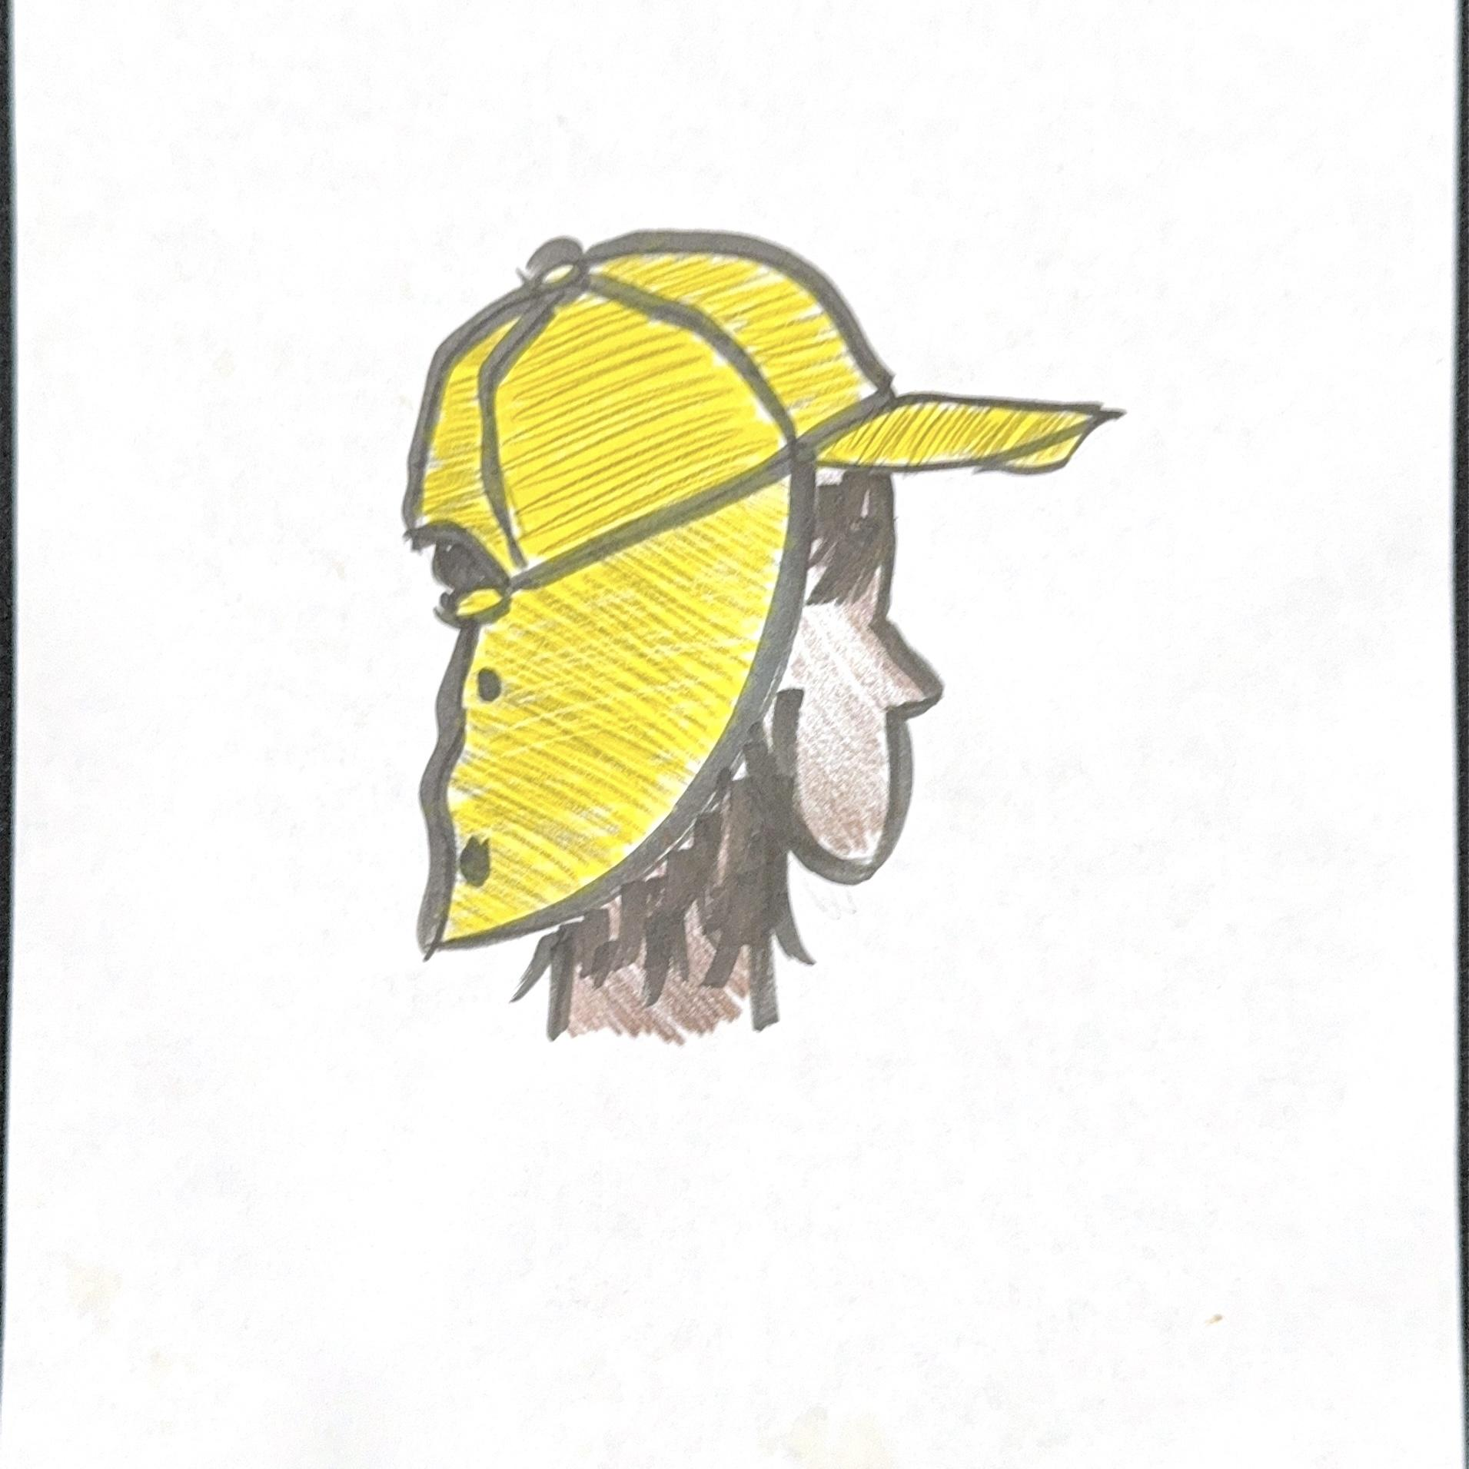

Fabric Color Choice:

Fleece Quarter Zip Sweater
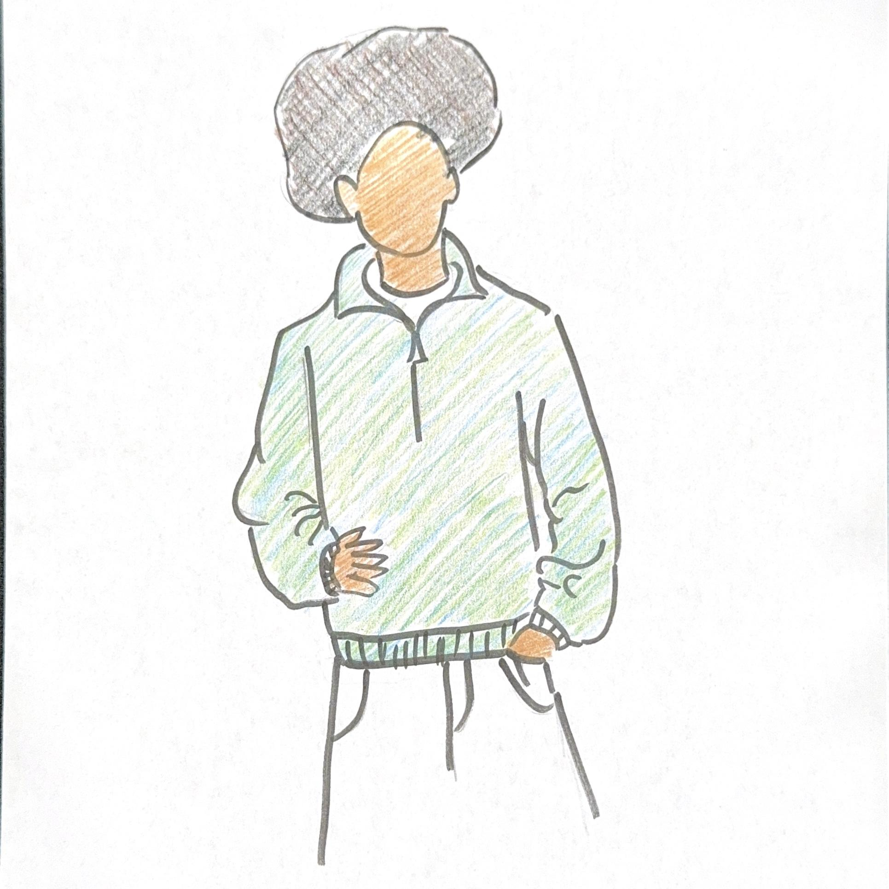

Fabric Color Choice

Water Repellent Puffer Vest
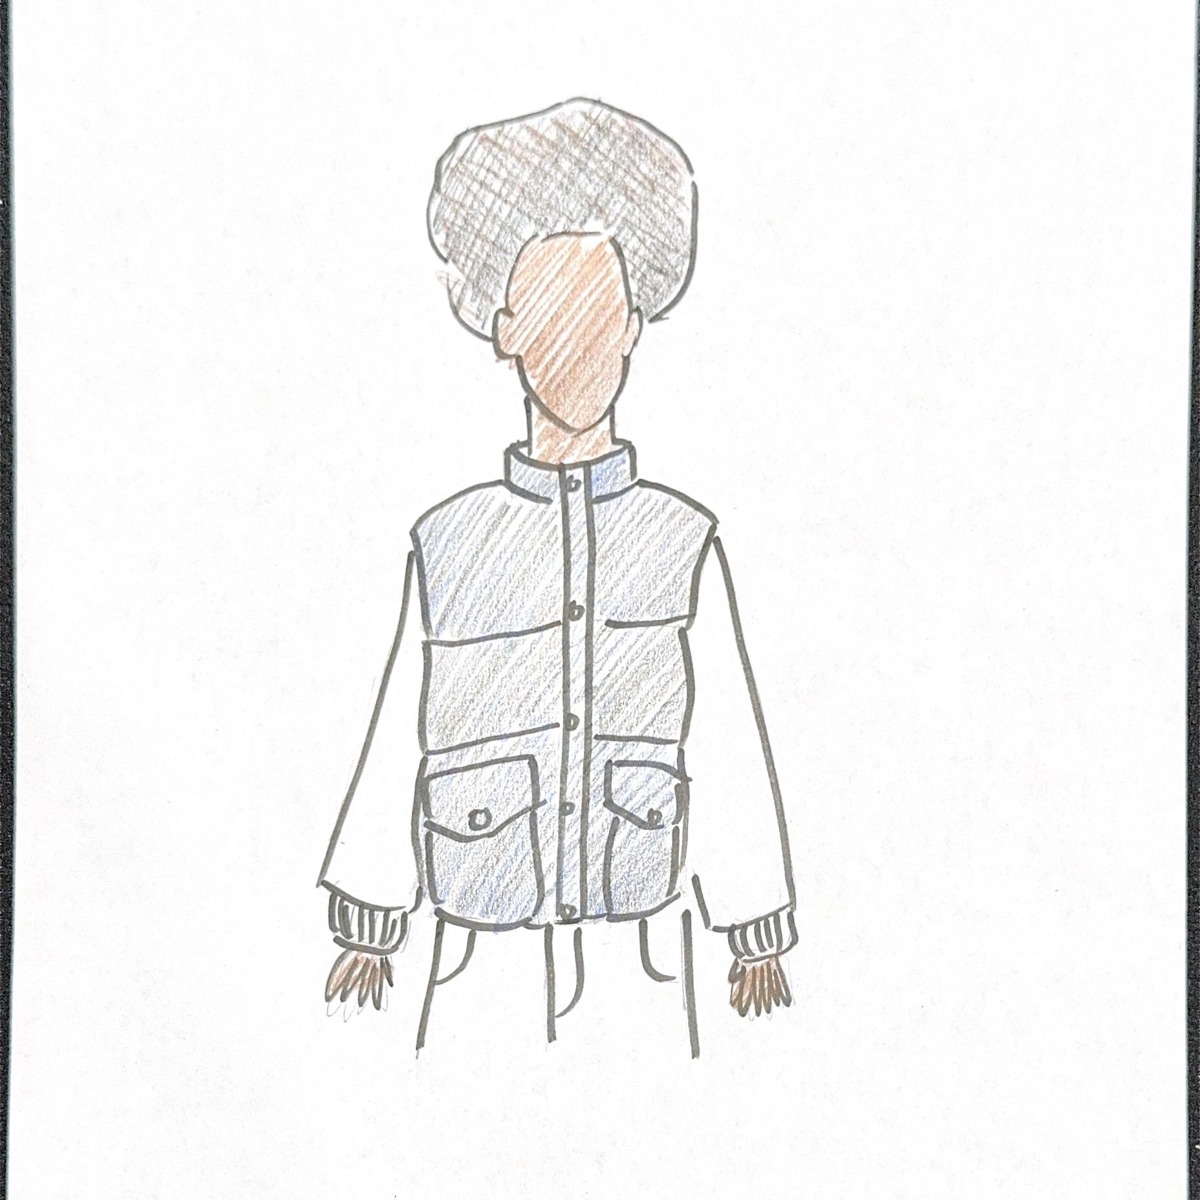
Fabric Color Choice:

Lightweight Trekking Anorak
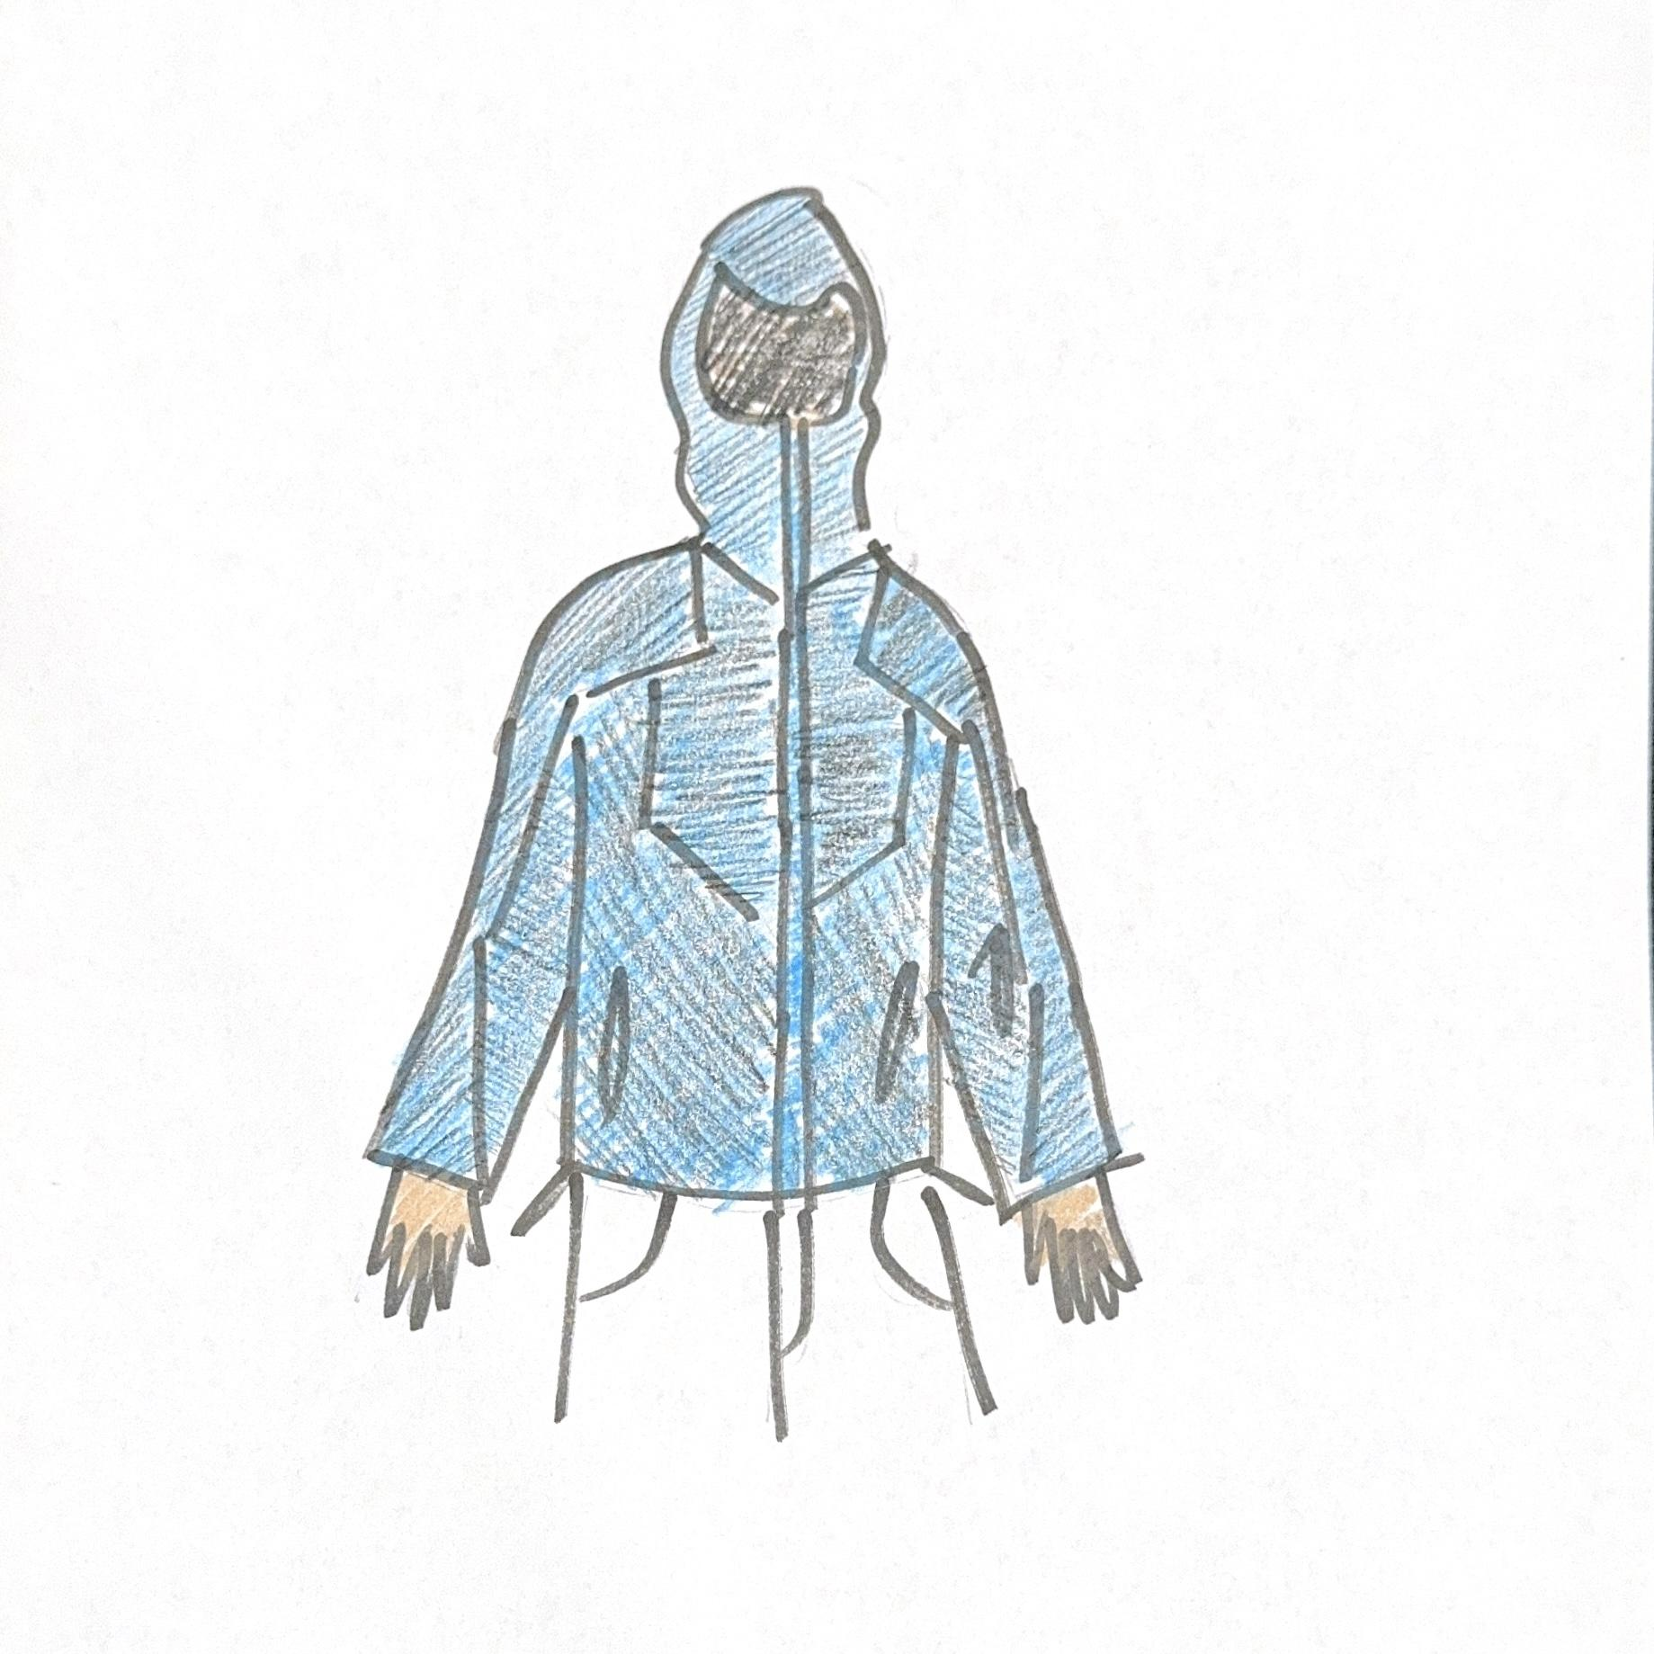
Fabric Color Choice:

Moisture Wicking Poncho
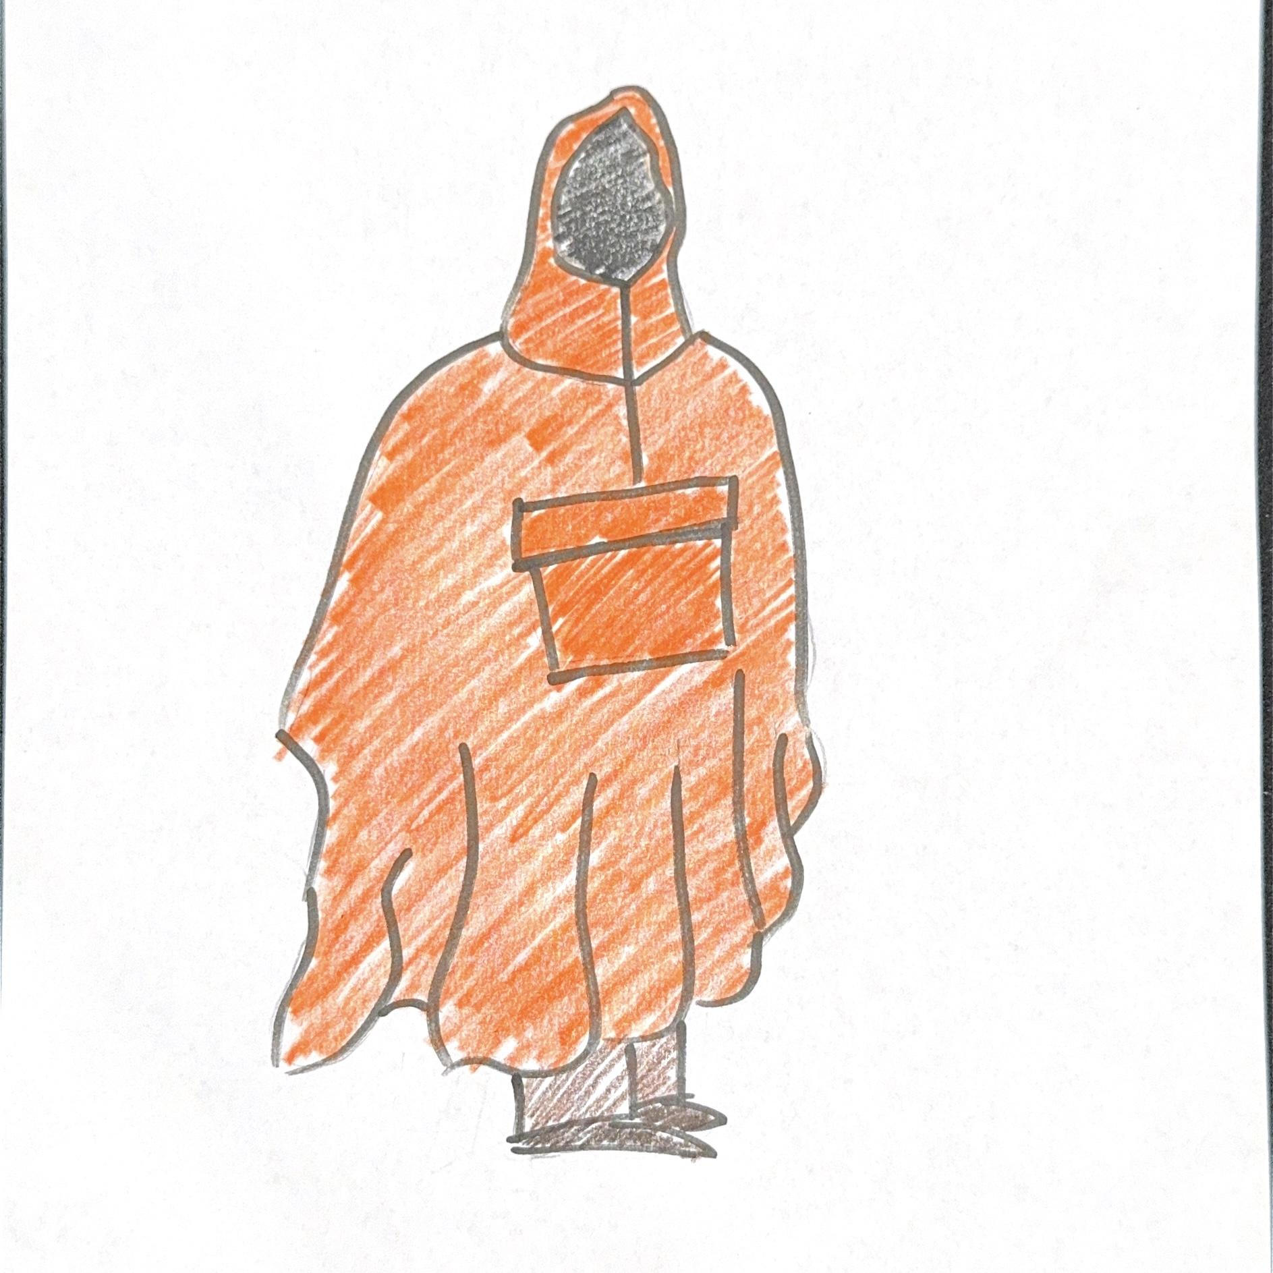
Fabric Color Choice:

Compression Pants
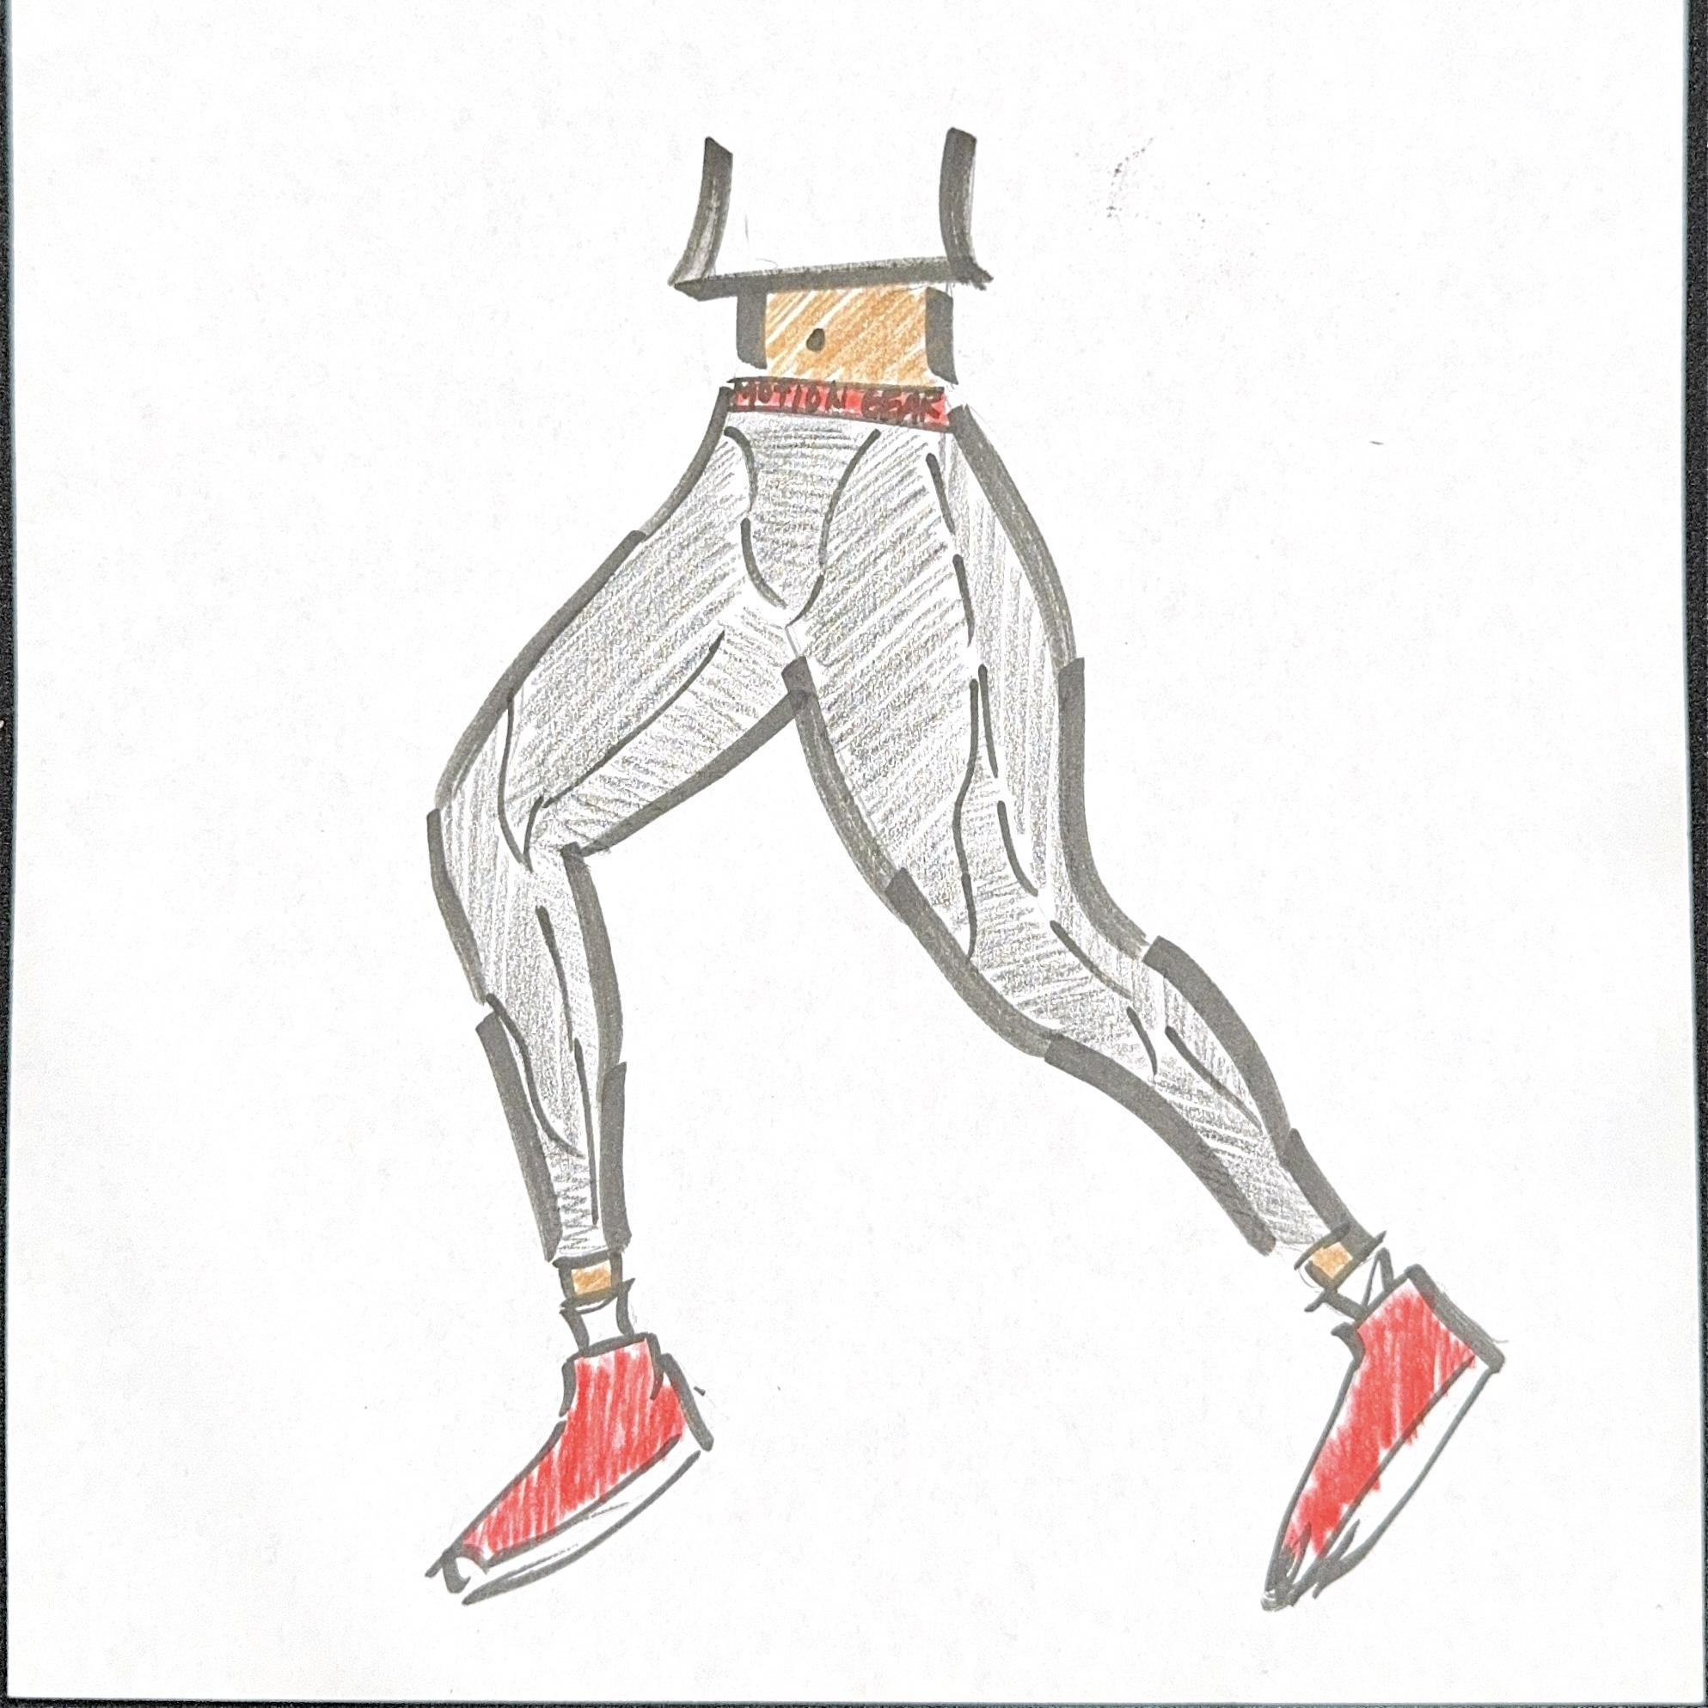

Fabric Color Choice:

Utility Shorts
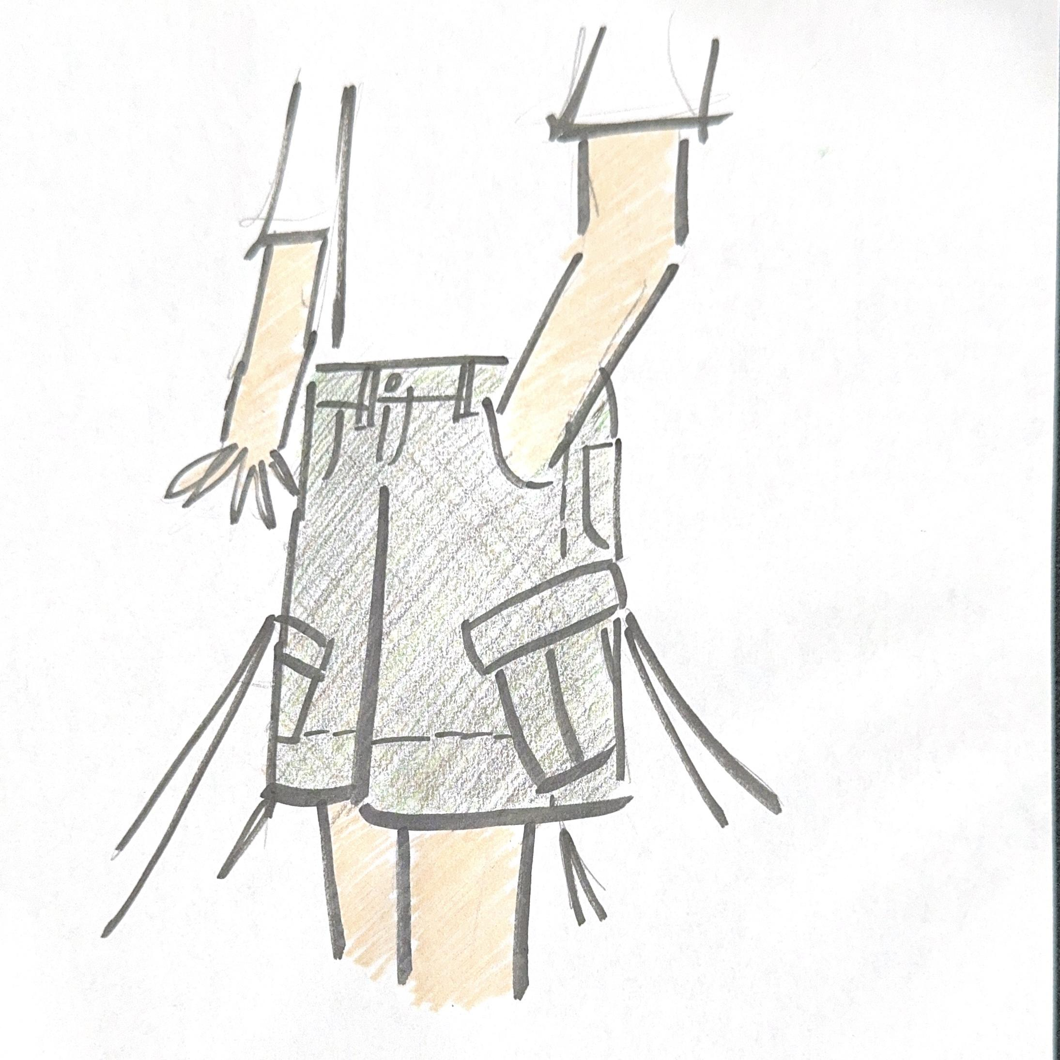
Fabric Color Choice:

Quick Dry Convertible Cargo Pants
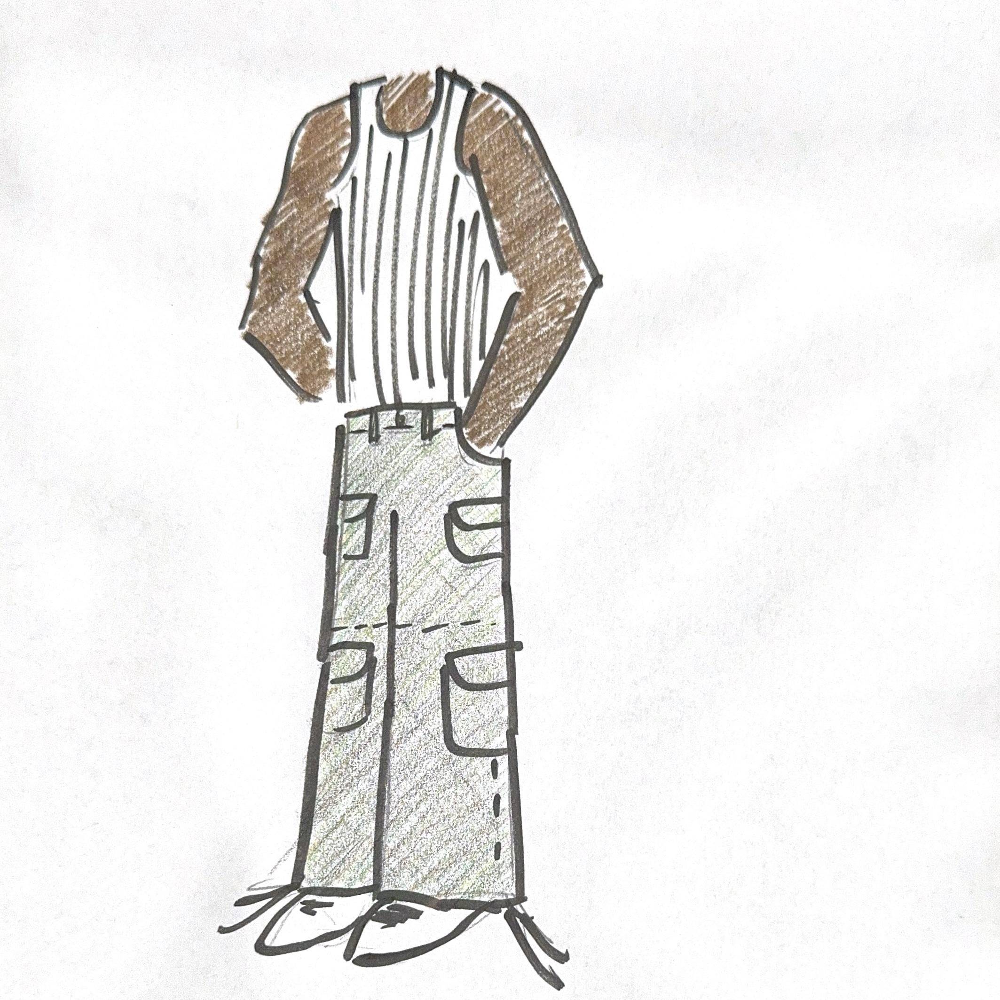
Fabric Color Choice:

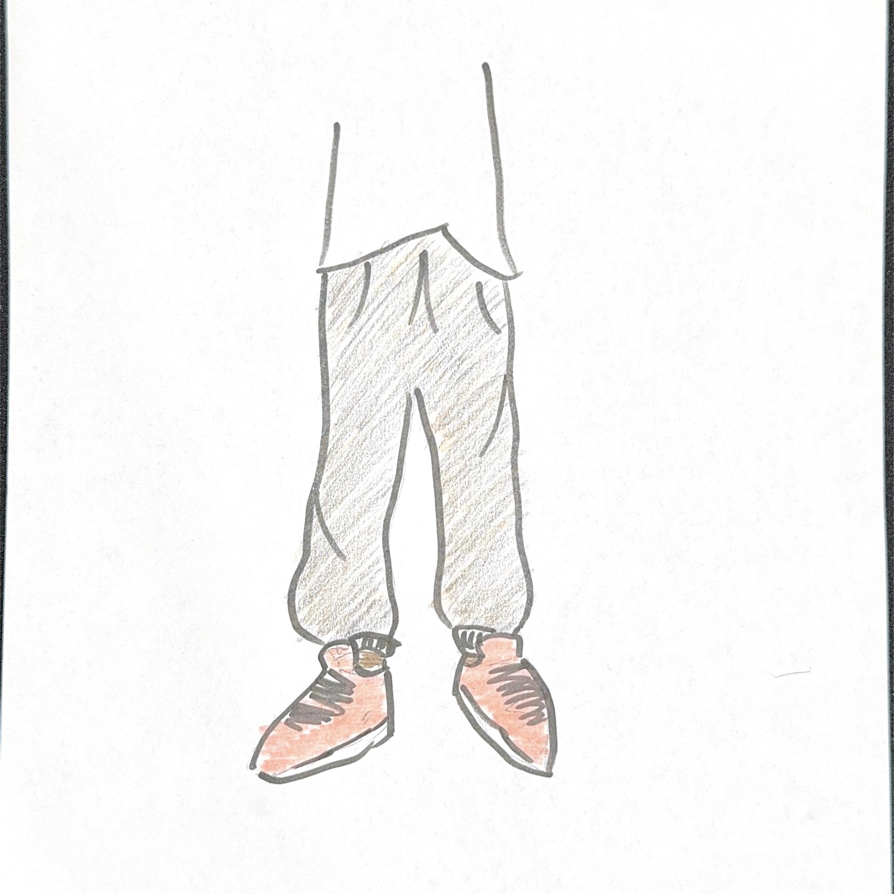
Sweatpants
Fabric Color Choice:

Waterproof Leg Gaiters
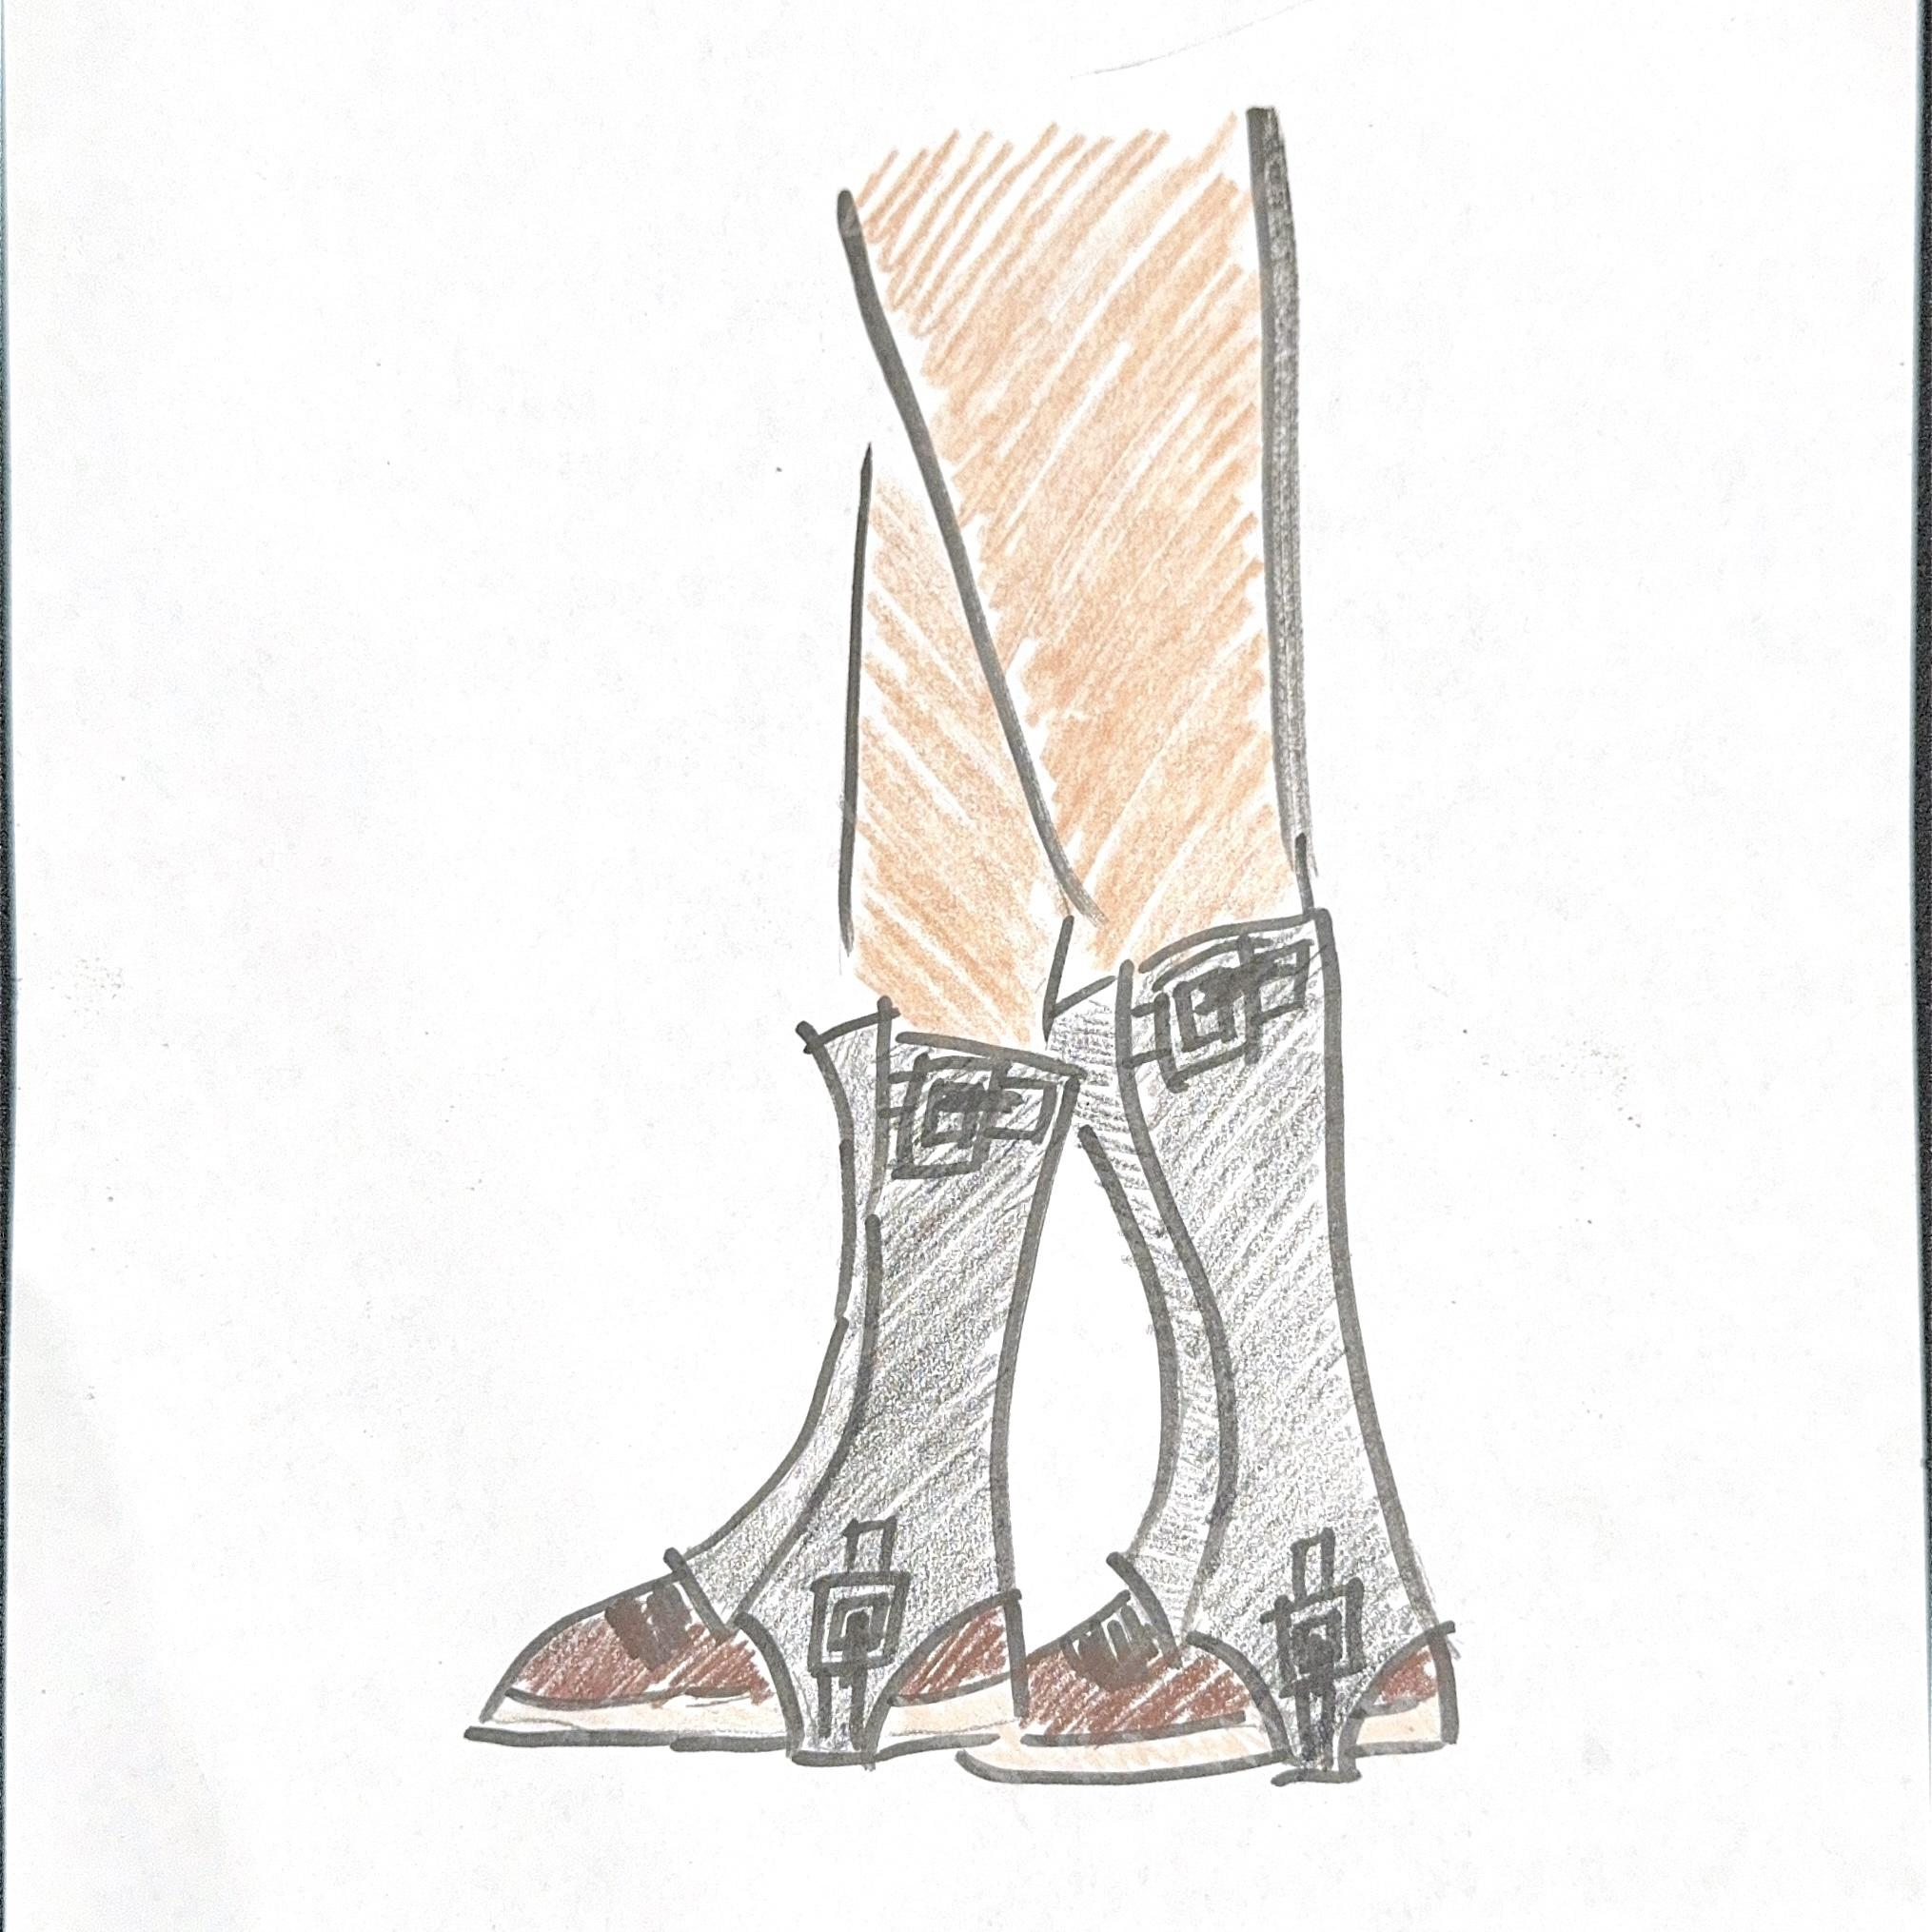
Fabric Color Choice:

Temperature Regulating Windbreaker
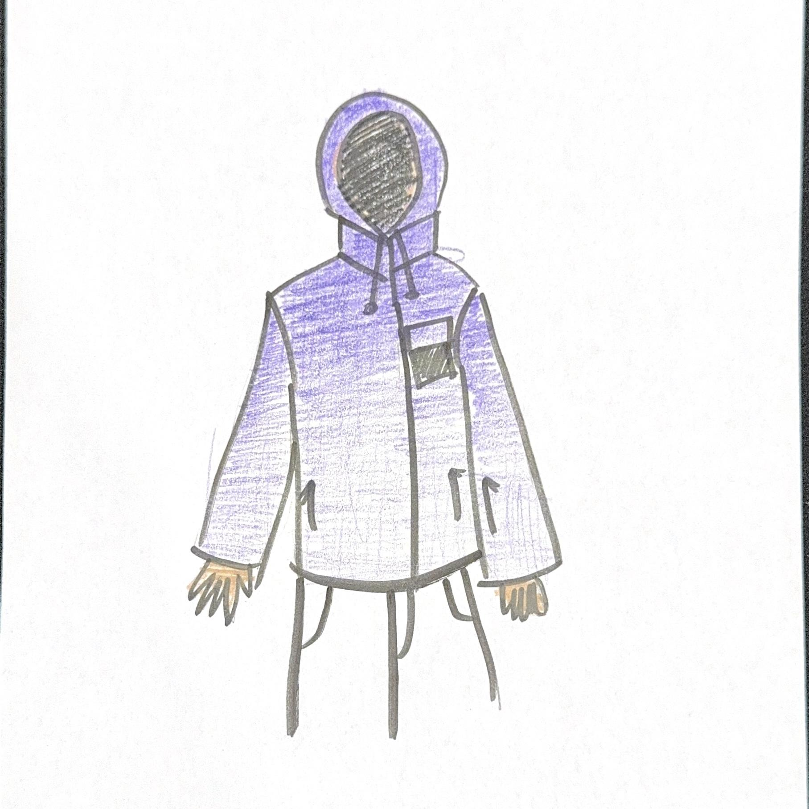
Fabric Color Choice:

Lightweight Paneled Down Jacket
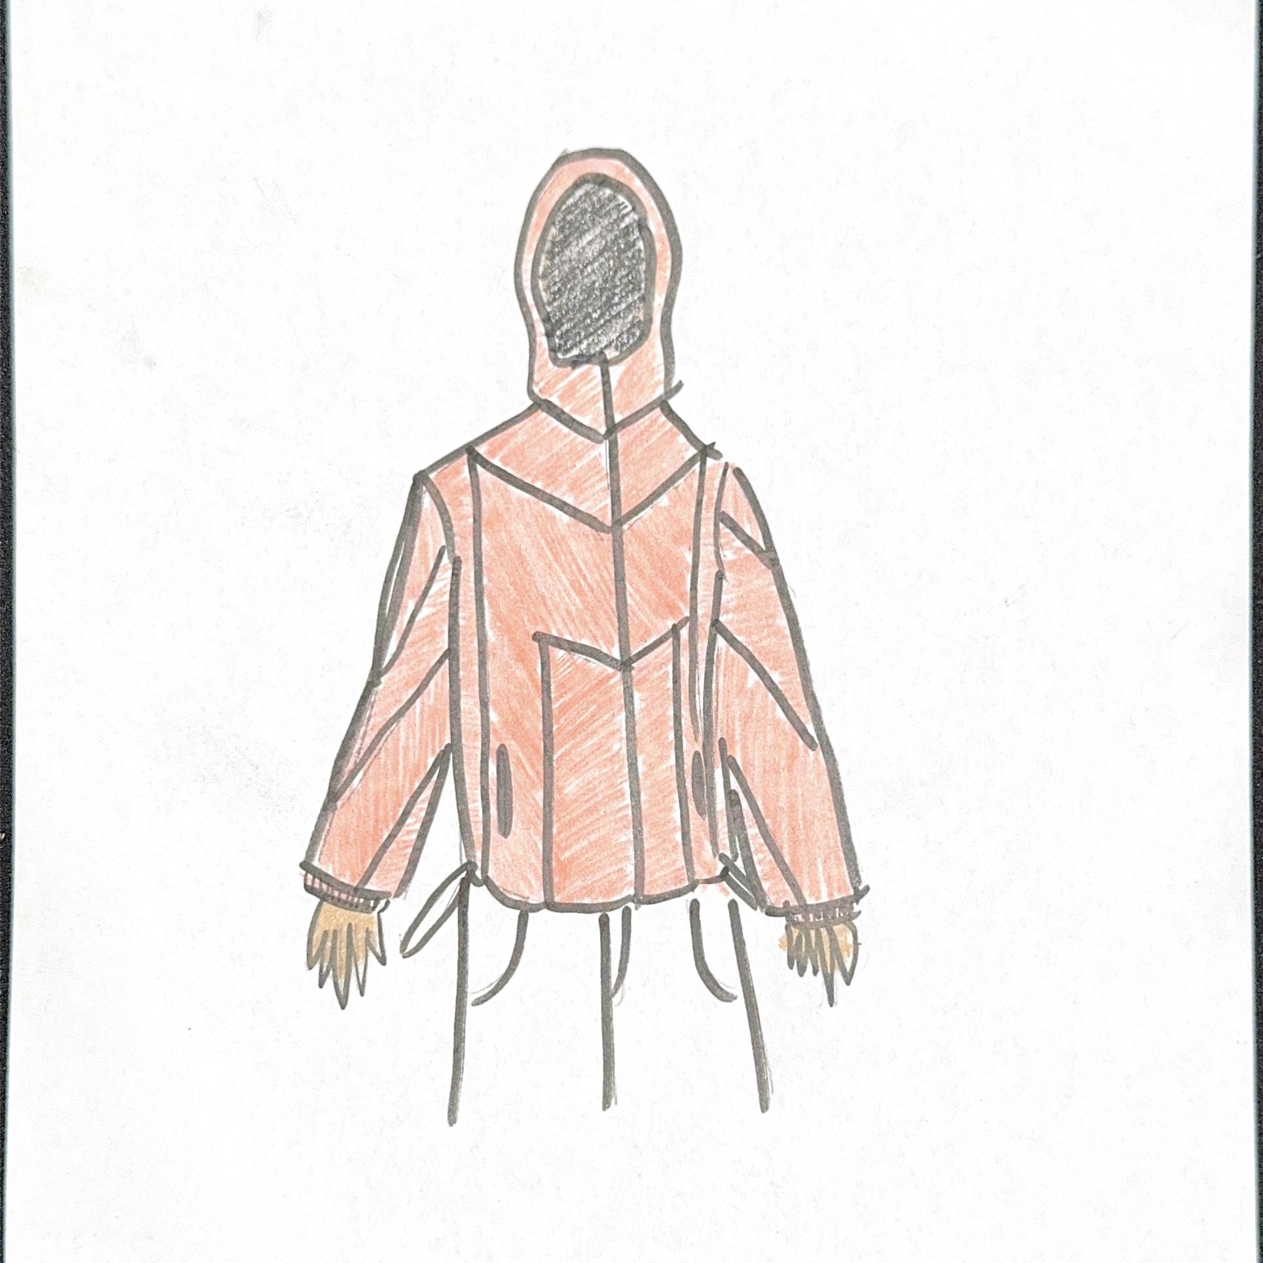

Fabric Color Choice:

Motion Gear
123 Mountain View Lane, Salt Lake City, UT 84101, www.MotionGearOutdoors.com, contact@motiongearoutdoors.com, 801-555-0123

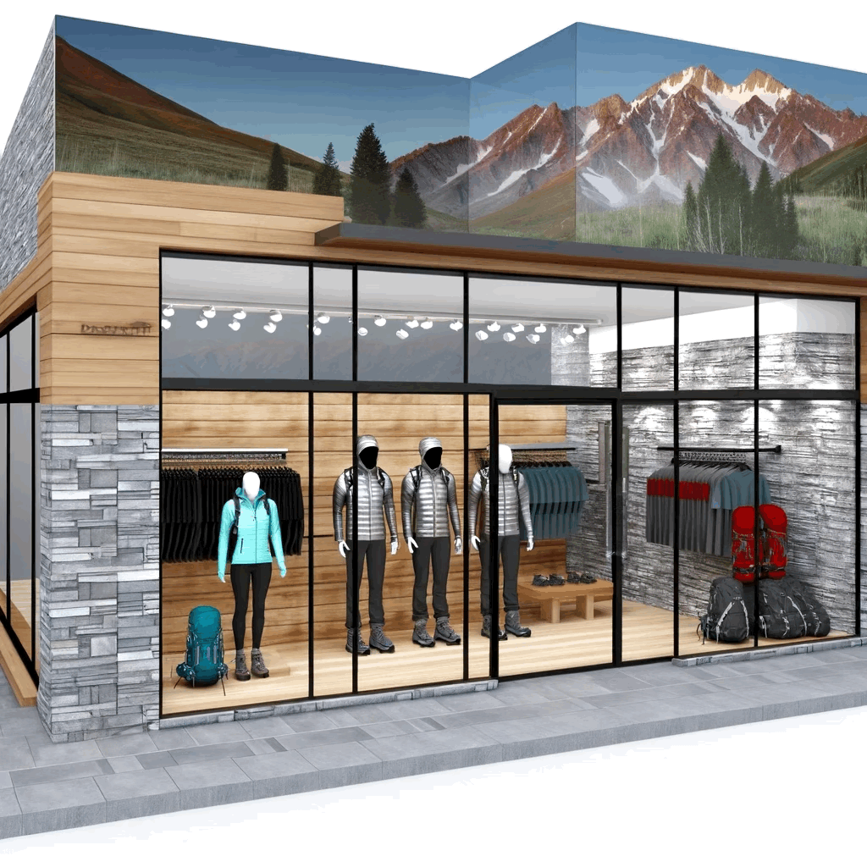
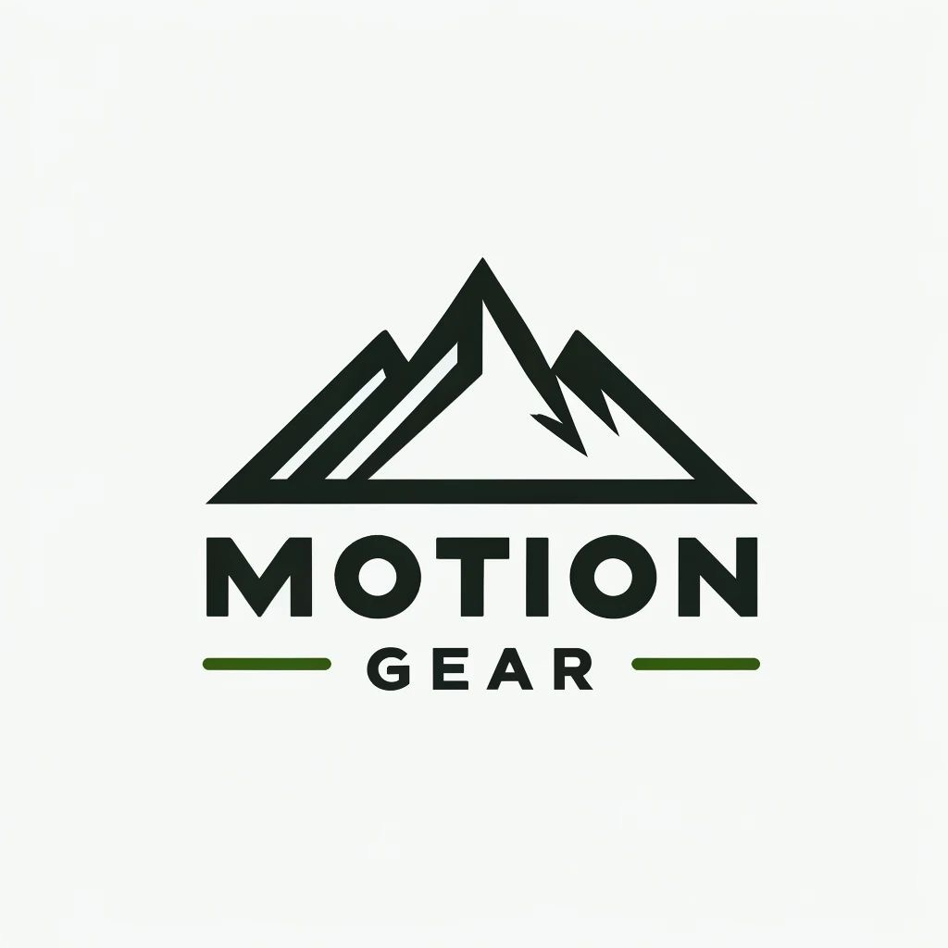

Part B:
B1.
February:
Planned Sale = $300,000
Reduction = $20,000
EOM Stock = $200,000
Total monthly needs = $520,000
BOM = $160,000
Planned Purchases = $360,000
Merch on order = $125,000
OTB = $235,000

March
Planned Sale = $200,000
Reduction = $26,000
EOM Stock = $80,000
Total monthly needs = $306,000
BOM = $200,000
Planned purchases = $106,000
merch on order = $15,000
OTB = $91,000

April
Planned Sale = $300,000
Reduction = $31,000
EOM Stock = $110,000
Total Monthly Needs = $441,000
BOM = $80, 000
Planned Purchases = $361,000
Merch on Orders = $145,000
OTB = $216,000

May
Planned Sale = $200,000
Reduction = $17,000
EOM Stock = $90,000
Total Monthly Needs = $307,000
BOM = $110,000
Planned Purchases = $197,000
Merch on Order = $35, 000
OTB = $162,000

June
Planned Sale = $400,000
Reduction = $46,000
EOM Stock = $210,000
Total Monthly Needs = $656,000
BOM = $90,000
Planned purchases = $566,000
Merch on Order = $170,000
OTB = $396,000

July
Planned Sale = $250,000
Reduction = $50,000
EOM Stock = $70,000
Total monthly needs = $370,000
BOM = $210,000
Planned Purchases = $160,000
Merch on Order = $24,000
OTB = $235,000

B2.
Average monthly sales
$300,000 + $200,000 + $300,000 + $200,000 + $400,000 + $250,000 / 6 = $275,000

B3.
Average monthly-order
$85,666

B4.
February: Employee Discount = 2% + MDS = 2% => Total Markdown = 4%
March: Employee Discount = 3% + MDS = 4% => Total Markdown = 7%
April: Employee Discount = 4% + MDS = 5% => Total Markdown = 9%
May: Employee Discount = 0% + MDS = 7% => Total Markdown = 7%
June: Employee Discount = 5% + MDS = 2% => Total Markdown = 7%
July: Employee Discount = 7% + MDS = 3% => Total Markdown = 10%

References
Bartlett, I. (2022, January 5). Why are so many people moving to Salt Lake City? 5 reasons Utah continues to see rapid growth. ABC4 Utah. https://www.abc4.com/gtu/gtu-sponsor/why-are-so-many-people-moving-to-salt-lake-city-5-reasons-utah-continues-to-see-growth/
Paulsen, M. (2021, November 19). Trails for who? accessibility and sustainability in Salt Lake’s Foothills. Wasatch Magazine. https://wasatchmag.com/trails-for-who-accessibility-and-sustainability-in-salt-lakes-foothills/
Quick Facts & Statistics About Salt Lake City, Utah. Visit Salt Lake. (2024a, April 8). https://www.visitsaltlake.com/plan-your-visit/about-salt-lake/quick-facts-stats/
Salt Lake City: An emerging market to watch in 2022. Knowledge Leader - Commercial Real Estate Content Hub. (2023, August 15). https://knowledge-leader.colliers.com/u-s-national-research/salt-lake-city-an-emerging-market-to-watch-in-2022/
Salt lake weather. Visit Salt Lake. (2024b, April 8). https://www.visitsaltlake.com/plan-your-visit/about-salt-lake/weather-climate/
Uinta-Wasatch-Cache National Forest - districts. Forest Service National Website. (2024, April 8). https://www.fs.usda.gov/detail/uwcnf/about-forest/districts/?cid=fsem_035528
White, K., Hardisty, D. J., & Habib, R. (2024, February 22). The elusive green consumer. Harvard Business Review. https://hbr.org/2019/07/the-elusive-green-consumer
CFDA. (n.d.). https://cfda.com/resources/materials/detail/polyester#:~:text=To%20make%20polyester%20fibers,%20PET,create%20fibers%20with%20different%20qualities.
Gd-Admin. (n.d.). News - benefits of importing recycled polyester fiber from China. https://www.weihighpsf.com/. https://www.weihighpsf.com/news/benefits-of-importing-recycled-polyester-fiber-from-china/#:~:text=China’s%20well%2Destablished%20infrastructure%20and,competitiveness%20in%20the%20global%20market.
Is recycled polyester green or greenwashing?. Common Objective. (n.d.). https://www.commonobjective.co/article/is-recycled-polyester-green-or-greenwashing
Melt Spinning. Melt Spinning - an overview | ScienceDirect Topics. (n.d.). https://www.sciencedirect.com/topics/engineering/melt-spinning
Preferred fiber and materials market report 2022. Textile Exchange. (2024, April 15). http://textileexchange.org/knowledge-center/reports/materials-market-report-2022/
Recycled polyester (RPET) fabric: Navigating the transforming textile industry. View the website in Español. (n.d.). https://blog.qima.es/sustainability/recycled-polyester-fabric-transforming-textile-industry
Sewport. (n.d.). What is polyester fabric: Properties, how its made and where. https://sewport.com/fabrics-directory/polyester-fabric

