Jailine Collado

BUF 2246

April 19, 2023

**Once A Beet To The Street**

We will be going on a journey discussing the history of the beet. While also discussed how this dyestuff came about, the many shades of color it can achieve, and what I hope to achieve; a soft pink. Not only will I discuss the history of the Beet but a step-by-step on how to successfully dye a garment or fabric of your choice as well as contribution a resistant with the dye using rubber bands and strings.

Beets originated along the coast of the Mediterranean and were consumed within the culture around 2,000 BC; In the modern day, the beet gained popularity for its ability to variate colors and usage in dyes (Pinion, 2022). Beets have been used since the 16th century as a natural dye to stn cheeks and lips. In 19th-century England, the Victorians used beets to dye their hair and garments (Chilson, 2023). Since ancient times, beets have been used for dyes, teas, and medicinal properties (History of the Beet, 2023). It is possible to produce a range of colors with beets, which varies with each beet and the water-to-beet ratio used. The more water, the darker the resulting color will be, and the less faint the resulting color will be. Beets are used to give a pink or red color but can also range from dark purple to bright red and yellow (HealthySD, 2023). When I purchased the beets, they were relatively inexpensive. I purchased three beets for $2. It is easy to say that beet is simply a beet, but it means more than we think or what I may have previously thought. In Greek mythology, Aphrodite, the goddess of love, ate beets to enhance her appeal (Avey, 2014).

Color significantly impacts how I dress and what it means to me daily. My favorite color is pink and always has been. Although it is simply a color, it means so much more. Pink embodies the epitome of love, kindness, and femininity. When I wear Pink, I always feel the most in touch with my innocence and womanhood. Growing up, I adored fairytale movies; Princess Aurora was one of my favorites because of her elegant pink dress. My favorite garment is sheer pink Long gloves my mom gifted me for my 22nd birthday. It reminds me of a particular vulnerability and innocence I felt watching those fairytale movies. I try my best not to dress how I feel but how I want to be perceived that day, and when I wear those pink gloves, I feel like I embody my inner princess. I admire and resonate the most with Instagram influencer Koleen Diaz known by her username Koleendz. Who represents the princess style and a mix of streetwear.



**Koleen Diaz**

I knew this would be a complex process, but it was definitely more challenging than I thought; with trial and error, I did everything I could with my fabric and dyestuff. I first gathered all the Material needed: 3 beets, a poot, a yard of white silk fabric, rubberbands, string, water, stainless steel spoon, and salt.

Step 1: Prep your fabric

I prep my fabric by thoroughly cleaning it, putting the fabric in [a boiling pot of water and a few tablespoons of fabric detergent. I let that simmer for about two hours while occasionally stirring and checking on the fabric. When the two hours have passed, I drain and rinse the fabric.

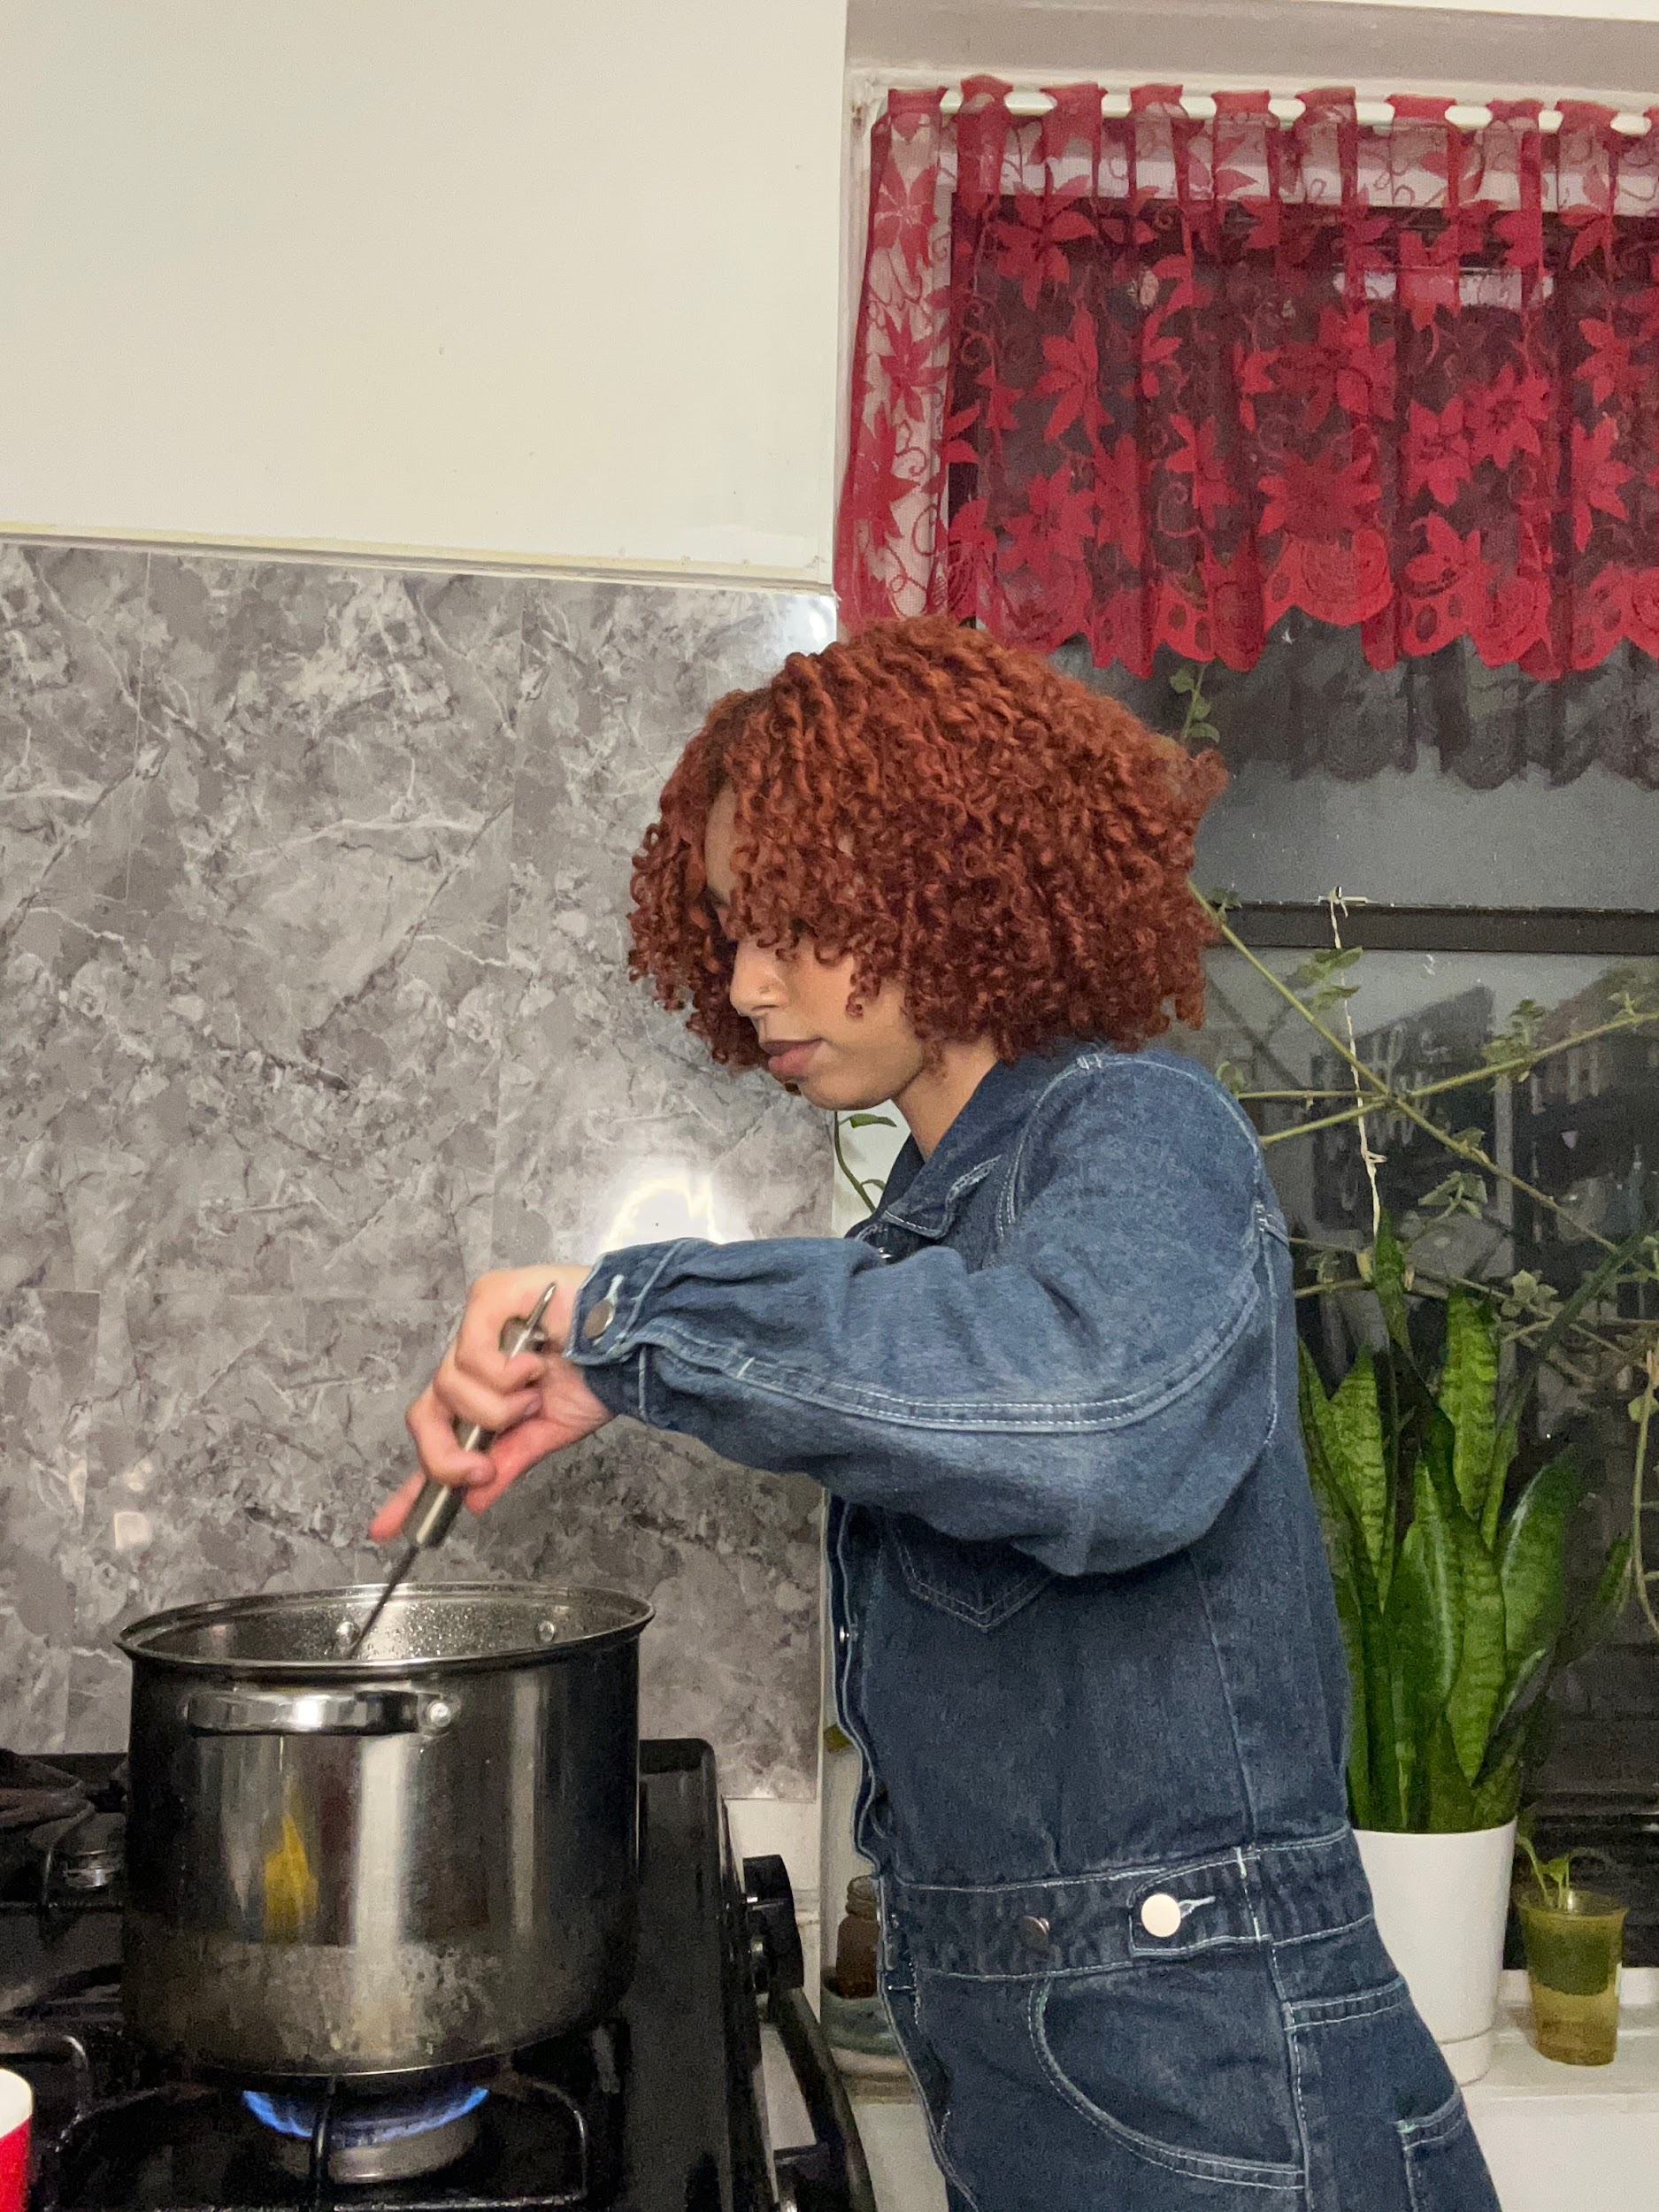

**Stirring the pot With the fabric**

Step 2: Prep the beets

As my fabric is in the boiling pot simmering. I prep my beets by thoroughly washing each beet. Then, peel and chop up the beets into medium-sized cubes and transfer them to a small bowl. Then thoroughly washing my hand! I avoided wearing gloves because I wanted to be hands-on and feel the dyestuff.

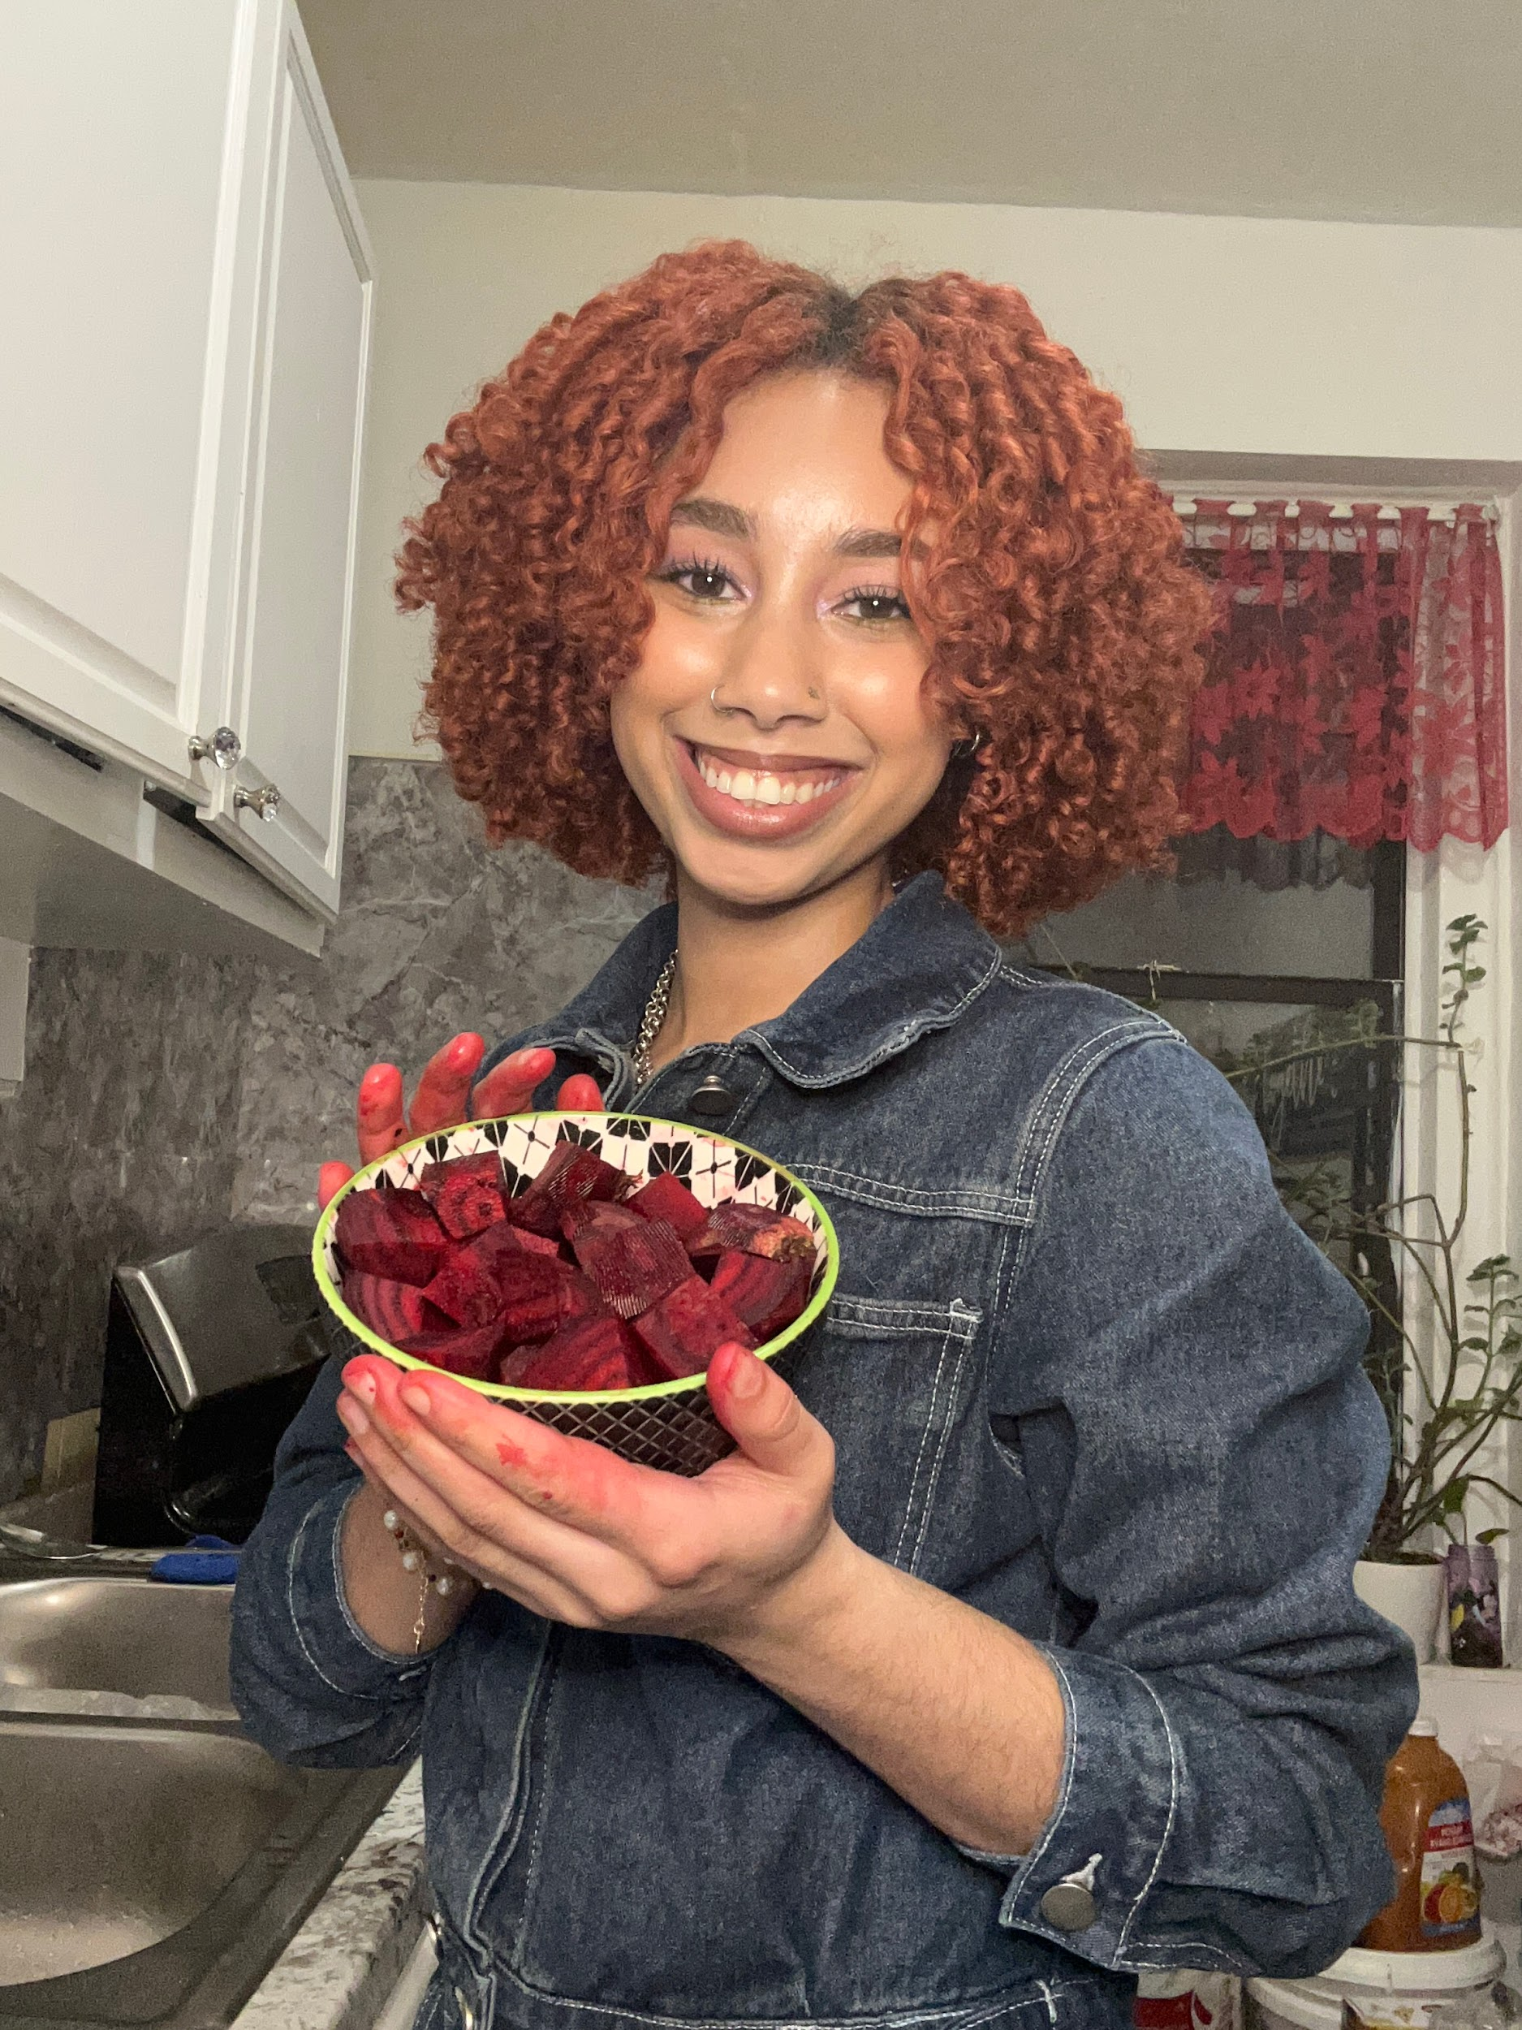 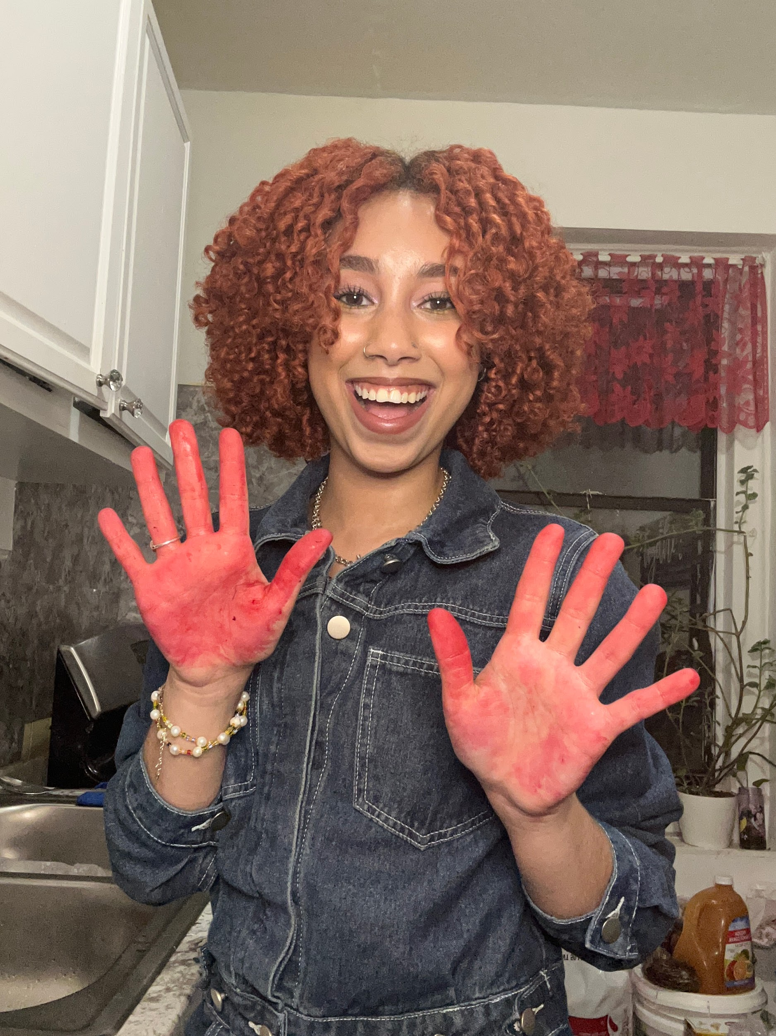

**Beets chopped up and stained red hands**

Step 3: Add salt, then strain

I grab my second pot, fill it with water, add a few teaspoons of salt, and bring it to a boil. I then let it simmer for an hour while occasionally stirring and checking the color development. After an hour, achieving what I thought was my desired color, I strained the compost beets into a separate pot.

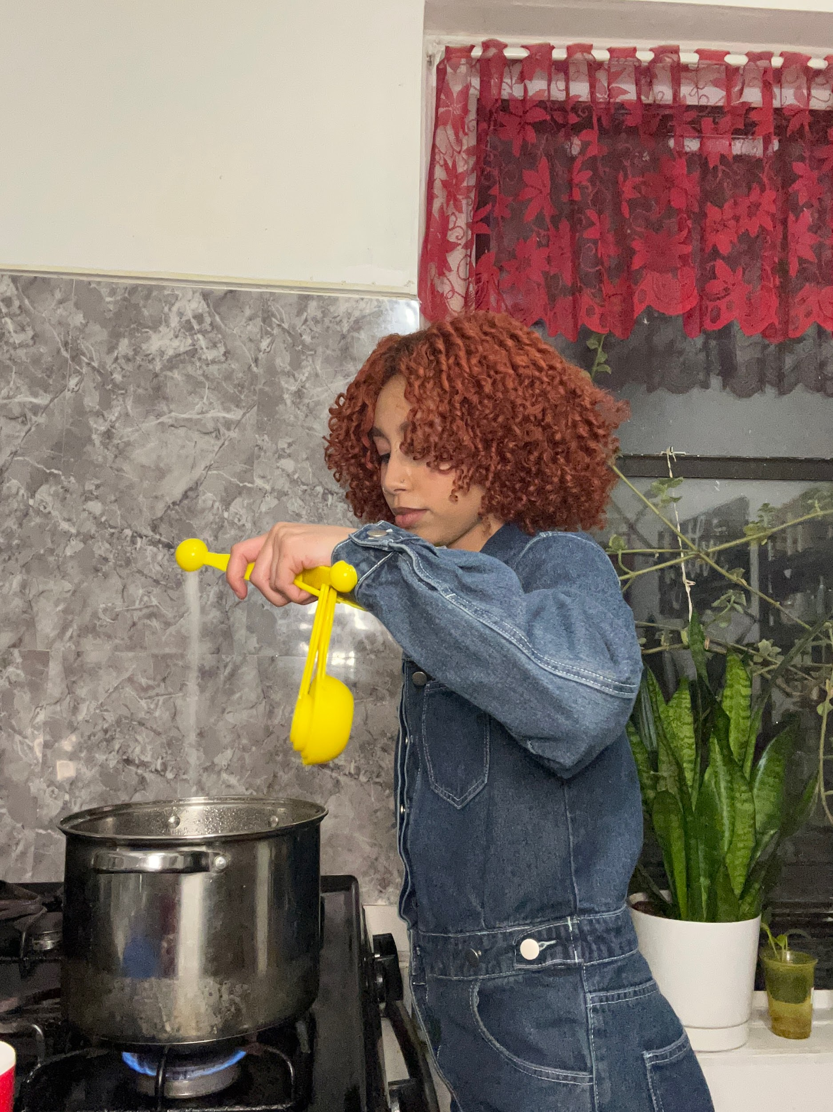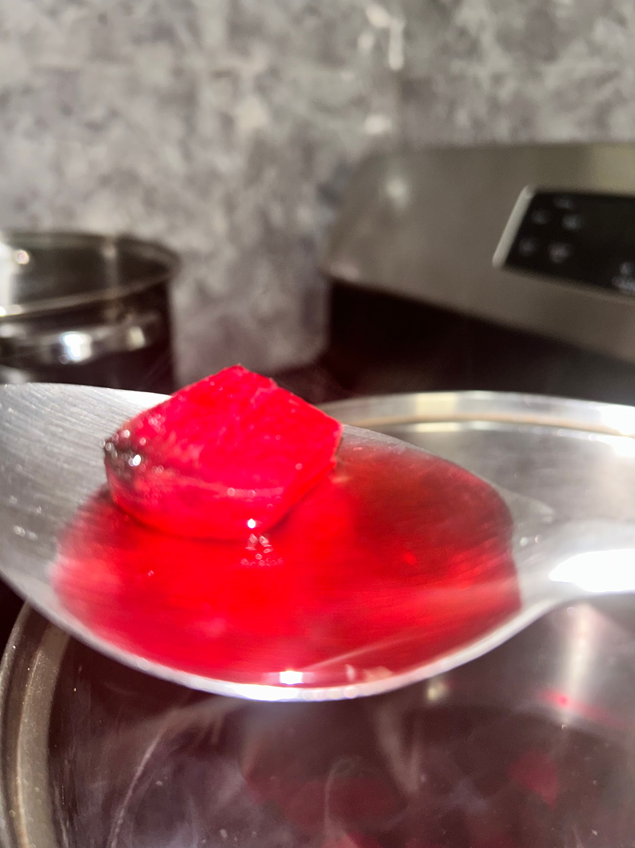

**Adding salt and checking dyestuff**

Step 4: Dry and pleats

Now that the fabric has simmered in the pot, I take it out and let it air dry a bit; however, not too much because it is best to dye the fabric when the fabric is damp. Then I proceed to pleat my fabric to give the fabric its tie-dye effect. Again, I knew I did not want to follow a tutorial; I simply went with my gut on how I wanted it done. I then use a rubber band for my resistance, place it in my still-simmering pot of dyestuff, and leave it in overnight.

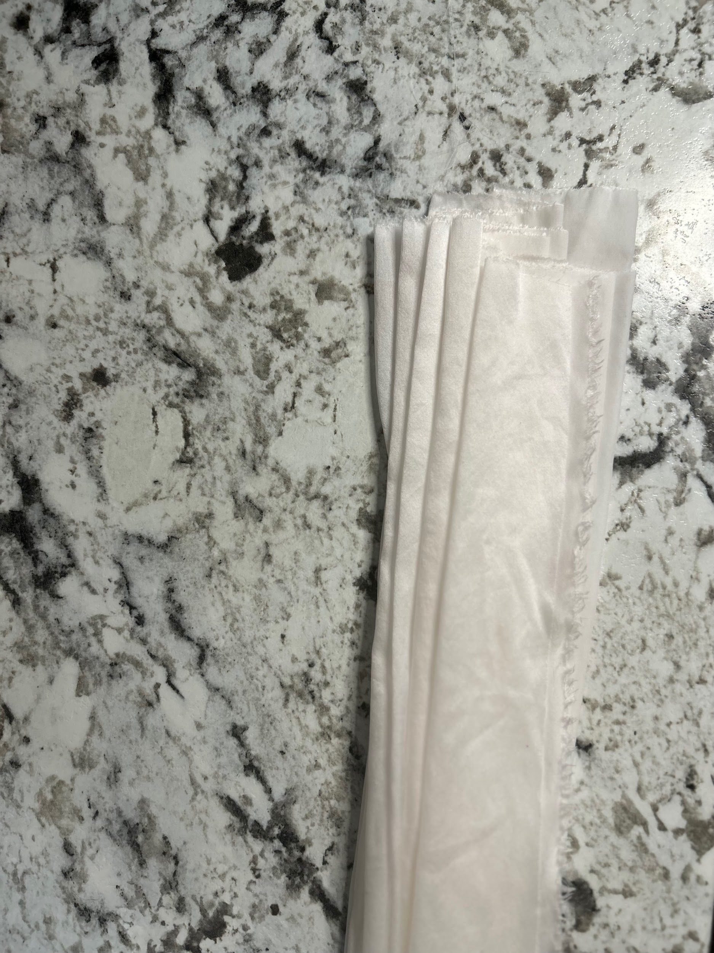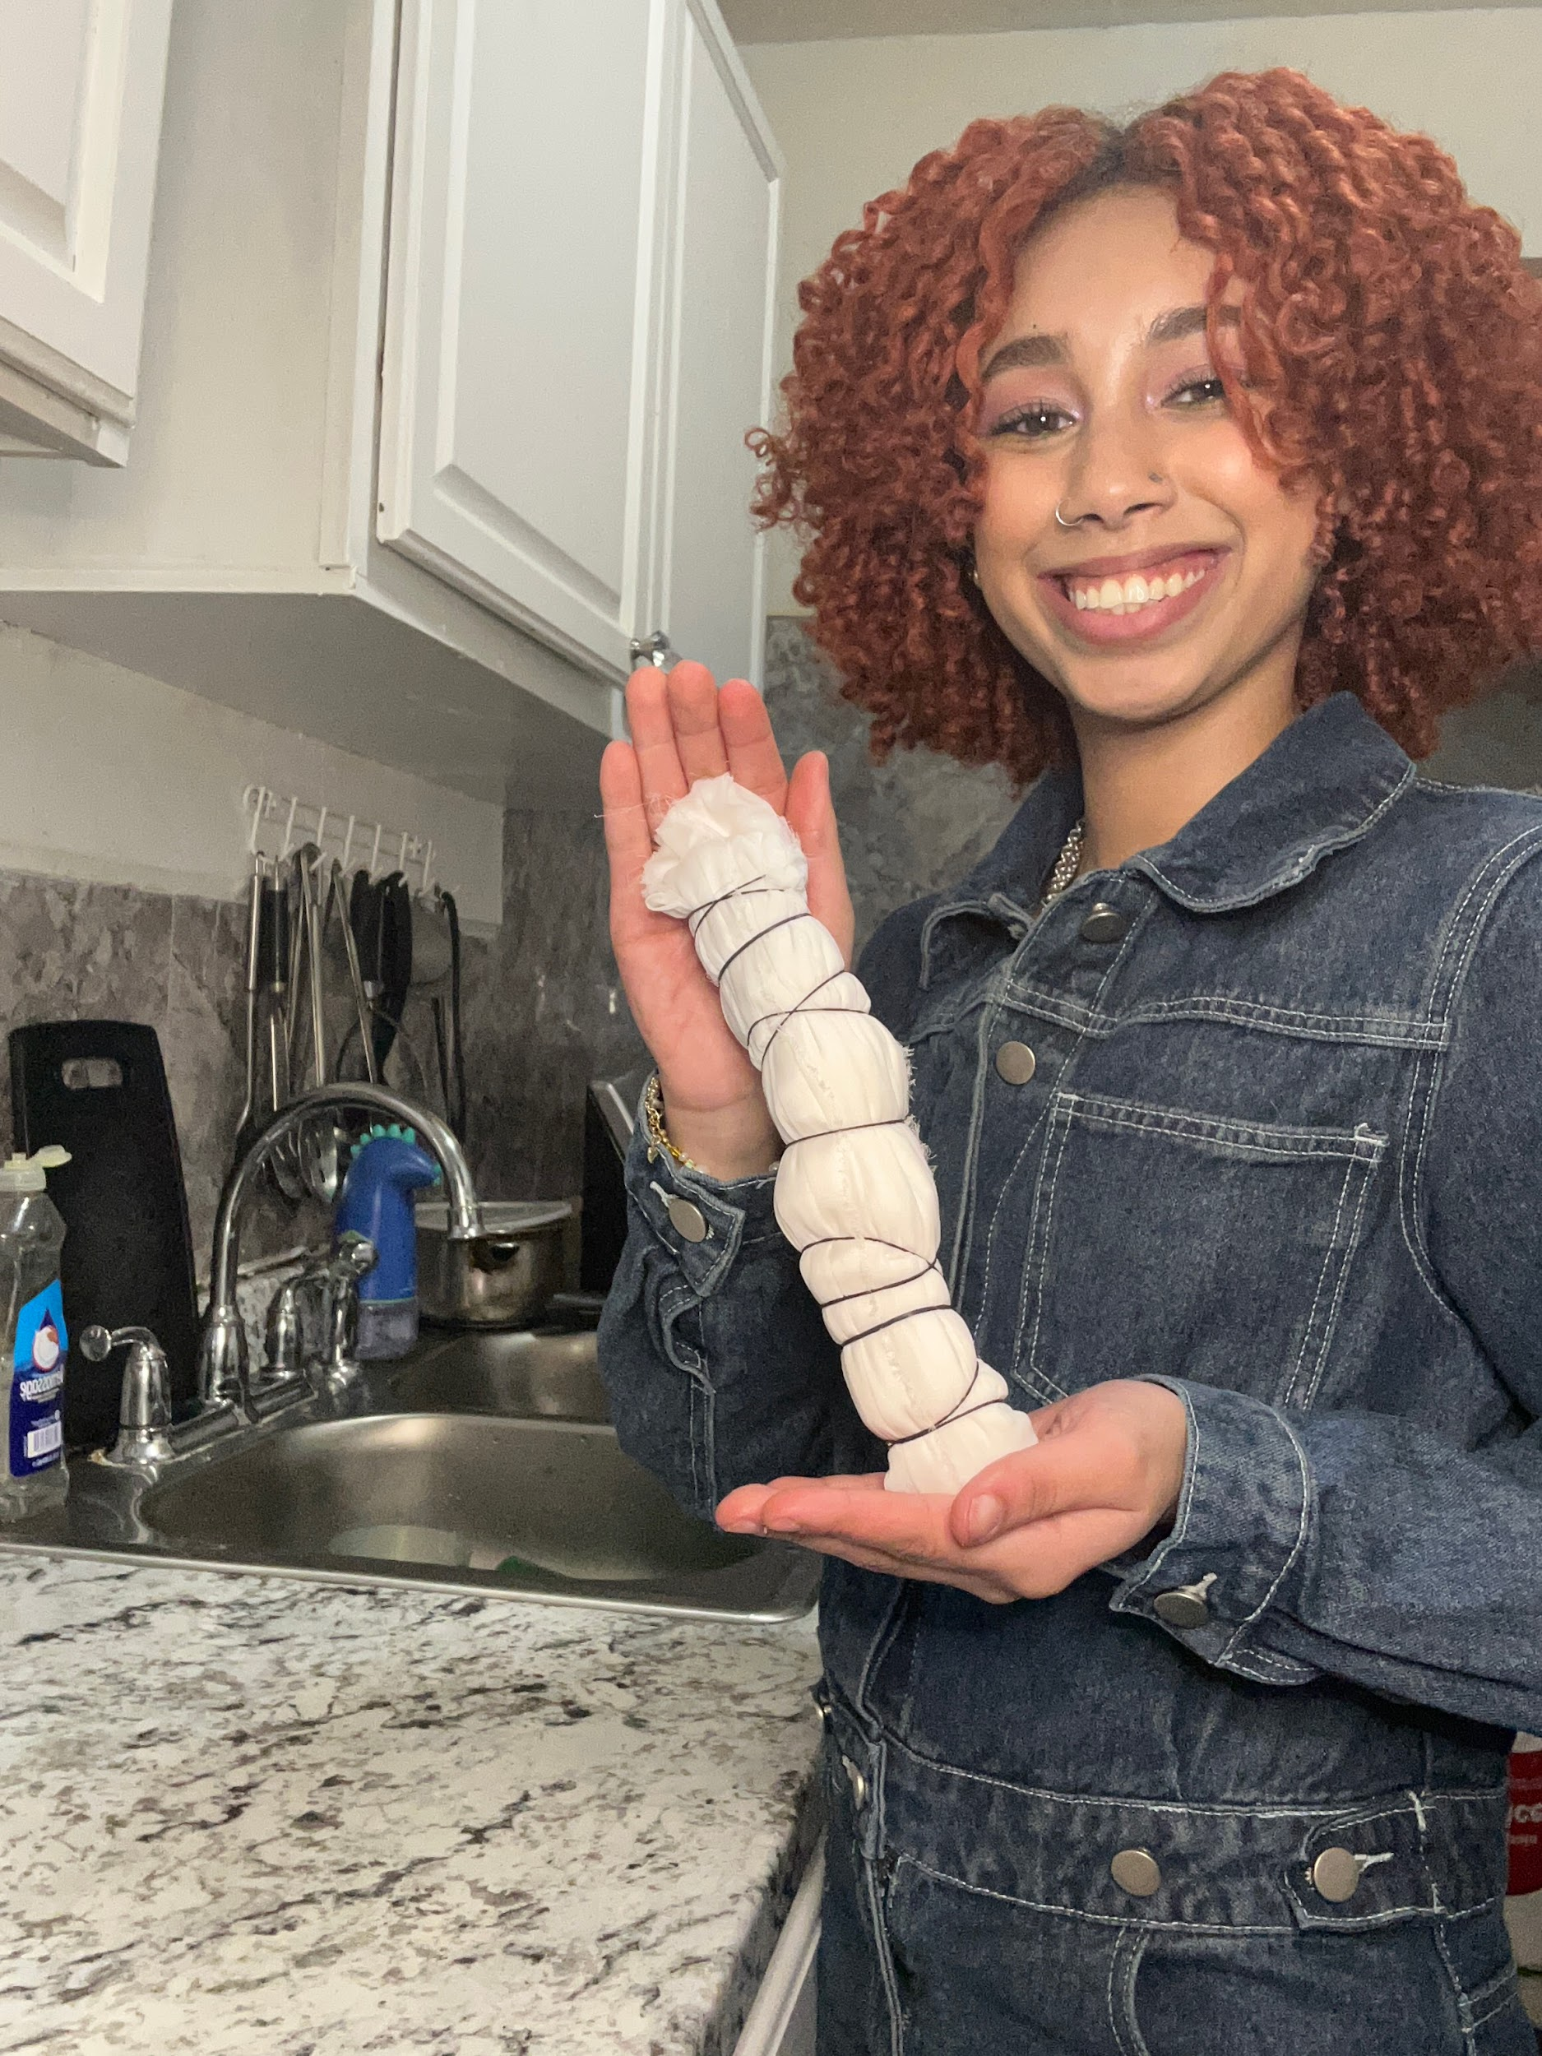

**Pleating and rubberbands**

Step 5: Final step

After letting my garment sit overnight, I take the garment out and rinse it with cold water. The fabric will be two shades lighter after you rinse it, which is perfect because I wanted to achieve a soft pink. I then let my garment hang dry overnight.

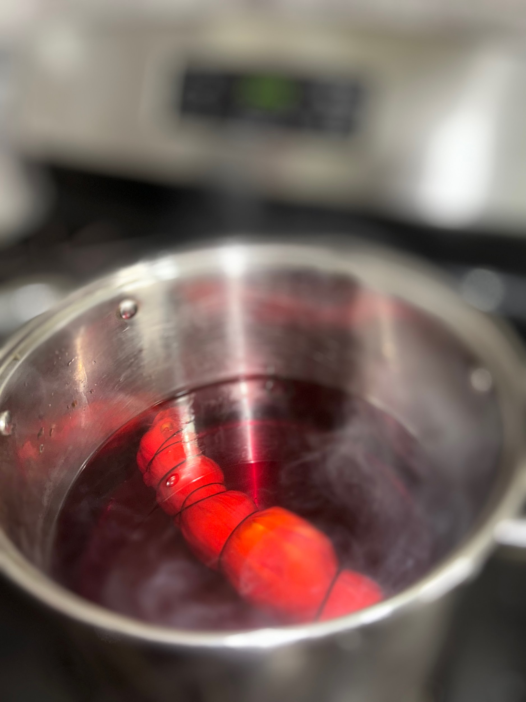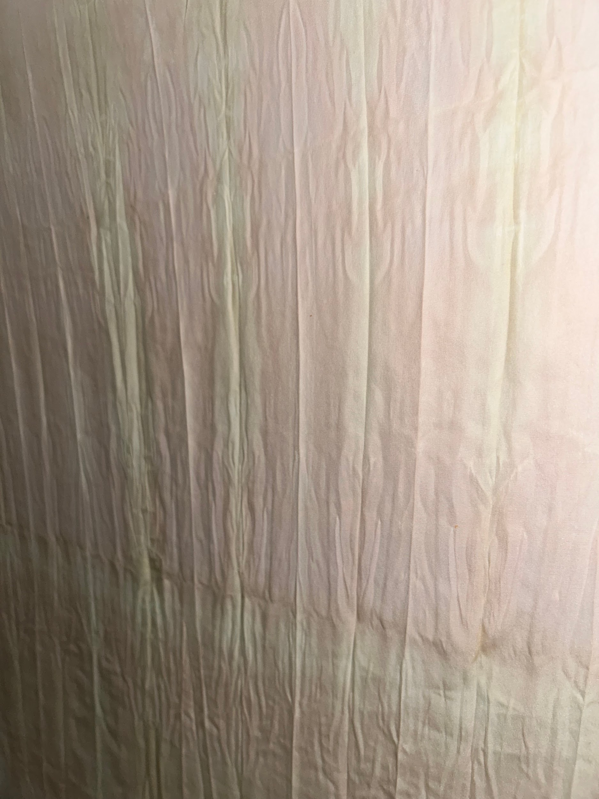

**Garment simmering in dyestuff and Final product**

Unfortunately, my project turned out differently than I would have liked. I desired to achieve a soft pink color. Adding in more water, I assumed that would help me achieve the desired color, but it looked blotchy, and the pattern I wanted with the pleats was not how I had envisioned it. Through my research, several texts stated that alum is an ideal mordant but that salt can be used as an alternative. That may have led to my downfall, with my fabric not absorbing the dyestuff as well as I would have liked. It would have been more successful if I had used a tighter rubber band or string.

In conclusion, I thoroughly enjoyed and learned from this experience. If I had left let my Fabric in my dyestuff for a more extended period, it would have absorbed the color significantly better. Patience and research go a long way. This project has influenced me to use natural dye on my garment; I have been actively choosing to be more sustainable. This is perfect for incorporating into my lifestyle as I am constantly looking for ways to repurpose my garments.

**References**

Annika. (2023, February 2). *How to dye fabric with natural dyes*. Rosemary And Pines Fiber Arts. Retrieved April 19, 2023, from https://www.rosemaryandpinesfiberarts.de/dye-fabric-with-natural-dyes/

Avey, T. (2014, October 8). *Discover the history of beets*. PBS. Retrieved April 18, 2023, from https://www.pbs.org/food/the-history-kitchen/history-beets/#:~:text=Beets%20have%20long%20been%20considered,beets%20to%20enhance%20her%20appeal.

Contributor, G. (2023, January 26). *Your Five-step DIY guide to natural dyeing*. The Good Trade. Retrieved April 19, 2023, from https://www.thegoodtrade.com/features/diy-natural-fabric-dye/

Diaz, K. (2023, March 5). *Koleen Diaz on Instagram: "yeah?"*. Instagram. Retrieved April 19, 2023, from https://www.instagram.com/p/CpYnGGON_96/

*History of the beet*. Just Beet It. (n.d.). Retrieved April 18, 2023, from https://www.justbeetit.com/history-of-the-beet

*Home*. Healthy SD. (n.d.). Retrieved April 18, 2023, from https://healthysd.gov/beet-lesson-plan/#:~:text=Beet%20juice%20is%20widely%20used,red%2C%20yellow%2C%20and%20white.

Pinon, S. (2022, July 21). *The history of beets & how they changed the world*. Medium. Retrieved April 18, 2023, from https://medium.com/the-orange-journal/the-history-of-beets-how-they-changed-the-world-234998f9ffbd