Jailine Collado

New York City College of Technology

BUF 2204

Dr. Nazanin Munroe

December 17, 2023

Kenya is a coastal zone, and their livelihood depends on the country’s natural resources to support life and meet the needs of its people. The Kenya Lake System presents an exceptional range of geological and biological natural properties of outstanding beauty (Centre, 2023). According to an article titled *A Drowning World: Kenyas Quiet Slide Underwater* (2022), The Indian Ocean surrounds the region of Eastern Africa, but Kenya’s lakes are essential to the country’s people, economy, and wildlife wrestling in About 1 million people living near Kenya’s freshwater lakes. Among its land, Kenya is rich in mineral resources, including gold, iron ore, talc, soda ash, and gems, including Amethyst, Aquamarine, lolite, ruby, and sapphire. Kenya’s most valuable resource is soda ash, Kenya’s leading mineral export (AZoMining, 2019). Along with Kenya being known for the outstanding beauty of their landscapes, the country in East Africa is also known for its delectable cuisines. Kenya is home to some of the most popular dishes in the world, like *Ugali,* which is made from maize flour that turns into a doughy texture (Simborio, 2023). The soils used in agriculture are ferralsols, vertisols, acrisols, lixiosols, luvisols, and nitisols (Infonet-biovision, 2023). Healthy soil is the foundation of productive, sustainable agriculture. Many profitable crops can be grown in Kenya, varying on local climate, soil conditions, and market demand. Building up communities has become one of Kenya’s primary methods of alleviating poverty.  
 One may say that one of Kenya’s greatest struggles is poverty; the wealthiest people are Kikuyu, the best-represented ethnic group with the highest status, and their job reflects that status with government, business, and education positions—followed by the Luo, who find jobs such as fishermen and boat loaders (Everyculture, 2023). Kenya’s capital is based on its monetary unit, the Shilling. Kenya has a lower middle-income status, yet it is the most powerful economy in Africa, with many commercial, merchants, and foreign banks (Worldbank, 2023). One may say that Kenya is the leader in digital technology in Africa, witnessing significant growth in Entrepreneurship due to new technology. Kenyans have depended on agriculture for economic growth; however, increased literacy and human labor created more opportunities, resulting in early entrepreneurs working in roles such as pottery, carpentry, and wool making (Mutuku, 2022). These natural resources are essential for the economic life of the people in Kenya. Kenya’s rich and diverse captivating culture affects international retailing in ways like how they process socialization practices in their culture that adhere to how their retail system functions and how their culture influences what they purchase. According to the author, one may say that Kenya’s style of dress is *multi-cultural* since it is considered to have 42 different tribes housed under one country; all their traditional attires are compounded to have headgear, a loin cloth, and a cloak that sits across the shoulders (Wambugi, 2017). All 42 Kenyan tribes are heavily influenced by how they are being represented as a country, and they are very conscious of how they developed their unique dress style compared to the rest of Africa.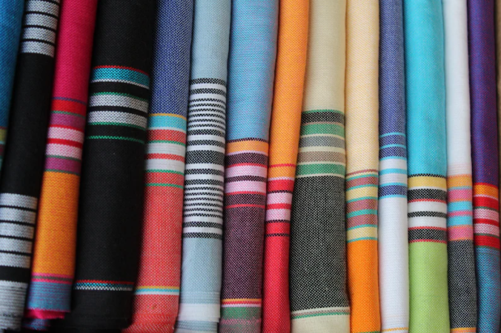 Figure 1. Kenyan Kikoi Cloth <https://www.etsy.com/listing/1110373488/kenyan-beach-kikoi-sarongkikoy-beach>

The term ***Kikoi*** “*KIKOY*” is a Swahili term that means “*wrap-around*” that is intended to be worn in several ways (ClipKulture, 2023). ***Kikoi*** refers to a traditional piece of colored cloth used as clothing, usually around the waist, legs, or shoulders. Typically, ***Kikoi*** is made of one hundred percent cotton and is woven by machine. ***Kikoi*** cloth is indigenous to the East African coast, specifically Kenya and Tanzania. Early examples of the use of kikoi were *sarongs*, originally worn by Arab merchants until East Africans adopted ***kikoi*** by trade (Gift, 2018). ***Kikoi*** cloths were first hand-loomed by local skilled craftsmen, but now they are commonly made by a machine. (Marhoun & Sampler, 1994). Varying in many colors, a kikoi’s top and bottom ends have contrasting colored stripes. ***Kikoi*** cloth communicates personal style, social/political stances, and Swahili pride (Mwedekeli, 2023). Typically measuring about 44″ wide and 66″ long, ***kikoi*** cloth is a staple item for Kenyan households. Utilized as baby slings, towels, head wraps, and covering for the lower portion of the body, ***kikoi*** cloth is essential for men, women, and children. The dying process for the ***kikoi*** cloth is called *batik*, an ancient Indonesian traditional method of dyeing garments using wax and dye (Gaffney, 2023). The ***kikoi*** cloth makes a great souvenir gift for visitors as it encapsulates Kenya’s identity and can be inexpensively purchased from the mainland. In Kenya, exceptional craftsmanship using upcycled material has become a social and economic resource that is widely appreciated and heavily influenced. Similar products utilized for the same purpose by African regions nearby include Kente print fabric, Kanga, Ankara, Adire, Isu Agu, and Barkcloth (CXDQtextiles, 2023). ***Kikoi*** cloth is special because of its durability and versatility. ***Kikoi*** cloth has *longevity* and the power to remain popular and sought after in many different regions throughout centuries. This proves its convenience and adequacy.

The most appropriate, reliable, and safest approach to expand the *Kikoi* cloth market into the United States would be to become a wholly owned subsidiary. In a wholly-owned subsidized company, 100% of an organization’s common stock is owned by its parent company (Kenton, 2022). Parent companies can diversify their product, manage their streamline, and reduce risk with subsidiary companies. For property and international distribution, it is best for Kenyan citizens to legalize their subsidiaries and apply for business permits (Giacobbe et al., 2015). For example, registering with the KRA and social services ensures legal compliance and operating freedom (Kenton, 2022). Parent companies offer subsidiaries interchangeable access, risk reduction, and brand recognition. Legally, subsidiaries are assets to parent companies and can operate independently from several locations. They maintain their own corporate culture, management structures, and service clients despite being owned by another entity (Park, 2012). It can take up to one year to legitimize a Kenya subsidiary, and subsidiaries can own other subsidiaries. Applying to become a wholly owned subsidized c*ompany* is a multi-step application process that can be submitted through [eCitizen](https://accounts.ecitizen.go.ke/en/), an online database on eRegulations, a website operated by Kenyan officials (Business et al. – Kenya, 2023). Subsidiaries in Kenya are positively impacted by the interchangeable access, risk reduction, and brand recognition offered by the relationship with parent companies. Access to intellectual property, modern equipment, and effective systems offered by a subsidiary’s parent company grows and stabilizes the Kenyan subsidiary. For the business to remain active, the subsidiary must pay dividends to its parent company and be in good standing (Lopez-Duarte & Vidal-Suarez, 2013). The distribution of *kikoi* cloth as a business to the United States may only be possible by establishing a subsidiary. Establishing a subsidiary will prepare Kenyan business owners for the due diligence performed by the International Trade Administration, ITA, and the Customs Services Departments, CDS (Kenya Intl. Trade Administration, 2023). ITA and CDS are government agencies entrusted with controlling and monitoring exports and imports.

The primary consumer groups for *kikoi* cloth would be **experiencers** and **achievers**. 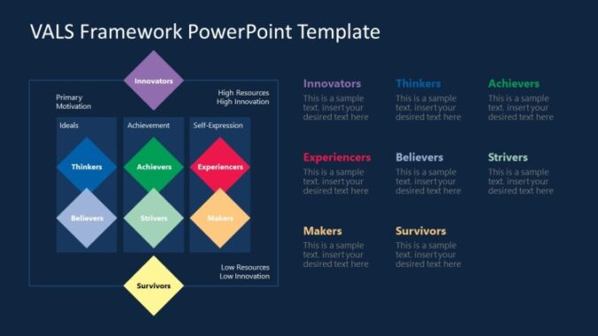

Figure 2. VALS Framework Template

Experiencers are known to be motivated by self-expression (VALS Survey, 2023). They are sociable and spontaneous and love physical activity (VALS Survey, 2023). They spend a comparatively high proportion of their income on fashion, entertainment, and socializing (VALS Survey 2023). Tourists, travelers, and Kenyan natives are examples of experiencers. Achievers are fun, loving people that can wear their wealth. They are interested in street culture and are carefree. (VALS Survey, 2023). They desire to better their lives and are motivated to strive and accomplish achievements (VALS Survey, 2023). Achievers place a high value on commitment to their families and jobs (Tondu, 2015).

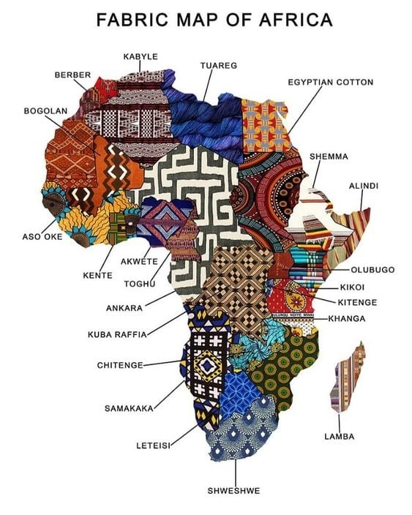

Figure 3. Fabric Map of Africa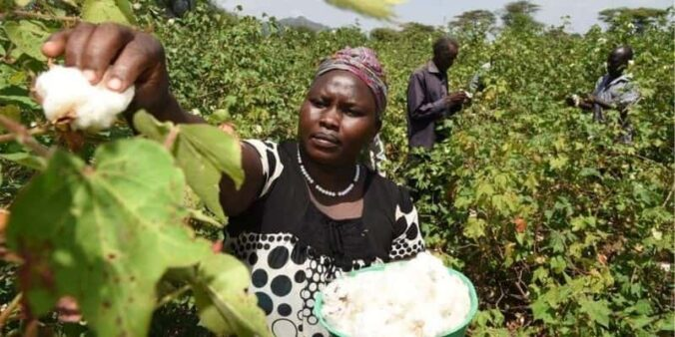

East Africa, primarily Kenya, historically known for its vibrant, full-of-life textiles and patterns, has made a mark In the African diaspora. For example, Kenya has birthed a few traditional fabrics like the Kitenge and Kikoi textiles. According to the article, “the kitenge is a cotton flowery designed fabric, produced in 40-meter rolls and sold in meters, or yards. The kitenge can be worn as a wrap or tailored into loosely flowing garments for women and currently for men’s casual shirts (Wanduara, 2018). The kitenge could be made into anything that the designer would like to create, like a shirt, pants, or even a dress. If the designer wants to incorporate it into something beautiful, they could do that if they would like. They outsource to other African countries since their local production is not as high. According to the article, “Local production is low, so imports from the West African countries fulfill the rest of the demand: Nigeria and Ghana (Wanduara, 2018). So, the textile “Kitenge ” does not have a strong textile industry manufacturing in Kenya; Kitenge is outsourced because to create this specific textile, they would need big manufacturing plants to create this specific textile. Meanwhile, “Kikoi,” the other textile fabric made in Kenya and outsourced from India, differs from “Kitenge” because the practices to make this textile differ from Kitenge. The article states, “This is a cotton striped fabric with fringes at the narrow ends, measuring about 1.5 meters by 1 meter. It is worn casually as a wrap for the lower torso for both men. The women may wear it on the upper body as well. Most kikoi fabric is locally manufactured, and some are imported from India. (Wanduara, 2018). One of the facts that one found intriguing is that Kenya found other textiles to be able to outsource but simultaneously keep some of the traditions in their country. The creation of indigenous textiles in Kenya is very important because they created something unique to their country. Even though their neighboring regional African countries have textiles, these fabrics adhere to the Kenyan culture from which these two textiles came to life. Natural fibers in Kenya are important to house natural resources because they are needed to maintain their crucial role in the country’s economy. This also helps maintain the deep-rooted culture within the country’s natural resources. According to the author, one may say that Kenya’s cotton-growing regions are in the western, eastern, coastal, and central regions, which in result caused cotton to increase from fifteen to twenty percent because they made sure that the quality of the cotton was intact and caused Kenya’s resources of cotton to be stable (Kegode, 2003). Sisal fiber, a fiber born in nature in Kenya and introduced recently as a sustainable natural fiber, is a durable and biodegradable material derived from the Agave sisalana plant. The luxurious patterns the Sisal fiber creates in its uniqueness are the rustic patterns/ weaves it creates (Sawa Sawa, 2023). Kenya is also home to a Bamboo fiber plant, which is becoming useful for creating products such as home furnishings and wooden jewelry (Maina, 2014). One may say that Kenya has put innovation to use with its ability to think outside of the box by turning natural fibers into sustainable creative projects that would still achieve the need for products to be created into a market that would still have natural handmade products, whereas with synthetic there is a difference in quality but still would be beneficial for international interest in doing business with them. Kenya is not a significant exporter of synthetic materials. However, they have a few synthetic materials that they still create even though they are still susceptible to other countries dumping their non-degradable clothing in Kenya and creating very hostile conditions for Kenyan people to survive the toxic clothing trade in place. According to the author, synthetic filament yarn is lab-created and derived from plastic used to create clothing, bags, and footwear (Wigmore Trading, 2021). Kenyan people are experiencing very unsafe conditions living with used clothing brushed up on the shore in big volumes, which is shipped to Kenya, and the waste of synthetic clothing is creating devastating consequences to its environment and people (Lu, 2023). According to the article, one may say that Kenya is filled with toxic fumes since it is extremely illegal to dump unwanted clothing in Kenya because it harms its waters and because it takes a long time for it to degrade, especially when the backbone of the Fashion Industry plastic clothing whether you donate it or keep it is still considered to be illegal when handing it out (Stinson, 2023). Even though it may seem that Kenya may not have fair trading practices in place and that other countries do not respect Kenya’s not to dump their old clothing there, Kenya is making strides in trying to combat this dyer issue.

Kenya’s apparel industry is vertically integrated, with 21 large companies in the Export Processing Zone (EPZ), 170 medium to large companies, and 70,000 micro to small companies outside the EPZ (Kohantextilejournal, 2021). The Cotton Textile Apparel (CTA) industry is Kenya’s second-largest manufacturing sector after the food processing industry and is considered a core industry. Kenya’s CTA manufacturing value chain includes researchers, ginners and farmers, spinners and input suppliers, textile producers, and extension service providers. Kenya’s current cotton lint production is about 7,000 tons, while the potential production is 200,000 tons (or 750,000 tons) of lint or seed cotton. Lint production in Kenya has been fluctuating in recent years and has not been enough to meet the demand of domestic mills. Consequently, Kenyan companies import cotton from neighboring cotton-producing countries like Uganda and Tanzania. Kenya has a total of 52 textile mills. Of these, only 15 are operating at below 45 percent of capacity. Electricity and high import costs are the main cost drivers for these companies (ITA, 2023). However, these textile mills support the livelihoods of Kenya’s neighboring countries. Morocco, Tunisia, and Ethiopia are Africa’s leading producers of textiles. Currently, Africa produces more than 90 percent of the world’s cotton crop. The cotton exported to the rest of the world is second-rate despite being harvested by hand (Abdouramane et al., 2022). Kenya’s textile and apparel value chain includes input providers, yarn spinners, semi and fully-integrated weaving/knitting/ dyeing/ finishing mills and plants, and design and sewing companies (Kohantextilejournal, 2021). A fully integrated value chain in the apparel sector could employ as many as 10% of the country’s population, as both cotton cultivation and apparel production are labor-intensive and employ many women. (Shiundu, 2022). One of the most significant advantages for the apparel industry in Kenya is implementing the AGO (African et al. Act) in 2000. The AGO Act grants duty-free access to the USA market to sub-Saharan African countries (Jesse, 2019). The duty-free access allows the exportation of goods into other countries for distribution and consumption.

Technological advances have changed how global markets operate, meaning Kenya and the manufacturing sector must keep pace with these trends (Alando, 2017). Kenya is relentlessly becoming one of the fastest-growing e-commerce markets in Africa, with many dealers and shoppers utilizing social media stages to advance, offer, and purchase items and administrations. The effects of COVID-19 have inclined people to consume their goods online; 38.07 million is the projected number of e-commerce users in Kenya by 2027. Sky Garden is a platform that allows consumers to purchase goods and pay in installments, making it feasible for Kenyans in rural areas to access the same quality of goods (Wanjiru, 2023). After food processing, the cotton, textiles, and apparel (CTA) sector is Kenya’s second-largest industrial sector and has been designated a core industry. Researchers, ginners, farmers, spinners, input suppliers, textile manufacturers, and extension service providers are just a few participants in Kenya’s CTA manufacturing value chain. Kenya now produces around 7,000 tons of cotton lint, compared to a possible 200,000 tons of lint or 750,000 tons of seed cotton. Production has been inconsistent since a few years ago and has fallen short of domestic mills’ needs. As a result, Kenyan businesses import cotton from nearby nations that also produce it, such as Tanzania and Uganda. One of Kenya’s most important cash crops is cotton. Kenya presently produces 25,000 cotton bales on average, far less than the 200,000 currently required. As a result, a significant amount of cotton is imported from other nearby nations to make up for the shortfall (Kohantextilejournal, 2021). The future of the green economy in Kenya is intertwined with the country’s green potential.

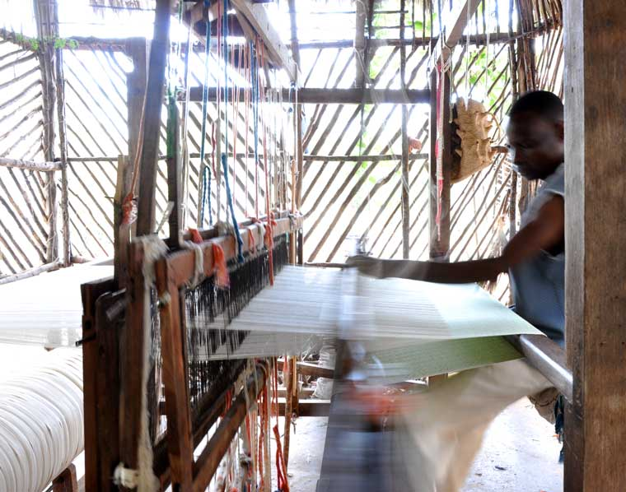

Figure 4. Master weaver looming ***Kikoi*** cloth.[https://motozanzibar.wordpress.com/handwoven-swahili-kikois](https://motozanzibar.wordpress.com/handwoven-swahili-kikois/)

Several steps have been taken to build a more environmentally friendly economy in Kenya, and the country produces the highest percentage of renewable energy in Africa, with 89.6% of its total electricity produced from renewable sources. With 89.6% of its total electricity production derived from renewables, it is Africa’s leader in wind and solar energy generation. Businesses and governments are increasingly considering the principles and practices of the circular economy (Ashraf & Seters, 2022). Local or regional suppliers are a large part of companies’ interest in using fabrics, but they simply cannot fulfill their requirements. Companies state that the following factors affect their performance: poor or uneven quality, incorrectness, and failure to comply with technological specifications. Most of the textiles needed by garment companies exporting to export markets are imported, mainly from China. It is not the cost that makes it necessary to import these articles but rather a lack of availability because domestic producers cannot comply with both volume and quality requirements (Vbodmer, 2020). Technology has transformed the way people do business in and with Kenya.

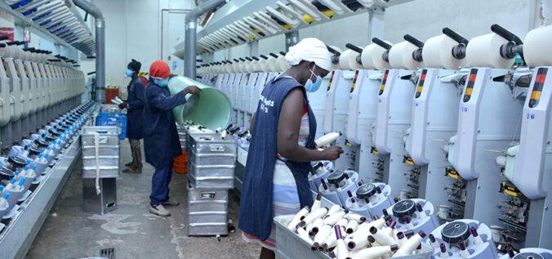

Figure 5. Cotton Processing and Ginning, April 1, 2022, <https://sectors.kenyayearbook.co.ke/2022/04/01/cotton-processing-ginning/>

**References**

Abdouramane, N., Efeze, N. D., Noah, P. M. A., Betene, F. E., Valery, H. G., Geraldo, S. A., … Ngum, N. L. (2022). Retrieved from <https://www.internationaljournalssrg.org/IJEMS/2022/Volume9-Issue1/IJEMS-V9I1P107.pdf>

Ashraf , N. A., & Seters, J. van. (2022). <https://ecdpm.org/work/kenyas-potential-sustainable-textiles>

Business Registration Service – Kenya. (2023, June 13). *Doing Business Made Easier*. Business Registration Service. https://brs.go.ke/

*Centre, U. W. H. (n.d.). Kenya Lake System in the Great Rift Valley. UNESCO World Heritage Centre.* [*https://whc.unesco.org/en/list/1060/*](https://whc.unesco.org/en/list/1060/)

ClipKulture. (2023, April 30). *Kikoi and Maasai Shuka fashion trends: Include these in your wardrobe*. Clipkulture. https://clipkulture.com/kikoi-and-maasai-shuka-fashion-trends-include-these-in-your-wardrobe/

CXDQtextile. (2023, April 2). *Discover the different types of African print fabric*. https://www.cxdqtextile.com/blog/types-of-african-print-fabric/

Gaffney, D. (2023). *What is Batik?*. What is Batik? | The Batik Guild. https://www.batikguild.org.uk/batik/what-is-batik

Giacobbe, F., Matolcsy, Z., & Wakefield, J. (2015, April). An Investigation of Wholly-Owned Foreign Subsidiary Control Through Transaction Cost Economics Theory. <https://onlinelibrary-wiley-com.citytech.ezproxy.cuny.edu/doi/full/10.1111/ajes.12241>

Gift, M. (2019, April 15). *What is the story of the Kikoi? – origins of Kikoys / Kikois –*. Mzansi Gift. <https://www.mzansigift.com/index.php/2018/06/27/origins-story-of-the-kikoi/#:~:text=The%20kikoi%20is%20a%20traditional,the%20most%20famous%20African%20fabric>.

Italian Trade Agency. (2015). Textile Industry in Kenya. https://www.ice.it/it/area-clienti/eventi/allegato-evento/28087/allegato.pdf

Jesse. (2019). Retrieved from https://blog.bizvibe.com/blog/textiles-and-garments/kenyas-textile-apparel-industry-revive

*Kenya*. Countries and Their Cultures. (n.d.). <https://www.everyculture.com/Ja-Ma/Kenya.html#:~:text=Many%20Luo%20are%20fishermen%20and,of%20Indian%20or%20Arab%20descent>.

*Kenyan soils*. Return to site content. (G. Kimaru). [https://infonet-biovision.org/EnvironmentalHealth/kenyan-soils#:~:text=Soil%20resources%20vary%20from%20sandy,%2C%20lixisols%2C%20luvisols%20and%20nitisol](https://infonet-biovision.org/EnvironmentalHealth/kenyan-soils#:~:text=Soil%20resources%20vary%20from%20sandy,%2C%20lixisols%2C%20luvisols%20and%20nitisols)s

Kenton, W. (2023, July 7). *What is a wholly-owned subsidiary?*. Investopedia. [https://www.investopedia.com/terms/w/whollyownedsubsidiary.asp#:~:text=A%20wholly%2Downed%20subsidiary%20is,no%](https://www.investopedia.com/terms/w/whollyownedsubsidiary.asp#:~:text=A%20wholly%2Downed%20subsidiary%20is,no%20obligations%20to%20minority%20shareholders)

Kohan Textile Journal. (2022, June). *Textile Industry in Kenya*. Middle East Africa Textile News – Kohan Textile Journal. <https://kohantextilejournal.com/textile-industry-in-kenya/>

Lopez-Duarte, C., & Vidal-Suarez, M. (2013). Cultural distance and the choice between wholly owned subsidiaries and joint ventures. <https://www-sciencedirect-com.citytech.ezproxy.cuny.edu/science/article/pii/S0148296312000495>

Maina, S. (2014). *Mainstreaming Indigenous Natural Fibres for eco-friendly African …* Mainstreaming Indigenous Natural Fibres for Eco-Friendly African Product Design in Kenya: A Case Study of (Mugio) Triumfeta Macrophylla Fibre. <https://www.researchgate.net/publication/322519463_Mainstreaming_Indigenous_Natural_Fibres_for_Eco-Friendly_African_Product_Design_in_Kenya_A_Case_Study_of_Mugio_Triumfeta_Macrophylla_Fibre>

Marhoum, A, Sampler, D. East Africa Living Encyclopedia. (2023). <https://www.africa.upenn.edu/newsite/pages/Ali/eastafricanencyl/newone/kenya/kmculture.html>

Mutuku, R. (2022, November 28). *The history of entrepreneurship in Kenya and its evolution*. Tuko.co.ke – Kenya news. <https://www.tuko.co.ke/263846-history-of-entrepreneurship-kenya.html>

Mwedekeli, L. (2023, January). *“Fom Grass to Glory: The Story of Kikoy Fabric by Afrobatics.”* afropoa. <https://www.afropoa.com/post/the-history-of-kenyan-kikoy-by-afrobatics>

Park, B. (2012). What changes the rules of the game in wholly owned subsidiaries? Determinants of knowledge acquisition from parent firms. <https://www-sciencedirect-com.citytech.ezproxy.cuny.edu/science/article/pii/S0969593111001363>

Shiundu, A. (2022). Retrieved from https://www.dandc.eu/en/article/kenyas-textile-and-apparel-sector-struggling-various-bottlenecks

Simborio, T. S. (2023). Retrieved from <https://www.willflyforfood.net/food-in-kenya/>

Stinson, G. (2023, February 24). *“ground zero of the Fast Fashion World:” how Kenya became the fashion industry’s illegal junkyard*. Impakter. <https://impakter.com/ground-zero-fast-fashion-world-kenya-fashion-industrys-eu-waste-illegal-junkyard/>

Tech, F. T., Corporation, F. R., GmbH, F. C. Z. M., From Carl Zeiss – Raw Materials, & Ltd, F. K. I. (2019, August 15). *Kenya: Mining, minerals and fuel resources*. AZoMining.com. <https://www.azomining.com/Article.aspx?ArticleID=143#:~:text=The%20natural%20resources%20of%20Kenya,zinc%2C%20wildlife%2C%20and%20hydropower>.

Tondu, T. (2015). VALS Types – linkedin. https://www.linkedin.com/pulse/vals-types-thaddeus-tondu

Trading, W. (2022, July 19). *Wigmore trading- knitting yarn, weaving fabric in KenyaWi*. Wigmore Trading Nigeria. https://wigmoretrading.com/buy-synthetic-filament-yarn-woven-fabric-in-kenya-with-wigmore-trading/

Wambugi, J. (2017, February 9). *An Introduction to Kenyan Traditional Dress*. Culture Trip.

Wanduara, M. (2018). *Looking at the Past and Current Status of Kenya ’ s Clothing and Textiles*. Digital Commons at University of Nebraska. https://digitalcommons.unl.edu/cgi/viewcontent.cgi?article=2121&context=tsaconf

Wanjiru, J. (2023). Technology a Key Driver for Growth in the E-Commerce Sector <https://www.citizen.digital/opinion-blogs/opinion-technology-a-key-driver-for-growth-of-the-e-commerce-sector-n318154>

World Bank Group. (2019). Kenya Economic Update: Accelerating Kenya’s Digital Economy [https://www.worldbank.org/en/country/kenya/publication/kenya-economic-update-accelerating-kenyas-digital-economy#:~:text=Known%20as%20the%20“Silicon%20Savannah,every%20sector%20of%20the%20econom](https://www.worldbank.org/en/country/kenya/publication/kenya-economic-update-accelerating-kenyas-digital-economy#:~:text=Known%20as%20the%20%E2%80%9CSilicon%20Savannah,every%20sector%20of%20the%20economy)y

Vbodmer. (2020). Technology Upgrading in East Africa’s Textiles and Apparel Sector <https://textile-future.com/archives/35228>