Designer Research Paper

The designer I've chosen is Massimo Vignelli . He is an Italian designer who worked in a number of areas such as packaging, houseware, furniture, public signage, and showroom design. But he’s most famous for his of the Map of the New York City Subway. He based his work off of modernism and simplicity. In 1965 he and his wife, Lella moved to Chicago where they founded Unimar International that focused on graphic design for larger compaines. 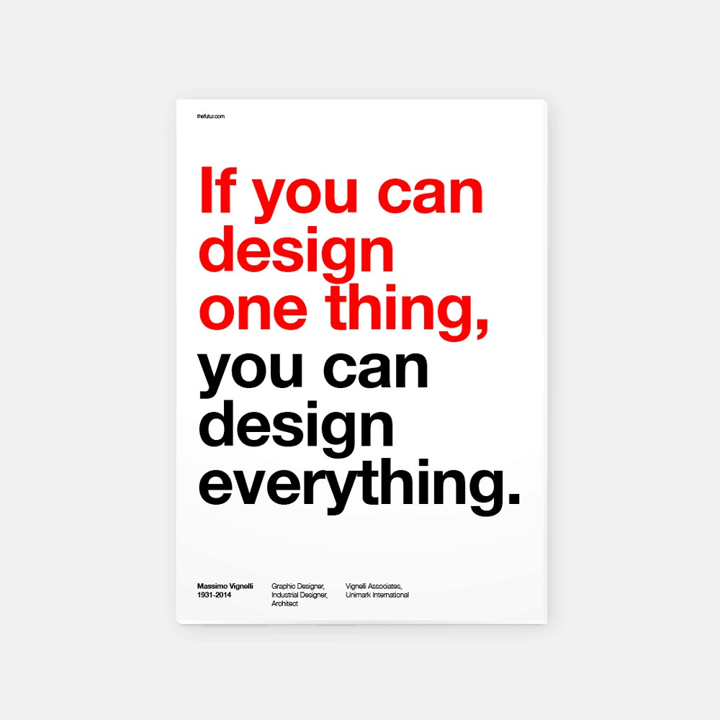
In 1966, Vignelli expanded the company and launched another second Unimar headquarters in New York. Then it became the largest company in the world. The Work that Vignelli is known for is the map of the New York City Subway System. During his career, he taught at the Institute of Design in Chicago, Umanitaria School in Milan, the University of Venice’s School of Design, Columbia University’s School of Architecture, Philadelphia College of Art, the Parsons School of Design. He even gave lectures in the USA, Europe, and China. He also designed the logos of The Ford Motor Company, Washington DC Metro, American Airlines, and Bloomingdales
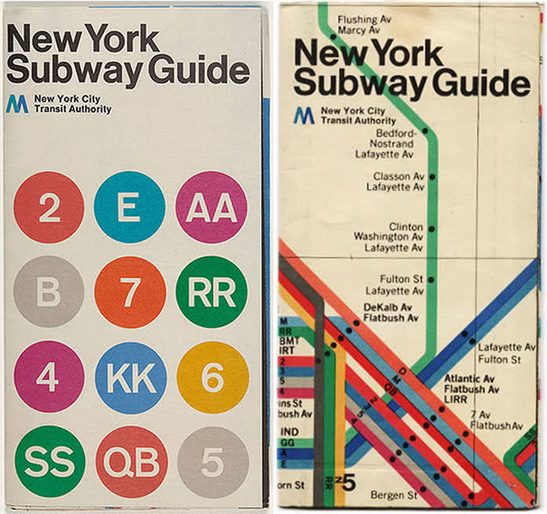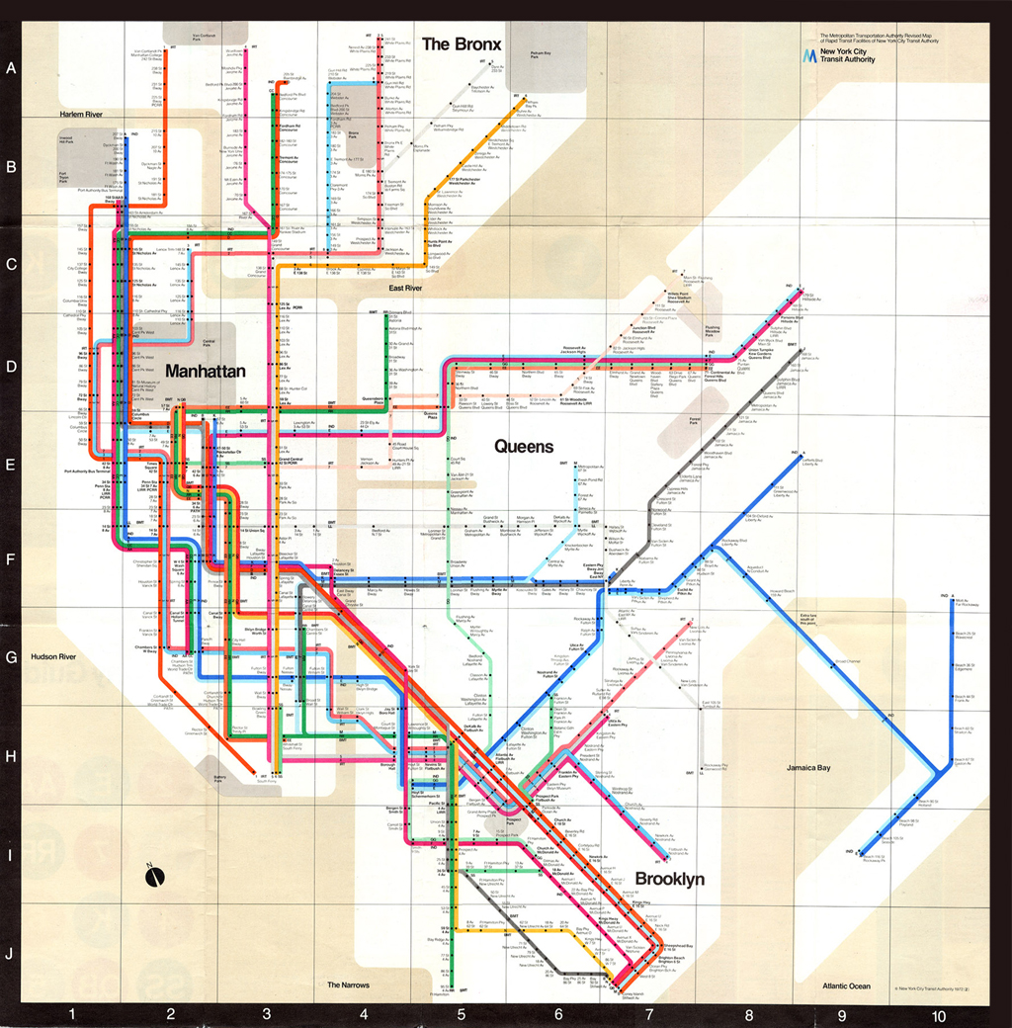
Not only Vignelli was in the graphic design field, he designed dinnerware. His iconic dinnerware, “Heller” was released in 1964. He even won that years Compasso d’Oro award for it’s good design. It became the touchstone of modern design and has been called the “icon of the sixties utilitarian chic”. It was introduced in the U.S. in 1971 and has never been out of production with it still in its original molds.

