Irena Shlomov
DEN 2315 Pharmacology
Summer 2020

Dong quai

Dong quai, known as Angelica sinensis, tang-kuei, dang-gui, and Chinese angelica, is derived from the root of the Chinese herbal Angelica sinensis. It has been used for many years in traditional Far Eastern medicine. Dong quai has been used for various health conditions affecting women, which include: dysmenorrhea, pelvic pain, recovery from childbirth and menopausal symptoms, and has also been used to manage hypertension, joint pain, ulcers, anemia, and constipation as well psoriasis and many other conditions. The root of Dong quai has shown an effect on estrogen and other hormones in animals, however there is no evidence of the same effects occurring in humans. Dong quai is a member of the celery family and grows at high altitudes in cold, damp mountain ravines, meadows, river banks, and coastal areas of China, Korea, and Japan. This remedy is available in various formulations, tablets, capsules, tinctures, and tea and it is also used in some topical creams or powders.
In the United States, the FDA has not approved this product yet. The manufacturers are the ones who are responsible to ensure the safety of this product, however they do not have to demonstrate its efficacy and safety before its marketed. It has been shown that Dong quai may have severe side effects and therefore special precautions have to be taken in people who have bleeding disorders for whom this product can further slow the blood clotting and therefore increase the chances of bruising and severe bleeding. Special precautions have to be taken with pregnant women for whom this product is contraindicated as well as for breastfeeding women since this product is unsafe for the baby. Dong quai has estrogen- like properties, therefore patients with hormone sensitive conditions such as breast cancer, untrine cancer, ovarian cancer, endometriosis, or uterine fibroids should not take this product which could exacerbate their conditions. Another contraindication for Dong quai is protein S deficiency, which predisposes some people to increased bleeding. People who take Dong quai should discontinue taking it 2 weeks before any surgery.
Dong quai has important interactions with other drugs such as Warfarin (Comadin) which is used to prevent blood clotting and which taken together with Dong quai may lead to uncontrolled bleeding. Additionally, anticoagulant and antiplatelet drugs such as clopidogrel (Plavix), diclofenac (Voltaren), Cataflam,, ibuprofen (Advil, Motrin, others), naproxen (Anaprox, Naprosyn, others), dalteparin (Fragmin), enoxaparin (Lovenox), heparin, apixaban (Eliquis), rivaroxaban (Xarelto) and aspirin may slow blood clotting and will increase the chances of bleeding when combined with Dong quai.
In a similar fashion, Dong quai may interact with other herbal remedies which may affect the blood coagulation such as garlic, ginger, ginkgo, panax, ginseng, poplar, re clover and willow. Apart from its contraindications and interactions with other drugs Dong quai may have some side effects that include a drop in blood pressure, difficulty breathing, drowsiness, fever, headaches, increase in bleeding, upset stomach, low blood sugar, sweating, difficulty in sleeping, photosensitivity and also loss of vision. Multiple FDA approved medications such as NSAID’s (Naproxen Celebrex, ibuprofen), etc., have similar anti pain effects but unlike Dong quai, they have been thoroughly studied and approved by FDA. Despite the potential severe side effects and contraindications of Dong quai, a large number of people continue to take this product due to the fact that it is part of the popular culture, it is relatively cheap and can be obtained without the hassle of a formal doctor’s appointment. The popular remedies have an important role in the written and oral history of many ethnic populations and modern science is met with a lot of resistance due to the confidence in the old popular herbal products.
It is very important for a dental hygienist to become familiar not only with the major classes and effects of FDA approved medications, but also with natural medications, remedies and plants-based preparations commonly used in the population, and especially in the particular population served by the hygienist. Different cultures and ethnicities use a variety of more-or-less scientifically proven remedies, some of which may have some benefit and many, which have no benefit or can be toxic and interfere with the activity of legitimately prescribed medications.
Ideally, all persons taking an unapproved medication or plant-based remedy should investigate their benefits and potential side effects and contraindications and notify their primary care physician of their intention to take this product. All health practitioners should routinely encourage their patients to google the product they intend to take and to look them up on specific medical sites such as WebMD.
In the case of Dong quai, which apparently has been prescribed as a miracle cure for pain as well as a cure for various illness, the hygienist should be alert to the side effects of this medication on the patient’s mouth. A thorough history taking by the dental hygienist will alert the dentist or oral surgeon to the patient’s use of this potentially dangerous remedy and prevent complications during complex procedures, which require a normal coagulation function.
The dental hygienist has to use every opportunity and interaction with the patients to be an educator and advocate for the patients, enlightening them to the benefits and risks associated with the use of empiric and not formally approved medications. As for the specific use of Dong quai, I personally would not recommend to any patient but I would routinely ask all my patients about their use of unapproved popular remedies such as Dong Quai.
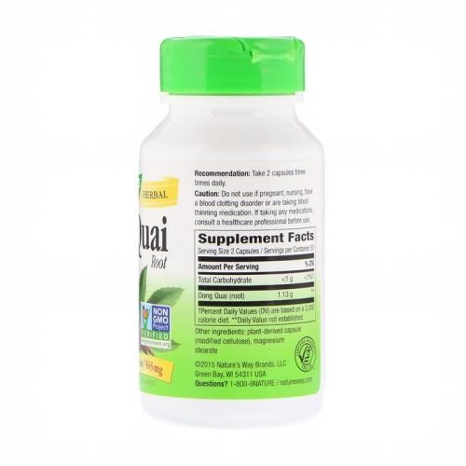
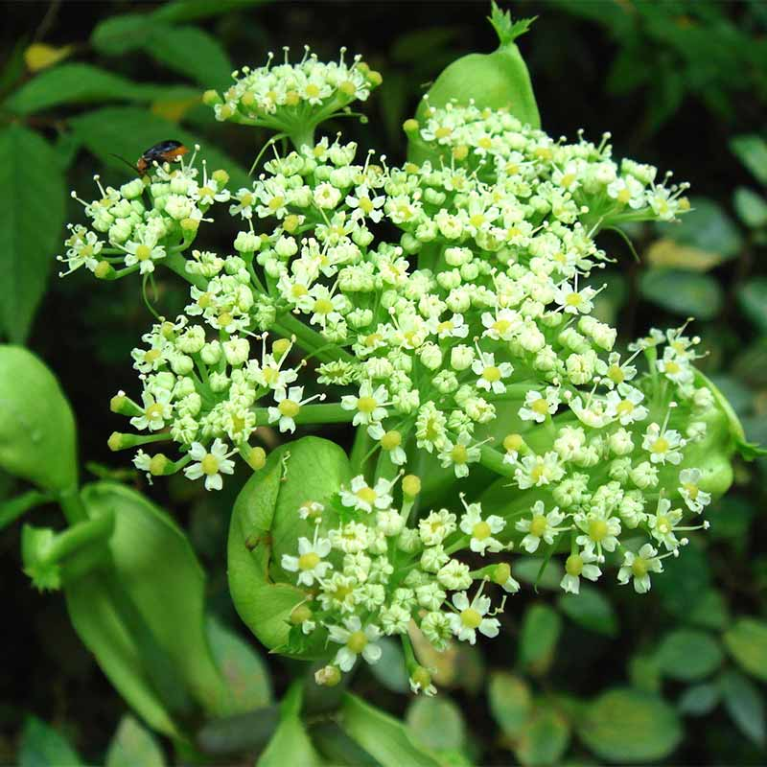
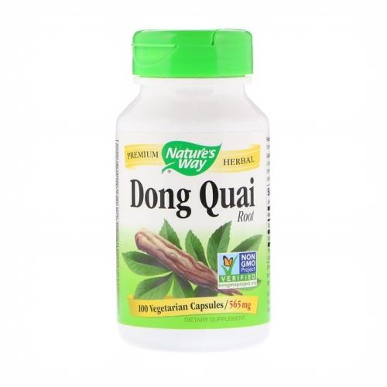

References
- Dong Quai: MedlinePlus Supplements. (n.d.). Retrieved June 30, 2020, from https://medlineplus.gov/druginfo/natural/936.html
- DeRosa, R., & Cupp, M. (1970, January 01). Dong Quai. Retrieved June 30, 2020, from https://link.springer.com/chapter/10.1007/978-1-59259-020-9_28
- Dong Quai. (n.d.). Retrieved June 30, 2020, from https://www.mskcc.org/cancer-care/integrative-medicine/herbs/dong-quai
- Al-Bareeq, R., Ray, A., Nott, L., Pautler, S., & Razvi, H. (2010, February). Dong Quai (angelica sinensis) in the treatment of hot flashes for men on androgen deprivation therapy: Results of a randomized double-blind placebo-controlled trial. Retrieved June 30, 2020, from https://www.ncbi.nlm.nih.gov/pmc/articles/PMC2811999/
- Dong Quai. (2018, December 03). Retrieved June 30, 2020, from https://www.ncbi.nlm.nih.gov/books/NBK501836/
- Dong Quai: Health Benefits, Uses, Side Effects, Dosage & Interactions. (2019, September 17). Retrieved June 30, 2020, from https://www.rxlist.com/dong_quai/supplements.htm
- Angelica sinensis. (2020, May 10). Retrieved July 01, 2020, from https://en.wikipedia.org/wiki/Angelica_sinensis

