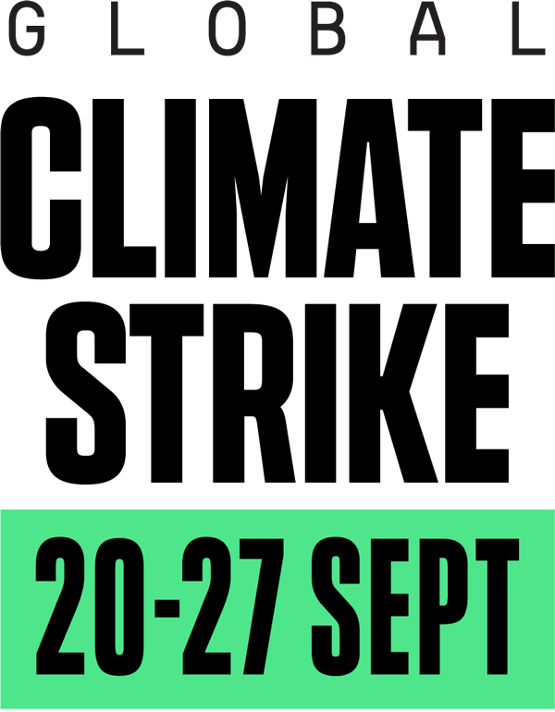
This September, millions of us will walk out of our workplaces and homes to join young climate strikers on the streets and demand an end to the age of fossil fuels.
Our house is on fire — let’s act like it. We demand climate justice for everyone.

Dear Students,

I am happy you will be attending the Global Climate Strike this Friday, September 20 trying to gather information for the class presentation we discussed. As I explained, you are expected to do some ethnographic work involving observation, data gathering and analysis which you will provide in a final power point presentation due at the end of October.

While at the protest take photographs of signs, banners or other artifacts that people have put together to communicate their message. Try to document any groups and organizations you might see in attendance so you can look them up later and gather further information. Record and videotape any speeches. Greta Thunberg, for instance, the young environmental activist from Sweden will definitely give a speech. Find out who the speakers are and try to record as many of those speeches as possible.

Walk around and observe the crowd. What age groups, genders, races, ethnicities do you mostly see? Furthermore, make sure that you talk to as many people as possible. Pay attention to police presence, security and anything else that you might consider worth of discussion.

Conduct some brief interviews. Approach people and politely introduce yourselves, explain that you would like to talk to them for a class project and ask their permission to videotape them, if you choose to do so. If not you should take notes. Ask questions such as – What brings you here today? – What you hope to achieve? – Is this the first time you participate in a protest or you have been politically active before? – What you see as the most pressing issues regarding climate change and its reversal? – Have you been working with a group or organization? – How you think we should go about in order to avert further environmental disasters? Politely ask them if they would like to state their age and occupation.

Be bold, assertive and did I mention, polite? Most often people want to communicate their message and they will be happy to talk to you!

I look forward to discussing your observations and your overall experience!

