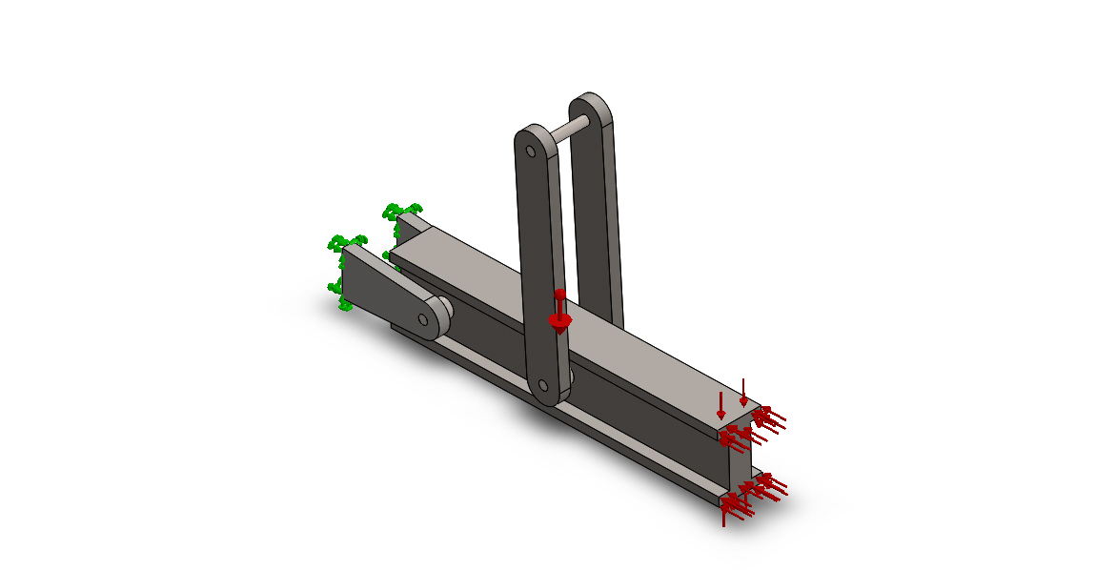
EX02
<L_MdInf_SldBd_Nm/> | Treated As | Volumetric Properties | Document Path/Date Modified
Boss-Extrude1  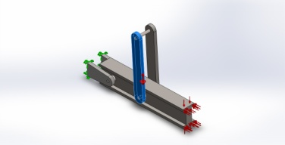 | Solid Body | Mass:58.9371 kg  Volume:0.00750791 m^3  Density:7850 kg/m^3  Weight:577.583 N | EX02
Boss-Extrude1  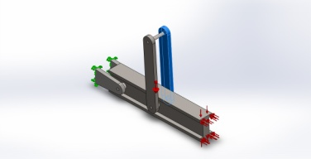 | Solid Body | Mass:58.9371 kg  Volume:0.00750791 m^3  Density:7850 kg/m^3  Weight:577.583 N | EX02

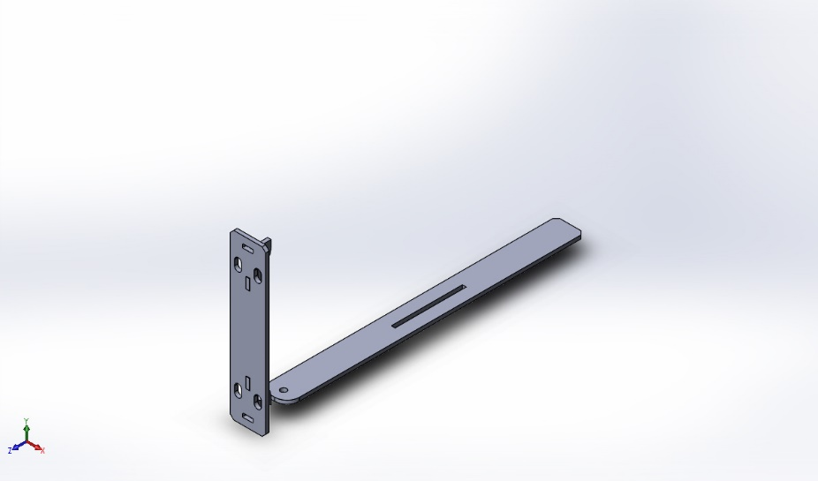 | Simulation BEAM  Date: Wednesday, November 13, 2019  Designer: Viki Bailey  Study name: EX01

Model name: svet_01
Current Configuration: По умолчанию
Solid Bodies
Document Name and Reference | Treated As | Volumetric Properties | Document Path/Date Modified
Chamfer1  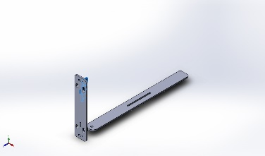 | Solid Body | Mass:5.91916e-005 kg  Volume:5.91916e-005 m^3  Density:1 kg/m^3  Weight:0.000580077 N | EX01
Chamfer1  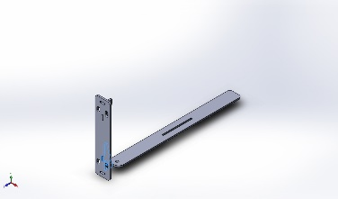 | Solid Body | Mass:5.91916e-005 kg  Volume:5.91916e-005 m^3  Density:1 kg/m^3  Weight:0.000580077 N | EX01
Chamfer1  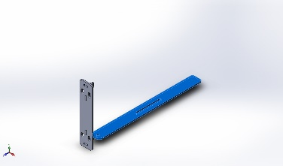 | Solid Body | Mass:0.000641786 kg  Volume:0.000641786 m^3  Density:1 kg/m^3  Weight:0.0062895 N | EX01

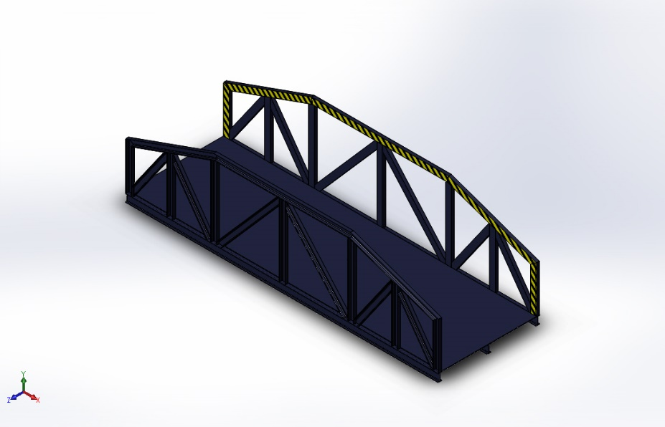 | Simulation BEAM  Date: Wednesday, November 13, 2019  Designer: Viki Bailey  Study name: EX03

Model Information

Model name: The Bridge 2
Current Configuration: Default<As Machined>
Beam Bodies:
Document Name and Reference | Formulation | Properties | Document Path/Date Modified
Beam-1(H section 200 X 100 X 21(1)[6])  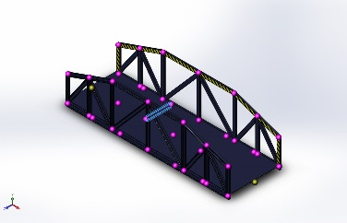 | Beam – Uniform C/S | Section Standard-AVP Frequently use/H Section/200 x 100 x 21  Section Area: 0.00266694m^2  Length:1188.32mm  Volume:0.00316628m^3  Mass Density:7860kg/m^3  Mass:24.887kg  Weight:243.892N | EX03

