Solar Panel Side Walk patches/ Street Patches and Glass Curtain Window Receptors.

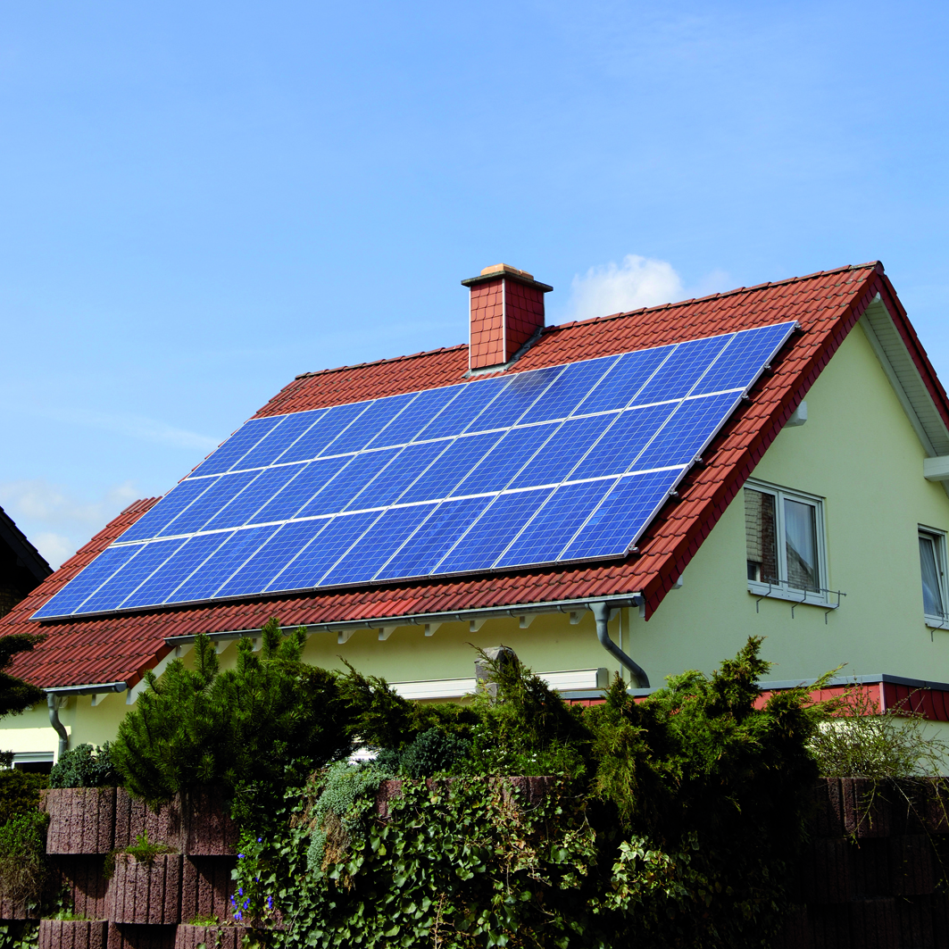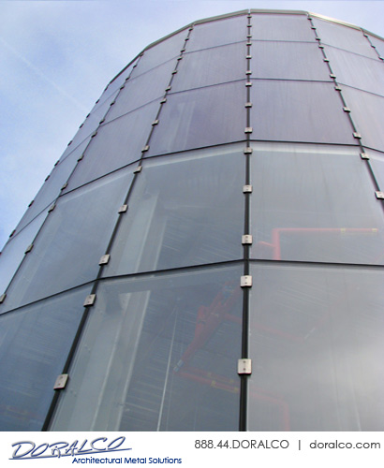

- Solar energy is a completely free source of energy and it is found in abundance. Though the sun is 90 million miles from the earth, it takes less than 10 minutes for light to travel from that much of distance.
- The Government already support people who make the move to solr eneregy. It's only the next step we should take.
- It’ll put more money in our pockets
- 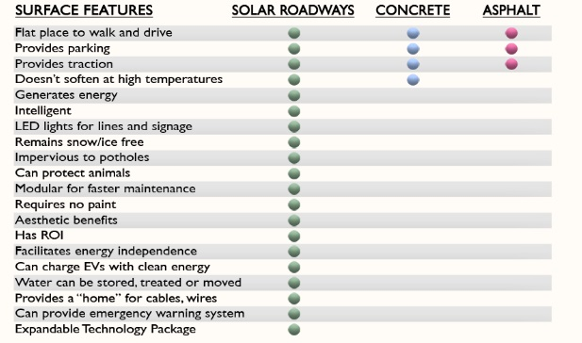

Most Reliable source of energy in the Universe !

