Islam Mahrouss
Digital Media Foundations
May 19, 2019
Graphic Designer Paula Scher
Throughout history there were many famous graphic designers such as Paul Rand, Saul Bass, and Wolfgang Weingart. Graphic designers are important because they create important visuals that send direct messages to the viewer in an artistic way. We see examples of these in our everyday lives. Every logo, poster, and sign you see has been made by a graphic designer. Throughout time design has changed and it still is changing to this very day. This industry has some revolutionary people such as Paula Scher. Paula Scher is a contemporary graphic designer, painter, and an art educator. Scher is most known for her iconic theater posters and her use of illustrated type. In her early life, Scher grew up in Washington DC and Philadelphia. Her father was photogrammetric which is what inspired her to start making hand printed maps. In 1970 Scher completed her Bachelor of Fine Arts at the Tyler School of Art in Pennsylvania. She soon moved to New York to start her first job as a designer. Throughout her career Scher has worked for many companies such as CBS, Atlantic Records, Pentagram, and etc.
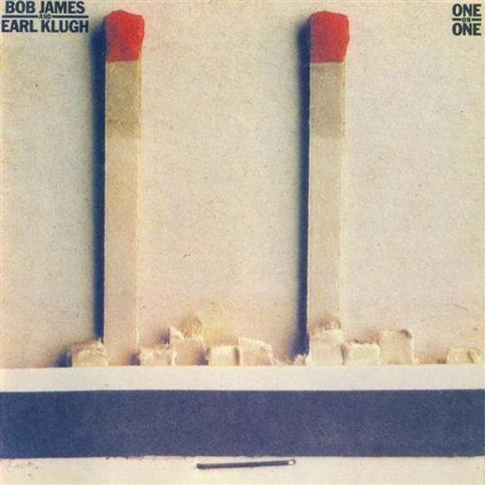
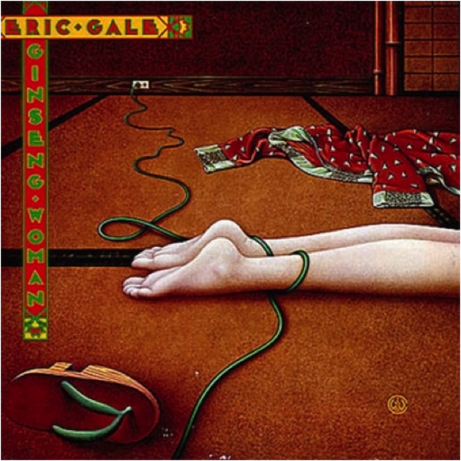
In her early career Scher worked at CBS and Atlantic records as an art director. It is believed that she has created over 150 designs a year. Some of those album cover designs were for people such as Eric Gale, Leonard Bernstein, and Bob James. In 1982 Scher had left CBS Records to work on her own. It was during those time where she developed one of the thing that makes her work truly unique to her which is her typographic style. She was inspired by the Russian constructivism and art deco style which helped develop her own style of typography. “I could never do the type on my projects, I could come up with an idea and I would illustrate the idea but he said to me: ‘Why don’t you illustrate with type?’ So I began drawing the type and discovering that typography could have form and then later when I began setting type at CBS Records, I found that you could be expressive simply by making choices(John L Walters)”. This quote from Scher describes how she came upon illustrating type in her college career. With the combination of the art deco and Russian constructivism style, as well as illustration she came upon developing her style as a graphic designer. One of the unique aspects of Scher’s style is her illustrated type in her designs. She is not a Designer but also a painter so combining both together helps makes her designs stronger. She carried this style of expressing typography as well in her work at CBS by just making choices such as the arrangement of type on the page.
In 1991 Scher had become a partner at the Pentagram in their New York office. This partnership lead to her designing a variety of work including identity images for Citibank and the The Metropolitan Opera. There were also many more such exhibitions, editorial, and environmental work. Scher's most popular design work also included her theater posters. Her theater posters have changed and influenced how theatrical and promotional posters are designed today. Scher’s challenge with creating a poster for the Public Theater was trying to have it bring attention to a diverse crowd. She solved this solution by creating posters influenced by street typography and graffiti style arrangements. “In 1995, Paula Scher and her Pentagram team created promotional campaigns for The Public Theater’s production of Savion Glover Bring in Da Noise, Bring in ‘Da Funk that featured the wood typefaces used throughout The Public Theater’s identity. Scher was inspired by Rob Ray Kelly’s American Wood Types and the Victorian theater's poster when she created the cacophony of disparate wood typefaces, silhouetted photographs and bright flat colors for the theater's posters and billboard(www.history graphic design.com)”. The Public Theater is one of the projects that Scher has done at the Pentagram and in this article she mentions her source of inspiration from the victorian posters where she used the type face, flat colors, and photographs. All these elements can be seen in many of her posters.
In conclusion, aside from her successful work in design from CBS records, Atlantic records, Pentagram, and The public Theater Scher was also a educator. She taught design at the School of Visual Arts. Scher has also won many awards such as the Beacon Award, Chrysler Design Award, AIGA Medal, and the Type Directors Club Medal. Scher has revolutionized the industry of graphic design with her work. She has introduced new styles while combining both design and illustration. We can see these influences in many of her projects such as her album covers and theater posters. Her iconic imagery and designs will one day inspire the future generation of designers in this continuously changing industry.

Works Cited
“Paula Scher.” History of Graphic Design, www.historygraphicdesign.com/the-age-of-information/postmodern-design/207-paula-scher.
“Paula Scher | Biography, Designs and Facts.” Famous Graphic Designers, www.famousgraphicdesigners.org/paula-scher.
“Eye Magazine.” Eye Magazine | Feature | Reputations: Paula Scher, www.eyemagazine.com/feature/article/reputations-paula-scher.
Dunne, Carey. “Graphic Designer Paula Scher: ‘I Figured Out Every Identity I've Ever Done In A Taxicab.’” Fast Company, Fast Company, 13 Apr. 2015, www.fastcompany.com/3043997/graphic-designer-paula-scher-i-figured-out-every-identity-ive-ever-done-in-a-taxicab.
“1974-1983 CBS/Atlantic Records.” Paula Scher, paulastribute.weebly.com/1974-1983-cbsatlantic-records.html.

