**OSTEOBLASTOMA**

Oral Pathology DEN2311/8243

Inesa Legrian



**OSTEOBLASTOMA**

Osteoblastoma is a benigh bone tumor that arises from osteoblasts. It accounts for about 1% of all bone tumors. The most frequently effected bones with osteoblastoma are the vertebral column, sacrum, cavlarium, long bones, and the small bones of the hands and feet. However, osteoblastoma may develop within jaws; there is a slight mandubular predilection, with most examples of arising in the posterior regions. The most common locations in the skull are calvarial bones, the temporal bones, and the parietal bones. It is also was reported hat osteoblastoma was seen in thyroid cartilage. Diagnosing osteoblastoma at first clinical presentation is usually difficult because of its rarity and nonspecific presentation. At clinical inspection, a bone expansion of hard consistency is detectable that manifests benign features because of slow and progressive growth and absence of mucosal ulceration, paresthesia, or abnormal tooth mobility. Approximately 85% of osteoblastoma occur before age 30, and there is slight female predominance.

Most osteoblastomas are between 2 and 4 cm, but they may be as large as 10 cm. Common futures of osteoblastoma arising from jaw are pain, tenderness, and swelling. Diagnosing osteoblastoma at first clinical presentation is usually difficult because of its rarity and nonspecific presentation. At clinical inspection, a bone expansion of hard consistency is detectable that manifests benign features because of slow and progressive growth and absence of mucosal ulceration, paresthesia, or abnormal tooth mobility. The radiographic appearance of osteoblastoma is variable, often nonspecific, and can mimic other tumors, including malignant ones. Osteoblastoma may appear as a well-defined or ill-defined radiolucent lesion; however, in some cases it may present as a bony outgrowth projecting form the periosteum without evidence of a more central destructive process. When osteoblastoma occurs in the jaw it is difficult to distinguish it histological from cementoblastoma. To make a differentiation between them it is important to confirm whether or not the tumor is connecting with the tooth root.

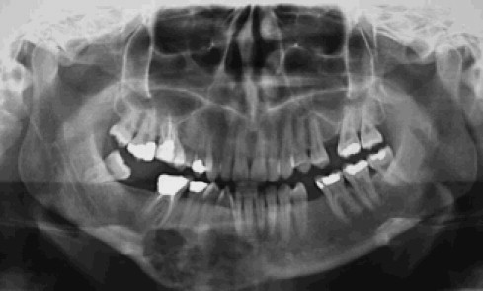http://www.sciencedirect.com/science/article/pii/S026643561100698X

In group of people older than 30 years, osteoblastoma may occur as an aggressive osteoblastoma which tends to be large than conventional osteoblastoma greater than 4 cm in diameter. Pain is a common severe symptom. Radiografically this lesion appears same as conventional osteoblastom but tend to be larger.

Most cases of osteoblastoma are treated by local excision or curettage. The prognosis is good if the lesion has been removed completely; however, a small number of lesions will recur; in rare instances an osteoblastoma may undergo transformation into an osteosarcoma. Although about 50% of aggressive osteoblastoma will recur, metastasis or death from the tumor has not been reported.

Dental hygienist should carefully focus on any significant findings during extra and intra oral examination. Osteoblastoma is a significant finding that should be taken into consideration. A team approach is necessary to identify, diagnose, and provide necessary treatment for patients with this condition. Dental hygienist should question the patient for the symptoms, provide necessary procedure such as PAN, x-rays, and refer a patient to a specialist.

References:

https://www.jstage.jst.go.jp/article/omp/14/1/14_1_37/_pdf Book: “Oral and Maxillofacial Pathology” David Lucas “Osteoblastoma”. Accepted for publication May 24, 2010. From the Department of Pathology, University of Michigan, Ann Arbor.