MVRAL

WHO WE ARE MVRAL is a carefully designed line that represents art, positivity and culture through our clothing. It's crucial that we explain our intentions with this brand because our company involves more than just clothing and apparel. Here at MVRAL we look at our line as a movement and an impact to society as a whole. Every piece that our company releases are carefully designed by a group of fashion designers graduated from schools such as Central Saint Martins, Parsons School Of Design, London College of Fashion and other Universities around the world. These fashion designers team up with artists, and when we say artists we speak for everyone across the spectrum. Artists in architecture, sculpture, painting, literature, music, performing and film. “As a means to cope, many young designers are adopting a collaborative spirit, looking to the world of art to draw inspiration from in which to apply to their respective crafts.(The Rise of Art Collaborations in Streetwear, Hypebeast)” These seven forms of art and the individuals who are passionate about it create the muse for our clothing. Along with our concept, MVRAL gives back to society whether it's building schools in other countries to lowering gang violence in irritated communities, the list goes on.

WHO THEY ARE MVRALs main product are the classic bomber jackets. Excluding the alternations of design and fabric material used as tools to create different types pieces, the possibilities can be endless with the creations of bomber jackets. “Perhaps the most characteristic aspect of streetwear, and an aspect that high fashion brands are now attempting to emulate, is the model of the “drop. (How Streetwear Is Influencing a New Era, Adweek)” Towards consumers our releases are highly anticipated from our online store to our flagship store. Due to countless marketing analytics our consumers are based around ages of 20 to 35 years of age and since the brand is strictly unisex we touch base with males and females with annual income of $75,000 to $100,000 (or more) a year who strive to obtain our products through drops and waiting in line to physically buy the merchandise. Following 2021 MVRAL has been running laps around our Competitors such as Supreme, Off-White and Palace due to it's carefully planned concept design and quality being a hybrid of street & high fashion.

THE NEXT STEP Due to the quick entrance into the year of 2021 our company is currently working on MVRAL’s 2021’s spring/summer collection including ready to wear bomber jackets from heavy winter bombers to light weight spring and summer bomber jackets. This collection will follow an interesting artistic platform to present our new collection at our flagship store in Soho where our consumers will be able to come in and interact with our store in a way like never before. The following pages will provide information about members of the team along with a basic outline of the brand.

MEET THE TEAM

Financial Director
Ikram Ahmad a graduate from Boston college in Finance Management joined our company in 2014 and has been with us ever since. Before that he was a Financial advisor at Fendi’s Corporate office in Rome, Italy. Ikram has been with us for seven years and as a finance director Mr. Ahmad is in charge for the Financial branch of MVRAL. Ikram and his team are responsible for accounting and holding all financial records with the company. As well as managing the company's expenses and analyzing statistics of the future financial situation of the brand. Ikram and his team do a tremendous job in forecasting the sales in each quarter and will continue to do so as the company proceeds.
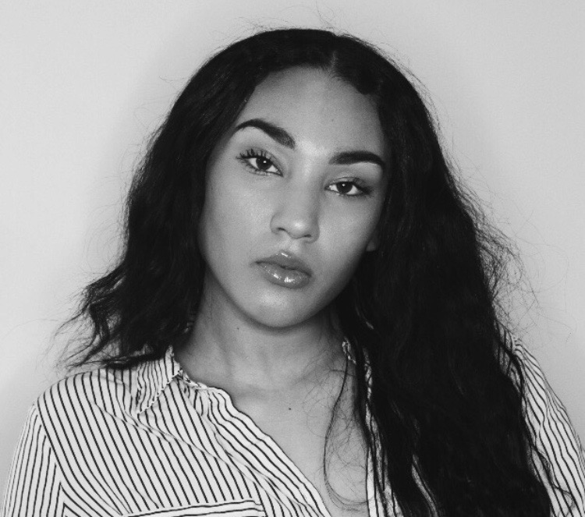
Merchandising Director
Here at MVRAL our first leg of success comes from our merchandising department. Ileana Rivera is a devoted college graduate from Fashion Institute of Design & Merchandising located in Los Angeles. With her bachelors in Fashion Merchandising Mrs. Rivera was able to obtain a job at Diesels corporate office in Breganze, Italy as a merchandising manager. Ileana has been MVRALs merchandising director since 2018. For three years Mrs. Rivera and her team of merchandising assistants have been in charge of MVRAL’s planning and buying for materials and products. As well as product development involving modification and changes to the brands merchandise. Mrs Rivera holds responsibility in the stores operations aspect of the business such as it's retail management as well as it's delivering and receiving of its merchandise. As of right now Ileana is doing an amazing job in her position as well as taking classes in New York's LIM for her masters to grow in our company.

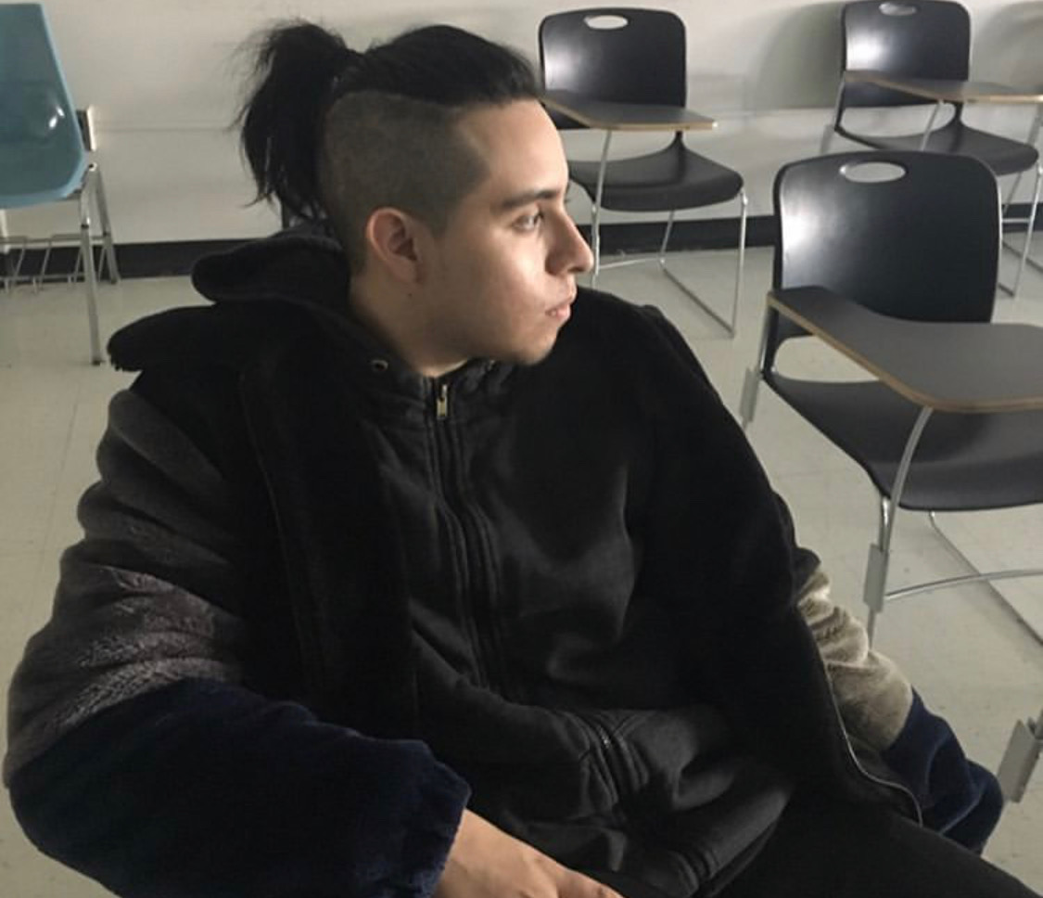
Marketing Director
The second leg of success in our brand comes from the Marketing aspect. Understanding our clientele and extending our reach has been accomplished by Erick Chavez’s ability to curate marketing efforts with his team for MVRAL and has been largely successful so far. Mr. Chavez’s experience includes working for the LVMH corporation as Marketing Director in New York and has effectively translated his work ethic into the independent clothing brand. Mr.Chavez’s credentials include a Master’s degree at Baruch College in Marketing Management. His work includes working under Dior as Marketing Director and as Assistant Marketing Manager at Rimowa. Mr.Chavez ability to gauge the audience and effectively communicate with the customers has been accounted for in order to use this new endeavor as a climax point for his professional career.

OVERVIEW

Company Name: MVRAL
Location: 49 Howard St, New York NY 10013
Products: Clothing & Apparel(Jackets)
Main Product: Classic Bomber Jackets

Company Branches:
- Financial Department
- Merchandising Department
- Marketing Department

General Consumer Analytics-
- Age: 20-35
- Any Culture & Ethnicity
- Consumer Income: $50,000 to $100,000
- Apparel for both genders

Demographics-
- Men and women within the ages of 20-35 and any one considered as Millenials.
- By 2020 Millennials are expected to count as one in three adults in the United States
- Millenials are the most diverse generation with 44.2% being part of a minority race or ethnic groups such as Hispanics, African American and Asian.

Psychographics-
- Athletes
- Students
- Famous Instagrammers
- Personal Trainers
- Active men & women
- Celebrities

Geographics-
- Los Angeles, CA
- New York, NY
- Miami, FL
- Moscow, Russia
- Brasilia, Brazil
- Paris, France

RETAIL LOCATION

MVRAL will be located on 49 Howard st, New York NY 10013. This is a perfect location for our brand due to the fact it's located in one of the fashion capitals of the world. Being in manhattan MVRAL is exposed to a number of consumers ranging from young high schoolers to celebrities and hypebeast residents as well as close cumpetetors that share the same fashion style as us such as Supreme, Off-White and Palace. We chose New York for a number of reasons but the main was due to its natural concept art and contagious atmosphere. When we want you to think of MVRAL we want you to think of art and what the brand stands for. Having it originating from New York brings it that authentic feel to it when buying our products.
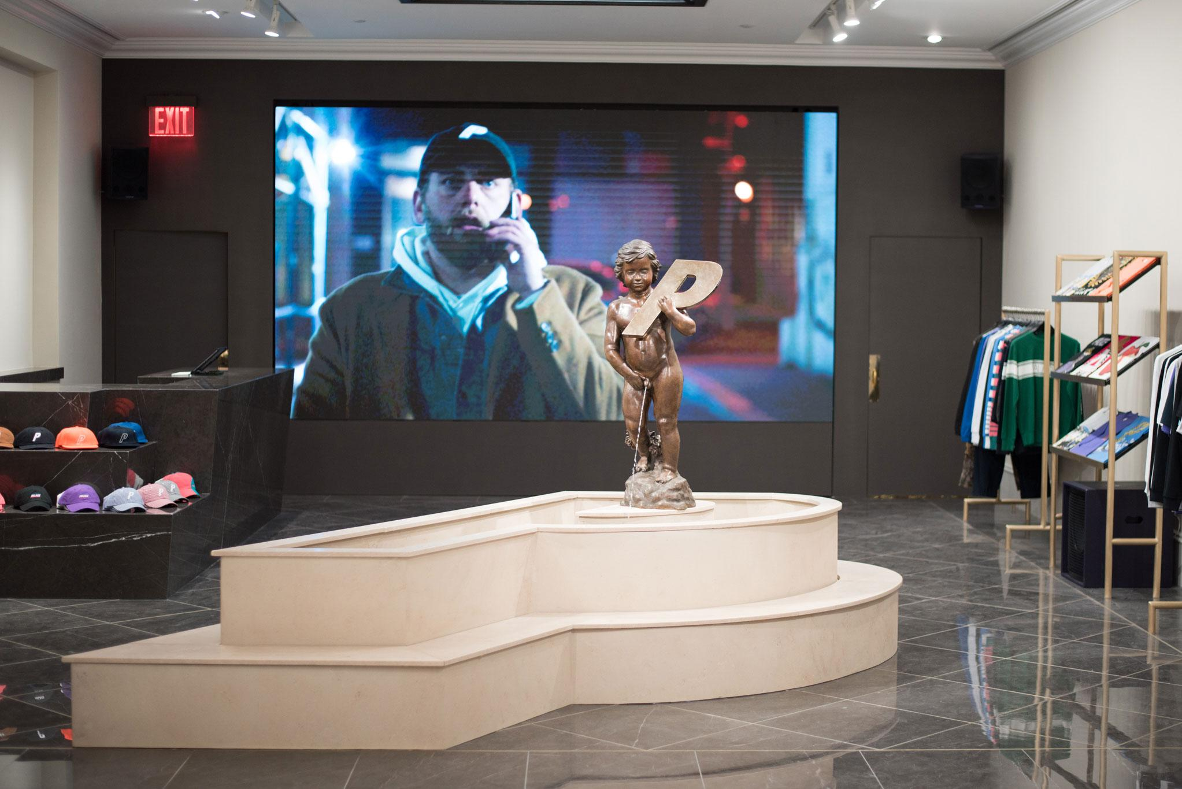
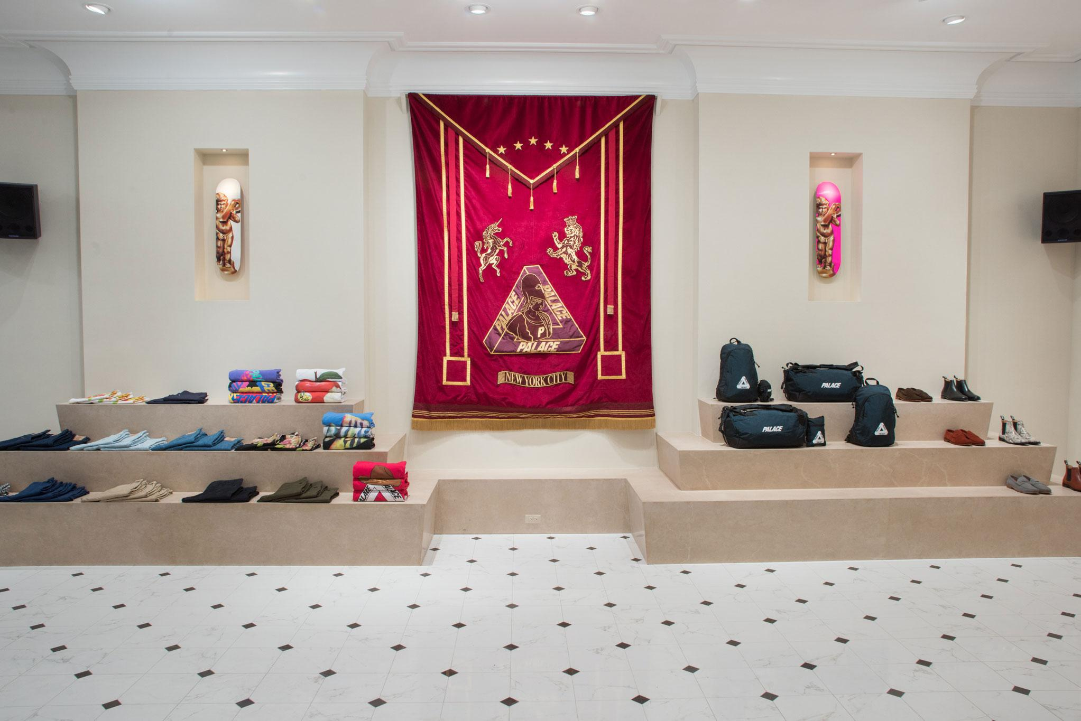
WORK CITED

Stan. (2017, November 24). The Rise of Art Collaborations in Streetwear. Retrieved from https://hypebeast.com/2017/10/the-rise-of-art-collaborations-in-streetwear

Sulima, J., & Sulima, J. (2018, August 23). How Streetwear Is Influencing a New Era of Luxury Fashion. Retrieved from https://www.adweek.com/brand-marketing/how-streetwear-is-influencing-a-new-era-of-luxury-f ashion/

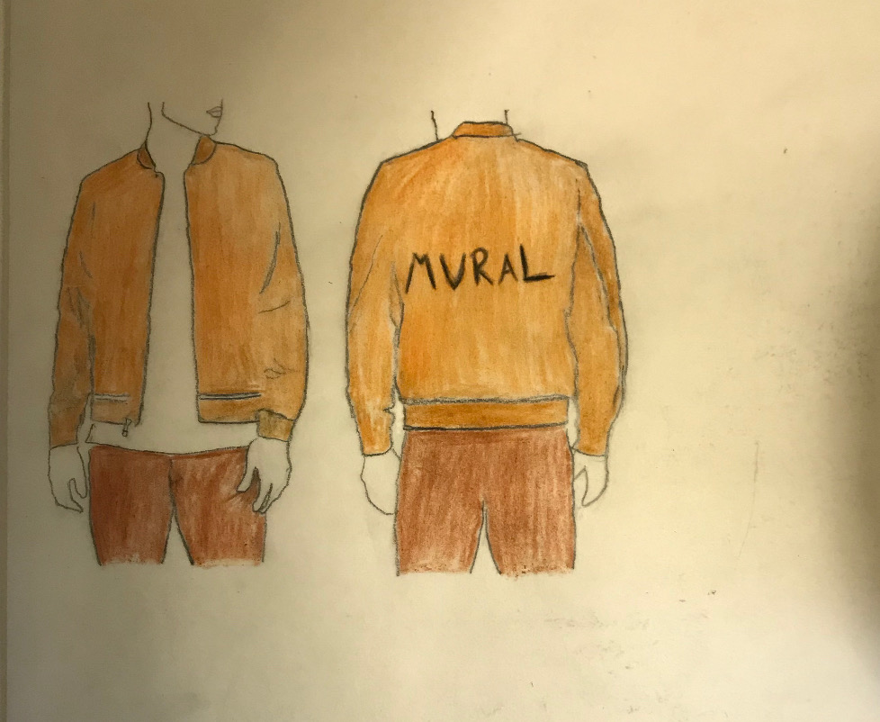

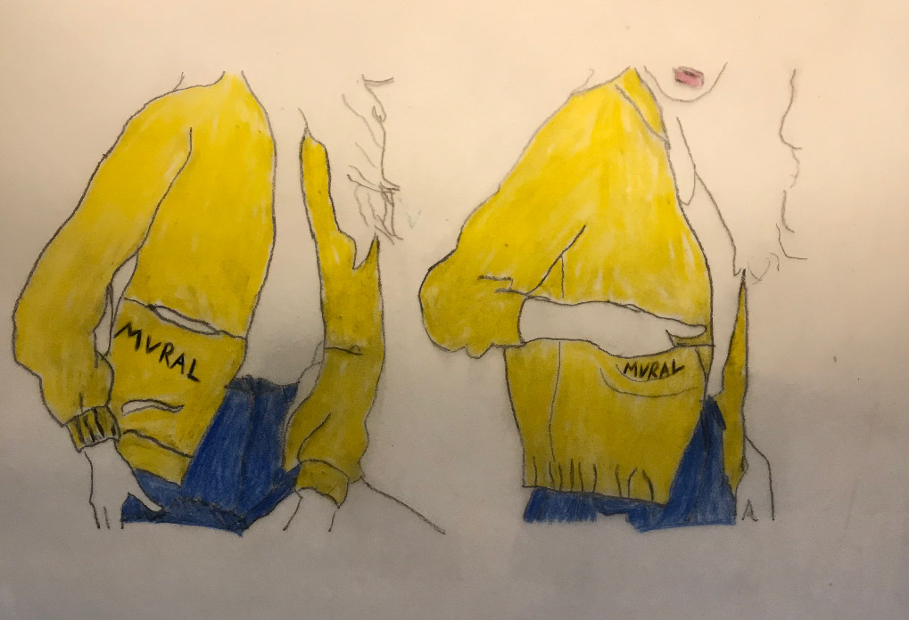

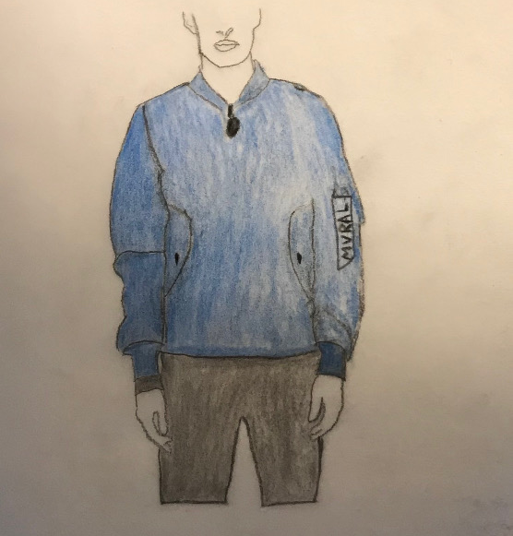

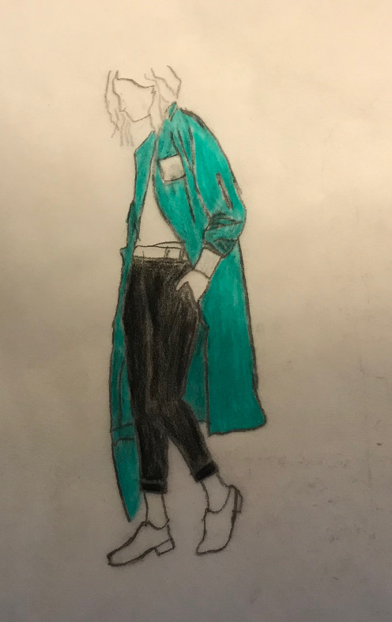
OPEN TO BUY SCHEDULE

PART B1:

FEBRUARY:

Planned Sales | $300,000
- Planned Reduction | $20,000
- EOM Stock | $200,000
= Total Monthly Needs | $520,000
- BOM Stock | $160,000
= Planned Purchase | $360,000
- Merchandise on order | $125,000
= Open to buy | $235,000

MARCH:

Planned Sales | $200,000
- Planned Reduction | $26,000
- EOM Stock | $80,000
= Total Monthly Needs | $306,000
- BOM Stock | $200,000
= Planned Purchase | $106,000
- Merchandise on order | $15,000
= Open to buy | $91,000

APRIL:

Planned Sales | $300,000
- Planned Reduction | $31,000
- EOM Stock | $110,000
= Total Monthly Needs | $441,000
- BOM Stock | $80,000
= Planned Purchase | $361,000
- Merchandise on order | $145,000
= Open to buy | $216,000

MAY:

Planned Sales | $200,000
- Planned Reduction | $17,000
- EOM Stock | $90,000
= Total Monthly Needs | $307,000
- BOM Stock | $110,000
= Planned Purchase | $197,000
- Merchandise on order | $35,000
= Open to buy | $162,000

JUNE:

Planned Sales | $400,000
- Planned Reduction | $28,000
- EOM Stock | $210,000
= Total Monthly Needs | $638,000
- BOM Stock | $90,000
= Planned Purchase | $548,000
- Merchandise on order | $170,000
= Open to buy | $378,000

JULY:

Planned Sales | $250,000
- Planned Reduction | $25,000
- EOM Stock | $70,000
= Total Monthly Needs | $345,000
- BOM Stock | $210,000
= Planned Purchase | $135,000
- Merchandise on order | $24,000
= Open to buy | $111,000

Part B2:

Average Monthly Sales:
February | $300,000
March | $200,000
April | $300,000
May | $200,000
June | $400,000
July | $250,000
Total on Sales: | $1,650,000
Total Average: | $275,000

Part B3:

Average Monthly on Order:
February | $125,000
March | $15,000
April | $145,000
May | $35,000
June | $170,000
July | $24,000
Total on Order: | $514,000
Total Average: | $85,666.

Part B4

Markdown % for Each Month
February | (MD/Planned Sales)*100  (8,000/300,000)*100 | 2.67%
March | (MD/Planned Sales)*100  (12,000/200,000)*100 | 6%
April | (MD/Planned Sales)*100  (4,000/300,000)*100 | 1.3%
May | (MD/Planned Sales)*100  (3,000/200,000)*100 | 1.5%
June | (MD/Planned Sales)*100  (18,000/400,000)*100 | 4.5%
July | (MD/Planned Sales)*100  (25,000/250,000)*100 | 10%

FEBRUARY SKU LIST

SEASON | STYLE # | COLOR CODE | COLOR NAME | SIZE | ITEM
SPRING 2021 | 222255-001 | 001 | BLACK | EXTRA SMALL | HEAVY BOMBER
SPRING 2021 | 222255-001 | 001 | BLACK | SMALL | HEAVY BOMBER
SPRING 2021 | 222255-001 | 001 | BLACK | MEDIUM | HEAVY BOMBER
SPRING 2021 | 222255-001 | 001 | BLACK | LARGE | HEAVY BOMBER
SPRING 2021 | 222255-001 | 001 | BLACK | EXTRA LARGE | HEAVY BOMBER

SEASON | STYLE # | COLOR CODE | COLOR NAME | SIZE | ITEM
SPRING 2021 | 222255-031 | 031 | ORANGE | EXTRA SMALL | HEAVY BOMBER
SPRING 2021 | 222255-031 | 031 | ORANGE | SMALL | HEAVY BOMBER
SPRING 2021 | 222255-031 | 031 | ORANGE | MEDIUM | HEAVY BOMBER
SPRING 2021 | 222255-031 | 031 | ORANGE | LARGE | HEAVY BOMBER
SPRING 2021 | 222255-031 | 031 | ORANGE | EXTRA LARGE | HEAVY BOMBER

SEASON | STYLE # | COLOR CODE | COLOR NAME | SIZE | ITEM
SPRING 2021 | 220636-005 | 005 | GREEN | EXTRA SMALL | HUNTER BOMBER
SPRING 2021 | 220636-005 | 005 | GREEN | SMALL | HUNTER BOMBER
SPRING 2021 | 220636-005 | 005 | GREEN | MEDIUM | HUNTER BOMBER
SPRING 2021 | 220636-005 | 005 | GREEN | LARGE | HUNTER BOMBER
SPRING 2021 | 220636-005 | 005 | GREEN | EXTRA LARGE | HUNTER BOMBER

SEASON | STYLE # | COLOR CODE | COLOR NAME | SIZE | ITEM
SPRING 2021 | 220636-011 | 011 | BROWN | EXTRA SMALL | HUNTER BOMBER
SPRING 2021 | 220636-011 | 011 | BROWN | SMALL | HUNTER BOMBER
SPRING 2021 | 220636-011 | 011 | BROWN | MEDIUM | HUNTER BOMBER
SPRING 2021 | 220636-011 | 011 | BROWN | LARGE | HUNTER BOMBER
SPRING 2021 | 220636-011 | 011 | BROWN | EXTRA LARGE | HUNTER BOMBER

SEASON | STYLE # | COLOR CODE | COLOR NAME | SIZE | ITEM
SPRING 2021 | 480938-045 | 045 | PINK | EXTRA SMALL | FUR BOMBER
SPRING 2021 | 480938-045 | 045 | PINK | SMALL | FUR BOMBER
SPRING 2021 | 480938-045 | 045 | PINK | MEDIUM | FUR BOMBER
SPRING 2021 | 480938-045 | 045 | PINK | LARGE | FUR BOMBER
SPRING 2021 | 480938-045 | 045 | PINK | EXTRA LARGE | FUR BOMBER

SEASON | STYLE # | COLOR CODE | COLOR NAME | SIZE | ITEM
SPRING 2021 | 480938-076 | 076 | BLUE | EXTRA SMALL | FUR BOMBER
SPRING 2021 | 480938-076 | 076 | BLUE | SMALL | FUR BOMBER
SPRING 2021 | 480938-076 | 076 | BLUE | MEDIUM | FUR BOMBER
SPRING 2021 | 480938-076 | 076 | BLUE | LARGE | FUR BOMBER
SPRING 2021 | 480938-076 | 076 | BLUE | EXTRA LARGE | FUR BOMBER

SEASON | STYLE # | COLOR CODE | COLOR NAME | SIZE | ITEM
SPRING 2021 | 863973-001 | 001 | BLACK | EXTRA SMALL | REVERSIBLE BOMBER
SPRING 2021 | 863973-001 | 001 | BLACK | SMALL | REVERSIBLE BOMBER
SPRING 2021 | 863973-001 | 001 | BLACK | MEDIUM | REVERSIBLE BOMBER
SPRING 2021 | 863973-001 | 001 | BLACK | LARGE | REVERSIBLE BOMBER
SPRING 2021 | 863973-001 | 001 | BLACK | EXTRA LARGE | REVERSIBLE BOMBER

SEASON | STYLE # | COLOR CODE | COLOR NAME | SIZE | ITEM
SPRING 2021 | 863973-093 | 093 | GREY | EXTRA SMALL | REVERSIBLE BOMBER
SPRING 2021 | 863973-093 | 093 | GREY | SMALL | REVERSIBLE BOMBER
SPRING 2021 | 863973-093 | 093 | GREY | MEDIUM | REVERSIBLE BOMBER
SPRING 2021 | 863973-093 | 093 | GREY | LARGE | REVERSIBLE BOMBER
SPRING 2021 | 863973-093 | 093 | GREY | EXTRA LARGE | REVERSIBLE BOMBER

SEASON | STYLE # | COLOR CODE | COLOR NAME | SIZE | ITEM
SPRING 2021 | 149045-076 | 076 | BLUE | EXTRA SMALL | COLLAR BOMBER
SPRING 2021 | 149045-076 | 076 | BLUE | SMALL | COLLAR BOMBER
SPRING 2021 | 149045-076 | 076 | BLUE | MEDIUM | COLLAR BOMBER
SPRING 2021 | 149045-076 | 076 | BLUE | LARGE | COLLAR BOMBER
SPRING 2021 | 149045-076 | 076 | BLUE | EXTRA LARGE | COLLAR BOMBER

SEASON | STYLE # | COLOR CODE | COLOR NAME | SIZE | ITEM
SPRING 2021 | 149045-011 | 011 | BROWN | EXTRA SMALL | COLLAR BOMBER
SPRING 2021 | 149045-011 | 011 | BROWN | SMALL | COLLAR BOMBER
SPRING 2021 | 149045-011 | 011 | BROWN | MEDIUM | COLLAR BOMBER
SPRING 2021 | 149045-011 | 011 | BROWN | LARGE | COLLAR BOMBER
SPRING 2021 | 149045-011 | 011 | BROWN | EXTRA LARGE | COLLAR BOMBER

MARCH SKU LIST

SEASON | STYLE # | COLOR CODE | COLOR NAME | SIZE | ITEM
SPRING 2021 | 390183-013 | 013 | OLIVE GREEN | EXTRA SMALL | OG BOMBER
SPRING 2021 | 390183-013 | 013 | OLIVE GREEN | SMALL | OG BOMBER
SPRING 2021 | 390183-013 | 013 | OLIVE GREEN | MEDIUM | OG BOMBER
SPRING 2021 | 390183-013 | 013 | OLIVE GREEN | LARGE | OG BOMBER
SPRING 2021 | 390183-013 | 013 | OLIVE GREEN | EXTRA LARGE | OG BOMBER

SEASON | STYLE # | COLOR CODE | COLOR NAME | SIZE | ITEM
SPRING 2021 | 390183-052 | 052 | RED | EXTRA SMALL | OG BOMBER
SPRING 2021 | 390183-052 | 052 | RED | SMALL | OG BOMBER
SPRING 2021 | 390183-052 | 052 | RED | MEDIUM | OG BOMBER
SPRING 2021 | 390183-052 | 052 | RED | LARGE | OG BOMBER
SPRING 2021 | 390183-052 | 052 | RED | EXTRA LARGE | OG BOMBER

SEASON | STYLE # | COLOR CODE | COLOR NAME | SIZE | ITEM
SPRING 2021 | 701543-008 | 008 | CAMO | EXTRA SMALL | WORLD WAR BOMBER
SPRING 2021 | 701543-008 | 008 | CAMO | SMALL | WORLD WAR BOMBER
SPRING 2021 | 701543-008 | 008 | CAMO | MEDIUM | WORLD WAR BOMBER
SPRING 2021 | 701543-008 | 008 | CAMO | LARGE | WORLD WAR BOMBER
SPRING 2021 | 701543-008 | 008 | CAMO | EXTRA LARGE | WORLD WAR BOMBER

SEASON | STYLE # | COLOR CODE | COLOR NAME | SIZE | ITEM
SPRING 2021 | 701543-093 | 093 | GREY | EXTRA SMALL | WORLD WAR BOMBER
SPRING 2021 | 701543-093 | 093 | GREY | SMALL | WORLD WAR BOMBER
SPRING 2021 | 701543-093 | 093 | GREY | MEDIUM | WORLD WAR BOMBER
SPRING 2021 | 701543-093 | 093 | GREY | LARGE | WORLD WAR BOMBER
SPRING 2021 | 701543-093 | 093 | GREY | EXTRA LARGE | WORLD WAR BOMBER

SEASON | STYLE # | COLOR CODE | COLOR NAME | SIZE | ITEM
SPRING 2021 | 421983-002 | 002 | WHITE | EXTRA SMALL | RENEGADE BOMBER
SPRING 2021 | 421983-002 | 002 | WHITE | SMALL | RENEGADE BOMBER
SPRING 2021 | 421983-002 | 002 | WHITE | MEDIUM | RENEGADE BOMBER
SPRING 2021 | 421983-002 | 002 | WHITE | LARGE | RENEGADE BOMBER
SPRING 2021 | 421983-002 | 002 | WHITE | EXTRA LARGE | RENEGADE BOMBER

SEASON | STYLE # | COLOR CODE | COLOR NAME | SIZE | ITEM
SPRING 2021 | 421983-052 | 052 | RED | EXTRA SMALL | RENEGADE BOMBER
SPRING 2021 | 421983-052 | 052 | RED | SMALL | RENEGADE BOMBER
SPRING 2021 | 421983-052 | 052 | RED | MEDIUM | RENEGADE BOMBER
SPRING 2021 | 421983-052 | 052 | RED | LARGE | RENEGADE BOMBER
SPRING 2021 | 421983-052 | 052 | RED | EXTRA LARGE | RENEGADE BOMBER

SEASON | STYLE # | COLOR CODE | COLOR NAME | SIZE | ITEM
SPRING 2021 | 302832-081 | 081 | PURPLE | EXTRA SMALL | MADNESS BOMBER
SPRING 2021 | 302832-081 | 081 | PURPLE | SMALL | MADNESS BOMBER
SPRING 2021 | 302832-081 | 081 | PURPLE | MEDIUM | MADNESS BOMBER
SPRING 2021 | 302832-081 | 081 | PURPLE | LARGE | MADNESS BOMBER
SPRING 2021 | 302832-081 | 081 | PURPLE | EXTRA LARGE | MADNESS BOMBER

SEASON | STYLE # | COLOR CODE | COLOR NAME | SIZE | ITEM
SPRING 2021 | 302832-052 | 052 | RED | EXTRA SMALL | MADNESS BOMBER
SPRING 2021 | 302832-052 | 052 | RED | SMALL | MADNESS BOMBER
SPRING 2021 | 302832-052 | 052 | RED | MEDIUM | MADNESS BOMBER
SPRING 2021 | 302832-052 | 052 | RED | LARGE | MADNESS BOMBER
SPRING 2021 | 302832-052 | 052 | RED | EXTRA LARGE | MADNESS BOMBER

SEASON | STYLE # | COLOR CODE | COLOR NAME | SIZE | ITEM
SPRING 2021 | 904975-001 | 001 | BLACK | EXTRA SMALL | DEMON BOMBER
SPRING 2021 | 904975-001 | 001 | BLACK | SMALL | DEMON BOMBER
SPRING 2021 | 904975-001 | 001 | BLACK | MEDIUM | DEMON BOMBER
SPRING 2021 | 904975-001 | 001 | BLACK | LARGE | DEMON BOMBER
SPRING 2021 | 904975-001 | 001 | BLACK | EXTRA LARGE | DEMON BOMBER

SEASON | STYLE # | COLOR CODE | COLOR NAME | SIZE | ITEM
SPRING 2021 | 904975-052 | 052 | RED | EXTRA SMALL | DEMON BOMBER
SPRING 2021 | 904975-052 | 052 | RED | SMALL | DEMON BOMBER
SPRING 2021 | 904975-052 | 052 | RED | MEDIUM | DEMON BOMBER
SPRING 2021 | 904975-052 | 052 | RED | LARGE | DEMON BOMBER
SPRING 2021 | 904975-052 | 052 | RED | EXTRA LARGE | DEMON BOMBER

APRIL SKU LIST

SEASON | STYLE # | COLOR CODE | COLOR NAME | SIZE | ITEM
SPRING 2021 | 548902-002 | 002 | WHITE | EXTRA SMALL | WATERPROOF BOMBER
SPRING 2021 | 548902-002 | 002 | WHITE | SMALL | WATERPROOF BOMBER
SPRING 2021 | 548902-002 | 002 | WHITE | MEDIUM | WATERPROOF BOMBER
SPRING 2021 | 548902-002 | 002 | WHITE | LARGE | WATERPROOF BOMBER
SPRING 2021 | 548902-002 | 002 | WHITE | EXTRA LARGE | WATERPROOF BOMBER

SEASON | STYLE # | COLOR CODE | COLOR NAME | SIZE | ITEM
SPRING 2021 | 548902-093 | 093 | GREY | EXTRA SMALL | WATERPROOF BOMBER
SPRING 2021 | 548902-093 | 093 | GREY | SMALL | WATERPROOF BOMBER
SPRING 2021 | 548902-093 | 093 | GREY | MEDIUM | WATERPROOF BOMBER
SPRING 2021 | 548902-093 | 093 | GREY | LARGE | WATERPROOF BOMBER
SPRING 2021 | 548902-093 | 093 | GREY | EXTRA LARGE | WATERPROOF BOMBER

SEASON | STYLE # | COLOR CODE | COLOR NAME | SIZE | ITEM
SPRING 2021 | 8490234-045 | 045 | PINK | EXTRA SMALL | LIGHT BOMBER
SPRING 2021 | 8490234-045 | 045 | PINK | SMALL | LIGHT BOMBER
SPRING 2021 | 8490234-045 | 045 | PINK | MEDIUM | LIGHT BOMBER
SPRING 2021 | 8490234-045 | 045 | PINK | LARGE | LIGHT BOMBER
SPRING 2021 | 8490234-045 | 045 | PINK | EXTRA LARGE | LIGHT BOMBER

SEASON | STYLE # | COLOR CODE | COLOR NAME | SIZE | ITEM
SPRING 2021 | 8490234-001 | 001 | BLACK | EXTRA SMALL | LIGHT BOMBER
SPRING 2021 | 8490234-001 | 001 | BLACK | SMALL | LIGHT BOMBER
SPRING 2021 | 8490234-001 | 001 | BLACK | MEDIUM | LIGHT BOMBER
SPRING 2021 | 8490234-001 | 001 | BLACK | LARGE | LIGHT BOMBER
SPRING 2021 | 8490234-001 | 001 | BLACK | EXTRA LARGE | LIGHT BOMBER

SEASON | STYLE # | COLOR CODE | COLOR NAME | SIZE | ITEM
SPRING 2021 | 543982-093 | 093 | GREY | EXTRA SMALL | AIR FLIGHT BOMBER
SPRING 2021 | 543982-093 | 093 | GREY | SMALL | AIR FLIGHT BOMBER
SPRING 2021 | 543982-093 | 093 | GREY | MEDIUM | AIR FLIGHT BOMBER
SPRING 2021 | 543982-093 | 093 | GREY | LARGE | AIR FLIGHT BOMBER
SPRING 2021 | 543982-093 | 093 | GREY | EXTRA LARGE | AIR FLIGHT BOMBER

SEASON | STYLE # | COLOR CODE | COLOR NAME | SIZE | ITEM
SPRING 2021 | 543982-021 | 021 | MAGENTA | EXTRA SMALL | AIR FLIGHT BOMBER
SPRING 2021 | 543982-021 | 021 | MAGENTA | SMALL | AIR FLIGHT BOMBER
SPRING 2021 | 543982-021 | 021 | MAGENTA | MEDIUM | AIR FLIGHT BOMBER
SPRING 2021 | 543982-021 | 021 | MAGENTA | LARGE | AIR FLIGHT BOMBER
SPRING 2021 | 543982-021 | 021 | MAGENTA | EXTRA LARGE | AIR FLIGHT BOMBER

SEASON | STYLE # | COLOR CODE | COLOR NAME | SIZE | ITEM
SPRING 2021 | 843902-064 | 064 | TAN | EXTRA SMALL | STATEMENT BOMBER
SPRING 2021 | 843902-064 | 064 | TAN | SMALL | STATEMENT BOMBER
SPRING 2021 | 843902-064 | 064 | TAN | MEDIUM | STATEMENT BOMBER
SPRING 2021 | 843902-064 | 064 | TAN | LARGE | STATEMENT BOMBER
SPRING 2021 | 843902-064 | 064 | TAN | EXTRA LARGE | STATEMENT BOMBER

SEASON | STYLE # | COLOR CODE | COLOR NAME | SIZE | ITEM
SPRING 2021 | 843902-001 | 001 | BLACK | EXTRA SMALL | STATEMENT BOMBER
SPRING 2021 | 843902-001 | 001 | BLACK | SMALL | STATEMENT BOMBER
SPRING 2021 | 843902-001 | 001 | BLACK | MEDIUM | STATEMENT BOMBER
SPRING 2021 | 843902-001 | 001 | BLACK | LARGE | STATEMENT BOMBER
SPRING 2021 | 843902-001 | 001 | BLACK | EXTRA LARGE | STATEMENT BOMBER

SEASON | STYLE # | COLOR CODE | COLOR NAME | SIZE | ITEM
SPRING 2021 | 210932-086 | 086 | YELLOW | EXTRA SMALL | GOLDEN BOMBER
SPRING 2021 | 210932-086 | 086 | YELLOW | SMALL | GOLDEN BOMBER
SPRING 2021 | 210932-086 | 086 | YELLOW | MEDIUM | GOLDEN BOMBER
SPRING 2021 | 210932-086 | 086 | YELLOW | LARGE | GOLDEN BOMBER
SPRING 2021 | 210932-086 | 086 | YELLOW | EXTRA LARGE | GOLDEN BOMBER

SEASON | STYLE # | COLOR CODE | COLOR NAME | SIZE | ITEM
SPRING 2021 | 210932-002 | 002 | WHITE | EXTRA SMALL | GOLDEN BOMBER
SPRING 2021 | 210932-002 | 002 | WHITE | SMALL | GOLDEN BOMBER
SPRING 2021 | 210932-002 | 002 | WHITE | MEDIUM | GOLDEN BOMBER
SPRING 2021 | 210932-002 | 002 | WHITE | LARGE | GOLDEN BOMBER
SPRING 2021 | 210932-002 | 002 | WHITE | EXTRA LARGE | GOLDEN BOMBER

MAY SKU LIST

SEASON | STYLE # | COLOR CODE | COLOR NAME | SIZE | ITEM
SUMMER 2021 | 542092-009 | 009 | AQUA | EXTRA SMALL | AQUA BOMBER
SUMMER 2021 | 542092-009 | 009 | AQUA | SMALL | AQUA BOMBER
SUMMER 2021 | 542092-009 | 009 | AQUA | MEDIUM | AQUA BOMBER
SUMMER 2021 | 542092-009 | 009 | AQUA | LARGE | AQUA BOMBER
SUMMER 2021 | 542092-009 | 009 | AQUA | EXTRA LARGE | AQUA BOMBER

SEASON | STYLE # | COLOR CODE | COLOR NAME | SIZE | ITEM
SUMMER 2021 | 542092-009 | 009 | AQUA | EXTRA SMALL | AQUA BOMBER
SUMMER 2021 | 542092-009 | 009 | AQUA | SMALL | AQUA BOMBER
SUMMER 2021 | 542092-009 | 009 | AQUA | MEDIUM | AQUA BOMBER
SUMMER 2021 | 542092-009 | 009 | AQUA | LARGE | AQUA BOMBER
SUMMER 2021 | 542092-009 | 009 | AQUA | EXTRA LARGE | AQUA BOMBER

SEASON | STYLE # | COLOR CODE | COLOR NAME | SIZE | ITEM
SUMMER 2021 | 710832-075 | 075 | LIGHT BLUE | EXTRA SMALL | PULLOVER BOMBER
SUMMER 2021 | 710832-075 | 075 | LIGHT BLUE | SMALL | PULLOVER BOMBER
SUMMER 2021 | 710832-075 | 075 | LIGHT BLUE | MEDIUM | PULLOVER BOMBER
SUMMER 2021 | 710832-075 | 075 | LIGHT BLUE | LARGE | PULLOVER BOMBER
SUMMER 2021 | 710832-075 | 075 | LIGHT BLUE | EXTRA LARGE | PULLOVER BOMBER

SEASON | STYLE # | COLOR CODE | COLOR NAME | SIZE | ITEM
SUMMER 2021 | 710832-081 | 081 | PURPLE | EXTRA SMALL | PULLOVER BOMBER
SUMMER 2021 | 710832-081 | 081 | PURPLE | SMALL | PULLOVER BOMBER
SUMMER 2021 | 710832-081 | 081 | PURPLE | MEDIUM | PULLOVER BOMBER
SUMMER 2021 | 710832-081 | 081 | PURPLE | LARGE | PULLOVER BOMBER
SUMMER 2021 | 710832-081 | 081 | PURPLE | EXTRA LARGE | PULLOVER BOMBER

SEASON | STYLE # | COLOR CODE | COLOR NAME | SIZE | ITEM
SUMMER 2021 | 548202-005 | 005 | GREEN | EXTRA SMALL | NO ZIP BOMBER
SUMMER 2021 | 548202-005 | 005 | GREEN | SMALL | NO ZIP BOMBER
SUMMER 2021 | 548202-005 | 005 | GREEN | MEDIUM | NO ZIP BOMBER
SUMMER 2021 | 548202-005 | 005 | GREEN | LARGE | NO ZIP BOMBER
SUMMER 2021 | 548202-005 | 005 | GREEN | EXTRA LARGE | NO ZIP BOMBER

SEASON | STYLE # | COLOR CODE | COLOR NAME | SIZE | ITEM
SUMMER 2021 | 548202-008 | 008 | CAMO | EXTRA SMALL | NO ZIP BOMBER
SUMMER 2021 | 548202-008 | 008 | CAMO | SMALL | NO ZIP BOMBER
SUMMER 2021 | 548202-008 | 008 | CAMO | MEDIUM | NO ZIP BOMBER
SUMMER 2021 | 548202-008 | 008 | CAMO | LARGE | NO ZIP BOMBER
SUMMER 2021 | 548202-008 | 008 | CAMO | EXTRA LARGE | NO ZIP BOMBER

SEASON | STYLE # | COLOR CODE | COLOR NAME | SIZE | ITEM
SUMMER 2021 | 120382-021 | 021 | MAGENTA | EXTRA SMALL | HQ BOMBER
SUMMER 2021 | 120382-021 | 021 | MAGENTA | SMALL | HQ BOMBER
SUMMER 2021 | 120382-021 | 021 | MAGENTA | MEDIUM | HQ BOMBER
SUMMER 2021 | 120382-021 | 021 | MAGENTA | LARGE | HQ BOMBER
SUMMER 2021 | 120382-021 | 021 | MAGENTA | EXTRA LARGE | HQ BOMBER

SEASON | STYLE # | COLOR CODE | COLOR NAME | SIZE | ITEM
SUMMER 2021 | 120382-005 | 005 | GREEN | EXTRA SMALL | HQ BOMBER
SUMMER 2021 | 120382-005 | 005 | GREEN | SMALL | HQ BOMBER
SUMMER 2021 | 120382-005 | 005 | GREEN | MEDIUM | HQ BOMBER
SUMMER 2021 | 120382-005 | 005 | GREEN | LARGE | HQ BOMBER
SUMMER 2021 | 120382-005 | 005 | GREEN | EXTRA LARGE | HQ BOMBER

SEASON | STYLE # | COLOR CODE | COLOR NAME | SIZE | ITEM
SUMMER 2021 | 483024-002 | 002 | WHITE | EXTRA SMALL | DUGOUT BOMBER
SUMMER 2021 | 483024-002 | 002 | WHITE | SMALL | DUGOUT BOMBER
SUMMER 2021 | 483024-002 | 002 | WHITE | MEDIUM | DUGOUT BOMBER
SUMMER 2021 | 483024-002 | 002 | WHITE | LARGE | DUGOUT BOMBER
SUMMER 2021 | 483024-002 | 002 | WHITE | EXTRA LARGE | DUGOUT BOMBER

SEASON | STYLE # | COLOR CODE | COLOR NAME | SIZE | ITEM
SUMMER 2021 | 483024-011 | 011 | BROWN | EXTRA SMALL | DUGOUT BOMBER
SUMMER 2021 | 483024-011 | 011 | BROWN | SMALL | DUGOUT BOMBER
SUMMER 2021 | 483024-011 | 011 | BROWN | MEDIUM | DUGOUT BOMBER
SUMMER 2021 | 483024-011 | 011 | BROWN | LARGE | DUGOUT BOMBER
SUMMER 2021 | 483024-011 | 011 | BROWN | EXTRA LARGE | DUGOUT BOMBER
JUNE SKU LIST

SEASON | STYLE # | COLOR CODE | COLOR NAME | SIZE | ITEM
SUMMER 2021 | 483023-045 | 045 | PINK | EXTRA SMALL | PASSION BOMBER
SUMMER 2021 | 483023-045 | 045 | PINK | SMALL | PASSION BOMBER
SUMMER 2021 | 483023-045 | 045 | PINK | MEDIUM | PASSION BOMBER
SUMMER 2021 | 483023-045 | 045 | PINK | LARGE | PASSION BOMBER
SUMMER 2021 | 483023-045 | 045 | PINK | EXTRA LARGE | PASSION BOMBER

SEASON | STYLE # | COLOR CODE | COLOR NAME | SIZE | ITEM
SUMMER 2021 | 483023-086 | 086 | YELLOW | EXTRA SMALL | PASSION BOMBER
SUMMER 2021 | 483023-086 | 086 | YELLOW | SMALL | PASSION BOMBER
SUMMER 2021 | 483023-086 | 086 | YELLOW | MEDIUM | PASSION BOMBER
SUMMER 2021 | 483023-086 | 086 | YELLOW | LARGE | PASSION BOMBER
SUMMER 2021 | 483023-086 | 086 | YELLOW | EXTRA LARGE | PASSION BOMBER

SEASON | STYLE # | COLOR CODE | COLOR NAME | SIZE | ITEM
SUMMER 2021 | 039283-075 | 075 | LIGHT BLUE | EXTRA SMALL | GENIE BOMBER
SUMMER 2021 | 039283-075 | 075 | LIGHT BLUE | SMALL | GENIE BOMBER
SUMMER 2021 | 039283-075 | 075 | LIGHT BLUE | MEDIUM | GENIE BOMBER
SUMMER 2021 | 039283-075 | 075 | LIGHT BLUE | LARGE | GENIE BOMBER
SUMMER 2021 | 039283-075 | 075 | LIGHT BLUE | EXTRA LARGE | GENIE BOMBER

SEASON | STYLE # | COLOR CODE | COLOR NAME | SIZE | ITEM
SUMMER 2021 | 039283-005 | 005 | GREEN | EXTRA SMALL | GENIE BOMBER
SUMMER 2021 | 039283-005 | 005 | GREEN | SMALL | GENIE BOMBER
SUMMER 2021 | 039283-005 | 005 | GREEN | MEDIUM | GENIE BOMBER
SUMMER 2021 | 039283-005 | 005 | GREEN | LARGE | GENIE BOMBER
SUMMER 2021 | 039283-005 | 005 | GREEN | EXTRA LARGE | GENIE BOMBER

SEASON | STYLE # | COLOR CODE | COLOR NAME | SIZE | ITEM
SUMMER 2021 | 420983-086 | 086 | YELLOW | EXTRA SMALL | ROCKSTAR BOMBER
SUMMER 2021 | 420983-086 | 086 | YELLOW | SMALL | ROCKSTAR BOMBER
SUMMER 2021 | 420983-086 | 086 | YELLOW | MEDIUM | ROCKSTAR BOMBER
SUMMER 2021 | 420983-086 | 086 | YELLOW | LARGE | ROCKSTAR BOMBER
SUMMER 2021 | 420983-086 | 086 | YELLOW | EXTRA LARGE | ROCKSTAR BOMBER

SEASON | STYLE # | COLOR CODE | COLOR NAME | SIZE | ITEM
SUMMER 2021 | 420983-052 | O52 | RED | EXTRA SMALL | ROCKSTAR BOMBER
SUMMER 2021 | 420983-052 | O52 | RED | SMALL | ROCKSTAR BOMBER
SUMMER 2021 | 420983-052 | O52 | RED | MEDIUM | ROCKSTAR BOMBER
SUMMER 2021 | 420983-052 | O52 | RED | LARGE | ROCKSTAR BOMBER
SUMMER 2021 | 420983-052 | O52 | RED | EXTRA LARGE | ROCKSTAR BOMBER

SEASON | STYLE # | COLOR CODE | COLOR NAME | SIZE | ITEM
SUMMER 2021 | 482012-010 | 010 | SILVER | EXTRA SMALL | THRONE BOMBER
SUMMER 2021 | 482012-010 | 010 | SILVER | SMALL | THRONE BOMBER
SUMMER 2021 | 482012-010 | 010 | SILVER | MEDIUM | THRONE BOMBER
SUMMER 2021 | 482012-010 | 010 | SILVER | LARGE | THRONE BOMBER
SUMMER 2021 | 482012-010 | 010 | SILVER | EXTRA LARGE | THRONE BOMBER

SEASON | STYLE # | COLOR CODE | COLOR NAME | SIZE | ITEM
SUMMER 2021 | 482012-012 | 012 | GOLD | EXTRA SMALL | THRONE BOMBER
SUMMER 2021 | 482012-012 | 012 | GOLD | SMALL | THRONE BOMBER
SUMMER 2021 | 482012-012 | 012 | GOLD | MEDIUM | THRONE BOMBER
SUMMER 2021 | 482012-012 | 012 | GOLD | LARGE | THRONE BOMBER
SUMMER 2021 | 482012-012 | 012 | GOLD | EXTRA LARGE | THRONE BOMBER

SEASON | STYLE # | COLOR CODE | COLOR NAME | SIZE | ITEM
SUMMER 2021 | 583029-052 | 052 | RED | EXTRA SMALL | KING BOMBER
SUMMER 2021 | 583029-052 | 052 | RED | SMALL | KING BOMBER
SUMMER 2021 | 583029-052 | 052 | RED | MEDIUM | KING BOMBER
SUMMER 2021 | 583029-052 | 052 | RED | LARGE | KING BOMBER
SUMMER 2021 | 583029-052 | 052 | RED | EXTRA LARGE | KING BOMBER

SEASON | STYLE # | COLOR CODE | COLOR NAME | SIZE | ITEM
SUMMER 2021 | 583029-012 | 012 | GOLD | EXTRA SMALL | KING BOMBER
SUMMER 2021 | 583029-012 | 012 | GOLD | SMALL | KING BOMBER
SUMMER 2021 | 583029-012 | 012 | GOLD | MEDIUM | KING BOMBER
SUMMER 2021 | 583029-012 | 012 | GOLD | LARGE | KING BOMBER
SUMMER 2021 | 583029-012 | 012 | GOLD | EXTRA LARGE | KING BOMBER

JULY SKU LIST

SEASON | STYLE # | COLOR CODE | COLOR NAME | SIZE | ITEM
SUMMER 2021 | 729239-002 | 002 | WHITE | EXTRA SMALL | ART BOMBER
SUMMER 2021 | 729239-002 | 002 | WHITE | SMALL | ART BOMBER
SUMMER 2021 | 729239-002 | 002 | WHITE | MEDIUM | ART BOMBER
SUMMER 2021 | 729239-002 | 002 | WHITE | LARGE | ART BOMBER
SUMMER 2021 | 729239-002 | 002 | WHITE | EXTRA LARGE | ART BOMBER

SEASON | STYLE # | COLOR CODE | COLOR NAME | SIZE | ITEM
SUMMER 2021 | 729239-052 | 052 | RED | EXTRA SMALL | ART BOMBER
SUMMER 2021 | 729239-052 | 052 | RED | SMALL | ART BOMBER
SUMMER 2021 | 729239-052 | 052 | RED | MEDIUM | ART BOMBER
SUMMER 2021 | 729239-052 | 052 | RED | LARGE | ART BOMBER
SUMMER 2021 | 729239-052 | 052 | RED | EXTRA LARGE | ART BOMBER

SEASON | STYLE # | COLOR CODE | COLOR NAME | SIZE | ITEM
SUMMER 2021 | 583023-001 | 001 | BLACK | EXTRA SMALL | DANCE BOMBER
SUMMER 2021 | 583023-001 | 001 | BLACK | SMALL | DANCE BOMBER
SUMMER 2021 | 583023-001 | 001 | BLACK | MEDIUM | DANCE BOMBER
SUMMER 2021 | 583023-001 | 001 | BLACK | LARGE | DANCE BOMBER
SUMMER 2021 | 583023-001 | 001 | BLACK | EXTRA LARGE | DANCE BOMBER

SEASON | STYLE # | COLOR CODE | COLOR NAME | SIZE | ITEM
SUMMER 2021 | 583023-045 | 045 | PINK | EXTRA SMALL | DANCE BOMBER
SUMMER 2021 | 583023-045 | 045 | PINK | SMALL | DANCE BOMBER
SUMMER 2021 | 583023-045 | 045 | PINK | MEDIUM | DANCE BOMBER
SUMMER 2021 | 583023-045 | 045 | PINK | LARGE | DANCE BOMBER
SUMMER 2021 | 583023-045 | 045 | PINK | EXTRA LARGE | DANCE BOMBER

SEASON | STYLE # | COLOR CODE | COLOR NAME | SIZE | ITEM
SUMMER 2021 | 909234-011 | 011 | BROWN | EXTRA SMALL | ARCHITECT BOMBER
SUMMER 2021 | 909234-011 | 011 | BROWN | SMALL | ARCHITECT BOMBER
SUMMER 2021 | 909234-011 | 011 | BROWN | MEDIUM | ARCHITECT BOMBER
SUMMER 2021 | 909234-011 | 011 | BROWN | LARGE | ARCHITECT BOMBER
SUMMER 2021 | 909234-011 | 011 | BROWN | EXTRA LARGE | ARCHITECT BOMBER

SEASON | STYLE # | COLOR CODE | COLOR NAME | SIZE | ITEM
SUMMER 2021 | 909234-093 | 093 | GREY | EXTRA SMALL | ARCHITECT BOMBER
SUMMER 2021 | 909234-093 | 093 | GREY | SMALL | ARCHITECT BOMBER
SUMMER 2021 | 909234-093 | 093 | GREY | MEDIUM | ARCHITECT BOMBER
SUMMER 2021 | 909234-093 | 093 | GREY | LARGE | ARCHITECT BOMBER
SUMMER 2021 | 909234-093 | 093 | GREY | EXTRA LARGE | ARCHITECT BOMBER

SEASON | STYLE # | COLOR CODE | COLOR NAME | SIZE | ITEM
SUMMER 2021 | 402939-002 | 002 | WHITE | EXTRA SMALL | POETS BOMBER
SUMMER 2021 | 402939-002 | 002 | WHITE | SMALL | POETS BOMBER
SUMMER 2021 | 402939-002 | 002 | WHITE | MEDIUM | POETS BOMBER
SUMMER 2021 | 402939-002 | 002 | WHITE | LARGE | POETS BOMBER
SUMMER 2021 | 402939-002 | 002 | WHITE | EXTRA LARGE | POETS BOMBER

SEASON | STYLE # | COLOR CODE | COLOR NAME | SIZE | ITEM
SUMMER 2021 | 402939-001 | 001 | BLACK | EXTRA SMALL | POETS BOMBER
SUMMER 2021 | 402939-001 | 001 | BLACK | SMALL | POETS BOMBER
SUMMER 2021 | 402939-001 | 001 | BLACK | MEDIUM | POETS BOMBER
SUMMER 2021 | 402939-001 | 001 | BLACK | LARGE | POETS BOMBER
SUMMER 2021 | 402939-001 | 001 | BLACK | EXTRA LARGE | POETS BOMBER

SEASON | STYLE # | COLOR CODE | COLOR NAME | SIZE | ITEM
SUMMER 2021 | 739923-052 | 052 | RED | EXTRA SMALL | ACTORS BOMBER
SUMMER 2021 | 739923-052 | 052 | RED | SMALL | ACTORS BOMBER
SUMMER 2021 | 739923-052 | 052 | RED | MEDIUM | ACTORS BOMBER
SUMMER 2021 | 739923-052 | 052 | RED | LARGE | ACTORS BOMBER
SUMMER 2021 | 739923-052 | 052 | RED | EXTRA LARGE | ACTORS BOMBER

SEASON | STYLE # | COLOR CODE | COLOR NAME | SIZE | ITEM
SUMMER 2021 | 739923-031 | 031 | ORANGE | EXTRA SMALL | ACTORS BOMBER
SUMMER 2021 | 739923-031 | 031 | ORANGE | SMALL | ACTORS BOMBER
SUMMER 2021 | 739923-031 | 031 | ORANGE | MEDIUM | ACTORS BOMBER
SUMMER 2021 | 739923-031 | 031 | ORANGE | LARGE | ACTORS BOMBER
SUMMER 2021 | 739923-031 | 031 | ORANGE | EXTRA LARGE | ACTORS BOMBER

