2/13/2019
COM 2403 Health Com (ID)
This file shows screenshots of emails.
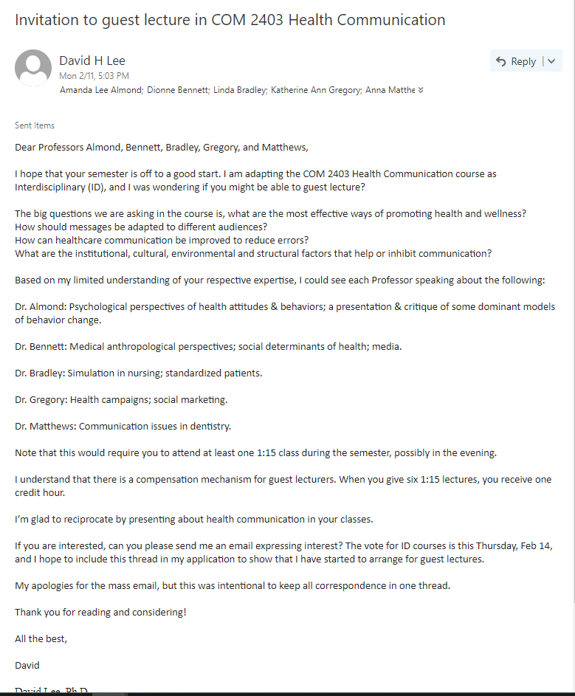Above: Letter inviting guest lecturers

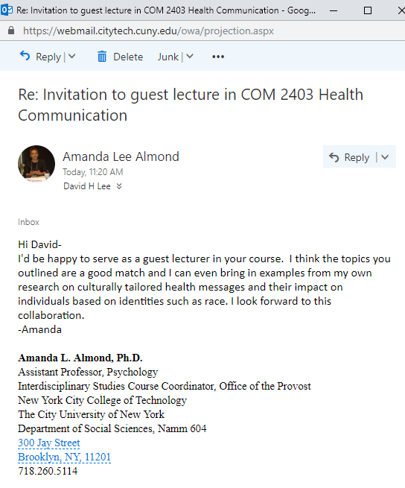
Above: Affirmative response from A.Almond
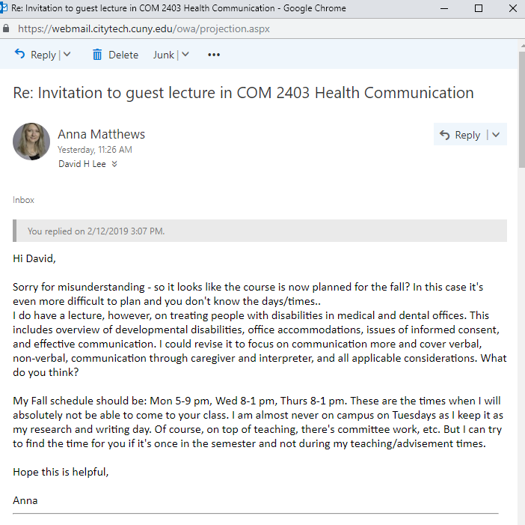
Above: Affirmative response from A.Matthews
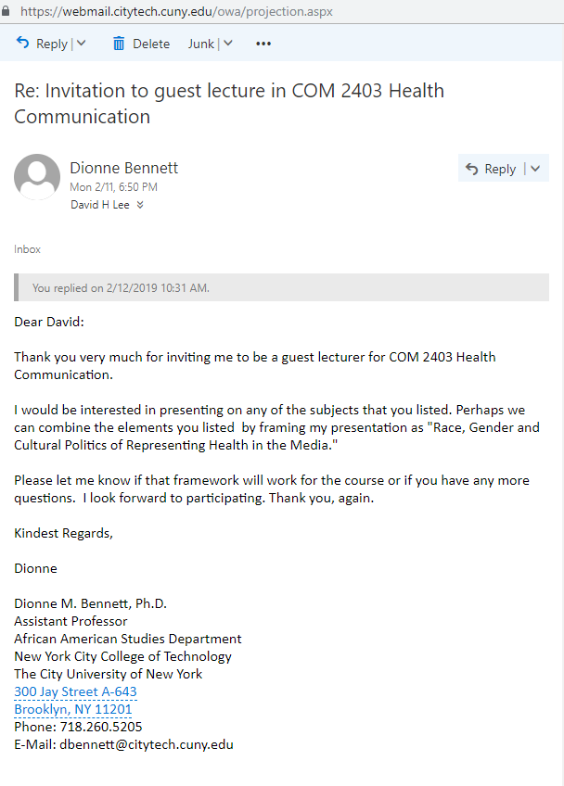
Above: Affirmative response from D.Bennett

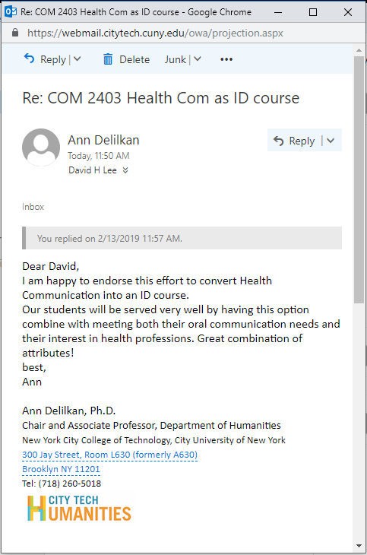
Above: Email from A.Delilkan showing Humanities Chair support

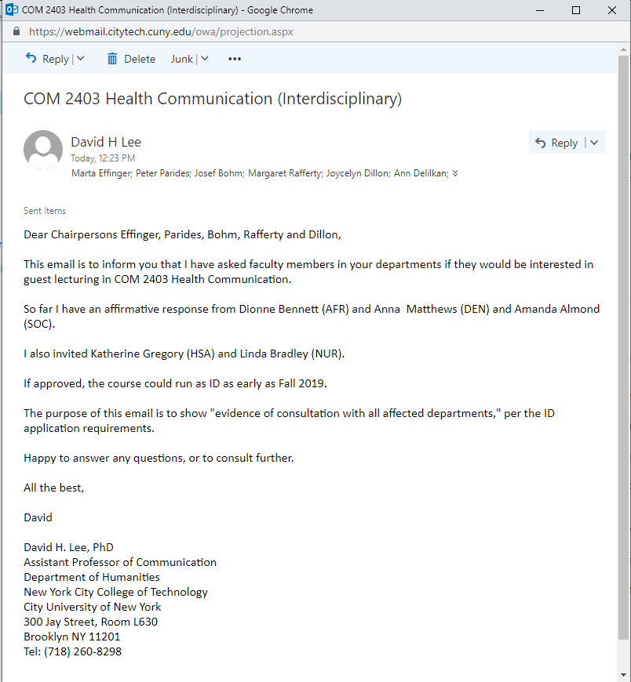
Above: Letter to Chairs of AFR, SOC, HAS, and NUR, showing consultation with affected departments.

