Feb. 13, 2018
Dear Roman:
I would be very pleased to be a guest speaker for PHYS 2443, ID, Principles of Modern Physics.
My talk will be on “The Literature Review and Tips for Good Presentations.” I will teach the students how a literature review fits into doing research and we can possibly have them come to the library’s eclassroom. The session will provide some background on scientific publishing and peer review and then we’ll practice looking for articles via the library as well as Google Scholar and learn how to “deconstruct” a scientific article and read citations. Then I’ll cover some basics of citation and good practices in effective presentations. If time permits, I’d like to teach the students how to find and attribute Creative Commons licensed images (available for use without permission) for their presentations so they understand a little more about copyright.
Best, Monica
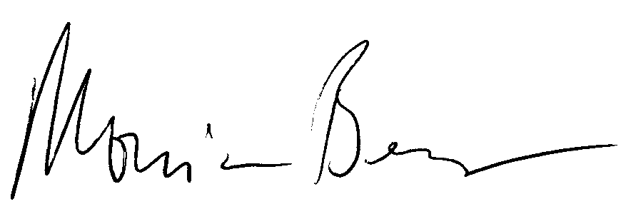
Monica Berger
Associate Professor
Ursula C. Schwerin Library

