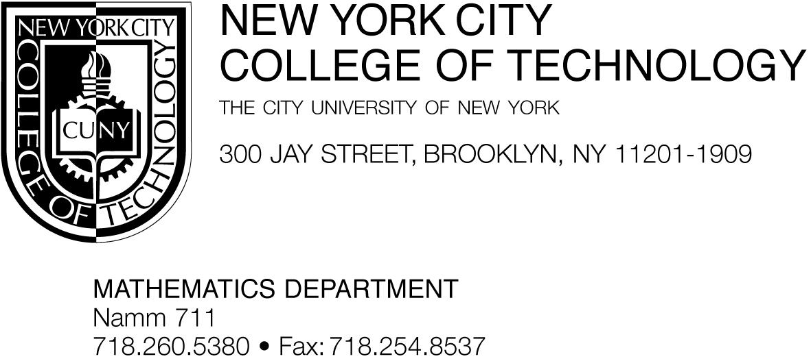

To whom it may concern,

I give my support for the Interdisciplinary Modern Physics course proposed by the City Tech Physics department. I commit to giving the guest lecture(s) on the topic “An Introduction to Quantum Computers and Quantum Computation.”

This field is my research specialization. I have published a doctoral dissertation and several papers in this area. I have also recently been invited by the mathematics department of the American University of Beirut (AUB) to give a presentation on Quantum Computation, and I am currently on the doctoral committee for a Ph.D. student in physics at the CUNY Graduate Center in this area.

Sincerely,

Dr. Marianna Bonanome

Associate Professor of the Department of Mathematics and
Co-coordinator of the Writing Across the Curriculum (WAC) Program
Co-director of the Opening Gateways Title V Grant
Co-director of the CUNY/UNESCO Partnership Program
City Tech, CUNY
646-662-1331 (cell)
718-260-5292 (office)
mbonanome@citytech.cuny.edu

