Learning Places Fall 2016
Chin/Swift

SITE REPORT [part II: performer/spectator]
name of site report

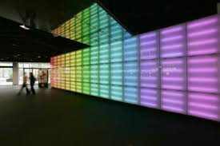

STUDENT NAME
00.00.2016

INTRODUCTION
Describe Scope of Activity [identify performer (object/building/humans/technology) and spectators]

PRE-VISIT REFLECTION
PRIOR to site visit, reflect on what you anticipate learning or seeing during the visit. PRIOR to site visit, reflect on what you anticipate learning or seeing during the visit. PRIOR to site visit, reflect on what you anticipate learning or seeing during the visit. PRIOR to site visit, reflect on what you anticipate learning or seeing during the visit. PRIOR to site visit, reflect on what you anticipate learning or seeing during the visit. PRIOR to site visit, reflect on what you anticipate learning or seeing during the visit.

SITE DOCUMENTATION (photos/sketches)

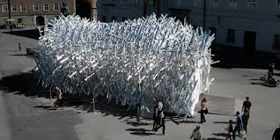

Write description of sketch or photo here, explaining why it is important and what it shows

Write description of sketch or photo here, explaining why it is important and what it shows Write description of sketch or photo here, explaining why it is important and what it shows Write description of sketch or photo here, explaining why it is important and what it shows Write description of sketch or photo here, explaining why it is important and what it shows Write description of sketch or photo here, explaining why it is important and what it shows
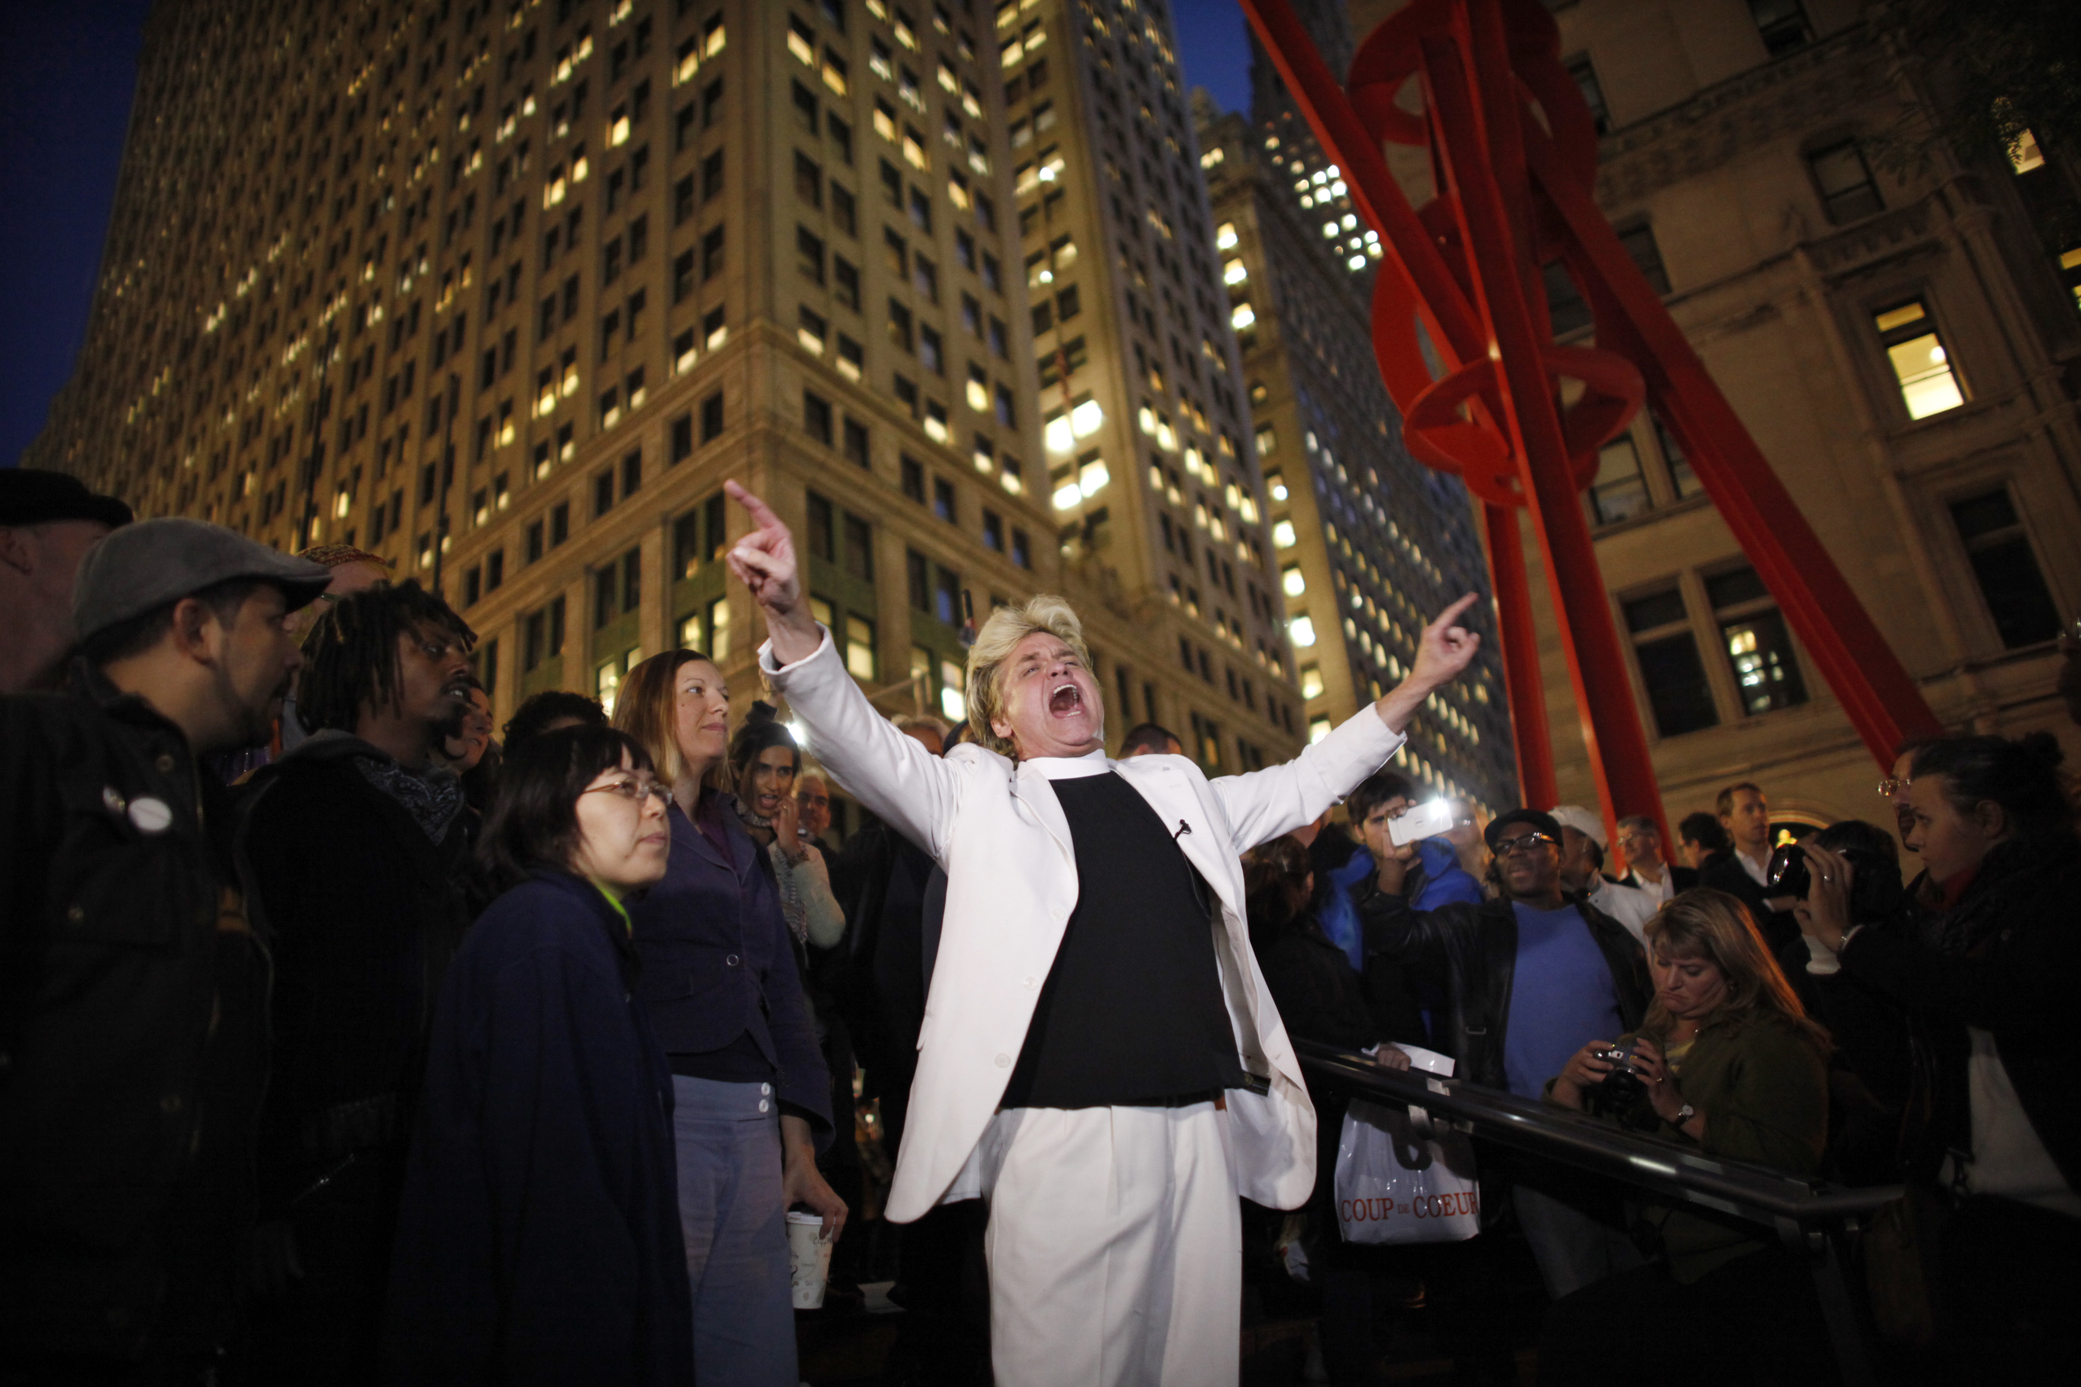

Write description of sketch or photo here, explaining why it is important and what it shows

Write description of sketch or photo here, explaining why it is important and what it shows Write description of sketch or photo here, explaining why it is important and what it shows Write description of sketch or photo here, explaining why it is important and what it shows Write description of sketch or photo here, explaining why it is important and what it shows Write description of sketch or photo here, explaining why it is important and what it shows

QUALITATIVE SITE OBSERVATIONS
- Description of the performance object, person, or technology (costume, media, text, props, sets, etc.)

- Choreography of performance

- Description of performance limits (ground, walls, barricades, streets, buildings)

- Description of audience (static, moving, direction of attention)

- Description of audience (socio-economic, community identity)

- Description of performer/spectator dynamics (engagement, morphology)

- Other Observations

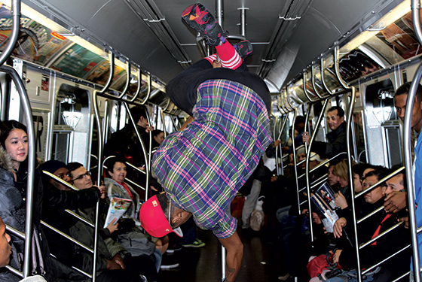

QUANTITATIVE DATA for Area of Study
Subject | Data
Size of performance space
Size of spectator space
Range of dynamic change

# of points of focus
Number of spectators (range)
Time period of performance
# of repetitions
Cost of performance (if any)
Other data

QUESTIONS TO RESEARCH FURTHER
QUESTIONS:
- Lorem ipsum dolor sit amet?
- Consectetuer adipiscing elit?
- Sed diam nonummy nibh euismod?
RESEARCH METHOD/SOURCE FOR EACH QUESTION ABOVE:
- Question 1
  - xx
  - xx
  - xx
- Question 2
  - xx
  - xx
  - xx
- Question 3
  - xx
  - xx
  - xx

SUMMARY / POST VISIT REFLECTION
Lorem ipsum dolor sit amet, consectetuer adipiscing elit, sed diam nonummy nibh euismod tincidunt ut laoreet dolore magna aliquam erat volutpat. Ut wisi enim ad minim veniam, quis nostrud exerci tation ullamcorper suscipit lobortis nisl ut aliquip ex ea commodo consequat. Lorem ipsum dolor sit amet, consectetuer adipiscing elit, sed diam nonummy nibh euismod tincidunt ut laoreet dolore magna aliquam erat volutpat. Ut wisi enim ad minim veniam, quis nostrud exerci tation ullamcorper suscipit lobortis nisl ut aliquip ex ea commodo consequat.

