New York City College of Technology, CUNY
CURRICULUM MODIFICATION PROPOSAL FORM
This form is used for all curriculum modification proposals. See the Proposal Classification Chart for information about what types of modifications are major or minor. Completed proposals should be emailed to the Curriculum Committee chair.

Title of Proposal | LIB 2205/ARCH 2205 Learning Places: Understanding the City
Date | 9/25/14
Major or Minor | Major
Proposer’s Name | Jason Montgomery and Maura Smale
Department | Architectural Technology and Library
Date of Departmental Meeting in which proposal was approved | Architectural Technology: 9/18/14  Library: 9/16/14
Department Chair Name | Shelley Smith and Maura Smale
Department Chair Signature and Date | 9/16/14
Academic Dean Name | Kevin Hom and Bonne August
Academic Dean Signature and Date | 09-23-14
Brief Description of Proposal  (Describe the modifications contained within this proposal in a succinct summary. More detailed content will be provided in the proposal body. | This document proposes a new interdisciplinary special topics course, LIB 2205/ARCH 2205 Learning Places: Understanding the City, to be taught by faculty from the Architectural Technology and Library departments.
Brief Rationale for Proposal  (Provide a concise summary of why this proposed change is important to the department. More detailed content will be provided in the proposal body). | The built environment of the city is a critical context that impacts all of our daily lives on multiple levels, including our sense of community and cultural heritage, temper and well-being, physical accessibility and mobility to name a few. Therefore it is important that we understand the nature of our built environment and the forces that guide its development. An interdisciplinary approach to investigating the built environment provides a rich educational experience and a model for effective research.
Proposal History  (Please provide history of this proposal: is this a resubmission? An updated version? This may most easily be expressed as a list). | New Course Proposal – 9/25/14  First round revisions – 11/2/14  Second round revisions – 11/3/14  Third round revisions – 11/5/14

Please include all appropriate documentation as indicated in the Curriculum Modification Checklist.
For each new course, please also complete the New Course Proposal and submit in this document.
Please submit this document as a single .doc or .rtf format. If some documents are unable to be converted to .doc, then please provide all documents archived into a single .zip file.

ALL PROPOSAL CHECK LIST
Completed CURRICULUM MODIFICATION FORM including: | X
- Brief description of proposal | X
- Rationale for proposal | X
- Date of department meeting approving the modification | X
- Chair’s Signature | X
- Dean’s Signature | X
Evidence of consultation with affected departments  List of the programs that use this course as required or elective, and courses that use this as a prerequisite. | X
Completed Chancellor’s Report Form. | X

Section AIV: New Courses

AIV.1. Library Department/Architectural Technology Department

Course Number: LIB 2205/ARCH 2205
Title: Learning Places: Understanding the City
Hours: 1 Class Hour, 4 Lab Hours
Credits: 3 Credits
Prerequisites: ENG1101 and 1 course in the Flexible Common Core

Course Description: This special topics course offers an interdisciplinary approach to investigating our built environment using a case study focused on a specific place each semester. This course combines physical examination with information research and data collection using methodologies developed in multiple disciplines. Students from a variety of departments engage in on-site exploration and in-depth research of a location in New York City.

Rationale: The built environment of the city is a critical context that impacts all of our daily lives on multiple levels, including our sense of community and cultural heritage, temper and well-being, physical accessibility and mobility to name a few. Therefore it is important that we understand the nature of our built environment and the forces that guide its development. An interdisciplinary approach to investigating the built environment provides a rich educational experience and a model for effective research.

Evidence of Consultation with Affected Departments

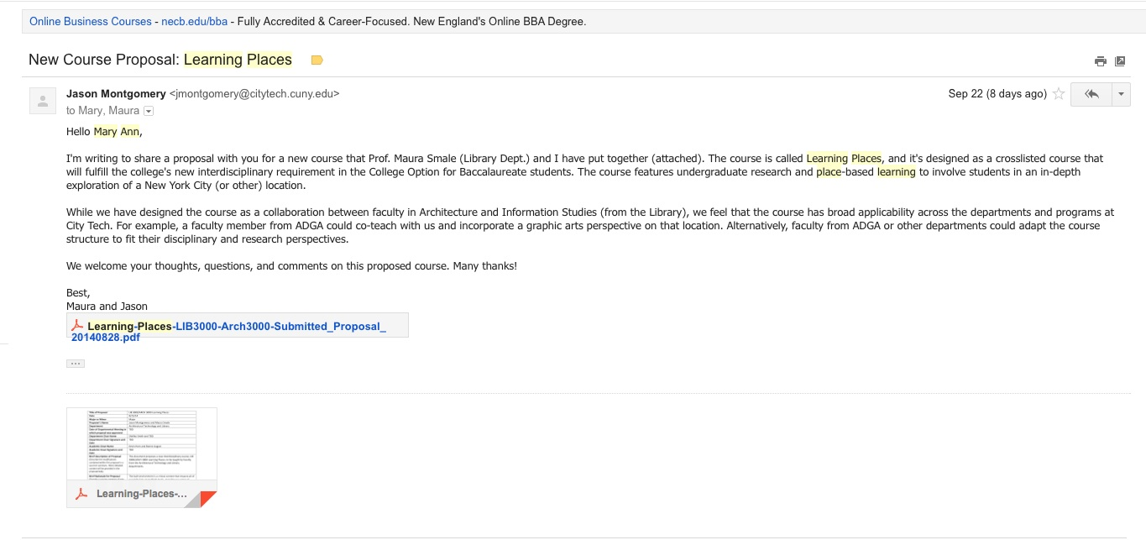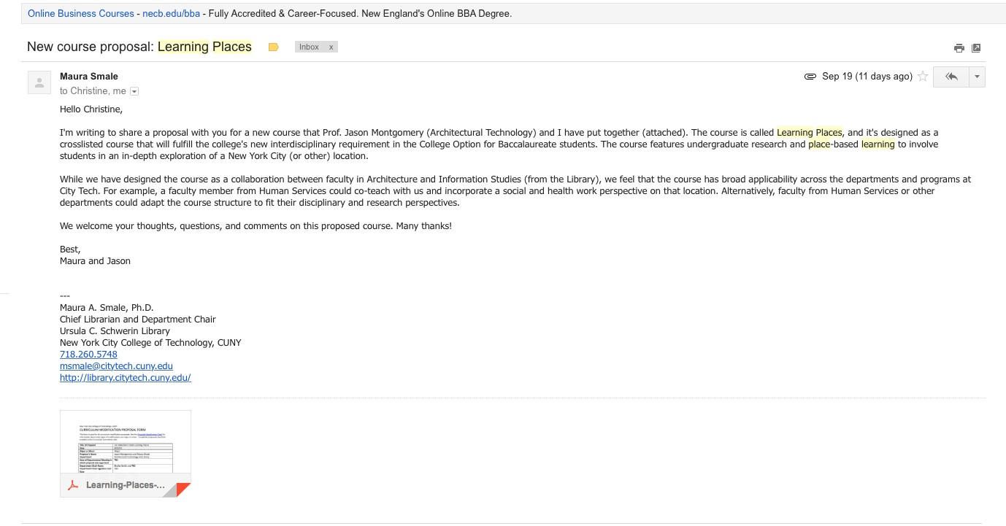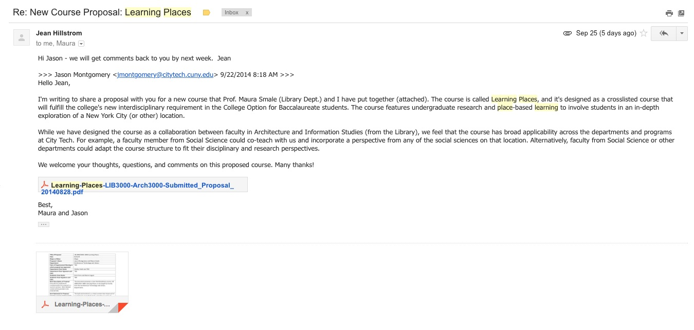
New York City College of Technology, CUNY
NEW COURSE PROPOSAL FORM
This form is used for all new course proposals. Attach this to the Curriculum Modification Proposal Form and submit as one package as per instructions. Use one New Course Proposal Form for each new course.

Course Title | Learning Places: Understanding the City
Proposal Date | 9/25/14
Proposer’s Name | Jason Montgomery and Maura Smale
Course Number | LIB 2205/ARCH 2205
Course Credits, Hours | 3 credits, 1 classroom hour, 4 lab hours
Course Pre / Co-Requisites | ENG 1101 and 1 Flexible Core Course
Catalog Course Description | This special topics course offers an interdisciplinary approach to investigating our built environment using a case study focused on a specific place each semester. This course combines physical examination with information research and data collection using methodologies developed in multiple disciplines. Students from a variety of departments engage in on-site exploration and in-depth research of a location in New York City.
Brief Rationale  Provide a concise summary of why this course is important to the department, school or college. | The built environment of the city is a critical context that impacts all of our daily lives on multiple levels, including our sense of community and cultural heritage, temper and well-being, physical accessibility and mobility to name a few. Therefore it is important that we understand the nature of our built environment and the forces that guide its development. An interdisciplinary approach to investigating the built environment provides a rich educational experience and a model for effective research.
Intent to Submit as An Interdisciplinary Course | This course is submitted as a College Option Interdisciplinary course, and was approved by the Interdisciplinary Committee on 10/21/14.

Please include all appropriate documentation as indicated in the NEW COURSE PROPOSAL Combine all information into a single document that is included in the Curriculum Modification Form.

NEW COURSE PROPOSAL CHECK LIST
Use this checklist to ensure that all required documentation has been included. You may wish to use this checklist as a table of contents within the new course proposal.
Completed NEW COURSE PROPOSAL FORM | x
- Title, Number, Credits, Hours, Catalog course description | x
- Brief Rationale | x
Completed Library Resources and Information Literacy Form | x
Course Outline  Include within the outline the following. | x
Hours and Credits for Lecture and Labs  If hours exceed mandated Carnegie Hours, then rationale for this | x
Prerequisites/Co- requisites | x
Detailed Course Description | x
Course Specific Learning Outcome and Assessment Tables  - Discipline Specific  - General Education Specific Learning Outcome and Assessment Tables | x
Example Weekly Course outline | x
Grade Policy and Procedure | x
Recommended Instructional Materials (Textbooks, lab supplies, etc) | x
Library resources and bibliography | x
Course Need Assessment.  Describe the need for this course. Include in your statement the following information. | x
Target Students who will take this course. Which programs or departments, and how many anticipated?  Documentation of student views (if applicable, e.g. non-required elective). | x
Projected headcounts (fall/spring and day/evening) for each new or modified course. | x
Where does this course overlap with other courses, both within and outside of the department? | x
Does the Department currently have full time faculty qualified to teach this course? If not, then what plans are there to cover this? | x
Course Design  Describe how this course is designed. | x
Course Context (e.g. required, elective, capstone) | x
Course Structure: how the course will be offered (e.g. lecture, seminar, tutorial, fieldtrip)? | x
Anticipated pedagogical strategies and instructional design (e.g. Group Work, Case Study, Team Project, Lecture) | x
How does this course support Programmatic Learning Outcomes? | x
Is this course designed to be partially or fully online? If so, describe how this benefits students and/or program. | x
Additional Forms for Specific Course Categories | x
Interdisciplinary Form (if applicable) | x

Course Needs Assessment

Cities, streets, squares, and neighborhoods are the backdrop for the drama of human life. They are a testament to those who came before us and built these places. They are a touchstone for issues that are wide ranging across many disciplines. Cities are only growing as the critical habitat of the future as rural populations diminish. As urban populations grow, the pressure on existing urban conditions to change and adapt will increase. How should this change occur? What is the significance of the city that we have today? How can we ensure that our built environment is sustainable and resilient? How should issues of gentrification, social justice and economic segregation be addressed in the context of densification and redevelopment? These questions are not limited to one discipline; they require an interdisciplinary approach. It is important, therefore, that our students understand the nature of our cities, the complex forces that guide their development and the cultural inheritance imbedded in them. This understanding will be critical to the future development of our cities that each student contributes to through their life’s work.

To accomplish this, students require a methodology and strategy for investigating the built environment. Therefore this course will be centered on investigation and research. Today’s students have an ever growing digital access to information and research sources. This digital access to sources threatens to weaken or sever students’ connection to physical experiences and places during their formative educational years. This course addresses this growing problem by offering an experiential approach to investigation with an emphasis on direct field investigation and research that brings students face to face with primary sources. Careful observation will be the threshold skill that enables the rigorous investigation and research to take place.

Each semester the course will focus on one new place (usually in New York City). Places will be selected based on historical/cultural significance, current or recent events, or subjects being explored in courses across the curriculum. The place will be selected by the faculty team teaching each individual section of the course. Examples of possible places are Times Square, Five Points, the Erie Basin Red Hook, Zuccotti Park. As an interdisciplinary course, Learning Places may be taught by faculty in a range of departments at the college. Faculty members who are teaching the course each semester will propose the specific place that the course will focus on, which will be approved by all affected departments.

Students will work in teams in a forensic manner to first document the existing condition of the place through notes, sketches, and photographs. Next the students will propose a research methodology and develop a bibliography for the place, searching for primary sources pertaining to important issues inherent to the place including its physical and social development and evolution, its history, and its cultural significance. Then they will visit libraries and archives to further research primary source materials. From the site documentation and the primary sources, the students will develop new documents (written and graphic) to record and illustrate the layers of complexity embedded in the place as well as the chronological stages of development of the place and its significance. These documents will be organized and made accessible via the development of an OpenLab project site. They will finish by preparing a final report that includes a broad assessment of the place and guidelines for interventions and/or preservation of the place. The OpenLab project site that students create will remain publicly available after the course has concluded, so it may become a resource for anyone interested in the place.
As an interdisciplinary elective course, we expect students to be drawn from many departments across the college, and for one section of the course to be offered each academic year (beginning in the Fall 2015 semester), enrolling 20 students. There is not excessive overlap of this course with other courses that are currently offered at the college. Architectural Technology offers a course in the History of New York City Architecture, though it does not take an in-depth approach to one building or area of the city in the same way that our course will. The Library Department offers a course in Research and Documentation for the Information Age – an introductory course on information-based research that does not delve into primary source and archival research to the extent that our course will.

In its current instantiation, this course requires at a minimum two faculty, one each from the Architectural Technology Department and the Library. The course is flexible and can include one additional faculty member as a primary instructor. In the typical semester, the faculty member from the Architectural Technology Department will lead the fieldwork investigation and the development of the report and graphic materials. The Library faculty member will guide the research methodology, bibliography and primary source investigation. In the case of an additional faculty member, we envision shared leadership on the fieldwork investigation and the addition of workshops in which the faculty can conduct activities that allow the disciplines to debate the impacts and interrelationships of the complex issues arising from the place.
After the course is established, other faculty from both departments can help sustain the course, especially Anne Leonard from the Library and Michael Duddy from the Architectural Technology Department. All of us have participated in the Living Lab Seminar and have the experience and knowledge to apply a broad-based, general education, multidisciplinary approach to this course.

Course Outline

LIB 2205 LEARNING PLACES: UNDERSTANDING THE CITY
1 classroom hour, 4 lab/studio hours, 3 credits

Course Description: This special topics course offers an interdisciplinary approach to investigating our built environment using a case study focused on a specific place each semester. This course combines physical examination with information research and data collection using methodologies developed in multiple disciplines. Students from a variety of departments engage in on-site exploration and in-depth research of a location in New York City.

Course context: This special topics course is an Interdisciplinary Liberal Arts and Sciences Course that applies toward the BTech/BS General Education Common Core College Option requirements.

Prerequisites: ENG 1101 and any Flexible Core Course

Recommended Texts: At the discretion of the faculty teaching the course

Course Structure: This course combines a series of research seminars with field work, site visits and documentation, and on and off campus research. Combinations of individual and team assignments as well as class participation are the basis for the final grade. The culmination of the weekly assignments is the Final Report as well as a Wikipedia Entry or Existing Site Editing. The Final Report will be published on the Open Lab and accessible to the entire City Tech community.

Grading: Final grade will be determined according to the following grade weighting:

50% Site Documentation Reports
10% Annotated Bibliography
15% Team Research Assignment
20% Final Report Assignment
5% Class Participation

General Education Learning Outcomes / Assessment Methods

Learning Outcomes | Assessment Methods
Upon successful completion of this course the student shall be able to: | To evaluate the students’ achievement of the learning objectives, the professor will do the following:
1. Develop, purposefully connect and integrate knowledge from a range of disciplinary perspectives presented in the course. | 1. Review the final report assignment to evaluate integrative, multidisciplinary thinking.
2. Utilize skills in inquiry/analysis to derive meaning from experience as well as gather information from observation. | 2. Review the students’ site documentation report, research notes and diagrams.
3. Integrate information literacies by gathering, interpreting, evaluating and applying information discerningly from a variety of sources. | 3. Review the students’ research methodology proposal annotated bibliography, and team research assignment to evaluate critical thinking and analysis across disciplines.

Interdisciplinary Learning Outcomes / Assessment Methods

Learning Outcomes | Assessment Methods
Upon successful completion of this course the student shall be able to: | To evaluate the students’ achievement of the learning objectives, the professor will do the following:
1. Purposefully connect and integrate across-discipline knowledge and skills to solve problems. | 1. Review student reflections and Wikipedia assignment to evaluate integrative, multidisciplinary thinking.
2. Synthesize and transfer knowledge across disciplinary boundaries. | 2. Review student reflections and the final report assignment to evaluate integrative, multidisciplinary thinking.
3. Comprehend factors inherent in complex problems. | 3. Review the students’ research methodology proposal and bibliography to evaluate critical thinking and analysis across disciplines.
4. Think critically, communicate effectively, and work collaboratively. | 4. Review the students’ class participation and research notes and diagrams; Review the final report to evaluate critical thinking, effective communication, and effective collaboration.
5. Become flexible thinkers. | 5. Review the students’ site documentation report, notes, sketches, and photographs to evaluate the discovery process.

Course Intended Learning Outcomes / Assessment Methods

Learning Outcomes | Assessment Methods
Upon successful completion of this course the student shall be able to: | To evaluate the students’ achievement of the learning objectives, the professor will do the following:
1. Use the city as a laboratory for learning. | 1. Review the students’ site documentation reports, notes, sketches, and photographs to evaluate the care of observation and the reflection of important issues discovered.
2. Develop a methodological approach to research. | 2. Review the students’ research methodology proposal, annotated bibliography, and team research assignment to evaluate critical thinking and analysis across disciplines.
3. Understand the cultural, social and economic processes that guide the physical development of the built environment. | 3. Review the students’ research notes and diagrams; Review the team research assignment and the final report assignment to evaluate integrative, multidisciplinary thinking.
4. Use analytical skills to investigate places. | 4. Review the students’ site documentation report, notes, sketches, and photographs to evaluate the care of observation and the reflection of important issues discovered.
5. Develop, document, catalogue, and organize information to make it accessible to the public. | 5. Review the students’ site documentation report, notes, sketches, and photographs to evaluate the care of observation and the reflection of important issues discovered; Review the final report to evaluate integrative, multidisciplinary thinking.
6. Apply observational skills to research and analysis. | 6. Review the students’ notes, sketches, and photographs to evaluate the care of observation and the reflection of important issues discovered.

Course Readings and Calendar

Faculty teaching the course will add readings that address the specific location and research methodologies covered in that iteration of the course. Note that the course’s design – with one lecture and four lab hours – enables the class to meet off-campus throughout the semester. Faculty should plan on at least 4 visits to the specific location covered in the course, as well as additional trips to libraries, museums, archives, and other institutions as appropriate for research into the location studied via the disciplinary focus of the faculty teaching the course. A sample calendar follows:

WEEK 1:
Week 1 Lecture: Course Introduction
Week 1 Lab: Review of Research Methodologies, Source Evaluation

WEEK 2:
Week 2 Lecture: Site Introduction
Week 2 Lab: Field Visit: General Review
Week 2 Homework: Site Reflection

WEEK 3:
Week 3 Lecture: Research Seminar: Site Background, Library and Internet Research
Week 3 Lab: Field Visit: Site Observation & Documentation
Week 3 Homework: Site Observation Sketches and Notes

WEEK 4:
Week 4 Lecture: Research Seminar: Information Sources & Primary Sources
Week 4 Lab: Field Visit: Site Observation & Documentation
Week 4 Homework: Site Observation Sketches and Notes

WEEK 5:
Week 5 Lecture: Research Seminar: Identify Research Tracks and Teams
Week 5 Lab: Team Research Organization, Wikipedia Campus Ambassador Presentation
Week 5 Homework: Team Research Outline & Task List

WEEK 6:
Week 6 Lecture: Research Seminar: In-depth research methods for the discipline
Week 6 Lab: Field Visit: Library/Museum/Archive/etc.
Week 6 Homework: Research Notes

WEEK 7:
Week 7 Lecture: Research Seminar: In-depth research methods for the discipline
Week 7 Lab: Field Visit: Library/Museum/Archive/etc.
Week 7 Homework: Research Notes

WEEK 8:
Week 8 Lecture: Research Seminar: In-depth research methods for the discipline
Week 8 Lab: Field Visit: Site Observation & Documentation
Week 8 Homework: Site Observation Sketches and Notes

WEEK 9:
Week 9 Lecture: Team Progress Presentations
Week 9 Lab: Team Progress Presentations, Final Deliverable Assignments
Week 9 Homework: Reflection on Progress, Next Steps

WEEK 10:
Week 10 Lecture: Final Report Mock Up
Week 10 Lab: Research Documentation: Annotated Bibliography
Week 10 Homework: Annotated Bibliography

WEEK 11:
Week 11 Lecture: Wikipedia Campus Ambassador Presentation
Week 11 Lab: Presentation Tools Workshop

WEEK 12:
Week 12 Lecture: Report Development
Week 12 Lab: Report Development Review
Week 12 Homework: Draft of Final Report / Wikipedia edits finished

WEEK 13:
Week 13 Lecture: Report Development
Week 13 Lab: Report Development Review
Week 13 Homework: Continue working on Final Report and Presentation

WEEK 14:
Week 14 Lecture: Final Editing
Week 14 Lab: Final Editing
Week 14 Homework: Continue working on Final Report and Presentation

WEEK 15:
Week 15 Lecture: Formal Presentation of Report
Week 15 Lab: Reflection
Course Syllabus

Library Department / Department of Architectural Technology

LIB 2205/ARCH 2205 LEARNING PLACES: UNDERSTANDING THE CITY
1 classroom hour, 4 lab/studio hours, 3 credits

Course Description: This special topics course offers an interdisciplinary approach to investigating our built environment using a case study focused on a specific place each semester. This course combines physical examination with information research and data collection using methodologies developed in multiple disciplines. Students from a variety of departments engage in on-site exploration and in-depth research of a location in New York City.

Faculty from the Library and Architectural Technology Departments are teaching the course this semester, and will thus focus course material through a lens of architecture, urban studies, and information studies.

Course context: This special topics course is an Interdisciplinary Liberal Arts and Sciences Course that applies toward the BTech/BS General Education Common Core College Option requirements.

Prerequisites: ENG 1101 and any Flexible Core Course

Recommended Texts:

Badke, William. Research Strategies: Finding Your Way Through the Information Fog. New York: Iuniverse, 2014.

Crowe, Norman, and Paul Laseau. Visual Notes for Architects and Designers. Hoboken, NJ: Wiley, 2012. Print.

Attendance Policy: No more than 10% absences are permitted during the semester. For the purposes of record, two lateness are considered as one absence. Exceeding this limit will expose the student to failing at the discretion of the instructor.

Course Structure: This course combines a series of research seminars with field work, site visits and documentation, and on and off campus research. Combinations of individual and team assignments as well as class participation are the basis for the final grade. The culmination of the weekly assignments is the Final Report as well as a Wikipedia Entry or Existing Site Editing. The Final Report will be published on the Open Lab and accessible to the entire City Tech community.

Grading: Final grade will be determined according to the following grade weighting:

50% Site Documentation Reports
10% Annotated Bibliography
15% Team Research Assignment
20% Final Report Assignment
5% Class Participation

Academic Integrity: Students and all others who work with information, ideas, texts, images, music, inventions and other intellectual property owe their audience and sources accuracy and honesty in using, crediting and citation of sources. As a community of intellectual and professional workers, the college recognizes its responsibility for providing instruction in information literacy and academic integrity, offering models of good practice, and responding vigilantly and appropriately to infractions of academic integrity. Accordingly, academic dishonesty is prohibited in The City University of New York and is punishable by penalties, including failing grades, suspension and expulsion.

General Education Learning Outcomes / Assessment Methods

Learning Outcomes | Assessment Methods
Upon successful completion of this course the student shall be able to: | To evaluate the students’ achievement of the learning objectives, the professor will do the following:
1. Develop, purposefully connect and integrate knowledge from a range of architectural, urban studies, information science, and other disciplinary perspectives presented in the course. | 1. Review the final report assignment to evaluate integrative, multidisciplinary thinking.
2. Utilize skills in inquiry/analysis to derive meaning from experience as well as gather information from observation. | 2. Review the students’ site documentation report, research notes and diagrams.
3. Integrate information literacies by gathering, interpreting, evaluating and applying information discerningly from a variety of sources. | 3. Review the students’ research methodology proposal annotated bibliography, and team research assignment to evaluate critical thinking and analysis across disciplines.

Interdisciplinary Learning Outcomes / Assessment Methods

Learning Outcomes | Assessment Methods
Upon successful completion of this course the student shall be able to: | To evaluate the students’ achievement of the learning objectives, the professor will do the following:
1. Purposefully connect and integrate across-discipline knowledge and skills to solve problems. | 1. Review student reflections and Wikipedia assignment to evaluate integrative, multidisciplinary thinking.
2. Synthesize and transfer knowledge across disciplinary boundaries. | 2. Review student reflections and the final report assignment to evaluate integrative, multidisciplinary thinking.
3. Comprehend factors inherent in complex problems. | 3. Review the students’ research methodology proposal and bibliography to evaluate critical thinking and analysis across disciplines.
4. Think critically, communicate effectively, and work collaboratively. | 4. Review the students’ class participation and research notes and diagrams; Review the final report to evaluate critical thinking, effective communication, and effective collaboration.
5. Become flexible thinkers. | 5. Review the students’ site documentation report, notes, sketches, and photographs to evaluate the discovery process.

Course Intended Learning Outcomes / Assessment Methods

Learning Outcomes | Assessment Methods
Upon successful completion of this course the student shall be able to: | To evaluate the students’ achievement of the learning objectives, the professor will do the following:
1. Use the city as a laboratory for learning. | 1. Review the students’ site documentation reports, notes, sketches, and photographs to evaluate the care of observation and the reflection of important issues discovered.
2. Develop a methodological approach to research. | 2. Review the students’ research methodology proposal, annotated bibliography, and team research assignment to evaluate critical thinking and analysis across disciplines.
3. Understand the cultural, social and economic processes that guide the physical development of the built environment. | 3. Review the students’ research notes and diagrams; Review the team research assignment and the final report assignment to evaluate integrative, multidisciplinary thinking.
4. Use analytical skills to investigate places. | 4. Review the students’ site documentation report, notes, sketches, and photographs to evaluate the care of observation and the reflection of important issues discovered.
5. Develop, document, catalogue, and organize information to make it accessible to the public. | 5. Review the students’ site documentation report, notes, sketches, and photographs to evaluate the care of observation and the reflection of important issues discovered; Review the final report to evaluate integrative, multidisciplinary thinking.
6. Apply observational skills to research and analysis. | 6. Review the students’ notes, sketches, and photographs to evaluate the care of observation and the reflection of important issues discovered.

Course Outline

WEEK 1:
Week 1 Lecture: Course Introduction
Readings: Wikipedia article on Times Square, Encyclopedia of New York City article on Times Square
Week 1 Lab: Review of Research Methodologies, Source Evaluation
Readings: How Search Works, Evaluating Internet Sources

WEEK 2:
Week 2 Lecture: Site Introduction
Readings: Selections from Bibliography (below) on Times Square
Week 2 Lab: Field Visit: General Review
Readings: Selections from Visual Notes for Architects and Designers
Week 2 Homework: Site Reflection

WEEK 3:
Week 3 Lecture: Research Seminar: Site Background, Library and Internet Research
Reading: Architectural Technology Subject Guide
Week 3 Lab: Field Visit: Site Observation & Documentation
Readings: Selections from Bibliography (below) on Times Square
Week 3 Homework: Site Observation Sketches and Notes

WEEK 4:
Week 4 Lecture: Research Seminar: Information Sources & Primary Sources
Readings: Primary, Secondary, and Tertiary Sources, What are Primary Sources?
Week 4 Lab: Field Visit: Site Observation & Documentation
Readings: Selections from Visual Notes for Architects and Designers
Week 4 Homework: Site Observation Sketches and Notes

WEEK 5:
Week 5 Lecture: Research Seminar: Identify Research Tracks and Teams
Week 5 Lab: Team Research Organization, Wikipedia Campus Ambassador Presentation
Reading: Nicholson Baker “The Charms of Wikipedia”
Week 5 Homework: Team Research Outline & Task List

WEEK 6:
Week 6 Lecture: Research Seminar: Digital Maps and Sketchup Documentation
Readings: Historic Maps as Historian’s Evidence, Making Sense of Maps
Week 6 Lab: Field Visit: NYPL Map Room
Week 6 Homework: Map Research Notes

WEEK 7:
Week 7 Lecture: Research Seminar: Archival Sources
Readings: Introduction to Archives, Digital Archives Materials, What are archives and how do they differ from libraries?
Week 7 Lab: Field Visit: Archives (Either the New York Historical Society or the Museum of the City of New York)
Readings: About page and other selections of the website for whichever archive we visit
Week 7 Homework: Archive Research Notes

WEEK 8:
Week 8 Lecture: Research Seminar: Data Sources and GIS Documentation and Analysis
Week 8 Lab: Field Visit: Site Observation & Documentation
Readings: Selections from Bibliography (below) on Times Square
Week 8 Homework: Site Observation Sketches and Notes

WEEK 9:
Week 9 Lecture: Team Progress Presentations
Week 9 Lab: Team Progress Presentations, Final Deliverable Assignments
Week 9 Homework: Reflection on Progress, Next Steps

WEEK 10:
Week 10 Lecture: Final Report Mock Up
Week 10 Lab: Research Documentation: Annotated Bibliography
Readings: Annotated Bibliography, Quoting, Paraphrasing, and Summarizing, Why and How to Avoid Plagiarism, Is it Plagiarism Yet?
Week 10 Homework: Annotated Bibliography

WEEK 11:
Week 11 Lecture: Wikipedia Campus Ambassador Presentation
Week 11 Lab: Presentation Tools Workshop
Reading: How to Use Prezi

WEEK 12:
Week 12 Lecture: Report Development
Week 12 Lab: Report Development Review
Week 12 Homework: Draft of Final Report / Wikipedia edits finished

WEEK 13:
Week 13 Lecture: Report Development
Week 13 Lab: Report Development Review
Week 13 Homework: Continue working on Final Report and Presentation

WEEK 14:
Week 14 Lecture: Final Editing
Week 14 Lab: Final Editing
Week 14 Homework: Continue working on Final Report and Presentation

WEEK 15:
Week 15 Lecture: Formal Presentation of Report
Week 15 Lab: Reflection

Course Readings

Annotated Bibliography, City Tech Library:
http://library.citytech.cuny.edu/research/subjectGuides/wiki/index.php/Annotated_Bibliography

Architectural Technology Subject Guide, City Tech Library:
http://library.citytech.cuny.edu/research/subjectGuides/wiki/index.php/Architectural_Technology

Baker, Nicholson. “The Charms of Wikipedia.” The New York Review of Books. N.p., 20 Mar. 2008. 55(4) http://www.nybooks.com/articles/archives/2008/mar/20/the-charms-of-wikipedia/

Digital Archives Materials, Purdue OWL:
http://owl.english.purdue.edu/owl/resource/988/07/

Evaluating Internet Sources, University of Illinois Libraries:
http://www.library.illinois.edu/export/ugl/howdoi/evaluate_internet.pdf

Evaluating Sources, City Tech Library:
http://library.citytech.cuny.edu/uploads/recap.pdf

Historic Maps as Historian’s Evidence, Newberry Library:
http://publications.newberry.org/frontiertoheartland/exhibits/show/perspectives/historicmaps/mapsasevidence

How Search Works, Google:
http://static.googleusercontent.com/media/www.google.com/en/us/intl/en/insidesearch/howsearchworks/assets/searchInfographic.pdf

How to Use Prezi, Oregon State University:
http://oregonstate.edu/tac/how-to-use/prezi

Introduction to Archives, Purdue OWL:
http://owl.english.purdue.edu/owl/resource/988/01/

Is It Plagiarism Yet? Purdue OWL:
http://owl.english.purdue.edu/owl/resource/589/02/

Making Sense of Maps, George Mason University and the American Social History Project, CUNY
http://historymatters.gmu.edu/mse/maps/

Primary, secondary, and tertiary sources, Virginia Tech University Libraries:
http://www.lib.vt.edu/help/research/primary-secondary-tertiary.html

Quoting, Paraphrasing, and Summarizing, Purdue OWL:
http://owl.english.purdue.edu/owl/resource/563/01/

Times Square, Wikipedia:
http://en.wikipedia.org/wiki/Times_Square

What are archives and how do they differ from libraries? Society of American Archivists:
http://www2.archivists.org/usingarchives/whatarearchives

What are primary sources? Yale University Libraries:
http://www.yale.edu/collections_collaborative/primarysources/primarysources.html

Why and How to Avoid Plagiarism, City Tech Library:
http://library.citytech.cuny.edu/instruction/plagiarism/index.php

Bibliography

Devine, Jane, and Egger-Sider, Francine. Going Beyond Google Again: Strategies for Using and Teaching the Invisible Web. Chicago: ALA-Neal Schuman, 2013.

Jackson, Kenneth T. The Encyclopedia of New York City, 2nd edition. New Haven, CT: Yale University Press, 2010.

Miller, Kristine F. Designs on the Public: The Private Lives of New York's Public Spaces. Minneapolis: University of Minnesota Press, 2007.

Reichl, Alexander J. Reconstructing Times Square: Politics and Culture in Urban Development. Lawrence, KS: University Press of Kansas, 1999.

Sagalyn, Lynne B. Times Square Roulette: Remaking the City Icon. Cambridge, MA: MIT Press, 2001.

Taylor, William R., ed. Inventing Times Square: Commerce and Culture at the Crossroads of the World. Baltimore: Johns Hopkins University Press, 1996.

LIBRARY RESOURCES & INFORMATION LITERACY: MAJOR CURRICULUM MODIFICATION

Please complete for all major curriculum modifications. This information will assist the library in planning for new acquisitions; it will not affect curriculum proposals either positively or negatively.

Consult with library faculty subject selectors (http://cityte.ch/dir) 3 weeks in advance when planning course proposals to ensure enough time to allocate budgets if materials need to be purchased.

Course proposer: please complete boxes 1-4. Library faculty subject selector: please complete box 5.

1 | Title of proposal  Learning Places: Understanding the City (LIB 2205/ARCH 2205) | Department/Program  Library/Architectural Technology
 | Proposed by (include email & phone)  Jason Montgomery, jmontgomery@citytech.cuny.edu, 718-260-5994; Maura Smale, msmale@citytech.cuny.edu, 718-260-5748 | Expected date course(s) will be offered  Fall 2015  # of students 20

2 | Are City Tech library resources sufficient for course assignments? Please elaborate.  The library’s book collections are sufficient for most of our course assignments, though we have a few items to recommend for purchase (below). We will use library databases in the course.

3 | Are additional resources needed for course assignments? Please provide details about format of resources (e.g., ebooks , journals, DVDs, etc.), author, title, publisher, edition, date, and price.  Crowe, Norman, and Paul Laseau. Visual Notes for Architects and Designers. Hoboken, NJ: Wiley, 2012. $47.00  Devine, Jane, and Egger-Sider, Francine. Going Beyond Google Again: Strategies for Using and Teaching the Invisible Web. Chicago: ALA-Neal Schuman, 2013. $75.00  Sagalyn, Lynne B. Times Square roulette: Remaking the city icon. Cambridge, MA: MIT Press, 2001. $26.00  Taylor, William R., ed. Inventing Times Square: Commerce and culture at the crossroads of the world. Baltimore: Johns Hopkins University Press, 1996. $28.00

4 | Library faculty focus on strengthening students' information literacy skills in finding, evaluating, and ethically using information. We can collaborate on developing assignments and offer customized information literacy instruction and research guides for your course.  Do you plan to consult with the library faculty subject specialist for your area? Please elaborate.  This course, as an interdisciplinary course team taught with a library faculty member, includes a strong information literacy component. We will consult with Prof. Anne Leonard, Library, as the course evolves to ensure that information literacy remains an integral part of the course.

5 | Library Faculty Subject Selector___Prof. Anne Leonard____  Comments and Recommendations  I look forward to working with my colleagues in the Library and Architectural Technology departments to make this interdisciplinary course successful. Integrating information literacy into this course could include a range of teaching modalities: teaching 1-2 research orientations, developing a research guide or tutorial on the library website, OpenLab, or elsewhere, accompanying the class on visits to libraries and archives for primary source research, and/or offering feedback on assignment design to ensure that learning outcomes that promote information literacy are met. I am prepared and eager to pursue any of these to support this course. With my colleague Ian Beilin, subject selector for Architectural Technology, I will review the proposed syllabus well in advance in order to meet students’ needs for print and electronic resources.  Date 9/15/14

New York City College of Technology
Interdisciplinary Committee

Application for Interdisciplinary Course Designation

Date: August 25, 2014

Submitted by: Jason Montgomery, Maura Smale

Department(s): Architectural Technology, Library Department

- Proposal to Offer an Interdisciplinary Course

- Identify the course type and title:
◻ An existing course____________________________________________________________
☒ A new course: Learning Places: Understanding the City LIB 2205/ARCH 2205
◻ A course under development ____________________________________________________
- Provide a course description: This special topics course offers an interdisciplinary approach to investigating our built environment using a case study focused on a specific place each semester. Students from multiple departments learn together in a methodology that combines physical examination through the lens of architecture and urban studies with information research and data collection through the lens of information studies.

- How many credits will the course comprise? 3 credits How many hours? 1 class hour, 4 lab hours

- What prerequisite(s) would students need to complete before registering for the course? Co-requisite(s)?
Prerequisites: ENG 1101 and at least one course in the Flexible Core. No co-requisites.

- Explain briefly why this is an interdisciplinary course. This course’s central approach is place-based learning, researching a case study each semester that is inherently rich and deep in terms of the issues connected to the place. The mode of operation in the course will be to uncover the multiple layers and complexity of the sites’ history, ecology, social implications, economic impact, geography, and cultural meaning.

- What is the proposed theme of the course? What complex central problem or question will it address? What disciplinary methods will be evoked and applied? The theme of the course is using places to learn to see (observation) and reveal new knowledge (research). The central problem the course addresses is: how can places teach us to observe the world around us and help us broaden our knowledge and understanding of things in general, helping foster the desire and skills for lifelong learning? Careful observation skills of the physical environment will be developed through the lens of architectural investigation and research skills and data collection will be developed through the discipline of information studies.

- Which general learning outcomes of an interdisciplinary course does this course address?
Please explain how the course will fulfill the bolded mandatory learning outcome below. In addition, select and explain at least three additional outcomes.

◻ Purposefully connect and integrate across-discipline knowledge and skills to solve problems
The investigation of the case study project will involve investigation along seemingly disparate disciplines and then a process of seeking connections to understand the forces that shaped the place.

◻ Synthesize and transfer knowledge across disciplinary boundaries
The final report prepared by the students will require synthesizing the findings across the lines of research and disciplines to communicate a coherent story about the place.

◻ Comprehend factors inherent in complex problems
The case study project will challenge the students to come to terms with its breadth and level of complexity in the many layers of issues that need to be considered in the research process.

◻ Apply integrative thinking to problem solving in ethically and socially responsible ways

◻ Recognize varied perspectives

◻ Gain comfort with complexity and uncertainty

◻ Think critically, communicate effectively, and work collaboratively
The final report development will require critical thinking as well as effective communication. Each student team will prepare the report together, requiring productive collaboration.

◻ Become flexible thinkers
The case study will start as a wide open subject, and the direction of the investigation will only become clear as the work goes on. In this way it will challenge the students to become flexible in their attitude and thinking about the project.
◻ Other

General Education Learning Goals for City Tech Students

- Knowledge: Develop knowledge from a range of disciplinary perspectives, and hone the ability to deepen and continue learning.
- Skills: Acquire and use the tools needed for communication, inquiry, creativity, analysis, and productive work.
- Integration: Work productively within and across disciplines.
- Values, Ethics, and Relationships: Understand and apply values, ethics, and diverse
perspectives in personal, professional, civic, and cultural/global domains.

- How does this course address the general education learning goals for City Tech students?
This course will leverage the diverse talents of the students, bring diverse perspectives to the project. The case study itself will allow for multiple perspectives and lines of inquiry. Its open-ended nature will encourage creative analysis, and the final report will require integration across the disciplines.

- Which department would house this course? The course will be cross-listed in the Architectural Technology and Library Departments, but housed in the Library Department.
- Would all sections of the course be interdisciplinary? ◻ No ☒ Yes

  - Would the course be cross-listed in two or more departments? ◻ No ☒ Yes
Explain.
The course will be cross-listed in the Architectural Technology and Library Departments.
  - How will the course be team-taught? ◻ Co-taught ◻ Guest lecturers ◻ Learning community
If co-taught, what is the proposed workload hour distribution? 2 credits for the Architectural Technology faculty member, 1 credit for the Library Department faculty member.
◻ Shared credits ◻ Trading credits
If guest lecturers, for what approximate percentage of the course? ◻ Minimum 20% ◻ other: __%
Please attach the evaluation framework used to assess the interdisciplinarity of the course.
See below

  - What strategies/resources would be implemented to facilitate students’ ability to make connections across the respective academic disciplines?
The observations made on site will involve note taking, sketching, photography. The process of making nuanced careful observations at many scales and with many differing points of focus: ecology, social make-up, economic activity, physical structure among others will foster analysis on the interaction and connections between disciplines. The research process will compliment the field work as a connected critical mode of inquiry.

- Would the course be designated as:
☒ a College Option requirement? ☒ an elective? ◻ a Capstone course? ◻ other? Explain.
This course is structured and conceived to fulfill the College Option requirement for an interdisciplinary course. The course is rooted in a liberal arts approach to research places through the perspective of multiple disciplines.

Course Evaluation Framework

We propose to team teach this course with a credit distribution of 2 credits for the Architectural Technology faculty member, 1 credit for the Library Department faculty member. Our evaluation framework is as follows:

- For the Student Evaluation of Teaching, we would like students in the course to complete two evaluation forms, one for each faculty member. This will allow students the opportunity to consider our teaching individually.

- For the Faculty Classroom Observation, we would like one faculty member to observe a class session in which we are both participating. This will allow both faculty members teaching the course to be observed, while not imposing an undue time burden on the observer. The observer could be a faculty colleague from either of our departments.

An interdisciplinary course for the College Option requirement may be housed in a department that is not liberal arts.
Attach evidence of consultation with all affected departments.
While an interdisciplinary course must be team-taught, there is no formal percentage requirement, but this minimum is a guideline.
In the case that a course is equally taught, include proposed plans for faculty classroom observation and student evaluation of teaching.
To qualify for the College Option, such a course must also meet the New York State definition of a liberal arts and sciences course. http://www.highered.nysed.gov/ocue/lrp/liberalarts.htm
A course proposed as a Capstone course must be separately approved by the Capstone Experience Committee.

