HOSPITALITY SERVICES MARKETING MANAGEMENT
HMGT 4702
Term Year

Instructor |  | Class Number | Section
E-mail |  | Day
Phone |  | Location
Office |  | Time
Office Hours |  | Class Hours | 3
 |  | Lab Hours | 0
 |  | Credits | 3
______________________________________________________________________________
Department Mission Statement
The Hospitality Management Department of New York City College of Technology educates students for careers in the hospitality industry through foundational knowledge of hospitality operations and experiences that cultivate diverse perspectives, lifelong learning, collaboration, and community engagement.

Program Learning Outcomes
To graduate students who 1. identify and demonstrate skills relevant to the operational areas of hospitality management. (PLO #1) 2. utilize the dynamics of collaboration in diverse settings. (PLO #2) 3. demonstrate effective communication skills. (PLO #3) 4. exhibit the analytical and social skills essential for success in the global workplace. (PLO #4) 5. value and integrate lifelong learning, civic engagement, ethical reasoning, and social responsibility. (PLO #5)

Course Description
Relationship among the various components of the hospitality industry and the markets it serves. Study of the corporate mission, goals, vision statement, company history, customer perception, environment and social factors as influences on profitability; techniques for analyzing business, strategy formation and implementation.

Prerequisites
HMGT 3501, HMGT 3502, HMGT 3602

Course Objectives
Upon completion of HMGT 4702, students will be able to
- Demonstrate the unique characteristics of service marketing
- Identify and describe various marketing strategies that are employed in today’s successful service enterprises
- Identify and analyze strategic elements of service marketing and their impact on revenue and profitability
- Analyze and explain current service marketing and management issues
- Demonstrate an understanding of industry specific key language and concepts

Student Learning Outcomes | Method of Assessment
- Identify and summarize the distinctive characteristics of service marketing and management (HMGT: Knowledge; Gen Ed: Skill) | Participation & Professionalism, Case study and Current Event Analysis, Final exam
- Recognize and paraphrase the relationship between the internal workplace environment and customer satisfaction (HMGT: Knowledge; Gen Ed: Integration) | Participation & Professionalism, Case study and Current Event Analysis, Servicescaping Project Presentation, Final exam
- Identify and exemplify the three physical dimensions of a service environment (HMGT: Knowledge, Skills; Gen Ed: Integration; PLO #4) | Servicescaping Project Report, Servicescaping Project Presentation
- Compare, contrast, hospitality website elements to personal experience (HMGT: Knowledge, Skills; Gen Ed: Integration; PLO #3, #4) | Servicescaping Project Report, Servicescaping Project Presentation
- Define and describe service industry language and concepts (HMGT: Knowledge; Gen ED: Knowledge, Integration) | Participation & Professionalism, Case study and Current Event Analysis, Final exam

Grading Procedure
Participation & Professionalism (homework, in-class discussion/activities) 20%
Case Study & Current Event Analysis 20%
Servicescaping Project
Report 20%
Presentation 20%
Final Exam 20%

Total 100%

Assignments
- Participation & Professionalism
- Participation: the instructor will monitor students' participation in in-class exercises/discussions. No missed participation exercise will be allowed.
- Professionalism: this course requires professional and respectful classroom behavior. Students engaging in the following activities (including but not limited to), cell phone usage, inappropriate posture, reading non-class materials, and chatting/sleeping/eating will be continuously monitored and such behavior will be reflected in the grade.

- Case Study & Current Event Analysis
- Read TWO articles WEEKLY on the assigned topics and post them with a comment on Twitter. This assignment is due at the start of a class meeting. No late work will be accepted.

- Servicescaping Project (the rubrics for written report and oral presentation are on pp. 6-7)
- Report: Conduct a 'digital' servicescape analysis for a selected local hospitality venue and summarize the results of the study in APA style.
- Presentation: Conduct a 'physical' servicescape analysis for the venue and compare online servicescapes to offline servicescapes.

- Final Exam
- A comprehensive essay exam will be given at the end of the semester.

Grading System
A 93 – 100
A- 90 – 92.9
B+ 87 – 89.9
B 83 – 86.9
B- 80 -- 82.9
C+ 77 – 77.9
C 70 – 76.9
D 60 – 69.9
F 59.9 and below

Required Text
No required text

Suggested Texts and Readings
Bitner, M. J. (1992). Servicescapes: The impact of physical surroundings on customers and
employees. Journal of Marketing, 56, 57-71.

Kim, H., & Fesenmaier, D. R. (2008). Persuasive design of destination websites: an analysis of
first impression. Journal of Travel Research, 47, 3-13.

Lovelock, C., & Wirtz, J. (2017). Essentials of services marketing. 3rd ed. Harlow, Essex:
England, Pearson.

Pine II, B. J., & Gilmore, J. H. (1998). Welcome to the experience economy. Harvard Business
School Press. Retrieved from https://hbr.org/1998/07/welcome-to-the-experience-economy

Yongme, M., & Queich, J. (2018). Starbucks: delivering customer service. Harvard Business
School Press, Retrieved from https://hbsp.harvard.edu/product/504016-PDF-ENG

Course Materials
N/A

Rubrics

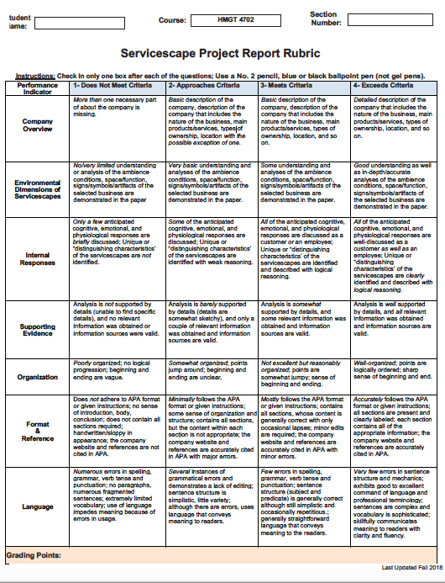

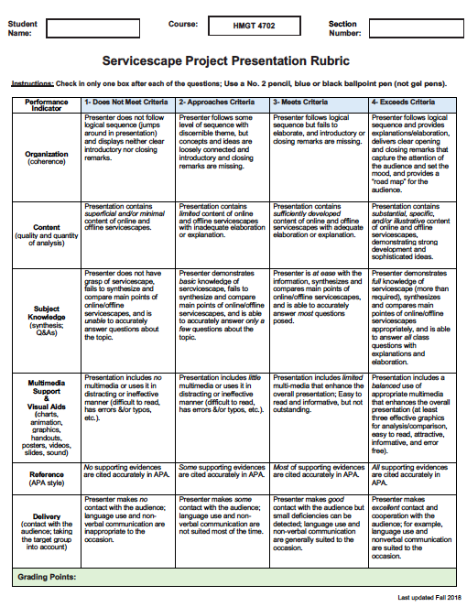

Selected Bibliography

Confessore, N., Dance, G. J. X., Harris, R., & Hansen, M. (2018) The follower factory. The New
York Times. Retrieved from https://www.nytimes.com/interactive/2018/01/27/technology/social-media-bots.html

Hall , K. (2019). Stories that stick: How storytelling can captivate customers, influence
audiences, and transform your business. New York, NY: HarperCollins Leadership.

Hopkins, C. D., Grove, S. J., Raymond, M. A., & LaForge, M. C. (2009). Designing the e-
servicescape: implications for online retailers. Journal of Internet Commerce, 8, 23-43.

Hospitality Sales and Marketing Association International (2019). HSMAI-CHDM book. 2nd ed.,
Retrieved from
http://digital.graphcompubs.com/allarticle/23310/203889/203889/allarticle.html#

Lin, I. Y., & Mattila, A. S. (2010). Restaurant servicescape, service encounter, and perceived
congruency on customers’ motions and satisfaction. Journal of Hospitality Marketing & Management, 19, 819-841.

Lovelock, C., & Wirtz, J. (2017). Services marketing: people, technology, strategy, 8th ed.
Derby, England: Pearson.

Hwang, J. (2008). Restaurant table management to reduce customer waiting times. Journal of
Foodservice Business Research. 11(4), 334-351.

Pulizzi, J. (2013). Epic content marketing: How to tell a different story, break through the
clutter, and win more customers by marketing less. New York, NY: McGraw-Hill Education.

Scott, D. M. (2017). The new rules of marketing & PR: How to use social media, online video,
mobile applications, blogs, news releases & viral marketing to reach buyers directly. 6th ed., Hoboken, NJ: Wiley.

The Disney Institute., & Kinni, T. (2011). Be our guest: perfecting the art of customer service.
New York, NY: Disney Editions.

Tuten, T. L., & Solomon, M. R. (2020). Social media marketing. 3rd ed., Thousand Oaks, CA:
Sage.

Class Meeting Schedule

The following course schedule is tentative and may be subject to change.

Week | Date | Topics
1 |  | Introduction to the Course & Projects  Review the 4Ps & the SWOT Analysis  Why Study Services?
2 |  | Service Definition & Characteristics  Consumer Behavior in the Experience Economy  Services Theater Model
3 |  | Introduction to Servicescape  The Bitner’s Servicescape Model
4 |  | Digital Servicescapes  Congruency between Digital and Physical Servicescapes
5 |  | Delivering Services & Service Blueprint
6 |  | Website as a Marketing Tool & Effective Website Design
7 |  | Marketing on Google & Key Measurement Index on the Web
8 |  | Social Media and Mobile Marketing  Managing Online Reviews
9 |  | Sharing Economy
10 |  | Customer Relationship Management (CRM)  Managing Negative Customer Service Experience
11 |  | Managing Loyal Customers
12 |  | Service Leaderships & Future Challenges
13 |  | Project Presentations – Part I
14 |  | Project Presentations – Part II
15 |  | Exam

Student Accessibility
Qualified students with disabilities, under applicable federal, state, and city laws, seeking reasonable accommodations or academic adjustments must contact the Center for Student Accessibility for information on City Tech’s policies and procedures to obtain such services. Students with questions on eligibility or the need for temporary disability services should also contact the Center at The Center for Student Accessibility:
300 Jay Street, room L-237, 718 260 5143. http://www.citytech.cuny.edu/accessibility/

Professionalism and Participation
The Department of Hospitality Management follows industry standards in order to educate, develop and mentor future hospitality and tourism professionals. In order to successfully complete a course, students must consistently participate in class and meet deadlines

NYC College of Technology Statement on Academic Integrity
Students and all others who work with information, ideas, texts, images, music, inventions, and other intellectual property owe their audience and sources accuracy and honesty in using, crediting, and citing sources. As a community of intellectual and professional workers, the College recognizes its responsibility for providing instruction in information literacy and academic integrity, offering models of good practice, and responding vigilantly and appropriately to infractions of academic integrity. Accordingly, academic dishonesty is prohibited in The City University of New York and at New York City College of Technology and is punishable by penalties, including failing grades, suspension, and expulsion.

As stated in the Academic Integrity Policy Manual,
"academic dishonesty occurs when individuals plagiarize or cheat in the course of their academic work. Plagiarism is the presenting of someone else’s ideas without proper credit or attribution. Cheating is the unauthorized use or attempted use of material, information, notes, study aids, devices or communication during an academic exercise."

The complete text of the College Academic Integrity Policy Manual may be found on the College website.

Statement of Classroom Behavior
Each student has the right to study and learn in a comfortable, safe, supportive environment that promotes self-esteem – free of fear, humiliation, intimidation, offensive or suggestive language.
.
Use of Electronic Devices
The use of cellular phones and audio equipment in all academic and study areas of the college is prohibited. Students are not permitted to take calls or text message during class. Students may not use their cell phones as calculators. In some instances, an instructor may allow the use of personal electronic devices for in class activities.

Writing Style Statement
The hospitality management department requires that all written work must be prepared using APA Style Publication Manual of the American Psychological Association as a reference guide. This includes editorial formats, abbreviations, use of statistics, graphs, citations and references. Visit the City Tech Library website for APA Style Guides.
HM Department Calendar

