Complete the following information about the regions/appellations before class begins.

Country/Region/Appellation Monterey County, California
Southwest of San Francisco Bay area on the California Coast
The largest of the Northern part of central coast
Sub appellation: Salinas Valley, and other AVA regions: Santa Cruz Mountains, Chalone, Mount Harlan, Carmel Valley, and Santa Lucia Highlands. (pg. 725)

Grape variety
Dominant grape variety: Chardonnay, Pinot Noir.
Chenin Blanc, Riesling, Cabernet Sauvignon
(http://www.wine-information-online.com/california-wines.html)

Climate
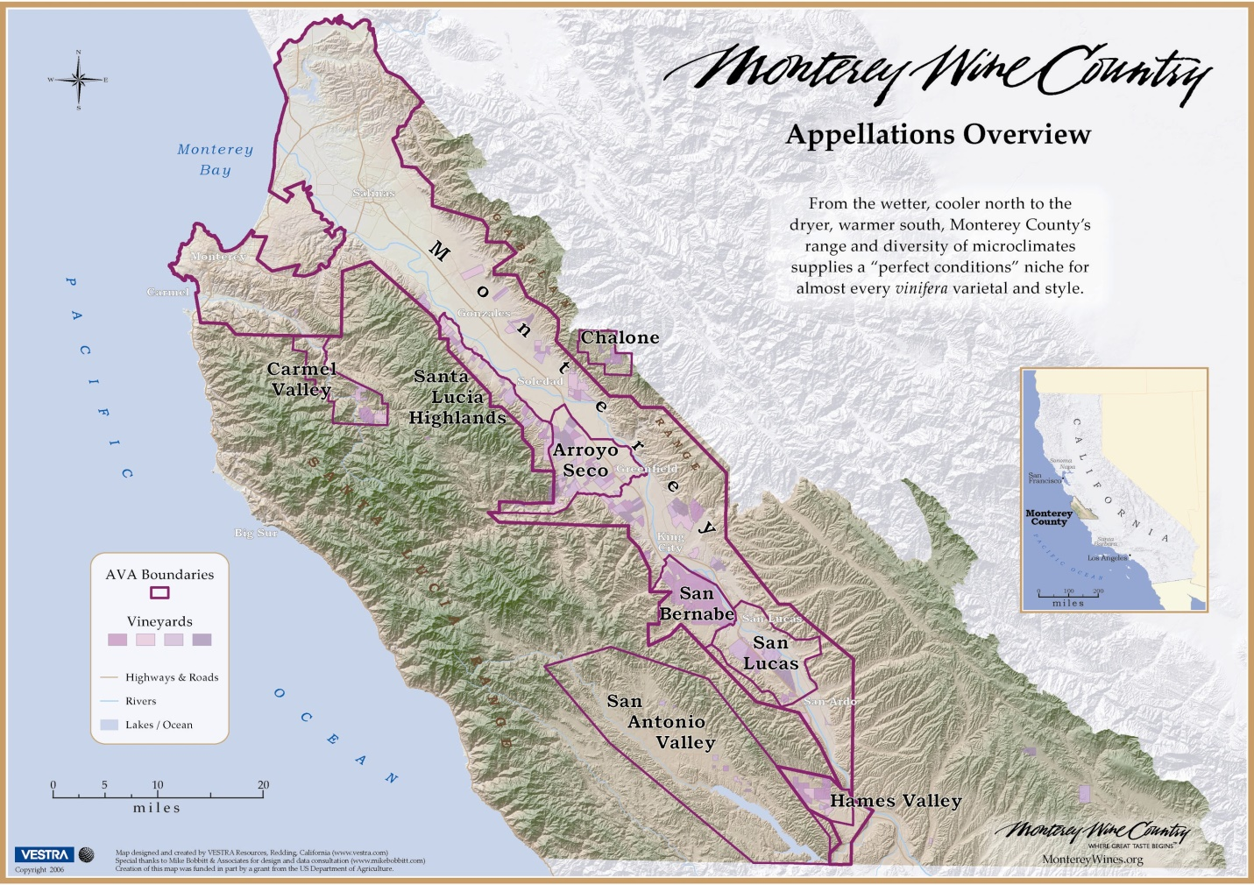
(http://wine.appellationamerica.com/wine/data/Monterey.html)

Generally warm, but with variations such as the cooler areas of the Santa Cruz Mountains and the Northern part of Salinas Valley, low rainfall percentage.

Soil
A wide variety of gravel loams, often high on stone content and rich in limestone, gravelly, well-drained, low-fertility soils in Monterey County. Eight primary soils at Monterey County: Soils: Oceano Loamy Sand, Lockwood Shaly Loam, Chualar Loam, Garey Sandy Loam, Arroyo Seco Gravelly Sandy Loam, Rincon Clay Loam and Placentia Sandy Loam.
(https://montereywines.org/vineyards/eight-soils/)
Viticulture
A small number of big wine companies produce a vast quantity of inexpensive wines utilizing high-tech, production-line methods.

Vinification
The number of small wineries is growing. Many of these are quality-conscious and some are justifiably famous. Chardonnay and Pinot Noir are the dominant grapes in the county, especially in the cooler northern part, where wines of real character can be made.

Add additional notes about the regions/appellations/labels during.
How to Read a Wine Label
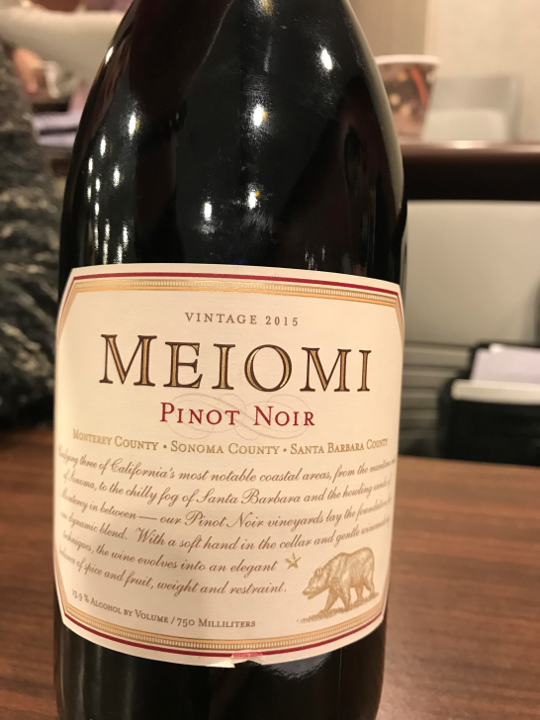
(https://www.meiomi.com/)
Monterey – 52%
Sonoma – 24%
Santa Barbara – 24%
Producer: Meiomi
Region: Monterey County, Sonoma County, and Santa Barbara
Variety: Pinot Noir
Vintage: 2015

Interesting fact
(Most Information Retrieved From Textbook and Online)

