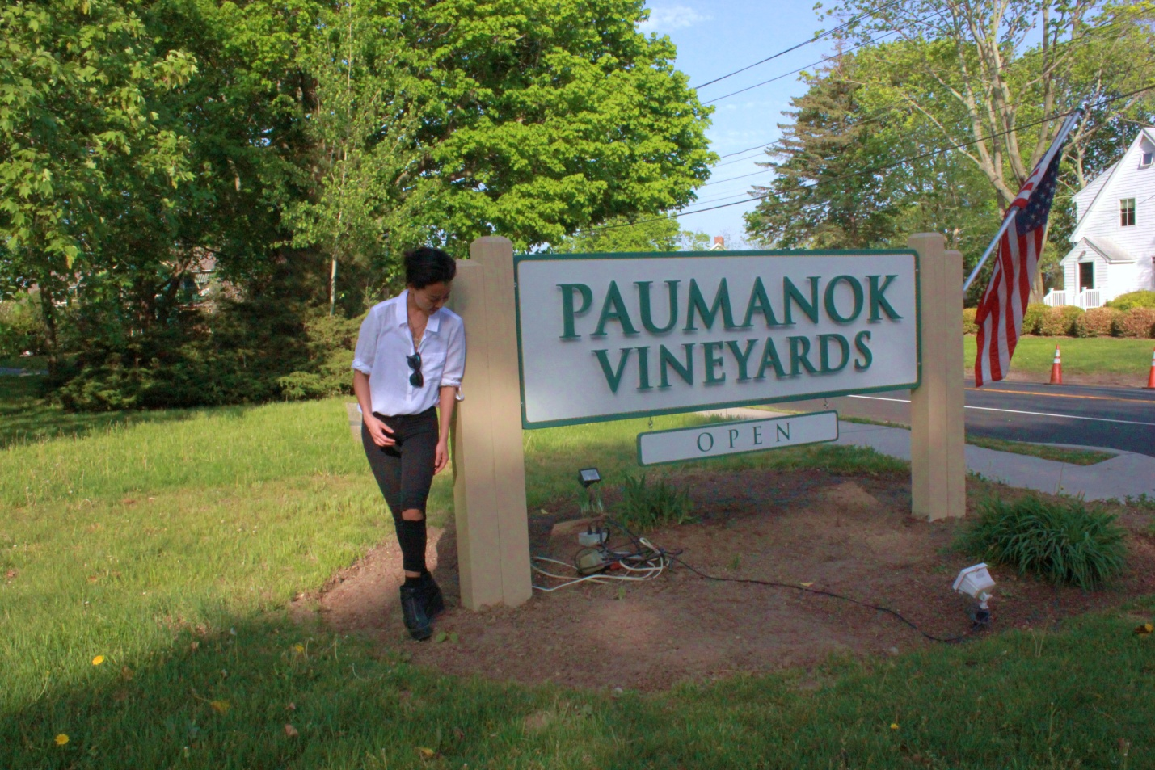
Visiting on a bright and sunny Wednesday afternoon, I was surprised (and slightly pleased) to find no one in the tasting room. The tasting room is a large OPEN space with high ceilings. The bar itself is located front and left as you immediately walk in, not giving visitors much reason to walk in further and peruse the gift shop that was along the back right wall. Producing wines for almost 30 years, Paumanok sits on about 100 acres of glorious Long Island fertile ground.

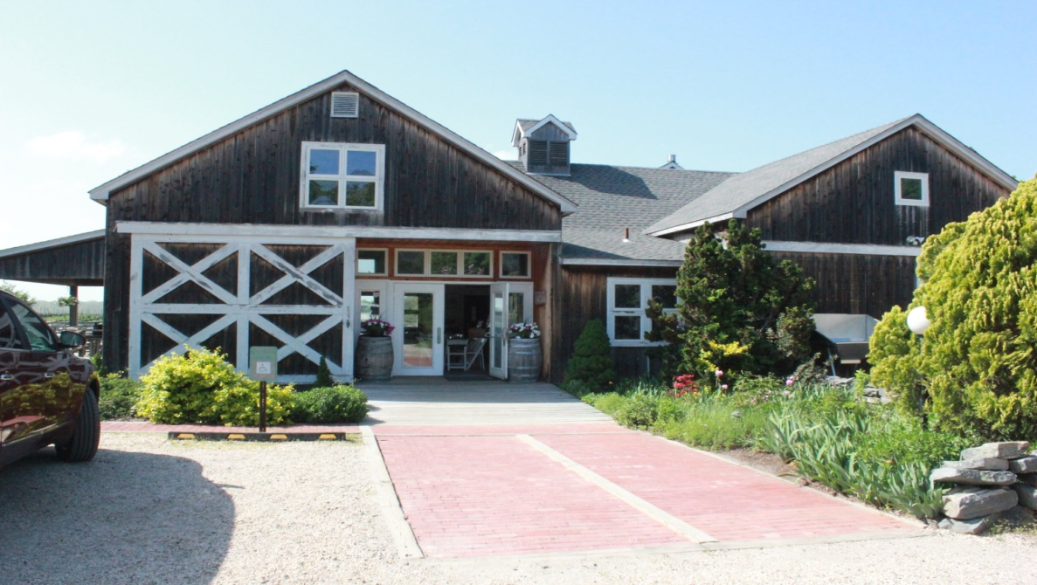
Everything about Paumanok Vineyards is impressive. Paumanok, owned by the Massoud family, is a winery that owns all of their vineyards, and estate bottles all of their wines. This is an important element of the PROCESS, because it enables them to control the grape growing from beginning to harvest, and then oversee all cellar practices. Their wines stand with the best Long Island has to offer, and amongst the finest in the US.
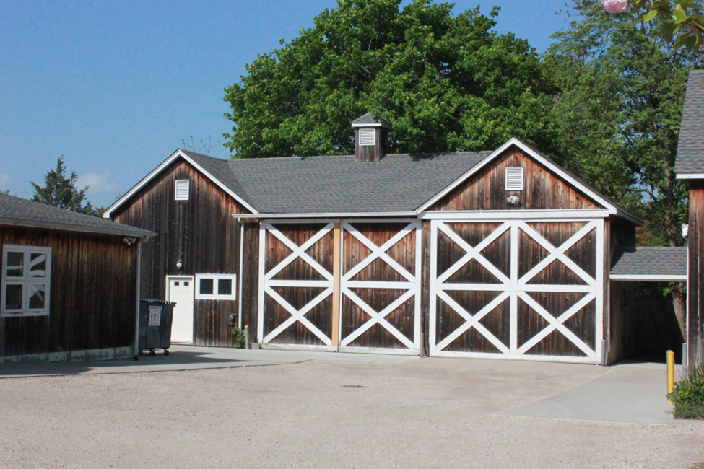

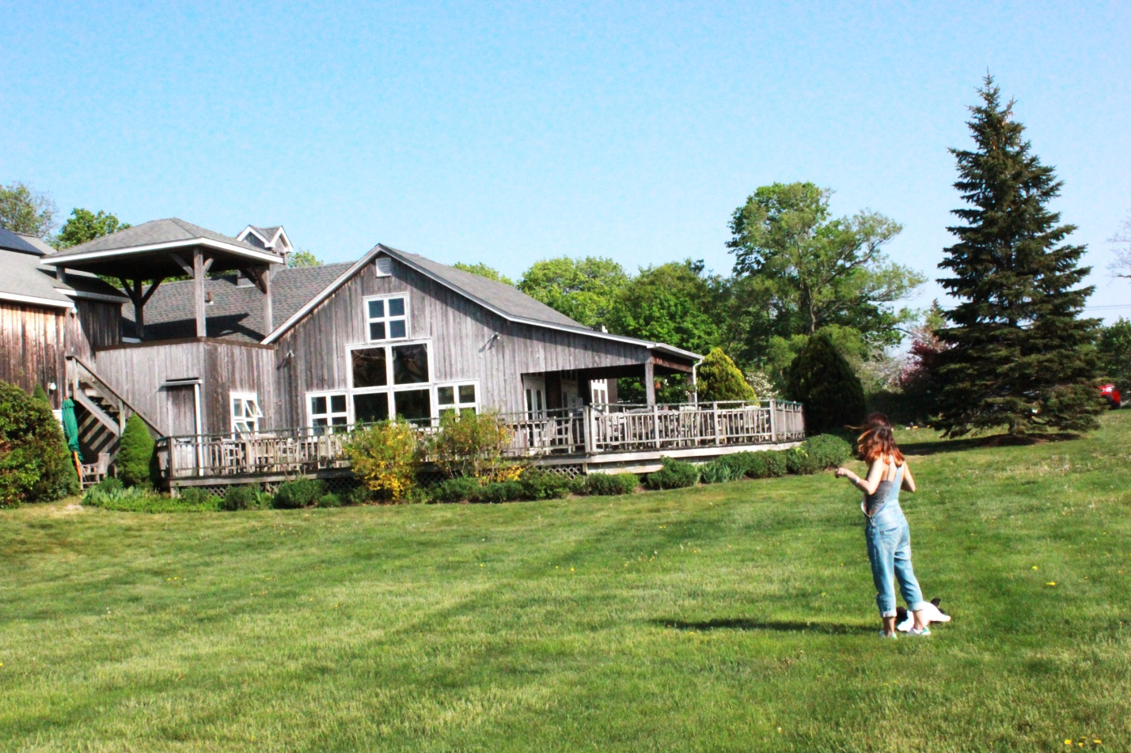

They founded Paumanok Vineyards in 1983 when they planted theirr first vines on the North Fork of Long Island. Today their family estate winery produces premium Chardonnay, Chenin Blanc, Sauvignon Blanc, Riesling, Merlot, Cabernet Franc, Cabernet Sauvignon and Petit Verdot.
Charles and Ursula oversee the operation and their three sons handle day-to-day business: Kareem Massoud is winemaker and marketing director; Salim Massoud manages logistics and administrative duties; and Nabeel Massoud works as vineyard manager.
The winery is a charming, renovated barn with a great patio area overlooking the estate’s vineyards.

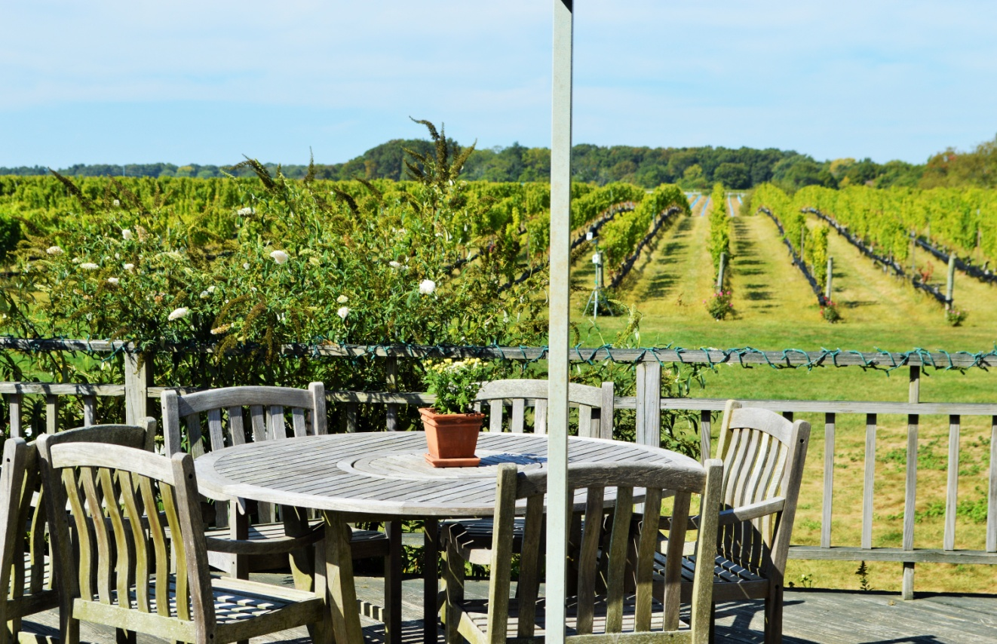

As we made our way to the tasting bar we were presented with several tasting options, I met with Anthony Quattrone who spends most of his time in Paumanok’s tasting room pouring for, EDUCATING and giving tours to all those who stop by the vineyard. But, as many in the industry do, Quattrone wears multiple hats and also manages fulfillment of wholesale accounts, works in the cellar and assists with harvest for Paumanok.

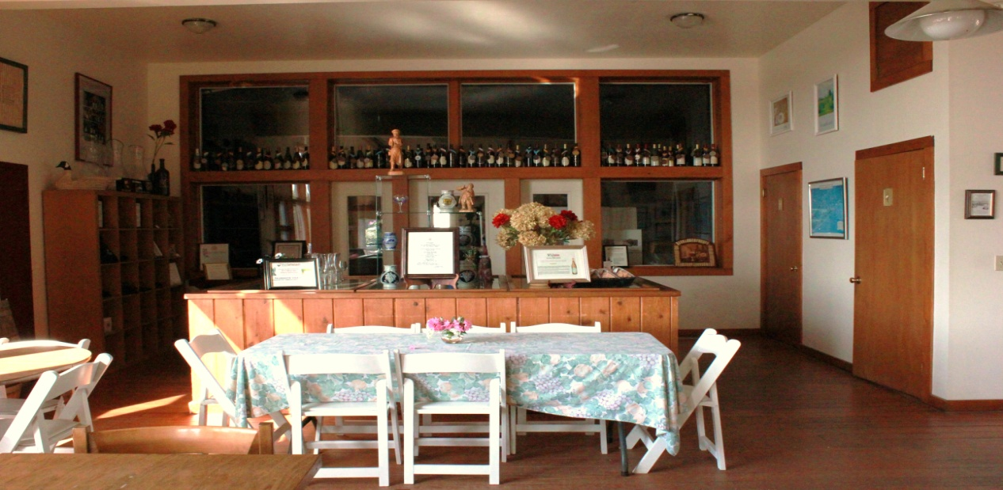

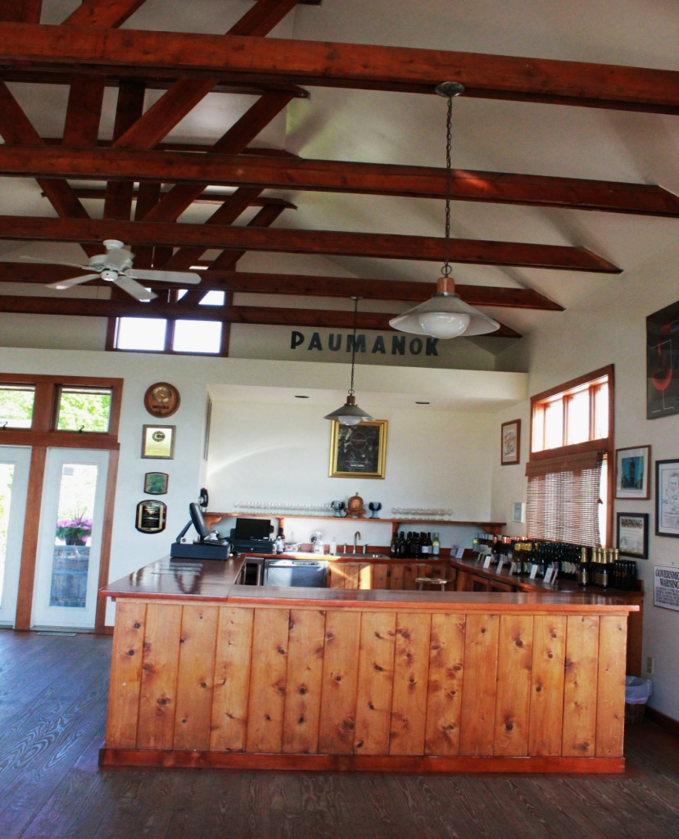

We decided to try the classic Paumanok FLIGHT ($9) because we felt it covered the most based whereas the others focused on white wine, red wines or Loire varietals for example. We tasted:

Barrel Fermented Chardonnay ($24): Soft with subtle creamy tropical NOTES. It starts out crisp and then rounds out on the palate.
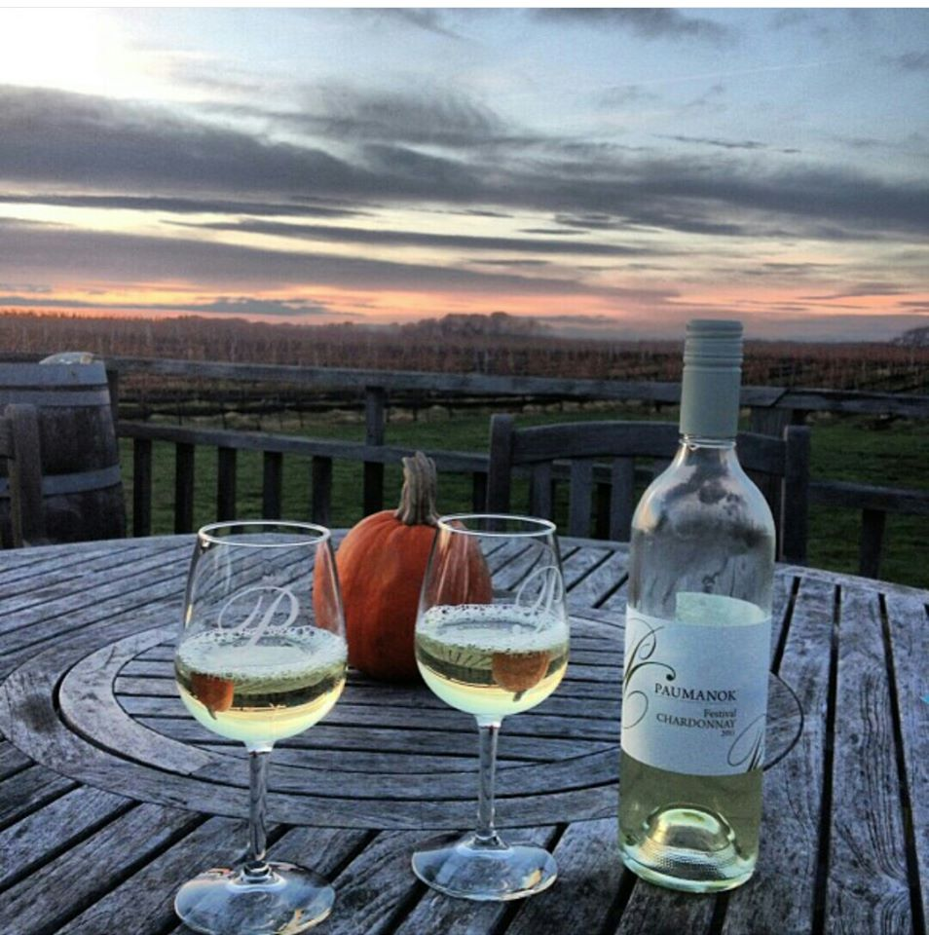
Dry Riesling 2013 ($22): The nose SUGGESTED it would be sweet but it was quite the opposite when we tasted it. The palate is refreshingly tart and crisp with a good bit of lime. This was my pick of what we tasted and I could have easily sipped this on their patio.

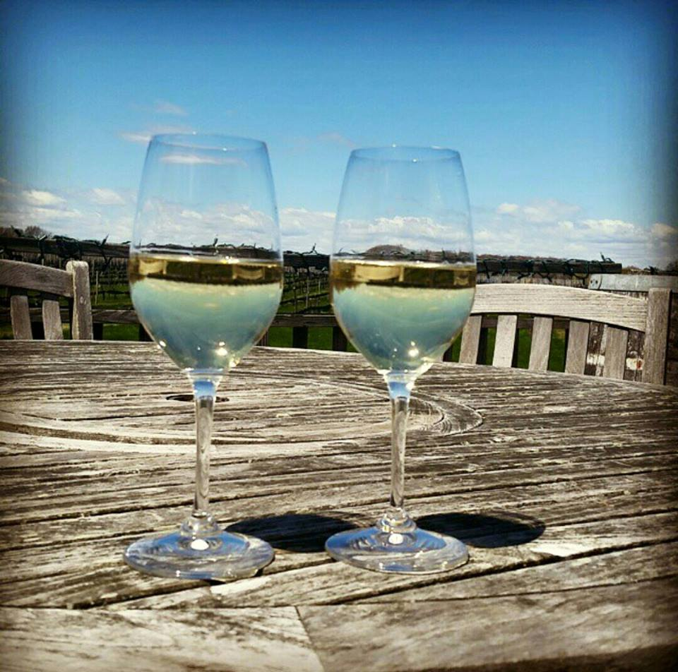

Cabernet Sauvignon 2012 ($24): This reminded me more of Pinot Noir than Cabernet. The nose was fruit forward with a soft medium body. More understated NOTES of soft red fruit, ginger and spice emerged.

