Retail Wine Shop Experience ~ Grisell Garcia

Taking advantage of my day off I had decided to visit the winery shop I had in mind. So Monday afternoon I head downtown to The Flatiron Wines and Spirit. As I was in front of the shop they seemed to be receiving some orders because they had a few cardboard boxes outside the shop. So that’s when I decided to take a picture of the top part of the store. As I entered the shop it looked kind of dark but the shop was full of wines stocked everywhere around the shop. There was an associate from the shop that very politely asked me if I needed any help and I told him the purpose of me being there and if he would mind if I asked a few questions. He was very approachable and said to sit down with him and that he didn’t mind. As he walked me down the aisle I noticed he different wines he had from different countries. I had asked him how he has his wine stored and he told me that he has them in sections by country and had also sections of the region within the country. I had asked him which is the oldest wine when it comes to aging that they had and he told me the oldest one was has been aged since 1920. I asked him if they had wine tasting, he had mentioned that they do but mostly on the weekend but due to their space since its very small they have small groups. He had answered as well that their top seller wine from the entire shop was Burgundy and Sauvignon Blanc. Which he also had a very large section of just Burgundy wines. After all it was a great experience and I will go back and buy some good wine. He was very polite and nice and he even said to come again. 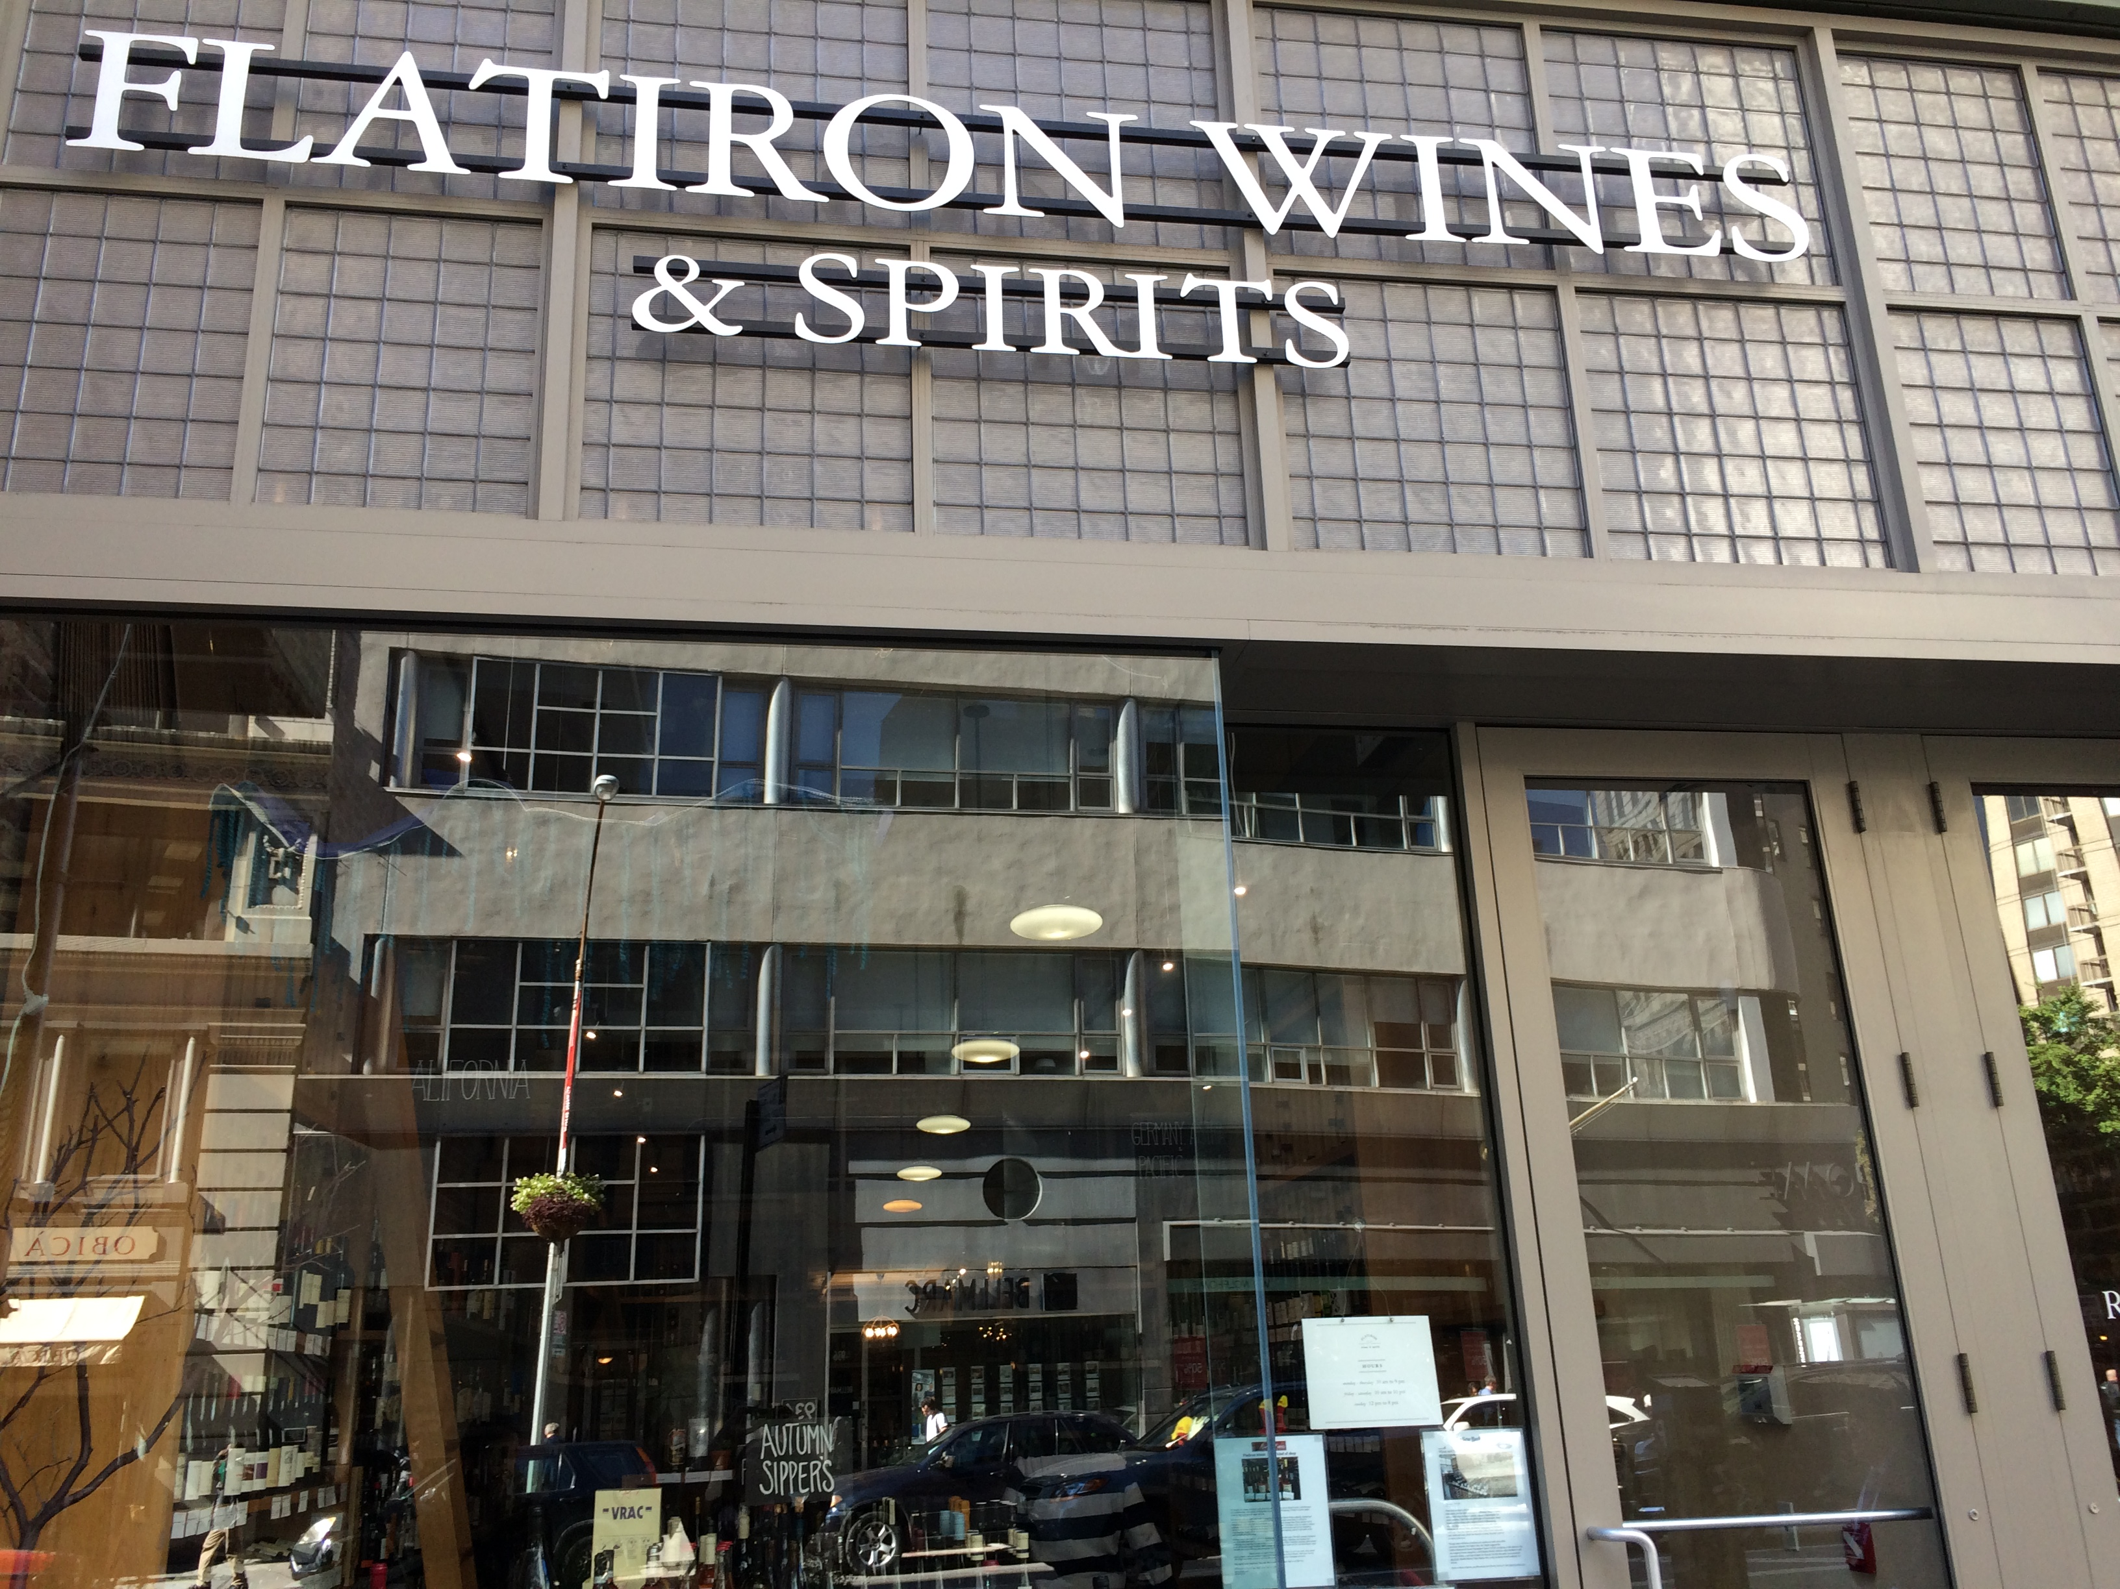 This was the front of the shop.

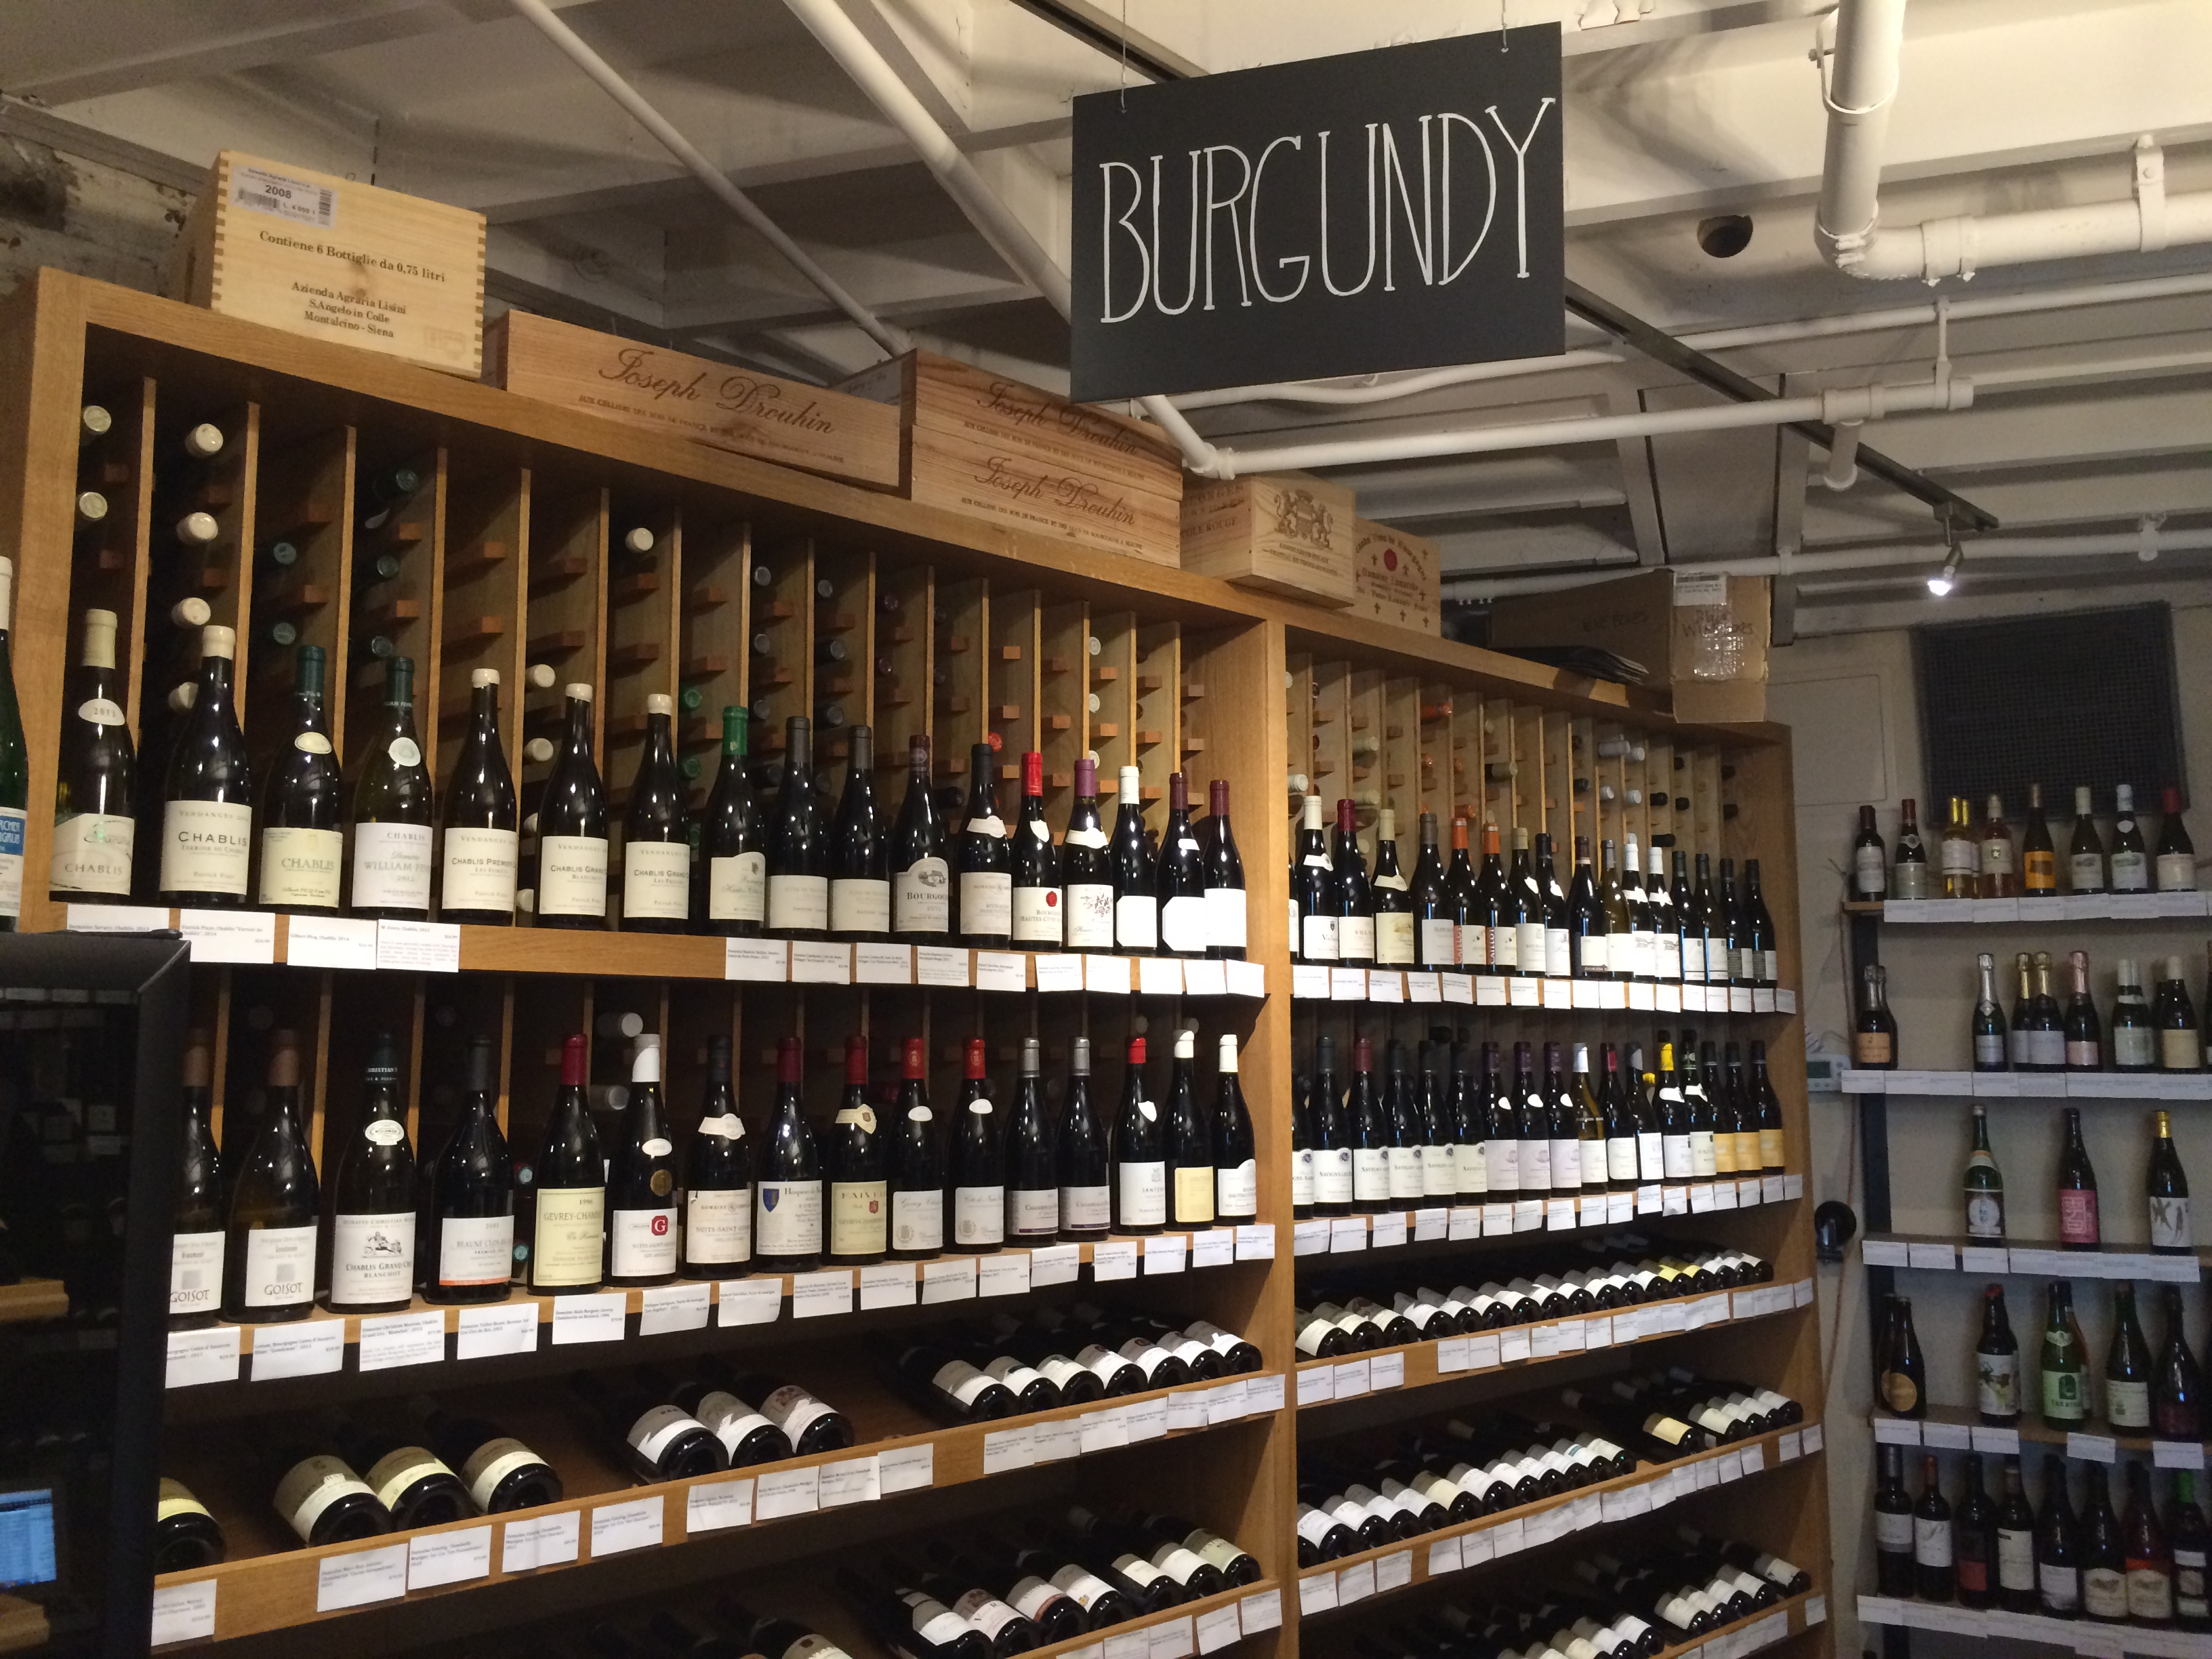This was the entire section of Burgundy wines.

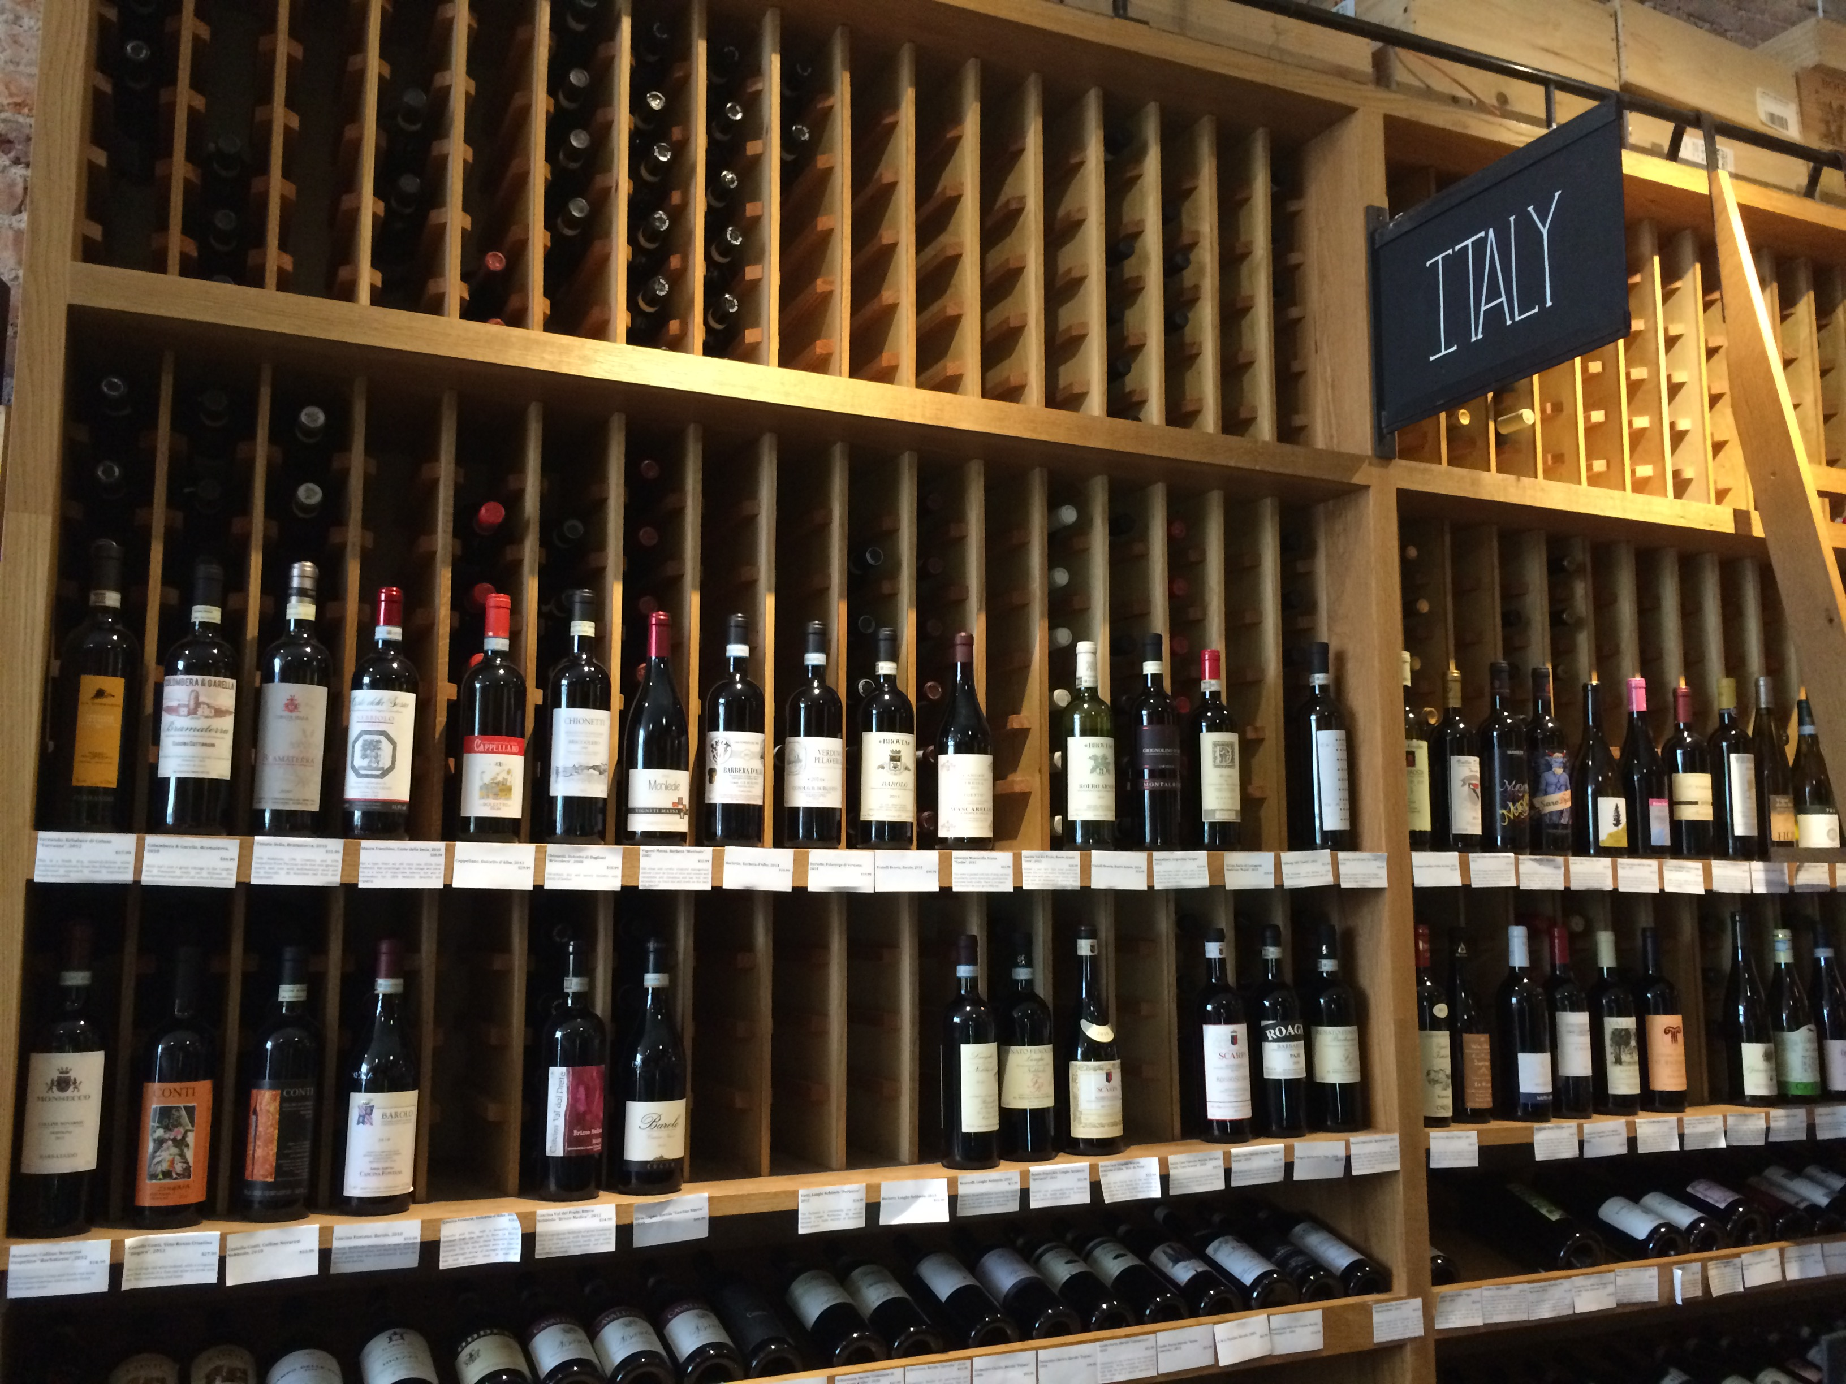Wines from Italy, I noticed that the display Wine bottles were vertical and the rest were laid horizontal.

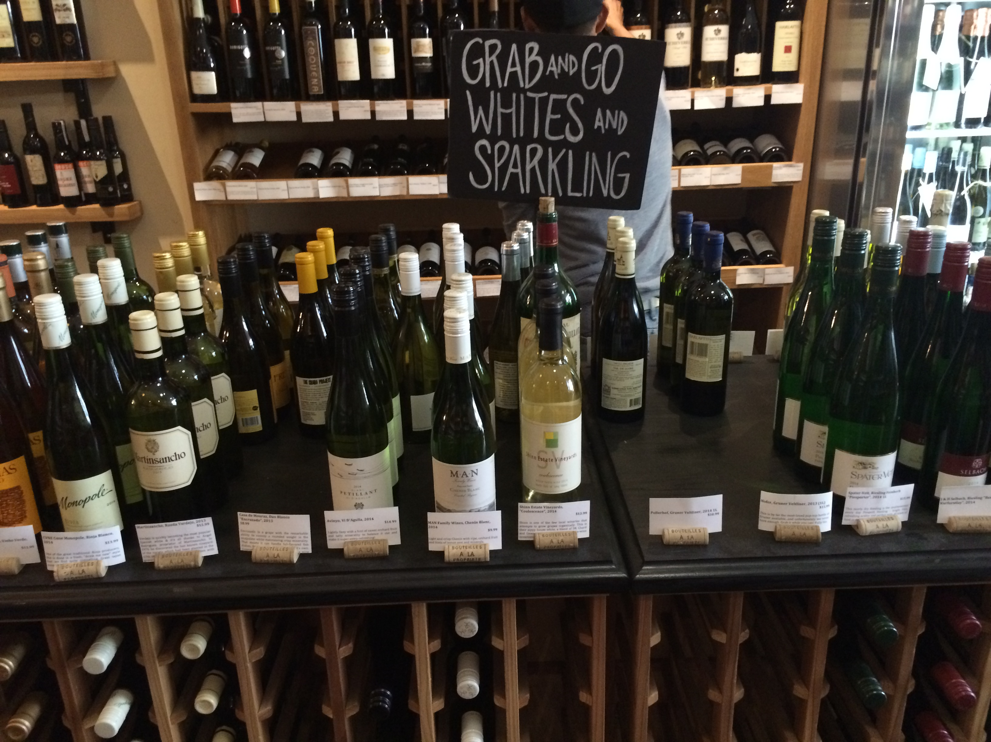 The grab and go Sparkling wines.

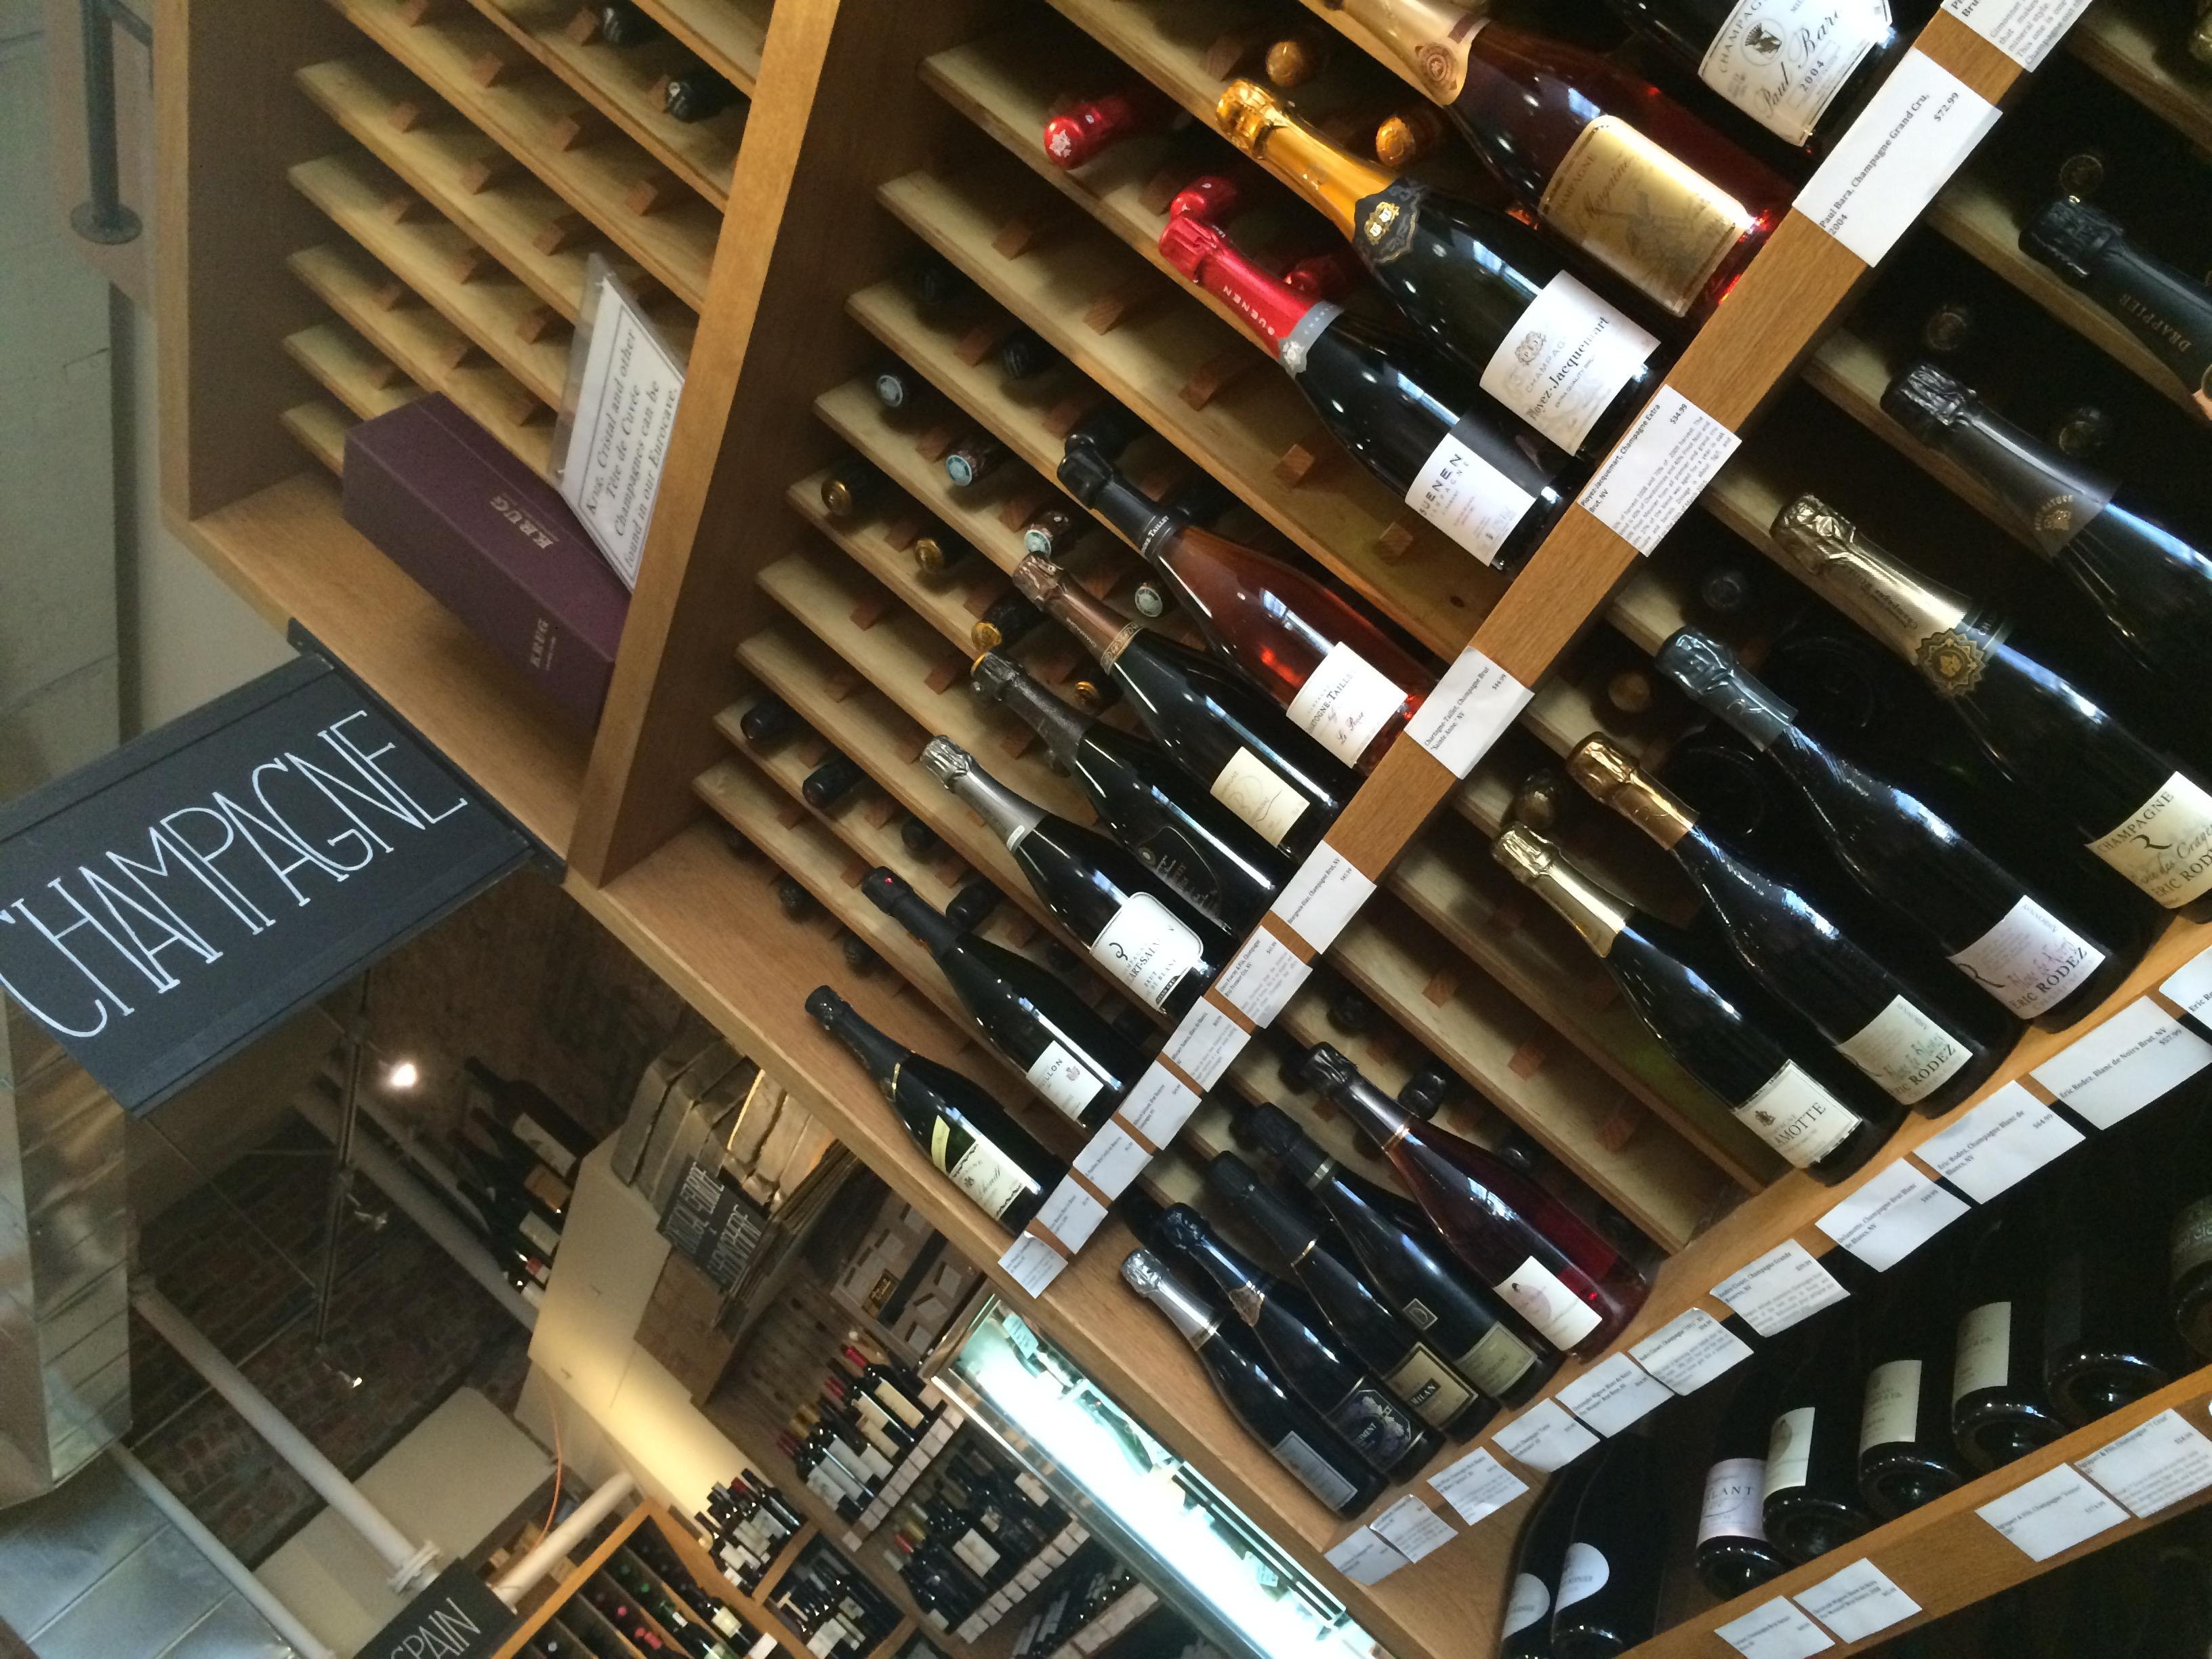 Different kinds of champagne.

