Retail Wine Shop Analysis – Martin Benitez
I never noticed how many retail wine stores there were around my neighborhood until this assignment. The first wine store that I have chosen and visited is called “Sanctuary of Spirits” located at 476 Onderdonk Ave, Ridgewood. When walking into the store I began to talk to one of the employees and my reason for visiting the wine shop and he went to call the other employee who knew more about wine. If I remember correctly, the other employee’s name was Juan. I was waiting a couple of minutes for Juan to finish talking on the phone and in the mean time I was evaluating the liquors section and looking at a few of the red wines that were displayed just close to the entrance. This store had a decent décor, wooden floor tiles with brick like walls and good lighting to read labels on the wines. When he was done talking on the phone, I asked him if I was able to ask him a few quick questions about their wines and he responded something like “how long will it be? *looks at his watch* I have to pick up my son”, even though I called a day before to know what time was appropriate to come by. These were the questions I asked Juan,
- About how many different types of red and white wines are sold in this store?
- “We have about 200 reds and 150 whites”
- How do you decide how the wines are arranged?
- Juan told me that there isn’t a certain way the wines are arranged. Some red and white wines are placed together on the same shelf and there are other red wines that are arranged separately from the white wines. There are certain wines that are arranged by the grape variety such as pinot noir.
- Based on your wines what countries or regions do you sell at this store?
- “We sell wines from Spain, Argentina, South Africa, Chile, Italy, French, Portugal, Romanian”
After I asked him these questions I asked for permission to take pictures of the store and gladly he said yes.
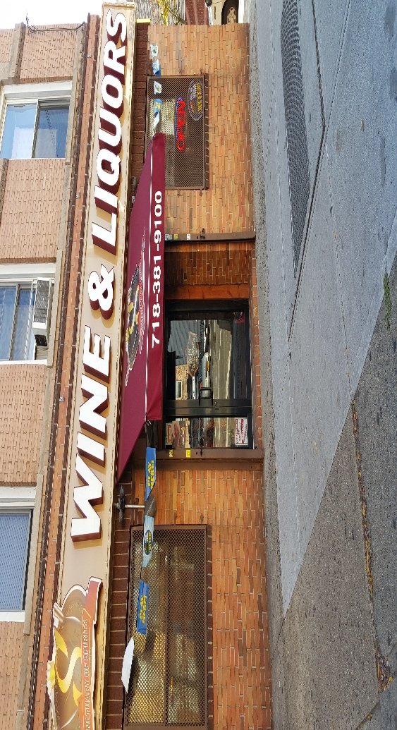
The Front of Sanctuary of Spirits
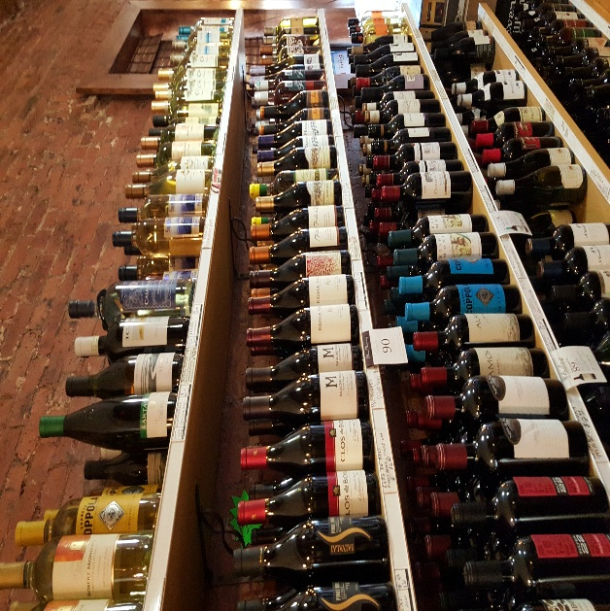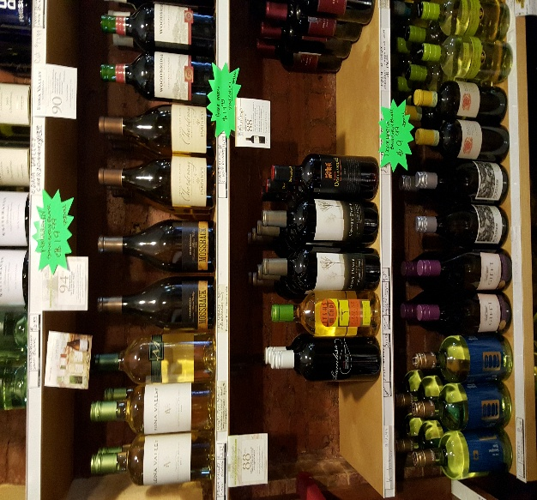
Some of the red wines with the white wines in both pictures

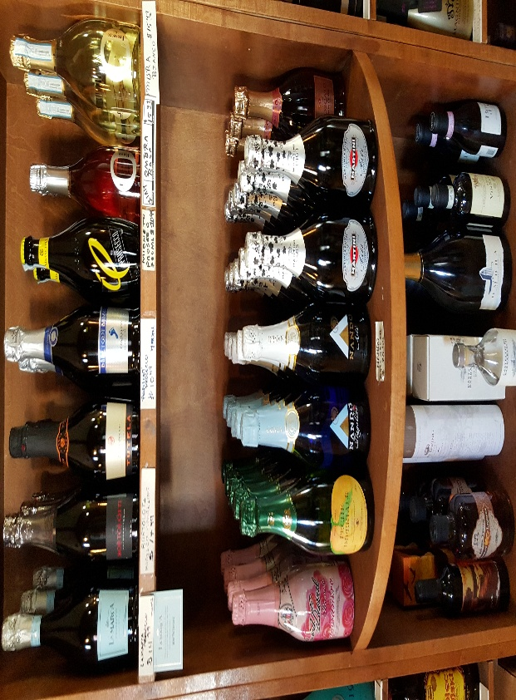
The sparkling wines section

The 2nd Wine Store that I visited is called “Legacy Liquor & Wine” located around my neighborhood as well on 71-28 Fresh Pond Rd in Ridgewood. When walking into the store I was able to tell it was smaller than the first wine shop I visited and not a lot of light, but definitely a friendlier environment. This establishment has been open for approximately six years. When I asked the store employee about how many different types of red and white wines are sold at this location, she didn’t know, but other than that she was knowledgeable of the questions of wines I have asked. In terms of how the wines are arranged, the wines are arranged by the brand and some by the grape variety. Within this location the wines are from California, Italy and mostly Chile. Prices were almost the same in both wine shops. Some wines were about $10-$40.

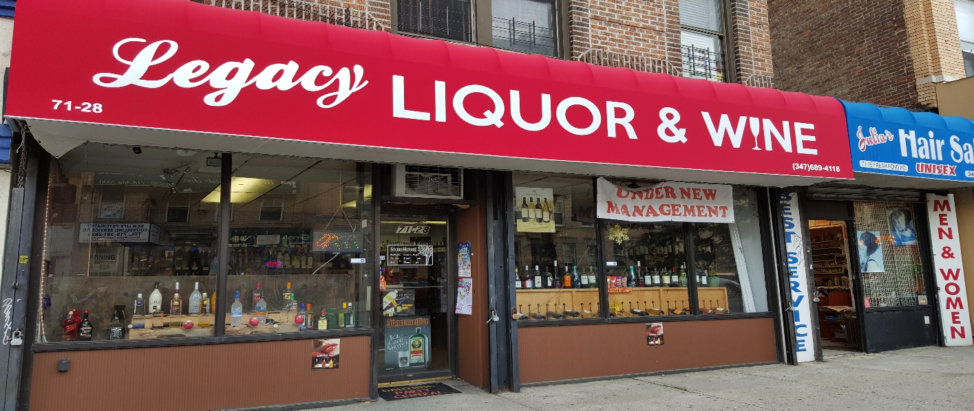
The Front of Legacy Liquor & Wine
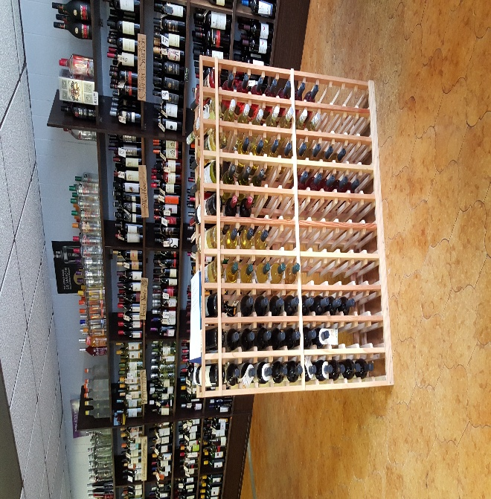 The right side of the entrance where you can see some red and whites arranged horizontally

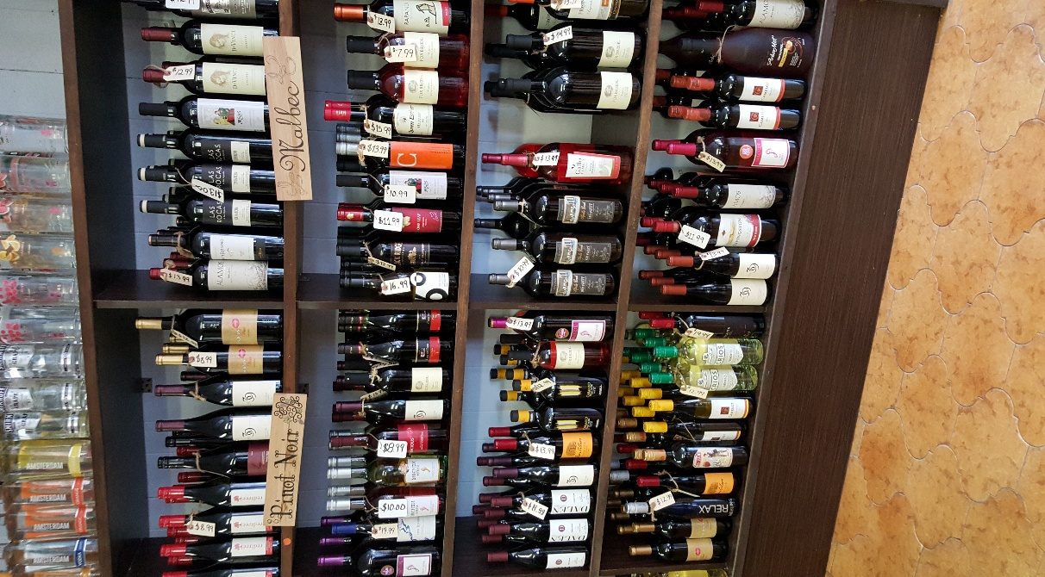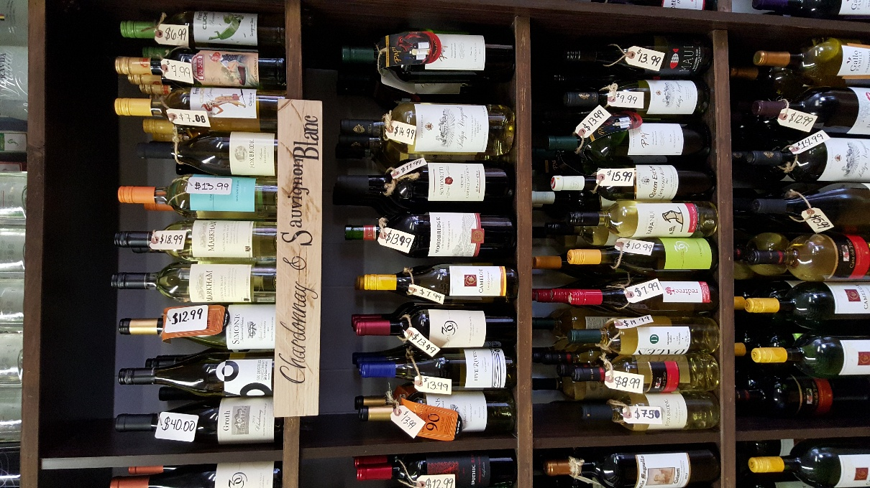
The display of red wines such as Pinot Noir and Malbec (LEFT) and The display of white wines such as Chardonnay and Sauvignon Blanc (RIGHT)

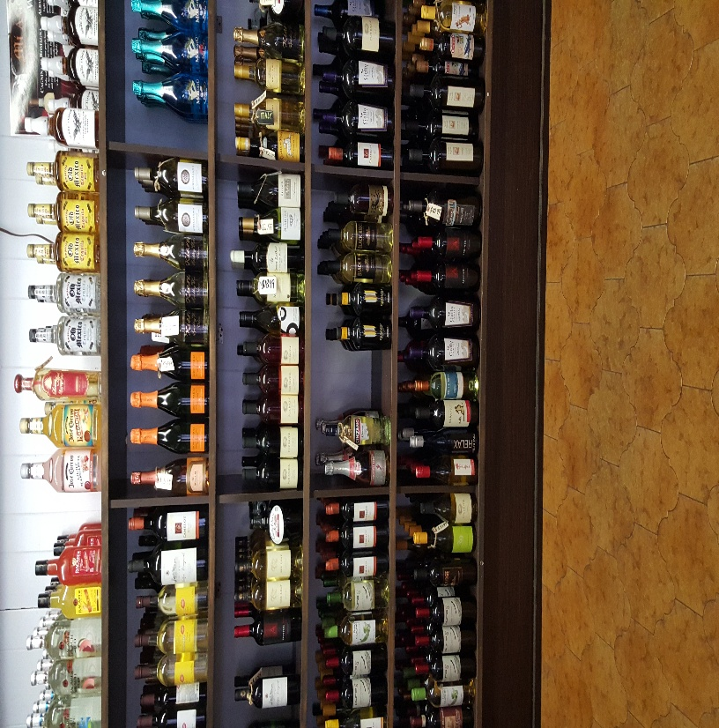 The sparkling wines section towards the back

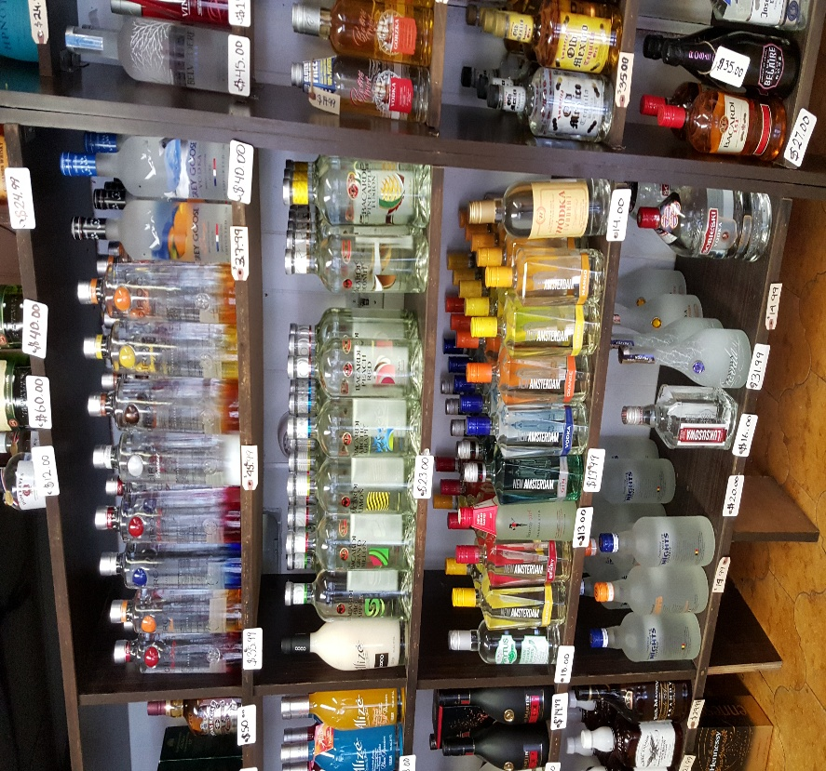 The liquors section close to the register

