Retail Wine Assignment
I went to two wine shops. One in Manhattan and the other one in the Bronx. The first one I went to is Crush Wine at 153rd East 57th Street in Manhattan. The store is founded by three native New Yorkers, Drew Nieponent, Josh Guberman, and Bob Schagrin. The store has three sections and a tasting room.
When you walk into the store, on the right has a large amount of French, Italian, Spanish, Germany, and Austria red and white wines on the wall. In the middle of the store are assorted wines, champagne and sparkling wines. On the left side of the store spirit and liquors. There is a tasting room at the far end of the store for people to go and taste wine on a schedule bases.
The employees were very nice and present. They were totally okay with me taking picture when I asked them. I asked for a nice full bodied less expensive wine and one of the employee recommended Durigutti, 2014 Malbec from Argentina which cost $13.99 plus tax. It has a black berries and some herd taste but it was good.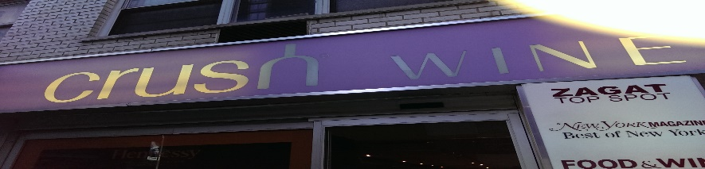 Outside the store
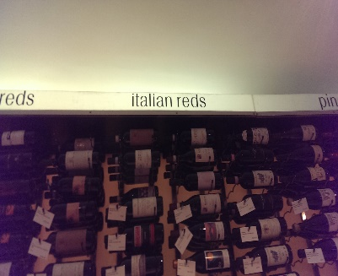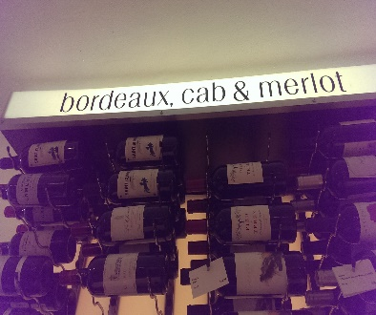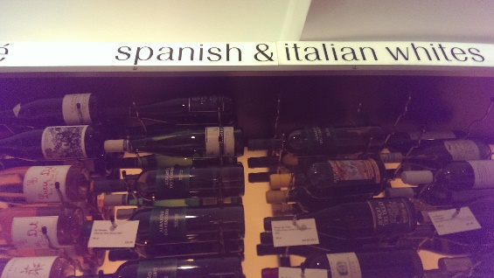
Some of the red and white wines on the right side of the store
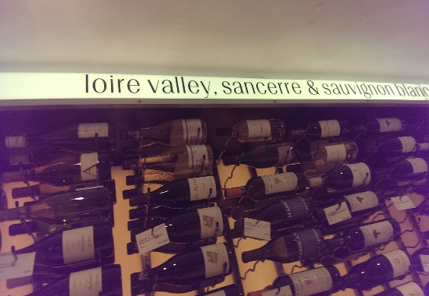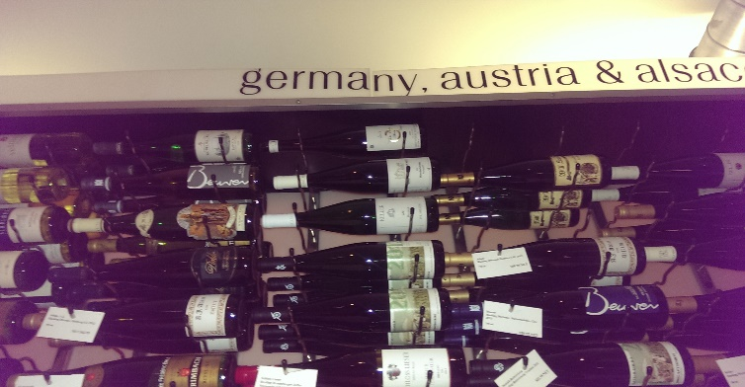
Wines from Loire Valley, Sancerre, Germany, Austria and Alsace.
The second store I went to is North End Wine and Liquor located at 2509 Webster Ave in the Bronx. The store has a huge selection of wines, liquor and sparkling wines from around the world. They have their wines on half of the store and liquors and spirit on the other side. They have wine from Italy, Chile, Africa, California and New York State, and also Kosher and Organic wine. The store manager was busy getting ready to close the store but he was nice as well.
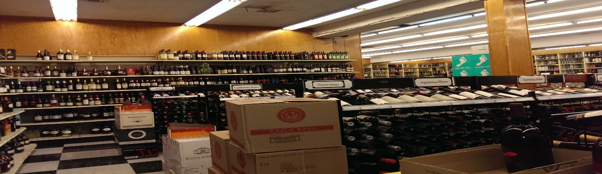
The wine section
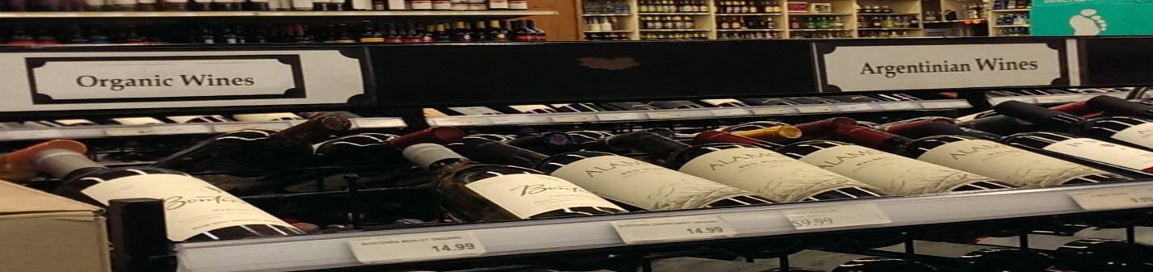
Organic and Argentina wines
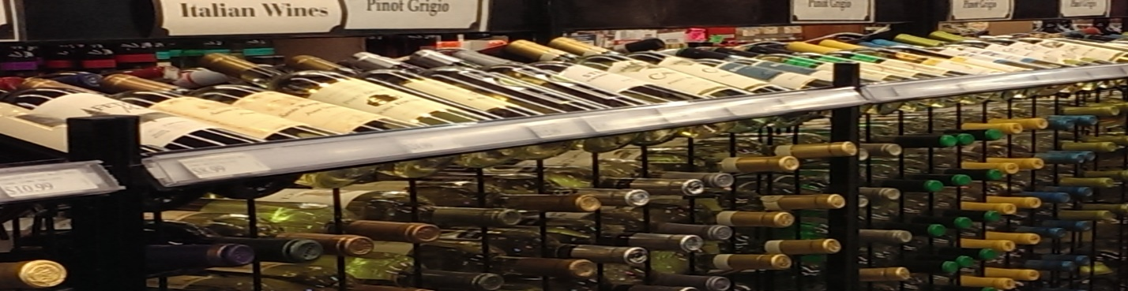
Italian wines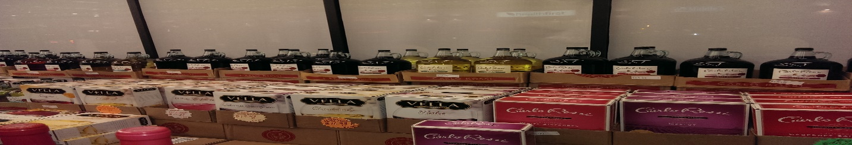

Other types of wine.

