Market Photo Essay

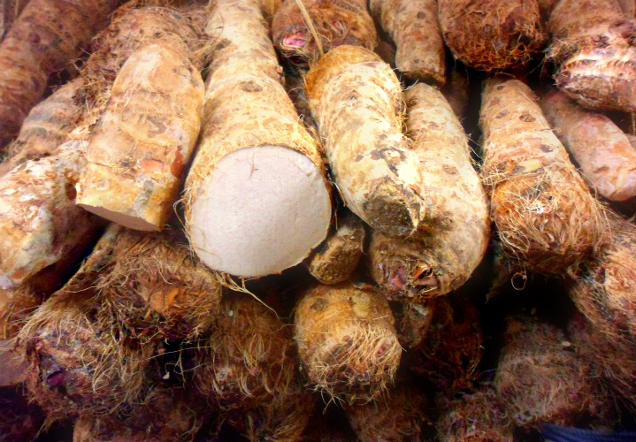
Brooklyn Borough Hall Green Market On plaza at Court St and Montague St, Brooklyn

I grew up in the interior savannahs of Guyana. Where I’m from, the main food for the Amerindians there is Cassava, as they know it, or in other terms Yuca, Tapioca and Manioc. In the present day it has been given the status of cultigens with no untamed forms of this species being known. This root comes from the family of Euphorbiaceae. Cassava originated in Brazil and Paraguay, cassava is required at least 8 months of warm weather to produce a crop. Cassava is the main basis of low cost carbohydrates for populations in the humid tropics. The world market for cassava starch and meal is limited, due to the abundance of substitutes. However this is not so for the Amerindians of Guyana, it’s almost like cassava is the only food they know, and in each and every community all the farms are filled with cassava roots.
They can be peeled and boiled, baked, or fried. It is not recommended to eat cassava uncooked. The foods are original fermented in water. Alcoholic beverages are also made from the roots. Some of the famous bi-products of cassava that the indigenous people make are, farine, cassava bread, casareep, tapioca balls, pone, and piwari. Cassava and farine is made almost using the same process, however while farine is thrown into a big frying pan, cassava bread is baked on the pan and constantly turned. When making farine, the root is pealed and thoroughly washed, then grated. After it is grated, the juice is extracted using a matapee, because it is known to be poisonous. Finally, after the juice is completely extracted, the remains are sifted using a sifter. It is then thrown into a very hot, very big pan to fry. But when making cassava bread, the remains is brought together in a big circle to bake. These two foods are substitutes for rice for the Amerindians since they don’t usually have money to buy rice. It goes perfectly with their pepper pot, or fish stew. Tapioca balls are usually made to use as a breakfast dish wish they make as a portage. Pone is a sweet desert that is perfectly complimented with the famous piwari drink, these humble people love so dearly. Dried roots can be crushed into flour, Maize may be added at some point in time to the milling process to add protein to the flour. The flour is use for baking breads. The fresh roots can also be sliced thinly and fried to make a product almost identical to potato chips.
Since I came to New York, I rarely see foods made from cassava, and I really miss it. This particular root helps the indigenous people of my country, keep their food cultures alive and not spend so much money on rice and other carbohydrates.

