36 hours on Brooklyn Waterfront
By TEISIS SANCHEZ MAY 13, 2016

This landmark waterfront park offers 400 years of history with breathtaking views of east river, Brooklyn Bridge, and lower Manhattan.
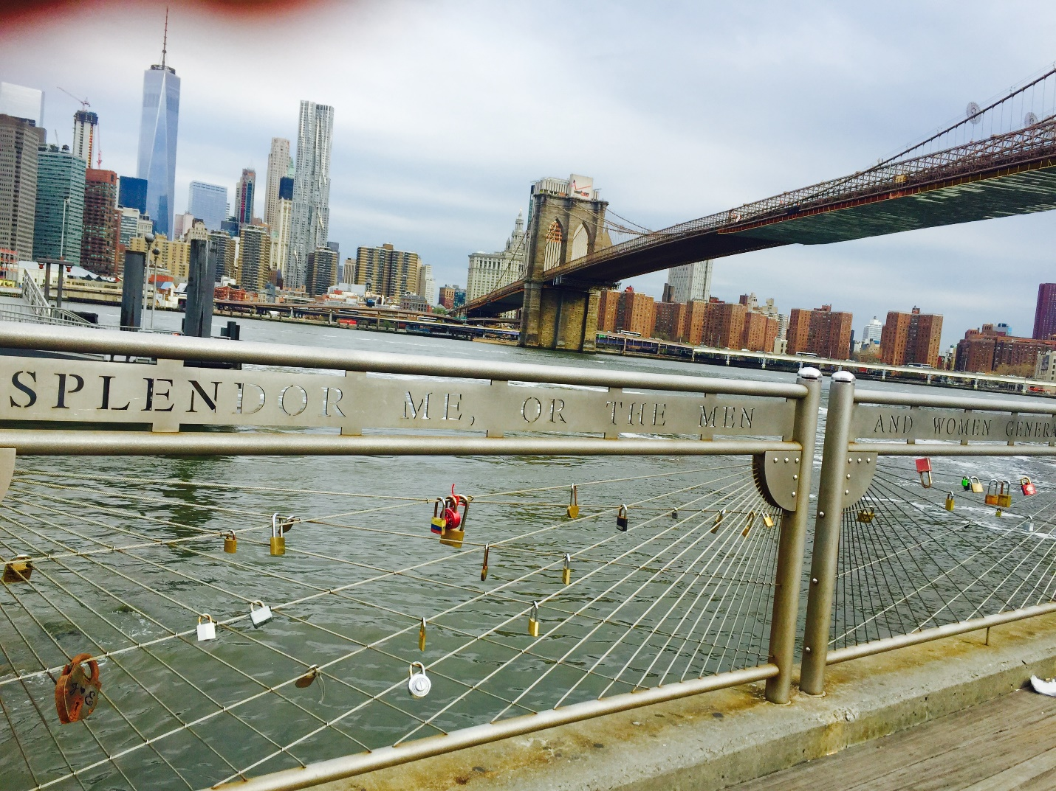Figure 1 picture by TEISIS SANCHEZ. Waterfront.

“The fate of unborn millions will now depend on the courage and conduct of this army. We have, therefore, to resolve to conquer of die.” (George Washington July 22, 1776)

The Brooklyn waterfront park has suffered four century of changes. From the day (August 27, 1776) General George Washington and the American army, were determined to fight to protect the village of Brooklyn and the ferry crossing, 18thC (Coughlin, 2010). To finally become a world-class (“Brooklyn Waterfront History,” n.d.) located in DUMBO (Down Under Manhattan Bridge Overpass). This rich historical waterfront park is one of the best example of New York City’s historical places to visit.

Friday
1. Know the history. 1:00 P.M.
“These men came to the new world neither as soldiers nor sailors, not even as traders; agricultural pursuit was their gain … They brought their families with them and all their household effects; for they looked forward to making the New World a permanent home for themselves and their children.”
– Gertrude Lefferts Vanderbilt, A Social History of Flatbush, 1881.
To fully understand the history of Brooklyn Bridge Waterfront Park you first need to stop at the Brooklyn Historical Society (BHS). By exploring the legacy of the Leffersts family and look at the extended well preserved collection of documents that document the evolution of Brooklyn, starting from 17 th. Museum hours 12 pm to 5 pm. Admission $10.
2. A WALK OF HISTORY. 3:00 P.M.
Take a walk around the Brooklyn bridge park (BBP) to take fully advantage what the waterfront have to offer and to enjoy the views of the stunning and famous NYC’s landmarks. Stop by the Brooklyn ice cream factory (fireboat house) and try one of their famous vanilla or chocolate ice creams ($4 for a scoop). Walk a short distance to pass by the Jane’s Carrousel (built in 1922) a real antique. Make sure you do not miss the Empire Store built between 1869 and 1885. Firstly used to the storing of coffee in the 20thC when Brooklyn was the capital of the coffee business in America.
3. GREEN DINNER. 6:00 P.M.
In a neighborhood where 19thC style is still appreciated and what a better example than, the cobblestone streets. The Atrium restaurant gives to DUMBO a touch of freshness and the best part is that is easy approachable from the waterfront park. Located on 15 Main Street. This new restaurant brings to DUMBO gourmets options for lunch or dinner. Try the highly recommended in reviews, black sea bass, is served with market vegetable fricassee, mushroom dashi, and miso ($25). Also, this interesting “hay smoked potato bread with culture butter” ($3).
4. 19th C WAREHOUSE. 7:30 P.M.
St Ann’s Warehouse moved into a 19thC Tobacco Warehouse, transformed this structure into a 21thC theater and a live performance destination (“The New ST. Ann’s Warehouse,” n.d.). Come early for a show and grab a drink (procecco $11) and a snack (spiced maple peanuts $3) in BAR JOLIE. "Nofit State Circus Bianco" is a recommended play with interesting reviews, "Hauntingly beautiful" THE HEATALD.A dynamic, exotic and, unrealistic circus. (May15-May29) tickets start at $35.

Saturday 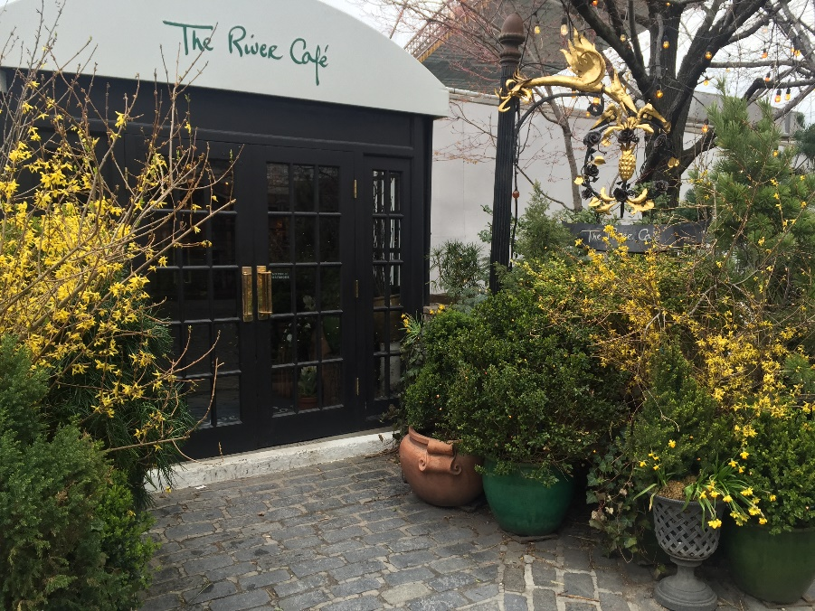
Figure 2 by Teisis Sanchez, Front Garden.
5. Brunch by the water. 12:00 A.M.
Opened in 1977 the River Café is part of Brooklyn waterfront history. To be able to get a table, is recommended to call and make a reservation, couple weeks in advance. For Brunch the Fixed price menu is $55.00, seems a rational price to eat in this historical place while admiring the view of the east river, Brooklyn Bridge, and lower Manhattan.
6. Beer tour. 2:00P.M
When we talk about history of Brooklyn, we cannot avoid talking about beers. Just like, Tabaco and coffee were very popular, Brooklyn brewing had a good business with almost 50 brewing in 19thC (Scherer, 2014). There is no a better place to taste some good beer that Brooklyn Brewery. Walking to 79N-11th Street to the Brooklyn Brewery and grab a free ticket for a tour, every ½ hour. Normally open from 1:00 pm to 5:00pm. Open-toed or high heeled shoes are no allowed. Buy some tokens in the store at the entry, this is the only way you will buy a beer in the tasting room. One token has the value of $5 which is the price of one beer.

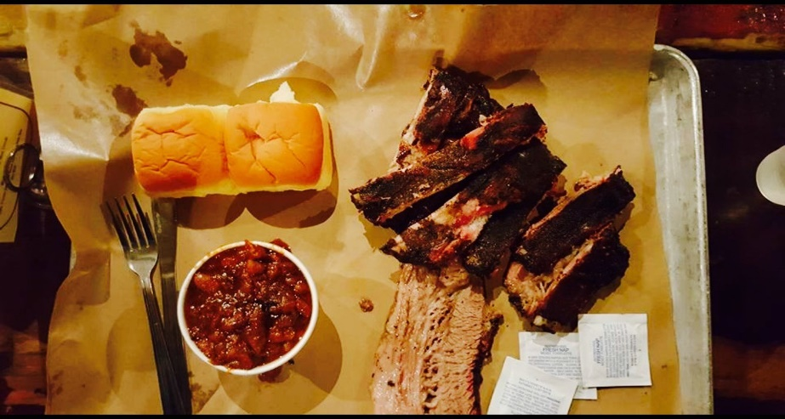
Figure 3 by TEISIS SANCHEZ. Burnt end Bake Beans, Bibs, and Brisket.
7. Best BBQ. 5:00P.M.
As many others immigrants, the Germans brought their culture to Brooklyn in 19thC. Take the ferry in DUMBO and stop in South Williamsburg, find you way to the Fette Sou (German, fat pig) about 15 minutes walking distance .This unique BBQ place only serves organic meat, suppliers are seven local family farms for this reason the menu change daily. The wait of almost an hour is nothing, when delighting their unique German style BBQ. Dry-rubbed and smoked for several hours Berkshire sausage, $3 each and the Berkshire St Luis style perfectly smoke ribs, $16 per LB. most of the meat is sell by pounds portion, be careful you may have to take a doggy bag. Nothing better than a beer with a BBQ try “Coney Island Mermaid Pils” they have it in sizes of pint, quart, ½ gallon, and a gallon. Located in 354 Metropolitan Avenue, Williamsburg.
Sunday

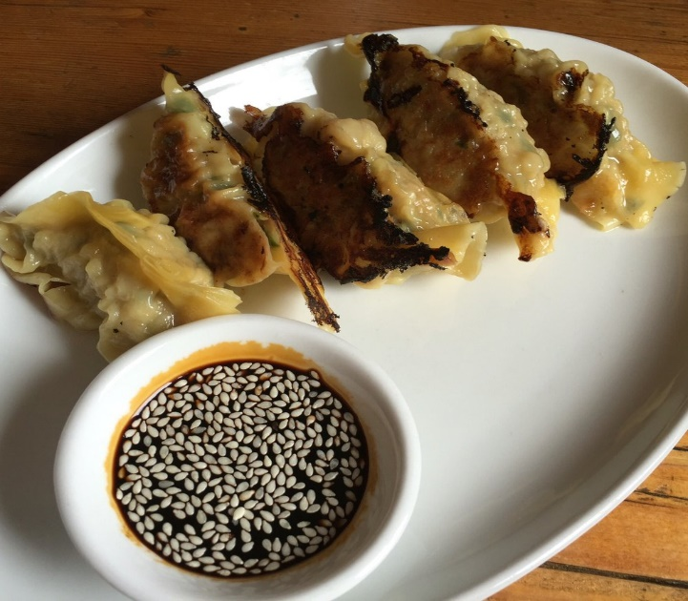
Figure 4 by Young Y. Best Korean Style Dumplings in New York. Yelp.com

8. RED HOOK. 11:00 A.M.
Red hook is known to be one of the first areas of Brooklyn to settle in 1636 when Netherlanders (Duck) came to stay (“Red Hook History,” n.d.). Take the twenty minutes “Ikea Express Ferry” front the lower Manhattan (pier 11) to Red Hook (free on weekends). Stop for brunch at The Good Fork this restaurant is surrounding by plants and it make you feel like you are eating at someone backyard. Their homemade pork dumplings ($9) are the bestselling. However, their Steak and eggs ($16) is also really popular. For drink try the “Primo Colado” (rum, st.Germaine, coconut liqueur, and pineapple juice $11)
9. A floating Museum. 2:00P.M.
The waterfront museum was founded in 1986 with the main purpose of education and culture. This floating piece of history is located in pier 45 Red Hook. Is designed by the United Nation as the “Regional Craft of the Oceans” in 1998. Is known for be the only survivor wooden of the railroad navy and its lighterage (“The Waterfront,” n.d.). Admission is free and is open 1-5pm on Saturdays. dsharps@waterfrontmuseum.org phone number, (718) 624-4719.

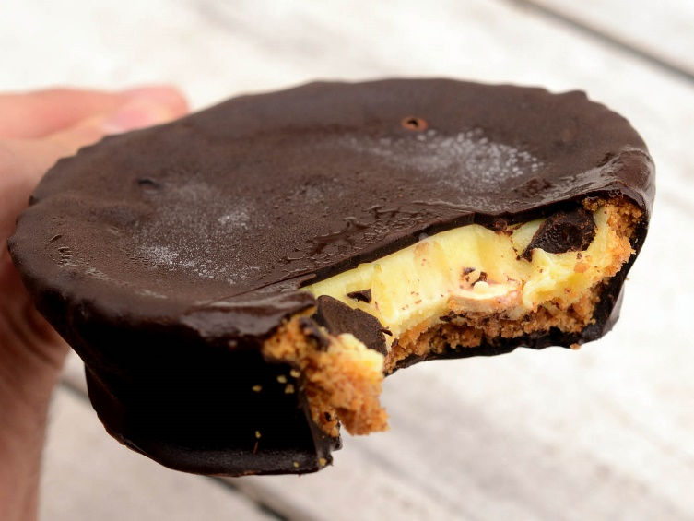
Figure 5 provided by: Serious Eats from Foursquare. ‘La Victoria”

10. Sweet treat. 5:00P.M.
Open for 21 years, Steve’s Authentic Key Lime Pies is a place you cannot miss, if you are a dessert lover, when you are in Red Hook. Located in pier 41, hours are on Saturday from 11:00AM to 7:00PM.This whole sale store, has the most original key lime pies. “The LAVictoria” is a key lime pie is served in a Popsicle stick, is topped with a chipotle puree and hand dipped in Belgian chocolate ($5:00).
11. Shop. 6:00P.M
As a place with amazing histories of past decades, is easy to imaging all the antiques that Red Hood stores may hold. The Erie Basin, located in 388 van brunt is where you can find antiques from the 18thC to the 19thC and vintage jewelry. This store will give you a unique experience in shopping.

Lodging
For a luxury boutique hotel with the unique atmosphere of Brooklyn artistic decoration, go to NU hotel. (85 smith street Brooklyn, http://www.nuhotelbrooklyn.com/) is walk distance of DUMBO. Around $269 a night.
For a classic and traditional option hotel go to Condor hotel. (56 Franklin Avenue, http://www.condorny.com) Average rate, $211.

References
Bill Coughlin. (April 24, 2010). Brookland Ferry Landing. Retrieved from
http://www.hmdb.org/marker.asp?marker=30052
Brooklyn Waterfront History. Retrieved from
http://www.brooklynbridgepark.org/pages/brooklyn-waterfront-history
The new St. Ann’s warehouse (n.d). Retrieved from
http://stannswarehouse.org/tobacco-warehouse/
Jenna Scherer. (Aug 19, 2014). The Brooklyn Brewery: the history, beer, tour, and gift shop. Retrieved from
http://explorebk.com/2014/08/19/brooklyn-brewery-history-beer-tours-gift-shop/
Red Hook History (n.d.) retrieved from
The waterfront museum and showboat barge. (n.d.). Retrieved from
http://bobmcdonald.ba.ttu.edu/Waterfront%20Museum%20in%20Red%20Hook,%20Brooklyn,%20New%20York,%20NY.htm

