Alex Chao
HMGT 1101
Prof Goodlad
5/13/16
36 Hours assignment

36 Hours on the Brooklyn Water Front

By: Alex Chao

The neighborhood in Dumbo it has different outdoor activities that people can enjoy.

Historically the area of the Brooklyn Water Front was once a site of a transportation terminal and also an entry point for immigrants. The park also visited by millions of tourists and New Yorkers every year because to see the unique design of New York. There are different types of volunteers people can do at the Brooklyn Bridge Water Front for example Coastal Clean up, Spring Spruce Up And Cutbacks, The Green Team and etc. It is an exciting and enjoyable place to be. 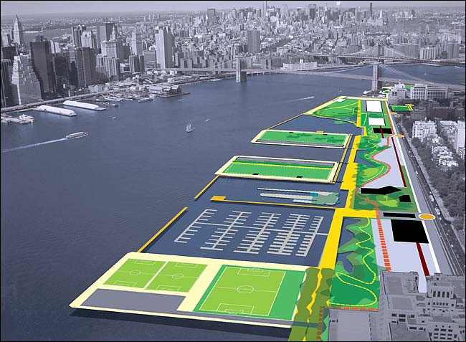

Friday

1. Costal Clean up

One of the first thing people arrive to the Brooklyn Bridge Water Front is how beautiful Brooklyn is. Coastal Cleanup Volunteers give back to the community by helping us remove hundreds of pounds of trash from pier 1 salt marshes and beaches. Children are welcome to participate with a parent or guardian. Group with 10 members or fewer are welcomed to join in our 2 hour long Costal Cleanup.

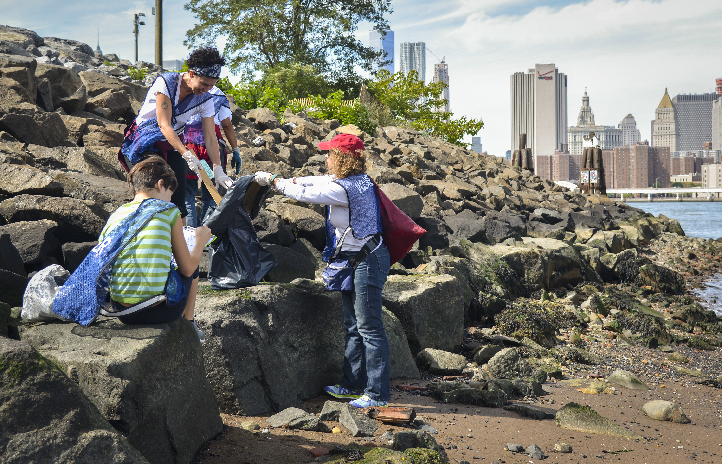

Saturday

2. Corporate Groups
Corporate groups play a big role in the health to up keep of the Brooklyn Bridge Park. The Brooklyn Bridge Park can host corporate groups with up to 30 members the actives are based as need needed at the park. The corporate volunteers at the Brooklyn Bridge Park are beneficial to people because volunteers want to help contribute to what is going on.

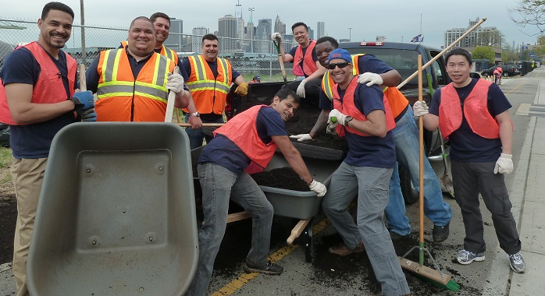

Sunday

3. Red Hook Boaters
It’s a volunteer only group dedicated to providing free kayaking. Volunteers can carry the boats, paddles, and life jackets on the water also help people get in and out of the boat. As a volunteer you get to join a trip kayaking around New York Harbor. To be able to do this job is have the ability to swim.

