36 Hours in Brooklyn
By Johnnie Davis 05/2016

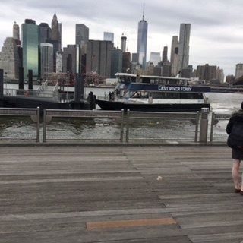

They say the best things in life are free. I say Freedom, is not free. As a resident of Brooklyn, one of the world’s best places to visit, you can see the price so many have paid to live this certain lifestyle. The ambience, the grandeur of this borough is unmistakably elegant, possessing a life force of its own. The people here are unlike any other in the world. They come from many places to make one. One big, loving, caring, kind, generous, firm and forward people. As the hustle and bustle carries on through-out the City, Brooklyn is a place of refuge. The Waterfront soothes the heart and soul. Gives one time to reflect and ponder. In the heart of the City we are surrounded by nature, which reminds us of pleasant things.

Friday
- Early-Bird 8:00am Coffee and a Bagel on the go to take in the early morning scenery by Brooklyn Bridge Park. The Pier is mostly empty with the exception of a few workers scurrying about to receive deliveries. Pedestrians tethered to their favorite pets stroll at a distance ever watchful. The Recreation areas are bone dry, but you can imagine what their sold out performances would be like. On the weekends the whole Waterfront is transformed into a carnival like atmosphere with a mix of many varieties. Just as you focus on one thing in particular, something else grabs your attention.

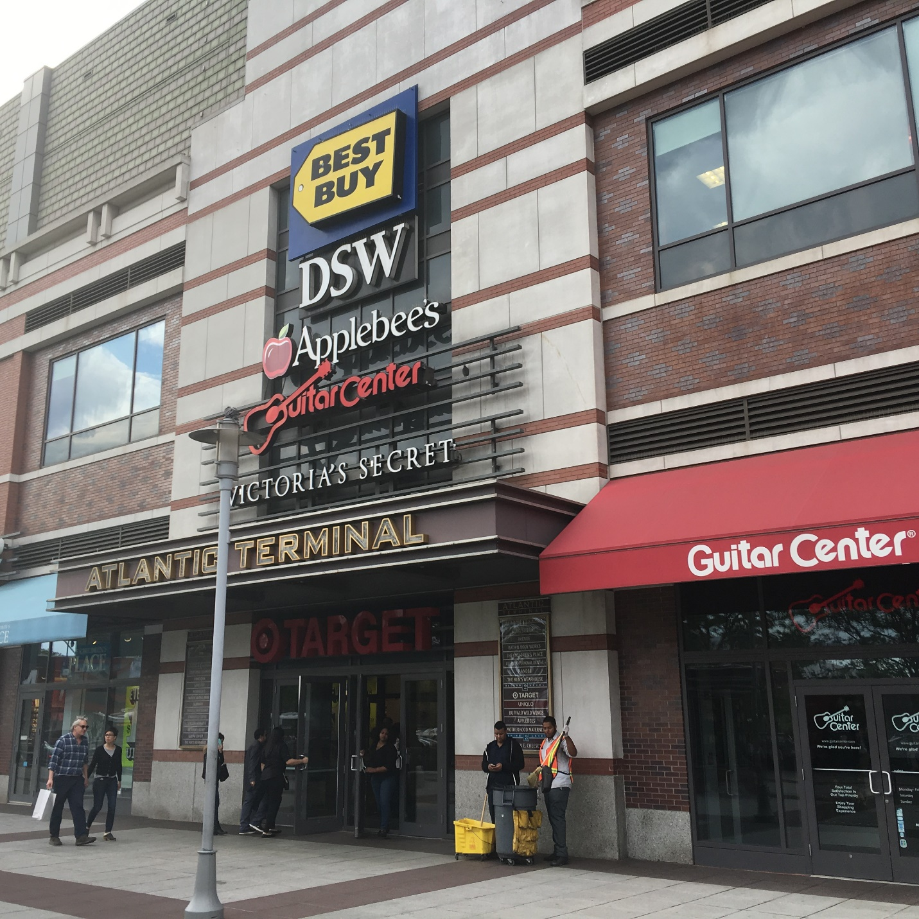
- Ready to go 8:30am Last sip on your splendid coffee while you finalize your early shopping and things to do list. Transportation is easily accessible but you may choose to walk, or if you get tired you can rent a Citi-bike. Personally I prefer the public transportation system, it’s fast and efficient. Also it gives you the most value for your dollar. On your way to the shopping areas you might see one of the building projects underway. Brooklyn is becoming more popular than Manhattan, and developers are cashing in on it. Many businesses are popping up over night while the rents are skyrocketing. It’s a real estate haven for wise investors.

- Shop-Till-U-Drop 10:00am The Atlantic Terminal Mall has a variety of different stores. They are very competitive for the American dollar. You can save up to 30-70% on everyday items. They have to make a quick turn-over in order to stay in business. After all rent is not cheap.
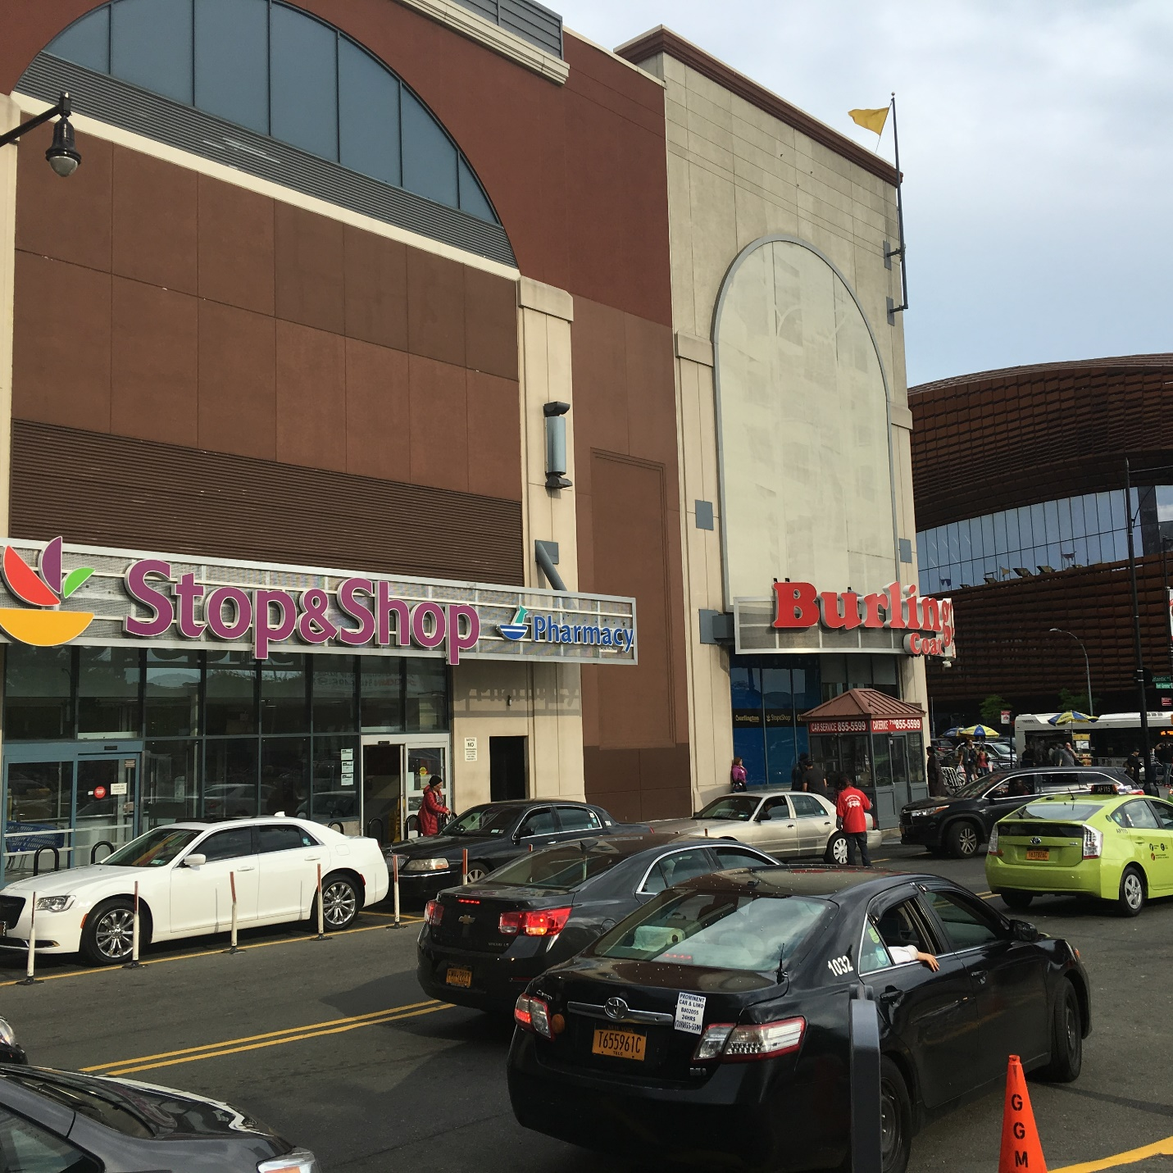

- Lunch-time 12:00pm After a few hours of knock-down, drag-em-out, bargaining and haggling, you may develop an appetite. There are so many places to eat that can fit your budget. I enjoy dining at “Junior’s. They make the World Famous Cheesecake. I have always been a fan of theirs. Besides great food, they have very nice service. There are very few Old Time establishments of this caliber that are still doing business. Most of them have fallen by the wayside.
Photo by Johnnie Davis
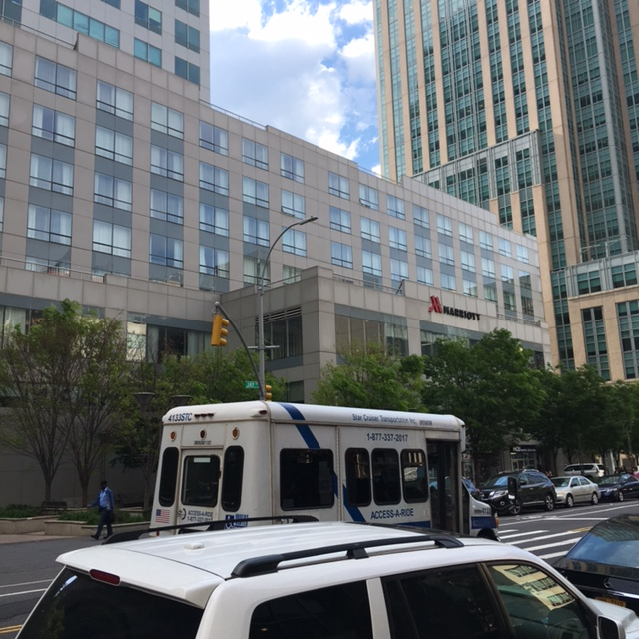
- Regroup and compose 3:00pm Spending so many hours out and about can leave you somewhat drained. If so it’s time to take a siesta. Off we go to the New York Marriott at Brooklyn Bridge. Rooms range from $270-650 a night, depending on your circumstances. However you may save a lot to book your stay in advance. Not everyone is into saving or counting pennies, if so this is the place for you. The hotel is located on 333Adams St., just right for the numerous eateries and watering holes. Anything you want is a stone throw away. always something to do.

- Free entertainment 5:pm Street performers often frequent the area full of tricks. Sometimes its hard find a job so they might do what ever they can to make a living. In that case everyone benefits. Overall Brooklyn is a wonderful place with so much to offer.

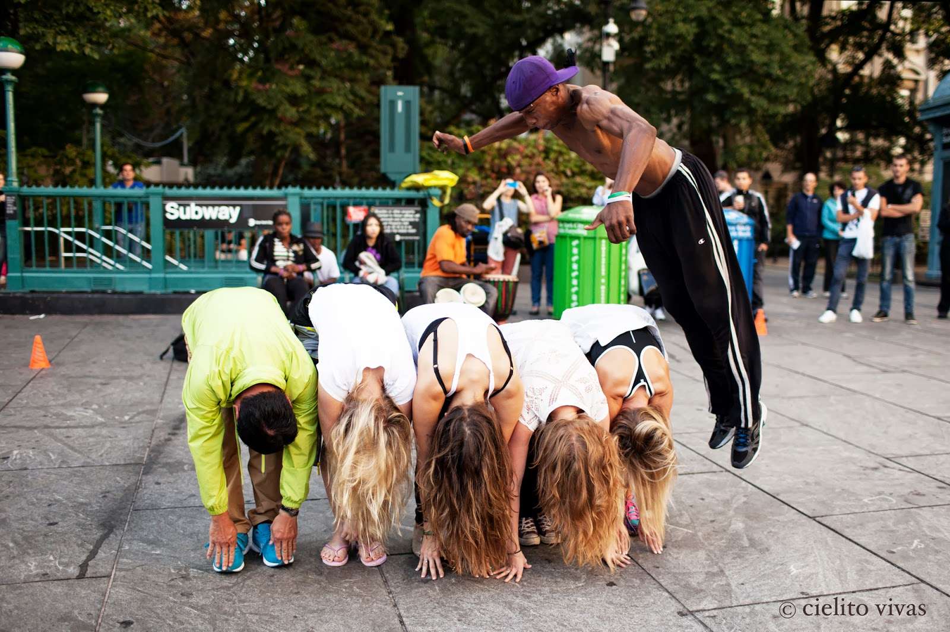
Photo Source: Cielito, Vivas. Link: http://www.thepostups.com/2013/10/street-performers-new-york-city.html
Free Movies 8:00pm The Alamo Drafthouse offers its movie programming with free admission outdoor screenings at Fort Greene Park. Featuring Contemporary and Classics movies. It’ll be a memorable experience. 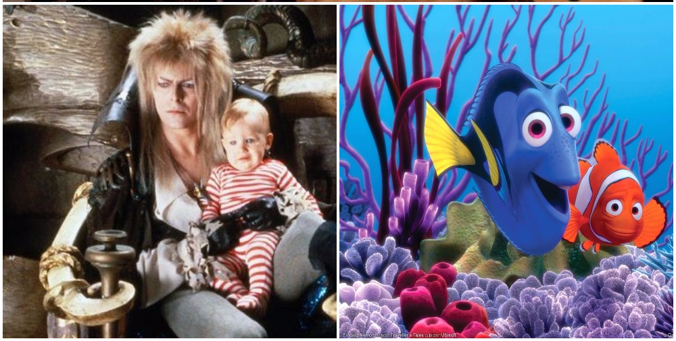
Photo Source: Davis, Clayton. Link: http://www.awardscircuit.com/2016/05/19/alamo-drafthouse-greets-brooklyn-free-outdoor-film-screenings
Basketball at 9:00pm I suggest you follow up with some time at the Barclay’s Sports and Entertainment Center. This is the home of the Brooklyn Nets. Also it hosts many venues accessible to many of the residents in proximity the surrounding neighborhoods.

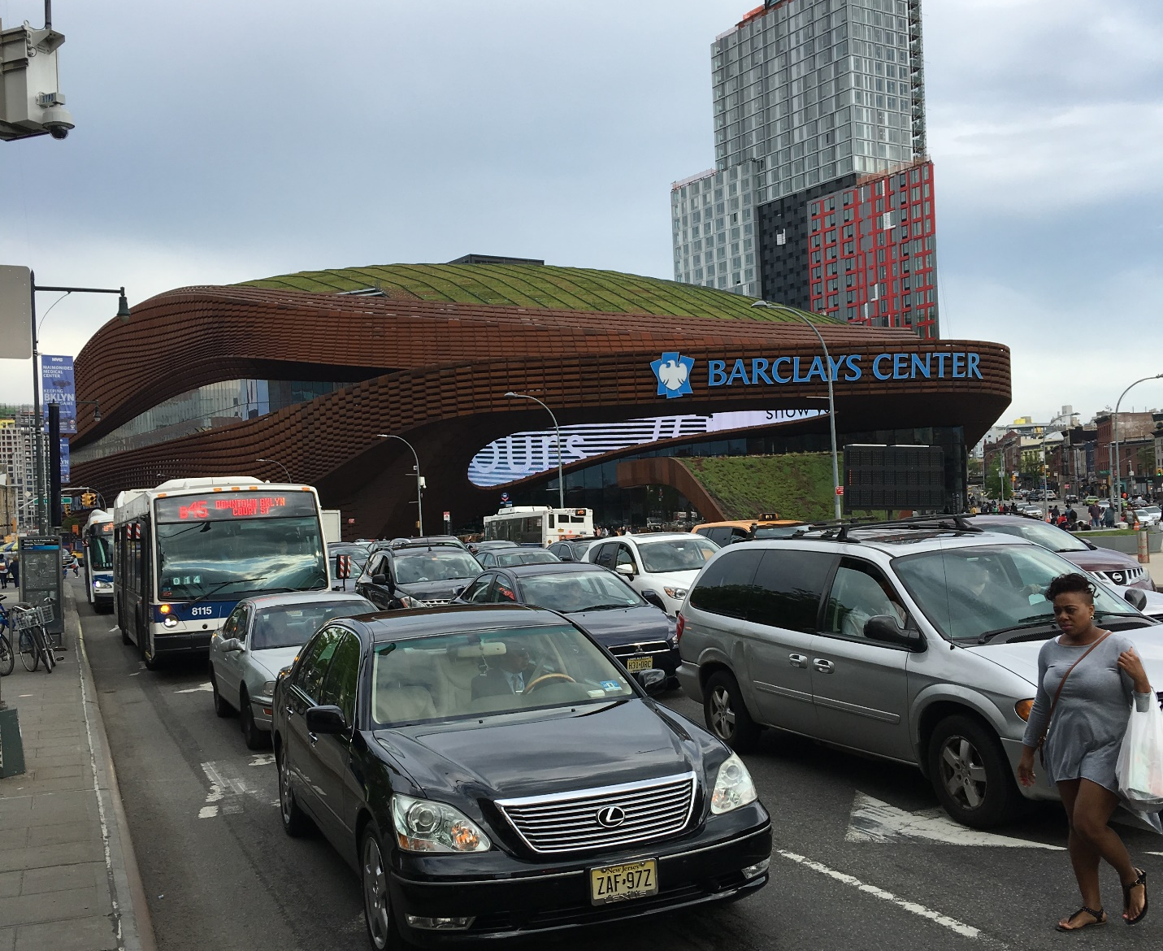
Photo by Johnnie Davis

There are many advantages to living here, so why go elsewhere to find the huge, compromising differences. If so many people flock from distant places to this part of the world , its because of what it has to offer. I’ll say it’s a very nice place to visit, and an even better place to live.

After the excitement of frequenting a live NBA game, it’ll a little hard to get some sleep. The ruckus will no doubt be endilably etched in th far recesses of your mind.

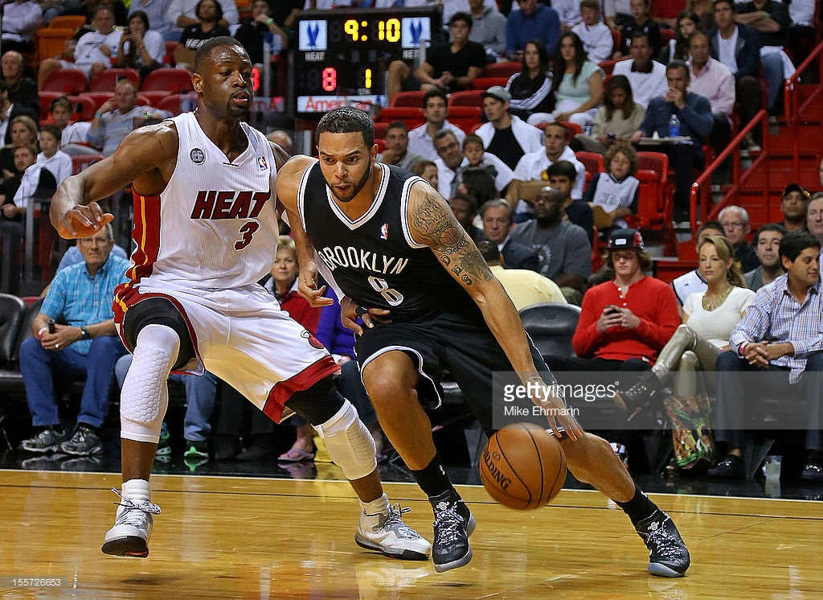
Photo Source: Ehrmarin, Mike Link: http://www.gettyimages.com/detail/news-photo/deron-williams-of-the-brooklyn-nets-drives-against-dwyane-news-photo/155726653

Back to the Hotel 12:30am It’s kind of late now and if you are tired, you might travel back to the Marriott to have a few drinks. Room service is available 24/7, however I think a trek to Junior’s Restaurant might be in order. There you can find just the right treat for your late night excursion. Perhaps you will think of this before you head in. The tantalizing menu is filled with the food we crave during the night. As you can see, even though the competition is very stiff for food favorites, Junior’s leaves very little wiggle room for the competitors to compete.

After seizing the opportunity of a fun filled night, you can appreciate the grand experience of waking up in a beautiful, well-kept room. The freshness invigorates your senses leading you to a tranquil moment of solitude.

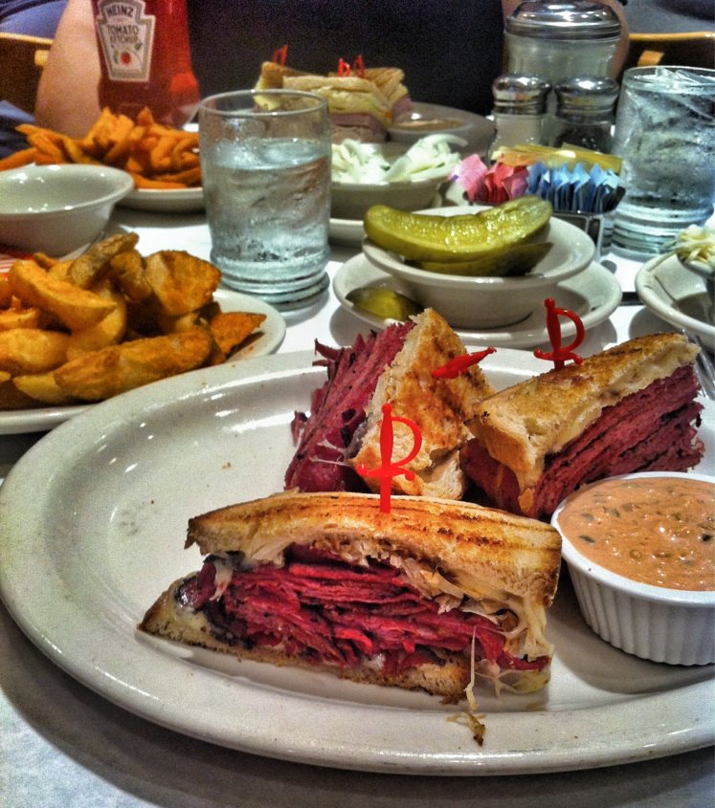
Photo Source: Yelp-Junior’s: www.juniorscheesecake.com

Saturday

- 2:00pm Prospect Park The morning dew has dissipated as the park goer’s flock to the slice of wilderness in the heart of the city. The smells of Bar-Be-Que permeate the air while children play carelessly.
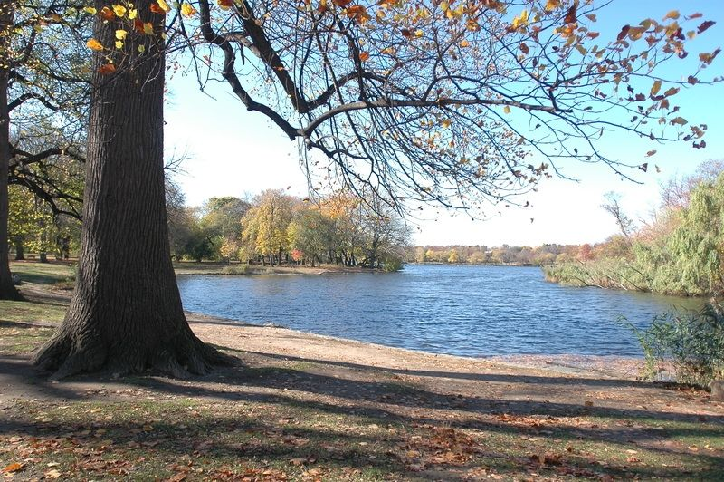 N.Y. C. Dept. of Parks and Recreation: https://www.nycgovparks.org/parks/prospect-park/photos

Nice long walk 5:00pm A time to reflect and give thanks for all you have is in order. The beauty of Nature sends a strong message to the senses of each and every one who gets a chance to experience it. The fishes in the pond, and the colorful proliferation of foliage in the spring time are just simple reminders that we are very small in the scheme of things. Traveling through the land we appreciate all the sacrifices of those who came here before us. Hopefully we can leave some of this magnificent beauty for our future generations to explore and enjoy as we do today. This is the price we pay for Freedom. The ever growing cost to having “look-back” (consideration for future generations that may follow).
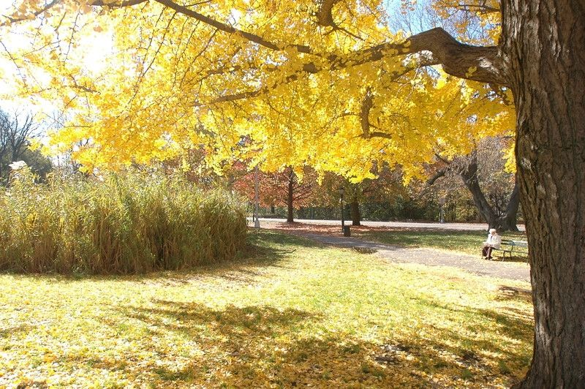
N.Y. C. Dept. of Parks and Recreation: https://www.nycgovparks.org/parks/prospect-park/photos

Sunday

As we ready to depart: 10:00am The journey back home is somehow too short. Wondering if and when will you come back to visit, you embed the memory of an elderly person sitting on a park bench, then ask yourself is there anything better?
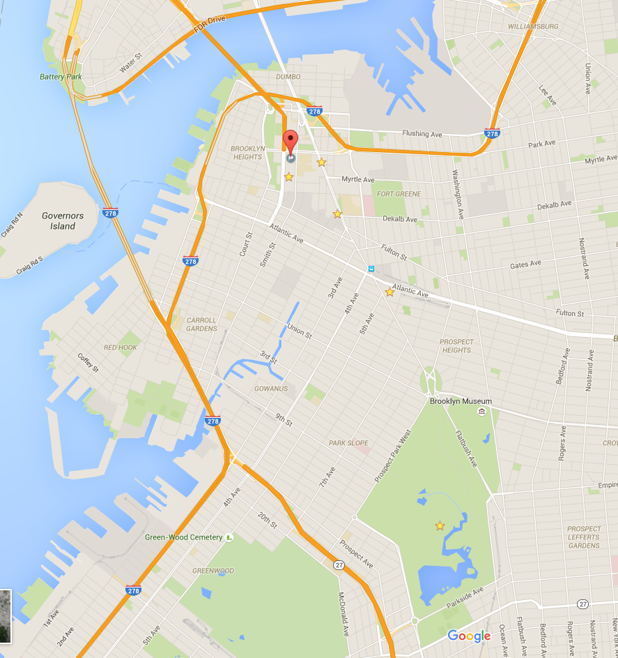

Map of Brooklyn

References List

Vivas, Cielito. (2013, September 29). Street Performers-New York City. Retrieved from http://www.thepostups.com/2013/10/street-performers-new-york-city.html

Ehrmarin, Mike. (2012, November 7). Getty Images-Miami Florida. http://www.gettyimages.com/detail/news-photo/deron-williams-of-the-brooklyn-nets-drives-against-dwyane-news-photo/155726653

N.Y. C. Dept. of Parks and Recreation: https://www.nycgovparks.org/parks/prospect-park/photos

