The Greatest Retail Spots in New York City

By Jadira Bermudez
New Your City have been known for many things and their shopping district all throughout Manhattan and downtown is one of them. When is come to shopping while being in NYC your will never has to worry about running about of places to go because your options are all but limitless. In New York you will be able to find the best department stores in the world including but not limited to Bloomingdale’s and Macy’s. If you have the time to travel through New York you may even be able to find iconic NYC specialty shops like Saks Fifth Avenue, Green Flea Market, and famous toy store in NYC like FAO Schwarz.
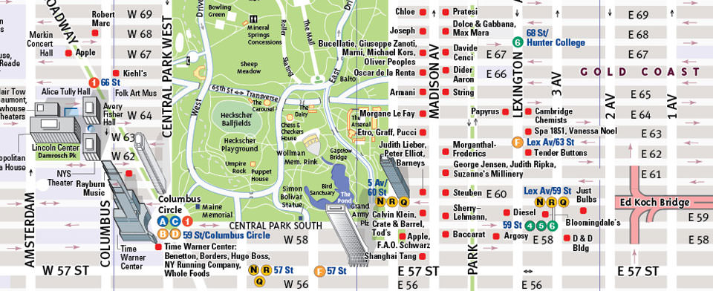Photo Credit : VanDam.com
Where you should go
Madison Avenue
Madison Avenue is on the Upper East Side of Manhattan and is known as North America’s premier luxury district. Madison Avenue exhibits the timeless elegance with a contemporary flavor this is distinctively New York. This shopping district has more than 140 luxury designer boutiques which make up the mile and a half stretch between 57th and 86th street. Madison Avenue Shopping District contains many high-end retailers, large-scale and small boutiques, jewelry, accessories and much more. The highlights that come with the shopping district are Barney’s, Ralph Lauren, and Lalique. Some stores that are in this district are Alexander McQueen (747 Madison Ave.), Bottega Veneta Maison (740 Madison Avenue), Celine (650 Madison Avenue), Diptyque (971 Madison Avenue), Gabriela Hearst ( 985 Madison Avenue) and many more.
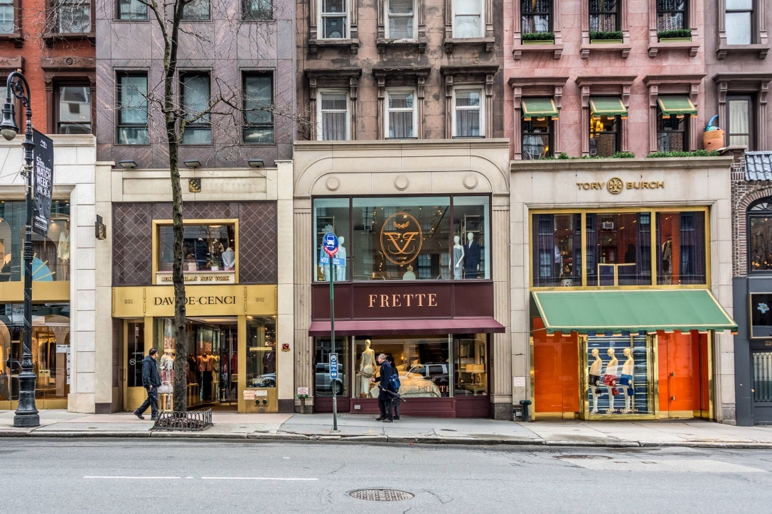
Photo Credit: findingnewpath.com

34th Street District
The 34th Street Shopping District includes other smaller shopping districts that known in New York City such as Herald Square and Greeley Square. The 34th street district is the home to over 175 department stores, including but not limited to specialty shops, boutiques, and national chain flagships. All these stores that are in this shopping district for everyone’s interest whether its shoes, accessories, cosmetics, or vintage. The main highlights to 34th street have to be Macy’s which is known to be the largest department store in the world, with having 9 floors and one million square feet of retail space. and the Manhattan Mall.

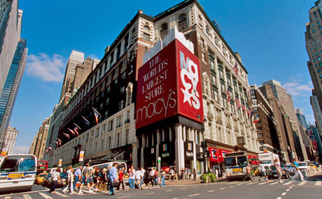
Photo Credit: therealdeal.com

Nolita Shopping District
Nolita also known as North of Little Italy and is connected to several popular downtown neighborhoods such as Soho, Noho, the Lower East Side, and Little Italy. Nolita was originally filled with Italian slaughterhouses, bakeries, and churches but is now known for its attraction for retail tourism. If you walk down Mott and Mulberry Streets will be able to find several trendy boutiques around the way. You should also look out for Belle by Sigerson Morrison for shoes and Resurrection for a more vintage look style clothing. Nolita is known for its beautiful and great quality boutiques instead of change store. When being a tourist traveling to shop in Nolita you should keep in mind if you are traveling or shopping on a budget it might be a little hard to buy things, but it usually does not stop anyone form shopping.

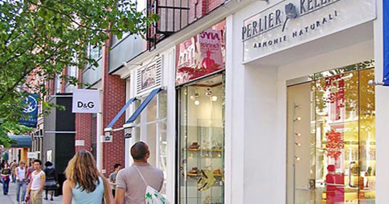
Photo Credit: broadway.showticket.com

Transportation

Citi Bicycles
Citi Bikes are something that has become very convenient for travelers that are not able to take trains or uber. A city bike rental prices change depending on the number of hours you need. The day pass which includes a 24-hour period is $10 and the one-week rental pass costs $25
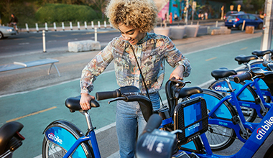
Credit to: citybikenyc.com
Subway
The subway is something can get you to point a to point b is the fastest and cheapest way possible. You will be able to find a station very easily when being in Manhattan and it will not also cost anything. A subway fare is $2.75 when purchasing a metro card. You can also get a single ride which is on $3.00. I do encourage just buying a metro card and adding the amount you may need or more just to be save. The good thing about purchasing a metro card is that it has an expiration date, and it lasts long so you may be able to use it again if wanted to travel around NYC another time.
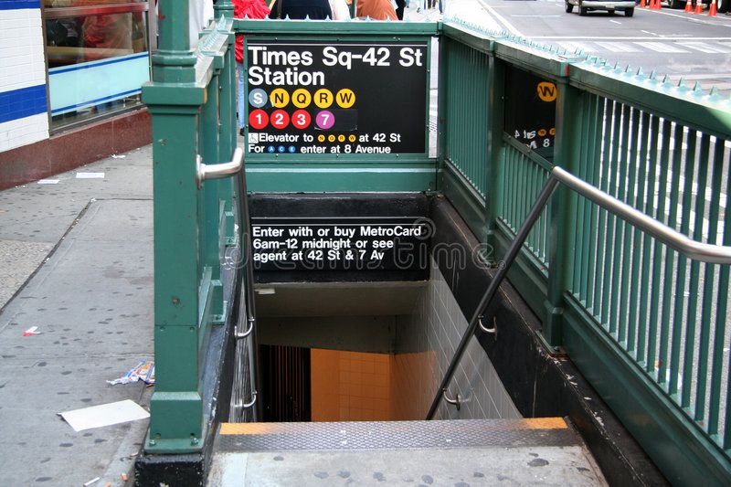
Photo Credit: untappedcities.com
Bus
The bus is as easy as taking the train, but it may be easier than others. You can really rely on the bus driver to make sure you do not miss your stop if you ask. A bus ride only cost $2.75 which is not pricy at all.
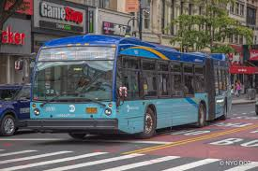
Photo credit: ny.curbed.com
Taxi/Uber
An uber and taxi are more on the expensive side depending on how far you are traveling. A taxi you will be able to find on the busy streets of New York and there is a meter in the car which charges by distance so at the end of your ride you will get your price, just make sure they are not ripping up of by taking a longer way to get more money. When taking an uber you just add the app to your phone connect it to your card and put in your destination and wait for them to pick you up.
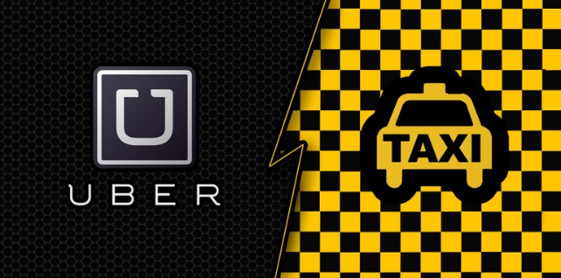
Photo Credit: bostonairportcab.com

Lodging
The Sherry Netherland
The Sherry Netherland is a classical hotel which mas an amazing romantic view of Central Park. This hotel has a great staff who warmly greets every guest with fresh flowers and Belgian chocolates. The Sherry Netherland is located at 781 Fifth Avenue which is great when wanting to shop because it near Maddison Avenue shopping area. The nearest transportation id the 5th Ave- 60th station which is the N,R, and W tarin following the 57th St- 6th Ave station which is the F train. The Netherland provides a state-of-the-art center for fitness and is very flexible and welcoming to any guests’ pets that have come along for the stay at the hotel. The Sherry Netherland rates begin at $649 per night.
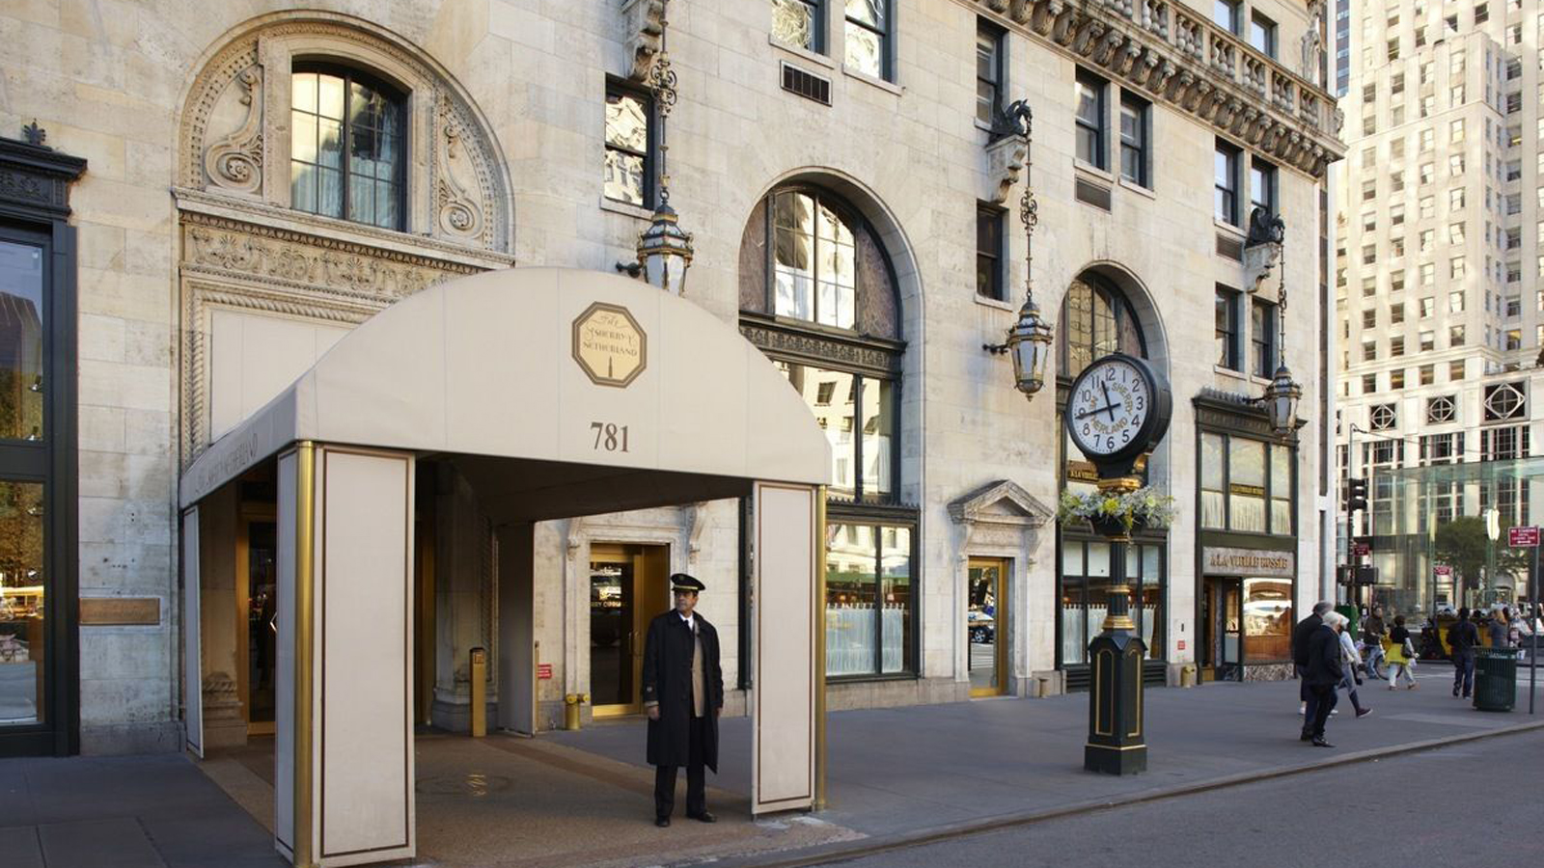
Photo Credit: cityreality.com
The Doubletree Metropolitan Hotel
The Doubletree Metropolitan Hotel is located at 569 Lexington Avenue in Midtown East Manhattan. The Doubletree is considered to be an affordable first-class accommodation on historic Lexington Avenue. The hotel offers all the guests’ complimentary access to their fitness centers, spacious hotel rooms by New York standards, and a bright, friendly hotel that have been greatly designed. The Doubletree is great for travelers because it has hotel rooms for under $100 that are in central Midtown East which is a great bargain. The hotel is made to make people that are not residents to feel at home by their friendly 60’s style decor which consist of bright tones. The hotel rate begins at $199 per night.
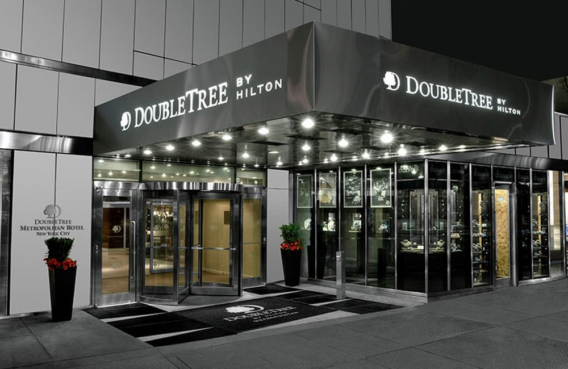
Photo Credit: newyorkbyrail.com
The Pierre, New York
The Pierre Hotel is located on 2 E 61st St. in in the Upper Est Side of Manhattan. The best features that come with the hotel is he view of Central Park. The nearest transportation to this hotel is the 5th Ave-60th St station which is the N, R, and W train following the 57th St-6th Ave station which is the F train and the 59th St-Lexington station which is the 4,5,6,N, R, and W train. The Pierre hotel is known for their extremely great guest experience with their babysitting amenities, relaxing spa, and pet services. This hotel offers 140 beautiful guest room and close to 50 swanky suites. Making a reservation at The Pierre will definitely fulfill the lavish experience expectations. The hotels rates start at $591 per night.
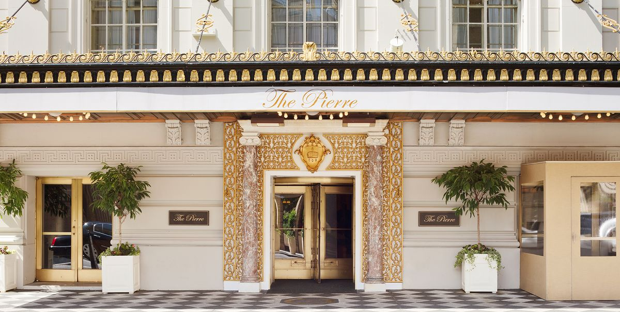
Photo Credit: elledecor.com

Food and Beverage
Pizza
Capizzi which is located at 547 9th Ave
Joe’s Pizza which is located at 1435 Broadway
Norma Gastronomia Siciliana which is located at 438 Ave
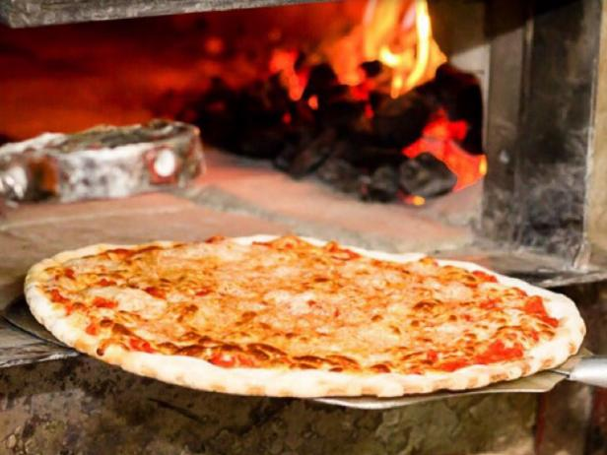
Photo Credit: foodnetwork.com
Indian Frybread
Taco Mahal which is located at 73 7th Ave S
Swagat which is located at 205 W 29th St.
Khiladi NYC which is located at 17 Avenue B
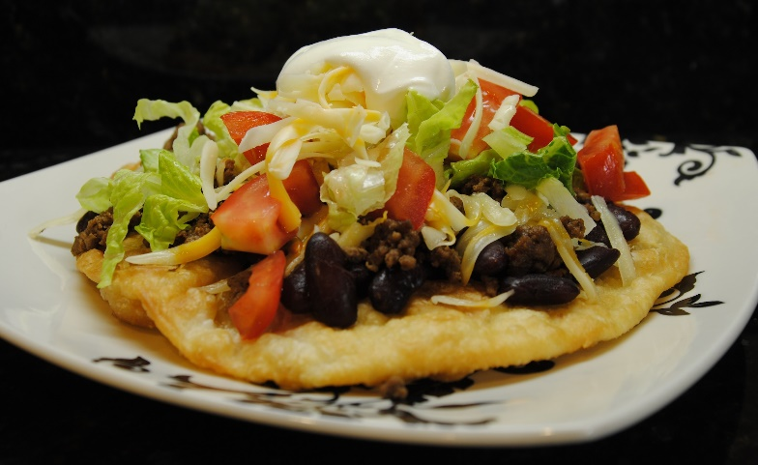
Photo Credit: 10buckdinners.com
Steak and Potatoes
Gallaghers Steakhouse which is located at 228 W 52nd St.
STK Steakhouse Midtown NYC which is located at 1114 6th Ave
Frankie & Johnnie’s Steakhouse which is locate at 320 W 46th St.
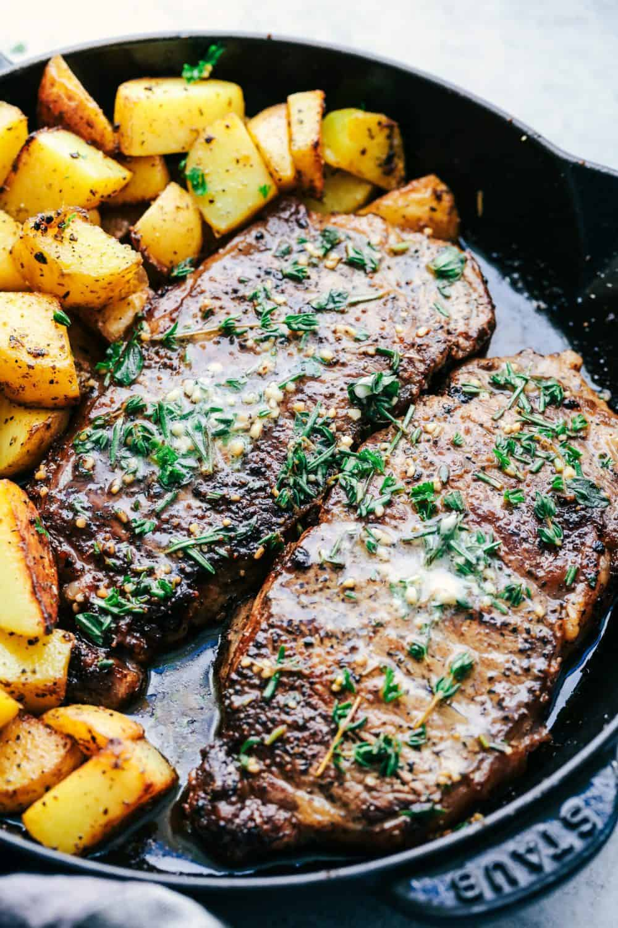
Photo Credit : therecipecritic.com
Seafood Boils
The Boil which is located at 139 Chrystie St
Claw Daddy’s which is located at 185 Orchard St.
Aqua Boil which is located at 750 9th Ave
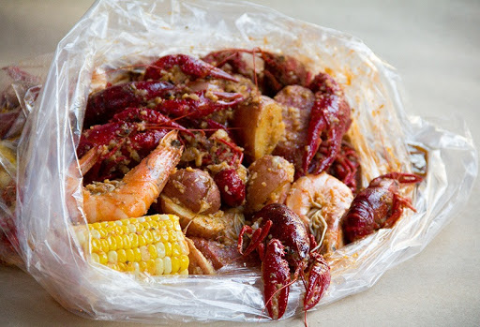
Photo Credit: checkmarkeats.com
References :
by NYCgo.com Staff. (2019, November 12). Best Madison Avenue Boutiques. NYCgo.Com. https://www.nycgo.com/itineraries/madison-avenue-shopping
Madison Avenue Business Improvement District. (n.d.). Madison Avenue NewYork. https://madisonavenuebid.org/
New York City Shopping Districts | Directory & List of Best NYC Shopping from Must See New York. (n.d.). MustSeeNewYork. http://www.mustseenewyork.com/shopping-districts-nyc.html
Nolita NYC Neighborhood Guide. (n.d.). Compass. https://www.compass.com/neighborhood-guides/nyc/nolita/
Shopping in NYC, New York City Shopping. (n.d.). NYC Tourist. https://www.nyctourist.com/shopping_menu.htm

