36 Hours in Brooklyn

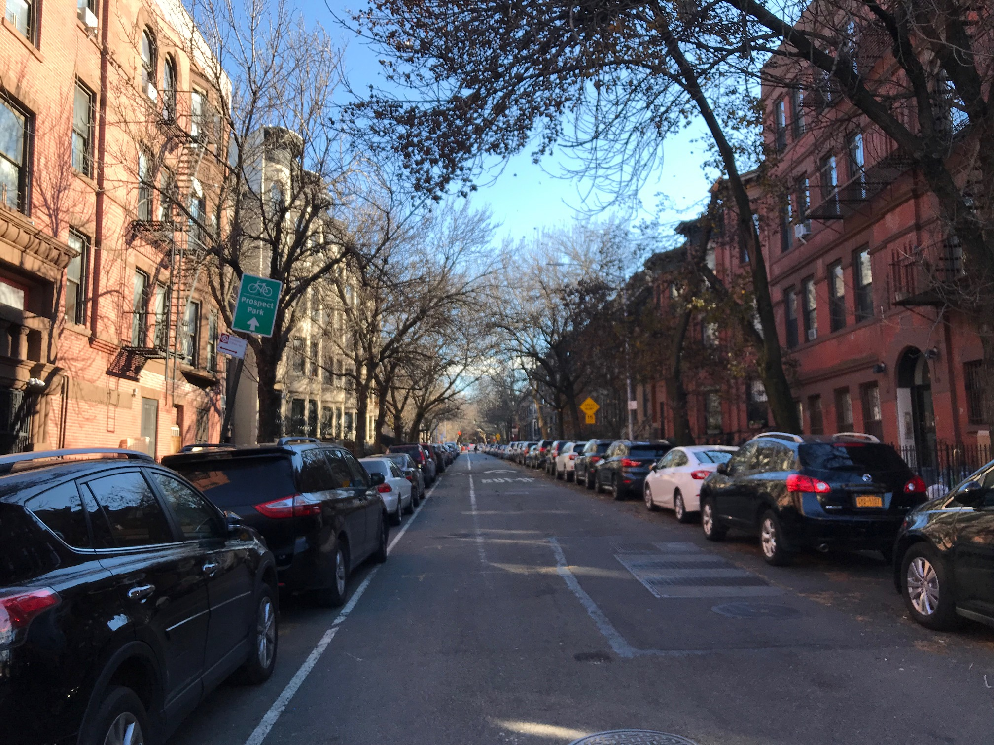
Brooklyn residential buildings
Photo Credit: Laura Fung

By Laura Fung

Dec. 11, 2018

New York City is one of the most popular cities in America to visit. Tourists roam the streets of Manhattan, but what about Brooklyn? A trip to Brooklyn is only a single stop away on the New York City subway from Manhattan. Brooklyn has more to offer than just the famous pizza shops and bagels. It was once considered a city within New York state before it became one of the five boroughs. As you take on your adventure in Brooklyn, take notice of the different cultures and variety of activities you can do.
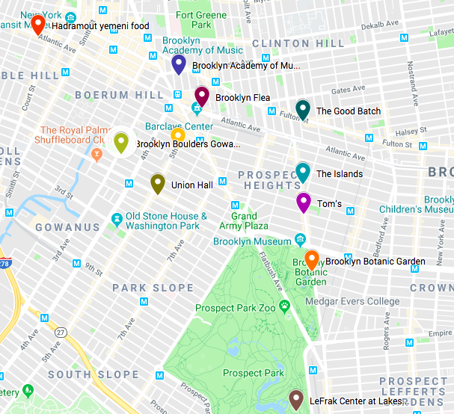
Brooklyn – Google Maps
(Pacificana not shown on map)

Friday

- 3 p.m. Brooklyn Boulders
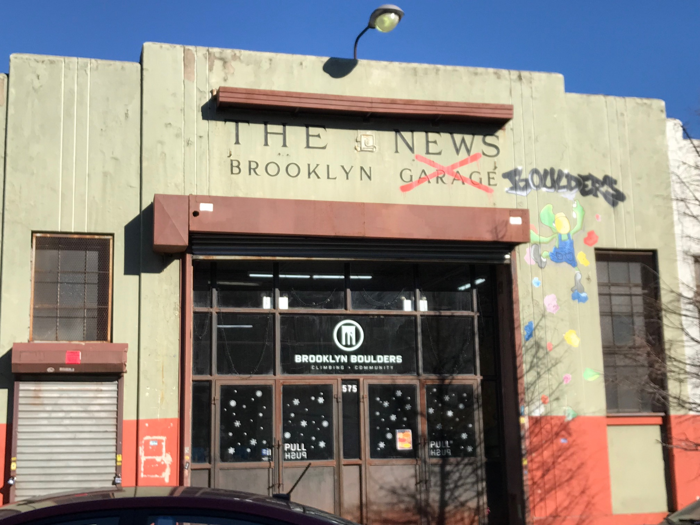
Entrance to Brooklyn Boulders; Rock climbing and physical activities available for all ages
Photo Credit: Laura Fung

To jump start your first adventure in Brooklyn, visit Brooklyn Boulders which offers indoor climbing activities. With 22,000 feet of climbing surface, you will find something within your skill level whether you are a beginner or expert. Brooklyn Boulders is a place for all ages to experience rock climbing safely while having a blast. For a day pass, it will cost you $32 which includes access to equipment like climbing gear and a fitness class. Go to Brooklyn Boulders during the slower times and it will cost you $28. You will be able to get cool videos for your social media posts to show all your friends that you rock climbed in Brooklyn.

- 5 p.m. Brooklyn Academy of Music (BAM)
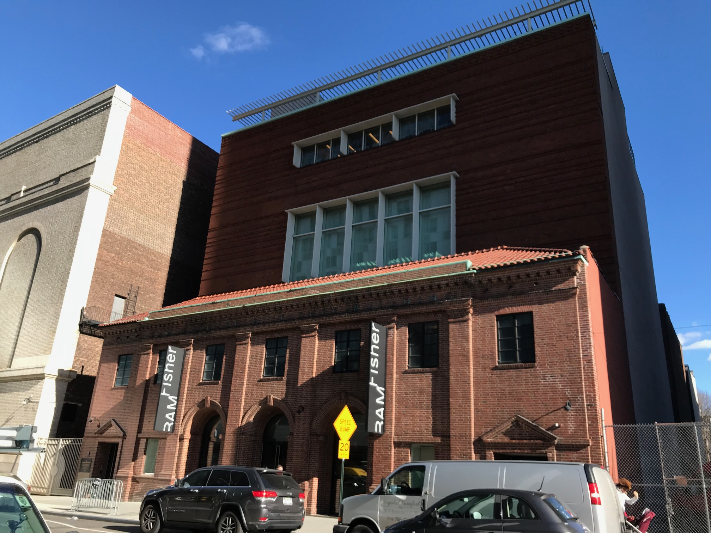
Beautiful brick building holds a variety of performances and shows located right on Atlantic Avenue
Photo Credit: Laura Fung

After an intense workout, walk over to Atlantic Avenue less than half a mile away to see what performances are showing at Brooklyn Academy of Music. BAM offers many shows and, “With world-renowned programming in theater, dance, music, opera, film, and much more, BAM showcases the work of emerging artists and innovative modern masters” (BAM). Check the calendar of showtimes prior to the performance to get the best seats. Adult tickets cost about $15 and children cost $11. With some planning, you can find some events at BAM which are free of cost if you are budget-conscious. If nothing interests you there, take a stroll along Atlantic Avenue to experience the joy and chaos of Brooklyn shopping.

- 7 p.m. Hadramout Restaurant
Strolling around works up an appetite so only a few blocks away, still on Atlantic Avenue, is Hadramout Restaurant which offers authentic Middle Eastern cuisine specifically from Yemen. Brooklyn is known to be a melting pot of many cultures and to experience some authentic Middle Eastern food is a unique experience. Their menu includes chicken, lamb, and seafood dishes with a variety of different flavors perfect for dinner. A popular dish is the lamb stew along with a side salad which costs around $18.

- 10 p.m. Union Hall
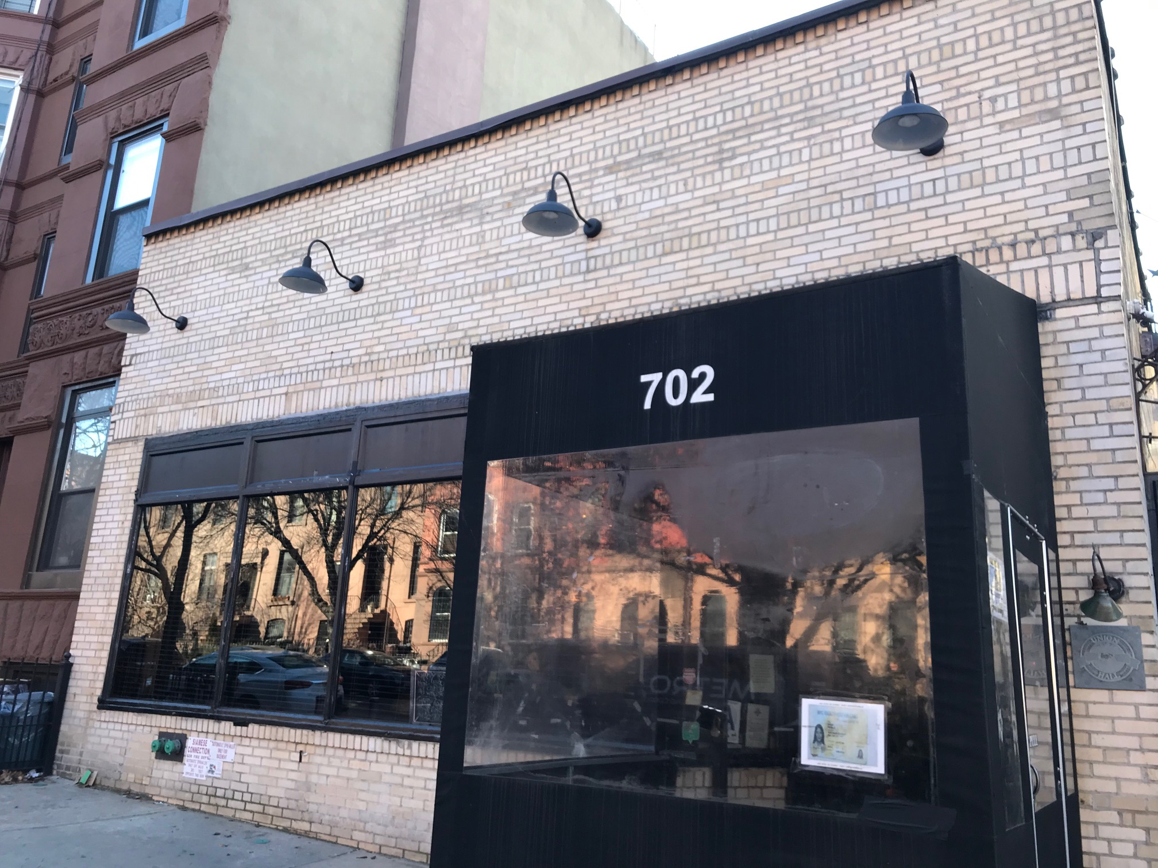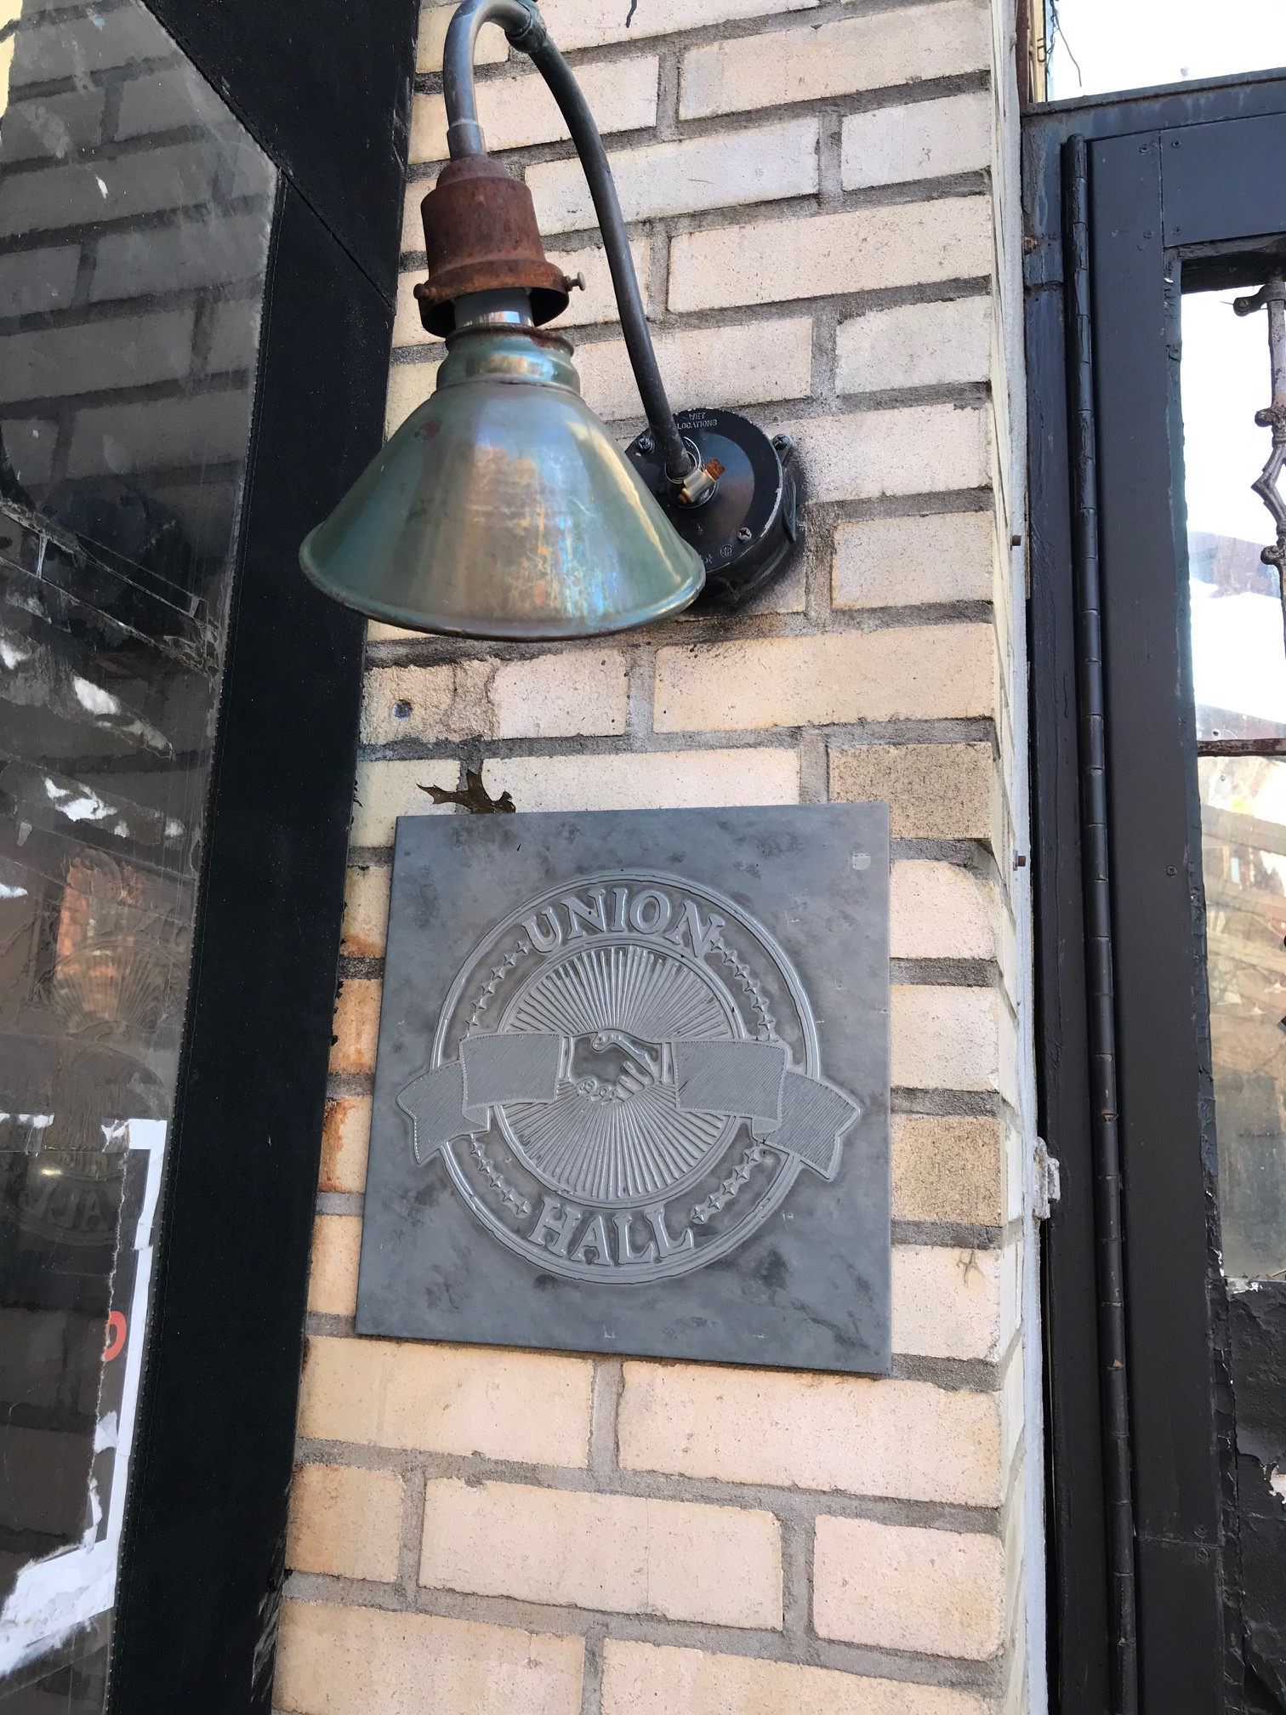
An intimate lounge to spend a night with friends and play a game of bocce ball.
Photo Credit: Laura Fung

End your night at the night club with a hipster vibe called Union Hall. Shelves of books line the walls of the club and leathered couches and lounge chairs fill the room. Further in, you will notice the bocce ball sport area for groups of people to enjoy drinks while playing together. It is a simple sport originated from the Roman Empire. If bocce ball is not your thing, head downstairs to watch a performance or join in on karaoke. But give bocce ball a try if it is something new, so you can tell your friends back home about it.

Saturday

- 9 a.m. Dim Sum
Start off your day with some traditional dim sum for breakfast at The Pacificana. Dim sum are small dishes of Chinese foods that range from savory to sweet. There is a variety of dishes to choose from and since the plates are small, it is great for sampling each dish. Dim sum follows Cantonese traditions where it is eaten for breakfast along with a pot of tea. Each dish, depending on the size, costs about $2 to $3. There are also specialty dishes, usually larger portions which may cost $6-$9. The Pacificana located in Sunset Park offers all the traditional dishes you would see in a typical dim sum restaurant.

- 11 a.m. LeFrak Center at Lakeside Prospect Park

From Sunset Park, take the subway to Prospect Park where there is something for everyone to enjoy. Bike rentals are available for self-guided tour at the LeFrak Center at Lakeside Prospect Park which takes about 3-4 hours to enjoy the scenery of Prospect Park. During the winter season, the LeFrak Center is open for ice-skating with rentals for skates as well. In this area, families can roller skate, go boating, and curl. The abundance of physical activities will keep you busy with your friends or family before heading over to get lunch.

- 12:30 p.m. The Islands
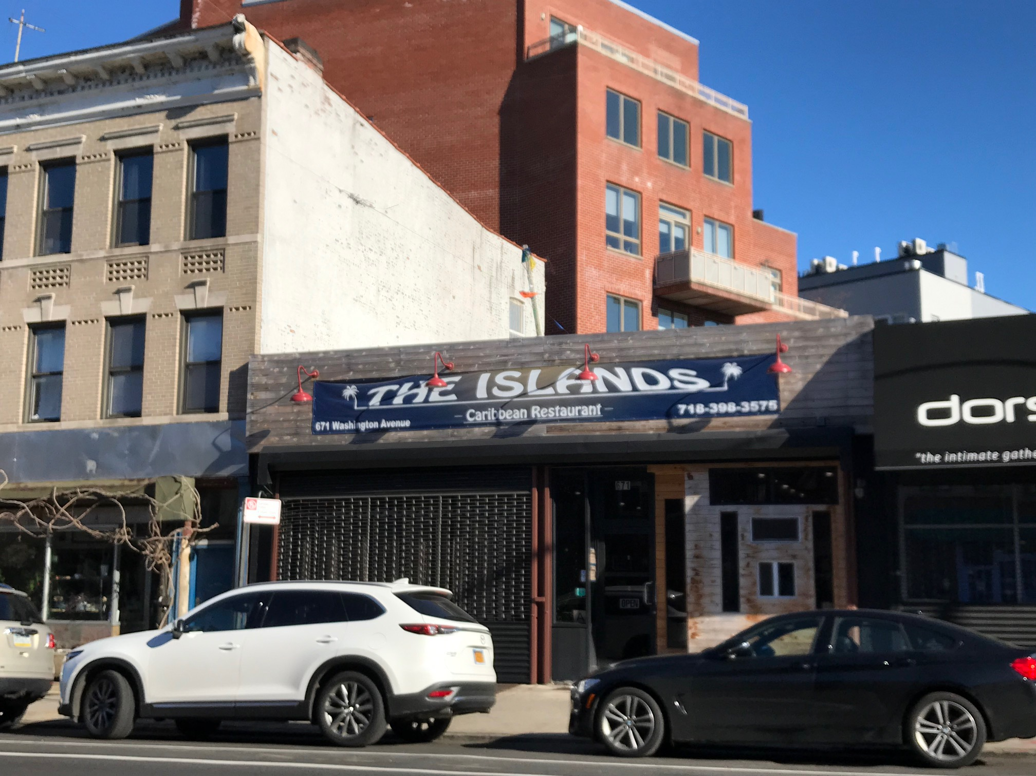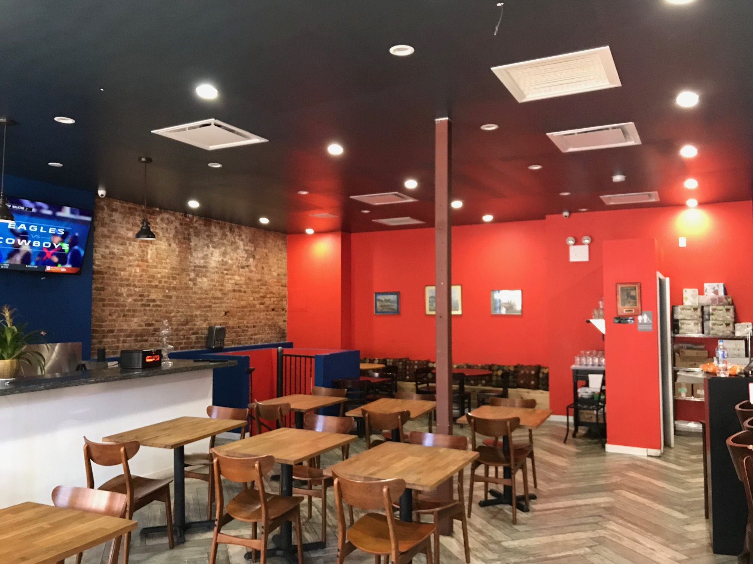
The Islands Restaurant: Caribbean Cuisine
Photo Credit: Laura Fung

In the same area of Prospect Heights, go over to The Islands where you can get a taste of Caribbean food. Experience the flavors of jerk chicken, oxtail, and plantains with sides of rice and beans. It is a great place to share a meal because portions are large and prices are reasonable. A seafood entrée costs $20, $17 for fowl dishes, and $16 to $22 for other meats. Be sure to fill up your stomachs before heading out to the next adventure.

- 3:00pm Brooklyn Botanical Garden
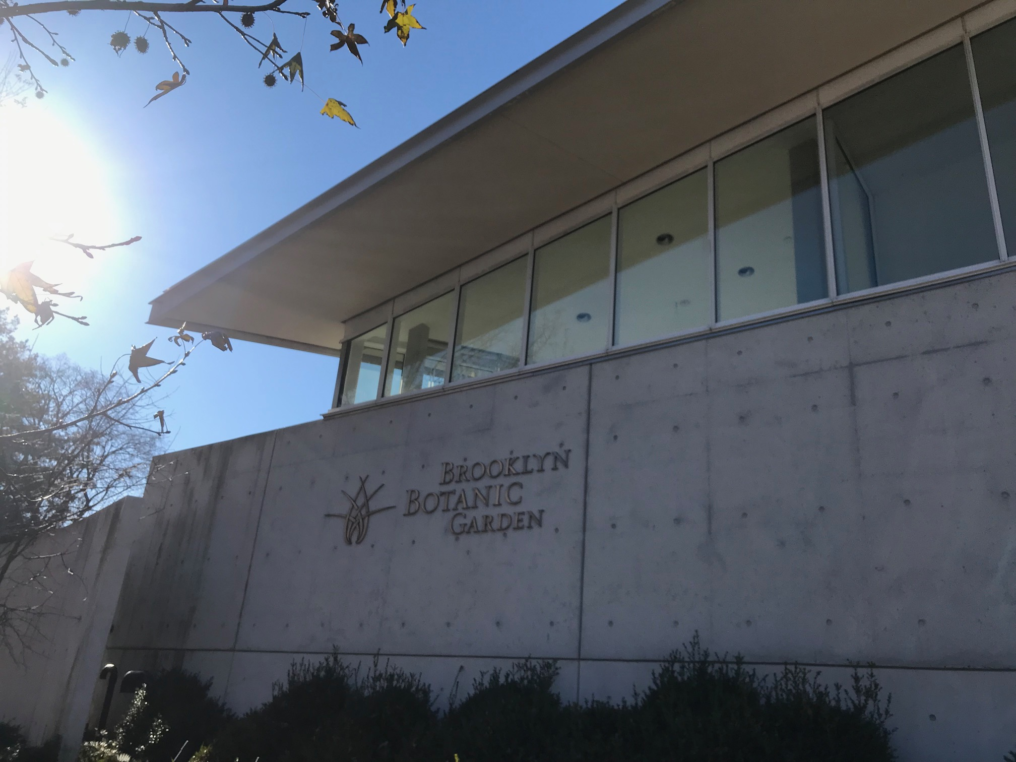
Welcoming center to the Brooklyn Botanic Garden to see the many species of plants in the middle of Brooklyn
Photo Credit: Laura Fung

Take a peaceful walk through the Brooklyn Botanical Garden and enjoy the view of the largest gardens in Brooklyn. The garden holds, “18,000 kinds of plants from all over the world. The garden is open year-round and has plants for every season, plus indoor tropical gardens and bonsai trees” (NYC The Official Guide). This gives you a nice break from seeing city skyscrapers and traffic. The botanical garden isolates you from the city rush and it is a great place to take beautiful pictures. Tickets for adults cost $15 and children under the age of twelve can attend for free.

- 6:30 p.m. Miriam
For your last night in Brooklyn, stop by Miriam that serves Israeli food. You may not know what Israeli cuisine is and that is what is unique about it. At Miriam, “…there exists no single dish, no single style of preparation that one might call uniquely Israeli. And yet this lack of identity is its identity, its beauty” (Miriam Restaurant). Be adventurous and get meze which is a group of finger foods. The Miriam Restaurant allows you to choose three mezes for $27. You could also get a main course and try the slow cooked roasted short rib with a fennel puree and a citrus salad for $28.

Sunday

- 10 a.m. Brooklyn Flea
For a vintage and antique shopping experience, go to the Brooklyn Flea which is a large flea market in Smorgasburg. It is open during the winter season for visitors to walk indoors at the Williamsburg location and open to visitors outdoors during summer on Atlantic Avenue. The Brooklyn Flea holds many vendors selling trinkets you can take home as gifts to friends and family or just some memorabilia to have for visiting Brooklyn. With so many vendors, you’ll find something that will grab your attention. Try to take a look at all the booths to see what each one is selling.

- 12 p.m. Tom’s
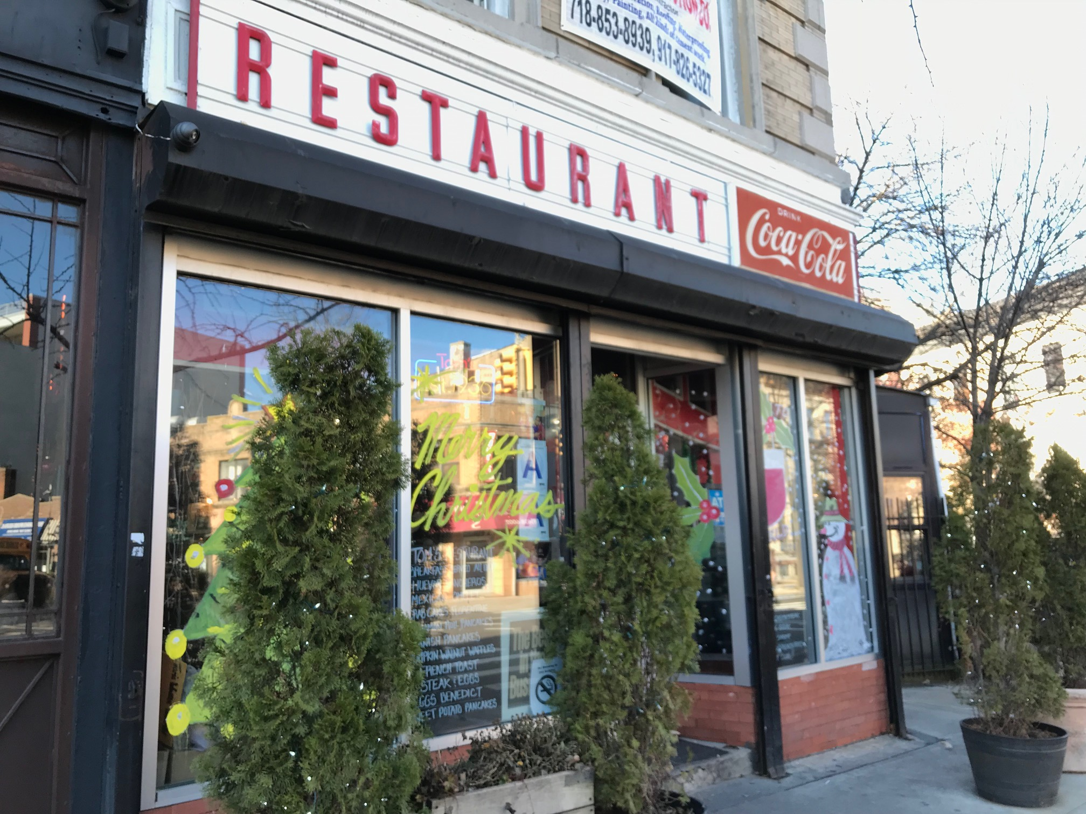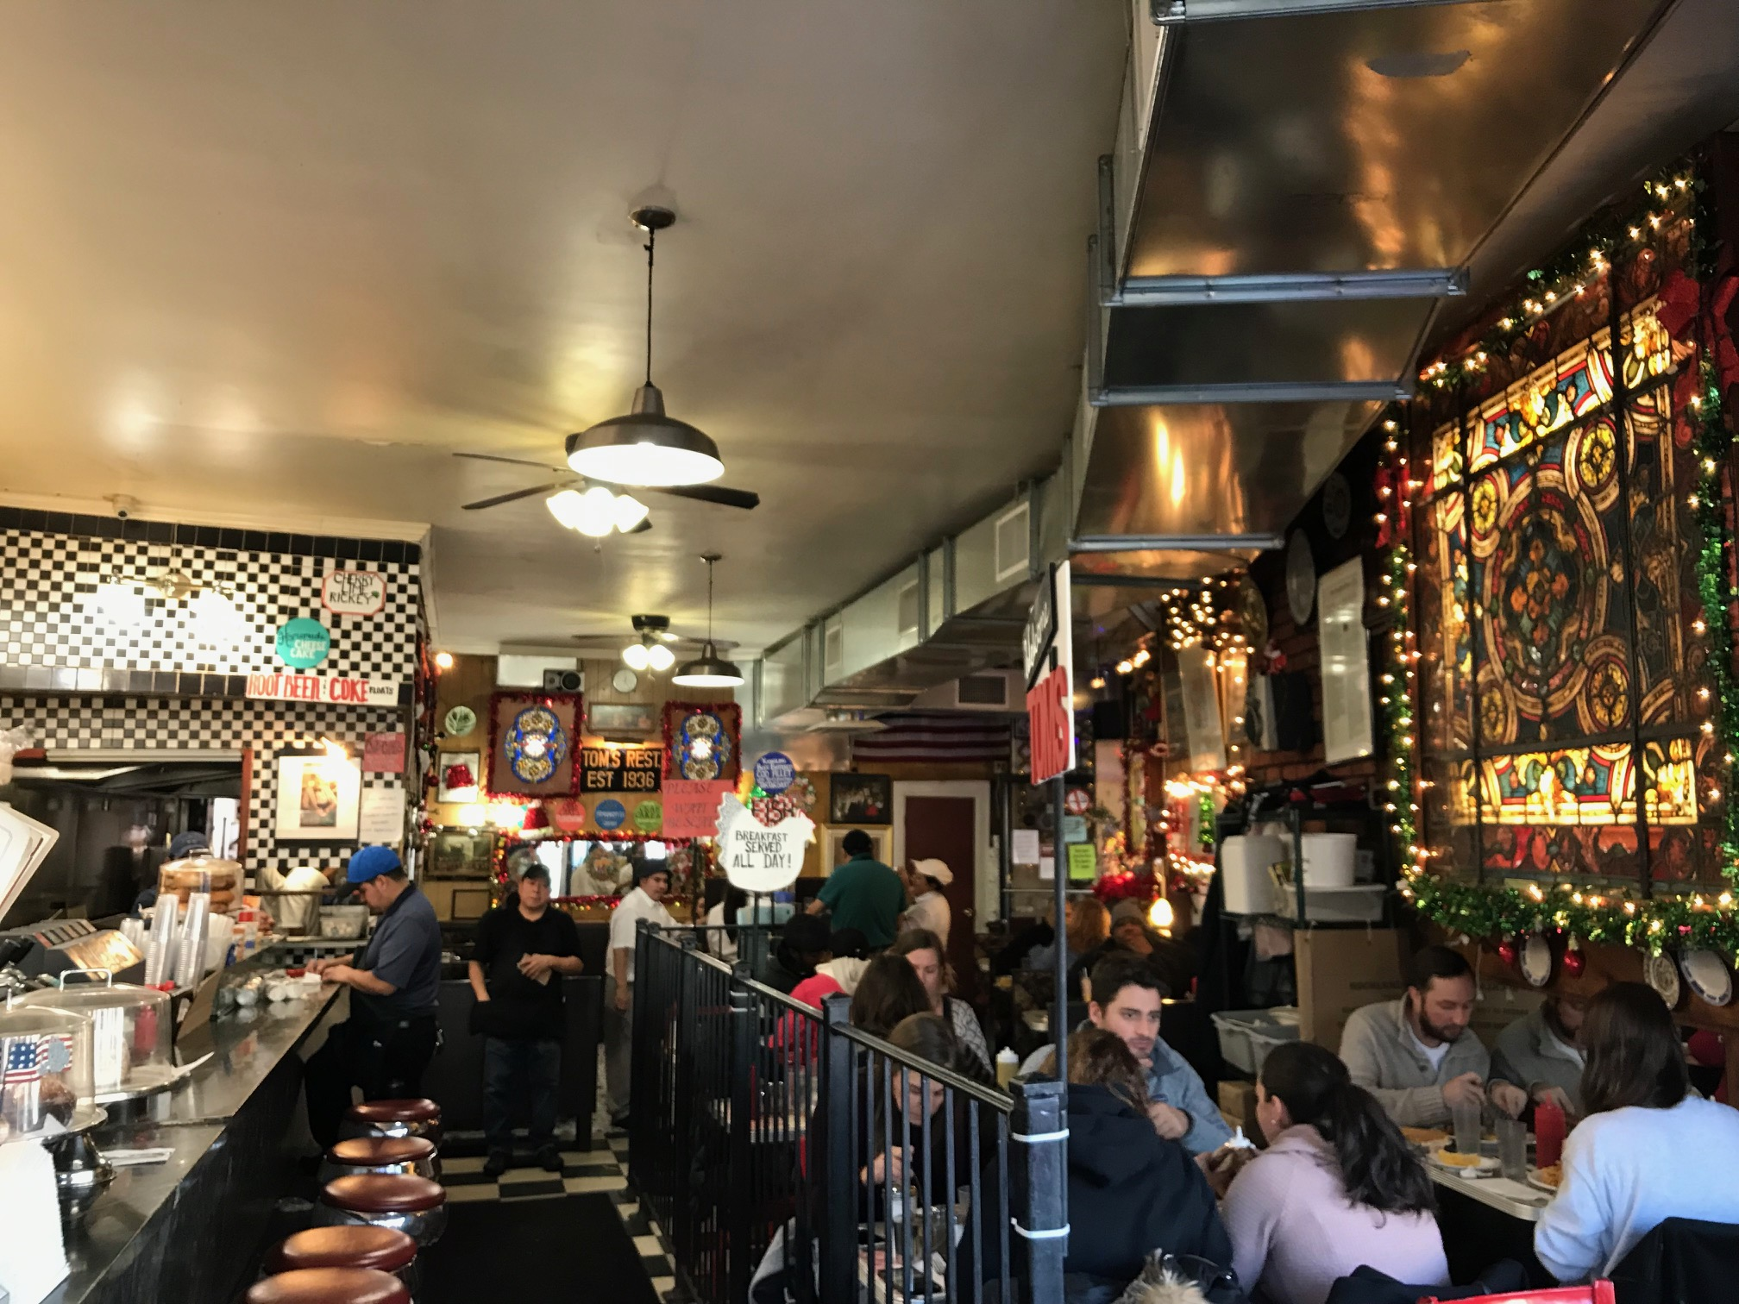
Outside view of the diner on the corner of the block and inside view of the customers eating their food
Photo Credit: Laura Fung

Have some brunch at Tom’s which has a museum feel when you first enter. It looks like a retro diner and they serve typical American diner menu. You can get your basic burger, fries, sandwiches and breakfast all in one location while your eyes feast on the décor. Entrees will average to $15 to $20.

- 1 p.m. The Good Batch
To satisfy your sweet tooth, visit The Good Batch known for their cakes and ice cream sandwiches. The Good Batch focuses on their quality of desserts and the use of local ingredients. Grab some cookies to share and take a picture to post on your social media. For their ice cream sandwich, you choose from a large selection of flavored cookies and they put vanilla ice cream between them. Ice cream sandwiches are sold for $30 to $40 for half a dozen.

Lodging

- Lefferts Manor Bed & Breakfast – located in Lefferts Gardens; small owner-operated Bed & Breakfast. A place for tourists to feel at home while visiting Brooklyn rather than staying at a typical hotel. One night costs $100 to $150.

- Hotel Le Bleu – located in Gowanus; modernized hotel is attractive to younger crowd but still a beautiful place to stay for anyone. A night at the Hotel Le Bleu costs around $200 for 2 double beds.

References
“About.” BAM. Retrieved from https://www.bam.org/about
“Brooklyn Botanic Garden.” NYC The Official Guide.
Retrieved from https://www.nycgo.com/museums-galleries/brooklyn-botanic-garden
“Miriam Restaurant.” Highpeak. Retrieved from http://www.miriamrestaurant.com/

