36 Hours in Dumbo Brooklyn.
Darlenis Diaz De Jesus
HMGT 1101
Professor: Goodlad.
12/04/2018

All over New York City we are surround with lots of places full of history and culture that makes our city home to us. We have the opportunity to experience many places around us that are so magical and worth seen, we have the honor to actually be able to see this on a daily. However there's many people all around the world that actually don’t have the chance to experience this everyday. Tourism is very important for everyone all over the world because of how advance technology have become it makes things easier for everyone to travel from one place to another. They have the chance to see a new environment and experience something out of their comfort zone.
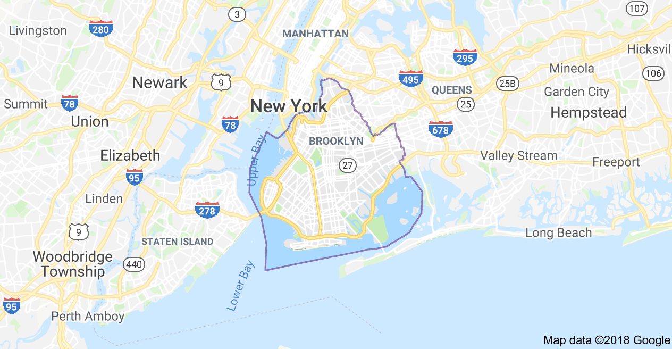
Dumbo Brooklyn holds a population of 1,139 people since 2010 in a area of 32 acres that was built in 1883, this is one of the fabulous places New York has to offer to everyone. This neighborhood is considered one of the most wealthiest places in Brooklyn it's definitely not a cheap place to live in or be around. Because of the many attributes this place holds it is why we have many people that loves to come and check it out and is considered to be a special place to be in and grow a family. Within the things this place is known for comes the history that it also holds that makes the place its own. Making many of there warehouse a design aspect of there unique styles makes there background a view to admire, these buildings have been turn into many different retail spaces. They now have these buildings structure to acominated and make the history and strucrture part of many restaurants that have a very high reputation, trendy comfort cafes and local retail stores.
This location has a little bit of everything for everyone it’s definitely doesn't not just hit a specific group there’s a lot for everyone and there different sense of style and taste. It brings an endless list of restaurant, galleries, street art, museum, bus tour, animals location. There's definitely a lot of entertainment for everyone to experience 36 hours full of adventures. Within the neighbor there's many areas that have a lot of very old historical buildings that many people love to walk around and get that experience, because we are so close to the Brooklyn Bridge people take advantage to also admired the parts within the bridge and the things that it brings. Yes there is many places in Dumbo that are extremely expensive however I wasn't wrong when I said there a little for everyone. For those looking for local places, a nice water front view, on top if looking for some romantic environment you will definitely find it in here. As it shows on the website provided all the updated places since November 27, 2007 information.

- Friday 8am.
Let's start our day with a nice walk or run through the Brooklyn Bridge. Enjoying the view of lower Manhattan and the New York Harbor view it's exactly what the soul needs. Being able to explore and let yourself escape from unwanted thoughts it's the most relaxing time you can do. For those who might have doubt about how safe it can be to walk the bridge with the amount of public transportation New York has, well this is completely safe! With how big the bridge is there also a lot of spaces, A big enough of a sidewalk to have many people enjoy the same attractions.
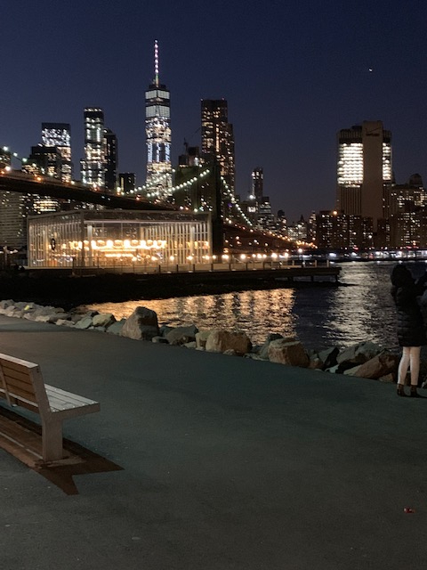

2) 10:30am
Breakfast at “ Bread & Spread” definitely a most after such a fun walk it's time to rebuild those energy buckets, This place is delicious it was open by chef John Coppola in January 2004, they offer all toasted and roasted well prepare sandwich with only the best of local product to accommodate customers demands. This place has a lot of success, a well done chicken sandwich with tomato and basil with mozzarella real toasted oh yes!!
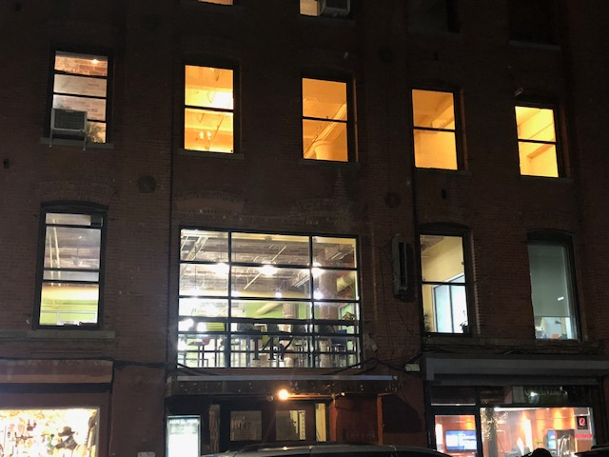

3) Friday 3:00 pm
Brooklyn Heights, one of the many neighborhood in there with so much to discover. A very lay back environment, lots of school and family friendly areas. This is very united and unique because of all the good things it has to offer. Having the opportunity to go to their local headquarters visit the bridge park. Adding on you get to go and see for yourself the amazing Jane’s Carousel. 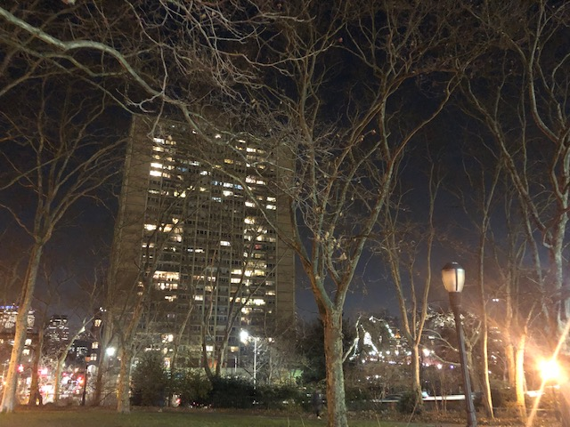

4) 7:30 pm Friday night.
Dinner at Celestina Middle Eastern spot in Dumbo. A very known place amazing to visit and experience. Being able to go with a special someone or anyone in general to enjoy a breathtaking view right next to the water long side of the Manhattan skyline with a nice dish of amazing well done dish and a glass of wine. Definitely a great way to end a saturday night.

5) 9:30 am Saturday Morning.
The powerhouse books store publisher opened a powerhouse arena right here in Dumbo. They opened this place to have articles showcase their creativity on top of that it became so popular to visit for everyone living in New York in general and those coming from other countries that want to experience the arena. Because of the success this place has it took Dumbo to the top chart better known on the map as a world class venue and art and literature. It's not only about the reputation people use this place for a nice quiet time to explore books and enjoy the surrounding. 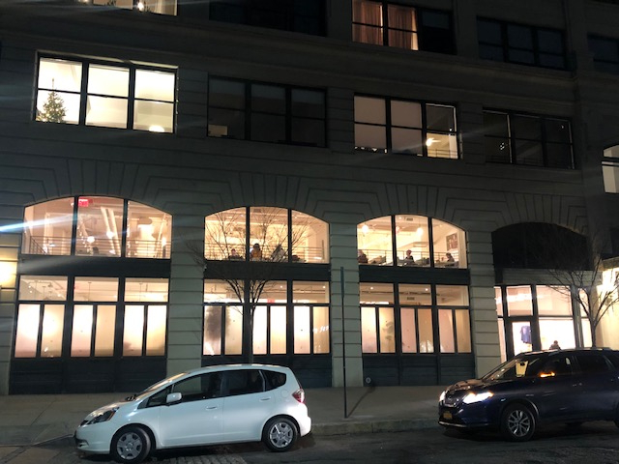

6) 1:30 pm Saturday.
Taking a walk through the Archway of the Manhattan Bridge it's one of the most fulfilling thing to experience in my opinion. Years ago this was a isolated dark space under the bridge after the years have passed this is now one of the most use places for events, weddings and use of photography. A very special place as a tourist to go and experience take in all the history and creativity this place holds.
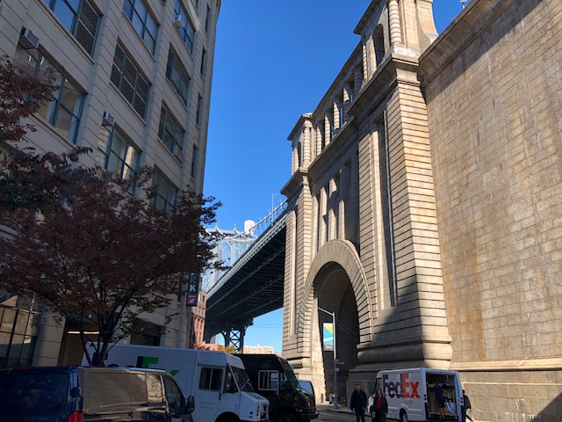

7) 5:00 pm Saturday.
Anyone want to do a picnic? Well Main Street Park is the right choice. A very come and friendly area with nature surroundings awesome view this is not something you do everyday but when you do it's nice to do it in the right space. With no worries of being in the outdoor with no bathroom because they offer public bathrooms for everyone to use, local food truck around. You will definitely enjoy the time being there.
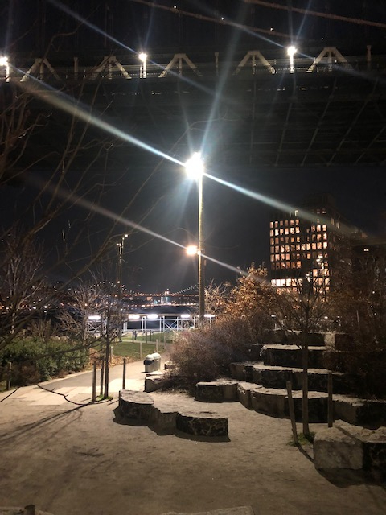
8) 9:00 pm Saturday.
Late night dinner and drinks oh yes sir, located in Dumbo there is this place called Sugarcane Raw bar & Grill. So amazing! Most the places in Dumbo have a very strong exterior poster much like many of the warehouse buildings. This is no different with a mysterious look of an old warehouse dont seem very large when you first look at it but don't let that fool you this place is pack with everything you need and all the space you want. Serving many classic dishes such as, sushi, BLT’s, rice, roasted chicken and many more draw people attention to come and visit and keep coming back. Long side any drink you can think of to released some stress or relax after long day of sightseeing and adventures.

9) Sunday Morning 10 2am.
Before starting your day it is a most to enjoy a every nice quick meal from Smile To Go an American cafe and bakery. The second location after soho's that's now open to customer service they bring a lot of good stuff to grab and eat and be on the go.
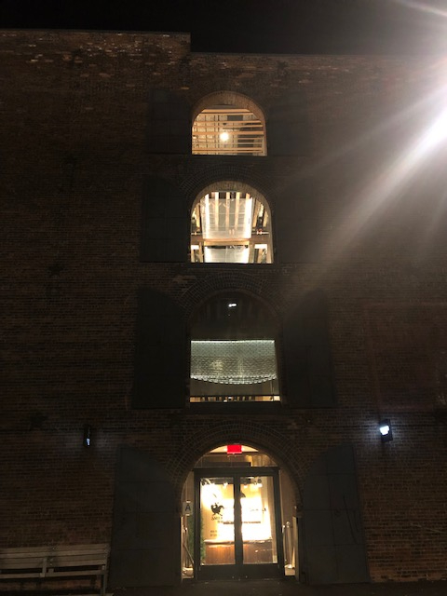

10) 12:30 pm Sunday.
If you happen to be here in Dumbo during April to October the Dumbo Flea is a must. If you are interested in a market environment this should be so much fun. Surrounded by awesome artisan craft, vintage clothe and products along side of cool retro furniture. Any last minute shopping can for sure be done here everything seems so special and meaningful most if not all are things actually made by this people themselves. Great fast food with good service a very nice energy to be around and take in and feel comfortable with whats around you.

11) 3:30 pm Sunday afternoon.
I would personally say, best for last. 1 Main Street at the corner of Plymouth street and main street a breathtaking location an actual building known as the Clocktower Building. Before this building became a luxury apartment for rent building this was actually an old forgotten industrial building. The name says it all, there is actually four big clocks around the building itself with an great view. One of the most expensive buildings to offorded in Dumbo it is definitely not cheap due to the history location and amenities plus the surroundings.
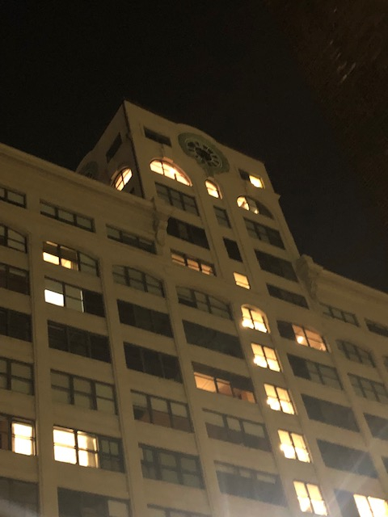
Just like many other location like Dumbo Brooklyn there's so much more out there very worth of experiencing. It's important to take an adventure and recognized the beauty every area around you’re environment has to offer. Even for those that have the chance to view this everyday should be more grateful because others could only wish to one day come and explore and have 36 hours of their life to do something beyond what your use to and 100% unique and different. A great place to stay while experiencing this adventure it's the New York Marriott at the Brooklyn Bridge, starting at $178 per night at this amazing location that its on the center of it all. Great resources of public transportation and local fast food restaurants.

Reference.

Where To Eat In Dumbo and Brooklyn Heights - New York. (2017, November 29).
Retrieved from https://www.theinfatuation.com/new-york/guides/best-dumbo-brooklyn-heights-restaurants

