Stephanie Udeji

36 Hours in Brooklyn

The most populous borough In New York City, will offers you diverse experiences, food options and amazing views of the iconic New York City sights.

Society as a whole has been making the conscience effort to enrich and detoxify ourselves. We make pledges to eat healthier foods, live more active lifestyles by incorporating sports activities and foods that give our bodies the energy they need. “New York City, with 99 percent of residents enjoying easy access to a park, playground, trail or other open area...” (Brody, 2018). The borough of Brooklyn has experienced a high amount of gentrification, which has contributed to the increase of tourism, specifically sports tourism. Rehabilitating parks and maintaining sports arenas helps Brooklyn residents and visitors enjoy indoor and outdoor sport activities all year round.

Thursday

- 9 a.m. Morning Drink

To start the day off right a cup of coffee or some water will do the trick. What you drink all depends on whether you’re preparing to run or walk across the bridge. Depending on the weather, grabbing cup of coffee from a Starbucks nearby will give you that boost you need. Or grabbing a green smoothie, bottle of water or Gatorade will help you during your run. Take a seat, and meditate, right before you take off.

- 10:30 a.m. Run the Bridge

The Brooklyn Bridge is one of the most iconic sites in New York City because it’s often featured in movies and television shows. Construction was completed in 1883, “which connected Brooklyn and Manhattan for the first time” (Brooklyn Bridge, History). Over 100,000 people use the bridge daily, either for their daily commutes for work or for a run. Starting your day with a run or walk across the bridge will surely wake you up and give you the boost of energy you need with an amazing view of the bridge itself and Manhattan across the river. If you’re not up for a run, walking is a great way to take in the sights and stop for pictures as you feel fit.

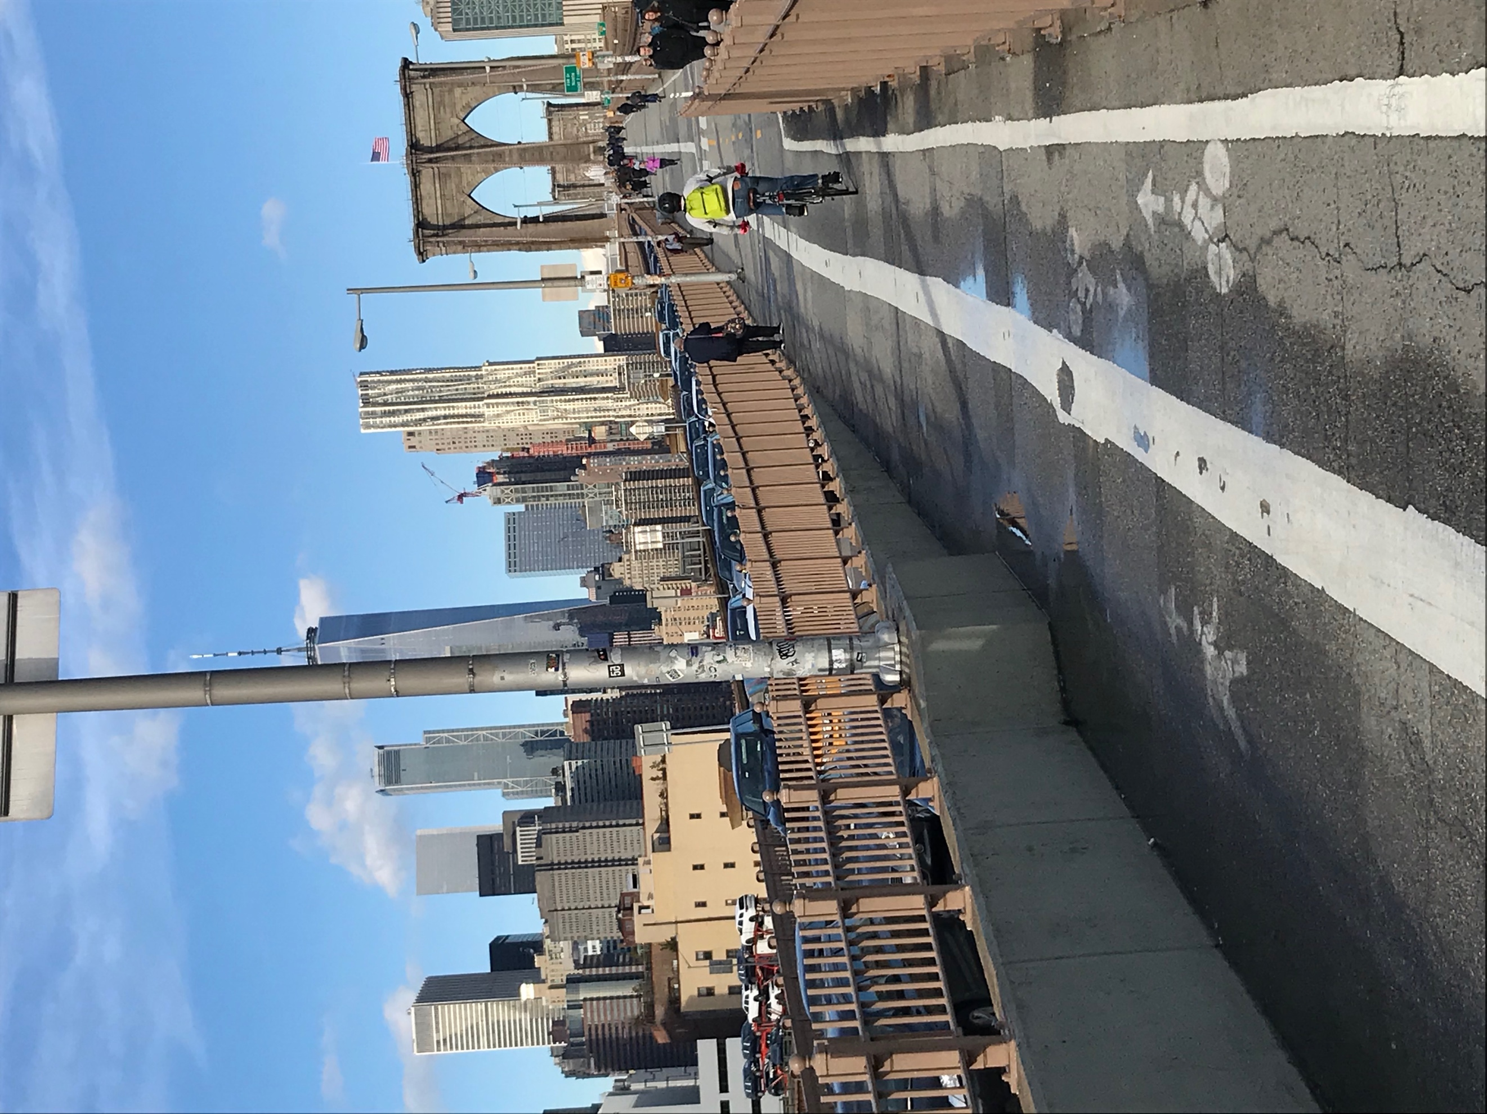

- 12:30 p.m. Dumbo

Fun Fact: DUMBO is an acronym for Down Under the Manhattan Bridge Overpass
Two and a half hours later, a short walk brings you to DUMBO. Its cobblestone streets, red brick buildings and front row view of the Manhattan Bridge all make this street unique. Many of the streets still have the original train tracks that were once used during the early 20th century. These tracks were used to transport coffee that was imported from far regions. Being that the Manhattan Bridge was completed in 1909 and many of the building surrounding it had already existed, it takes you back into time by the detail all over. The cobblestones being perfectly lined on the streets, the uniform brick buildings and the ornate design and color of the bridge itself. This neighborhood is littered with shops and restaurants that fit the aesthetic of their environment.

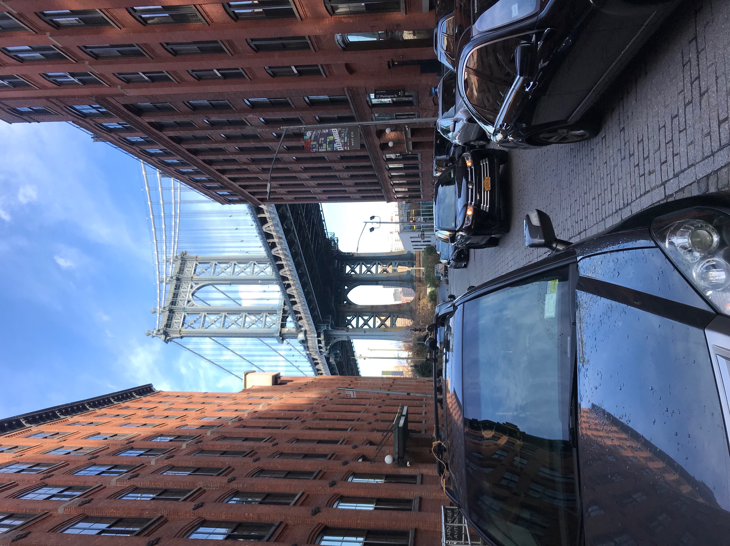

- 2 p.m. Shake Shack

After trying to get the perfect Instagram worthy shot in front of Dumbo, you’ve worked up an appetite and could really use a hamburger. When Shake Shack was first introduced to New York City in 2004 by Danny Meyer, it was an instant hit and changed the way New Yorkers eat hamburgers and fries. What all started as a hot dog cart in Madison Square Park in 2001, the chain has grown to have over 130 locations nationwide. The natural Angus beef used for their hamburgers sets them apart from all the other hamburger joints. A shack burger ($6), which is topped with lettuce, tomato and ShackSauce, cheese fries ($4), and a strawberry custard ($6) is an indulgent way to treat yourself after some exercise.

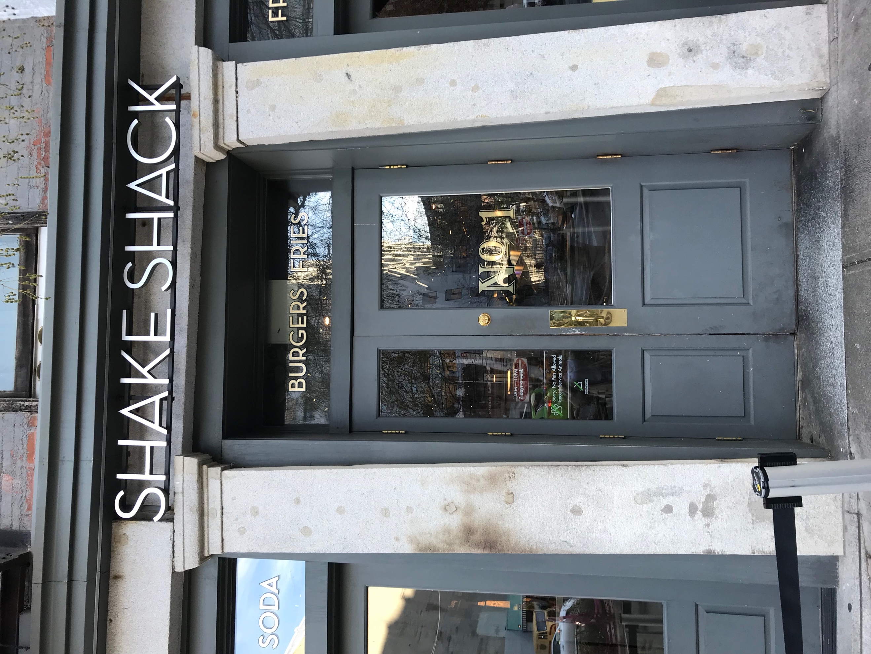

- 3:30 pm Brooklyn Bridge Park

This park looking over the Brooklyn Bridge and the east river has a lot to offer for people who are looking for a bike trail to ride or a lawn for their kids and dogs to run around on. The park has many piers, that are all designed to host certain kinds of sports. Pier 1 has lawns and granite steps that overlook the Statue of Liberty in the far distance. Pier 2 is home to the courts such as basketball, handball, shuffleboard, outdoor fitness equipment and a roller rink. This is great for a family or a group of people who all different interest, everyone has something that grabs their attention. Pier 3 is a central lawn that has picnic tables, and moveable furniture that is great for a picnic for small outdoor get together with some friends.
Friday

6) 10 a.m. First Meal of the Day

This quaint bistro, La defense Bistro, located near the entrance of the Brooklyn Bridge is the perfect spot for breakfast. The French themed bistro has some French classics and some Brooklyn themed dishes that will appeal to those who are health conscience but want a filling meal. The Brooklyn Breakfast which contains puffed quinoa with mushrooms, tomatoes, onions, jalapeños, scrambled eggs served with greens, French fries and whole wheat or white toast ($12.50). Due to how delicious the food is, it’s advised to make reservations before going to the bistro. This meal reminds me of a full English breakfast, even though its only missing sausages and baked beans.

7) 12 p.m. Trip down memory track

New York City is known for its transit system. Its fleet of buses, trains and even ferries help New Yorkers and their visitors get from place to place with a fare of $2.75 per ride. The Transit Museum displays old trains and buses used in New York City, is the largest museum in the United States that is dedicated to urban public transportation. Tickets for adults are $10, children and seniors are $5. All MTA employees, and active duty military personnel all receive free admission. This kid-friendly museum allows for you to see how the transit system in New York City has evolved over the years. From the colors, styles and shapes of the trains.
*The museum is closed on Mondays and major holidays. *
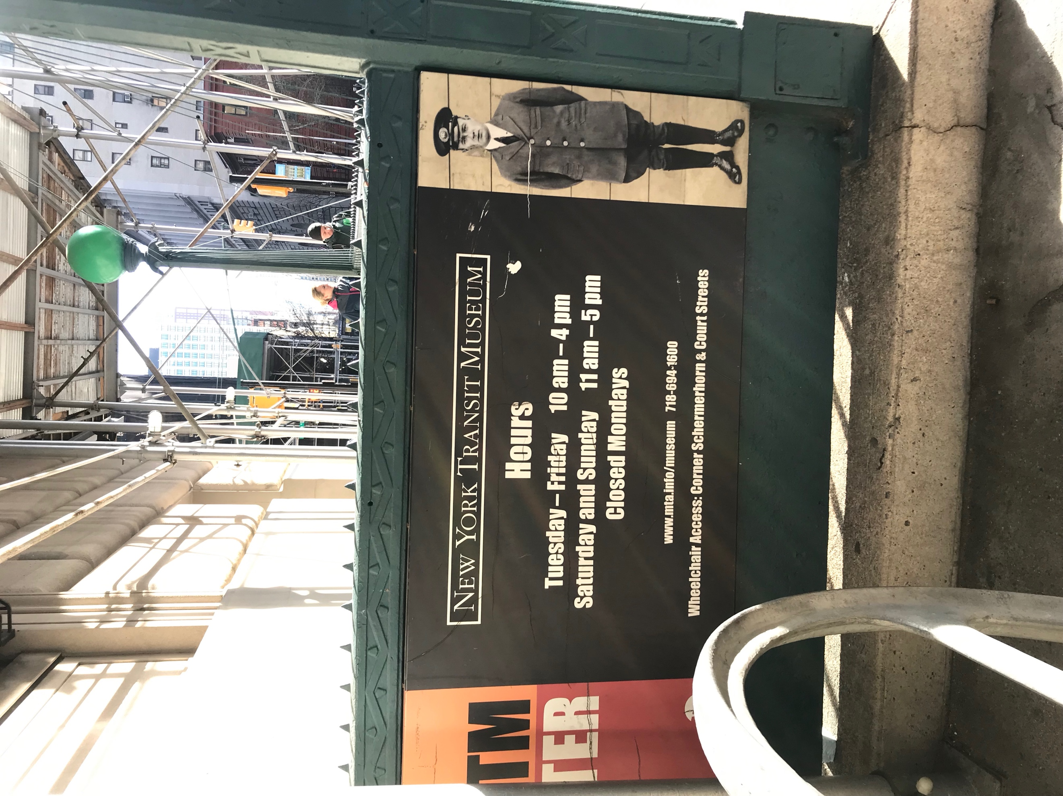

8) 3:30pm A pick me Up

Upon leaving the museum you want to grab a sweet treat before you continue your day. Uncle Louie G was known around Brooklyn for providing Italian ices during the summertime. These flavored treats are great all year round. Flavors such as lemon, strawberry, cherry, watermelon and chocolate ice are amongst the many to choose from. For a couple dollars, you can have a treat that fills you up a bit and quenched your thirst simultaneously.
*Some Uncle Louie G locations are seasonal*

9) 6 p.m. Take me to the Game

After a quick refresh, hop in an Uber and head to the Barclays Center located on Atlantic Avenue. The multi- purpose indoor space is home to the Brooklyn Nets and The New York Islanders. If there isn’t a sports game going on then there is an artist performing to a crowd of 17,000 people. The arena which was completed in 2012 has hosted many WWE wrestling events, mixed martial arts fights and even the MTV Video Music Awards. You can purchase your tickets to attend an event ahead of time or at the windows at the arena. While you’re there eat some of the great food the arena has to offer.

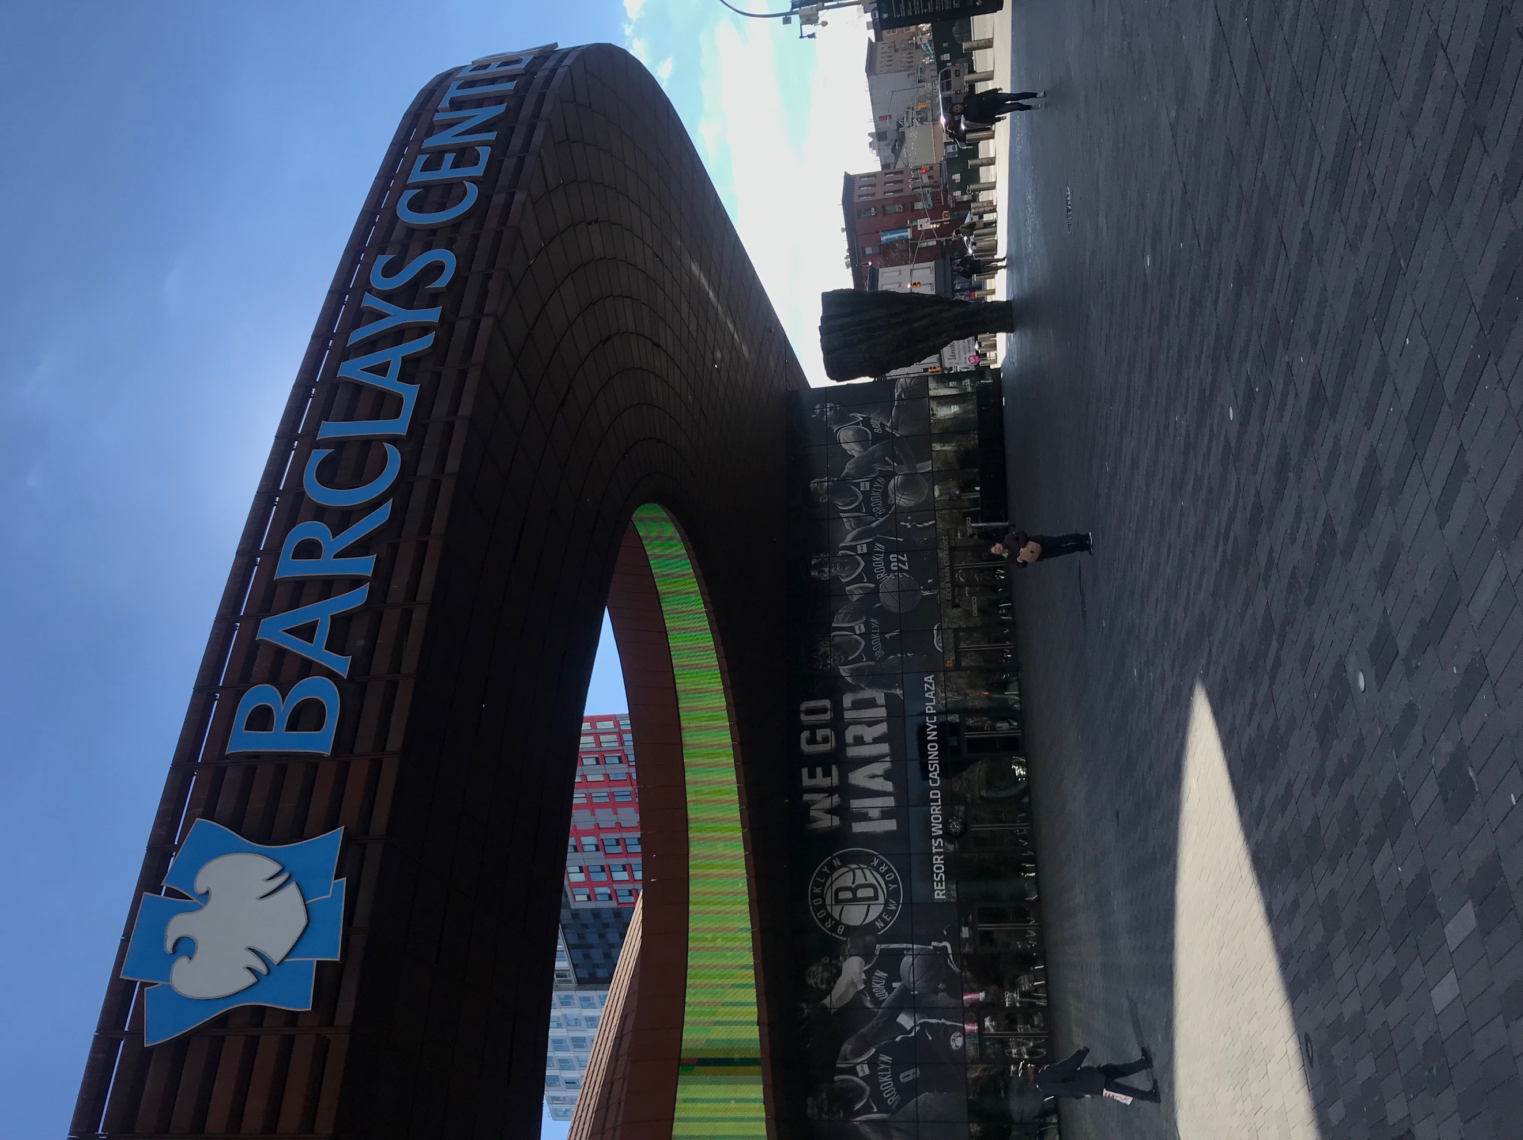

Saturday

10) 7 a.m. Columbus Park

An early morning in the park with breakfast and a book can help start your day off on the right foot. Sitting in the park watching the farmers market vendors set up their tables awaiting to see what goods they have for sale. Getting fresh food is often challenging for New York City residents. Being able to purchase fresh goods such as meats, vegetables, fruits and many more is quite special.

Lodging

Budget hotels are scarce in Downtown Brooklyn, so staying at a more budget friendly hotel is the way to go. The New York Marriot at the Brooklyn Bridge offers plenty of amenities that will help make your stay very comfortable. Located on 333 Adams St, Brooklyn, NY 11201, this hotel is located walking distance from Borough Hall and Jay St. train stations. Starting at $198 a night this four-star hotel will give you the comfort you need.

References

Brody, J. E. (2018, December 03). The Secret to Good Health May Be a Walk in the Park. Retrieved from https://www.nytimes.com/2018/12/03/well/move/the-secret-to-good-health-may-be-a-walk-in-the-park.html

Brooklyn Bridge Park. (2018). Pier 2. [online] Available at: https://www.brooklynbridgepark.org/park/pier-2.

Unclelouiegee.com. (2018). Brooklyn: 741 Union Street, Brooklyn, NY 11215 | Uncle Louie G. [online] Available at: http://unclelouiegee.com/locations/1511/brooklyn-741-union-street-brooklyn-ny-11215/.

