36 Hours in Manhattan Below 59th Street
By Neil Tsentner December 1, 2016
The City of Dreams or the Rotten Apple?

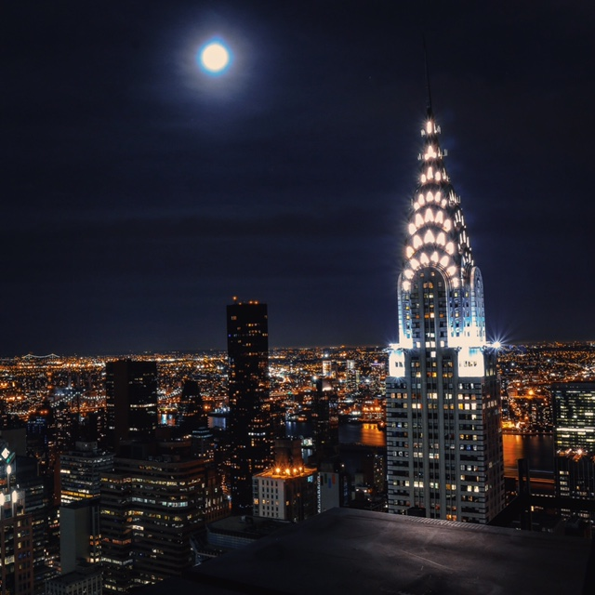

If you are searching for a place where nobody respects street signs Manhattan might be right place for you. The city is filled with every culture you can ever imagine and all the dirty water hotdogs you can eat. $3 if you have a New York accent and $5 if the vendor suspects any sign that you are a tourist, can get you a hot dog with ketchup, mustard and sautéed onions. The so-called “City of Opportunities” the “Rotten Apple” or “The City of Dreams” is what its known by. Filled with gentrifying neighborhoods and ridiculously expensive rent, New York can have a lot to offer. If you are looking for the center of the world, well you found it, don’t stay for too long, it can be a lot to handle.

Friday 2:00 PM
First impressions of the city might seem like too much at first glance. New York is a busy loud city with clashes of cultures and varieties of different food and you can smell it in the air. Whether its walking through the street and smelling honey roasted peanut street vendors that are standing by their carts in any weather or passing by cafes and smelling fresh brewed coffee New York is very robust in its culinary cuisines and nightlife. The American Museum of Natural History located on Central park west and 79th Street in the upper side of Manhattan is one of those things that should be on that little list you made on your smartphone to visit. Learn about Dinosaurs in the largest natural history museum in the world. The museum takes up 4 city blocks and has something for all ages to enjoy. Who wouldn’t want to see fossils of dinosaurs that walked our planet 230 and 65 million years ago? No, you cannot take one of these bones home and give it your little Pomeranian Skippy, but you can admire the life sized complete skeletons of these beasts.

Friday 4:00 PM
Grab a bite to eat at 4 ½ star restaurant Landmarc on 10 Columbus circle on the 3rd floor. This French and Italian Bistro is nothing less than amazing. With its rustic modern ambiance, this bistro has something for everyone in the family. Enjoy their crispy calamari with cherry peppers and saffron aioli or certified black angus herb-marinated skirt steak with French fries and field greens that would make you forget you were even vegan.

Friday 6:00 PM
If you are looking for a place to get away from the crazy taxi drivers and rude pedestrians, Central Park is the place you would probably like to visit. Rent a Citi bike for $2.50 for the first 30 minutes and additional $6.50 for the next additional 30 minutes and $9 for every 30 minutes after that or you can walk. You might even get lucky and see a free reincarnation of Shakespeare by the local actors. The park also has a zoo, which is 6.5 acres, which holds some rare animals including the Red Panda, Poison dart frogs and California Sea Lions. There are also paddleboats you can rent and enjoy sights of ducks and swans that like to eat bread thrown by people that think its good for these animals to consume. (Bread is not good for birds). This would cost you $12 for the first hour and $3 each additional 15 minutes so it isn’t too pricey.

Friday 8:00 PM
If you enjoy comedy and would like to have a chance at seeing famous comedians from SNL (Saturday Night Live) or see rude improv New York City humor, the UCB Theatre is calling your name, located on 307 West 26th street. With its gritty outside appearance, this little hole in the wall has $5 to $10 shows and a guaranteed laugh; just don’t be intimidated when you see the huge bald bouncer with a shiny head. After the show grab a bite to eat from a local Halal stand. A regular plate with rice and chicken or lamb with white sauce, BBQ sauce and hot sauce would usually cost you about $5 to $6. They also have gyros if you don’t want a rice plate. If you do not eat meat or simply don’t want chicken or lamb the stands usually have falafel, a chick pea ball with Mediterranean spices that is deep fried and is commonly found in Middle Eastern cuisine and are usually eaten with pita bread but also available in rice platters.

Saturday 12:00 PM
Manhattans China town is like being China but in New York if that makes any sense. Walk the streets of China Town and feel like you are in Bangkok. With the mix of foul odors from the fish markets and the varieties of Asian restaurants cooking, Chinatown is a real treat in the city. It is very easy to find a cheap and good bite to eat around this part of Manhattan. If you are looking for Xiao Long Bao also know as soup dumplings you can visit the famous Joe Shanghai’s on 9 Pell Street. The restaurant is nothing fancy and is just a few tables and few Asian decorations hanging on the walls. What comes out of the kitchen is the real show stopper. These little gifts from G-D come to the table in hot bamboo steamers and are dumplings filled with a meatball or seafood with a pouch of tasty broth. They have two different versions of the soup dumplings at Joes and it’s pork or crab. Joes also offers other varieties of authentic Szechuan dishes like braised pork shoulders and spicy Szechuan beef. Craving something sweet to cool off you taste buds? Go to Chinatown Ice Cream Factory on 65 Boyard Street. Their ice cream flavors are not the usual ones you find at your local ice cream parlor. The people over at the China Town Ice Cream Factory have been making ice cream for over 30 years and they do a good job at it. They carry many flavors like your typical Rocky Road and Strawberry but they also carry flavors such as Durian, Lychee and Taro. Occasionally they have the Special appearance flavors, which include Maple Bacon, NYC Cupcake, Caramel Bacon Swirl, Rainbow Cookie and Red Velvet. The ice cream is priced between $3.99- $7.75 and it is worth every penny.

Saturday 2:00 PM
After indulging all those calories it is always beneficial to have a nice walk. The Brooklyn Bridge, which is a few small blocks from China Town, is a great place to go visit if in the area. With its rope like cables, this bridge is one of the oldest bridges. Built in 1883 this bridge is a staple to New York City’s skyline. While walking across the bridge make sure to walk in the right lane because you don’t want to piss off the wrong cyclist and get told off. There is a nice view of the Freedom tower on one side of the bridge, along with a view of the Empire State building and Manhattan Bridge on the other side.
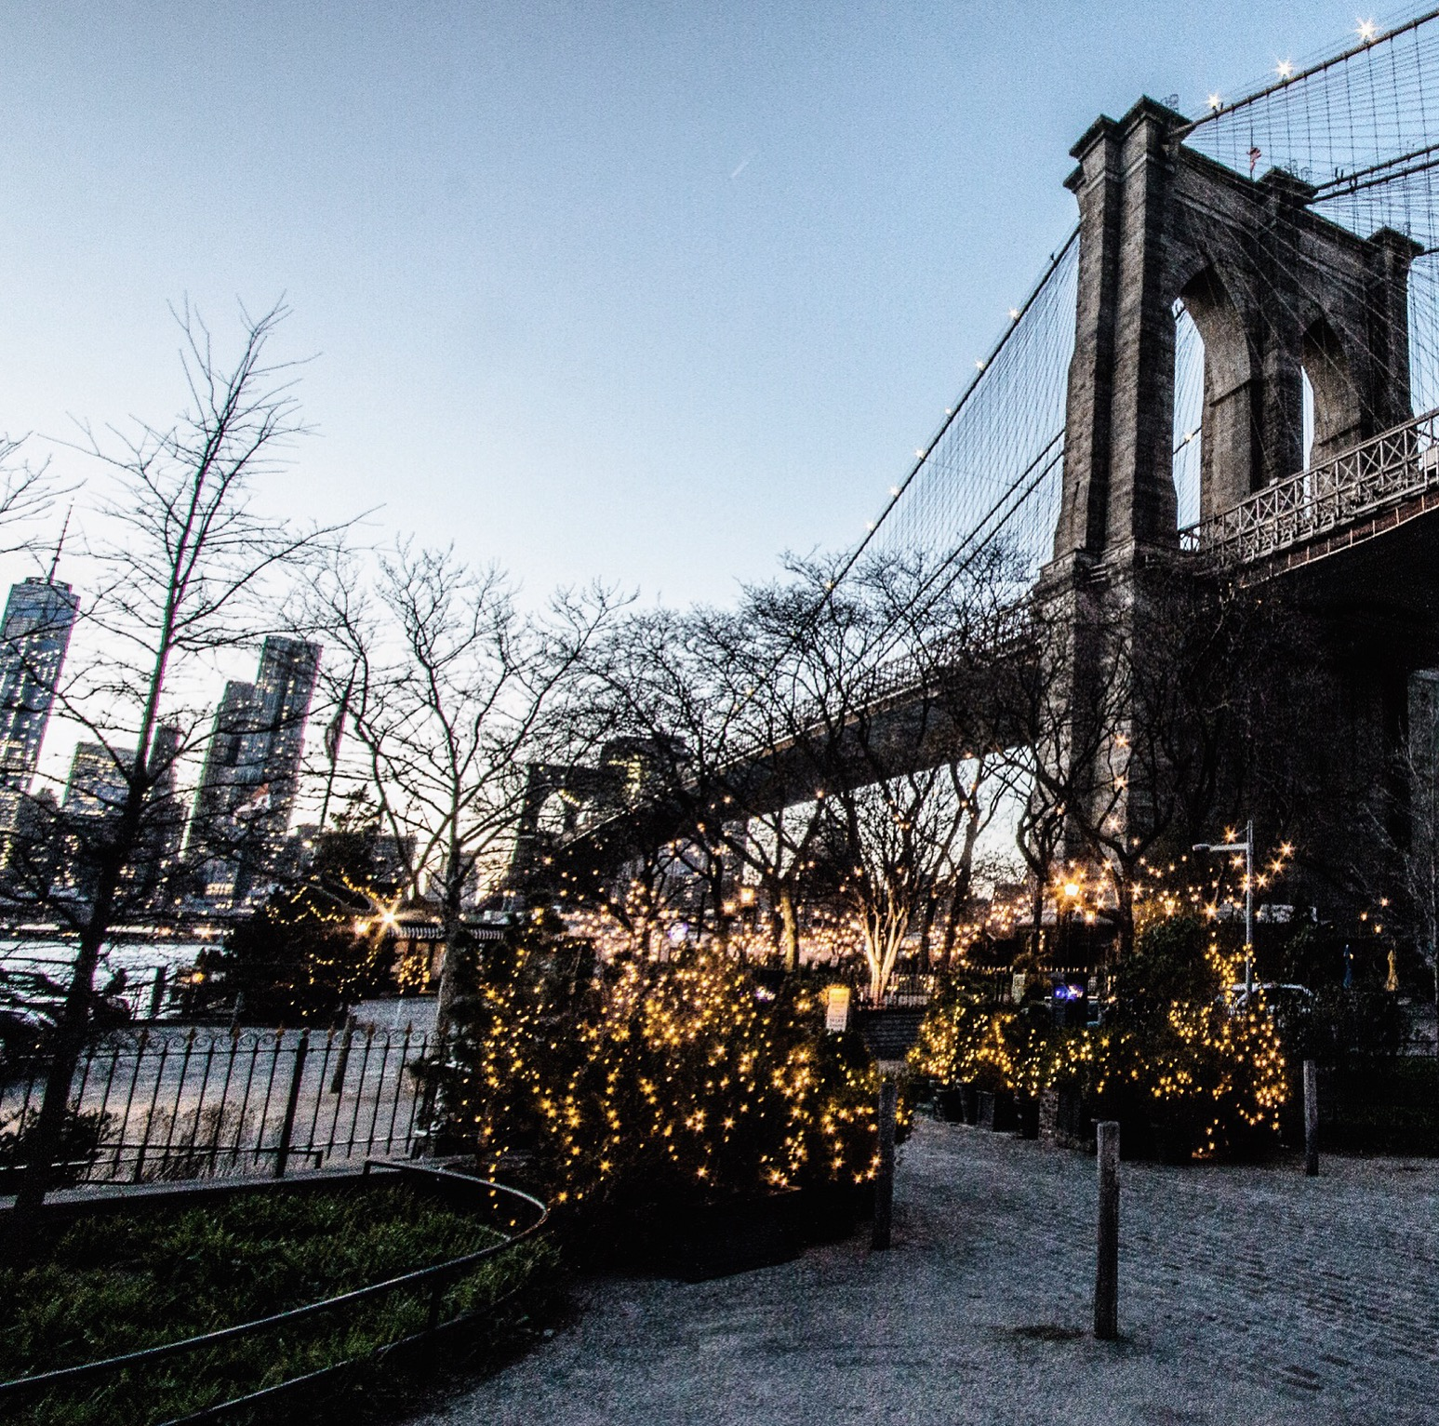View of the Brooklyn Bridge
Neil Tsentner for The New York Times
Saturday 3:00 pm
If you enjoy watching the waves clash against the docks then the South Street Seaport is the place to visit located on 199 Water Street. Visiting in the colder seasons might including bundling up because it wont be a pleasant experience if you are not dressed appropriately because it does get pretty chilly by the water. The South Street Seaport has varieties of excursions including shopping, different tours on land and on water as well as dining.

Saturday 4:00 PM
While at the South Street Seaport, Bodies The Exhibition is a must. Located in the South Seaport Pier 17 this small yet intriguing exhibit is entertaining yet educational for people of all ages. Who wouldn’t want to see a skinless body and to really see what we look like under our skin? With over 200 bodies on display this place is a bit creepy but awesome at the same time.

Saturday 5:30 PM
As many have heard, New York had a major tragedy happen on September 11, 2001. This catastrophe had the city in despair and opened up an unsealing wound to many New Yorkers along with the numerous families it touched in this disaster. In memory of the casualties in 9/11 there is a beautiful memorial located in the same spot the World Trade Center stood. There are over 3000 names of men, women and children that were killed in 9/11 and February 26, 1993, displaying the names inscribed in the memorial. Located on 180 Greenwich Street. There are two memorial pools in the North and South for both of the twin towers.
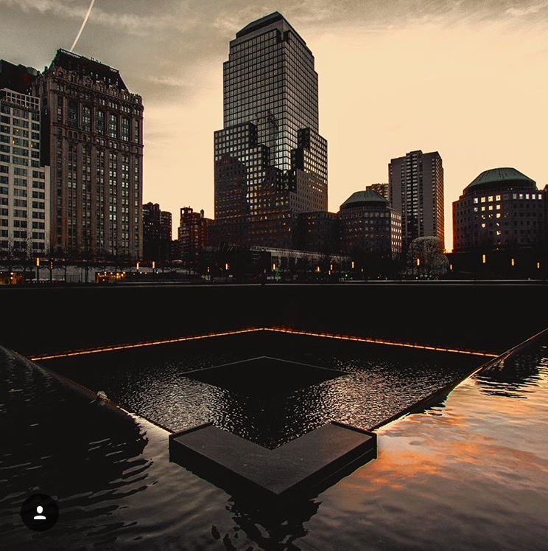
9/11 Memorial pool
Neil Tsentner for The New York Times
Saturday 6:30 PM
If you are looking for a scrumptious sit-down to grab bite, Pier A Harbor House is a place where you wouldn’t leave hungry. With its huge portion plates Pier A Harbor house will always give you a nice bang for your buck. With delicious appetizers that include varieties of fresh imported and local oysters, calamari with seaweed, wasabi mayo, garlic shrimp with white wine, housemade chorizo, preserved lemon and sourdough are always a good choice. There is always a baby field green salad that will still make your taste buds dance if meat or seafood isn’t your thing. The main course dishes are big enough to almost feed two people even if you are a big eater. The staff is very friendly and will cater to your every need. With its very laidback ambiance and calming views of the Hudson River, Pier A Harbor house will make sure you will not leave on an empty stomach. With their variety of main course’s known as “Large plates”, Pier A Harbor House offers different seafood dishes along with their Long Hall Burger which is hand pressed with caramelized onions and smoked gouda that comes with a obnoxious amount of fries.

Saturday 9:00 PM
What is visiting New York if you don’t go to a Broadway show? The Book a ticket online and make sure to look for the best deal because some of these shows will put a nice dent in your pocket. Go back to the wise guy era with a new musical on the life story of Sonny played by Nick Cordero in the Broadway show A Bronx Tale. If gangsters aren’t your cup of tea there is always a Broadway classic The Phantom of the Opera. Based on a horror story from 1910 by Gaston Lerox, this show will keep you at the edge of your seat. The Phantom of The Opera is based on a composer that haunts the grand Paris Opera House. There is a reason why this show is the longest show on Broadway simply because it is that good.

Lodging
Manhattan is a place where it’s a waste of time if you spend too much of it in a hotel. There is a lot to see and not enough time to see everything in one stay so it might take a few visits. Within New York City’s 5 boroughs, Manhattan is the busiest and most populated. Besides the city’s crazy commotion, staying at a luxury hotel can really make your stay much more enjoyable. There are many hotels to pick from when trying to decide and sometimes it is ok to spoil yourself. The Plaza Hotel is a great choice when choosing where to stay in New York City. Located on 5th Avenue at 59th Street it is one of the most famous 5- star hotels and it is the definition of going over the top with its elegance and class. It is located across from Central Park and stands over 5Th Avenue. Besides its popularity and well-known service worldwide, The Plaza Hotel is a National Historic Landmark. This luxurious stay will cost you $676 a night.
When looking for a bit less lavish stay and not wanting to put a big dent in your pockets the Crowne Plaza Times Square is a good choice. With great views of the city and just being minutes away from Rockefeller Center and Radio city Music Hall you can enjoy most of the Amenities of a luxury hotel for a fraction of the price. The Crowne Plaza offers an onsite New York Sports club with pool and sauna along with Breakfast lunch and dinner available from the Brasserie. This stay would cost you $128 a night.

http://www.amnh.org/
http://landmarc-restaurant.com/
https://ucbtheatre.com/
http://www.joeshanghairestaurants.com/chinatownstore_eng.html
http://www.chinatownicecreamfactory.com/
https://tfc.com/journal/nyc-kids/bodiesthe-exhibit-downtown-new-york-south-seaport-pier-17
https://www.911memorial.org/
http://www.broadway.com/shows/tickets/?category=broadway&gclid=CjwKEAiAvZTCBRDvnoOaoa2j3xISJABxPjN9L3grQq7RgsP4ZP1CA-Etajk0LaMwe_7gAMCWuk3BARoCLa3w_wcB

