36 Hours below 59 Street
By:BaoYu

In talking about New York City and exploring the diversity culture, you will fall in love with this city. There are so much things that one can see, one can eat, and one can spend more than a day in this city. Also, this city is a food “heaven” and best place for sightseeing.
Manhattan is crowded, busy and full of energy. It’s also a very diverse area. What can one do in Manhattan? You can do tons of things here, such as shopping, go to Movie Theater, go sightseeing and so much more.

Friday
1. 8:00a.m (Coffee Shop)
Walk into a busy street, go into a coffee shop to get a cup of coffee and bagel with cheese to start your new day. Once you finish eating, you will be full of energy and start to walk around the area.

2. 10:00 a.m. (Museum of Chinese in America)
One might be curious about the immigration experience and the history about the influence of Chinese immigrants on the U.S from the 1780s to today. If you are under 12, it’s free to walk in to take a look, but if you are an adult, you need to pay $10.

3. 12:00 P.M. (Triangle Building)
Have you ever seen the building with a triangular shape? If not, it’s ok. I’m going to bring you into a unique place that can get your attention, which is called the “Fuller Building”. This building was designed by Chicago architect Daniel Burnham and built in 1902. It has a long history and one of the most unusual looking steel-framed skyscrapers at that time.
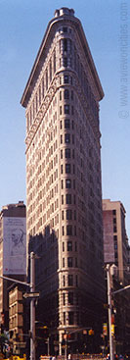

4. 3:00 P.M. (Movie Threat at Unique Square)
You might feel tired after you walk for too long. You can go into a place to rest, at the same time, you can have entertainment with your friends or family members. You can go to the snack area to get a big cup of coke or other juice, it cost like $3, with a free refill. And get a pack of fresh popcorn for $5, you can stay in the movie theater for the whole afternoon.

5. 7:00 P.M. (Republican- Thai Food restaurant)
Are you hungry now? Yes or no, maybe so! Republic is located at
Union square, the quality food served fast and for a reasonable price. They also have a bar for people to entertain you. I recommend you to order PAD THAI for ($16), or you can try sautéed curried chicken for ($14). At night time, you need to wait for a long time because the lines are long, especially on the weekend. It’s better to make a reservation before you go there.
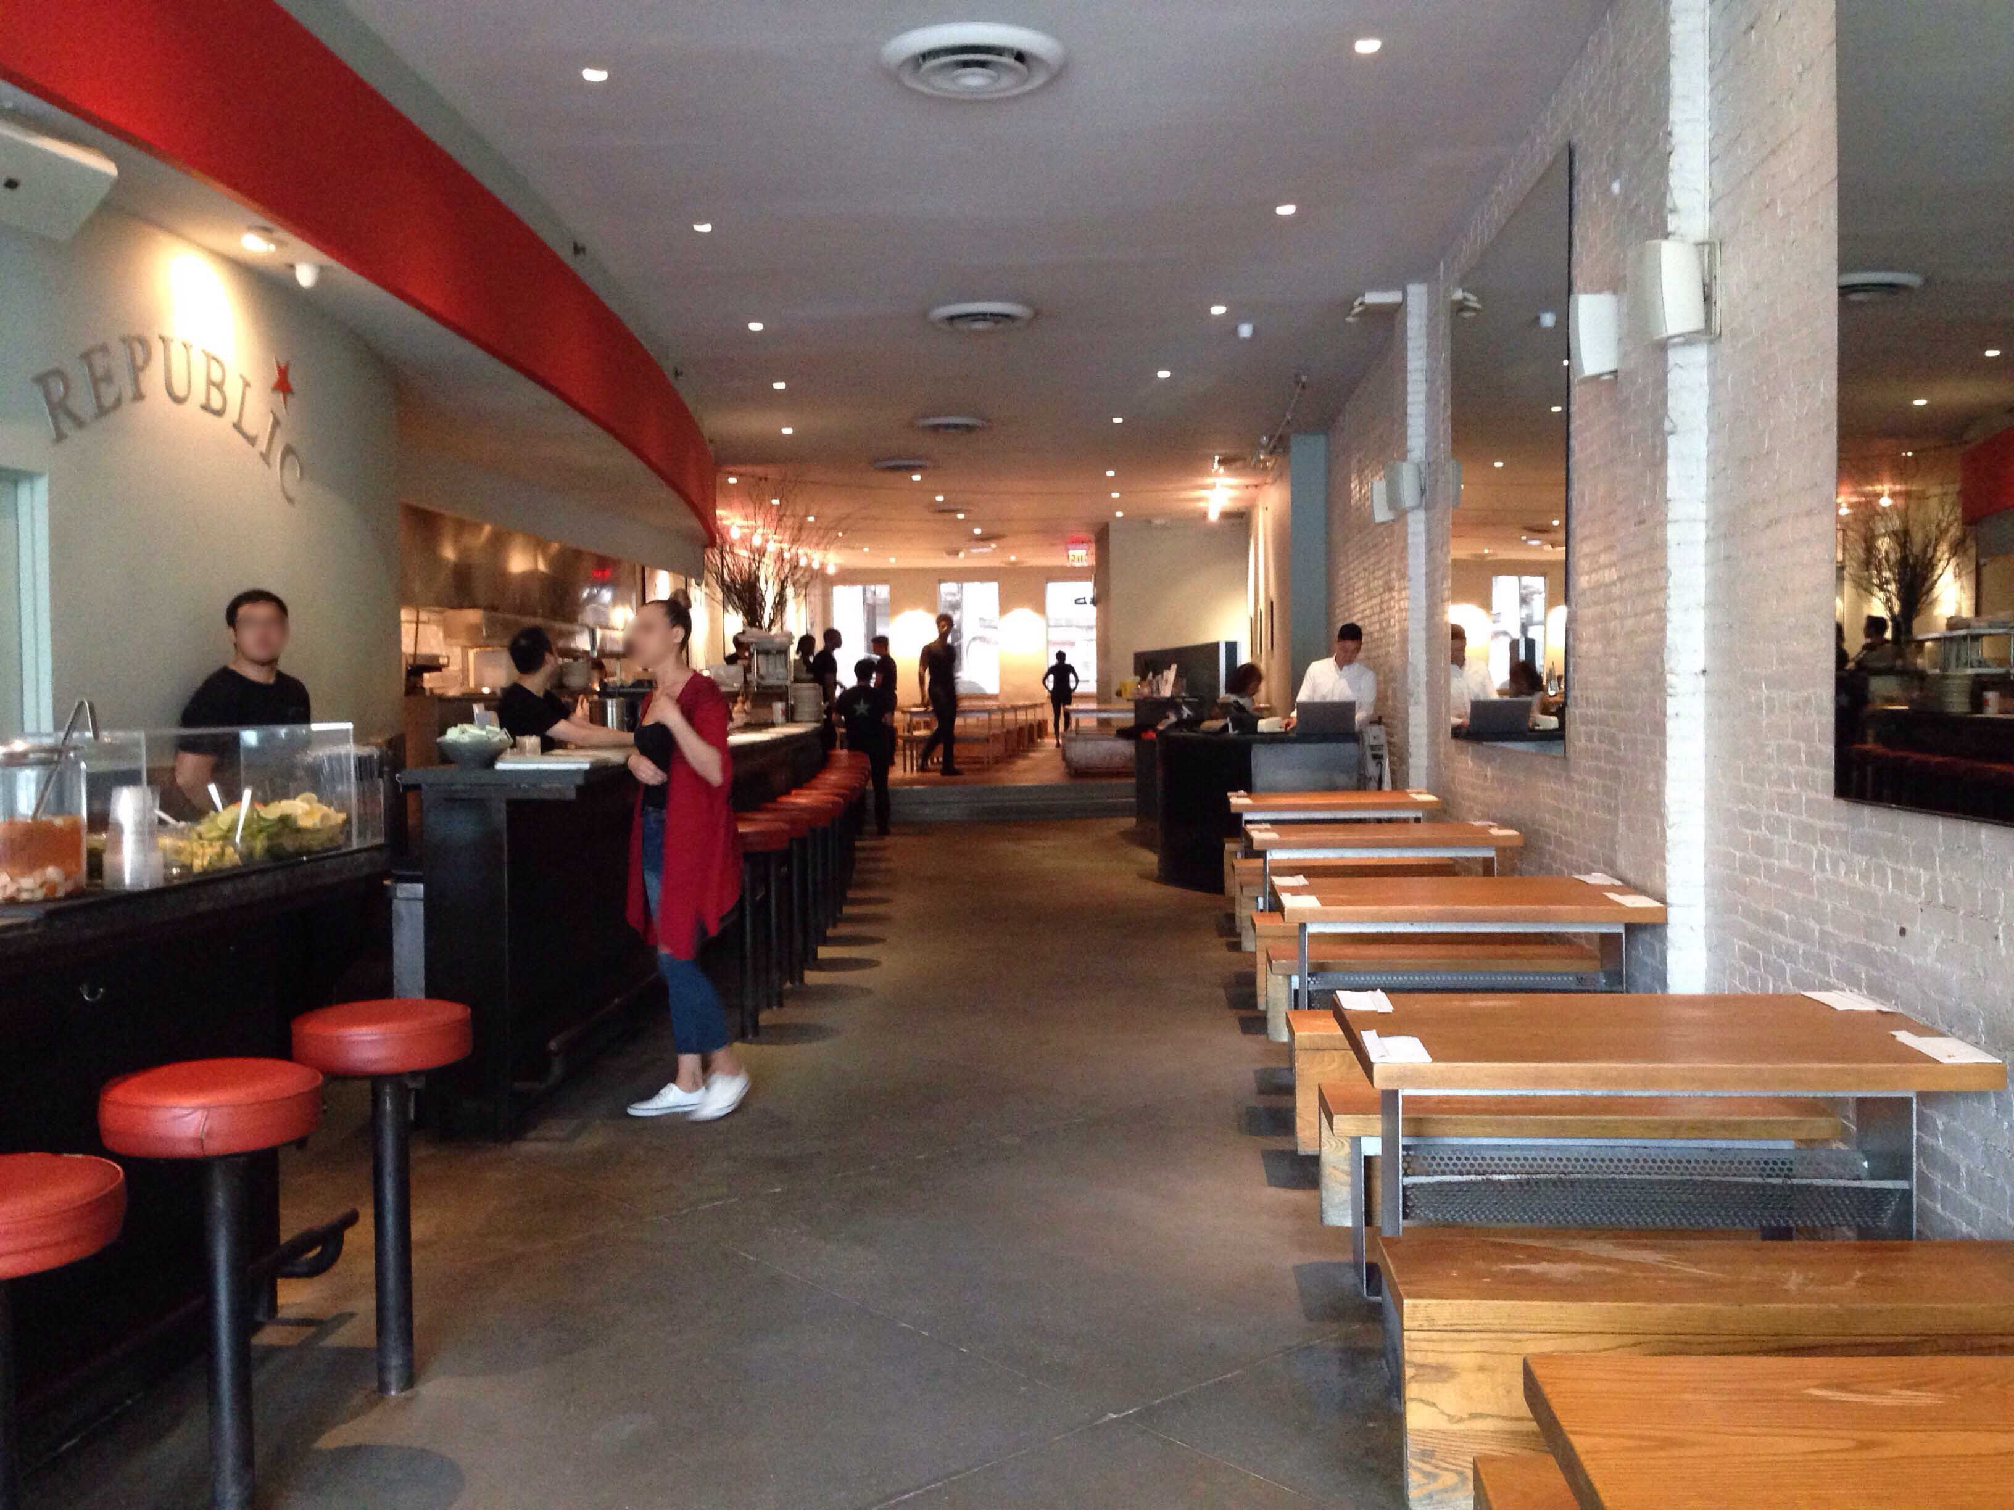

Saturday
6. 9A.M. (Empire State Building)
Empire State Building is the most famous and tallest building in NY. This building's construction was completed in 1931. Nowadays, there are a lot of travelers who come to visit and go to the top of the building to get a view of the whole city, which is an amazing. Also, when you go up to the top of the building, everything you see below looks so tiny once you look down. This building has 102 floors, I don’t think you can go up to the top part, but you can go as high as the 86th floor, which is not bad, at least you can enjoy the view from the top, but it's not at the highest point. It will give you a different viewpoint of the city. What are the standard pass to enjoy the 360 degree views from the 86th floor observatory, you might ask. An adult price is $34, child price is $27, and senior price is $31. Go check it out and enjoy your day there!

7. 1:00 P.M. (Time Square)
Time Square is a “shopping Heaven”, everyone likes to come here to shop. All the brand comes together, people can spend a day here if only to shop! Many people come here for the ambiance and the billboard spectacle. You can see yourself in the billboard, it’s a funny thing to do. More than that, there are a lot of restaurants around this area. You can eat a variety of food out there, it can make your day so meaningful.

8. 6:00 P.M. (World Trade Center)
World Trade Center is the most significant place in the city and a building is dedicated to international trade. It’s the time for you to explore this brand new building. You can shop and eat in the building. You can take buses or subway to get there, it is so convenience to get here by taking those modes of transportation.
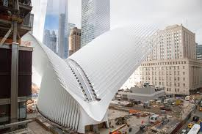

9. 10:00 P.M (K-Town)
K-Town? Why people named it that? The reason is because all the Korean restaurants get together in this one place. At night time, we should find something fun to do, let’s go to Karaoke, the name of the place is called “GAGOPA” and located at 32nd street. You can sing and drink all night, yeah! The room rate is $32 per hour plus tax.
10. 9:A.M. (Charging Bull)
Charging Bull located at Bowling Green Park, in the Financial District in Manhattan, New York. It was designed by Arturo Di Modica, a lot of tourist will stop by and take a picture here. The charging Bull is 7,100-pound sculpture, stands 11 feet tall and measure 16 feet long. You can touch it and feel it. It’s better to visit in the morning time, not as crowded as it is in the afternoon time.
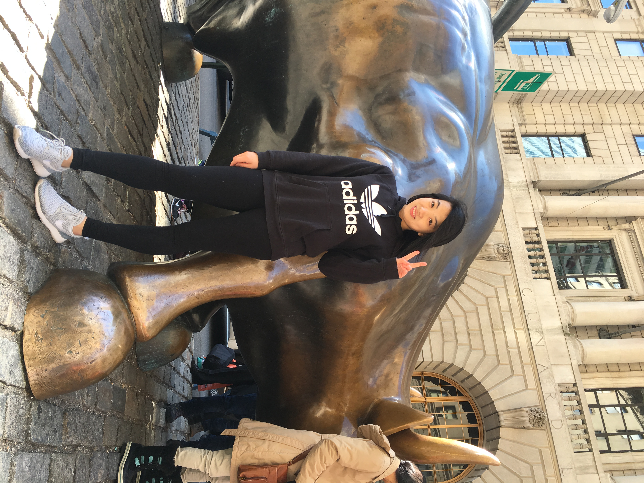

Lodging:
Not too big, not too small, not too expensive hotel. Where can you look for that? It’s located at Grand Street in the lower east side. The hotel is called “Best Western Bowery Hanbee Hotel”, it is so convenient to take transportation and shopping is everywhere. It cost $125 per night plus taxes.
But you might want to go to a little bit more pricy and fancy hotel, it located at Midtown Manhattan, this hotel is pretty close to Times Square and is only a 5-mintue walk from the United Nations Plaza. This hotel is called “Hilton Manhattan East Hotel”. It cost $295 per night plus tax.

Reference:

-Empire State Building
@EmpireStateBldg - https://www.esbnyc.com/

-Times Square, New York City – Visitor Information
@nycgo - http://www.nycgo.com/attractions/times-square

-Home || World Trade Center
https://www.wtc.com/

