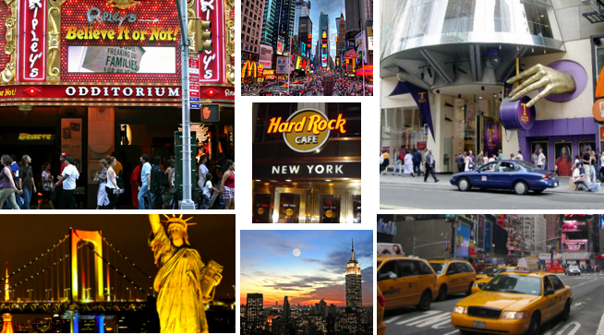
New York City is the most populus city of the united states of America. it is commonly called 'the city that never sleeps', and the residents of this metropolis are known as New Yorkers. The city prides itself of the historical and one and only Statue of Liberty. It boasts also on their main attractions such as the empire state building, central park, bryant park, rockefeller center, grand central terminal, union square, and much more. ‘New York exerts a great impact on finance, media, art, fashion, research, technology, education, and entertainment.’ This great city creates an area of advernture, ,movement, exhileraiton, and also madness into your heart that will impact you forever.
12AM- 6AM W Hotel
Stay in the marvelous suite 1200 a night
This includes 2 rooms a bathroom and an outside view with a porch. The beds are really comfy and there is great customer service. There is a restaurant and store at the hotel. The hotel is located at 541 Lexington Avenue (49 Street) nearby many attractions such as times square, central park, Rockefeller center, Bryant park, grand central terminal, and shopping on 5th Avenue.
8 AM Doughnuts
Many a man, nay many an American, loves the doughnut. Also one of those dishes that no one really knew who brought it over to America, but it was America that has made it awesome. This round, deep fried, delicious goodies can be sold from any Dunkin Donuts, but there are different flavors depending on which country one is from so trying it from its homeland can give a person a feel for what the doughnut really taste like. And if Dunkin Donut’s is too overrated there are other small yet popular doughnut shops such as Doughnut Plant (379 Grand Street New York, NY 10002)
Located right in the middle of Times Square, Ripley's Believe It or Not "Odditorium" is a place filled with unbelievable attractions and where fact is stranger then fiction. You will come across more than twenty gallery's of weird rare treasures from around the world, and remarkable relics. Ripley's Believe It or Not has a vast array of authentic shrunken heads to a authentic collection of Olympic flames, each exhibit is weirder than the next.This "Odditorium is located at 234 W 42st. The phone is 212-398-3133, tickets range from 32.61 for adults and 24.99 for children.
12PM Hamburger
One of the dishes up there with hot dog that no one can really tell who was the first to make but it was definitely in America that hamburgers became what they are today. One of the places with the most amazing burgers is the Corner Bistro (31 West 4th Street New York, NY 10014) mentioned in the comedy show How I Met Your Mother, a fantastic little burger joint with the most amazing burgers.
The world-renowned Madame Tussauds is one of the most attending, interactive and exciting attractions for visitors of all ages. Play ball with Derek Jeter and David Wright, make Jennifer Lopez blush, hang out with Madonna and Leonardo DiCaprio in the VIP Room. Travel through time with celebrities from the 1920s to today's in Popular Culture. The environment is filled with an exceptional showcase of incredibly life-like wax figures who are entertainment, music, sports, politics and world history. It's an entertaining and educational experience unlike any other. Madame Tussaud's wax museum is located at 234 W 42st, phone number is 866-841-3505. Tickets starting from 39.19 for adults and 31.57 for children.
3 PM Asian Style fit for kings
In the morning where everyone is tired and need a cup of coffee, there is no place like a packed Chinese restaurant with loud talking Asians to jolt you right up. Drinking tea is like breathing for Asians as they do it very, very often with close friends, relatives, and/or coworkers. Dim sum is served non-stop till the afternoon depending on the restaurant. There are many such restaurants located in Chinatown of Manhattan, Flushing, and Sunset Park that can give decent Cantonese styled Chinese food.
5 PM Ellen's stardust diner is wonderful place to go before and after your night out on town. Coming in for some breakfast late in the night and want to continue that fun that you just had? Well Ellen's Stardust diner has a thing that makes it different from every other diner. They sing to you while you wait for your food. Ellen's Stardust diner is a cool little retro diner brings back the 50's back into style. They are located on 16-15 broadway at 51st, the phone number is 212-956-5151
11PM Dinner
Dining in New York can be the most fun one can do with their close friends because there are so many varieties of food coming from so many different countries and they are all just here in New York. There is Chinese, Thai, Vietnamese, Indian, European, French, Italian, and many, many more. Some of the many places people can go to is the Union Square Café (21 East 16th Street New York, NY 10003) for dinner or also on Union Square, Max Brenner (841 Broadway New York, NY 10003).

