Humoyun Mahmudov

CDMG 1111 - Digital Media Foundation

Professor Thelma Bauer

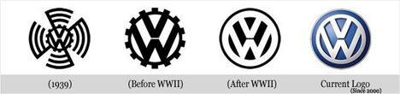

**VOLKSWAGEN**

Volkswagen is a German car manufacturer headquartered in Wolfsburg,Germany. Established in 1937, Volkswagen is now the second-largest auto maker in the world, behind Toyota. Volkswagen means “people’s car” in German and its current international slogan is “Das Auto”, meaning “The Car”.

The Volkswagen logo was originally designed in 1938 and modified in 1996 and 2000, when color blends and implied three-dimensionality were brought in. There is some controversy regarding the origin of its design. Some people say that the mark was created by [Franz Xaver Reimspeiss](http://classiccars.about.com/od/classiccarsaz/a/volkswagen.htm), a Porsche employee. Another theory states that [Martin Freyer](http://www.rosenthalusa.com/1288d858/FREYER_Martin.htm) created it and consequently won a design competition. The Volkswagen logo is one of the most memorable logos ever designed.

Logo contains two letters, a V over a W, which seem to interact beautifully with each other. The blue color in the Volkswagen logo represents excellence and class, while the white color depicts purity and charm.

**Notes:**

<https://en.wikipedia.org/wiki/Volkswagen>

<http://www.famouslogos.us/volkswagen-logo/>