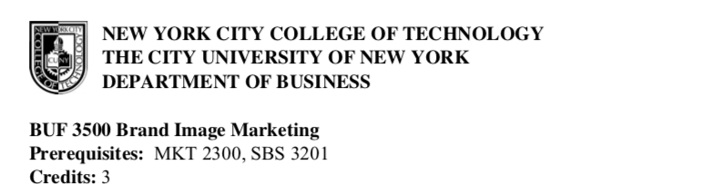**BUF 3500 Brand Image Marketing Prerequisites: MKT 2300, SBS 3201 Credits: 3**

**INSTRUCTOR: Professor Jackson**

**Office Hours: By Scheduled Appointment Only**

**E-mail:** [djackson@citytech.cuny.edu](mailto:djackson@citytech.cuny.edu)

**Meeting Date/ Time: Room: Namm N -804, Th 2:30PM-5:00PM**

**COURSE DESCRIPTION:**

Investigates how to build, measure, and manage a brand. An exploration of visual literacy by considering the symbols and imagery used in formulating fashion brands and line identity. Explores the theoretical and practical use of images as a form of visual communication intended to convey specific messages about brand identity. This course is an attempt to discover how ideas about identity are made, why some brand identities are more clearly understood than others, and how this ultimately affects consumer choice.

**LEARNING OUTCOMES:**

Upon successful Completion of this course, students will be able to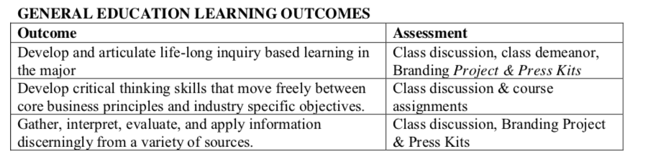

**RECOMMENDED TEXTBOOK:**

**Fashion Branding Unraveled: 1st Edition**, Hameid, 9781563678745, Fairchild/Bloomsbury

**ASSESSMENT AND GRADING:**

Grading and add/drop policies are in accordance with University policies. Students need to submit assignments on or before the due date.

Grades are assigned based on total points earned in the course. The total number of points a student earns is divided by the total number of possible points. The total possible points are 600. Two hundred points can be earned through examinations and 100 points through quizzes. A student’s score is converted into a percentage and grade will be assigned using the scale listed below.

**Grading Criteria**

|  |  |
| --- | --- |
| Participation | 100 points |
| 5 Quizzes (10 each) | 50 points |
| Homework assignments | 50 points |
| Term Project/Presentations | 150 points |
| Midterm Exam | 75 points |
| Final Exam | 75 points |
| **TOTAL**    **Process for Evaluation:** | **500 points** |
| Outstanding (A) | work went beyond the package and presentation requirements. |
| Good (B) | work met all grading criteria, performed to top standards. |
| Average (C) | work met all but one or two of the grading criteria. |
| Below Average (D)    **Grade Scale** | work met only one or two of the grading criteria. |
| A = | 93 – 100 |
| A- = | 90 – 92.9 |
| B+ = | 87 – 89.9 |
| B = | 83 – 86.9 |
| B- **=** | 80 – 82.9 |
| C+ **=** | 77 – 79.9 |
| C **=** | 70 – 76.9 |
| D **=** | 60 – 69.9 |
| F **=** | 59.9 and below |

**COURSE POLICIES AND PROCEDURES:**

PARTICIPATION: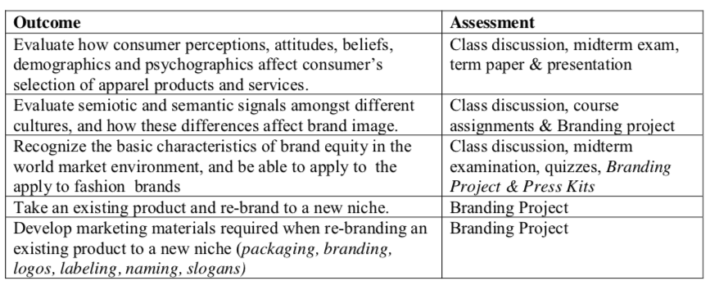

Your success in this class depends on your willingness to put effort into your work. You are expected to participate in all large and small group activities, exercises and discussions. Participation will help you understand the subject matter and will be considered when determining your final grade. **Participation is 20% of your final grade**. Coming to class is NOT participation.

Participation involves:

* **Active Learning**. Taking notes, asking questions and taking responsibility for your own learning.
* **Working with others in group activities**: A chain is only as strong as its weakest link. Don’t drag your team down by refusing to get involved.
* **Attending class regularly**. If you aren’t here, you can’t learn.

ELECTRONIC DEVICES:  
Accordingly, this class will adhere to the following “Digital Device Policy” prohibiting the use of such devices during all in class meetings:

* + Many people in our society have not yet learned professional, considerate, behavior regarding electronic devices.
  + Turn off all cellular telephones, beepers, wrist watch alarms, etc. before you enter class.
  + If your electronic device audibly activates during class, you will be deducted 5 points   
    from your final grade.
  + If you are expecting a life and death announcement from an immediate family member—   
    brother/sister/parent/spouse/child — please notify me before class of that situation.

GUIDELINES FOR WRITTEN ASSIGNMENTS:  
All papers MUST be typed. A page is the equivalent of a 2.0 line-spaced 8.5 x 11-inch paper with one-inch margins using 12- point type in black ink in Times New Roman font. Follow the page length guidelines for each assignment and number each page. All work MUST contain the student name(s), the course name and number, the date the assignment is submitted, and the name of the assignment. Please plan accordingly for all your assignment due dates.

Effective writing helps clarify ideas and communicate those ideas to others. Be organized, clear, and succinct. Grammar, punctuation, style, and spelling count. Write in college-level American English that is appropriate to the business community.

Papers will be graded on the following criteria:

* Clear and thorough application of direct and database marketing concepts and principles (including material covered in the assigned reading, lectures, and discussions).
* Demonstration of original, logical, strategic thinking including a complete analysis of facts, logical synthesis, and persuasive conclusion/recommendation. Specific examples should support the analysis. Address the specific requirements of the assignment.
* Quality of research (depth, breadth, appropriateness) and proper acknowledgement of references, including complete citations using APA style in-text notes, when appropriate.
* Appropriate language and tone, accurate spelling, correct grammar, appropriate punctuation, and logical organization. You will not receive an A if your writing is awkward, contains grammatical or punctuation errors, or is disorganized.

EMERGENCIES  
In a case of an emergency, you may submit your assignment the following class day. For once a week courses you may e-mail your assignment to me prior the start of the class to get full credit. Documentation on Professional Letterhead of the emergency will be expected. Coming late to class does not constitute an emergency.

**COLLEGE POLICIES (ACADEMIC INTEGRITY, ADA, RESOURCES):**   
See standard policy document

|  |  |  |
| --- | --- | --- |
| **WEEK** | **TOPIC** | page4image29384960.png page4image2878960.png  **ASSIGNMENT**  page4image29384960.png page4image29384960.png |
| 1  1/31/2019 | Understanding the Brand | * Introduction * Syllabus Overview * Branding In 2018 Case Study |
| 2  2/7/2019 | Brand Positioning and Values Choosing Brand Elements to Build Brand Equity | * Chapter 1:The Brand   Key terminology and ideas   * “Brand” and the characteristics of the brand * Explore ways to evaluate the brand * Demonstrate the value and importance of the brand for the company and the customer * Identify different brand types |
| 3  2/14/2019 | Designing Marketing Programs to Build Brand Equity  Integrating Marketing Communications to Build Brand Equity | * Chapter 2: The Brand Decision and Positioning   Key terminology and ideas   * Examine effective options and Channels for communicating the brand * VIP Model * Communication Channels * Understand and identify different branding growth strategies * Identify the difference among brand repositioning, relaunch and revitalization |
| 4  2/21/2019 | Leveraging Secondary Brand Knowledge to Build Brand Equity  Case: Nike - Building a Global Brand | * Chapter 3: The Branding Process   Key terminology and ideas   * Revisiting the Four P’s * Examine effective options and Channels for communicating the brand * VIP Model * Understand and identify different branding growth strategies * Identify the difference among brand repositioning, relaunch and revitalization * Brand Identity   Quiz #1 - Chapters 1 & 2 |
| 5  2/28/2019 | Developing Brand Equity Measurement and Management System  Measuring Sources of Brand Equity Case: Yahoo - Managing an Internet Brand | page4image29384960.png page4image29384960.pngChapter 4: Luxury Fashion Brands  Key terminology and ideas   * Defining Luxury Brands * The Elements of Heritage and Craftsmanship * Christian Dior case study * The Social Element of Luxury Brands * The Product Mix * Brand Identity * Positioning Strategy |
| 6  3/7/2019 | Measuring Outcomes of Brand Equity In class case: Snapple - Revitalizing a Brand | page4image29384960.png page4image29384960.pngChapter 4: Luxury Fashion Brands  Key terminology and ideas   * Defining Luxury Brands * The Elements of Heritage and Craftsmanship * Christian Dior case study * The Social Element of Luxury Brands * The Product Mix * Brand Identity * Positioning Strategy * Luxury Brand Communication   Quiz # 2- Chapters 3 & 4 |
| 7  3/14/2019 | MIDTERM EXAM | MIDTERM EXAM |
| 8  3/21/2019 | Design and Implementing Branding Strategies In class case: Nivea - Managing a Brand Hierarchy | page4image29384960.png page4image29384960.pngChapter 5: Mass Marketing Fashion Brands  Key terminology and ideas   * Mass-Market vs. Luxury Brands * Premium Brands: The New Luxury or New Luxe * Private Labels |
| 9  3/28/2019  page4image2878960.png page4image29384960.png | Introducing and Naming New Products and Brand Extensions | page4image29384960.png page4image29384960.pngChapter 6: Retail Brands  Key terminology and ideas   * Product vs. Service * The Retails Brand Decision * The Retail Consumer * The Retail Concept   Retails Case Study |

**SCHEDULE OF TOPICS:**

|  |  |  |
| --- | --- | --- |
| 10  4/4/2019 | Managing Brands Over Time | page4image29384960.pngChapter 7: iBrand: The Age of Interactive Wireless, and Virtual Brands  Key terminology and ideas   * The Interactive Brand: Mass Customization * The Wireless Brand * Wireless Technology and the Fashion Branding Process |
| 11  4/11/2019 | Managing Brands Over Time | Chapter 7: iBrand: The Age of Interactive Wireless, and Virtual Brands  Key terminology and ideas   * The Virtual Brand * The World of Social Networking * Virtual Environments and the Fashion Branding Process   Quiz # 3- Chapters 5, 6 and 7 |
| 12  4/18/2019 | Managing Brands Over Geographical Boundaries and Market Segments | page4image29384960.pngChapter 8:Redesigning the Brand  Key terminology and ideas   * The Impact on New Technologies and the Modes * Culture and Technology * Customer and Technology * Microbrands * Experiential Branding * Positioning * Image * The Relationship Redefined |
| 13  5/2/2019 | Group Presentations on Branding | To Be Discussed |
| 14  5/9/2019 | Group Presentations on Branding | To Be Discussed |
| 15  5/9/2019 | FINAL REVIEW | FINAL EXAM REVIEW |
| 16  5/16/2019 | FINAL EXAM | FINAL EXAM |

**BIBLIOGRAPHY:**

Benbow-Pfalzgraf and Richard Martin, eds. Contemporary Fashion. 2nd Ed. Detroit: St. James Press, 2002.

Gigi Ekstrom, Margaret. Fashion Marketing. New York: McGraw Hill/Glencoe, 2006.

Goworek, Helen. Careers in Fashion and Textiles. Ames, IA: Blackwell Pub., 2006.

Mauro, Lucia and Kathy Siebel. Careers for Fashion Plates & Other Trendsetters. Blacklick, OH: McGraw Hill, 2002.