HISTORY / BIO

ALEXANDER WANG

is creative director of the eponymous label he launched in 2005, aged 21. Wang’s foray into fashion began after he dropped out of the Parsons School of Design in 2004 to start his own label. Brand initially began with creating a knitwear collection based on six unisex silhouettes. After Wang debuted his first runway collection for Autumn/Winter 2007 at New York Fashion Week, response was immediate.  In 2008, Wang received the top award from the Vogue/CFDA Fashion Fund, a sum of $200,000. In 2009, he was announced as the winner of the Swarovski Womenswear Designer of the Year, and as the winner of the Swiss Textiles Award.

He also held the post of creative director at Balenciaga from 2012 to 2015.

ALEXANDER WANG

INVITES YOU TO

A

ONE-TIME-ONLY

SPECIAL NIGHT

#WANGFEST

SATURDAY, SEPTEMBER 14, 2019

9PM

90 SCOTT AVENUE

BROOKLYN, NY 11237

FOR UPDATES EMAIL

HALUHI@ALEXSANDERWANG.COM

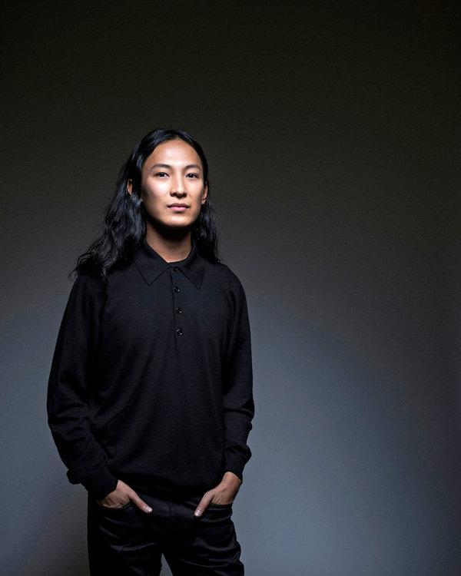

Designer/ Founder Alexander Wang

Look

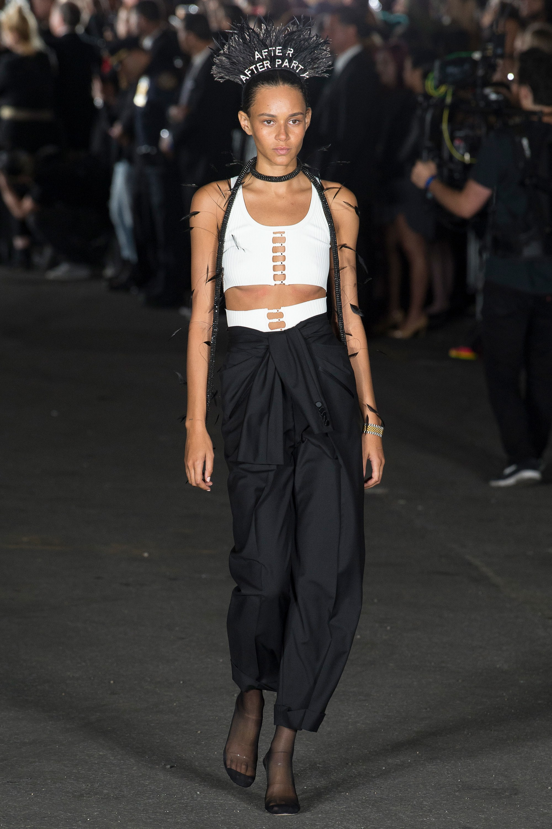

Spring /Summer 2018 Ready-To-Wear

Look