National Aeronautics and Space Administration (NASA) second shuttle orbiter Challenger disintegrated 73 seconds after liftoff, bringing a devastating end to the space craft’s 10th mission. Investigation by the Rodger Commission presided shortly after the disaster. President Ronald Reagan designated a special commission to depict what went wrong with Challenger and to develop future corrective analysis. The commission included former astronaut Neil Armstrong, former test pilot Chuck Yeager and renowned scientist Richard Feynman. Brought forward by the commission was a company called Morton Thiokol, who were subcontractors by NASA that designed and built the solid rocket boosters. Their ingenious design was to build the rocket boosters into sections allowing the rockets to be delivered by trains in a safe and cost effective manner. Furthermore, brought forward by the commission was Roger Boisijoly, who held various titles during his employment for Morton Thiokol such as Mechanical Engineer, Fluid Dynamicist and Aerodynamics. His main duty was to analyze and document the integrity of the boosters for any malfunctions on each of Challenger’s previous nine missions. He finally confessed to the commission that during his previous inspection of the aftermath of the 9th shuttle launch, he had noticed that the two O-rings that are designed to seal the gases within the chambers of the rocket boosters showed signs of disintegration.
In figure 1, by design and function, O-rings play a crucial role in constructing the rocket boosters. They are utilized to seal, preventing hot gasses from escaping the rocket chamber’s joints and most importantly be able to expand/contract during the whole journey of the space shuttle. Rocket boosters are attached to the space shuttle, and the gross weight of the rocket chamber seals the sects of the rocket boosters thus prohibiting the O-rings from sealing the gaps. When the engine fires, joint gaps from the rocket boosters expand and the resiliency of the O-rings expands also to fill in the gaps.

Figure1: Anatomy of o-ring
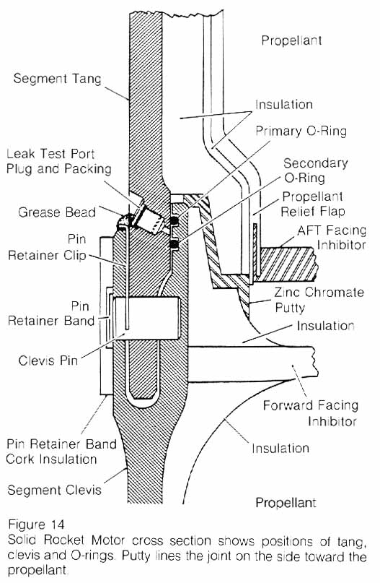
O-rings are extremely sensitive to cold temperatures. Renowned scientist Richard Feynman demonstrated this during the commission meeting by clamping an O-ring and submerging the clamped O-ring into a pitcher of ice water. The O-ring became very brittle and lost its element of being resilient. Mr. Boisijoly, was in charge of assessing the O-rings and analyzing the limitation of the O-rings when exposed to cold temperatures. His data concluded that the O-rings will malfunction if exposed to temperatures below 53 °F (12 °C). The temperature on the day of the launch was drastically below the cutoff point based on Mr. Boisijoly’s data at 28 to 29 °F (−2.2 to −1.7 °C). He raised his concerns to both his management and NASA that the space shuttle is deemed unsafe for liftoff. Unfortunately, his concerns were ignored. Morton Thiokol was in progress of having their contract renewed by NASA. Any setbacks revealed would have halted the mission progress and jobs and billions of dollars would have been at stake.
Shuttle Orbiter Challenger is one of humanities ultimate engineering marvels. In a synchronized motion, Challenger is a summation of over 2.5 million parts working in harmony that encompasses this ingenious design. Quantitative analysis comes to life in engineering; certainly if Mr.Boisijoly’s managers/ NASA strictly adhered to his quantitative data, the shuttle/crewmembers could have been spared. What I have learned from exploring this ethical disaster is that in engineering, there is always some degree of possible malfunction. If less focus were to be placed on financial aspects with more emphasis on safety, probabilities of disaster can be better reduced to predictability.

