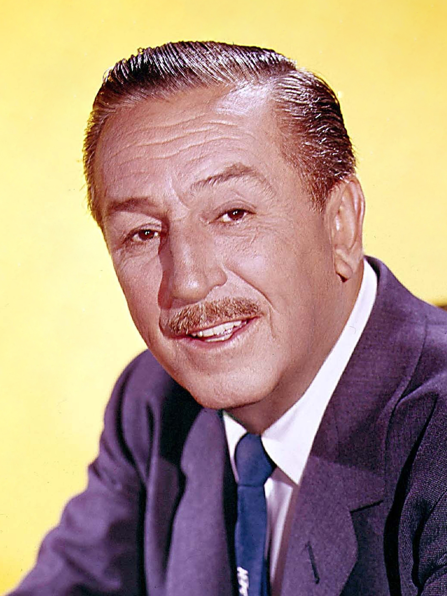
Walter Elias Disney was born on December 5th ,1901, in Chicago Illinois. Walt Disney was the fourth child of Elias Disney, a peripatetic carpenter, agriculturist, and building temporary worker, and his spouse, Vegetation Call, who had been an open school educator. When Walt was small more than a newborn child, the family moved to a cultivate close Marceline, Missouri, an ordinary little Midwestern town, which is said to have outfitted the motivation and demonstrate for the Most Road, U.S.A., of Disneyland. Walt soon developed an early interest for drawing and experienced coloring with pencils and watercolors.
His father became anxious and soon deserted his endeavors at cultivating and moved the family to Kansas City, Missouri, where he bought a morning daily paper course and compelled his youthful children to help him in conveying papers. Walt then said that numerous of the propensities and compulsions of his grown-up life stemmed from the disciplines and inconveniences of making a difference his father with the paper course. In Kansas City the youthful Walt started to ponder cartooning with a correspondence school and afterward took classes at the Kansas City Craftsmanship Founded and School of Plan.
In 1917 Walt Disney and his family moved back to Chicago, and Walt attended McKinley Tall School, where he took photos, made drawings for the school paper, and considered cartooning on the side, for he was confident of in the long run accomplishing a work as a daily paper cartoonist. But his progress soon became interrupted when American entered into the first World War. Walt dropped out of school and attempted to enroll within the armed force. He was rejected for being underage, but he was later able to connect within the Ruddy Cross and in late 1918 was sent to France to drive a rescue vehicle.
In 1919, he returned back to Kansas City where he worked many jobs, before finding employment in his area of greatest interest – the film industry. It was working for the Kansas City Film Ad company that he gained the opportunity to begin working in the relatively new field of animation. Walt used his talent as a cartoonist to start his first work.
Around this time, Disney started testing with a camera, doing hand-drawn movement. He chosen to open his possess activity trade. From the advertisement company, he enrolled Fred Harman as his to begin with employee. Disney and Harman made a bargain with a nearby Kansas City theater to screen their cartoons, which they called Laugh-O-Grams. The cartoons were tremendously well known, and Disney was able to obtain his possess studio, upon which he offered the same name. Laugh-O-Gram enlisted a number of representatives, counting Iwerks and Harman's brother Hugh. They did an arrangement of seven-minute pixie stories that combined both live activity and activity, which they called Alice in Cartoonland. By 1923, the studio had ended up burdened with obligation, and Disney became bankrupted.
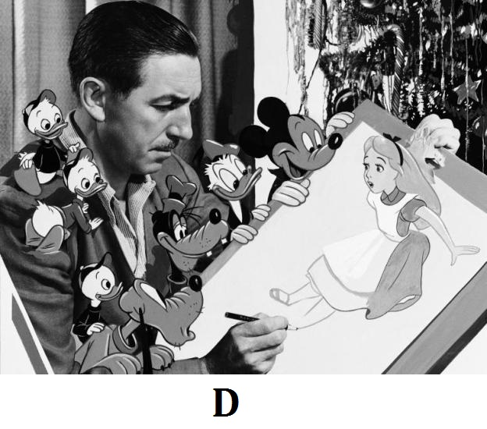
Walt Disney and his brother Roy later moved to Hollywood with cartoonist Ub Iwerks in 1923, and there the three started the Disney Brothers' Cartoon Studio. The company later on changed its name to Walt Disney. Walt was able to create and produce two lucky shorts called Alice, and Oswald the Lucky Rabbit. Both creations were successful but sadly Walt Disney failed to protect the copyright to his own creation and lost the contract to them. In the late 1920s he later came up with a cartoon called Steamboat Willie that featured a character he created named, Mickey Mouse, and friends.
One of Disney’s most popular cartoons, Flowers and Trees was the first to be produced in color and to win an Oscar. In 1933, The Three Little Pigs and its title song "Who's Afraid of the Big Bad Wolf?" became a theme for the country in the midst of the Great Depression. Disney produced more than 100 films. His first animated movie that he ever made was “Snow White and the Seven Dwarfs” which premiered in Los Angeles on December 21, 1937. That movie won eight Oscars, and this led Disney to create more full-length animated movie’s over the next five years. In 1940 to the 1960s Walt Disney continued to create animated films, a few of his famous movies were, Pinocchio (1940), Fantasia (1940), Dumbo (1941), Bambi (1942), Cinderella (1950), Treasure Island (1950), Alice in Wonderland (1951), Peter Pan (1953), Lady and the Tramp (1955), Sleeping Beauty (1959), and 101 Dalmatians (1961). Disney was also among the first people to use television as an entertainment medium. A few of his popular shows The Zorro, Davy Crockett series and Mickey Mouse Club.
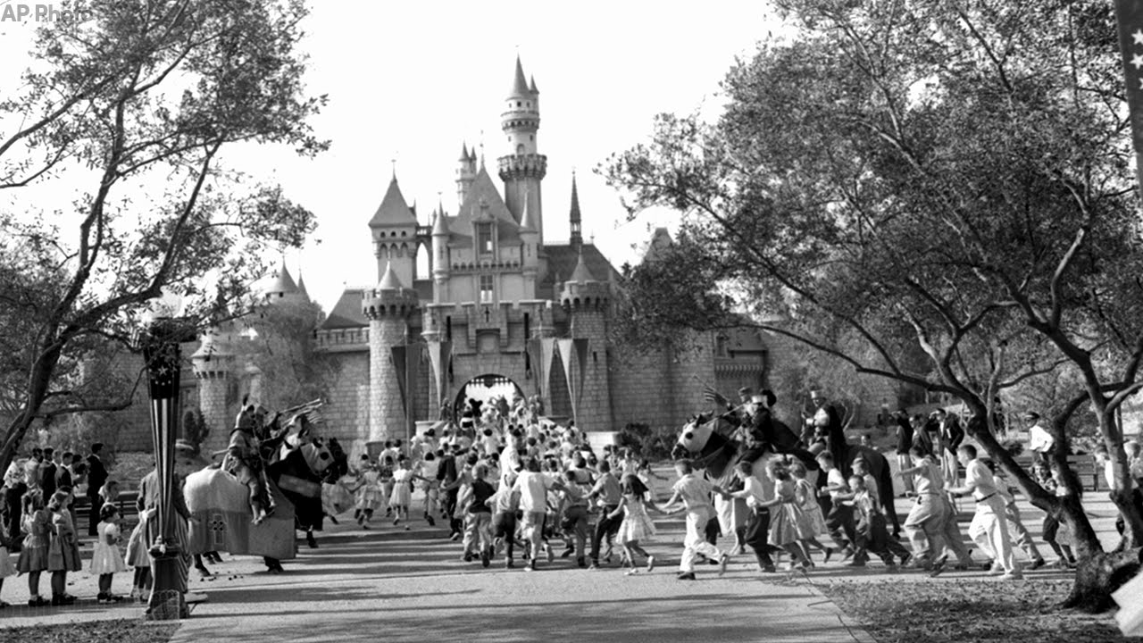
The Disneyland theme park opened on July 17, 1955, in Anaheim, California. Actor Ronald Reagan presided over the activities. This site became known as a place where children and their families could explore, enjoy rides and meet the Disney characters. Disneyland has expanded its rides over time and branched out globally with Walt Disney World near Orlando, Florida, and parks in Tokyo, Paris, Hong Kong and Shanghai. Sister property California Adventure opened in Los Angeles in 2001.
Inside a couple of long periods of Disneyland's 1955 opening, Disney started plans for another amusement park and to create Experimental Prototype Community of Tomorrow (EPCOT) in Florida. It was as yet under development when Disney kicked the bucket in 1966. After Disney's demise, his sibling Roy carried on the designs to complete the Florida amusement park, which opened in 1971 under the name Walt Disney World.
Disney was diagnosed with lung cancer in 1966 and died on December 15, 1966, at the age of 65. Disney was cremated, and his ashes interred at Forest Lawn Cemetery in Los Angeles, California.

https://www.biographyonline.net/artists/walt-disney.html
https://www.britannica.com/biography/Walt-Disney
https://en.wikipedia.org/wiki/Walt_Disney
https://historicmissourians.shsmo.org/historicmissourians/name/d/disney/
https://d23.com/about-walt-disney/

