MAT1372

Project #5
Due Date: Tuesday, April 8, 2014
Maximum points on this project: 12 points

Submit one EXCEL file: FirstName LastName-Project 5-MAT1372-Sp2014
Submit by the due date to: shan@citytech.cuny.edu

To get full credits for the project, you must:
- Turn in the project on time. One point will be deducted for “each day” (including weekends and holidays) that the project is late.
- State the goal (or the problem) of the project.
- State the process, including EXCEL commands used.
- State the results.

Playing the PLINKO game
The player drops a chip from any one of the 9 slots. The pegs send the chip bouncing all over the board until it lands in the slot representing the money amounts at the bottom.
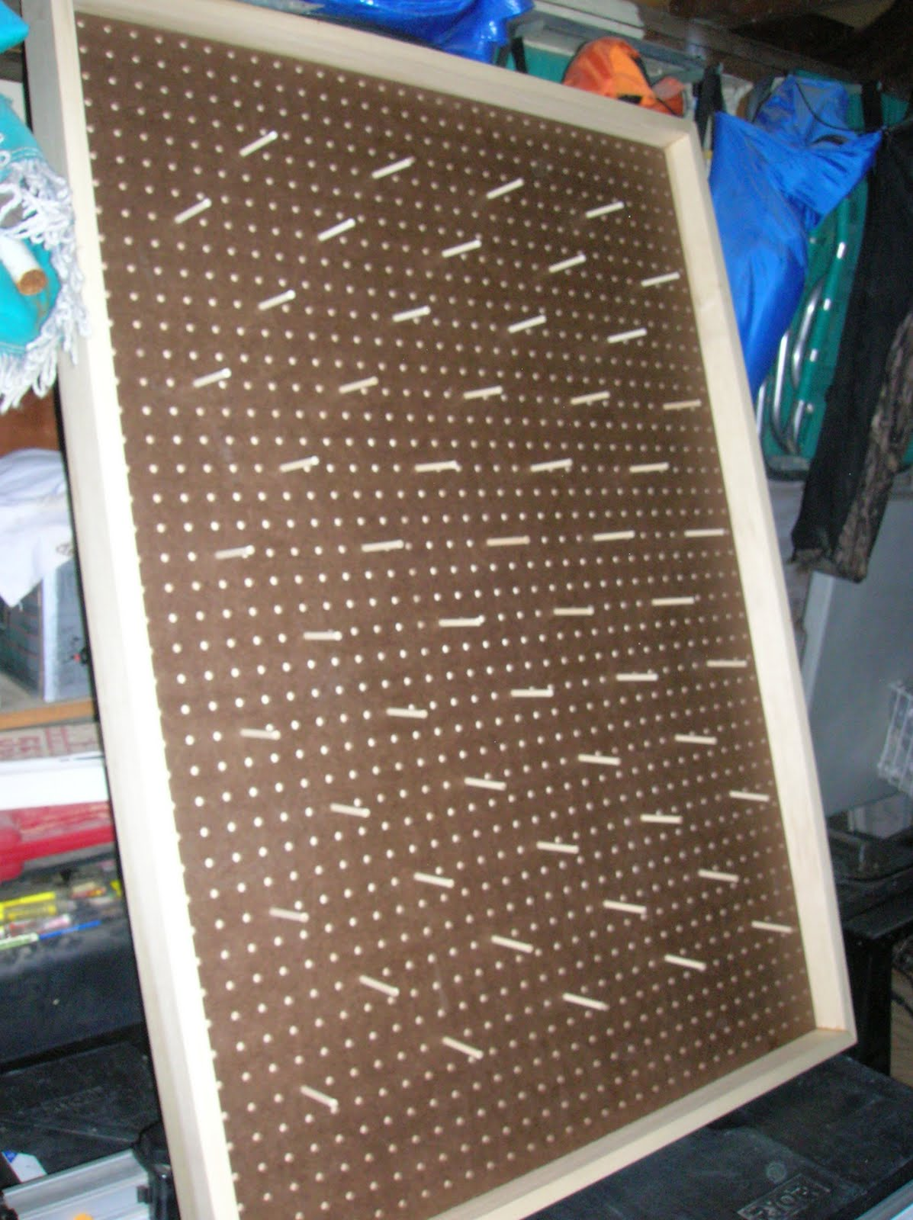
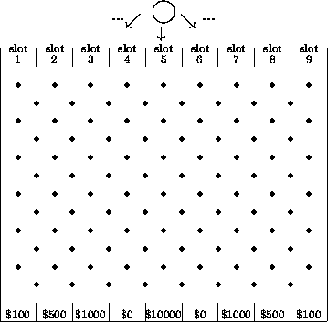

- Translate the Plinko board above into Excel spread sheet. For each cell, enter the correct conditional probability which involves the probabilities of the cells immediately preceding the current cell.

- Find the probabilities of each outcome when the chip is released from various slots. (See the table below)

- Find the expected winning of each slot where the chip is released. Show computations.

Probabilities that the chip will land on $100, $500, $1000, $0, $5000 when the chip is released from slot 1, slot 2, slot3, … slot 9:
 |  |  |  | Land on
From | $100 | $500 | $1,000 | $0 | $5,000 | $0 | $1,000 | $500 | $100
slot 1 | 0.226 | 0.387 | 0.242 | 0.107 | 0.032 | 0.006 | 0.000 | 0.000 | 0.000
slot 2 | 0.193 | 0.346 | 0.247 | 0.137 | 0.057 | 0.016 | 0.003 | 0.000 | 0.000
slot 3 | 0.121 | 0.247 | 0.242 | 0.196 | 0.121 | 0.054 | 0.016 | 0.003 | 0.000
slot 4 | 0.054 | 0.137 | 0.196 | 0.226 | 0.193 | 0.121 | 0.054 | 0.016 | 0.003
slot 5 | 0.016 | 0.057 | 0.121 | 0.193 | 0.226 | 0.193 | 0.121 | 0.057 | 0.016
slot 6 | 0.003 | 0.016 | 0.054 | 0.121 | 0.193 | 0.226 | 0.196 | 0.137 | 0.054
slot 7 | 0.000 | 0.003 | 0.016 | 0.054 | 0.121 | 0.196 | 0.242 | 0.247 | 0.121
slot 8 | 0.000 | 0.000 | 0.003 | 0.016 | 0.057 | 0.137 | 0.247 | 0.346 | 0.193
slot 9 | 0.000 | 0.000 | 0.000 | 0.006 | 0.032 | 0.107 | 0.242 | 0.387 | 0.226

