**THE NYC FASHION MARKETING GROUP**

Table of contents

I. Executive Summary. -----------------------------------------------------------------------Pages 3 - 4

II. Research Project Team -------------------------------------------------------------------Pages 5 – 9

III. Problem Discovery and Definition

a. Exploratory Research

1. Secondary Data Research Search ----------------------------------------- Pages 10 – 13  
 2. Experience Survey --------------------------------------------------------- Pages 14 – 18 b. Problem Definition -----------------------------------------------------------Page 19

1. Problem Statement ----------------------------------------------------------- Page 19  
 2. Research Objectives --------------------------------------------------------- Page 19  
 4. Hypotheses --------------------------------------------------------------------Page 20-21

5. Questionnaire Construction -------------------------------------------------Pages 20

IV. Planning the Research Design

1. Methodology ------------------------------------------------------------------------Page 22

V. Selection of Sample Design

a. Target population -------------------------------------------------------------------Page 23

VI. Collection of Data

1. Pre-test ------------------------------------------------------------------------------Page 24 – 26
2. Main study -------------------------------------------------------------------------Page 27 - 28

VII. Data Analysis

1. Editing ------------------------------------------------------------------------------Page 29
2. Coding ----------------------------------------------------------------------------- Page 30 - 31
3. Analysis --------------------------------------------------------------------------- Pages 31 - 39
4. Tables and figures --------------------------------------------------------------- Pages 40 – 47

VIII. Conclusions and Recommendations----------------------------------------------- Page 48

IX. Questionnaire ----------------------------------------------------------------------------- Page 48 – 59

Citation Sheet ---------------------------------------------------------------------------------------Page 60

**EXECUTIVE SUMMARY**

Sneakers: some may be comfortable, uncomfortable, colorful, uncolorful, good quality or on the other hand, some may be terrible quality. What would we do without sneakers? Footwear that protects our feet from the hard ground surface, or even prevents our feet from getting burned. Of course, you can wear other shoes in general to protect your feet, but we are speaking about sneakers, footwear that was designed for not only comfort but physical activities as well that are designed to wear as casual shoes. There are so many varieties of sneakers such as slip-on, athletic kicks, Plimsoll sneakers, Classic Canvas Converse Sneakers, high top basketball sneakers, and more. There are also multiple brands of sneakers. Some brands of sneakers are, but not only limited to, Nike, Adidas, Jordan's, Converse, Reebok, Puma, New balance and many more. The first sneakers that were released were a re-design of the Plimsoll which were called Keds in 1892. Sneakers became a massive fashion statement. They were also marketed as a meaning of personality as well as self-identity other than just simply athletic aids. Sneakers became super popular from the 1970s to 1998 to 2012 where the amount of sport shoe models grew rapidly throughout the United States. In our world today, these sneaker brands have competed with one another for the past years. There are also new brands that are opening to join a competition of which brand is better. This is determined by its quality, price, marketing, value, and more. However, the two most competitive brands have always been Adidas and Nike.

The NYC Fashion Marketing Industry Group has set out to determine, between

Nike and Adidas, which brand do New York consumers prefer or consider to be the

better brand. We are curious to find out how people choose and buy their sneakers and

what motivates them during their choices. We will also want to compare the answers

among the different age groups. We believe that it will be extremely interesting to see as

well as survey New Yorkers so that we will receive their full opinions and/ or get their point of view on which brand they would prefer to wear and why. We will ask each person the

same questions and compare the answers. We will also collect data to determine our findings at the end. This report will consist of multiple data from well-known sneaker companies which include Puma, Nike, Adidas, Converse, Jordan, Reebok, and more. The NYC Marketing Industry Group strongly believes that Nike, out of all of the shoe brands, attracts the attention of their customers’ more than all of the other competitors. The NYC Marketing Industry Group believes this mainly because of not only their trends and aesthetics but also because of their quality. Also because of their great technology and equipment to boost performances.

Team Profile and Responsibility



**Michael Vignoles**

Michael Vignoles is an aspiring business owner attending City College of Technology for his business and fashion major. Fresh out of High School he became a retail manager for various businesses. He hopes to use his experience as a manager to help him excel in the business world that is in front of him. Michael’s dream is to make an impact on the world with his restaurant while spreading a positive message by selling his shirts on the side!

Michael: Project Director



**Alicia Jeremiah**

Alicia Jeremiah is a transfer student who graduated with her Associates degree in fashion design. She transferred to city tech to pursue her bachelor's degree in Business and technology of Fashion. She is currently a Freelance fashion designer and a former Montessori toddler teacher. On the side, Alicia writes children’s fashion books that she hopes to get published soon. Her goal is to graduate, become a successful fashion designer/Entrepreneur/ Author/ Influencer owning multiple businesses in and out of the fashion industry. Her goal is also to travel all over the world, Vlog/ Blog and enjoy life.

Alicia: Statistical Writer.

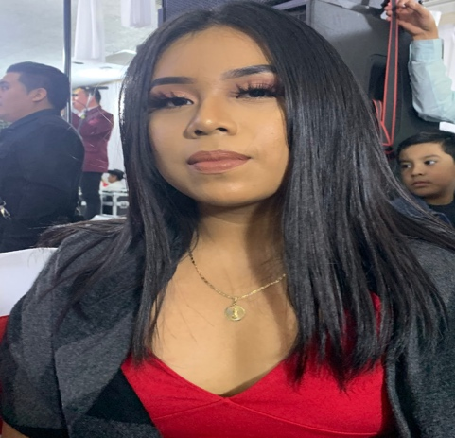

**Guadalupe Soriano**

Guadalupe but prefers to be called Lupe is a current student at New York City College of Technology majoring in Business & Technology of Fashion. Her goal is to succeed in her own cosmetic/ fashion line. A big part of her line is to enhance the Hispanic culture and its beauty. She currently creates her own ideas of clothing and cosmetic products to jump start her business, slowly but surely.

Guadalupe: Statistical Writer 

**Aminata Drame**

Aminata Drame is a student who is currently attending New York City College of Technology. Her major is Business and Technology of Fashion and she hopes to obtain her Associates degree by the end of May 2020. Aminata aspires to one day, own her own clothing and cosmetic line. Not only that, but she also aspires to create her own novel and make a name for herself in the future. She understands that her hard work will eventually pay off, which is why she lives by the following motto: “Everybody wants to be famous, but nobody wants to do the work. You grind hard, so you can play hard. At the end of the day, you put all the work in, and eventually it’ll pay off. It could be a year; it could be 30 years. Eventually, your hard work will pay off,” Kevin Hart.

Aminata: Research Analysis



**Iyoub Sahin**

Iyoub Sahin is a third-year student at The New York City College of Technology and is majoring in the Business & Technology of Fashion. Iyoub plans on graduating by May of 2020 and will further his education at either Parsons New School or FIT. Iyoub has a strong passion for skateboarding, music and art. Iyoub strives to make connections in the underground entertainment world and loves attending live music shows.

Iyoub: Research Analysis

**Secondary Data Summary (1/3):**

According to Forbes, Nike revenue is at $39 billion doubled the amount compared to Adidas at $26 billion. Nike is valued $13 billion more compared to Adidas. However, with Adidas putting more focus on marketing within recent years the annual average rate is 11.3%. While Nike has a 6.5% annual average rate. This means within the recent year Adidas has become more popular with consumers. A reason for an increase in customer purchase could have been Kanye Yeezy’s partnership with Adidas in 2015, with a prediction of $1.5 billion sales that year. However, Nike partnered with Michael Jordan in 1985, creating one of the most classic shoes in the market. On average, the Air Jordan shoes make $3 Billion in sales every year. The Nike Jordan shoes becoming a trend gave Nike an advantage in the shoe industry. Using this data, we can assume that Adidas has adapted and created an opportunity for the growing customer base and gaining the attention of the younger audience who now have the willingness to buy.

In conclusion, Nike is a more stable brand with a higher value, but Adidas has been growing steadily within recent years, due to proper marketing. Where the two brands excel within brand loyalty. Nike would not be Nike without Adidas. Just like how Kobe would not be Kobe without Lebron. Both brands create competition to push each other and create sides for consumers to choose from.

**Secondary Data Summary (Adidas** — 2/3**):**

When it comes to Beyoncé ’s IVY PARK collection, many people believe that this is her first time launching it. However, Beyoncé first launched her collection way back in 2016. At that time, she was in partnership with Topshop — a multinational British fashion retailer of clothing, make-up, shoes, and accessories which have around 500 shops worldwide as well as online operations. The name of the collection, IVY PARK, was of course inspired by her first child and daughter (Blue Ivy) and Parkwood Park that is located in Houston. This park is where Beyoncé used to go to exercise. Beyoncé eventually attained total ownership of the brand, by the end of 2018. She then announced her partnership with Adidas. The prices for her collections range from $25 to $250. The sizes also range from XS TO XL. According to the IVY PARK X Adidas press release, she stated that she partnered with Adidas because she wanted to design a collaboration that would be able to tell stories as well as combining fashion in the most extraordinary or “unprecedented” way. Beyoncé also stated that the IVY PARK collaboration promotes the values of not only inclusivity, but it promotes the values of community and diversity as well.

With Beyoncé ’s new collaboration with Adidas, launched on January 18, 2020, it is predicted that her IVY PARK Collection will be set to revitalize Adidas footwear when it comes to sales in particular. Before this collection, Adidas had already dealt with declines in sales. Thus, when Beyoncé joined the Adidas team as a creative partner, Adidas already knew that it would be a strong influencer marketing move for them. This was mainly because she had over 133 million followers at the time. After her announcement, Adidas shares immediately went up to approximately 1.5%. The company had a 76% growth in e-commerce as well. The increase was primarily compelled by improvements in direct-to-consumer revenue. Its main support came from e-commerce. As a result of this, revenues grew 36% to well over $2.24 billion. With all of this growth and all of the sales with this collection alone, analysts have said that IVY PARK could surpass Yeezy’s sales eventually.

**Secondary Data Summary (Nike** — 3/3**):**

With relevance to Nike, working with one individual helped the value go up by $26 billion. This individual is Colin Kaepernick. Colin Kaepernick was a quarterback for the National Football League’s, or NFL, San Francisco 49ers from 2011 to 2016. He even played in the 2013 Super Bowl XLVII for the San Francisco 49ers as well. However, Kaepernick, unfortunately, lost his job in 2016. This was due to taking a knee during the National Anthem which raised a lot of heads along with in the eyes and ears of people who were not even football fans. His decision to take a knee also turned to a huge debate on whether or not Kaepernick disrespected the country by his actions. He did this to protest racial injustice and racial inequality with police treatment in America, sparking the #TakeAKnee movement.

In 2018, that is when Nike signed with Colin Kaepernick even with all of the controversy (especially with President Donald Trump weighing in on it) and debate that was going on around him. In February of 2019, Nike released, online, a Kaepernick “Icon” jersey with his number on it, which was the number 7. The jersey sold out in a matter of weeks. It was priced at $150 when it was first released. However, the authentic version of the Nike jersey sells for more than $300. In September of 2019, Nike teamed up with Kaepernick again for the ad “Dream Crazy,” which featured both LeBron James as well as Serena Williams. Unfortunately, controversy soon followed with the hashtag #NikeBoycott. The company’s shares also fell once the “Dream Crazy” ad was dropped. Despite all of this, however, online sales quickly rose, and Nike continued to work with Kaepernick even with all of the controversy and debate. Nike’s collaboration with Kaepernick has helped Nike as well as the ad agency that created the

“Dream Crazy” ad win the Creative Arts Emmy for Outstanding Commercial in 2019. Nike has not won this category since 2002. The “Dream Crazy” commercial featured Kaepernick referring to all of the sacrifices that he made by instating the #TakeAKnee movement which again, has, unfortunately, cost him his professional football career. The main thing that stuck out in the ad was when he said that people should “believe in something even if it means sacrificing everything”. With Kaepernick endorsing Nike, the company value has skyrocketed according to Yahoo. Since the announcement of the Kaepernick deal, as well as collaboration, Nike’s stock rose over 18% that added a remarkable $26.6 billion to the Nike coffers. This also increased its value at nearly $146 billion.

**Experience Survey (1/2)**

Adidas

Name: Terris Greene  
Location: Downtown Brooklyn

Position: Sales Associate

1. **How long have you been working for Adidas?**

I’ve worked at adidas for 5 years.

1. **What are the top selling shoes? Classic or athletic?**

That more so depends on the location and availability. In most cases though the class is Superstar and Stan Smith is usually the top seller.

1. **What ethnicity mostly shop at your store?**

At the last location there were a lot of Asians more than anything. The popularity of NMD and Boost were a big thing for them.

1. **Do you normally get regular customers who always come and shop at your store?**

Of course. Some of the regulars became family to the point that they had my number and called me when they were going to come to the store. Even did parties with them. Laura Styles from Hot 97 was a regular along with ASAP Ferg and Nas.

1. **Do people normally only buy shoes, or do they also buy other products as well?**

In most cases if you were buying shoes you were going to buy socks along with it. We always suggested outfits to go along with it as well. So sometimes we might get a T-shirt sale along with it. But shoes are the hype and where we got our business.

1. **What are the top age ranges you see in your store?**

Top age range was between 17-24 I would say. —Majority of them were high school or college kids buying hype shoes to resell them.

1. **How do you feel about adidas marketing strategies?**

Top age range was between 17-24 I would say. The marketing for adidas was always a push for a family feel which is something I lived for. It wasn’t just a push for a product it was an incorporation of culture. I feel though the push for hype shoes such as Yeezys have been the focus and is getting too much attention.

1. **Are you a fan of Adidas yourself?**

I’ve been a fan of adidas since I was 10. Everyone hyped up Jordan’s and Nike’s and I was the one that said no let me get the Stripes. First day of school is always a fresh pair of Superstars. So, when I got the opportunity to work there it just felt like home to me.

1. **Do you know how many stores there are?**

In NYC there are 6. Globally I believe it’s about at least 450.

1. **What does this brand represent in the past and what does it represent now?**

In the past adidas was about being the innovators within sportswear and gear. For instance, being the innovator in soccer cleats and boots to the first basketball shoes with heel protection. Now it’s about remaining true to culture and fashion, while still taking on sportswear globally, mainly in soccer.

**Experience Survey (2/2):**

Nike

Name: Chamira

Location of work: Soho   
Position: Store Leader

1. **How long have you been working for Nike?**

I have been working at Nike for two years.

1. **What are the top selling shoes? Classic or athletic?**

Nike Airmax ... they are athletic footwear that are easy to wear they come in a multitude of color they are easy to transition from street wear to gym.

1. **What ethnicity mostly shop at your store?**

African Americans.

1. **Do you normally get regular customers who always come and shop at your store?** Yes, people normally come back to our stores. We have a consistent customer base because of our customer service and getting them what they need is always extraordinary. We keep things fresh with new releases so there is always something for them to try.
2. **Do people normally only buy shoes, or do they also buy other products as well?** They usually come in to buy shoes it depends on the season. In the summer we get more sneaker sales whereas in the winter apparel is our best sellers.
3. **What are the top age range do you see in your store?**

Our target market is typically 15 to 45 years of age. We do welcome all ages.

1. **How do you feel about Nike marketing strategies?**

Because Nike has different business segments it usually breaks up the marketing of segments to target that specific market. Nike is really great because they cater to the community and markets its products through using advertisements, parties, giveaways, social media and celebrities. They know how to keep people interested and aware. While keeping things fresh and youthful to be relatable to everyone.

1. **Are you a fan of Nike yourself?**

Yes, I am a fan of Nike, they provide me with comfort, and they last long. I personally like Nike SB the best.

1. **Do you know how many stores there are?**

There are 384 Nike retail stores in the US. There are 784 internationally... and 1,152 worldwide.

1. **What does this brand represent in the past and what does it represents now?**

The past brand represents sound of speed, movement, power and motivation.

Nike today represents versatility to take the people throughout any activity on a daily basis... today it represents expanding and highking human potential. While making products more sustainable. We strive to make a positive impact on communities.

**Problem Statement**

With Nike being the leader in the shoe industry at $39 billion, Adidas almost doubled the value growth rate compared to Nike; it shows that Adidas might *Just do it* and surpass Nike in value with time. We want to find the exact demographics that make the most impact on Adidas's growth in the past years to see how Adidas can ensure a healthy growth pace. We also want to find out which company has the most customer purchase and which age groups prefer to wear Nike or Adidas

**Research Objectives**

In the NYC marketplace there has always been a division between the athletic and casual styles as they can be seen as the same sometimes. We wanted to find whether the athletic or casual markets were making the most impact on the brands. We also wanted to figure what why people are attracted to the brands they are with now. Lastly, we wanted to figure out if people really care about the trends that are going in in the fashion industry or if they just purchase what they want because they want it (without the influence of celebrities). The Fashion Industry is always changing, and this research got us ahead of the fashion trend in the future.

**Research Questions:**

1. Is it a generational difference that is making the impact?
2. Which is the top-selling types of shoes; Athletic or lifestyle?
3. Can Adidas catch up to Nike and become the leaders in the shoe industry?
4. How has Adidas Marketing made an impact on their success?
5. Does Nike have anything to worry about from its competitor Adidas among consumers in the New York Marketplace?

**Hypothesis**

Adidas’ change in focusing on marketing for the newer and younger generations is the main reason for the successful growth of their brand within the past five years. With further data, we suggest that if Adidas keeps doing what they're doing when it comes to marketing/selling etc., then the data suggests that sooner or later Adidas could surpass Nike in the future. With more research being done we hope to find out how Adidas success has increased. We also believe that when it comes to consumers purchasing footwear, people care more about the price as well s how comfortable the shoes are more than anything. Pricing and comfortability are the two most important factors. Endorsements, not so much. Lastly, we believe that consumer’s income does affect what kinds of shoes and/or products they purchase. With this being said, we believe that because of this, what consumers are able to buy will unconsciously guide them into what brands they can shop in — and since they can afford it, it automatically become their favorite brand.

The NYS Fashion Marketing Group came up with multiple questions to ask the people of New York City. Before creating these questions, we all brainstormed and discussed about what type of questions that we should ask, as well as the order of the questions and how we would introduce our project to these people. In the beginning of the question we gave an introduction of ourselves. We kindly explained to the people who we are surveying what the name of our group was called as well as our topic and the reason for us completing the survey. We also stated that everyone’s information will be confidential especially their personal information. In total, we’ve created 31 survey questions, 9 of these questions are demographic questions which is added at the end of each survey and the remaining was many different types of questions. We asked a variety of questions in order to get to know the people that we are surveying more. The types of question that we ask were open-ended, Closed-ended, Multiple choice, Rank order scaling question, Likert Scale questions, Semantic Differential scale questions, Demographic questions and also the Matrix Table questions. We also asked about their interests in sneakers as well as the price that they prefer to pay and what they define as the best sneaker to wear. We made the question so that people will feel comfortable with taking our survey and we got more personal towards the ending of the survey questions. At the very end of all of the questions, we thanked everyone who will be taking the survey and also left a space so that if anyone wanted to make any comments that they would be able to.

**Methodology**

Research design is a set of different methods and/ or procedures that is used in collecting as well as analyzing measures of the variables in the problem research. Methodology is a specific type of techniques and procedures that is used to identify, select as well as process and analyze information about a specific topic.

A survey is a type of research method that is specifically used for collecting data from different groups of respondents in order to gain information on various topics of interest. It can have a variety of purposes as well as carried out in multiple ways depending on the methodology that is chosen.

We chose the Survey method because surveys can aid with understanding an individual’s point of view as well as their experience. Surveys can provide us with enough information so that we can collect data and compare as well as make our final decisions. Surveys provide people’s opinions, behaviors that we can use to make important and final decisions.

**Target Market / Target Populations**

Using the data from Forbes, we can conclude that Nike is an overall more established and valued company compared to the competitor; Adidas. However, Adidas within the past five years has doubled in growth value compared to Nike. We want to dig deeper and find the real reason why Adidas has been excelling almost double the growth of Nike. We want to conduct research of all demographics to evaluate a more diverse database. Particularly we want to question the generations that are currently and going to make the most impact in the fashion and shoe industry. We want to question fashion-forward thinkers, athletes, children, adults, and any users of the product.

**Pre-Test**

Before we decided to give out the questionnaire for people in our target market to complete, we decided to give it out to five people first. This is called a pre-test. A Pre-test is basically where a questionnaire is tested on a very small sample of respondents in your target market. This is done before a full questionnaire is given out. The reason for this is so the researchers and/or analysts can identify any problems — or errors — that may have unknowingly occurred. These errors may include wording that is unclear or questions that are way too lengthy.

As previously stated, we decided to give out our questionnaire to five people in our target population. While conducting the survey, we noticed that although we were focusing on mainly Nike and Adidas, there were other brands that we need to include. Some of these brands include VANS, Reebok, and New Balance, just to name a few. We also found that our questionnaire was out of place and it was not organized at all. For example, the first time around, we put most of our demographic questions at the beginning of the survey. Although we took a very small amount for this pre-test, we noticed that our respondents were quite uncomfortable when taking the questionnaire. They did not hesitate to express that they felt like it was more of a “personal” questionnaire rather than a questionnaire for sneakers. Other errors we made while conducting our questionnaire was that it was too wordy and lengthy. This resulted in our five respondents being confused to the point where it took them additional time to complete the questionnaire. The respondents stated that many of the questions were unclear: they did not know what was being asked nor did they know in what direction to take the question. Finally, the last error we made was that there was no cover page, no “thank you” statement nor was there an introductory paragraph. The respondents did not know what they were getting themselves into.

We took all of their feedback into consideration, of course. To fix these errors, we started by making the survey more about different brands of sneakers rather than just Nike and Adidas. We included different shoe brands such as Reebok, Puma, New Balance, VANS, Asics, and more. We also had an option available where the respondents could write and/or type in their favorite brand of footwear if it were not available. We understood that although we wanted to focus on Nike and Adidas, those two brands are not the only brands that people wear. We had to broaden our options as well as our research. The next error that we fixed was that we organized the questionnaire in its entirety. As mentioned before, we had our questions all over the place. With this being said, we made sure that all of our demographic questions went to the very end of the questionnaire. All of the questions regarding the actual footwear was moved to the beginning of the survey. This way, our respondents would know what they are getting themselves into. We also made sure we had a format and the questions itself was clear and easy to understand. Finally, we made sure that our questionnaire was engaging. We wanted our respondents to feel comfortable while taking our questionnaire. We did this by including a cover page that indicated the name of our group as well as the name of our research study. We also included a small introductory paragraph that expressed what type of research study we were conducting. We also expressed how important their responses to our research as well as how the responses will be held strictly confidential. We also made sure to thank them before they go on to respond to the questions as well as after they are done. Before the respondents went ahead to answer the

demographic questions, we made sure to include a very small paragraph indicated how they are appreciated. We also indicated how all of their responses to the demographic questions will be held confidential as well. We also expressed that the demographic questions will be used for statistical purposes only. At the very end of the questionnaire, we had sure to thank them one last time. This way, the respondents will understand how much they are appreciated and how much of their time was valued.

**Main Study**

Using prior research of Adidas and Nike data would suggest that Adidas within recent years have created successful business plans that could lead to surpassing Nike in value soon. Adidas annual average growth rate is at 11.3% while Nike’s was 6.5% according to Forbes Magazines. We as a team want to look deeper and try to find where Adidas is excelling in recent years and how it affects the NYC marketplace.  Finding why Adidas have made an increase in value will help continue a positive increase eventually surpassing Nike.

Adidas partnership with Beyoncé ’s IVY PARK collection, is a main reason for Adidas success creating a $2.24 Billion in revenue at a 36% increase and it is expected to be at the same value on Kanye West Shoes; The Yeezys. According to Riley Jones, writer for Complex, The Yeezy shoes sold $1.3 Billion just in 2019. Adidas has a lot to do to overcome Nike and the foundation that was already built with the help of The Michael Jordan shoes that create $3 Billion in sales yearly.

Nike adapted well to the opportunity Colin Kaepernick movement #TakeAKnee. Not only did the Kaepernick deal bring in $146 Billion in sales since he was signed to Nike in 2018, but it created a sense of unity within the Nike community. Nike brand loyalty is difficult to beat with the legacy Nike built. Conducting our survey will help see where the NYC Marketplace stands with Adidas Vs Nike.

Using the data from our survey we found similar results compared to our secondary research. Nike seems to have a larger following and loyal customer base compared to Adidas. From our survey we asked, “What shoes do you prefer the most?” (Figure 1) with 54.9% in favor of Nike, 13.7% for Vans and Adidas with 5.9%. More than half of the survey takers prefer to wear Nike branded shoes. After conducting the survey, we opened a comment section and it was a very clear community Adidas Vs Nike. Comments like “Checks over stripes!” or “I always preferred Three Stripes.” Checks refer to Nike's Check logo, and the 3 stripes represent Adidas.  Without the history and competition; Nike would not be near to what it is now without the competition of Adidas. Just like the debate of who is a better basketball player, Lebron or Coby? The friendly competition creates customer loyalty, and awareness for both Nike and Adidas brands.

Another question survey asked was “When buying Footwear, how important is a Celebrity Endorsement?” According to our survey, celebrity endorsement does not seem to have a strong impact on their willingness to buy; with 69% not caring at all, and 37% indicating celebrity endorsements is somewhat important in Table 2. This data suggests that when buying shoes, celebrity endorsement is not as important. Furthermore, customers look for things like comfort, variety of styles, and pricing when looking for shoes according to graph two asking what the 3 most important factors in shoes are (Figure 2). This shows that the overall quality, comfort, feel and look to the shoe is more important than the face behind it supporting it.

Overall, Nike has created a successful and strong foundation through their customer loyalty. Adidas must continue to find top influencers like Kanye West and Beyoncé, gaining the trust of newer generations that have not given their loyalty to Nike. By finding influencers that appeal to the newer generation is where Adidas should focus their target market. Adidas always needs to remember that comfort and look of the shoes matters first, compared to the person promoting the shoe.

**Editing**

In market research, Data editing is interpreted as the process of examining every completed question in the questionnaire to make sure that not only questions and answers are clear and consistent, but to also ensure that the proper arrangement of questions has been asked and they have been marked correctly. When it comes to our research, we made sure that our questionnaire was very easy to understand as well as in the right sequence. Overall, there were thirty-one questions in the entire questionnaire. Most questions, if not all, were open-ended questions. With this being said, we had to make sure that it was very easy to comprehend. The statistical writers on this project had to go back and forth, reading and rereading the questions to make sure that they were in the right place and that people could understand them. We also had to make sure that it related to our topic one hundred percent.

Going back to the responses of the questionnaire, we believe that we accomplished the task of editing pretty well. Our responses did not hesitate to let us know that they enjoyed talking about the questionnaire. With that being said, that was our goal: to ensure that our respondents do not feel forced or bored when taking the questionnaire. We wanted to make sure that taking the questionnaire was something that they truly enjoyed. Not only does this promote great answers and responses, but the respondents will also be able to provide honest answers as well. When researching a specific topic, all we want is honest answers from our responses. This will assure us that our research was not based on our false claims or nothing of that nature. As we previously mentioned before, both coding and editing was an important part of our research.

**Coding**

In terms of market research, coding is the process of taking questions and/or comments that are open-ended and categorizing them to have data analysis. For this research project, we have used a lot of open-ended questions regarding our questionnaire. An open-ended question is when a question that has been asked cannot be answered in either a “yes” or a “no”. The answer to an open-ended question is way more in-depth than just a simple response. In market research, researchers consider coding to be a valuable process. Not only that but it is also very necessary when reporting.

The process of coding begins by exporting the answers and/or responses into an excel spreadsheet. By doing this, it is ensuring that researchers — and/or analysts — to make sure that they read through every single item of the response. This way, it will allow the research to have a more broad and profound understanding of where each respondent stands in whatever it is that they did a questionnaire on.

As mentioned before, we have used many open-ended questions regarding our questionnaire. Using open-ended questions allowed us to find out not only which brand of sneakers people in different age groups preferred, but the questions allowed us to dig deeper and identify what it about the brands that people loved. Through this research, we determined that many times it has nothing to do with the name or who is endorsing the brand. We determined that income plays a significant part. We found that people sometimes do not really care for the brand name like “Nike” or “Adidas” or even “Converse”. they care more about the comfort, the image/prestige, the pricing (as mentioned before). Our respondents get different footwear for different reasons as well. Some of the reasons for getting footwear include going to the gym, when playing sports, to school, and simply for casual wear just to name a few. The brand's customer service plays a big part as well. Some of our respondents indicated that if the brand’s customer service is terrible at interacting with their customers and horrible at helping their customers resolve their issues, then they are most likely never to shop there again. As mentioned before, coding was an important step in completing the research project as well as understanding our respondents' responses entirely.

**Analysis**

1. **Which brand of athletic shoes do you prefer the most? (Please choose only one).**

While conducting the survey, we found that 56.9% of the respondents preferred Nike over any other shoe brand. We also found that out of all of our respondents, only 8.6% preferred Adidas. 15.5% of respondents preferred VANS, 5.2% preferred Puma and 3.4% of respondents preferred New Balance and Dr. Martens. Only 1.7% of respondents prefer the following athletic shoes: Converse, Under Armour, Skechers, and Asics.

1. **Which of the following athletic footwear brands do you currently own? (Please choose all that apply).**

Out of all our fifty respondents, we found that 84.3% of respondents own Nike, 70.6% own Adidas, and 58.8% own Vans. Puma is owned by 25.5% of our respondents and Reebok is owned by 23.5% of our respondents. 11.8% of respondents currently own New Balance and 9.8% currently own Asics as well. 2% of our respondents currently own Under Armour, Converse, and other athletic footwear brands.

1. **What are the most important factors to do when purchasing athletic footwear? Please rank your top three most important factors by numbering them 1, 2, and 3 with 1 being your most important factor).**

When purchasing athletic footwear, 90.2% of respondents believed that the most important factor when purchasing a shoe is comfort. 70.6% of respondents believed that pricing is the most important factor while 58.8% of respondents believed that the most important factor when buying athletic footwear is the variety of styles.

1. **In an average week, how often do you wear athletic footwear?**

In an average week, 33.3% of respondents wear athletic footwear daily. 27.5% of respondents wear athletic footwear five to six days. 21.6% of respondents wear athletic footwear both three to four days and one to two days. Only 2% of respondents wear athletic footwear less than one day a week.

1. **When do you usually wear athletic footwear?**

According to our results, 64.7% of respondents usually wear athletic footwear to both the gym and simply just casual wear. 45.1% of our respondents wear athletic footwear to go to school and 43.1% of our respondents wear athletic footwear when playing sports.

1. **By what means do you usually find out about new brands of athletic footwear the most? (Please choose only one).**

In our responses to our questionnaire, we found that 70.6% of respondents usually find out about new brands of athletic footwear from advertisements. 49% of respondents find out about new brands of footwear from friends, 13.7% from family members, 11.8% from celebrities, and 9.8% of respondents from classmates. Only 2% of people find out about new brands of athletics footwear from shopping, research, emails, Instagram influencers, and/or online.

1. **When buying athletic footwear, how important is a celebrity endorsement?**

When buying footwear, celebrity endorsements do not matter at all according to 68.6% of our respondents. 37.3% of respondents believed that celebrity endorsements are somewhat important. Only 2% of respondents believed that celebrity endorsements are mostly important.

1. **If the leading brands of athletic footwear all introduced similar products in terms of price, quality, and styles, which brand would you purchase? (Please choose only one).**

If the leading brands of athletic footwear all introduced similar products in terms of price, quality, and styles, 76.5% of our respondents would purchase Nike, 31.4% of respondents would purchase Adidas and 9.8% would purchase New Balance. 5.9% of our respondents indicated that they would purchase the

following brands of athletic footwear: Asics, Reebok, and Puma.

1. **Do you buy products other than sneakers from your favorite brand of athletic footwear? If yes, what types of other products /items do you usually buy? (Please specify).**

When asked if they buy products other than sneakers from their favorite brand of athletic footwear, 76.5% of our respondents said that they do purchase other products other than sneakers. 23.5% of respondents do not buy other products other than sneakers.

1. **If your brand price increases, would you continue to buy it?**

If their favorite brands' prices increase, 64.7% of respondents would certainly continue to buy products from their favorite brands. These respondents do not care about the price, but they care most about the quality of the products. However, 35.3% answered no, they would not continue to purchase from their favorite brand if the price increases.

1. **Do you prefer to buy your products online or in stores?**

Over half of our respondents prefer to buy their products in-store, 52.9% to be exact. However, 31.4% of respondents prefer to buy their products in stores. 3.9% of respondents claimed that it depends sometimes on the availability of the shoe and 2% said that they are indifferent. 9.8% of our respondents claimed that they prefer to buy their products both online and in-store.

1. **How loyal or disloyal are you to your favorite brand of athletic footwear?**

When asked how loyal or disloyal they are to their favorite brand of athletic footwear, 43.1% of respondents indicated that they are somewhat loyal to their favorite brand. 25.5% claimed that they are most loyal, 13.7% said that they are very loyal and 17.6% of respondents claimed that they are not loyal at all.

1. **How do you prefer to shop for athletic footwear the most? (Please choose only one).**

58.8% of our respondents responded that they prefer to shop for footwear mostly in-store. However, 35.5% of respondents responded that they rather shop for footwear online. Only 2% of our respondents indicated that they shop for footwear both online and in-store. Not one of our respondents’ shops for footwear in catalogs.

1. **What is your most preferred method of payment when purchasing athletic footwear?**

When purchasing footwear, over half of our respondents indicated that their most preferred method of payment is by using a debit card. Exactly 74.5% have indicated this. 13.7% of respondents prefer using a credit card when purchasing footwear and only 11.8% prefer using cash.

1. **Do you ever switch athletic footwear brands?**

56.9% of our respondents specified that they sometimes switch footwear brands. 33.3% of respondents stated that they always change footwear brands. Rarely, 7.4% of respondents change footwear brands and only 2% of respondents never change footwear brands.

1. **How often do you purchase athletic footwear?**

2% of respondents purchase shoes once a week or more. It was revealed that 3.9% of our respondents purchase footwear every two to three weeks or once a month. 35.3% of our respondents claimed that they purchase footwear once every two to three months. It was also revealed that 27.5% of our respondents purchase footwear either once every four to five months or once every six months.

1. **When shopping for athletic footwear if your favorite brand was not on stock would you switch to another brand?**

When asked if they would switch to another brand if their favorite brand and/or product was not on stock, 47.1% of our respondents stated that they would probably switch to another brand. 21.6% of respondents indicated that they would switch to another brand while 27.5% of respondents answered that they would probably not switch to another brand. Only 3.9% of our respondents answered that they would not change to another brand.

1. **How much money would you pay for a pair of athletic footwear? (Choose all that would apply).**

When asked how much they would pay for a pair of athletic footwear, 31.4% of our respondents expressed that they would spend less than $50 for a pair of footwear. 47.1% of respondents claimed that they would spend $50 to $75 on a pair of footwear. Many of our respondents, 58.8% to be exact, indicated that they would spend anywhere between $75 to $100. 41.2% of respondents would spend $100 to $125 while 37.3% would spend $125 to %150. 33.3% of respondents would spend $150 to $200 and 23.5% would spend $200 or more.

1. **In general, how satisfied or dissatisfied are you with your most preferred brand of athletic footwear?**

In regard to being satisfied or dissatisfied with their most preferred brand of footwear, 52.9% of our respondents answered that they are very satisfied. 4.1% of respondents are mostly satisfied while only 3.9% of respondents are somewhat satisfied. None of our respondents indicated that they were not satisfied with their most preferred brand.

1. **How interested are you in new product introductions by your favorite brand of athletic footwear?**

With new product introductions, by their favorite brand of footwear, 35% of our respondents claimed that they are very interested. However, 43.1% of respondents claimed that they are most interested when it comes to their brands introducing new products. 13.7% of respondents indicated that they are somewhat interested and only 7.8% indicated that they are not interested at all.

1. **In general, how would you rate the quality of your favorite brand of athletic footwear?**

Over half of our respondents, which is 54.9%, stated that the quality of their favorite brand of footwear is excellent. 45.1% of respondents stated that the quality of their favorite brand of footwear is good. However, none of our respondents indicated that the quality of their favorite footwear brand is either fair or poor.

1. **Which of the following sports do you participate in on a regular basis?**

While conducting the survey, we found that 23.5% of our respondents ran track. We also found that 13.7% of our respondents played basketball as well as skateboarding. 5.9% of our respondents played volleyball while 3.9% of our respondents are involved in weightlifting. The following sports indicated are played by 2% of our respondents: baseball, soccer, rugby, fencing, biking, “retail”, swimming and dance. Finally, we found that 19.6% of our respondents do not play sports at all.

1. **What is your gender?**

While conducting this survey, we found that well over half of our respondents are female, 60.8% to be exact. 39.2% of the respondents are male.

1. **What is your age?**

A majority of our respondents, 51.9%, are between the ages of 20 to 25. 40.4% of our respondents are between the ages of 18 to 19 and 5.8% of respondents are between the ages of 26 to 30. Only 1.9% are between the ages of 31 to 35. None of our respondents are between the ages of 36 to 40.

1. **Where do you currently reside?**

Many of our respondents, 34%, reside in Brooklyn. 24.5% reside in Queens, 15.1% of our respondents reside in the Bronx and 11.3% reside in Manhattan. 3.8% of our respondents reside in New Paltz. 1.9% of our respondents reside in the following locations: Saint Kitts and Nevis, Texas, West Palm Beach, Newark (New Jersey), Canada and Las Vegas. None of our respondents reside in Staten Island.

1. **What is your level of Education?**

We found that 49% of our respondent's highest level of education is some college. 29.4% of our respondents' highest level of education is high school graduates while 15.7% obtained their associate degree and 11.8% obtained their bachelor’s degree. Only 3.9% of our respondents' highest level of education is before high school. one of our respondents indicated that they are a senior. However, it was not specified whether they are a senior in high school or a senior in college.

1. **What year are you in college?**

When asked what year they are in college, 23.3% of our respondents indicated that they are either in their second year or they are in their third year. 20.9% indicated that they are in their first year of college and 14% stated that they are in their fourth year of college. 7% of our respondents indicated that they have graduated from college. However, 9.3% of respondents did not indicate what year in college there are currently in and 2.3% of our respondents stated that they have dropped out of college.

**28. What is your classification?**

A majority of our respondents are full-time students, 72.1% to be exact. 9.3% of our respondents are part-time students. 7% of our respondents graduated from school and only 2.3% are employed. 2.4% of our respondents either did not specify their classification or they are not a student.

**9.What is your current marital status?**

When asked about their current marital status, 92% of our respondents are single. Just 6% of our respondents are married and only 2% are widowed.

**30. What is your employment status?**

Regarding employment status, 50% of our respondents are unemployed and 44% of respondents are employed. 4% of respondents are self-employed and just 2% are laid off.

**31. What is your annual income?**

With annual income, 65.2% of our respondents had an income of less than $20,000. 13% of respondents has an income between $20,000 to $30,000 and 10.9% between $30,000 and $40,000. 2.2% has an annual income of the following: between $40,000 to $50,000, between $50,000 to $60,000, between $70,000 to $80,000, between $80,000 to $90,000 and finally $90,000 and up. Not one of our respondents has an annual income of $60,000 to $70,000.

**Tables and Figures**

**Table 1**

**Online or In-store percentage**

|  |  |  |
| --- | --- | --- |
| **Answer Choices** | **Number Answered** | **Percentage** |
| **Online** | 16 | 31% |
| **In stores** | 28 | 55% |
| **Both** | 7 | 14% |

|  |  |  |
| --- | --- | --- |
| **Total** | 51 | 100% |

**Question #13: Do you prefer to buy your products online or in-stores?**

**Source: The NYS Fashion Marketing Group 2020 Study**

**Figure 1**

**Shoe brand preference**

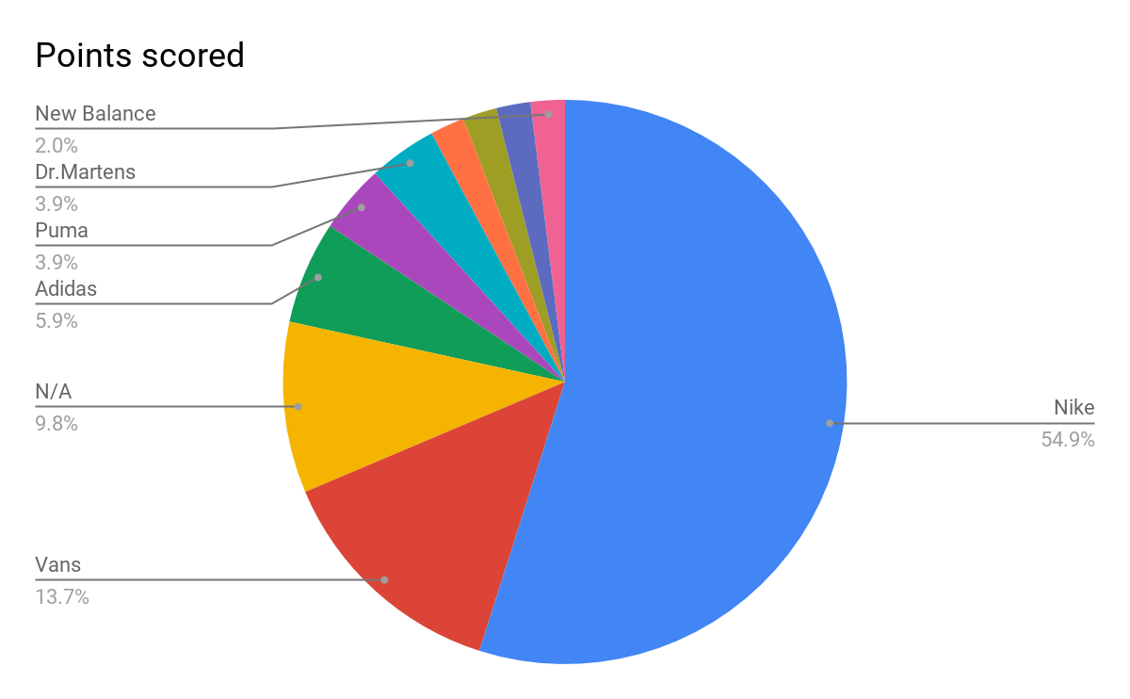

**Question #1: What brand of athletic shoes do you prefer the most**

**Source: The NYS Fashion Marketing Group 2020 Study**

**Table 2**

**Celebrity Endorsement**

|  |  |  |
| --- | --- | --- |
| **Answer Choices** | **Number Answered** | **Percentage** |
| **Very Important** | **0** | **0%** |
| **Mostly Important** | **1** | **2%** |
| **Somewhat Important** | **19** | **37%** |
| **Not Important at all** | **35** | **69%** |

**Question: When buying Footwear, how important is a Celebrity Endorsement?**

**Source: The NYS Fashion Marketing Group 2020 Study**

**Figure 2**

**Important Factors**

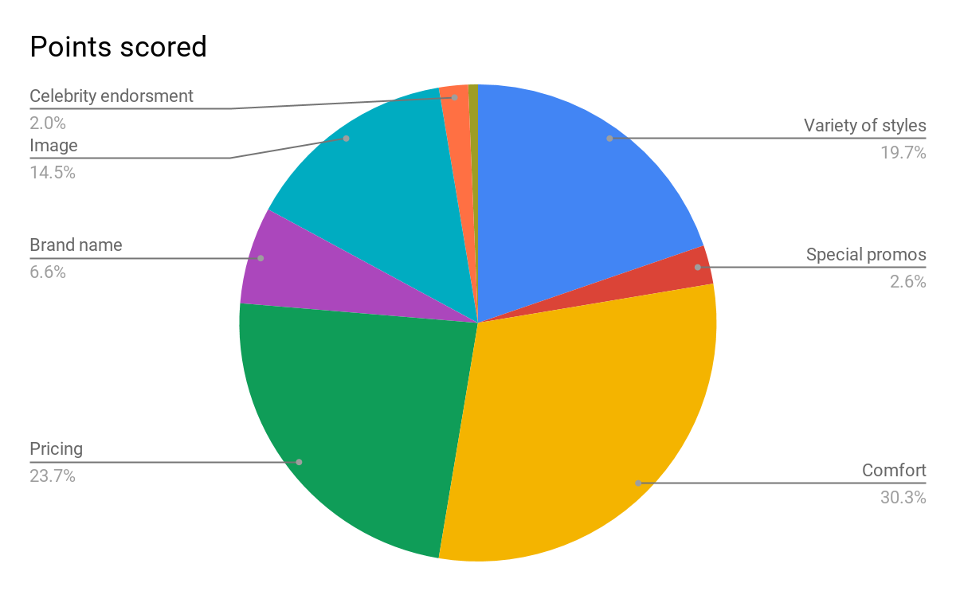

**Question #3: What are the most important factors to you when purchasing Athletic Footwear/ Casual footwear?**

**Source: The NYS Fashion Marketing Group 2020 Study**

**Table 3**

**Any purchased with footwear**

|  |  |  |
| --- | --- | --- |
| **Answer choices** | **Numbers answered** | **Percentage** |
| **Yes** | **39** | **76%** |
| **No** | **12** | **24%** |
| **Total** | **51** | **100%** |

**Question #10: Do you buy products other than sneakers from your favorite brand of Athletic Footwear?**

**Source: The NYS Fashion Marketing Group 2020 Study**

**Figure 3**

**Switching brands**

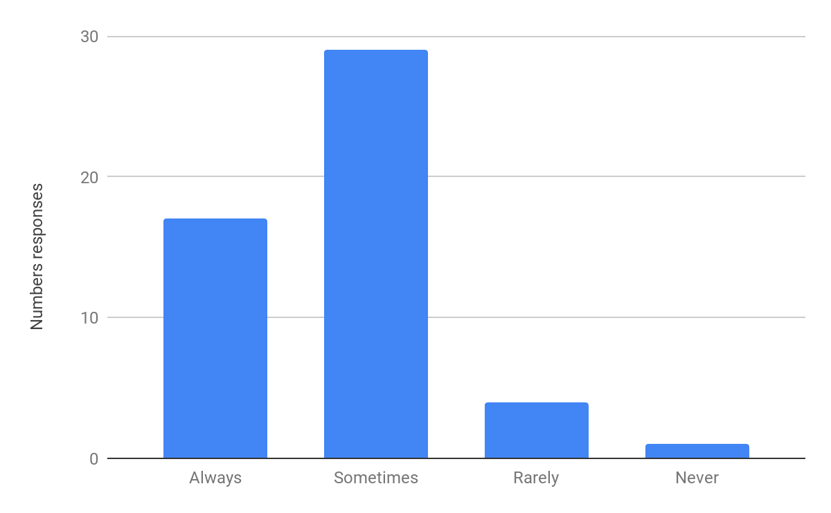

**Question# 17: . Do you ever switch Footwear brands?**

**Source: The NYS Fashion Marketing Group 2020 Study**

**Table 4**

**Payment Methods**

|  |  |  |
| --- | --- | --- |
| **Answer Choices** | **Number answered** | **Percentage** |
| **Cash** | **6** | **11%** |
| **Credit Card** | **7** | **14%** |
| **Debit Card** | **38** | **75%** |
| **Total** | **51** | **100%** |

**Question# 16: What is your most preferred Method of Payment when purchasing Footwear?**

**Source: The NYS Fashion Marketing Group 2020 Study**

**Figure 4**

**Purchasing Footwear**

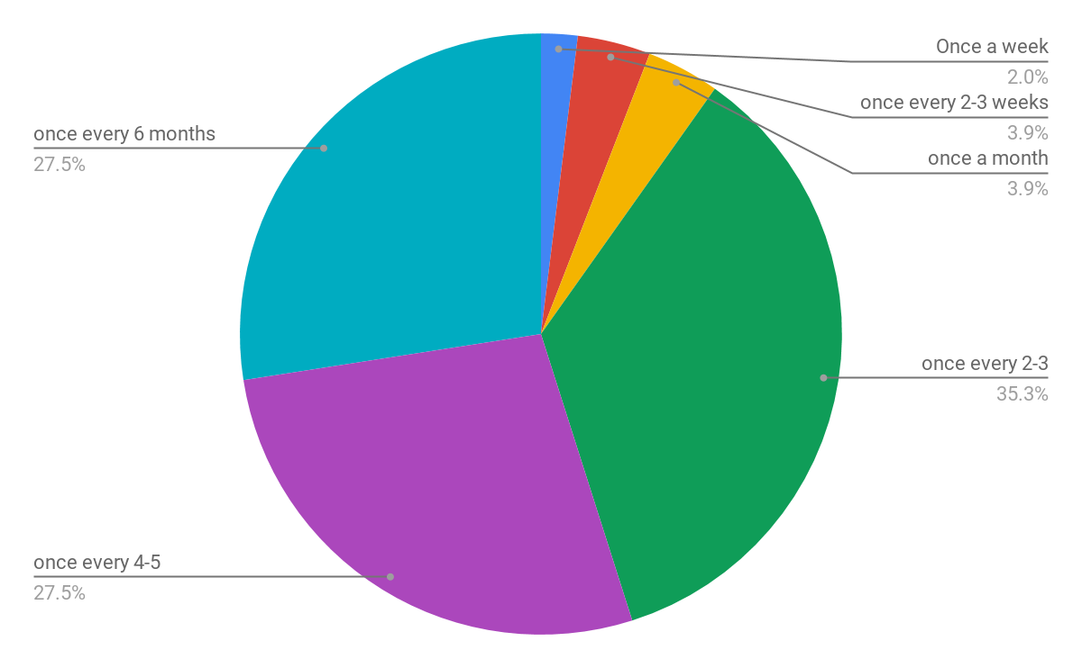

**Question #18: How often do you purchase Footwear?**

**Source: The NYS Fashion Marketing Group 2020 Study**

**Conclusion and Recommendations**

As we conclude our research on Nike and Adidas growth over the years we have theorized that as time goes on, we believe that if Adidas keeps doing what they are doing with their marketing sooner or later they can surpass Nike when it comes to selling. With the research we have done it proves that Adidas has done a lot to get to where they are now in the industry. With their help of marketing, promotions and even collaborations with big names such as Beyoncé with IVYPARK X Adidas and Kanye West Yeezy. They have had a successful increase in sales throughout the years. However, Nike still seems to be in the lead with a profit difference of $30 billion. Their iconic Air Jordan is what seems to be keeping them thriving overall. However, with the survey results that came from our questions proves that individuals have a preference over Nike than Adidas. What most people look for in footwear is the comfort and price, not much from celebrity endorsement, which happens to be very surprising coming from a survey of a younger audience. It's also surprising because of the collaborations that are done by each company. One would think that celebrities play a role in selling products, but our results prove otherwise.

With Covid-19 shutting down all essential businesses, the business will need to adapt to these changes. According to Pie Chart 4, 53% said they prefer to shop online. Adidas needs to take advantage of online shopping and find new ways to reach out to prospects through social media like Instagram, Twitter, and new sensation TikTok.

**[ QUESTIONNAIRE]**

Do people prefer to buy and wear Adidas or Nike?

Currently, we are conducting an important survey amongst people of all ages who are interested in sneaker brands in New York City. Your responses are extremely important to our research and will be kept strictly confidential. We would genuinely appreciate that you answer all of the questions honestly and to the best of your ability.

Thank You!

**1.** **What brand of athletic shoes do you prefer the most? (Please choose only one)**

Adidas

Asics

New Balance

Nike

Puma

Reebok

Other (Please Specify)_______________________

**2. Which of the following Athletic Footwear brands do you currently own? (Please choose all that apply)**

Adidas

Asics

New Balance

Nike

Puma

Reebok

Other (Please Specify) _______________________

3. **What are the most important factors to you when purchasing Athletic Footwear? (Please rank your top three most important factors by numbering them 1, 2, and 3 with 1 being your most important factor)**Variety of Styles

Special Promotions

Comfort

Customer Service

Durability

Pricing

Brand Name

Image/Prestige

Celebrity Endorsements

Other (Please Specify)_______________________

4. **In an average week, how often do you wear Athletic Footwear?**

Everyday

5 to 6 days a week

3 to 4 days a week

1 to 2 days a week

Less than one day a week

5. **When do you usually wear Athletic Footwear?**

To the Gym

When Playing Sports

To School

To Work

Causally

No Special Place

Other (Please Specify)_____________________

**6. By what means do you usually find out about new brands of Athletic Footwear the most? (Please choose only one)**

From Friends

Family Members

Classmates

Advertisements

Celebrity Endorsements

Magazines

Other (Please Specify)______________________

**7. When buying Athletic Footwear, how important is a Celebrity Endorsement?**

Very Important

Mostly Important

Somewhat Important

Not Important at all

**8. If the leading brands of Athletic Footwear all introduced similar products in terms of price, quality and styles, which brand would you purchase? (Please choose only one)**

Adidas

Asics

New Balance

Nike

Puma

Reebok

9. **Do you buy products other than sneakers from your favorite brand of Athletic Footwear?**

Yes

No

**If Yes, what types of other products/items do you usually buy? (Please Specify)**

10. **If your brand price increases would you continue to buy it?**Yes

No

11. **Do you prefer to buy your products Online or in stores?**

Online

In-store

Other (Please specify)

**12. How Loyal or Disloyal are you to your favorite brand of Athletic Footwear?**

Very Loyal

Mostly Loyal

Somewhat Loyal

Not Loyal at All

**13. How do you prefer to shop for Athletic Footwear the Most? (Please choose only one)**

From Catalogues

In Stores

Online

Other (Please Specify) ____________________________

**14. What is your most preferred Method of Payment when purchasing Athletic Footwear?**

Cash

Credit Card

Debit Card

Other (Please Specify) __________________________

15. **Do you ever switch Athletic Footwear brands?**

Always

Sometimes

Rarely

Never

**16. How often do you purchase Athletic Footwear?**

Once a week or more

Once every 2 to 3 weeks

Once a month

Once every 2 to 3 months

Once 4 to 5 months

Once every 6 months or Less

**17. When shopping for Athletic Footwear, if your favorite brand was not stock, would you switch to another brand?**

Definitely Yes

Probably Yes

Probably No

No

**18. How much money would you pay for a pair of Athletic Footwear?**

Less than $50.00

$50.00 to $74.99

$75.00 to $99.99

$100.00 to $124.99

$125.00 to $174.99

$175.00 to $199.99

$200.00 or More

**19. In general, how satisfied or dissatisfied are you with your most preferred brand of Athletic Footwear?**

Very Satisfied

Mostly Satisfied

Somewhat Satisfied

Not Satisfied at All

**20. How interested are you in new product introductions by your favorite brand of Athletic Footwear?**

Very Interested

Mostly Interested

Somewhat Interested

Not Interested at All

**21. In general, how would you rate the Quality of your favorite brand of Athletic Footwear?**

Excellent

Good

Fair

Poor

**22. Which of the following sports do you participate in on a regular basis?**

Baseball

Basketball

Football

Golf

Ice Hockey

Running/Track

Tennis

Other (Please Specify) _____________________

Thank you for taking the time to answer the previous questions. The following questions are of a personal nature and will be kept strictly confidential. Your answers will be used for statistical purposes only. Please complete the Questionnaire by answering the remaining questions.

23. **What is your Gender?**

Male  Female

24. **What is your Age?**

18

19-25

26-30

31-35

36-40

41 and Older

**25. Where do you currently reside?**  
Bronx

Brooklyn

Manhattan

Queens

Staten Island

Other (Please specify)________________________

**26.** **What is your level of education?**

Some high school

High School graduate

Trade school

Some college

Associate Degree

Bachelor’s degree

Master’s Degree

Prefer not to answer

**27. What year are you in college?**

First year college student

Second year college student

Third year college student

Fourth year college student

Other (Please specify) ___________________________

**28.** **What is your classification?**  
Part-time students

Full-time students

Other (Please specify) _____________________________

**29.** **What is your current Marital status?**

Single

Married

Separate

Divorce

Widowed

**30. What is your employment Status?**  
Employed

Unemployed

Self-employed

Other (Please specify)

**31.** **What is your annual income?**  
Less than $20,000

Between $20,000-$30,000

Between $30,000-$39,999

Between $40,000-$49,999

Between $50,000-$59,999

Between $60,000-69,999

Between $70,000-$79,999

Between $80,000-$89,999

Between $90,000-99,999

Above $99,999

PLEASE FEEL FREE TO USE THE SPACE PROVIDED BELOW FOR ANY ADDITIONAL COMMENTS ABOUT THE EXCITING TOPIC______________________________________________________________________________________________________________________________________________________________________________________________________________________________________________________________________________________________________________________________________________________________________________________________________

THANK YOU FOR YOU PARTICIPATION

**Citation Sheet**

Beyoncé gives fans a sneak peek at IVY PARK x Adidas. (2020, January 17).

Retrieved from [https://www.cnn.com/2020/01/17/cnn-underscored/Beyoncé -ivy-park-](https://www.cnn.com/2020/01/17/cnn-underscored/beyonce-ivy-park-adidas/index.html) adidas/index.html

Hale, K. (2019, April 8). Beyoncé Set to Revive Adidas Footwear Sales in New Deal. retrieved from [https://www.forbes.com/sites/korihale/2019/04/08/Beyoncé -set-to-revive-](https://www.forbes.com/sites/korihale/2019/04/08/beyonce-set-to-revive-adidas-footwear-sales-in-new-deal/#5cee98352693) adidas-footwear-sales-in-new-deal/#5cee98352693

Cedric, and Thornton. “Nike's Value Up $26 Billion Since Colin Kaepernick Endorsement.” *Black*  *Enterprise*, Black Enterprise, 27 Nov. 2019, [www.blackenterprise.com/nike-](http://www.blackenterprise.com/nike-value-up-26-billion-since-colin-kaepernick-endorsement/) value-up-26 -billion-since-colin-kaepernick-endorsement/.

Figner, Coleen. “Nike's Best Celebrity Endorsement Campaigns.” *ReviewThis*, ReviewThis, 9 Feb. 2020, [www.reviewthis.com/nikes-best-celebrity-endorsement-campaigns/](http://www.reviewthis.com/nikes-best-celebrity-endorsement-campaigns/).

-Russell, Cally. “Adidas or Nike? Which Retail Giant Is Winning The Sneakers War?” *Forbes*, Forbes Magazine, 22 Aug. 2019 .[www.forbes.com/sites/callyrussell/2019/08/22/adidas](http://www.forbes.com/sites/callyrussell/2019/08/22/adidas-or-nike-which-retail-giant-is-winning-the-sneakers-war/#4f36604e12b7) -or-nike-which-retail-giant-is-winning-the-sneakers-war/#4f36604e12b7.

-Team, Trefis. “Adidas Is Giving Nike A Run For Its Money.” *Forbes*, Forbes Magazine, 6 Aug. 2019,[www.forbes.com/sites/greatspeculations/2019/08/06/adidas-is-giving-nike-a-run-](http://www.forbes.com/sites/greatspeculations/2019/08/06/adidas-is-giving-nike-a-run-for-its-money/#59567f932e00) for-its-money/#59567f932e00